RELEASE NOTES: 08/25/2025
Monthly Service Pack – SC.CORE.6.0_1.36.000.2507.014

Executive Summary:

- No Show Services Signature Configuration (EII #130582): A new system config key (DisplayNoShowNotesAndAllowSignatureOnGroupServices) was introduced to control the enabling of the "Sign My Notes" button for No Show Services.
- Group Service Details Configuration Control (EII #130583): Added a system config key to control access for Program, Procedure, Attending, and Mode Of Delivery fields in the Group Service Details screen.
- Location Lock in Medication Connection Sessions (EII#131828): Enforced a location lock during medication connection sessions; a location can only be changed after disconnection of all medications.
- Re-Dispense Warning for MAT (EII # 126906): Introduced a warning when the dose in MAT (Medication Assisted Treatment) differs from the previous dispense to enhance safety and record accuracy.
- MAT Toxicology Screen Functionality (EII # 124362): Introduced a new MAT Toxicology Screen List Page and Flow Sheets to manage drug testing requirements for clients prior to receiving doses.
- Update on UDS Table 6b to 2025 Specifications:
UDS table 6b has been updated to comply with the 2025 specifications, incorporating the following enhancements:
  - Depression Remission Reporting (EII #129481): Section L Line 21a - Depression Remission at Twelve Months has been revised to meet the 2025 standards. A functionality for Start Date and End Date selection is added, allowing the users to retrieve records based on specific date ranges.
  - Section K Report Implementation (EII #129479): The UDS Table 6B Details - Section K Report has been implemented in alignment with the new 2025 standards.
  - Preventive Care and Screening Report (EII#129480): Updated UDS 6b Section L Line 21 regarding Preventive Care and Screening: Screening for Depression & Follow Up Plan to conform to the 2025 standards.

- Regenerated Billed Charge Workflow Fix (EII # 130499): Fixed issues caused by regeneration of billed charges which previously assigned a new ChargeId. Enhanced payment/denial posting processes and claim workflows.
- Toxicology Screen Flag Icon (EII #130456): Introduced an icon in the MAT column of the Reception/Front Desk list page for clients with an active Toxicology Screen flag, providing tooltip information.
- Goals and Objectives Initialization Control (EII#131696): A system config key added to determine initialization of Goals and Objectives in Service Notes, based on the latest ISP (Individualized Service Plan).
- Service Completion Error for Case Rates (EII #131598): Implemented an error to prevent the completion of case rates when multiple case rates can be created from a component service.
- Saved Physician Signature Application (EII#130759): Enabled application of a saved physician signature across documents, services, notes, and group services.
- Adjudication Date and PCCN Number Handling (EII #130182): Improvements made to select the appropriate adjudication date and PCCN number for secondary claims, ensuring compliance with payer requirements.
- Hover Popup for Flags on Reception Screen (EII#131617): Added a hover feature on ‘Reception Flags’ or ‘All Flags’ hyperlink to display a pop-up with flag icons that closes automatically.

*** DISCLAIMER: The document is only available to those customers who have purchased an annual subscription. It is a premium add-on to SmartCare and not included in SmartCare Base Subscription. If you are interested in learning more about this document, please contact your account manager.
Abbreviation: EII - Engineering Improvement Initiatives

Contents
TASKS LIST – ‘ACTIVE CHANGE' (6) 7
TASKS LIST– ‘PASSIVE CHANGE' (14) 7
TASKS LIST – ‘DEFECTS FIXES’ (50) 8
Functionality-wise Task Details: 10
ER sender 10
70. EII # 130999 (Feature 545341): Implemented the changes to make ‘Sender ID’ field Optional in ‘ER Sender Details’ screen. 10
Global Codes 11
71. Core Bugs # 131645: In the 'External Code Mapping UI Details' screen, the 'Purpose' field was missing during Global Code mapping. Additionally, the TableName and RecordID columns were being saved with blank values in the ExternalMappings table. 11
Group Services 12
72. Core Bugs # 132569: 'Note' Tab is not Disabled for Specific Note Types in Group Service Details page for attendance groups. 13
73. Core Bugs # 132482: Duplicate warning message created in Unsavedchanges table and Slowness in Group Services Details screen. 13
74. EII #130582 (Feature - 523754): Group Notes: "No Show" notes - Ability to sign at Group Service level. {ACTIVE CHANGE} 14
75. Core Bugs # 132393: Group Service user does not have permission to view clients. 15
76. Core Bugs # 132568: Edited recurrence is not appearing on either the Group Details screen. 16
77. EII # 130583 (Feature - 523757): Group Services – Implemented ServiceDropdownConfigurations settings to work the same as Individual Service Note. {ACTIVE CHANGE} 17
Inquiries 19
78. Core Bugs # 132486: Client Inquiries List Page displaying duplicates when multiple dispositions are associated with Inquiry & red error is displayed. 19
Interfaces 20
79. Core Bugs # 132268: “Date Received” column sorting issue in the "Messages Interface" screen. 20
Methadone 20
80. Core Bugs # 132083: MAT - Page unresponsive 21
81. Core Bugs # 132478: Medication Refusals are not always displayed on the Client in MAR. 22
82. Core Bugs # 132465: Getting an error while clicking on ‘Medication History’ button 23
83. Core Bugs # 132316: MAT Management Details: Alignment issues under the Dispensing Notes tab. 23
84. EII # 126906 (Feature - 342121): MAT: Implemented Re-Dispense Warning when the dose differs from previous Dispense. 24
85. Core Bugs # 132502: MAT: Calibration: Machine fault when prompting user to empty line. 26
86. EII # 124362 (Feature - 243612): MAT Toxicology Screen List page has been implemented. 27
87. Core Bugs # 132344: MAT: Future Data Not Displayed in Scheduled Grid on MAT Management Details Screen. 33
88. EII # 124363 (Feature - 243618): The MAT Toxicology functionality is implemented when dispensing the Face-to-Face dose in the MAT Management Details screen. 34
89. Core Bugs # 132464: MAT Management Details Screen: System is slow while dispensing. 49
90. Core Bugs # 132314: Medication Transaction Inventory: The Location field is not auto populated when the bottle number is selected. 49
91. Core Bugs # 132403: MAT Connection Details Pop up: The Bottle search functionality is not accepting the minimum 2 characters when tried to search for the Bottles. 50
92. EII # 131828 (Feature - 557927): MAT: Restrict Users from Connecting to Medications Across Multiple Locations. {ACTIVE CHANGE} 51
93. Core Bugs # 132462: MAT Configuration: Getting red error message while saving the ‘Mat Configuration’ screen. 57
My Calendar 57
94. Core Bugs # 132552: Red error Message is displayed when creating a Recurring appointment for Additional staff. 57
95. Core Bugs # 132395: Recurring Calendar Event on ‘My Calendar’ is not removing future events after modifying recurrence. 58
My Report 58
96. Core Bugs # 132255: Incorrect data is displayed in the ‘over 365 days’ column of the ‘AR Report by payer’ report. 59
97. Core Bugs # 132177: ER File Detail: ER File Detail requires User ID, Accounting Period to be entered. 59
98. EII # 129481 (Feature - 470115): Implementation of the ‘UDS Table 6B Details - Section L Line 21a - Depression Remission at Twelve Months’ to 2025 Standard. 59
99. EII # 129479 (Feature - 470113): Implementation of the ‘UDS Table 6B Details - Section K Report’ to the 2025 Standard. 66
100. EII # 129480 (Feature - 470114): Implementation of the ‘UDS 6b Section L Line 21 - Preventive Care and Screening: Screening for Depression & Follow Up Plan’ to 2025 Standard. 73
101. Core Bugs # 132127: Display Issue: Report is Opening in Minimized Window instead of full window from ‘Favorites Search'. 77
102. Core Bugs # 132443: Issue with favorites search causing endless processing loop after report deletion 77
Patient Portal 78
103. Core Bugs # 131744: URL showing sensitive information on resetting the password. 78
Payments/Adjustments 78
104. Core Bugs # 132323: Corrections and Delete Client ledger Entries reversing ledger entries improperly, leaving incorrect balance on charges. 79
105. EII # 130499 (Feature - 519458): Regenerate Charges Phase 2: FrontEnd: Implementation of Warning Messages. {ACTIVE CHANGE} 79
106. EII # 129864 (Feature - 401163): Regenerate Charges Phase 2: Back End: Implementation of logic functionality.{ACTIVE CHANGE} 84
Plans 86
107. Core Bugs # 132381: Rules Template not copying from specified Plan. 86
108. EII # 130182 (Feature - 495709): Implemented the changes to use the required payment date as primary adjudication date and the previous payer PCCN number on secondary claims when submitting secondary E-Claims. 87
Procedure/Rates 88
109. Core Bugs # 128473: Modified date was getting updated, when user processes the claim and modifies billing codes in Procedure and Plan. 89
Programs 89
110. Core Bugs # 132232: Program Assignments: Client Program enrollment and discharge records containing time values were not displayed on the Client Assignment list page. 89
Provider contract 90
111. Core Bugs # 132487: Contracted Rates Details: Problem with a trailing space after a modifier. 90
Reception 90
112. EII # 130456 (Feature - 517904): MAT: The Toxicology screen flag icon is implemented in the Reception/Front Desk list page. {ACTIVE CHANGE} 91
113. EII # 131617 (Feature - 548557): Reception Flags: Display flags pop-up on mouse hover of the count instead of click event. 93
Role Definition 95
114. Core Bugs # 132433: In 'Role Definition' screen, the Permissions "Deny All" feature was not working properly. 95
Rx Application 95
115. Core Bugs # 131889: Medication Management: Dosage & Instruction Updating Issue. 95
116. EII # 130925 (Feature - 540393): Implemented the changes to display Surescripts Message ID on Outbound Prescriber Tab for Troubleshooting. 96
Scanning 97
117. Core Bugs # 132302: Scanning- All Associations filter in the Scanning (My Office) list page is not displayed all associations related documents. 97
118. Core Bugs # 132426: Scanning: Scanned Medical Records Loading/Processing Error. 98
Services 98
Service/Notes screen: Invalid validation message displayed when the selected procedure did not allow decimal values. 98
119. Core Bugs # 132307: Client Name was not Filtered by Status chosen from the ‘Show Only Active Clients’ checkbox on Services Screen. 99
120. Core Bugs # 132292: Services: Validation for Disposition only staff and Work Group displayed when navigating back to Services from unsaved changes. 99
121. EII # 131598 (Feature - 546861): Case Rate Component Service Completion Validation is implemented. 99
122. Core Bugs # 132342: Duplicate Diagnoses are initializing to Billing Diagnosis tab. 101
123. Core Bugs # 132575: The ‘IC Cancellation’ reason appeared in the 'Cancel Reason' dropdown list for ‘Service Detail’, ‘Service Note’, and ‘Group Service Detail’ pages. 101
124. Core Bugs # 132513: Service/Notes screen: Invalid validation message displayed when the selected procedure did not allow decimal values. 102
Services from claims 102
125. Core Bugs # 132167: Service From Claim - Services From Claims "All" hyperlink is Not Working. 103
Services / Notes 103
126. Core Bugs # 132221: The Service/Notes detail screen remains in processing mode when the program is selected first. 103
127. Core Bugs # 132519: User is unable to ‘Sign’ an ‘Encounter Form’ in a service note using ‘Signature Pad’ device in the first attempt. 104
128. Core Bugs # 132351: Service/Notes - Add/View additional staffs added in the popup are not listing in calendar. 104
129. Core Bugs # 132418: Psychiatric Note – Displayed INSERT Statement conflict Errors on Services on sign. 105
130. Core Bugs # 132251: When diagnosis is changed in ‘Psychiatric Note’, new dx does not carry into future services. 105
131. Core Bugs # 132579: Psychiatric Note: Multiple radio buttons are being selected under ‘Thought Content and Process; Cognition’ portion of the ‘Psychiatric Note’ PDF. 106
132. EII # 131696 (Feature - 553150): Changes are implemented to Initialize the Goals and Objectives from the latest ISP to the Service Notes based on the Config Key value set. 107
Signature Popup 113
133. EII # 130759 (Feature - 532360): Implemented Saved Signature radio button in Signature Popup. {ACTIVE CHANGE} 113
SmartCare Improvements 119
134. Core Bugs # 132163: Services (My Office): Error was displaying when tried to open exported file in .xlsx or .xls format. 119
135. Core Bugs # 132087: Patient Safety Plan Template: the overridden text was not retained once after navigating from any other screens. 119
136. Core Bugs # 131875: Immunization Details: Bold label changes issue. 120
137. EII # 131858 (Feature - 558921): Implementation of deletion primary child data from Custom Grid. 120
Staff/Users 121
138. Core Bugs # 131757 Staff Details: “Highly Qualified Teacher" tab not loading due to an HTTP validation request thrown. 121
Team Productivity 122
139. Core Bugs # 132489: Team Productivity: Issue with ‘Team Name’ hyperlink. 122
Glossary of System Configuration Keys, Global Codes, Recodes, Data Model Changes 122
System Configuration Keys 122
Global Codes 122
Recodes 123
Data Model Changes 123

TASKS LIST – ‘ACTIVE CHANGE' (6)

Sl. No | Task No | Summary | Module Name
74 | EII # 130582 | Group Notes: "No Show" notes - Ability to sign at Group Service level | Group Services
77 | EII # 130583 | Group Services – Implemented ServiceDropdownConfigurations settings to work the same as Individual Service Note | Group Services
92 | EII # 131828 | MAT: Restrict Users from Connecting to Medications Across Multiple Locations. | Methadone
105 | EII # 130499 | Regenerate Charges Phase 2:Front End: Implementation of Warning Messages. | Payments/Adjustments
106 | EII # 129864 | Regenerate Charges Phase 2: Back End: Implementation of logic functionality. | Payments/Adjustments
112 | EII # 130456 | MAT: The Toxicology screen flag icon is implemented in the Reception/Front Desk list page. | Reception

TASKS LIST– ‘PASSIVE CHANGE' (14)

Sl. No | Task No | Summary | Module Name
70 | EII # 130999 | Implemented the changes to make ‘Sender ID’ field Optional in ‘ER Sender Details’ screen. | ER sender
84 | EII # 126906 | MAT: Implemented Re-Dispense Warning when the dose differs from previous Dispense. | Methadone
86 | EII # 124362 | MAT Toxicology Screen List page has been implemented. | Methadone
88 | EII # 124363 | The MAT Toxicology functionality is implemented when dispensing the Face-to-Face dose in the MAT Management Details screen. | Methadone
98 | EII # 129481 | Implementation of the ‘UDS Table 6B Details - Section L Line 21a - Depression Remission at Twelve Months’ to 2025 Standard. | My Reports
99 | EII # 129479 | Implementation of the ‘UDS Table 6B Details - Section K Report’ to the 2025 Standard. | My Reports
100 | EII # 129480 | Implementation of the ‘UDS 6b Section L Line 21 - Preventive Care and Screening: Screening for Depression & Follow Up Plan’ to 2025 Standard. | My Reports
108 | EII # 130182 | Implemented the changes to use the required payment date as primary adjudication date and the previous payer PCCN number on secondary claims when submitting secondary E-Claims | Plans
113 | EII # 131617 | Reception Flags: Display flags pop-up on mouse hover of the count instead of click event. | Reception
116 | EII # 130925 | Implemented the changes to display Surescripts Message ID on Outbound Prescriber Tab for Troubleshooting. | Rx Application
121 | EII # 131598 | Case Rate Component Service Completion Validation is implemented | Services
132 | EII # 131696 | Changes are implemented to Initialize the Goals and Objectives from the latest ISP to the Service Notes based on the Config Key value set | Services/Notes
133 | EII # 130759 | Implemented Saved Signature radio button in Signature Popup | Signature Popup
137 | EII # 131858 | Implementation of deletion primary child data from Custom Grid. | SmartCare Improvements

TASKS LIST – ‘DEFECTS FIXES’ (50)
Sl. No | Task No | Summary | Module Name
71 | Core Bugs # 131645 | In the 'External Code Mapping UI Details' screen, the 'Purpose' field was missing during Global Code mapping. Additionally, the TableName and RecordID columns were being saved with blank values in the ExternalMappings table. | Global Codes
72 | Core Bugs # 132569 | 'Note' Tab is not Disabled for Specific Note Types in Group Service Details page for attendance groups. | Group Services
73 | Core Bugs # 132482 | Duplicate warning message created in Unsavedchanges table and Slowness in Group Services Details screen. | Group Services
75 | Core Bugs # 132393 | Group Service user does not have permission to view clients. | Group Services
76 | Core Bugs # 132568 | Edited recurrence is not appearing on either the Group Details screen | Group Services
78 | Core Bugs # 132486 | Client Inquiries List Page displaying duplicates when multiple dispositions are associated with Inquiry & red error is displayed. | Inquiries
79 | Core Bugs # 132268 | “Date Received” column sorting issue in the "Messages Interface" screen. | Interfaces
80 | Core Bugs # 132083 | MAT - Page unresponsive | Methadone
81 | Core Bugs # 132478 | Medication Refusals are not always displayed on the Client in MAR. | Methadone
82 | Core Bugs # 132465 | Getting an error while clicking on ‘Medication History’ button | Methadone
83 | Core Bugs # 132316 | MAT Management Details : Alignment issues under the Dispensing Notes tab. | Methadone
85 | Core Bugs # 132502 | MAT: Calibration: Machine fault when prompting user to empty line. | Methadone
87 | Core Bugs # 132344 | MAT: Future Data Not Displayed in Scheduled Grid on MAT Management Details Screen. | Methadone
89 | Core Bugs # 132464 | MAT Management Details Screen: System is slow while dispensing. | Methadone
90 | Core Bugs # 132314 | Medication Transaction Inventory: The Location field is not auto populated when the bottle number is selected. | Methadone
91 | Core Bugs # 132403 | MAT Connection Details Pop up: The Bottle search functionality is not accepting the minimum 2 characters when tried to search for the Bottles. | Methadone
93 | Core Bugs # 132462 | MAT Configuration: Getting red error message while saving the ‘Mat Configuration’ screen. | Methadone
94 | Core Bugs # 132552 | Red error Message is displayed when creating a Recurring appointment for Additional staff. | My Calendar
95 | Core Bugs # 132395 | Recurring Calendar Event on ‘My Calendar’ is not removing future events after modifying recurrence. | My Calendar
96 | Core Bugs # 132255 | Incorrect data is displayed in the ‘over 365 days’ column of the ‘AR Report by payer’ report. | My Report
97 | Core Bugs # 132177 | ER File Detail: ER File Detail requires User ID, Accounting Period to be entered. | My Report
101 | Core Bugs # 132127 | Display Issue: Report is Opening in Minimized Window instead of full window from ‘Favorites Search'. | My Report
102 | Core Bugs # 132443 | Issue with favorites search causing endless processing loop after report deletion | My Report
103 | Core Bugs # 131744 | URL showing sensitive information on resetting the password. | Patient Portal
104 | Core Bugs # 132323 | Corrections and Delete Client ledger Entries reversing ledger entries improperly, leaving incorrect balance on charges. | Payments/Adjustments
107 | Core Bugs # 132381 | Rules Template not copying from specified Plan | Plans
109 | Core Bugs # 128473 | Modified date was getting updated, when user processes the claim and modifies billing codes in Procedure and Plan. | Procedure/Rates
110 | Core Bugs # 132232 | Program Assignments: Client Program enrollment and discharge records containing time values were not displayed on the Client Assignment list page. | Programs
111 | Core Bugs # 132487 | Contracted Rates Details: Problem with a trailing space after a modifier | Provider Contract
114 | Core Bugs # 132433 | In 'Role Definition' screen, the Permissions "Deny All" feature was not working properly. | Role Definition
115 | Core Bugs # 131889 | Medication Management: Dosage & Instruction Updating Issue. | Rx Application
117 | Core Bugs # 132302 | Scanning- All Associations filter in the Scanning (My Office) list page is not displayed all associations related documents. | Scanning
118 | Core Bugs # 132426 | Scanning: Scanned Medical Records Loading/Processing Error | Scanning
119 | Core Bugs # 132307 | Client Name was not Filtered by Status chosen from the ‘Show Only Active Clients’ checkbox on Services Screen. | Services
120 | Core Bugs # 132292 | Services: Validation for Disposition only staff and Work Group displayed when navigating back to Services from unsaved changes | Services
122 | Core Bugs # 132342 | Duplicate Diagnoses are initializing to Billing Diagnosis tab | Services
123 | Core Bugs # 132575 | The ‘IC Cancellation’ reason appeared in the 'Cancel Reason' dropdown list for ‘Service Detail’, ‘Service Note’, and ‘Group Service Detail’ pages. | Services
124 | Core Bugs # 132513 | Service/Notes screen: Invalid validation message displayed when the selected procedure did not allow decimal values. | Services
125 | Core Bugs # 132167 | Service From Claim - Services From Claims "All" hyperlink is Not Working | Services from claims
126 | Core Bugs # 132221 | The Service/Notes detail screen remains in processing mode when the program is selected first. | Services/Notes
127 | Core Bugs # 132519 | User is unable to ‘Sign’ an ‘Encounter Form’ in a service note using ‘Signature Pad’ device in the first attempt. | Services/Notes
128 | Core Bugs # 132351 | Service/Notes - Add/View additional staffs added in the popup are not listing in calendar. | Services/Notes
129 | Core Bugs # 132418 | Psychiatric Note – Displayed INSERT Statement conflict Errors on Services on sign. | Services/Notes
130 | Core Bugs # 132251 | When diagnosis is changed in ‘Psychiatric Note’, new dx does not carry into future services. | Services/Notes
131 | Core Bugs # 132579 | Psychiatric Note: Multiple radio buttons are being selected under ‘Thought Content and Process; Cognition’ portion of the ‘Psychiatric Note’ PDF. | Services/Notes
134 | Core Bugs # 132163 | Services (My Office): Error was displaying when tried to open exported file in .xlsx or .xls format | SmartCare Improvements
135 | Core Bugs # 132087 | Patient Safety Plan Template: the overridden text was not retained once after navigating from any other screens. | SmartCare Improvements
136 | Core Bugs # 131875 | Immunization Details: Bold label changes issue | SmartCare Improvements
138 | Core Bugs # 131757 | Resolve Http Request Validation Exceptions in AjaxScriptHighlyQualifiedTeachers.aspx | Staff/Users
139 | Core Bugs # 132489 | Team Productivity: Issue with ‘Team Name’ hyperlink. | Team Productivity

Functionality-wise Task Details:

ER sender

Reference No | Task No | Description
70 | EII # 130999 | Implemented the changes to make ‘Sender ID’ field Optional in ‘ER Sender Details’ screen.
Author: Rinki Kumari

70. EII # 130999 (Feature 545341): Implemented the changes to make ‘Sender ID’ field Optional in ‘ER Sender Details’ screen.
Note: This is a Passive Change.
Release Type: Change | Priority: High
Navigation Path: Administration’ -- ’ER Sender List’ -- Click on new icon – ‘ER Sender Details’ screen.
Purpose: This change will make ‘Sender ID’ field Optional in ‘ER Sender Details’ screen and to enhance the user experience on the ER Sender Details screen by eliminating unnecessary prompts.
Functionality Before and After release:
Before this release, here was the behavior. In the ‘ER Sender Details’ screen, the ‘Sender ID’ field appeared before the ‘Sender Name’ field and was incorrectly marked as required. As a result, users encountered validation errors when the ‘Sender ID’ field was left empty even though it wasn't mandatory. This setup was leading to confusion and unnecessary validation errors during data entry.
With this release, the ‘ER Sender Details’ screen has been improved for better usability, and the following changes have been made in the ‘ER Sender Details’.
- In the ‘Sender’ section, swapped the ‘Sender ID’ and ‘Sender Name’ fields. Now, the ‘Sender Name’ field will appear before the ‘Sender ID’ to ensure that required fields are encountered first.
- The ‘Sender ID’ field is correctly marked as optional and required field validation message has been removed for this ‘Sender ID’ field.

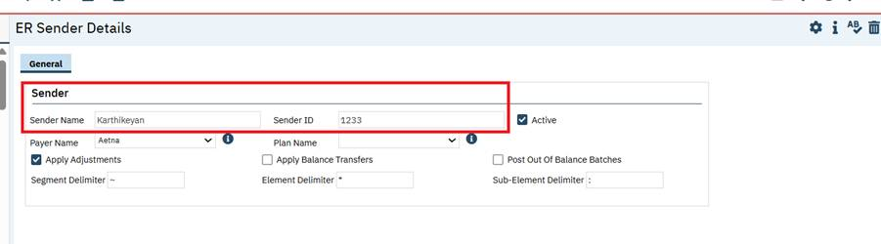

Global Codes

Reference No | Task No | Description
71 | Core Bugs # 131645 | In the 'External Code Mapping UI Details' screen, the 'Purpose' field was missing during Global Code mapping. Additionally, the TableName and RecordID columns were being saved with blank values in the ExternalMappings table.
Author: Savitha Siddaraju

71. Core Bugs # 131645: In the 'External Code Mapping UI Details' screen, the 'Purpose' field was missing during Global Code mapping. Additionally, the TableName and RecordID columns were being saved with blank values in the ExternalMappings table.

Release Type: Fix | Priority: Medium
Navigation Path 1: ‘Administrator’ -- ‘Global Codes’ -- ‘Global Codes’ list page -- click on ‘Category’ hyperlink -- ‘Global Code Details’ screen - ‘Category’ section – select ‘Has External Mappings’ checkbox – ‘Save’ – click on ‘Add More External Codes’ hyperlink - ‘External Code Mapping UI Details' screen.
Navigation Path 2: ‘Administrator’ --'External Code Mapping List’ -- 'External Code Mapping List’ page -- Click on ‘New’ icon -- 'External Code' pop up will display -- Select Mapping Criteria as ‘Global Codes’ radio button -- Select ‘Category code’ value -- Click on ‘OK’ button -- ‘External Code Mapping UI Details' screen.
Navigation Path 3: Administrator’ -- 'External Code Mapping List’ -- 'External Code Mapping List’ page -- Click on ‘New’ icon -- 'External Code' pop up will display -- Select Mapping Criteria as ‘Table Information’ radio button -- Select ‘Table Name’ value -- Click on ‘OK’ button -- ‘External Code Mapping UI Details' screen.
Functionality ‘Before’ and ‘After’ release:
Before this release, here was the behavior.
- When the user navigates to the 'External Code Mapping UI Details' screen either by selecting 'Global Codes' as the Mapping Criteria from the 'External Codes' popup or directly via the Global Codes screen, the following behaviors were observed:
- The 'Purpose' field was not displayed during the Global Code mapping process.
- Upon saving data to the ExternalMappings table from the Global Code view, the TableName and RecordID columns were being stored with blank values.
- When the user navigates to the 'External Code Mapping UI Details' screen by selecting 'Table Information' as the Mapping Criteria, the 'Purpose' field is displayed in the ‘Table Information’ section.

With this release, the above-mentioned issues have been resolved. Now
- When the user navigates to the 'External Code Mapping UI Details' screen—either by selecting 'Global Codes' as the Mapping Criteria in the 'External Codes' popup or directly through the Global Codes screen—the following behavior is observed:
- The 'Purpose' field is displayed in the External Codes section.
- Upon saving data to the ExternalMappings table, the following values are stored:
- Category column → Stores the ‘Global Code Category’ name
- TableName column → Stores the value as 'GlobalCodes'
- RecordID column → Stores the corresponding ‘GlobalCodeID’
- RecordCode column → Stores the ‘Global Code Name’
- When the user navigates to the 'External Code Mapping UI Details' screen by selecting 'Table Information' as the Mapping Criteria, the 'Purpose' field has been relocated from the ‘Table Information’ section to the ‘External Codes’ section.

Group Services

Reference No | Task No | Description
72 | Core Bugs # 132569 | 'Note' Tab is not Disabled for Specific Note Types in Group Service Details page for attendance groups.
73 | Core Bugs # 132482 | Duplicate warning message created in Unsavedchanges table and Slowness in Group Services Details screen.
74 | EII # 130582 | Group Notes: "No Show" notes - Ability to sign at Group Service level
75 | Core Bugs # 132393 | Group Service user does not have permission to view clients.
76 | Core Bugs # 132568 | Edited recurrence is not appearing on either the Group Details screen.
77 | EII # 130583 | Group Services – Implemented ServiceDropdownConfigurations settings to work the same as Individual Service Note.

Author: Niroop Hassan

72. Core Bugs # 132569: 'Note' Tab is not Disabled for Specific Note Types in Group Service Details page for attendance groups.

Release Type: Issue Fix | Priority: Medium

Navigation Path: ‘My Office’ – ‘Groups’ – ‘Groups’ list page – Click on ‘New’ icon – ‘Group Details’ page – Check ‘Attendance’ checkbox in ‘Attendance’ section – Select ‘Group Note Type’ as ‘Daily Stand-alone’ or ‘Weekly Stand-alone’ or ‘Screen’ and click on ‘Save’ icon – Click on ‘Schedule’ icon – ‘Attendance Assignment’ page – Select required data and click on ‘Save’ icon – Click on required ‘Open Group Service’ button – ‘Group Service Detail’ page.
Functionality ‘Before’ and ‘After’ Release:
Before this release, here was the behavior. When the user selected the Group Note Type as ‘Daily Stand-alone’, ‘Weekly Stand-alone’, or ‘Screen’ and opened the Group Service Detail page, the ‘Note’ tab was enabled.
With this release, the above-mentioned issue has been resolved. Now, when the Group Note Type is set to ‘Daily Stand-alone’, ‘Weekly Stand-alone’, or ‘Screen’, the ‘Note’ tab will be disabled on the Group Service Detail page.

Author: Chaithra Kunjilana

73. Core Bugs # 132482: Duplicate warning message created in Unsavedchanges table and Slowness in Group Services Details screen.

Release Type: Fix | Priority: Medium

Navigation Path: Go Search -- Groups(My Office) – New – Enter the required values – Save – Navigate to Schedule tab – Click on New Group Service button – Select the Client and enter the Date and click on Select – In Group Services Details screen – Change the Status to Show for few Clients – Save – Navigate to Note tab – Enter the values to few clients – Sign – In the validation pop up click on Cancel.

Functionality ‘Before’ and ‘After’ Release:
Before this release, here was the behavior. When users tried to sign the Group Services without entering the values in the Client Note tab for few clients, and in the Validation message pop up user clicked on the Cancel button, duplicate warning message was being created in Unsavedchanges table and causing slowness in the Group Services screen.
With this release, the above-mentioned issue is fixed. Now, no duplicate warning message is being created in Unsavedchanges table and there is no slowness in the Group Services screen.

Author: Chaithra Kunjilana

74. EII #130582 (Feature - 523754): Group Notes: "No Show" notes - Ability to sign at Group Service level. {ACTIVE CHANGE}

Note: This is Active Change, with this implementation a new system configuration key DisplayNoShowNotesAndAllowSignatureOnGroupServices is introduced. The value of this key is used to determine whether to allow the signature for No Show Services by enabling the "Sign My Notes" button within the Group Service details screen - Note -> Client Note.
Release Type: Change | Priority: Urgent

Navigation Path: My Office – Groups – Enter the required values – Save – Scheduled tab – New Group Service – Select the Client and enter the date – Ok – Change the status to No Show – Save/Sign.

Functionality ‘Before’ and ‘After’ release:

Before this release, for No show services in the Group Service the “Sign My Notes” button was disabled and the Note was enabled when the Configuration key DisableNoShowNotes was set to 'N' and When the value was set to 'Y', "The Client Service Status is No show, so Note tab is not Visible" message was displayed and Sign My Notes button was enabled.

With this release, a new system configuration key DisplayNoShowNotesAndAllowSignatureOnGroupServices is added to determine whether to allow the signature by enabling the "Sign My Notes" button within the Group Service details screen - Note -> Client Note.
- If the key value is set to "Yes", we are enabling the "Sign My Notes" button and allowing signing of Services that are marked as 'No Show'.
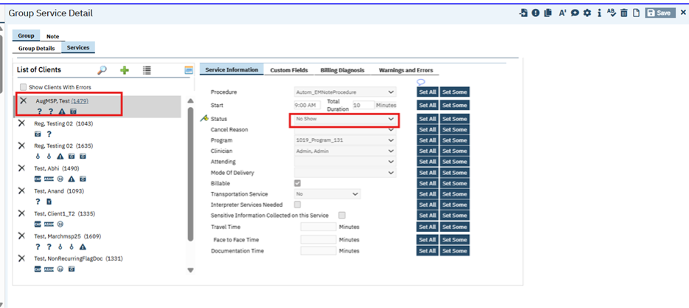
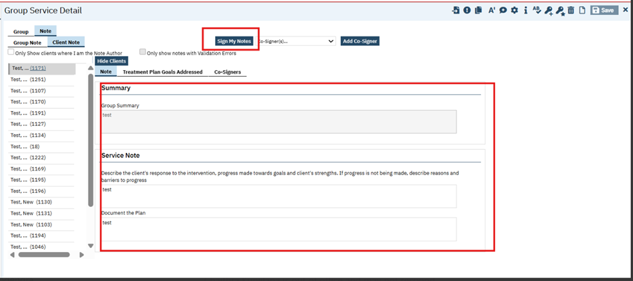

- If the key value is set to “No", then the existing behavior will work based on the value being set on the existing configuration key "DisableNoShowNote".
System Configuration Key Details:
Read Key as: Display No Show Notes and Allow Signature On Group Services.
Allowed Values: Yes, No
Default Value: No
Modules/Functionality: SCM Admin 2
Description: "This is a new feature being added to the Core product by introducing a system configuration key. The value of this key will be used to determine whether to allow the signature by enabling the "Sign My Notes" button within the Group Service details screen - Note -> Client Note.
A) If the key value is set to “Yes", enable the "Sign My Notes" button and allow signing of Services marked as 'No Show'. Additionally hide the current message saying, "The Client's Service Status is No Show, so Note tab is not Visible." and show the Note tab to access it.
B) If the key value is set to “No", then follow the existing behavior and it must work based on the value being set on the existing config key "DisableNoShowNote". This will be the default value of this key as it drives the existing functionality.
Note: If by chance the value of the key is updated with any value apart from the allowed values, the system will consider the default behavior, i.e., same as the key value being "No"."

Author: Chaithra Kunjilana

75. Core Bugs # 132393: Group Service user does not have permission to view clients.

Note: This functionality is implemented for a specific customer. If you have Primary and County types of setup and would like to use these functionalities, please get in touch with Streamline Support.
Release Type: Fix | Priority: Medium
Prerequisites:
- System configuration key “DisplayCDAGSectionInStaffDetails” is set to ‘Yes’.
- System configuration key ‘EnableClinicalDataAccessGrouping’ value is set to ‘Yes’.
Navigation Path 1: Groups(My office) – New – Enter the required values save – Navigate to Schedule tab – Click on New Group Services button – Select the Date and client – Click on Ok – In Group Services Detail screen enter the required values – Save.
Navigation Path 2: Staff/Users – Search and select the staff – Proc/Prog/Loc/Proxy/Supervisor tab – Check the ‘All Clinical Data Access Groups’ check box – Save – Navigate to the Group Services (Navigation Path 1) created above – Services tab.

Functionality ‘Before’ and ‘After’ release:

Before this release, here was the behavior. When the ‘All Clinical Data Access Groups’ checkbox was selected in the Proc/Prog/Loc/Proxy/Supervisor tab of the Staff Details screen, then the Client Names in the Group Services detail screen were masked with ****. On hovering over the masked names, a tooltip displays the message: “You do not have access to this client.”
With this release, the above-mentioned issue has been resolved. Now, the client names in the Group service details screen are visible to the clinician when ‘All Clinical Data Access Groups’ check box is checked in the Proc/Prog/Loc/Proxy/Supervisor tab of the Staff Details screen.

Author: Suganya Sivakumar

76. Core Bugs # 132568: Edited recurrence is not appearing on either the Group Details screen.
Release Type: Fix | Priority: Medium
Navigation Path 1: My office --- Groups --- Groups List page --- Click on New Icon --- Group Detail page --- Enter all the required fields in General tab --- Click on Save button --- Navigate to Schedule tab --- Click on New Group Service button --- Group Service Clients popup --- Select Date of Service and Clients --- Click on Select button.
Navigation Path 2 – Navigate to Group Service Detail Screen --- In Group tab --- Navigate to Group Details tab --- Ensure all details in Group section are initialized correctly --- In Staff section --- Ensure Staff Name, Unit, Type, Start and End timings are initialized correctly --- Click on the Recurrence icon --- Recurring Group Services popup displays --- Select Start and End Date --- Select Weekly radio button from Recurrence pattern section -- Click on Create Immediately checkbox --- Click on Ok button.
Functionality ‘Before’ and ‘After’ release:
Before this release, here was the behavior. In the Recurrence Group Services, when End Date of a recurring service was extended. The edited recurrence did not appear in the Group Details.
With this release, the above-mentioned issue has been resolved. Now, the extended end date of the recurring services gets displayed correctly in the Group Details.

Author: Suganya Sivakumar

77. EII # 130583 (Feature - 523757): Group Services – Implemented ServiceDropdownConfigurations settings to work the same as Individual Service Note. {ACTIVE CHANGE}

Note: This is Active Change. With this implementation, we are introducing a new system configuration key. The value of this key will control the access of Program, Procedure, Attending, and Mode Of Delivery fields in the Group Service Details screen by binding/refreshing these field values using the ServiceDropdownConfigurations settings to this screen, which works the same as the Individual Service Note.

Release Type: Change | Priority: Urgent

Navigation Path 1: My office --- Groups --- Groups List page --- Click on New Icon --- Group Detail page --- Enter all the required fields in General tab --- Click on Save button --- Navigate to Schedule tab --- Click on New Group Service button --- Group Service Clients popup --- Select Date of Service and Clients --- Click on Select button.

Navigation Path 2: Navigate to Group Service Detail Screen --- In Group tab --- Navigate to Group Details tab --- Ensure all details in Group section are initialized correctly --- In Staff section --- Ensure Staff Name, Unit, Type, Start and End timings are initialized correctly ---- Navigate to Services tab --- In List of Client section --- Ensure all Clients added are present in the list --- Enter all the required fields in the Service Information Tab, Custom fields, Billing diagnosis tabs --- Click on Save Button --- Navigate to Note tab --- Under Client Note enter required fields --- Click on Save Button --- Click on Sign Button --- Signature popup displays --- PDF.

Functionality ‘Before’ and ‘After’ release:

Before this release, in the Group Service detail screen, the Program, Procedure, Clinician, Attending, and Mode of Delivery fields displayed all the values based on the Staff level mapping.

With this release, a new system configuration key
EnableServiceDropdownConfigurationsInGroupServices has been introduced to control the dropdown fields during the Service creation.

- If the key value is set to "Yes” and ServiceDropdownConfigurations are applied to the Program, Procedure, Clinician, Attending, and Mode of Delivery fields in the Group Service Details screen by binding/refreshing the dropdown field values.
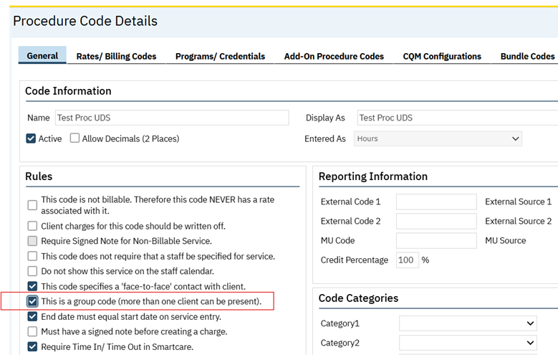

    - Program: It displays only client-Enrolled Programs in the Program dropdown field.
    - Procedure: It displays the Procedure based on the Group Procedure Code setup in the ("This is a group code (more than one client can be present)") under the Procedure Code Details.
    - Clinician: It Displays only the Clinician details who are providing the Group Services in the Clinician dropdown.
    - Attending: It Displays all the Staff Details in the Attending field dropdown.
    - Mode of Delivery: It Displays values based on the mappings in the Procedure code.

- When the key-value is set to “No”, then the ServiceDropdownConfiguration will not be applied to the Group service Details, and it will work as the existing behavior. All fields, including Program, Procedure, Clinician, Attending, and Mode of Delivery, will display values based on the logged-in Staff mappings.

System Configuration Key Details:

Read Key as: Enable Service Dropdown Configurations in Group Services
Allowed Values: Yes, No

Default Value: No

Modules/Functionality: SCM Admin 2

Description: This is a new feature being introduced to the core product by introducing a system configuration key. This key will control the access of Program, Procedure, Attending, Mode Of Delivery fields in the Group Service Details screen by binding/refreshing these field values using the ServiceDropdownConfigurations settings to this screen which must work same as Individual Service Note.

ServiceDropdownConfigurations:

As the name suggests, this setup/configuration controls the dropdown fields during service creation. The `ServiceDropdownConfigurations’ table references the entity values defined in the ` ‘ProgramIdFilteredBy’ columns to determine how the dropdown options should refresh/bind and populate the corresponding values via the associated stored procedure.
- If the key-value is set to “Yes”, apply the ServiceDropdownConfiguration to the Group Service Details.
- If the key-value is set to “No”, the ServiceDropdownConfiguration will not be applied to the Group service Details. This will be the default value of the key as it drives the existing behavior.

Note: If by chance the value of the key is updated with any value apart from the allowed values, the system will consider the default behavior, i.e. same as the key value being "No".

Inquiries

Reference No | Task No | Description
78 | Core Bugs # 132486 | Client Inquiries List Page displaying duplicates when multiple dispositions are associated with Inquiry & red error is displayed.

Author: Sachin Ranganathappa

78. Core Bugs # 132486: Client Inquiries List Page displaying duplicates when multiple dispositions are associated with Inquiry & red error is displayed.

Release Type: Fix | Priority: Medium

Navigation Path1: Login to ‘SmartCare’ application -- select client - - Client Inquiries(client).

Navigation Path2: Login to ‘SmartCare’ application -- Inquiries (My Office).

Functionality ‘Before’ and ‘After’ release:

Before this release, here was the behavior. When an Inquiry record (on Inquiry Details screen) had more than 1 disposition included (in the Disposition Section), Client Inquiries list page was displaying multiple records for each disposition associated with Inquiry.

With this release, the above-mentioned issue is resolved. Now, each inquiry will now appear as a single row. All associated Disposition names will be displayed separated by a comma list within the grid column with Ellipses and the full list of Disposition will be shown on hover.
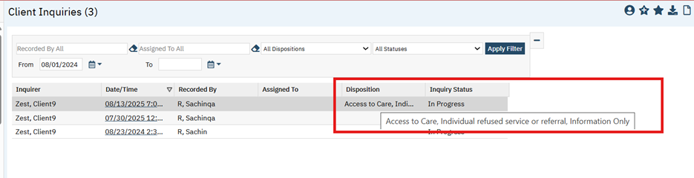

Interfaces

Reference No | Task No | Description
79 | Core Bugs # 132268 | “Date Received” column sorting issue in the "Messages Interface" screen.

Author: Munish Sood

79. Core Bugs # 132268: “Date Received” column sorting issue in the "Messages Interface" screen.
Release Type: Fix | Priority: High
Navigation Path: ‘Administration’ -- ‘Messages Interface’ -- ‘Messages Interface’ list page -- Click on “Date Received” column.
Functionality ‘Before’ and ‘After’ release:
Before this release, entries in the ‘Message Interface’ list page were not sorted correctly (in either ascending or descending order) when the user clicked on the “Date Received” column. Also, the system displayed all the records based on Client Filter.
With this release, the issue has been resolved. The entries now display in the correct sorting order when the “Date Received” column is clicked. Also, displaying the correct records based on Client Filter.

Methadone

Reference No | Task No | Description
80 | Core Bugs # 132083 | MAT - Page unresponsive
81 | Core Bugs # 132478 | Medication Refusals are not always displayed on the Client in MAR.
82 | Core Bugs # 132465 | Getting an error while clicking on ‘Medication History’ button
83 | Core Bugs # 132316 | MAT Management Details: Alignment issues under the Dispensing Notes tab.
84 | EII # 126906 | MAT: Implemented Re-Dispense Warning when the dose differs from previous Dispense.
85 | Core Bugs # 132502 | MAT: Calibration: Machine fault when prompting user to empty line.
86 | EII # 124362 | MAT Toxicology Screen List page has been implemented.
87 | Core Bugs # 132344 | MAT: Future Data Not Displayed in Scheduled Grid on MAT Management Details Screen.
88 | EII # 124363 | The MAT Toxicology functionality is implemented when dispensing the Face-to-Face dose in the MAT Management Details screen.
89 | Core Bugs # 132464 | MAT Management Details Screen: System is slow while dispensing.
90 | Core Bugs # 132314 | Medication Transaction Inventory: The Location field is not auto populated when the bottle number is selected.
91 | Core Bugs # 132403 | MAT Connection Details Pop up: The Bottle search functionality is not accepting the minimum 2 characters when tried to search for the Bottles.
92 | EII # 131828 | MAT: Restrict Users from Connecting to Medications Across Multiple Locations.
93 | Core Bugs # 132462 | MAT Configuration: Getting red error message while saving the ‘Mat Configuration’ screen.

Author: Chaitali Patil

80. Core Bugs # 132083: MAT - Page unresponsive
Release Type: Fix | Priority: High
Navigation Path 1: Administration - Orders’ - ‘Orders’ list page - New - ‘Order Details’ screen -Select ‘Medication’ Order Type - Enter the required fields - Select (Medication Assisted Treatment (MAT), Machine Connection Required, Take Home Allowed) = Yes, under ‘Medication Assisted Treatment’ section and display program? Must be ‘Yes’ for MAT Orders – Save
Navigation Path 2: My Office – ‘Medication/Lot/Bottle’ List page – New ‘Medication/Lot/Bottle Details’ screen - Enter the required fields – Enter Location - Insert – Save.
Navigation Path 3: ‘Client’- ‘Client Orders’ - ‘Client Orders’ list page - New - ‘Client Order details’ screen - Select the Order created in Navigation Path 1 - Enter the required fields –Select the Take home days as 30 or more than 30 -- select Program –Insert –click on ‘save’ and ‘Sign’.
Navigation Path 4: ‘My Office’ - ‘MAT Management ‘list page – click on ‘Connect User’ icon – Connection Details pop up will be displayed – select the Machine/Inventory and other required fields – Click on ‘Verified’ check box – and click on connect – Machine/Inventory get connected.
Navigation Path 5: ‘My Office’ - ‘MAT Management ‘list page – Select the Order (Navigation path 3) and click on ‘Dispense icon’ – MAT Management Details – dispense the dose – while dispensing Page Unresponsive pop up should not display.
Functionality ‘Before’ and ‘After’ release:
Before this release, here was the behavior. In the MAT Management Details screen, while dispensing the 28 days take home or more than that take home dose to the client, after 7 or 8 dispenses ‘page Unresponsive pop up’ was getting displayed and it was taking too much time to dispense the dose.
With this release, the above-mentioned issue has been resolved. Now, while dispensing the 28days or more that take home dose in the MAT Management Details screen page, unresponsive error pop up is not displaying.

Author: Chaitali Patil

81. Core Bugs # 132478: Medication Refusals are not always displayed on the Client in MAR.
Release Type: Fix | Priority: High
Navigation Path 1: Administration - Orders’ - ‘Orders’ list page - New - ‘Order Details’ screen -Select any Order Type - Enter the required fields – Save
Navigation Path 2: ‘Client’- ‘Client Orders’ - ‘Client Orders’ list page - New - ‘Client Order details’ screen - Select the Order created in Navigation Path 1 - Enter the required fields ––Insert –click on ‘save’ and ‘Sign’
Navigation Path 3: Client – ‘Client MAR’ –Select a client (from Navigation path 2)– click on the Date hyperlink in the select the administration Status as ‘Refused’– click on save – Perform action displayed in the Client MAR screen.
Navigation Path 4: ‘Client’- ‘Client Orders’ - ‘Client Orders’ list page - New - ‘Client Order Selection pop up will be displayed - Select the Order created in Navigation Path 1 from this pop up – click on ‘Ok’ -Details screen – check the Discontinue check box – save and sign the order – order will get Discontinued.
Navigation Path 5: Client – ‘Client MAR’ – Select a client (from Navigation path 2) – Verify that discontinued order is displayed the Refused status.
Functionality ‘Before’ and ‘After’ release:
Before this release, here was the behavior. The ’Refused’ status was not displayed on the Client MAR screen when a scheduled dose was marked as Refused after the client order was discontinued.
With this release, the above-mentioned issue is resolved. Now, the ‘Refused’ status is displayed on the Client MAR screen when a scheduled dose is marked as Refused after the client order has been discontinued.

Author: Smruthi Srikanth

82. Core Bugs # 132465: Getting an error while clicking on ‘Medication History’ button

Release Type: Fix | Priority: Medium
Navigation Path: My Office -- Medications -- Rx application -- Start Page -- Patient Summary -- ‘Medication History’ button.

Functionality ‘Before’ and ‘After’ release:

Before this release, here was the behavior. In the ‘Patient Summary’ screen of the Rx application, when the user clicked on ‘Medication History’ button, the following error message was displayed.

Error Message: Error in loading page.

With this release, the above-mentioned issue has been resolved. Now, the medication history is loaded without any error when the user clicks on the ‘Medication History’ button in the ‘Patient Summary’ screen of the Rx application.

Author: Smruthi Srikanth

83. Core Bugs # 132316: MAT Management Details: Alignment issues under the Dispensing Notes tab.
Release Type: Fix | Priority: High
Navigation Path 1: Administration - Orders’ - ‘Orders’ list page - New - ‘Order Details’ screen -Select ‘Medication’ Order Type - Enter the required fields - Select (Medication Assisted Treatment (MAT), Machine Connection Required, Take Home Allowed) = Yes, under ‘Medication Assisted Treatment’ section and display program? Must be ‘Yes’ for MAT Orders – Save.
Navigation Path 2: My Office – ‘Medication/Lot/Bottle’ list page – New ‘Medication/Lot/Bottle Details’ screen - Enter the required fields – Enter Location - Insert – Save.
Navigation Path 3: ‘Client’- ‘Client Orders’ - ‘Client Orders’ list page - New - ‘Client Order details’ screen - Select the Order created in Navigation Path 1 - Enter the required fields –Select the Take home days - select Program –Insert –click on ‘save’ and ‘Sign’.
Navigation Path 4: Go Search – MAT Management (My office)– Click on the dispense icon for required medication – MAT Management Details screen - Dispensing notes tab.
Functionality ‘Before’ and ‘After’ release:
Before this release, here was the behavior. The grid header and row columns were not aligned correctly in the Dispensing tab of the MAT Management Details screen.

With this release, the above-mentioned issue has been resolved. Now, the grid header and row columns are aligned correctly in the Dispensing tab of the MAT Management Details screen.

Author: Madhu Basavaraju

84. EII # 126906 (Feature - 342121): MAT: Implemented Re-Dispense Warning when the dose differs from previous Dispense.

Note: This is Passive Change. This enhancement states that staff will be warned if the re-dispense dose differs from the previous dose, in case they entered a dose amount erroneously.
1. The ability to auto-populate the last dispensed dose, in MAT re-dispense pop up screen.
2. The ability to provide a warning message when a Client's Re-dispense dose amount differs from the last client's dispense dose.
Release Type: Change | Priority: Urgent
Prerequisite 1: Create one MAT Program via the path below:
Path: Go Search – Program (Admin) – Program List page – click on New – add Program name – fill other required fields – under the ‘Categories’ section – select the ‘MAT Program’ checkbox – Save.
Prerequisite 2: Client has ‘MAT Program’ with ‘Enrolled’ Status. Via the path below.
Path: Perform client search – Go search programs(client) – Program List page – click on ‘New’ – select MAT Program from Program Name down -select status as enrolled – fill another required field – click on Save.

Navigation Path 1: Administration’ - Orders’ - Orders’ list page - New - Order Details’ screen - Select ‘Medication’ Order Type - Enter the required fields - Select (Medication Assisted Treatment (MAT), Machine Connection Required, Take Home Allowed) = Yes, under ‘Medication Assisted Treatment’ section – under the 'Option’ section display program? is ‘Yes’ for MAT Orders – Save.
Navigation Path 2: My Office – ‘Medication/Lot/Bottle’ list page – New - ‘Medication/Lot/Bottle Details’ screen - Enter the required fields – Select Location - Insert – Save.

Navigation Path 3: ‘Client’- ‘Client Orders’ - ‘Client Orders’ list page - New - ‘Client Order details’ screen - Select the Order created in Navigation Path 1 - Enter the required fields – select Program – Insert - Save and sign.

Navigation Path 4: ‘My Office’ - ‘MAT Management ‘list page – Select the Order (Navigation path 3) and click on ‘Dispense icon’ – MAT Management Details – Click on Sign – and dispense the Scheduled Dose (Like Clinic or Take Home) – Click on ReDispense icon – MAT ReDispense popup - Enter required fields – Re-Dispense.

Functionality ‘Before’ and ‘After’ release:
Before this release, here was the behavior:
1. While Re-Dispensing, the dose field was displayed blank, and staff was requiring to enter the dose amount.
2. The Reason drop down was not included with the ‘Client Request’,’ Drug Screen Concerns’, ‘Safety Concerns’, ‘Physician Request’ additional reasons.

3.A warning message pop up was not displayed, when Re-Dispense dose was different from the previously entered dispensed dose.

With this release, in the MAT Management Details screen, the below changes are implemented.
At the time of Re-Dispense, in the ‘MAT Re-Dispense Popup,
- The Dose field will be auto populated with the previously entered dispensed Dose.
- Additional reasons are added in the ‘Reason’ dropdown.
- A warning message popup has been implemented, when the Re-Dispense dose is different from the previously entered dispensed dose.

MAT Re-Dispense Popup:
- ‘Dose’ field: It will be auto populated with the most recent dispensed dose.
In the MAT Management Details screen, for the selected Client, if Dose 20mg has been dispensed for Face-Face/Take Home.
For Example: On click of Re-Dispense icon, in the ‘MAT ReDispense Popup’, the Dose field is auto populating with dispensed Dose of 20.
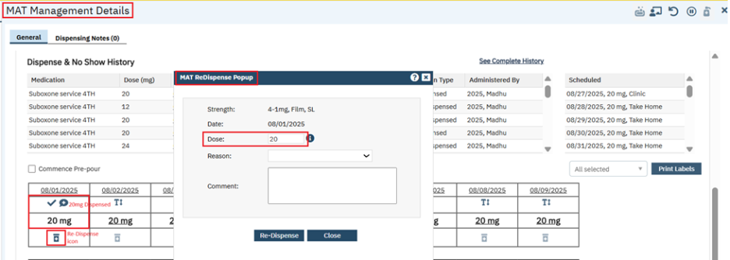
- ‘Reason’ dropdown: The below mentioned values are added to the existing Reason drop down:
- Client Request
- Drug Screen Concerns
- Safety Concerns
- Physician Request
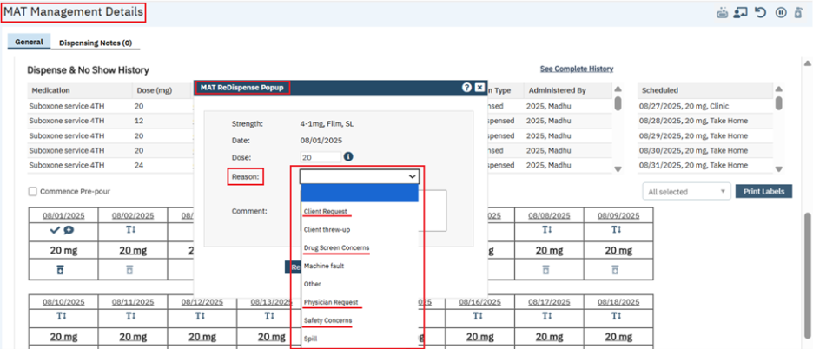
3.When the Re-Dispense dose differs from the previously dispensed dose, a warning message will be displayed with ‘OK’ and ‘Cancel’ buttons.
For Example: Selected Dose = 16mg (differ from dispensed Dose =20mg), Reason = Drug Screen Concerns, and Click on Re-Dispense Button.
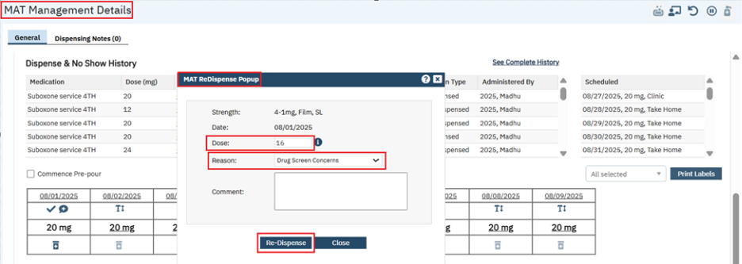
The below Warning message is displayed with ‘OK’ and ‘Cancel’ button.
Warning Message: "You are about to dispense an amount different from the previous dispense. Are you sure?"

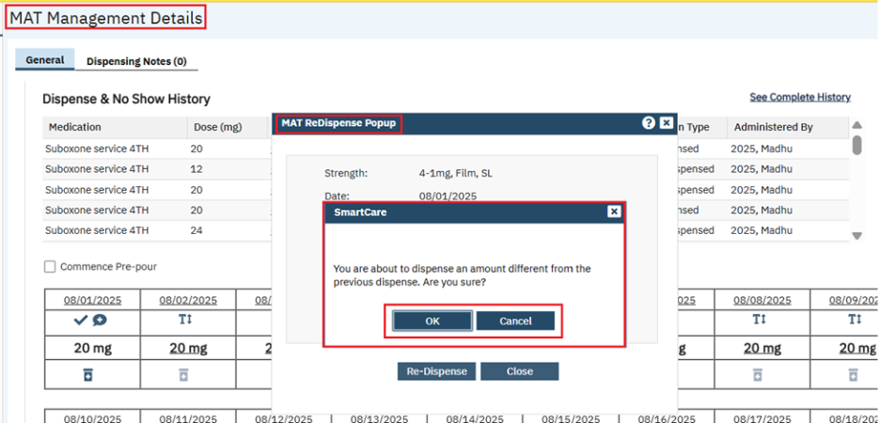
‘OK’ Button: On Click of ‘OK’, selected Dose will be Re-dispensed.
‘Cancel’ Button: On click of ‘Cancel’, no action will be performed and it will return to the 'MAT ReDispense Popup' screen.

Author: Madhu Basavaraju

85. Core Bugs # 132502: MAT: Calibration: Machine fault when prompting user to empty line.
Release Type: Fix | Priority: High
Pre-requisite: MAT Client Order is signed with Machine Connection.
Navigation Path: My Office’ - ‘MAT Management ‘list page – click on ‘Connect User’ icon – Connection Details pop up will be displayed – select the Methaspense Machine and Enter Inventory other required fields – Click on ‘Verified’ check box – click on connect – Machine/Inventory gets connected.
Functionality ‘Before’ and ‘After’ release:
Before this release, here was the behavior. In the MAT Management List screen,
- When the MethaSpense machine faulted, the system continued processing for a long time, which leads the user to refresh the application.
- UnPrime was faulted.
With this release, the above-mentioned issues have been resolved. Now, In the MAT Management screen,
- When the machine faults, instead of continuing to process indefinitely, a new warning message is displayed to indicate that the machine has faulted, and the operation has failed.
This warning message will appear for the following operations when they fail due to a machine fault: Unprime, Prime, Calibration, Dispense, and Redispense.
Example Warning Message: Machine faulted. Unprime failed.
2. For Unprime, the ‘m1’ command has been added for the MethaSpense machine.

Author: Madhu Basavaraju

86. EII # 124362 (Feature - 243612): MAT Toxicology Screen List page has been implemented.

Note: This is Passive Change. This Enhancement is for MAT module by using new MAT Toxicology Screen List Page to determine which clients are required to complete a drug test prior to receiving Face-to-Face doses and/or Take Home Bottles and will use Flow Sheets to validate the specimen collected.

Release Type: Change | Priority: High

Prerequisite 1: Create one MAT Program via the below path:
Path: Go Search – Program (Admin) – Program List page – click on New – add Program name – fill other required fields – under the ‘Categories’ section – select the ‘MAT Program’ checkbox – Save.

Prerequisite 2: The Client has a ‘MAT Program’ with ‘Enrolled’ Status. Via the below.
Path: Perform client search – Go search programs(client) – Program List page – click on ‘New’ – select MAT Program from Program Name down -select status as enrolled – fill another required field – click on Save.

Navigation Path 1: Administration’ - Orders’ - Orders’ list page - New - Order Details’ screen - Select ‘Medication’ Order Type - Enter the required fields - Select (Medication Assisted Treatment (MAT), Machine Connection Required, Take Home Allowed) = Yes, under ‘Medication Assisted Treatment’ section – under the 'Option’ section display program? is ‘Yes’ for MAT Orders – Save.

Navigation Path 2: My Office – ‘Medication/Lot/Bottle’ list page – New - ‘Medication/Lot/Bottle Details’ screen - Enter the required fields – Select Location - Insert – Save.
Navigation Path 3: ‘Client’- ‘Client Orders’ - ‘Client Orders’ list page - New - ‘Client Order details’ screen - Select the Order created in Navigation Path 1 - Enter the required fields – select Program – Insert - Save and sign.

Navigation Path 4: ‘My Office’ ‘MAT Management ‘list page – Click on Connect User Icon - ‘Connection details’ pop up will be displayed – Select ‘Machine’ – Select Medication – select ‘lot’, ‘Bottle’, ‘Quantity’(Which is created in Navigation path2) , click on ‘Verified’ check box – click on ‘Connect’-click on ‘ok’ – Machine will be connected successfully.

Navigation Path 5: ‘My Office’ ‘MAT Management ‘list page – Click on Connect User Icon –‘Connection details’ pop up will be displayed – select the ‘Location’ - ‘Select Medication – select ‘lot’, ‘Bottle’, ‘Quantity’ (Which is created in Navigation path 2) , click on ‘Verified’ check box – click on ‘Connect’-click on ‘ok’ – Inventory will be connected successfully.

Navigation Path 6: ‘My Office’ - ‘MAT Management ‘list page – Select the Order (Navigation path 3) and click on ‘Dispense icon’ – MAT Management Details – Click on Sign – and dispensed the Scheduled Dose (Like Clinic or Take Home).

Navigation Path 7: ‘My Office’ – MAT Toxicology Screen List Page – Select Home Clinic – Select Frequency, Phase/Level of Care, Date to Schedule Toxicology Screen – Apply Filter – Select Clients in the grid by checking checkbox – Click on Toxicology Screen icon – Select ‘Assign the selected clients for toxicology screens’ checkbox – Click on OK.

Navigation Path 8: ‘Client’ – Client Information(C) – ‘MAT’ tab – Random Toxicology Frequency - Toxicology Screen Date – Save.

Purpose: To ensure MAT clinics are compliant with toxicology screen testing on their clients and prevent clients from not completing this task.

Functionality ‘Before’ and ‘After’ release:
Before this release, Clients do not know when they were scheduled to be drug-tested. To avoid the perception of bias on the part of staff, the system needs to generate a report that randomly selects clients in the MAT program to be drug tested sometime within the next month.

With this release, the new MAT Toxicology Screen List page is implemented,
1. A configurable List Page has been implemented to create a list of Active MAT clients who are required to provide a drug test (Toxicology Screen) at random for a selected Date.
2. Using the MAT Configuration Admin-level screen, each user will determine which Flow Sheet is to be considered the 'Toxicology Screen Flow Sheet'.
3.The user will enter the Individual Client's Toxicology Screen Frequency in the new 'Random Toxicology Frequency' field in ‘Client Information’ under ‘MAT’ tab.
4. By using the new Tox Screen Toolbar Icon, the user can Bulk-Update the 'Toxicology Screen Date' field (Client Information - MAT) for the selected MAT Clients, which will also auto-create a Toxicology Screen Flag.

1. MAT Toxicology Screen List Page:
Filter Section: The below mentioned fields are displayed.
- Home Clinic
- Frequency
- Phase/Level of Care
- Date to Schedule Toxicology Screen

- ‘Home Clinic’: This is a Single-select Dropdown, this is a required field and it will display All MAT Locations.
- It will Display 'Select Home Clinic' as placeholder.
- It will display, <No Home Clinic> as top selection (this will pick up MAT clients who have no Home Clinic Location Type value present in Client Information - MAT).
- Standard validation will be displayed on Click of Apply Filter, when Home Clinic is not selected.
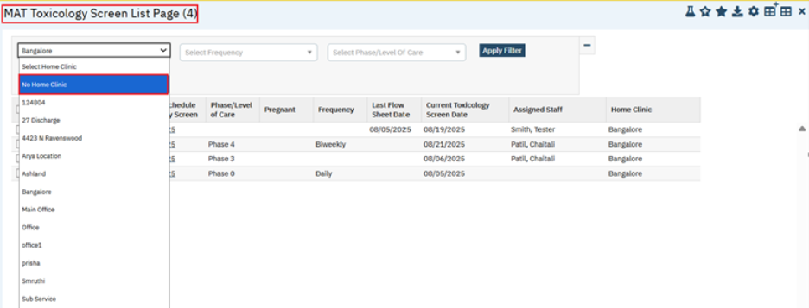
- ‘Frequency’ : This is a multi - select dropdown, it will display All Frequencies listed in TOXICOLOGYFREQUENCY global code.
- Displays 'Select Frequency' as placeholder.
- By Default, No Selection, which will consider ALL values, including Blank data (This will pick up MAT clients who have no Random Toxicology Frequency value present in Client Information - MAT).
- The <Select All> will be displayed as top selection.
- When <Select All> is selected, it will check all boxes in multi-select dropdown.
- If user wants to search for just 1 or 2 options, then unselect <Select All>, which will uncheck all boxes. Users then select the option(s) they want OR can Apply Filter as-is with no selections and will consider ALL values, including Blank data.
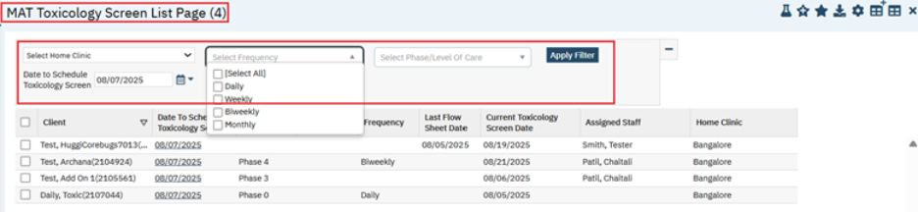
- ‘Phase/Level of Care’ : This is a multi-select dropdown, It will display All Phase/Level of Care values listed in ‘PHASELEVELOFCARE’ global code.
- Displays 'Select Phase/Level of Care' as placeholder.
- By default No Selection, which will consider ALL values, including Blank data (This will pick up MAT clients who have no Phase/Level of Care value present).
- The <Select All> will be displayed as top selection.
- When <Select All> is selected, it will check all boxes in multi-select dropdown
- If user wants to search for just 1 or 2 options, then unselect <Select All>, which will uncheck all boxes. Users then select the option(s) they want OR can Apply Filter as-is with no selections and will consider ALL values, including Blank data.
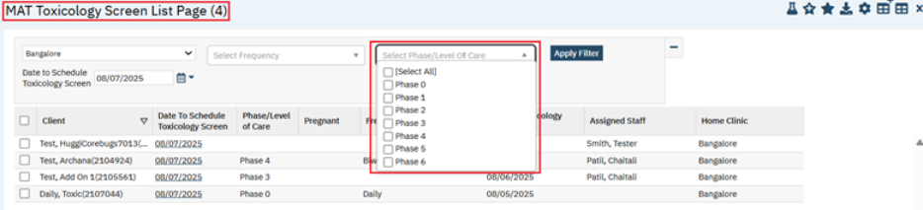
- ‘Date to Schedule Toxicology Screen’: This is a Calendar control textbox and this is a required field, which displays Todays Date as Default.
Standard validation will be displayed on Click of Apply Filter, when the Date is not selected.

- ‘Apply Filter’: On click of this button, it displays all Clients who meet below mentioned criteria to be pulled into Toxicology Screen List.
a) Active MAT Client (Client who is enrolled in Program where MAT Program is selected)
b) Client's Client Information - MAT - General - Location Type = Home Clinic matches Location selected in Filter.
c) Client's most recent Flow Sheet that matches MAT Configuration - General - Toxicology Screen Flow Sheet has a Date that is more recent than Client Information - MAT - Random Toxicology Date and falls within the parameters of the associated Client Information - MAT - General - Random Toxicology Frequency.

Note: When a user leaves the screen, it retains the filters and the List from the last time the 'Apply Filter' button is clicked, until 'Apply Filter' is clicked again.
Grid Section: The following columns are displayed in the grid header.
1.Check box: Includes a ‘Select All’ checkbox in the column header which will select all checkboxes.
The Clients who are selected will be considered for the Toxicology Screen Bulk Update.
2.Client: This is a read only column, which displays LastName, FirstName (Client ID) of the associated Client.
3.‘Date to Schedule Toxicology Screen’: This is a Hyperlink, which displays the Date that was selected in MAT Toxicology Screen List - 'Date to Schedule Toxicology Screen' filter.
When user clicks Hyperlink, it navigates to New Flow Sheet entry for associated Client, which matches the Flow Sheet identified in MAT Configuration - General - Toxicology Screen Flow Sheet.
4.Phase/Level of Care: This Read only column which displays 'Phase/Level of Care' field value of Client's most recent MAT Active Client Order signed.
5.Pregnant: This is a read only column.
- It will displays as 'Yes' when selected Client is Pregnant from Client Information - Demographics - Identifying Information - 'Pregnant' = 'Yes'.
- It will display as blank when any other value than 'Yes' is selected.
6.Frequency: This is read only column, it will display 'Random Toxicology Frequency' (Global code = TOXICOLOGYFREQUENCY) selected in the ‘MAT’ Tab of ‘Client Information’.
- If Random Toxicology Frequency = Daily, then there will be a Flow Sheet entry Date for every day of the calendar year.
- If Random Toxicology Frequency = Weekly, then there will be a Flow Sheet entry Date for every week of the calendar year (Sunday - Saturday).
- If Random Toxicology Frequency = Biweekly, then there will be a Flow Sheet entry Date for every two weeks of the calendar year (From 1st week of Sunday to 2nd week of Saturday Week ).
- If Random Toxicology Frequency = Monthly, then there will be a Flow Sheet entry Date for every month of the calendar year (Once in Every month).
7. Last Flow Sheet Date: This is a read only column.
- It displays Date of most recent Flow Sheet for the associated Client, which matches the Flow Sheet listed in MAT Configuration screen under 'Random Toxicology Flow Sheet'.
- If there is no Flow Sheet matches, it will display as Blank.

8.Current Toxicology Date: This is a read only column. It displays Toxicology Screen Date from Client Information under MAT tab.

9.Assigned Staff: This is a read only column ,it displays 'Assigned Staff' field value from the MAT Program Assignment Details Enrolled on the associated Date.

10.Home Clinic: This is a read only column, it displays associated Client Home Clinic Location selected in MAT Tab of ‘Client Information’ screen, where MATLocationType global code is included in SetCodeForLocationType Recode and Code = Home (This will be the same Location as the selected Filter).

2.Toxicology Screen Icon : A new icon has been implemented in the tool bar under the MAT Toxicology screen List page.
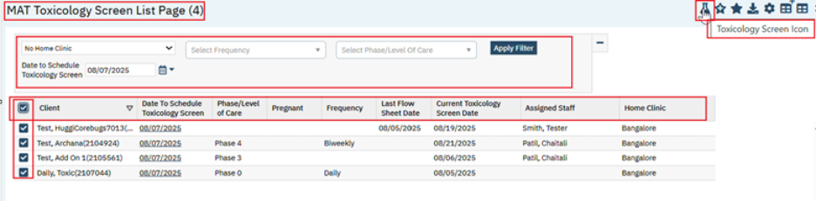
On click of ‘Toxicology Screen Icon’, the ‘MAT Toxicology Screen Bulk Update’ Popup will be displayed with below mentioned details :
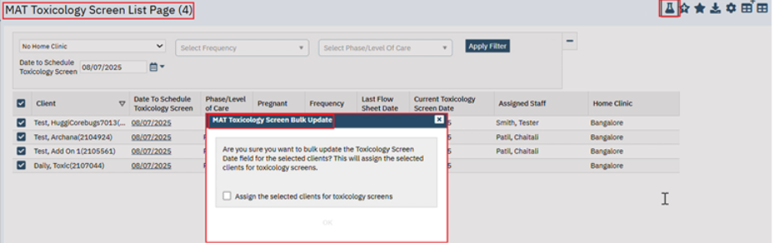
Message: “Are you sure you want to bulk update the Toxicology Screen Date field for the selected clients? This will assign the selected clients for toxicology screens.”
Assign the selected clients for toxicology screens: This is a check box, when the checkbox is checked, then ‘OK’ button will be displayed. If user unchecks this checkbox, then ‘OK’ button will be hidden.
The display and functionality of the ‘OK’ button is conditional on this checkbox being selected.
‘OK’ Button: On click of OK button, then
1. Auto-updates , the 'Toxicology Screen Date’ in the Client Information - MAT - to match 'Date to Schedule Toxicology Screen' from the MAT Toxicology Screen List Page.
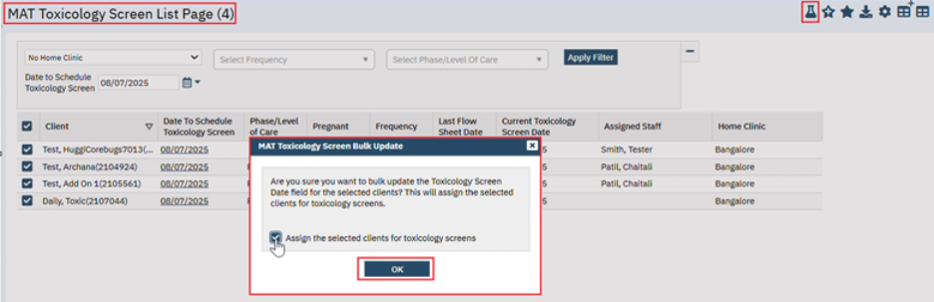

2.To Bulk-Update the 'Toxicology Screen Date' field (Client Information - MAT) for the selected MAT Clients, which will also auto-create a Toxicology Screen Flag.
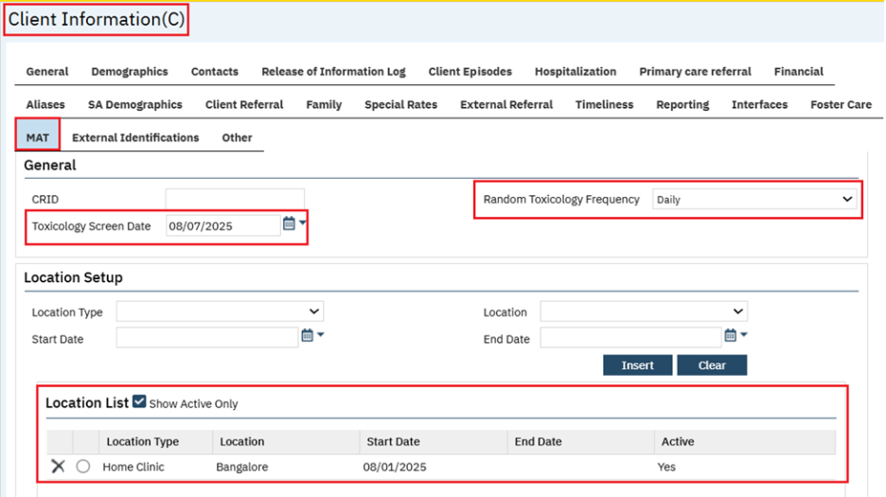
3.It will Check each Client for Flag Type=‘Toxicology Screen’.
i)If Client has never had a Toxicology Screen Flag, then creates a New Toxicology Screen Flag for each selected Client.
ii)If Client had a Toxicology Screen Flag before, then updates/reuse the existing Toxicology Screen Flag for each selected Client.

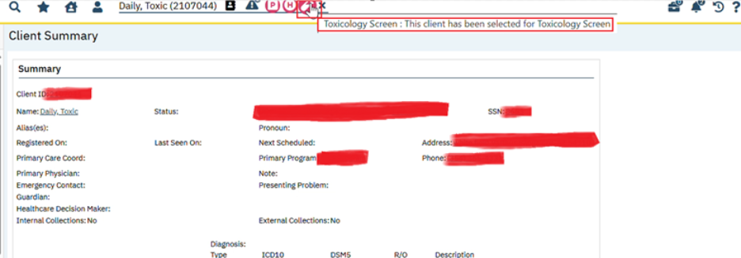

Author: Chaitali Patil

87. Core Bugs # 132344: MAT: Future Data Not Displayed in Scheduled Grid on MAT Management Details Screen.

Release Type: Fix | Priority: High
Navigation Path 1: Administration - Orders’ - ‘Orders’ list page - New - ‘Order Details’ screen -Select ‘Medication’ Order Type - Enter the required fields - Select (Medication Assisted Treatment (MAT), Machine Connection Required, Take Home Allowed) = Yes, under ‘Medication Assisted Treatment’ section and display program? Must be ‘Yes’ for MAT Orders – Save
Navigation Path 2: My Office – ‘Medication/Lot/Bottle’ list page – New ‘Medication/Lot/Bottle Details’ screen - Enter the required fields – Enter Location - Insert – Save.
Navigation Path 3:‘Client’- ‘Client Orders’ - ‘Client Orders’ list page - New - ‘Client Order details’ screen - Select the Order created in Navigation Path 1 - Enter the required fields –Select the Take home days - select Program – Do not select ‘END Date’ –Insert –click on ‘save’ and ‘Sign’.
Navigation Path 4: ‘My Office’ - ‘MAT Management ‘list page – click on ‘Connect User’ icon – Connection Details pop up will be displayed – select the Machine/Inventory and other required fields – Click on ‘Verified’ check box – and click on connect – Machine/Inventory get connected.
Navigation Path 5: ‘My Office’ - ‘MAT Management ‘list page – Select the Order (Navigation path 3) and click on ‘Dispense icon’ – MAT Management Details – Verify the Scheduled section.
Functionality ‘Before’ and ‘After’ release:
Before this release, here was the behavior. In the MAT Management Details screen, the Future Scheduled data was not displayed in the ‘Scheduled’ grid, when the associated Client Order does not have an Order End Date.
With this release, the above-mentioned issue has been resolved. Now, in the MAT Management Details screen, the Future Scheduled data is displayed in the ‘Scheduled’ grid, when the associated Client Order does not have an Order End Date.
Note: The future data in the Scheduled grid will be displayed based on the value of the ‘Show Dispense Schedule for Next ‘xx’ Days’ field, which is in the MAT Configuration screen.
Author: Chaitali Patil

88. EII # 124363 (Feature - 243618): The MAT Toxicology functionality is implemented when dispensing the Face-to-Face dose in the MAT Management Details screen.

Note: This is Passive Change. This Enhancement is for MAT module by using new MAT Toxicology Screen List Page to determine which clients are required to complete a drug test prior to receiving Face-to-Face doses and/or Take-Home Bottles and will use Flow Sheets to validate the specimen collected. If they have not completed drug test, then while Dispensing Face to Face to dose, ‘The Toxicology Screen has not been completed in the system. Please complete toxicology screen prior to dispenses’. This warning message will be displayed.

Release Type: Change | Priority: High
To Enable the Toxicology Functionality use below path:
Navigation Path 1: MAT Configuration (Admin) – Under the ‘Toxicology Screen’ section – check the checkbox of ‘Require toxicology screen before dispense’, ‘Allow for override’ and select the ‘Toxicology Screen Flow Sheet’ – save.
Navigation Path 2: Perform Client Search – Client Information (client) – Navigate to ‘MAT’ Tab – ‘General’ Section – select any ‘Random Toxicology Frequency’ from the dropdown (Like Daily, weekly, Biweekly, Monthly) – under the ‘Location Setup’ section – select ‘Location Type’, ‘Start Date’, ‘Location’ – Insert -- Save.

Navigation Path 3: ‘Administration’ - ‘Orders’ - ‘Orders’ list page - New - ‘Order Details’ screen - Select ‘Medication’ Order Type – Enter the required fields – Select (Medication Assisted Treatment (MAT), Take Home Allowed), and Machine Connection = Yes, under ‘Medication Assisted Treatment’ section and display program? Must be ‘Yes’ for MAT Orders – under ‘Option’ section select ’Add Order to MAR’ Radio button as ‘Yes’ – Click on ‘Save’.

Navigation Path 4: My Office – ‘Medication/Lot/Bottle’ list page – ‘New’ - ‘Medication/Lot/Bottle Details’ screen - Enter the required fields – Enter Location - Insert – Save.

Navigation Path 5: ‘Client’- ‘Client Orders’ - ‘Client Orders’ list page - New - ‘Client Order details’ screen - Select the Order created in Navigation Path 3 - Enter the required fields – select the ‘Phase/Level of Care’ - Insert order details into grid in the toolbar – click on ‘MAT Client Level Set up pop up’ – select the ‘Face to Face’ days - Save and sign – then sign the Client Order.

Navigation Path 6: ‘MAT Toxicology Screen List Page’ (My office) – select the ‘Location’ and ‘Date to Schedule Toxicology screen- check Client ‘Checkbox’ – click on ‘Toxicology Screen Icon’ in the tool bar – ‘MAT Toxicology Screen Bulk Update’ pop up will be displayed – checked the ‘Assign the selected clients for toxicology screens’ check box – click on okay – after completing the Bulk update from the Toxicology List page -- Navigate back to the Client Information Client Screen and under the MAT tab – check the ‘Toxicology Screen Date’ get updated.( The Date which is present in the toxicology List page that date will be updated in the ‘Toxicology Screen Date’)

Navigation Path 7: Select client – Client Flag (client) screen – check the Flag type as – ‘Toxicology Screen’ – click on the ‘Note’ Hyperlink – Flag Details will be displayed.

Navigation Path 8: ‘My Office’ - ‘MAT Management ‘list page – click on ‘Connect User’ icon – Connection Details pop up will be displayed – select the Machine and other required fields – Click on ‘Verified’ check box – and click on connect – Machine get connected.

Navigation Path 9: ‘My Office’ - ‘MAT Management ‘list page – Select the Order (Navigation path 5) – check the ‘Flask’ icon is displaying -- and click on ‘Dispense icon’ – MAT Management Details – While dispensing the ‘Clinic’ Dose – ‘MAT Toxicology Screen’ pop up will be display – check the ‘Proceed with Dispense’ checkbox – ‘OK’ button will get enabled – click on ‘OK’ – dose will get Dispensed.

To complete the flowsheet, use below path:

Navigation Path 10: ‘My Office’ - ‘MAT Management ‘list page – Select the Order (Navigation path 5) – check the ‘Flask’ icon is displaying – click on the Flask icon – the flowsheet which selected in MAT Configuration screen will be displayed – Fill the required fields – Save the flowsheet.

Purpose: Implemented the new ‘MAT Toxicology Screen List Page’ as a part of (Feature 243612) when the client is scheduled for the toxicology screen, then that client will be listed in then ‘MAT Toxicology Screen List Page’. After doing the bulk update from this list page, the ‘Toxicology Screen Date’ has been updated in the client information ‘MAT’ tab after the bulk update, once the ‘Toxicology Screen Date’ has updated then Toxicology Screen flag gets created and it will be displayed at Reception/Front Desk, then nurses will communicate to clients when they must complete a Toxicology Screen prior to receiving their MAT dose dispense. We have also created a Toxicology Pop up with logic behind allowing dispense and disabling dispense, to ensure the before taking their MAT Medication dose, client has to complete their Toxicology test.

Functionality ‘Before’ and ‘After’ release:
Before this release, Clients did not know when they are scheduled to be drug-tested. To avoid the perception of bias on the part of staff, the system needs to generate a report that randomly selects clients in the MAT program to be drug tested sometime within the next month. So, the system was not stopping the dispensing if a lab was scheduled and the patient didn't do it.

With this release, the following implementation has been done.

1. MAT Configuration : The ‘Toxicology Screen’ section is newly added under the General tab.
‘Toxicology Screen’ section : The below fields are present.
Note: Using the new MAT Configuration Admin-level screen, each users will determine which Flow Sheet is to be considered for the 'Toxicology Screen Flow Sheet'.
1: Require toxicology screen before dispense: This is a checkbox, by default the checkbox is enabled and unchecked. When this checkbox is checked, then 'Allow for Override' checkbox field gets enabled.
When the client is scheduled for the toxicology screen and Require toxicology screen before dispensing check box is checked then while dispensing ‘Face to Face’ dose in the Mat Management Details screen ‘Mat Toxicology pop up’ will be displayed.

2: Allow for override: This is a checkbox, by default this is disabled an Unchecked. When the 'Require toxicology screen before dispense' is checked, then 'Allow for override' checkbox will be enabled.
When the client is scheduled for the toxicology screen and If 'Allow for override' is checked, then while dispensing ‘Face to Face’ dose in the Mat Management Details screen the 'Proceed with dispense' checkbox will be ENABLED on the MAT Toxicology Screen pop up ,on checking this check box ‘Ok’ button will get enabled and on click on ‘Ok’ dispensed will be done.
If 'Allow for override' is NOT checked, then the 'Proceed with dispense' checkbox will be HIDDEN and DISABLED on the MAT Toxicology Screen pop up.
3: Toxicology Screen Flow Sheet: This is a searchable textbox. on search it will display all the active flow sheet. In this field selected flowsheet is used to map which Flow Sheet is considered the Toxicology Screen Flow Sheet.

Note: This is an Admin-level screen that the users will set up once to determine the functionality of the Toxicology Screen Pop Up Validation.
Screen shot:
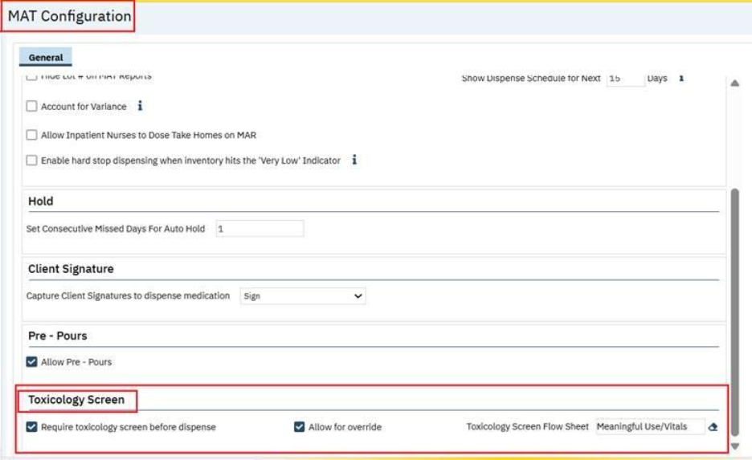

2: Toxicology screen Flag creation.
Implemented the new ‘MAT Toxicology Screen List Page’ as a part of (Feature 243612) when the client is scheduled for the toxicology screen then that client will be listed in then ‘MAT Toxicology Screen List Page’. after doing the bulk update from this list page, the ‘Toxicology Screen Date’ has been updated in the client information ‘MAT’ tab, once the ‘Toxicology Screen Date’ has updated then Toxicology Screen flag gets created and it will be displayed at Reception/Front Desk, client Flag screen, MAT Management list page under the Flags column and it can be viewed at the Client level.

- At any given point, there will be only one Toxicology Screen flag for Client.
- If the Client already has a Toxicology Screen Flag in their record, the system will update/reuse the existing flag.
While reusing the same flag system will Update the ‘Open Date’ and ‘Display Date’ of the existing flag and it will Remove End Date and Due Date.
Note: This is to prevent performance issues by reusing the same flag instead of creating new ones for every Tox Screen.
Clicking on the Toxicology Screen flag icon (image of vial) in the Flags column on the MAT Management List Page, then will take user to Flag Details screen.

Below are the fields for the flag.
- Flag Type: The flag type will be displayed as ‘Toxicology Screen’.
- Flag Content: This client has been selected for Toxicology Screen’ this is a flag content when user hovers on the ‘Toxicology Screen Flag’ this content will be displayed.
- Level: Level is displaying as ‘Information’
- Open Date: 'Toxicology Screen Date' in Client Information - MAT – General, this will be displayed as Open Date of the Flag.
- Display Date: 'Toxicology Screen Date' in Client Information - MAT – General, this will be displayed as Display Date of the Flag.
- End Date: Created a Nightly job(ssp_UpdateToxicologyClientNotes) that runs and checks for flow sheet entries that match flow sheet listed in MAT Configuration - General - Toxicology Screen Flow Sheet. If there is an entry for that flow sheet, and the Date is equal to or later than the Open Date of this Toxicology Screen Flag, then End Date get updated to Toxicology Screen Flow Sheet Entry Date. This will be caught during the nightly job.
Or else when user manually ends Flag that date will be ‘End Date’ of the flag.
- Due Date: No Due Date. The flag is always to display until a user Ends the flag or when user completed the Flowsheet then during the nightly job when flag gets ended then due date will be displayed as Flag End Date.
- Created By: who created the flag that logged in staff name will be displayed in the Assigned To field.

Screen shot for Flag:
Client Flag List page :

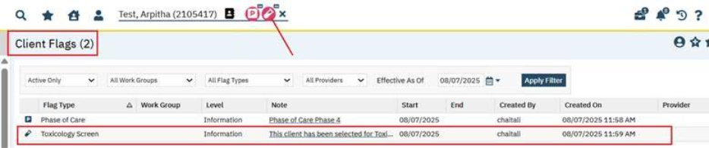

On Click of the Note Hyperlink, then Client Flag Details Screen will open.

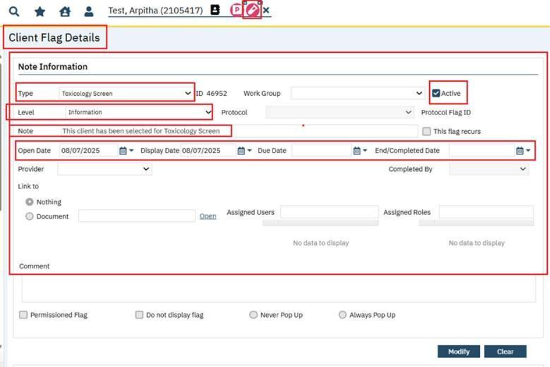
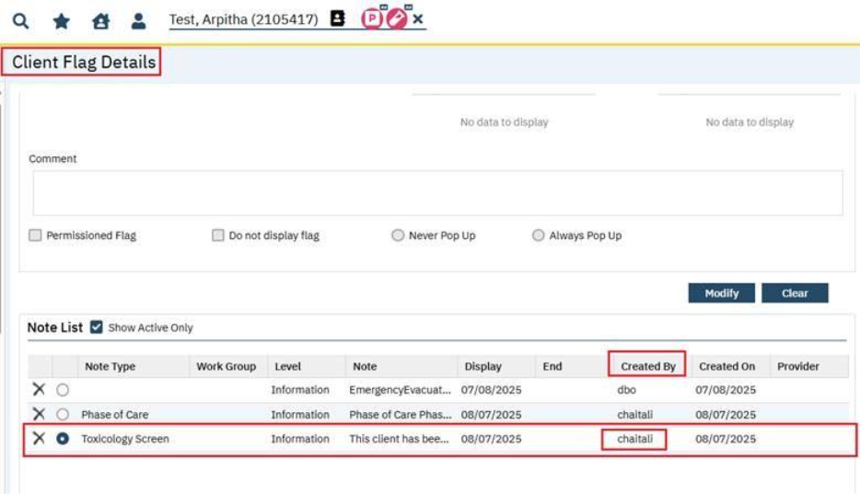

MAT Management List page: The ‘Toxicology Screen flag’ will be displayed in the Flags Column.
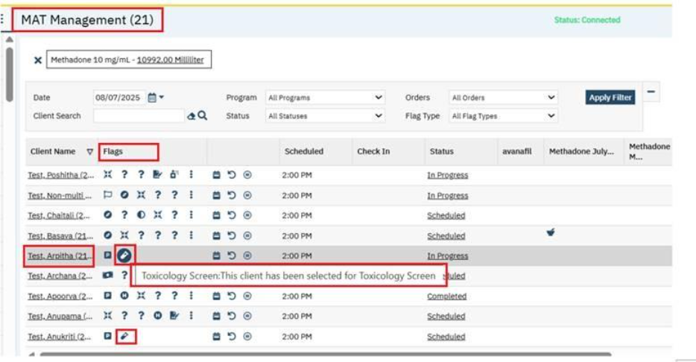

Reception Front Desk Screen ‘Toxicology Screen flag’ will be displayed under the ‘MAT’ column.
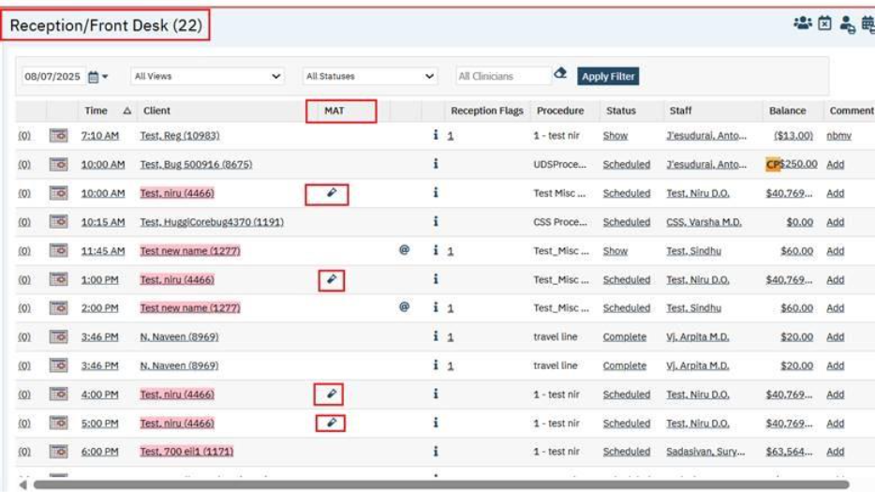

3: MAT Management List page: The ‘Toxicology Screen Flowsheet icon’ (image of flask/beaker)
When the client is scheduled for the toxicology screen then that client will be listed in then ‘MAT Toxicology Screen List Page’. after doing the bulk update from this list page, the ‘Toxicology Screen Date’ has been updated in the client information ‘MAT’ tab, once the ‘Toxicology Screen Date’ has updated then ‘Toxicology Screen flag’ gets created, once the ‘Toxicology Screen flag’ gets created the ‘Toxicology Screen Flowsheet icon’ (image of flask/beaker) will be displayed in the MAT Management list page – under the Blank Column.

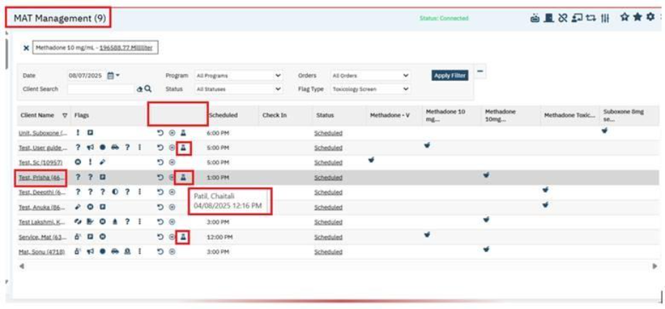
1.On clicking the ‘Toxicology Screen Flowsheet icon’ (image of flask/beaker) in the (Blank) column on the MAT Management List page, then it will take user to ‘NEW Entry Toxicology Screen Flow Sheet’. Which is selected in MAT Configuration screen ‘Toxicology Screen Flow Sheet’ filed.

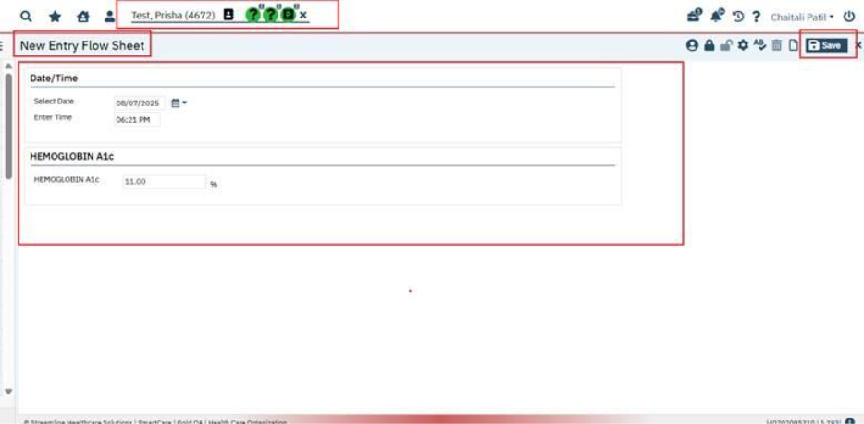

Hemoglobin Flow sheet selected in the MAT Configuration - General - Toxicology Screen Flow Sheet.

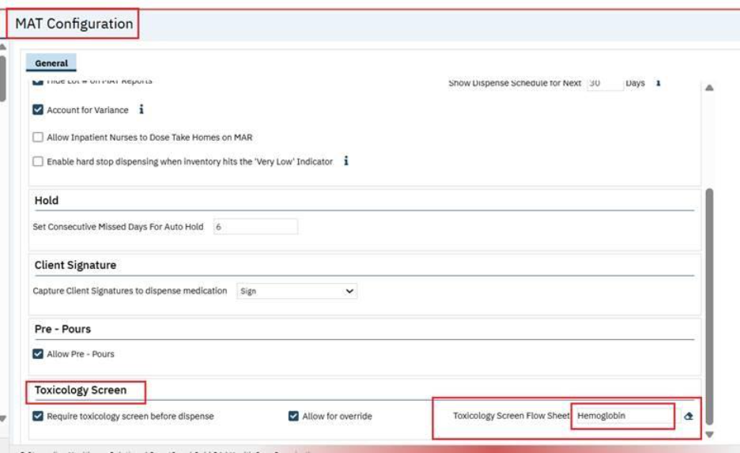
Enter the value in required field and save the Flowsheet entry. After completing the flowsheet while dispensing the Face-to-Face dose user will get the MAT Toxicology Screen (pop up).
Note: The specific Toxicology Screen Flow Sheet is determined at Admin-level from MAT Configuration - General - Toxicology Screen Flow Sheet.
2. When user hovers over this Flowsheet icon (image of flask/beaker) on the MAT Management List Page, then displayed the Date and Time of most recent Toxicology Screen Flow Sheet and Staff Name who logged and saved the entry.
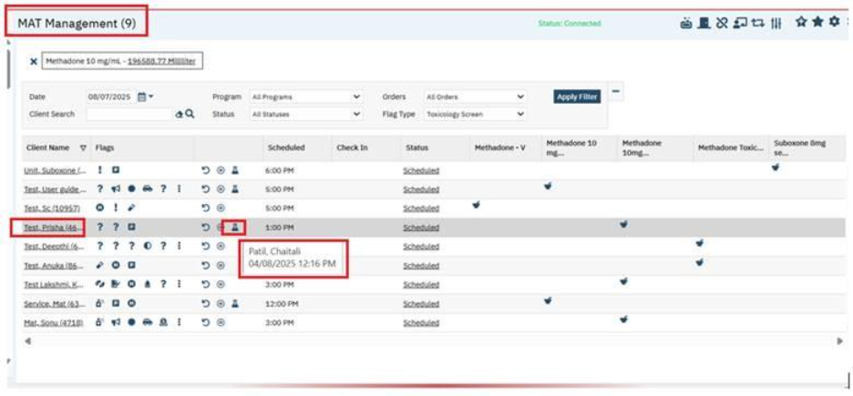
If no Toxicology Screen Flow Sheet has completed, then on hover over on this Toxicology Screen Flowsheet icon (image of flask/beaker) on the MAT Management List Page it will display blank.
Below are the conditions when system will display the ‘Toxicology Screen Flowsheet icon’ for Client in the MAT Management List page.
1: Client is scheduled for a Face-to-Face Dispense, AND
2: There has not been a flowsheet (which matches MAT Configuration - Toxicology Screen - Toxicology Screen Flow Sheet) with a Date ON or AFTER the Client Information - MAT - General – ‘Toxicology Screen Date’.
Below are the conditions when system will NOT display the ‘Toxicology Screen Flowsheet Icon’ for Client in the MAT Management List page.
1. If the Client does not have Active ‘Toxicology Screen Flag’.
2. Client Information - MAT - General - Toxicology Screen Date is blank, OR
3. MAT Configuration - Toxicology Screen - Toxicology Screen Flow Sheet is blank, OR
4. Client is scheduled for Take Home Dispense, not for a Face-to-Face Dispense

Note: Before Face to Face Dispense if the user completes the ‘Toxicology Screen Flowsheet’ on click on the Flask/beaker icon, then while dispensing ‘MAT Toxicology Screen (pop up)’ will not be displayed.

4: In the MAT Management list page in the filter section under the ‘Flag Type’ dropdown added new flag type as a ‘Toxicology Screen’.
When user filters by Flag Type = ‘Toxicology Screen’ then the list of MAT clients who are due for a toxicology screen will be displayed in the MAT Management List page.
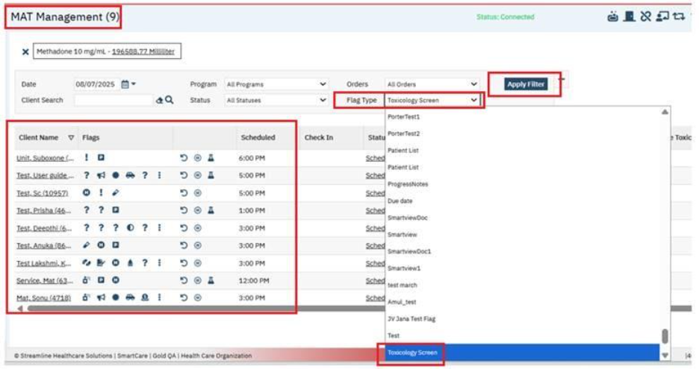

5: MAT Toxicology Screen (pop up): If the Client is scheduled for the Toxicology screen and when they have not completed the Toxicology screen before they are taking the MAT Medication Dose, then on while dispensing the ‘Face- to Face’ dose in the MAT Management Details screen ‘MAT Toxicology Screen (pop up)’ will be displayed.
Below are the conditions to display the ‘MAT Toxicology Screen (pop up)’ on dispensing of the ‘Face- to Face’ dose.
1. If MAT Configuration - General - 'Require Toxicology Screen before Dispense' checkbox is checked and allow for override is checked.
2. AND Client Information - MAT - General - Toxicology Screen Date that is equal to or prior to Dispense Date.
3. AND there is NO Flow sheet entry that matches MAT Configuration - General - Toxicology Screen Flow Sheet, with Date that is equal to or later than Date listed in Client Information - MAT - General - Toxicology Screen Date.
4. Then in the MAT Management Detail screen on 'Dispense’, will THROW MAT Toxicology Screen pop up.
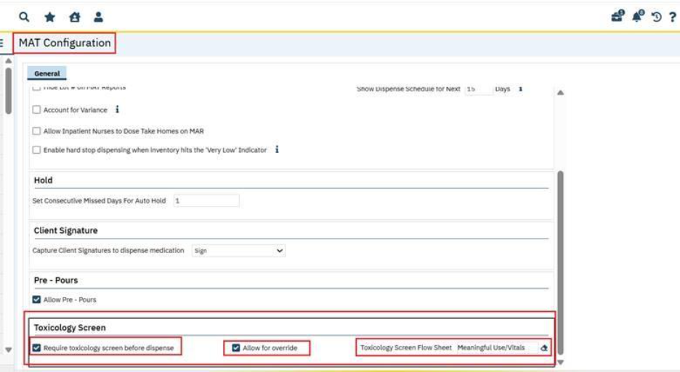
On Face to Face Dispensed: MAT Toxicology Screen pop up will be displayed.
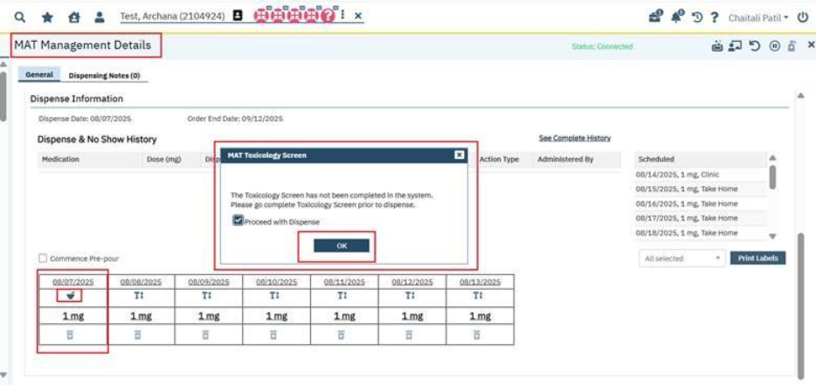
The MAT Toxicology Screen pop is displayed with following details:
- Warning Message: The Toxicology Screen has not been completed in the system. Please go complete toxicology screen prior to dispense.: This is ready only message.
- Proceed with Dispense: This is a checkbox, it can be checked and unchecked, if this checkbox is checked then user will proceed for the Dispense, if not then user will be returned to the previous screen.
- OK: This button gets enabled only when Proceed with Dispense check box is checked. On clicking Ok it will allow user to dispense.
Below are the ‘MAT Toxicology Screen pop up’ scenarios.
Scenario 1: When the user does not want ‘MAT Toxicology Screen popup’ on Dispense at all: In this scenario, users don’t need to select the ‘MAT Configuration - Require Toxicology Screen Dispense checkbox’. Then while dispensing the Face to Face dose ‘MAT Toxicology Screen pop up’ will not be displayed.

Scenario 2: The user wants the MAT Toxicology Screen popup on Dispense and does NOT want to allow nurses to override and proceed with dispense.
So, in this scenario, the users need to select the ‘MAT Configuration - Require Toxicology Screen Dispense checkbox’ and ‘Toxicology Screen flowsheet’ and no need to select the ‘Allow for Override checkbox’.

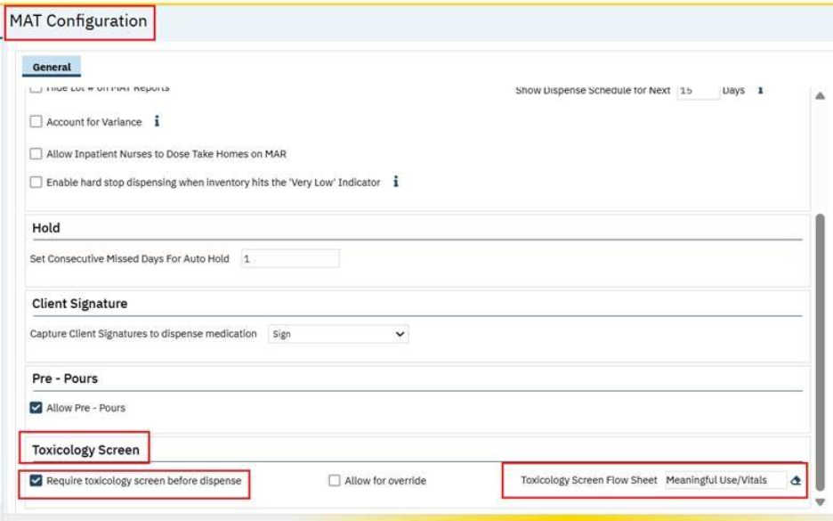
Then while dispensing the ‘Face- to Face’ dose in the MAT Management Details screen ‘MAT Toxicology Screen (pop up)’ will be displayed with the below warning message with ‘Ok’ Button.

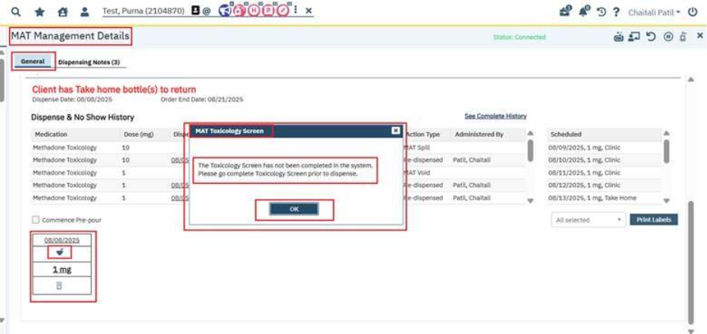
Warning Message: The Toxicology Screen has not been completed in the system. Please complete toxicology screen prior to dispenses.
OK: On click of ‘Ok’ Button user will return to the previous screen, system will not allow to dispense because ‘Allow for Override’ checkbox is not checked in the MAT Configuration screen due this 'Proceed with dispense' checkbox is hidden in this pop up.
Scenario 3: User wants the ‘MAT Toxicology Screen pop up’ on Dispense and wants to allow the nurse to override this warning.
So, in this scenario, the users need to select the ‘MAT Configuration - Require Toxicology Screen Dispense checkbox’, and ‘Allow for Override checkbox’ need to be checked & select the Toxicology Screen flowsheet’ as well.
Then while dispensing the ‘Face- to Face’ dose in the MAT Management Details screen ‘MAT Toxicology Screen (pop up)’ will be displayed with the below message.
Proceed with dispense checkbox will be displayed in this pop.
If proceed with dispense checkbox is checked, then on clicking 'OK' button, pop up will be close and system will allow to dispense.
If MAT Configuration - Toxicology Screen - 'Allow for Override' is checked, then OK button gets disabled until user clicks the 'Proceed with dispense' checkbox.
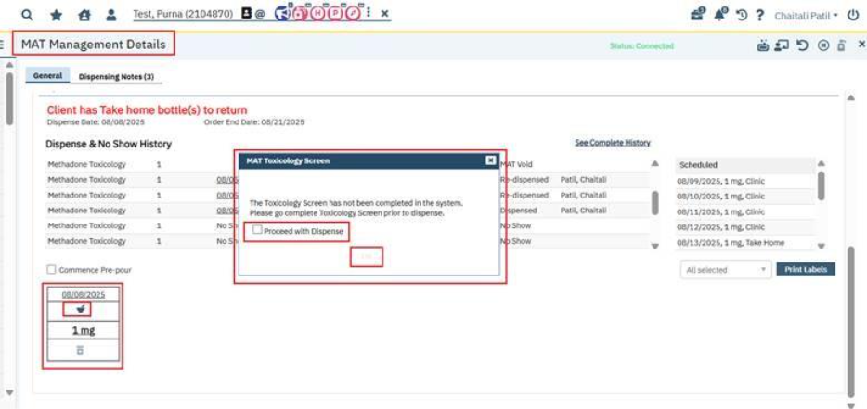
When the user checked the proceed with dispense checkbox in this pop up, then only ‘Ok’ button will be displayed.
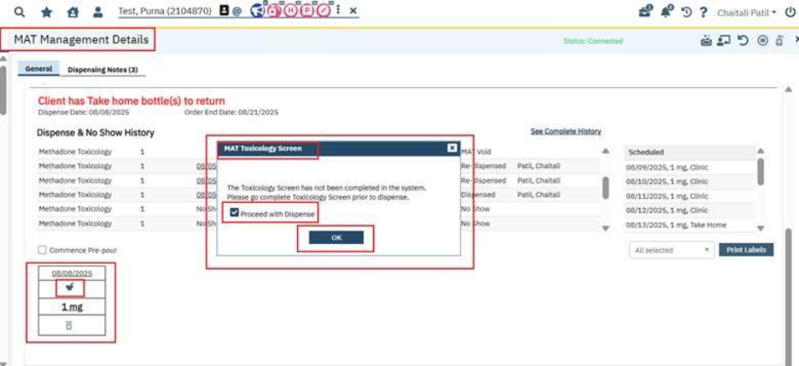

MAT Configuration Screen:
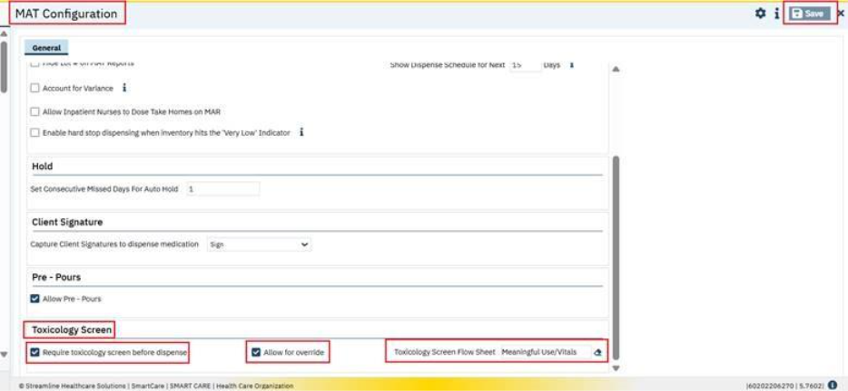

While dispensing the ‘Face- to Face’ dose in the MAT Management Details screen the ‘MAT Toxicology Screen pop up’ will be displayed.

On Click on ok button, Dose get dispensed:
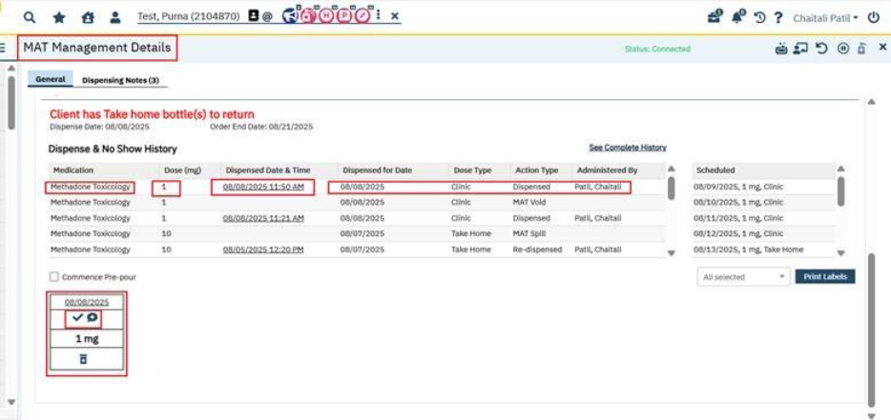

If user clicks corner X, then MAT Toxicology Screen pop up’ get closed, and the user will return to previous screen.
Corner X does not allow Dispense. It just returned to the previous screen.
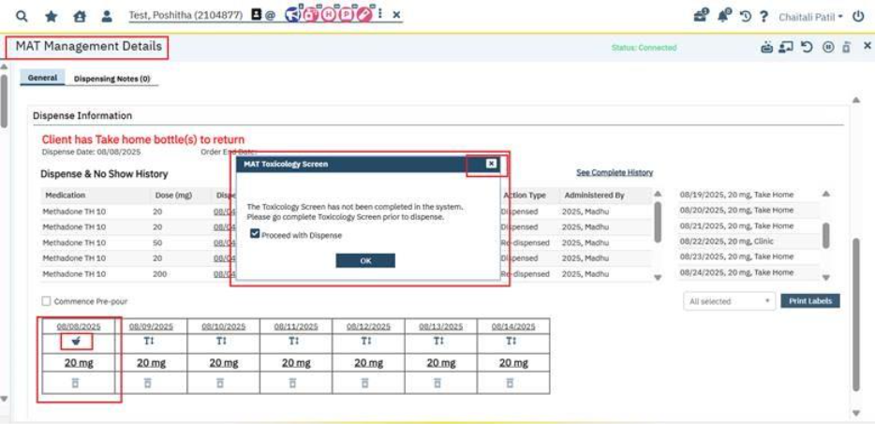

Data Model Change : The new columns ToxicologyScreenRequiredBeforeDispense,ToxicologyScreenAllowOverride,
ToxicologyScreenFlowSheetId are added to the MATConfigurations table.

Author: Smruthi Srikanth

89. Core Bugs # 132464: MAT Management Details Screen: System is slow while dispensing.

Release Type: Fix | Priority: High

Prerequisite: Client to have a MAT Medication scheduled to be dispensed.

Navigation Path: Go Search -- MAT Management -- Click on Dispense icon for the required medication -- MAT Management Details screen -- Click on Dispense icon.

Functionality ‘Before’ and ‘After’ release:

Before this release, here was the behavior. The user was experiencing slowness when dispensing the medication in the MAT Management Details screen.

With this release, the above issue has been fixed and the changes have been made to improve performance when dispensing the medication in the MAT Management Details screen.

Author: Madhu Basavaraju

90. Core Bugs # 132314: Medication Transaction Inventory: The Location field is not auto populated when the bottle number is selected.
Release Type: Fix | Priority: High
Pre-requisites:
1: MAT Medication Inventory Details must be added to the Medication/Lot/Bottle Details screen.
2. MAT Order must be signed for the selected Client.
3. MAT Medication must be dispensed for the selected Client using the below-mentioned Path:
MAT Management List Page—Connect Machine/Inventory – Click on Dispense Icon – MAT Management Details screen – Sign – Dispense on Click of Face-Face/Take Home icon in the Dispensing grid.

Navigation Path: My Office – Medication Inventory Transaction list page – Search and Select Bottle/Box ID – Apply Filter - New – Medication Inventory Transaction Details – Enter required fields – Save.
Functionality ‘Before’ and ‘After’ release:
Before this release, here was the behavior. The below issues were observed in the ‘Medication Inventory Transaction’ List screen,
- In the filter section, When the Bottle number was selected, the corresponding Location field was not auto populated.
- When the new icon was clicked on the Medication Inventory Transaction list page,
- Location was not carry forwarded/ populated with correct value.
- When the same Bottle number exists in multiple locations, the Location field was populated with an incorrect value.

With this release the above issue is fixed. Now, in the ‘Medication Inventory Transaction’ List screen,
1.In the Filter section,
a) The Location and Date range fields are moved to the first row.
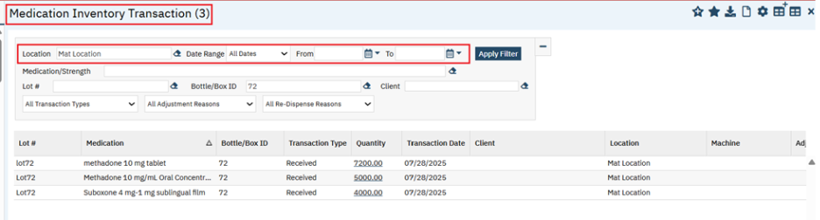
b) When Location is already selected, then Lot/Bottle Number search will retrieve lot/bottles only from the selected Location.
c) When no Location is selected, on selecting a Bottle Number, the corresponding Location field is auto-filled.

2.When the new icon is clicked on Medication Inventory Transaction list page,
- The Selected Location is carried over/ populates with the correct value.
- When the same Bottle Number exists in multiple locations, the Location and Bottle fields will retain the values corresponding to the selected bottle's location.

Author: Madhu Basavaraju

91. Core Bugs # 132403: MAT Connection Details Pop up: The Bottle search functionality is not accepting the minimum 2 characters when tried to search for the Bottles.

Release Type: Fix| Priority: High

Pre-requisites
1: MAT Medication Inventory Details must be added to the Medication/Lot/Bottle Details screen.
2. MAT Order must be signed for the selected Client.
3. MAT Medication must be dispensed for the selected Client using below
Path: MAT Management List Page—Connect Machine/Inventory – Click on Dispense Icon – MAT Management Details screen – Sign – Dispense on Click of Face-Face/Take Home icon in the Dispensing grid.

Navigation Path 1: My office-MAT Management list page-Click on Connect User icon-Connection Details Pop up-Bottle.

Navigation Path 2: My office-MAT Management list page-Click on Dispense icon-Click on Connect User icon-Connection Details pop up-Bottle field.
Navigation Path 3: My Office – Medication Inventory Transaction list page – Search and Select Bottle/Box ID – Apply Filter - New – Medication Inventory Transaction Details – Enter required fields – Save.

Functionality ‘Before’ and ‘After’ release:

Before this release, here was the behavior. In the MAT Management List and Details screen, while Connecting Machine and Inventory from ‘Connection Details’ Popup, when user tried to search the ‘Bottle/Box Id’ field with minimum of 2 characters/numbers, then it was not listed or displayed for the required Bottle selection.

With this release the above issue is fixed. Now, modified the Bottle search functionality to accept a minimum of 2 characters/numbers instead of 3 characters/numbers in the screens mentioned below:
- MAT Connection (user connect) popup in the MAT Management List and Details screen.
- Medication/Lot/Bottle List page.
- Medication Inventory Transaction List and Details screen.

Author: Shivakanth Moger

92. EII # 131828 (Feature - 557927): MAT: Restrict Users from Connecting to Medications Across Multiple Locations. {ACTIVE CHANGE}

Note: This is an Active Change. The system now enforces a Location lock during medication connection sessions. Once a user selects a Location and connects to a medication, that Location remains locked for all subsequent connections. The Location can only be changed after all medications have been disconnected. Additionally, the Location searchable field has been moved above the Machine dropdown to improve workflow clarity.
Release Type: Change | Priority: On Fire

Navigation Path 1: ‘Administration’ - ‘Orders’ - ‘Orders’ list page - New - ‘Order Details’ screen - Select ‘Medication’ Order Type – Enter the required fields – Select (Medication Assisted Treatment (MAT), Take Home Allowed), and Machine Connection = Yes, under ‘Medication Assisted Treatment’ section and display program? Must be ‘Yes’ for MAT Orders – under ‘Option’ section select ’Add Order to MAR’ Radio button as ‘Yes’ – Click on ‘Save’.
Navigation Path 2: My Office – ‘Medication/Lot/Bottle’ list page – New ‘Medication/Lot/Bottle Details’ screen - Enter the required fields – Enter Location - Insert – Save.
Navigation Path 3: ‘Client’- ‘Client Orders’ - ‘Client Orders’ list page - New - ‘Client Order details’ screen - Select the Order created in Navigation Path 1 - Enter the required fields – Insert order details into grid - Save and sign.
Navigation Path 4: ‘My Office’ - ‘MAT Management ‘list page – click on ‘Connect User’ icon – Connection Details pop-up.
Navigation Path 5: ‘My Office’ - ‘MAT Management ‘list page – Select the Order (Navigation path
3) and click on ‘Dispense icon’ – MAT Management Details.

Functionality ‘Before’ and ‘After’ release:
Purpose: To ensure dispensing consistency and improve workflow efficiency, the system will enforce a rule that restricts users to connecting medications from a single designated Location during a session. Once a Location is selected, it remains locked for all subsequent medication connections. Users must disconnect from all medications before selecting a different Location. This enhancement is designed to improve accuracy and prevent cross-location errors for MAT clinic staff.

Before this release, here was the behaviour. The Location searchable field was displayed below the Machine dropdown in the Connection Details pop-up, both on the MAT Management list page and the MAT Management details page.

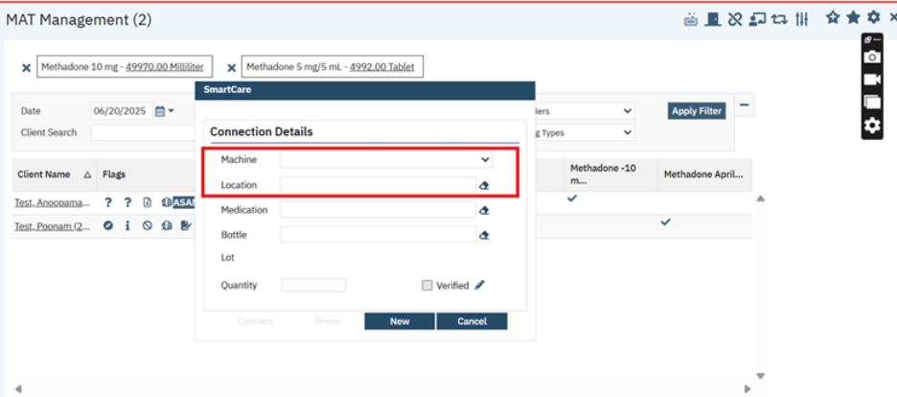

1. The Location searchable field was positioned below the Machine dropdown field, which often led to confusion during the connection process.
2.Users were able to select a different Location for each medication connection.
3.This allowed medications to be accidentally connected across multiple Locations.
4.As a result, dispensing logic became inconsistent, and the risk of label printing errors increased.
5.The tooltip icon was not present next to the Location searchable field.

With this release, the following changes have been implemented to the Connection Details pop-up in both the MAT Management list page and the MAT Management Details page:

The ‘MAT Management ‘list page:

- The Location searchable field has been moved above the Machine dropdown to ensure users select the Location first, to establish the correct context for subsequent selections.

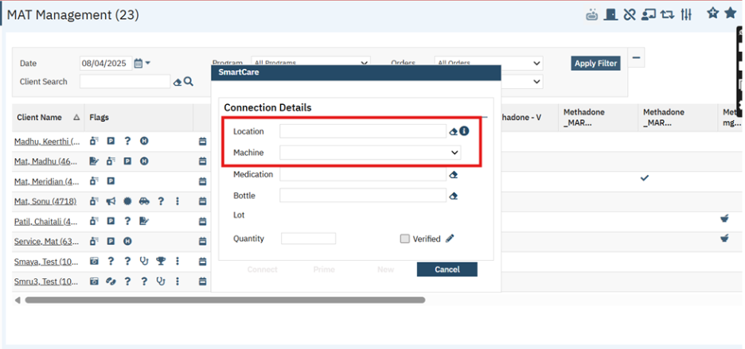
2.The Location searchable field will be enabled only when the user disconnects all medications, then only the user can select a new Location for future medication connections.
3. When a Location is selected and at least one medication is connected, the Location searchable field becomes disabled.

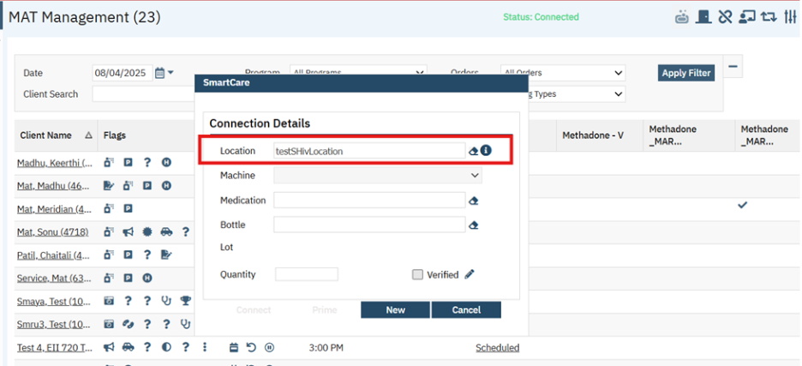
4. If a user disconnects all medications, the Location searchable field will be re-enabled to allow a user to select the new Location.

5.A tooltip icon has been implemented next to the Location searchable field. When users hover over the information (i) icon, the following message will be displayed:

Tool tip icon Message: “Staff can only connect to medications from one Location at a time. Please disconnect all medications to switch to a different Location.”

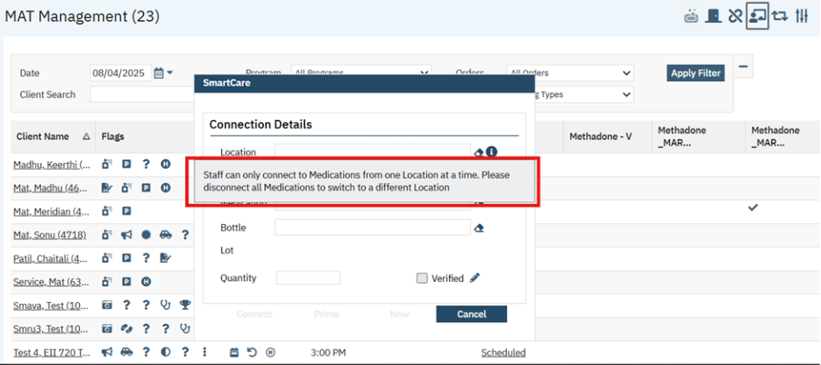

6.When no inventory or machine is connected, the NEW button will be disabled. Once a connection is established, the NEW button will be enabled in the Connection Details pop up.

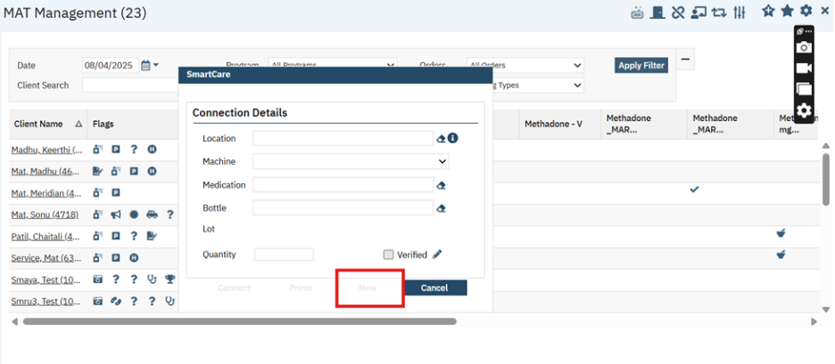

The ‘MAT Management Details’ Page:

- The Location searchable field has been moved above the Machine dropdown to ensure users select the Location first, establishing the correct context for subsequent selections.
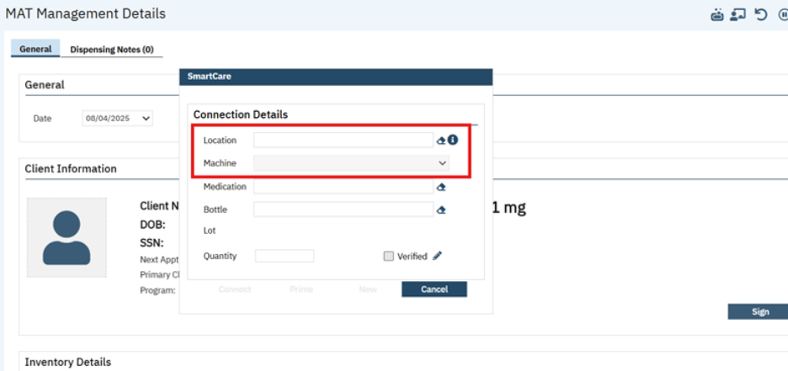
- The Location searchable field will be enabled only when the user disconnects all medications, then only the user can select a new Location for future medication connections.
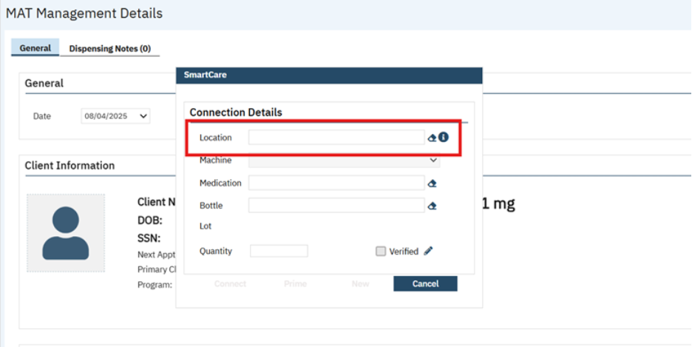
- Once a Location is selected and at least one medication is connected, the Location searchable field becomes disabled.
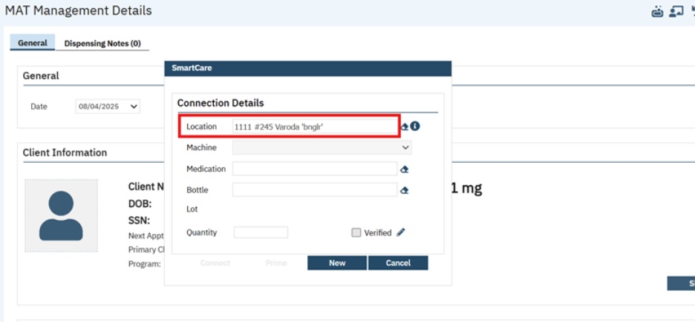

- If a user disconnects all medications, the Location searchable field will be re-enabled to allow a user to select the new Location.

- A tooltip icon has been implemented next to the Location searchable field. When users hover over the information (i) icon, the following message will be displayed:

Tool Tip icon Message: “Staff can only connect to medications from one Location at a time. Please disconnect all medications to switch to a different Location.”
- When no inventory or machine is connected, the NEW button will be disabled. Once a connection is established, the NEW button will be enabled in the Connection Details pop up.
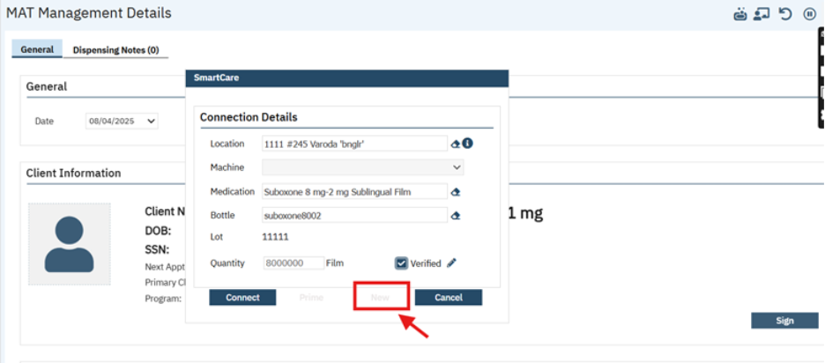

Author: Shivakanth Moger

93. Core Bugs # 132462: MAT Configuration: Getting red error message while saving the ‘Mat Configuration’ screen.

Release Type: Fix | Priority: High

Navigation Path: ‘Administration’ -- ‘MAT configuration’ -- ‘MAT Configuration’ Screen – Modify any data – Click on ‘Save’

Functionality ‘Before’ and ‘After’ release:

Before this release, here was the behavior. In the ‘MAT Configuration’ screen, when the user modified any details and clicked the Save button, the following red error message was displayed.

Error Message: The INSERT statement conflicted with the FOREIGN KEY constraint "MATConfigurations_MATConfigurationNoShows_FK". The conflict occurred in database "LexingtonSmartcareSetup", table "dbo.MATConfigurations", column 'MATConfigurationId'. The statement has been terminated.

With this release, the above-mentioned issue has been resolved. Now, an error message is not displayed when the user clicks on the Save button after modifying the data in the ‘MAT Configuration’ screen.

My Calendar

Reference No | Task No | Description
94 | Core Bugs # 132552 | Red error Message is displayed when creating a Recurring appointment for Additional staff.
95 | Core Bugs # 132395 | Recurring Calendar Event on ‘My Calendar’ is not removing future events after modifying recurrence.

Author: Suganya Sivakumar

94. Core Bugs # 132552: Red error Message is displayed when creating a Recurring appointment for Additional staff.

Release Type: Fix | Priority: Medium
Navigation Path : My Office- New Calendar Entry- Select the particular date-Click on the selected timing slot -New Entry popup displays-Select New Calendar Entry Radio button - Click on OK button --- In Scheduler Event popup - Enter all the required fields - Added New Section -Add Additional Staff section - Enter all the required fields -Click on the Recurrence checkbox-select start and end date- select recurrence pattern - Enter all the required fields -Click on Ok button.
Functionality ‘Before’ and ‘After’ release:
Before this release, here was the behavior. When a recurrence entry was created for a calendar appointment that includes additional staff, the nightly job fails and displays the below red error message.
Error Message: The DELETE statement conflicted with the REFERENCE constraint "AppointmentId_AppointmentAdditionalStaff_FK".
With this release, the above-mentioned issue has been resolved. Now, when a recurrence entry is created for a calendar appointment that includes additional staff, the nightly job runs successfully, and no error message is displayed.

Author: Niroop Hassan

95. Core Bugs # 132395: Recurring Calendar Event on ‘My Calendar’ is not removing future events after modifying recurrence.
Release Type: Fix | Priority: High
Navigation Path: ‘My Office’ -- ‘My Calendar’ -- ‘My calendar’ screen -- Click on required calendar date and time -- ‘Smart Care’ popup -- Select ‘New Calendar Entry’ -- Click on ‘OK’ button -- ‘Scheduler Event’ popup -- Add/Select required data and select ‘Recurrence’ checkbox -- Select required ‘End by’ date as future date -- Click on ‘OK’ button -- Click on Calendar entry -- ‘Open Recurring Appointment’ popup --Select ‘Open this series’ and click on ‘OK’ button -- ‘Scheduler Event’ popup -- Change the ‘End by’ date -- Click on ‘OK’ button.
Functionality ‘Before’ and ‘After’ Release:
Before this release, here was the behavior. In the ‘Scheduler Event’ popup, when the user changed the future Recurrence ‘End by’ date to past date and clicked ‘OK’ button, the future Recurring events were not removed from the ‘My Calendar’.
With this release, the above-mentioned issue has been resolved. Now, when the user changes the future Recurrence ‘End by’ date to past date, the future Recurring events are removed from ‘My Calendar’. Now, Recurrence entries will be displayed based on the ‘End by’ date set in the ‘Scheduler Event’ popup.

My Report

Reference No | Task No | Description
96 | Core Bugs # 132255 | Incorrect data is displayed in the ‘over 365 days’ column of the ‘AR Report by payer’ report.
97 | Core Bugs # 132177 | ER File Detail: ER File Detail requires User ID, Accounting Period to be entered.
98 | EII # 129481 | Implementation of the ‘UDS Table 6B Details - Section L Line 21a - Depression Remission at Twelve Months’ to 2025 Standard.
99 | EII # 129479 | Implementation of the ‘UDS Table 6B Details - Section K Report’ to the 2025 Standard.
100 | EII # 129480 | Implementation of the ‘UDS 6b Section L Line 21 - Preventive Care and Screening: Screening for Depression & Follow Up Plan’ to 2025 Standard.
101 | Core Bugs # 132127 | Display Issue: Report is Opening in Minimized Window instead of full window from ‘Favorites Search'.
102 | Core Bugs # 132443 | Issue with favorites search causing endless processing loop after report deletion

Author: Lavanya Shivakumar

96. Core Bugs # 132255: Incorrect data is displayed in the ‘over 365 days’ column of the ‘AR Report by payer’ report.

Release Type: Fix | Priority: Medium

Navigation Path: ‘My Office’ -- ‘AR Report By Payer’ -- Select ‘Ending Accounting Period Id’ -- Click On ‘View Report’ button.

Functionality ‘Before’ and ‘After’ Release:

Before this release, here was the behaviour. In the ‘AR Report by payer’ report, an Incorrect data was displayed in the ‘over 365 days’ column. It displayed the ‘181-365 Days’ column data in the ‘over 365 days’ column. As a result, the ‘Total AR Balance’ calculation was incorrect.

With this release, the above-mentioned issue has been resolved. Now, the correct data is displayed in the ‘Over 365 days’ column. The ‘Total AR Balance’ calculation is accurate in the ‘AR Report by payer’ report.

Author: Debanjit Das

97. Core Bugs # 132177: ER File Detail: ER File Detail requires User ID, Accounting Period to be entered.

Release Type: Fix | Priority: Medium
Navigation Path: 'My Reports' -- Search for 'ER File Detail' report

Functionality ‘Before’ and ‘After’ Release:

Before this release, here was the behavior. In the ER File Detail report, it required a 'User Id' and 'Accounting Period Id' field parameter to be entered in addition to the ER File Id to return the records in the ER File Detail report.

With this release, the 'User Id' and 'Accounting Period Id' fields have now been removed, and now only the 'ER File Id' field needs to be entered to retrieve the records.

Author: Syed Shafiq

98. EII # 129481 (Feature - 470115): Implementation of the ‘UDS Table 6B Details - Section L Line 21a - Depression Remission at Twelve Months’ to 2025 Standard.
Release Type: Change | Priority: Urgent
Note: This is Passive Change. The ‘UDS Report- 6B Details – Section L Line 21a - Depression Remission at Twelve Months’ is updated to 2025 Standard.
Also, Start Date and End Date functionality is implemented to allow users to fetch the records within specific selected from and to dates.
Navigation Path 1: ‘My Office’ – ‘UDS Table 6B Details Section L Line 21a - Depression Remission at Twelve Months’ -- Click on Detail report hyperlink.
Navigation Path 2: ‘My Office’ – ‘UDS Table 6B Details – Section L Line 21a -Depression Remission at Twelve Months’
Purpose: Ability to see specific information for each section of Table 6B, ability to see the full list of clients eligible for this section of Table 6B as well as the data used to calculate Meets Numerator, Meets Denominator, Index Depression Assessment, Depression Assessment Date, Depression Encounter Date, 12 Month Depression Assessment, 12 Month Depression Assessment Score, 12 Month Depression Assessment Date, Excluded, Exclusion Reason.
Functionality ‘Before’ and ‘After’ release:
Before this Release, UDS Table 6B – Section L Line 21a -Depression Remission at Twelve Months’ for the 2025 Reporting Year 2025 Standard was not updated.
With this release, a report ‘UDS Table 6B Details Section L Line 21a - Depression Remission at Twelve Months’ is updated to 2025 Standard and measure value sets are added in the ‘FQHCUDSMeasureValueSet’ table for CMS ID ‘CMS159v13’. Reporting year 2025 updates will be followed for 2026 also until the updates are done for 2026 standard.

Start Date and End Date has been newly added to the filter section under ‘DS Table 6B Details Section L Line 21a - Depression Remission at Twelve Months’ report.

Start Date and End Date will be displayed in ‘MM/DD/YYYY’ format.

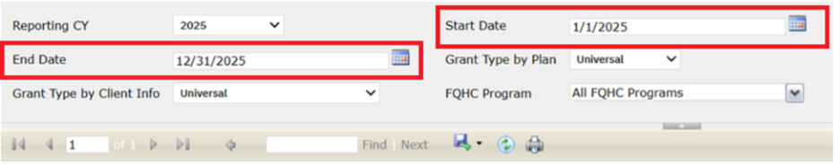

Filter section:
The below following filter options are displayed in Filter section:
Reporting CY:
- This displays the default year based on the most recent values available.
- When the ‘Procedure code ID’ is mapped to the ‘Integer Code ID’ of this below recode category, it will not display the client details in all the above reports.
- UDSScreeningProcedures
- UDSGroupVisitsProcedures
- UDSDispenseMedsProcedures
- UDSHealthCheckProcedure
- UDSWICServicesProcedure

- It will display the count of clients based on the following conditions: Date of service, which is chosen in the Reporting CY, and the Serviced Program will be in Complete Status (Program Details – Reporting – ‘FQHC Reporting’ Check box is Selected).
Start Date: The Filter will display the calendar icon and by clicking on the calendar icon it will open the calendar and allow the user to search for a date. This is compulsory field value selection. While opening the report based on the default value of reporting CY year, the start date will be defaulted to January 1st of the reporting CY year. Later if the ‘Reporting CY’ changed to another year, then Start Date needs to be changed by user, it will not change automatically based on the change of ‘Reporting CY’.
If ‘Reporting CY’ is selected a Particular year and ‘Start Date’ is having another Year, then below validation message will be displayed. Report will display the data for ‘Denominator’ or ‘Numerator’ or ‘Exclusion’ based on the selected ‘Start Date’ Filter.
Validation Message: 'Start Date must fall within the Reporting Year'
End Date: The Filter will display the calendar icon and by clicking on the calendar icon it will open the calendar and allow users to search for a date. This is compulsory field value selection. While opening the report based on the default value of ‘Reporting CY’ year, the ‘End Date’ will be defaulted to December 31st of the ‘Reporting CY’ year. Later if the ‘Reporting CY’ changed to another year, then ‘End Date’ needs to be changed by user, it will not change automatically based on the change of ‘Reporting CY’.
If ‘Reporting CY’ is selected a Particular year and ‘End Date’ having another Year, then below validation message will be displayed. Report will display the data for ‘Denominator’ or ‘Numerator’ or ‘Exclusion’ based on the selected ‘End Date’ Filter.
Validation Message: 'Start Date cannot be later than End Date. Please select valid dates.'
Grant type by Plan:
- The Filter field name is changed from ‘Grant type’ to ‘Grant type by Plan’ and the drop-down has values: Universal, MHC, HCH, and PHPC, with having default value of ‘Universal’.
- If the selected filter type is ‘Universal’, it will display the data of clients with all grant types, and it will also display data of clients without a plan.
- If the selected filter type is MHC or HCH, or PHPC, it will display the data of clients based on the client coverage plans (Plan – Reporting – UDS Reporting – FQHC Grant Type) value selected.
Grant type by Client Info:
- This is a Drop-down filter field with values (Universal, MHC, HCH, PHPC) and has a default value of ‘Universal’. All Included Clients will be displayed as ‘Universal’.
- If the Selected filter in the ‘Grant type by Client Info’ dropdown is ‘MHC’, it will display the clients based on the category selection as ‘Migratory’ or ‘Seasonal’ in the ‘Client information’ – Reporting – Check box fields.
- If the Selected filter is ‘HCH’, it will display the Clients based on the category selection as HomelessShelter or Transitional or DoublingUp or Street or PermanentSupportiveHousing or Other or Unknown in Client information – Reporting – Check box fields.
- If the Selected filter is ‘PHPC’, it will display the Clients based on the category selection as ‘PermanentSupportiveHousing’ in the Client information – Reporting – Check box fields.
- If the Client has multiple Grant type checkboxes selected and if they qualify for multiple grant reports, it will display in each grant report they qualified.
- If the Client has two or more Grant type checkboxes selected, for the same grant report type, it will display in each grant report only once.
FQHC Program: This is a Drop-down filter field and will display the FQHC Programs (Program Details – Reporting – ‘FQHC Reporting’ Check box is Selected) and having a default value as ‘All FQHC Programs’.
Title:
The following titles will be displayed in the section:
Title 1: UDS Table 6B Details Section L Line 21a - Depression Remission at Twelve Months
Title 2: CMS159v13
Title3: https://ecqi.healthit.gov/ecqm/ec/2025/cms0159v13
This is a hyperlink and on clicking this will redirect user to the above-mentioned link or user can select the Link by right-clicking on it and selecting the open link in a new tab.
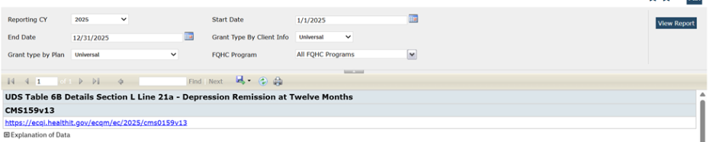
Ref Image 2
‘Explanation of Data’ section:
This will be displayed in collapse mode by default, by clicking on the (+) Plus Symbol will get the explanation page expanded with the information below. In Explanation of data ‘Initial Population’ was removed for reporting year 2025.
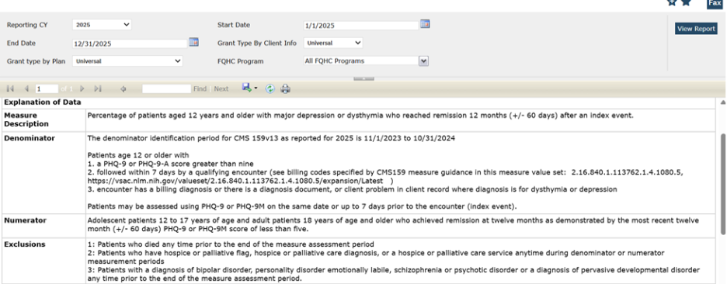
Summary section:
The below-mentioned columns will be displayed in the summary section:
- Total Denominator: This Column will display the total clients who meet the denominator=Y and Excluded = N as per the above explanation of data.

- Total Numerator: This Column will display the total clients who meet Numerator = Y as per the above explanation of data.

- % Numerator: This Column will display the percentage (Numerator Total / Denominator Total) in percentage.

- Total Excluded: This Column will display the total clients who meet Excluded = Y as per the above explanation of data.

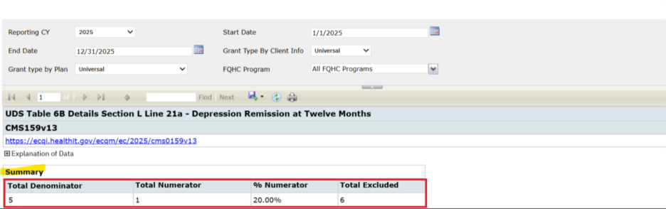
Grid Section:
The below-mentioned columns have changes in the grid section with below mentioned logic changes on the selection of reporting year as ‘2025’. Client Details will be displayed in the report only if matches either ‘Denominator’ or ‘Numerator’ or ‘Exclusion’. If this does not match, those clients will not be displayed in the report.
1. ClientID: This Column will display the ClientID.

2. Client Name: This Column will display the Client’s Last name and First name.

3. Date of Birth: This Column will display the Client's Date of Birth.

4. Age: This Column will display the Client's Age.

5. Meets Denominator: This Column will display the value 1 if the Client is enrolled in an FQHC program or Plan during the reporting year, have at least one qualifying FQHC service in that year and meet Grant filter criteria if applicable, client age should be at least 12 years old as of January 1 of the reporting year, have an age‑appropriate depression assessment (PHQ‑9, PHQ‑9A, or CCBHC Data Collection Document) with a score greater than 9 during the denominator identification period (November 1, 2023 through October 31, 2024 for the 2025 measurement year), and have a qualifying depression encounter within seven days of the assessment date where the program is an FQHC program, the status is Complete, at least one billing code matches the “Contact or Office Visit” value set (OID 2.16.840.1.113762.1.4.1080.5), and the encounter is associated with a diagnosis code from the Dysthymia value set (OID 2.16.840.1.113883.3.67.1.101.1.254) or the Major Depression Including Remission value set (OID 2.16.840.113883.3.67.1.101.3.2444); the Index Depression Assessment is defined as the first assessment meeting all of these criteria within the specified period.

If it does not match the above condition, it will display as 0.

6. Meets Numerator: A client will be displayed as 1 if the client meets the denominator criteria (value = 1) and has a depression assessment (PHQ‑9, PHQ‑9A, or CCBHC Data Collection Document) with a score less than 5 and an effective date that falls within 12 months +/- 60 days of the Index Depression Assessment date; if multiple assessments occur within this timeframe, use the most recent assessment to determine whether the score is less than 5;

It does not match the above condition, it will display as 0.

7. Index Depression Assessment: This Column will display the Type of document used and Show the depression assessment document type only if the client meets the denominator criteria (value = 1) and the document type is PHQ‑9, PHQ‑9A, or CCBHC Data Collection Document.

8. Depression Assessment Date: This column will display the Date (in ‘MM/DD/YYYY’ format) on which the Screening document was signed and only show when client Meets Denominator = 1.

9. Depression Encounter Date: This column will display the date(in MM/DD/YYYY format) of depression encounter (must be on or up to 7 days after index depression assessment date) and only show when client Meets Denominator = 1.

10. 12 Month Depression Assessment: If the client meets numerator criteria (value = 1), displays the most recent depression assessment document type with a score less than 5 within the numerator measurement window (12 months ± 60 days after the Index Depression Assessment date); if the client does not meet numerator criteria (value = 0), displays the most recent depression assessment document type with any score within the same measurement window; if no depression assessment is found within this window, leaves the field blank.

11. 12 Month Depression Assessment Score: Displays score from the assessment found within numerator measurement window (12 months +/- 60 days) after index depression assessment.

PHQ9-A , Score field = PHQ9ADocuments > TotalScore
CCBHC Data Collection Document, Score field = documentccbhcdatacollectionforms > PHQ9Score
PHQ9, Score field = PHQ9Documents > TotalScore
12. 12 Month Depression Assessment Date: Displays Date (in MM/DD/YYYY format) of depression assessment (must be 12 months +/- 60 days after the index depression assessment).

13. Excluded: This Column will display the value as 1 based on any of the conditions below:

Patients who died any time prior to the end of the measure assessment period
-Client Information > Deathdate > client is included in FQHC data population but death date is prior to end of calendar year selected in filter OR

Clients who have a client flag created within the reporting period with the name 'Hospice care' that is mapped in Recode Category ‘FQHCHospiceCare’. OR

Clients who have a client flag created within the reporting period with the name 'Palliative care' that is mapped in Recode Category ‘FQHCPalliativeCare’. OR

Client has service with Status ‘Complete’ within a reporting period where Qualifying service = Client Serviced Procedure code with a Billing code matches the code in ‘FQHCUDSMeasureValueSet’ table with CMS Version ID ‘CMS159v13’ and any of the below Value Set OID ‘Hospice Care Ambulatory (2.16.840.1.113883.3.526.3.1584)’ or ‘Hospice Encounter (2.16.840.1.113883.3.464.1003.1003)’ or ‘Palliative Care Encounter (2.16.840.1.113883.3.464.1003.101.12.1090)’. OR

Client has a diagnosis (client problems list, diagnosis document, OR a billing diagnosis) at any point prior to the end of the measure assessment period where the Diagnosis code matches the code in ‘FQHCUDSMeasureValueSet’ table with CMS Version ID ‘CMS159v13’ and Value Set OID ‘Hospice Diagnosis (2.16.840.1.113883.3.464.1003.1165)’ or ‘Palliative Care Diagnosis (2.16.840.1.113883.3.464.1003.1167)’ OR

3. Patients with a diagnosis of bipolar disorder, personality disorder emotionally labile, schizophrenia or psychotic disorder or a diagnosis of pervasive developmental disorder any time prior to the end of the measure assessment period. OR

Client has a diagnosis (client problems list, diagnosis document, OR a billing diagnosis) at any point prior to the end of the measure assessment period where the diagnosis code matches the code in ‘FQHCUDSMeasureValueSet’ table with CMS Version ID ‘CMS159v13’ and Value set OID ‘Bipolar Disorder (2.16.840.1.113883.3.67.1.101.1.128)’ or ‘Personality Disorder Emotionally Labile (2.16.840.1.113883.3.67.1.101.1.246)’ or ‘Pervasive Developmental Disorder (2.16.840.1.113883.3.464.1003.105.12.1152)’ or ‘Schizophrenia or Psychotic Disorder (2.16.840.1.113883.3.464.1003.105.12.1104)’

If it does not match any of these conditions, it will be display as 0.

14. Exclusion Reason: This Column will display the ‘Exclusion Reason’ based the matching excluded condition. ‘Excluded due to Death’, ‘Excluded due to Hospice Care flag’, ‘Excluded due to Palliative Care flag’, ‘Diagnosis Exclusion Reason found - [Diagnosis exclusion code, Date of Diagnosis], ‘Service Exclusion Reason Found [Service Billing code, Date of Service]’.

Report screenshots:

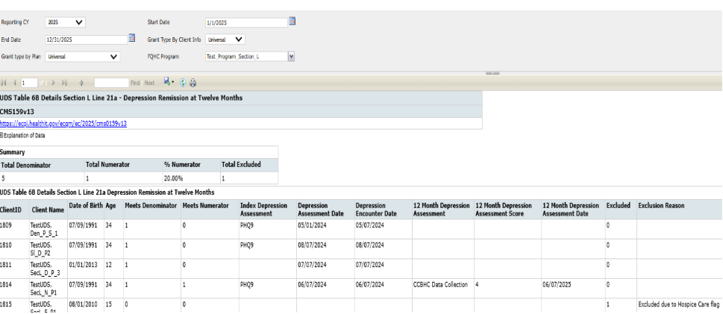

Author: Boovendiran Chinnusamy

99. EII # 129479 (Feature - 470113): Implementation of the ‘UDS Table 6B Details - Section K Report’ to the 2025 Standard.
Note: This is Passive Change. We have updated the UDS Report- 6B Details – Section K to 2025 Standard.
Also, Start Date and End Date functionality is implemented to allow users to fetch the records within specific selected from and to dates.
Release Type: Change | Priority: Urgent
Navigation Path 1: ‘My Office’ – ‘UDS Table 6B Quality of Care Measures’ report - ‘Section K—HIV Measures’ -- Click on Detail report hyperlink.
Navigation Path 2: ‘My Office’ – ‘UDS Table 6B Details – Section K’ Quicklink.
Purpose: Ability to see specific information for each section of Table 6B, ability to see the full list of clients eligible for this section of Table 6B as well as the data used to calculate Meets Numerator 20 and 20a, Meets Denominator 20 and 20a, Diagnosis, Diagnosis Start Date, HIV Follow Up Service, HIV Follow Up Service Date, Order, Order Date, Exclusion and Exception.
Functionality ‘Before’ and ‘After’ release:
Before this Release, UDS Table 6B – Section K for 2025 Reporting Year 2025 Standard was not updated.
With this release, a report ‘Section K—HIV Measures’ to 2025 Standard is Implemented and measure value sets are added in ‘FQHCUDSMeasureValueSet’ table for CMS ID ‘CMS349v7. Reporting year 2025 updates will be followed for 2026 also until the updates are done for 2026 standard.

Start Date and End Date has been newly added to the filter section under ‘UDS Table 6B Quality of Care Measures’ report - ‘Section K—HIV Measures’

Start Date and End Date will be displayed in ‘MM/DD/YYYY’ format.

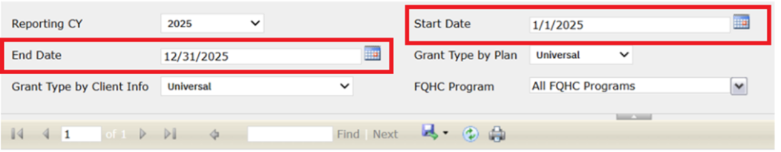
Filter section:
The below following filter options are displayed in Filter section:

Reporting CY:
- This field displays the default year based on the most recent values available.

- When the ‘Procedure code ID’ is mapped to the ‘Integer Code ID’ of this below recode category, it will not display the client details in all the above reports.
- UDSScreeningProcedures
- UDSGroupVisitsProcedures
- UDSDispenseMedsProcedures
- UDSHealthCheckProcedure
- UDSWICServicesProcedure
- It will display the count of clients based on the below conditions, Date of service which is chosen in the ‘Reporting CY’ and ‘Serviced Program’ will be in ‘Complete’ Status (‘Program Details’ – ‘Reporting’ – ‘FQHC Reporting’ Checkbox is Selected).
Start Date: The Filter will display the calendar icon and by clicking on the calendar icon it will open the calendar and allow the user to search for a date. This is compulsory field value selection. While opening the report based on the default value of reporting CY year, the start date will be defaulted to January 1st of the reporting CY year. Later if the ‘Reporting CY’ changed to another year, then Start Date needs to be changed by user, it will not change automatically based on the change of ‘Reporting CY’.
If ‘Reporting CY’ is selected a Particular year and ‘Start Date’ is having another Year, then below validation message will be displayed. Report will display the data for ‘Denominator’ or ‘Numerator’ or ‘Exclusion’ based on the selected ‘Start Date’ Filter.
Validation Message: 'Start Date must fall within the Reporting Year'
End Date: The Filter will display the calendar icon and by clicking on the calendar icon it will open the calendar and allow users to search for a date. This is compulsory field value selection. While opening the report based on the default value of ‘Reporting CY’ year, the ‘End Date’ will be defaulted to December 31st of the ‘Reporting CY’ year. Later if the ‘Reporting CY’ changed to another year, then ‘End Date’ needs to be changed by user, it will not change automatically based on the change of ‘Reporting CY’.
If ‘Reporting CY’ is selected a Particular year and ‘End Date’ having another Year, then below validation message will be displayed. Report will display the data for ‘Denominator’ or ‘Numerator’ or ‘Exclusion’ based on the selected ‘End Date’ Filter.
Validation Message: 'Start Date cannot be later than End Date. Please select valid dates.'
Title:
The below-mentioned titles will be displayed in the section if selected reporting year as 2025:
Title 1: UDS Table 6B Details Section K HIV Measures
Title 2: CMS349v7
Title3: https://ecqi.healthit.gov/ecqm/ec/2025/cms0349v7
This is a hyperlink and on clicking this will redirect user to the above-mentioned link or user can select the Link by right-clicking on it and selecting the open link in a new tab.
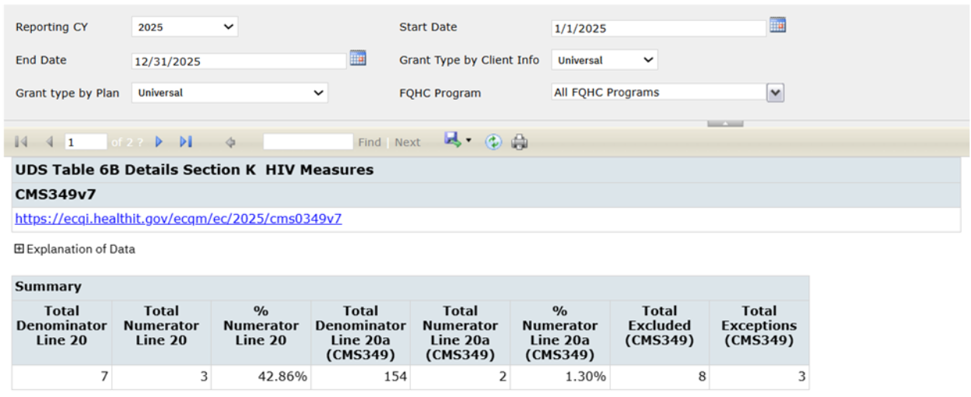
Ref Image 2
‘Explanation of Data’ section:
This will be displayed in collapse mode by default, by clicking on the (+) Plus Symbol will get the explanation page expanded with the information below. In Explanation of data ‘Initial Population’ was removed for reporting year 2025.
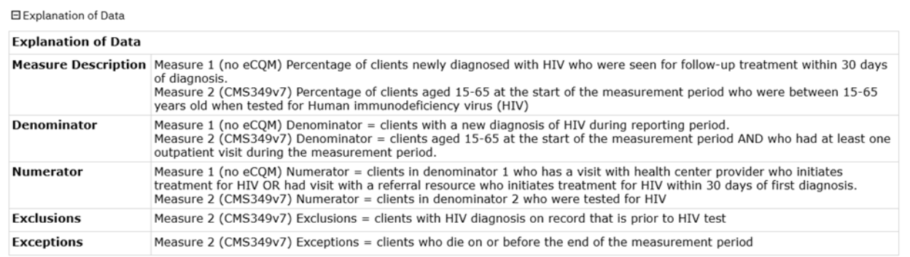

Summary section:
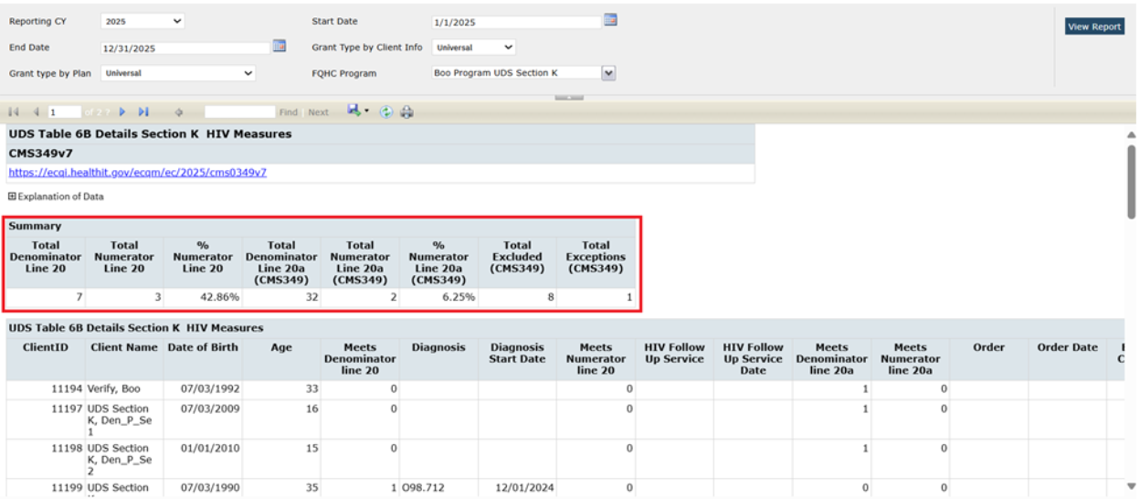
The below-mentioned columns will be displayed in the summary section:
- Total Clients: This Column and its value are removed for reporting year 2025.
- Total Denominator Line 20: This Column will display the total clients who meet the Meets Denominator Line 20 = 1 (Y) as per the above explanation of data.
- Total Numerator Line 20: This Column will display the total clients who meet Numerator Line 20 = 1 (Y) as per the above explanation of data.
- % Numerator Line 20: This Column will display the Percentage of Total Numerator Line 20 / Total Denominator Line 20.
- Total Denominator Line 20a (CMS349): This Column will display the total clients who meet the Meets Denominator Line 20a = 1 (Y)as per the above explanation of data.
- Total Numerator Line 20a (CMS349): This Column will display the total clients who meet Meets Numerator Line 20a = 1 (Y) as per the above explanation of data.
- % Numerator Line 20a (CMS349): This Column will display the Percentage of Total Numerator Line 20a (CMS349) / Total Denominator Line 20a (CMS349).
- Total Excluded (CMS349): This Column will display the total clients who Meet Excluded CMS349v7= 1 (Y) as per the above explanation of data.
- Total Exceptions (CMS349): This Column will display the total clients who meet Exceptions CMS349v7= 1 (Y) as per the above explanation of data.

Grid Section:
The below-mentioned columns have changes in the grid section with below mentioned logic changes on the selection of reporting year as ‘2025’. Client Details will be displayed in the report only if matches either ‘Denominator’ or ‘Numerator’ or ‘Exclusion’. If this does not match, those clients will not be displayed in the report.
- Meets Denominator line 20: This Column will display the value 1
if the Client is enrolled in an FQHC program or Plan during the reporting year and has a qualifying FQHC service during reporting year and client's age is 15 to 65 years as on ‘Start Date’ of the Measurement period and Client has Diagnosis using client problems list or diagnosis document or a billing diagnosis with ‘Start Date’ between December 1, 2024 to November 30, 2025 where Diagnosis Code matches the code in ‘FQHCUDSMeasureValueSet’ table with CMS Version ID ‘CMS349v7’ and Value Set OID ‘HIV (2.16.840.1.113883.3.464.1003.120.12.1003)’.

- Meets Denominator Line 20a: This Column will display the value 1 Client is enrolled in an FQHC program or Plan during the reporting year and has a qualifying FQHC service during reporting year and client's age is 15 to 65 years on January 1st of Reporting year Qualifying Service within a reporting period where Qualifying service with Status ‘Complete’ = Client Serviced Procedure code with a Billing code matches the code in ‘FQHCUDSMeasureValueSet’ table with CMS Version ID ‘CMS349v7’ and Value Set OID ‘Preventive Care Services, Initial Office Visit, 0 to 17 (2.16.840.1.113883.3.464.1003.101.12.1022) or Preventive Care Services Initial Office Visit, 18 and Up (2.16.840.1.113883.3.464.1003.101.12.1023) or Preventive Care or Established Office Visit 0 to 17 (2.16.840.1.113883.3.464.1003.101.12.1024) or Preventive Care Services Established Office Visit, 18 and Up (2.16.840.1.113883.3.464.1003.101.12.1025) or Office Visit (2.16.840.1.113883.3.464.1003.101.12.1001)’

If it does not match the above condition, it will be display as 0.

- Excluded CMS349v7: This Column will display Field name as ‘Excluded CMS349v7’ and it will display 1 if Client has Diagnosis using client problems list or diagnosis document or a billing diagnosis with Start Date Prior to Start date of reporting year where Diagnosis Code matches the code in FQHCUDSMeasureValueSet table with CMS Version ID ‘CMS349v7’ and Value Set OID ‘HIV (2.16.840.1.113883.3.464.1003.120.12.1003)’.

If it does not match the above condition, it will display as 0.

- Excluded CMS349v7 Reason: This Column will display Field name as ‘Excluded CMS349v7 Reason’ and it will display Exclusion reason as ‘Exclusion due to prior HIV diagnosis’ if Excluded CMS349v7 = 1.

- Exceptions CMS349v7: This Column will display Field name as ‘Exceptions CMS349v7’ and it will display 1 if Client Information > Demographics > Deceased on Date is within the reporting year.

Else it will display as 0.

- Exceptions CMS349v7 Reason: This Column will display Field name as ‘Exceptions CMS349v7 Reason’ and it will display reason as ‘Patient Died prior to end of measurement period’ if Exceptions CMS349v7 = 1.

If no Death Date is found, it will display as blank.

Report screenshots:

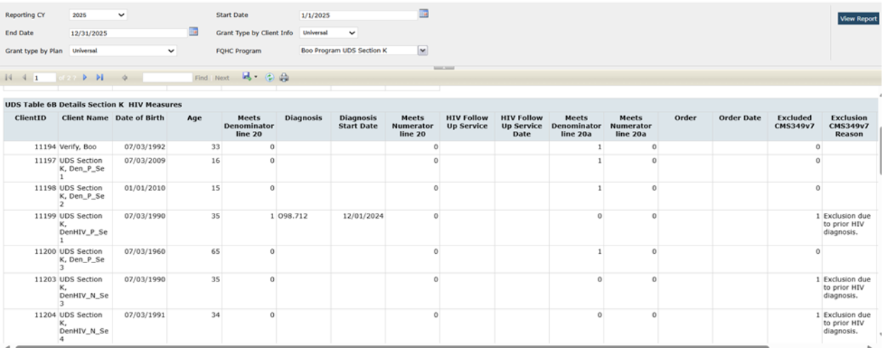

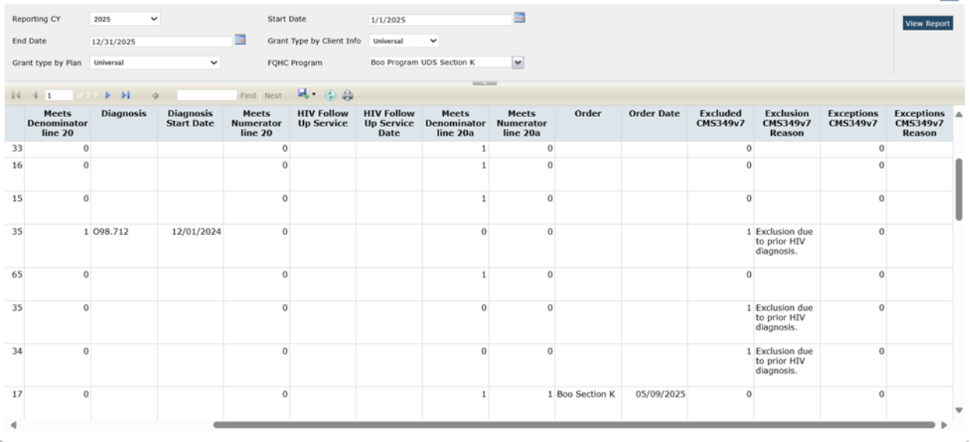
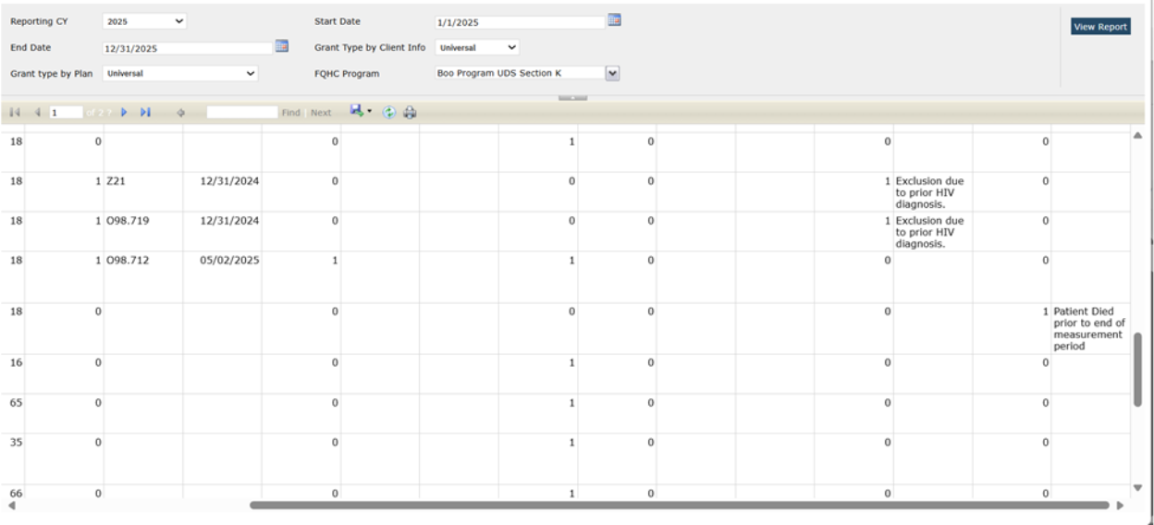

Author: Chandan Kanchinkoti

100. EII # 129480 (Feature - 470114): Implementation of the ‘UDS 6b Section L Line 21 - Preventive Care and Screening: Screening for Depression & Follow Up Plan’ to 2025 Standard.
Note: This is a passive change. This task’s scope is to see specific information for each section of Table 6B, ability to see the full list of clients eligible for this section of Table 6B as well as to calculate Denominator, Numerator, Diagnosis, Screening & follow up data for the eligible reported clients.
Release Type: Change | Priority: Urgent
Navigation Path: My Office’ -- ‘UDS 6B Details - Section L Line 21’ report -- ‘UDS Table 6B Details Section L Line 21 - Preventive Care and Screening: Screening for Depression and Follow-Up Plan’ detail report screen.
Functionality ‘Before’ and ‘After’ release:
Before this Release, UDS Table 6B Details - Section L Line 21 for the 2025 Reporting Year 2025 Standard was not updated.
With this release, A report ‘UDS 6b Details -Section L Line 21- Preventive Care and Screening: Screening for Depression and Follow-Up Plan’ has been updated to 2025 Standard.

The following changes have been implemented in the ‘UDS Table 6B Details - Section L Line 21’ report for 2025.

Filter Section:

Reporting CY: The ‘Reporting CY’ is updated to 2025. This filter determines the logic to use based on the reporting year selected. Reporting year 2025 updates will be followed for 2026 also until the updates are done for 2026 standard.

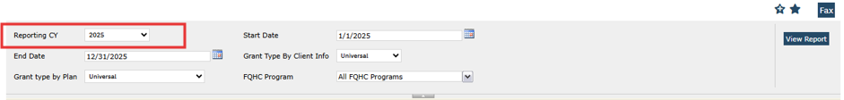

Start Date: It is a newly added field in the Filter section. It will be displayed in ‘MM/DD/YYYY’ format.
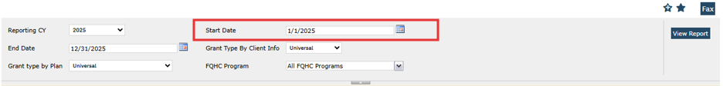

The Start Date filter includes a calendar icon. When the user clicks this icon, a calendar opens, allowing them to select a date. This is a mandatory field. When the report is initially opened, the Start Date defaults to January 1st of the selected Reporting Calendar Year (CY). However, if the user later changes the Reporting CY, the Start Date will not update automatically. The user must manually adjust the Start Date to match the new Reporting CY.
If the selected Start Date does not fall within the selected Reporting CY, a validation message will be displayed. Report will display the data for ‘Denominator’ or ‘Numerator’ or ‘Exclusion’ based on the selected ‘Start Date’ Filter.
Validation Message: 'Start Date must fall within the Reporting Year'.

End Date: It is a newly added field in the Filter section. It will be displayed in ‘MM/DD/YYYY’ format.
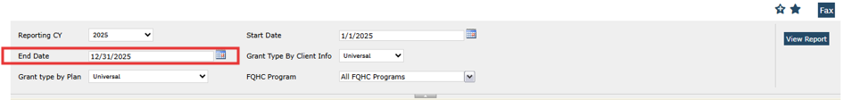

The End Date filter includes a calendar icon. When the user clicks this icon, a calendar opens, allowing them to select a date. This is a mandatory field. When the report is first opened, the End Date is automatically set to December 31st of the selected Reporting Calendar Year (CY). If the user later changes the Reporting CY, the End Date will not update automatically. The user must manually adjust the End Date to match the new Reporting CY.
If the selected End Date does not fall within the selected Reporting CY, a validation message will be displayed. The report will display data for Denominator, Numerator, or Exclusion based on the selected End Date filter.
Validation Message: Start Date cannot be later than End Date. Please select valid dates.

Titles:
Title 1: UDS Table 6B Details Section L Line 21 - Preventive Care and Screening: Screening for Depression and Follow-Up Plan
Title 2: In the document title, Version updated to 2025 reporting year version i.e. CMS2v14
Title3: In the document title, Hyperlinks updated to the 2025 specifications i.e. https://ecqi.healthit.gov/ecqm/ec/2025/cms0002v14
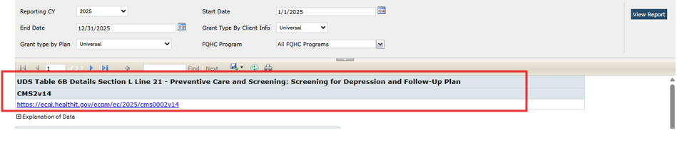
Explanation of Data: It will be displayed by default in collapsed format. Clicking on the (+) Plus symbol will expand the explanation page.
- In the Explanation of data ‘Initial Population’ is removed for the reporting year 2025.
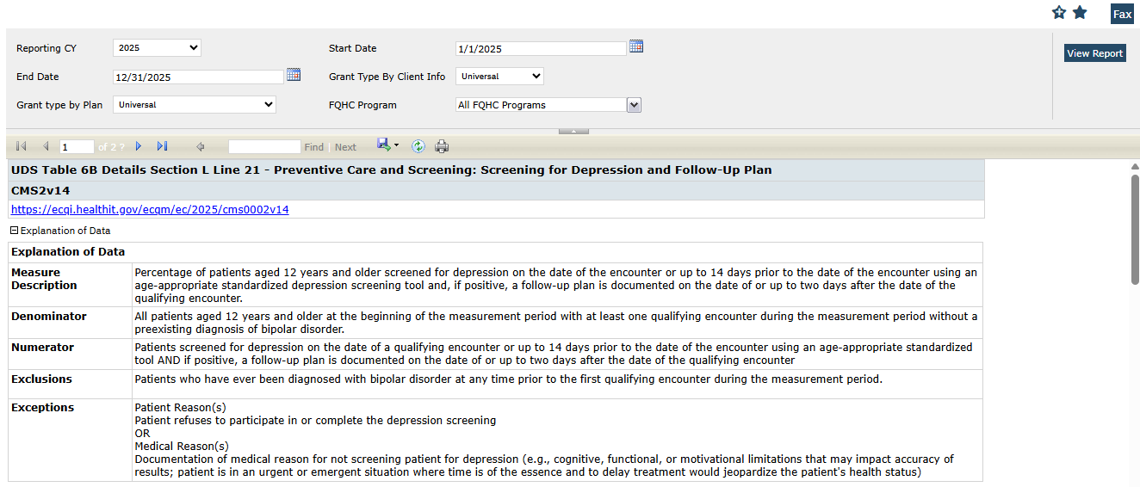
Summary section:

In ‘Summary’ section, ‘Total Clients’ field and its values are removed for reporting year 2025.

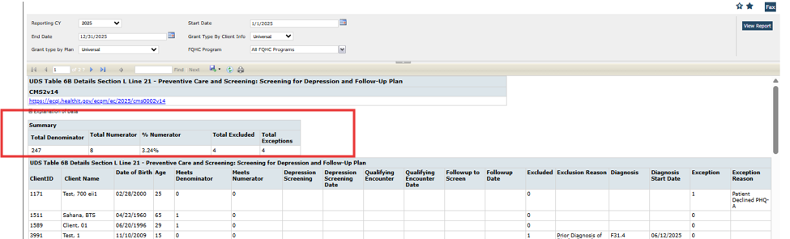

Grid section:

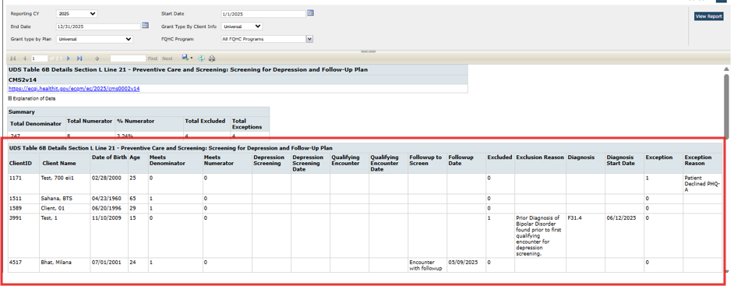

- Meets Denominator: This column will be displayed as 1, if clients are enrolled in an FQHC program or plan and have a qualifying FQHC service during the reporting year that meets the selected Grant filter criteria, are 12 years or older as of January 1st of the reporting year, and have a completed service under an FQHC program with a billing code that matches the CMS2v14 value set under one of the following OIDs: Encounter to Screen for Depression, Physical Therapy Evaluation, or Telephone Visits. Additionally, the client must not be excluded (Client Excluded = 0). If any of these conditions are not met, the client will be displayed as 0.

- Meets Numerator: This column will be displayed as 1, if client meets the denominator criteria, have an age-appropriate depression screening document dated up to 14 days before the effective date of a qualifying encounter, AND

Have either a negative score (PHQ9, PHQ9A, CCBHC < 9 or PHQ2 < 2) OR

a positive score (PHQ9, PHQ9A, CCBHC ≥ 9 or PHQ2 > 2).
In the case of a positive score, there must be follow-up documentation, depression medication, or a procedure with CQM configuration for depression follow-up recorded on or after the screening date and within 2 days of the qualifying encounter.
If these conditions are not met, the client will be displayed as 0.
- Qualifying Encounter: Billing code of the service will be displayed for the associated client with the service with a status = Complete > Charge > Billing Code matches a value in "Code" category of CMS2v14 measure value set tab and in one of the following "Value Set OID": If more than one charge exists, look for a match from any of the Charges for the Service.
-Encounter to Screen for Depression (2.16.840.1.113883.3.600.1916)
-Physical Therapy Evaluation (2.16.840.1.113883.3.526.3.1022)
-Telephone Visits (2.16.840.1.113883.3.464.1003.101.12.1080)
- Follow-up to Screen: This will display one of the following values based on the follow-up process used considering the Measure Value Set CMS2v14 for reporting year 2025.
- Screening Checkbox
- Medication Prescribed
- Encounter with Follow-up
- Excluded: It will display as 1 if they have a diagnosis recorded in the client’s problem list, diagnosis document, or billing diagnosis that starts before the qualifying encounter, and the diagnosis code matches the bipolar disorder value set (OID: 2.16.840.1.113883.3.67.1.101.1.128) from the CMS2v14 measure value set. If this condition is not met, the client will be displayed as 0.
- Diagnosis: It will display the diagnosis code when Excluded = 1, displays the first diagnosis document containing a Bipolar Disorder diagnosis from any date during or prior to the selected reporting year. The diagnosis must be recorded in the client’s problem list, diagnosis document, or billing diagnosis, and must start before the qualifying encounter. The diagnosis code must match the Bipolar Disorder value set (OID: 2.16.840.1.113883.3.67.1.101.1.128) from the CMS2v14 measure value set. If these conditions are not met, the display will be blank.
Author: Rakesh Naganagoda

101. Core Bugs # 132127: Display Issue: Report is Opening in Minimized Window instead of full window from ‘Favorites Search'.
Release Type: Fix | Priority: Medium
Prerequisites: Add the report to the ‘Favorites Search' section.
Navigation Path: Login to ‘SmartCare’ application – Click on the ‘Favorites Search' icon at the header – In the list displayed-- click on the ‘Report’ added.
Functionality ‘Before’ and ‘After’ release:
Before this release, here was the behavior. When the user opened a report from the ‘Favorites Search’ section, a blank space appeared at the bottom of the report or in a minimized view. The report did not utilize the full available window space.
With this release, the above-mentioned issue has been resolved. The blank space at the bottom of the report no longer appears when the report is opened from the ‘Favorites Search’ section, and now, the report is displaying in full window space.

Author: Rakesh Naganagoda

102. Core Bugs # 132443: Issue with favorites search causing endless processing loop after report deletion

Release Type: Fix | Priority: Medium

Prerequisites: Create new report and add the report to the ‘Favorites Search' section through the Path :
Login to SmartCare application – Administration – ‘Reports’ Screen – Click on New button - Enter all the required fields - Click on Save - Open the created report and add it to the Favorites list

Navigation Path 1: Login to SmartCare application – Administration – ‘Reports’ Screen – Click on report created hyperlink - Click on the delete button to delete the report

Navigation Path 2: Login to SmartCare application – Click on the ‘Favorites Search' icon at the header – Deleted favorite report should not show in ‘Favorites Search' section

Functionality ‘Before’ and ‘After’ release:

Before this release, here was the behavior. When a report record is soft deleted, any favorites associated with that report become orphaned or "parentless." These orphaned favorites remain visible in the user's favorites list and are represented by a 'Q' icon without a background, indicating the absence of a valid report link.

With this release, above mentioned issue has been fixed. Now, the deleted favorite Report is no longer visible or accessible in the ‘Favorite Search’ filter or list

Patient Portal

Reference No | Task No | Description
103 | Core Bugs # 131744 | URL showing sensitive information on resetting the password.

Author: Abhishek Naik

103. Core Bugs # 131744: URL showing sensitive information on resetting the password.

Release Type: Fix | Priority: Medium

Navigation Path: Search ‘Non-staff Users’ – Click ‘New’ icon – Fill in all required details – Click on ‘Reset Password’ button – ‘Do you want to print this Information?’ – Yes

Functionality ‘Before’ and ‘After’ release:

Before the release, here was the behavior. Sensitive information like Staff ID and Temp Password were displayed on the PDF of Reset Password Link and also in the password reset URL. Also, users were able to login by entering Password as ‘password’.

With this release, reset password URL will include a secure token or encoded string instead of sensitive information like Staff ID and Temp Password on the PDF of Reset Password Link and also in the password reset URL.

Validation message: “A password reset link has already been sent to your registered email address. Please check your inbox (and your spam or junk folder), follow the link to reset your password, and then log in to the Patient Portal.” will be displayed when user enters the wrong password.

Payments/Adjustments

Reference No | Task No | Description
104 | Core Bugs # 132323 | Corrections and Delete Client ledger Entries reversing ledger entries improperly, leaving incorrect balance on charges.
105 | EII # 130499 | Regenerate Charges Phase 2: FrontEnd: Implementation of Warning Messages
106 | EII # 129864 | Regenerate Charges Phase 2: Back End: Implementation of logic functionality

Author: Yashas Kydalappa

104. Core Bugs # 132323: Corrections and Delete Client ledger Entries reversing ledger entries improperly, leaving incorrect balance on charges.
Release Type: Issue Fix | Priority: Medium
Prerequisites: The ‘RegenerateChargesForServicesWithPayments’ configuration key value is set to ‘Yes’.
Navigation Path 1: ‘Client’ -- ‘Services’ -- ‘Services’ List page -- Click on the DOS hyperlink – ‘Service Detail’ screen -- Click on the ‘Charge’ hyperlink -- ‘Ledger Entries’ screen -- Click on ‘Regenerate Charge’ button after posting the Payment and Adjustment -- Click on Edit and Delete icon.
Navigation Path 2: ‘My Office’ -- ‘Billing’ -- ‘Charges/Claims’ -- ‘Charges/Claims’ list page – Select the Charge Id -- Click on ‘E-claim’ button.
Functionality ‘Before’ and ‘After’ release:
Before this release, here was the behaviour for the Regenerated Charge. In the ‘Ledger Entries’ screen, when the user attempted to correct and delete ledger entries using the edit (pencil) and delete(X) icons in the grid section, the system did not recalculate the associated balances correctly. This led to incorrect remaining charge balances, which in turn caused errors during secondary charged ID billing even when the primary charge had a $0 balance.
Error Message: Secondary Billing: COB information for (Primary Plan Name and Insured ID) Does not balance at claim line level.
With the release, the above-mentioned issue has been resolved. Now, when ledger entries are corrected or deleted using the edit (pencil) and delete(X) icons in the grid section of ‘Ledger Entries’ screen, the system recalculates charge balances accurately. Regenerated charges reflect the correct remaining balance. The charge error no longer occurs when billing the secondary charge ID even when the primary charge balance is $0.

Author: Yashas Kydalappa

105. EII # 130499 (Feature - 519458): Regenerate Charges Phase 2: FrontEnd: Implementation of Warning Messages. {ACTIVE CHANGE}

Note: This is Active change. This change is to address the timely workflow complications due to a regenerated billed charge. When a billed charge is regenerated, a new ChargeId is assigned, with the original ChargeId and history being removed. This causes payment/denial posting issues, along with a complex replacement claim workflow.

Release Type: Change | Priority: Urgent

Prerequisites 01: The ‘RegenerateChargesForBilledServices’ configuration key value to be set as ‘Yes’.

Prerequisites 02: The ‘RegenerateChargesForServicesWithPayments’ configuration key value to be set as ‘Yes’.

Navigation Path 1: For Service Details screen: Select an existing Client -- ‘Client’ -- ‘Finance’ -- ‘Services’ – Services list page -- Click on the ‘New’ button to create a new Service – Service Detail screen-- Click on ‘Regenerate Charge’ button after completing a Service.

Navigation Path 2: For Ledger Entry screen: ‘Client’ -- Services hyperlink -- Services List page -- Click on the DOS hyperlink -- Service Details screen -- click on the Charge hyperlink -- Leder Entry screen.

Navigation Path 3: For Service (My Office) list page: ‘My Office’ -- ‘Services’ -- Select a few Services with completed status and select ‘Regenerate Charge’ from the ‘Select Action’ dropdown.

Functionality ‘Before’ and ‘After’ release:

Before this release, here was the behavior. Currently there is a configuration key to monitor the regeneration of charge for the services that have the payment entry for the service. But there is no configuration key to monitor the regeneration of charge for the charges that are either billed or unbilled.

With this release, a new configuration key RegenerateChargesForBilledServices has been implemented and the existing configuration key RegenerateChargesForServicesWithPayments has been updated with the warning and confirmation messages.

System Configuration Key Details:

Key Name: RegenerateChargesForBilledServices

Read Key as: Regenerate Charges for Billed Services

Default Value: No

Allowed Values: Yes, No

Modules: Billing-Regenerate Charges for a Service

Description: If the service has been billed then before regenerating charges, the system looks for the value of this system configuration key (RegenerateChargesForBilledServices).

- If the key-value is set to "Yes", the system will check for service has a payment entry. If the service has a payment entry, then before regenerating charges, the system looks for the value of this system configuration key (RegenerateChargesForServicesWithPayments).
- If the key-value is set to "Yes", the system will regenerate charges for those services which have payments.
- If the key-value is set to "No", the system will not regenerate charges for services which have payment entry
- If the key-value is set to "No", the system will not regenerate charges for services that have already been billed. The system will consider the default behavior, i.e. same as the key value being "No".

1. According to the ‘RegenerateChargesForServicesWithPayments’ configuration key value, the Confirmation and Warning messages with and without payment entry will be displayed respectively.
- If the ‘RegenerateChargesForServicesWithPayments’ configuration key value is Yes and the payment entry exists for the service. For this scenario, when users try to apply the regeneration of charge either in the Service Details screen or in the Ledger Entry screen, the system will display a warning message in a pop-up with Yes and No options. Warning Message: "You are attempting to regenerate charges for Service with posted payments. The charge(s) will be recalculated. Adjustment, Transfer and Charge will be reversed, but Posted payments will not be reversed. A new Charge Ledger Entry will be created. Do you wish to continue?"
- If the ‘RegenerateChargesForServicesWithPayments’ configuration key value is Yes and the no payment entry exists for the service. For this scenario, when users try to apply the regeneration of charge either in the Service Details screen or in the Ledger Entry screen, the system will display a warning message in a pop-up with Yes and No options. Warning Message: “You are attempting to regenerate charges for Service without payments. The charge(s) will be recalculated. Adjustment, Transfer and Charge will be reversed. A new Charge Ledger Entry will be created. Do you wish to continue?”
- If the ‘RegenerateChargesForServicesWithPayments’ configuration
- key value is No and the payment entry exists for the service. For this scenario, when users try to apply the regeneration of charge either in the Service Details screen or in the Ledger entry screen, the system will display the warning message in a pop-up.
- If the ‘RegenerateChargesForServicesWithPayments’ configuration key value is No and no payment entry exists for the service. For this scenario, when users try to apply the regeneration of charge either in the Service Details screen or in the Ledger Entry screen, the system will display a warning message in a pop-up with Yes and No options. Warning Message: “You are attempting to regenerate charges for Service without payments. The charge(s) will be recalculated. Adjustment, Transfer and Charge will be reversed. A new Charge Ledger Entry will be created. Do you wish to continue?”

2. When a user clicks the 'Regenerate Charge' button on either the 'Service Detail' or 'Ledger Entries' screen, the system first verifies whether the service has been billed and if a payment entry exists. The subsequent functionality then proceeds based on the following scenarios.

Scenario 1: RegenerateChargesForBilledServices = No
RegenerateChargesForServicesWithPayments =No

- If the service has not been billed and no payment entries exist, upon clicking on the regenerate charge button, the below confirmation message will be displayed in a pop-up with Yes and No option.
Confirmation Message: You are attempting to regenerate the charge for an unbilled service. The charge will be recalculated. Any adjustments or transfers associated with the charge will be reversed. A new ledger entry will be created. Do you wish to continue?

- If the service has not been billed and payment entries exist, upon clicking on the regenerate charge button below message will be displayed.
Warning Message: “The charge cannot be regenerated because a payment exists for the charge.”
- If the service has been billed and no payment entries exist, upon clicking on the regenerate charge button below message will be displayed.
Warning Message: “The charge cannot be regenerated because the service has already been billed.”
- If the service has been billed and payment entries exist, upon clicking on the regenerate charge button below message will be displayed.
Warning Message: “The charge cannot be regenerated because the service has already been billed.”
- If the service has not been billed and payment entries exist, upon clicking on the regenerate charge button below message will be displayed.
Warning Message: “The charge cannot be regenerated because a payment exists for the charge.”
- If the service has been billed and no payment entries exist, upon clicking on the regenerate charge button below message will be displayed.
Warning Message: “The charge cannot be regenerated because the service has already been billed.”
- If the service has been billed and payment entries exist, upon clicking on the regenerate charge button below message will be displayed.
Warning Message: “The charge cannot be regenerated because the service has already been billed.”
Scenario 2: RegenerateChargesForBilledServices = Yes
RegenerateChargesForServicesWithPayments =Yes
- If the service has not been billed and no payment entries exist, upon clicking on the regenerate charge button below confirmation message will be displayed in a pop-up with Yes and No option.
Message: “You are attempting to regenerate the charge for an unbilled service. The charge will be recalculated. Any adjustments or transfers associated with the charge will be reversed. A new ledger entry will be created. Do you wish to continue?”
- If the service has not been billed and payment entries exist, upon clicking on the regenerate charge button below confirmation message will be displayed in a pop-up with Yes and No option. Message: “You are attempting to regenerate the charge for an unbilled service. The charge will be recalculated. Any adjustments or transfers will be reversed, but posted payments will be retained. A new ledger entry will be created. Do you wish to continue?”
- If the service has been billed and No payment entries exist, upon clicking on the regenerate charge button below confirmation message will be displayed in a pop-up with Yes and No option. Message: “You are attempting to regenerate the charge for a billed service. The charge will be recalculated. Any adjustments or transfers associated with the charge will be reversed. A new ledger entry will be created. Do you wish to continue??”
- If the service has been billed and payment entries exist, upon clicking on the regenerate charge button below confirmation message will be displayed in a pop-up with Yes and No option. Message: “You are attempting to regenerate the charge for a billed service. The charge will be recalculated. Any adjustments or transfers associated with the charge will be reversed, but posted payments will be retained. A new ledger entry will be created. Do you wish to continue?”

Scenario 3: RegenerateChargesForBilledServices = Yes

RegenerateChargesForServicesWithPayments =No
- If the service has not been billed and no payment entries exist, upon clicking on the regenerate charge button below confirmation message should be displayed in a pop-up with Yes and No option. Confirmation message: “You are attempting to regenerate the charge for an unbilled service. The charge will be recalculated. Any adjustments or transfers associated with the charge will be reversed. A new ledger entry will be created. Do you wish to continue?”
- If the service has not been billed and payment entries exist, upon clicking on the regenerate charge button below message should be displayed. Warning Message: “The charge cannot be regenerated because a payment exists for the charge."
- If the service has been billed and No payment entries exist, upon clicking on the regenerate charge button below message should be displayed in a pop-up with Yes and No option. Confirmation Message: “You are attempting to regenerate the charge for a billed service. The charge will be recalculated. Any adjustments or transfers associated with the charge will be reversed. A new ledger entry will be created. Do you wish to continue?”
- If the service has been billed and payment entries exist, upon clicking on the regenerate charge button below message should be displayed. Warning Message: “The charge cannot be regenerated because a payment exists for the charge.”

Scenario 4: RegenerateChargesForBilledServices = No
RegenerateChargesForServicesWithPayments =Yes
- If the service has not been billed and no payment entries exist, upon clicking on the regenerate charge button below confirmation message will be displayed in a pop-up with Yes and No option. Confirmation Message: “You are attempting to regenerate the charge for an unbilled service. The charge will be recalculated. Any adjustments or transfers associated with the charge will be reversed. A new ledger entry will be created. Do you wish to continue?”
- If the service has been billed and no payment entries exist, upon clicking on the regenerate charge button below confirmation message will be displayed.
Warning Message: "The charge cannot be regenerated because the service has already been billed."
- If the service has not been billed and payment entries exist, upon clicking on the regenerate charge button below confirmation message will be displayed in a pop-up with Yes and No option.
Confirmation Message: “You are attempting to regenerate the charge for an unbilled service. The charge will be recalculated. Any adjustments or transfers will be reversed, but posted payments will be retained. A new ledger entry will be created. Do you wish to continue?”
- If the service has been billed and payment entries exist, upon clicking on the regenerate charge button below confirmation message will be displayed.
Warning Message: "The charge cannot be regenerated because the service has already been billed."

3. When user tries to apply the regeneration of charge in Services (My Office) list page: When the user selects the dropdown namely “Regenerate Charge” in Services (My Office) screen,
the system looks for the value of this system configuration key (RegenerateChargesForServicesWithPayments and ‘RegenerateChargesForBilledServices’).

Scenario 1: RegenerateChargesForBilledServices = Yes

RegenerateChargesForServicesWithPayments =Yes

- Then the system will regenerate charges for those services which do not have payments and which have payments, and which are billed and unbilled. Before regenerating charges, the below warning message will be displayed, with ‘Yes’ and ‘No’ options.
Warning Message: “You are attempting to regenerate charges for Service(s). The charge(s) will be recalculated. Adjustment, Transfer and Charge will be reversed, but Posted payments will not be reversed. A new Charge Ledger Entry will be created. Do you wish to continue?”.
- If “Yes” is selected, charges are regenerated. If “No” is selected, then the system stays on the screen.

Scenario 2: RegenerateChargesForBilledServices = No

RegenerateChargesForServicesWithPayments =No

- Then the system will regenerate charges for those services which do not have payments and unbilled charges, WILL NOT regenerate charges for those services which have payments and for billed charges. Before regenerating charges, the below warning message will be displayed, with ‘Yes’ and ‘No’ options.
Warning Message: " You are attempting to regenerate charges for Service(s). The charge(s) will be recalculated. Adjustment, Transfer and Charge will be reversed. A new Charge Ledger Entry will be created. Do you wish to continue?"
- If “Yes” is selected, charges are regenerated. If “No” is selected, then the system stays on the screen.

Scenario 3: RegenerateChargesForBilledServices = Yes

RegenerateChargesForServicesWithPayments =No

- Then the system will regenerate charges for those services which do not have payments along with Billed and Unbilled charges, WILL NOT regenerate charges for those services which have payments. Before regenerating charges, the below warning message will be displayed, with ‘Yes’ and ‘No’ options.
Warning Message: "You are attempting to regenerate charges for Service(s). The charge(s) will be recalculated. Adjustment, Transfer and Charge will be reversed. A new Charge Ledger Entry will be created. Do you wish to continue?"
- If “Yes” is selected, charges are regenerated. If “No” is selected, then the system stays on the screen.

Scenario 4: RegenerateChargesForBilledServices = No

RegenerateChargesForServicesWithPayments = Yes
- Then the system will regenerate charges for those services which do not have payments, and which have payments along with the unbilled charges, WILL NOT regenerate charges for the billed charges. Before regenerating charges, the below warning message will be displayed, with ‘Yes’ and ‘No’ options.
Warning Message: " You are attempting to regenerate charges for Service(s). The charge(s) will be recalculated. Adjustment, Transfer and Charge will be reversed, but Posted payments will not be reversed. A new Charge Ledger Entry will be created. Do you wish to continue?"
- If “Yes” is selected, charges are regenerated. If “No” is selected, then the system stays on the screen.

Author: Yashas Kydalappa

106. EII # 129864 (Feature - 401163): Regenerate Charges Phase 2: Back End: Implementation of logic functionality.{ACTIVE CHANGE}
Note: This is an Active change. This change is to address the timely workflow complications due to a regenerated billed charge. When a billed charge is regenerated, a new ChargeId is assigned, with the original ChargeId and history being removed. This causes payment/denial posting issues, along with a complex replacement claim workflow.
Release Type: Change | Priority: Urgent
Prerequisites 1: The ‘RegenerateChargesForBilledServices’ configuration key value to be set ‘Yes’.
Prerequisites 2: The ‘RegenerateChargesForServicesWithPayments’ configuration key value to be set ‘Yes’.
Navigation Path 1: For Service Details screen: Select an existing Client -- ‘Client’ -- ‘Finance’ --‘Services’ – Services list page -- Click on the ‘New’ button to create a new Service – Service Detail screen-- Click on ‘Regenerate Charge’ button after completing a Service.
Navigation Path 2: For Ledger Entry screen: ‘Client’ -- Services hyperlink -- Services List page -- Click on the DOS hyperlink -- Service Details screen -- click on the Charge hyperlink -- Leder Entry screen – click on ‘Regenerate Charge’ button – click on Yes button in confirmation pop-up.
Functionality ‘Before’ and ‘After’ release:
Before this release, here was the behavior. When applying for the regeneration of charge in service details screen, Ledger entries screen and services (My office) list page the following scenarios were observed:
- The Charge ID was updated with new, despite whether the original coverage plan was continued as the primary plan or a different plan was assigned as the new primary.
- After regenerating the charge, the Service ID remained unchanged.
- Upon regeneration of the charge, the system was creating a new Charge ID. As part of this process, the previous Charge ID was automatically removed from the system.
- All prior ledger activity was reversed, with only the posted payment remained unchanged. Any associated adjustments or transferred charge amounts were reverted to the original primary payer.
- The history in the payer section was also removed in Ledger entry screen after the charge regeneration.

With this release. When user applies for the regeneration of charge, the following are the changes in functionality for charge regeneration.

Ledger Activities:
- The Charge ID remains unchanged even though the initial primary plan remained the same.
- The Service ID remains unchanged regardless of any changes to the primary coverage plan.
- The system generates the new Charge ID for the following scenarios.
- When the primary coverage plan has been changed.
- The Primary coverage plan has been removed from the client.
- The Coverage plan is added to the client.
- All the prior ledger activity are reversed, Only the posted payments details are retained. Any associated adjustments or transferred charge amounts will be reverted to the original primary payer.

Examples:
- A service is created and let’s say the Service ID is 001 and Charge ID are 002. After applying the regeneration of charge, the Service ID and Charge ID will remain 001 and 002 respectively.
- Service is created with the charge amount of $100 and a $50 payment was paid from the coverage plan and $25 is the adjustment amount. The rest of the $25 is transferred to the client. After applying the regeneration of the charge, only the $50 payment posted will be retained and the adjustment and transfer will be revoked. After applying the regeneration of charge, the remaining $50 balance will be updated to the coverage plan.
- The History in the payer section is retained in ledger entry screen after charge regeneration.

Charge Priority:
- If the service is created for the primary coverage plan, and if the primary coverage plan remains the same during the regeneration of charge, then following are the system outcomes.
- The system does not change the charge priority order.
- The regeneration of charge happens for the same charge ID.
- If the service is created for the primary coverage plan, and later the primary coverage plan has been changed to a different plan, then the following are the system outputs when user applies the regeneration of charge.
- The system changes the charge priority order.
- The system will be creating a new Charge Id for the new plan.
- The latest primary coverage plan will be considered as the 1st priority.
- The previous primary coverage plan will be considered as the secondary priority.
- Since the primary plan has been changed, the regeneration of the charge will happen against the new charge ID.

Example: Initially the service was created for Plan A, and later a new coverage plan (Plan B) has been added to the client as the primary plan. Then, after applying the regeneration of charge, the system will change Plan B to the 1st priority, and Plan A will be dropped to the 2nd priority.
- If the service is created for the Client, and later the primary coverage plan has been mapped to the client, then the following are the system outputs when user applies for the regeneration of charge.
- The system changes the charge priority order to 1 from 0.
- A new charge Id is generated.
- The latest primary coverage plan is considered as the 1st priority even the services is created for the client.
- The previous charge priority will remain as 0 since the service was created for the client.
- Since the primary plan has been added, the regeneration of the charge happens for a new charge ID.
Example: Initially the service was created for Client, and later coverage plan (Plan A) has been added to the client as the primary plan. Then, after applying the regeneration of charge, the system should change Plan A to the 1st priority.
- If the service is created for the Coverage Plan, and later the primary coverage plan has been removed from the client, then following are the system output when applies the regeneration of charge.
- The system changes the charge priority order to 0 from 1.
- A new charge Id is generated for client.
- The primary coverage plan is considered as the 1st priority for the previous charge ID.
Example:
- Initially the service was created for the Plan A. Say, the charge ID is 001 and service ID as 002, and the charge priority as 1.
- A coverage plan (Plan A) is removed from the client.
- After applying for the regeneration of charge, the system will create a new charge ID (charge ID 002 for the client), and the priority of charge ID 002 is 0, and the service ID 001 will be retained.
- The previous charge priority will remain as 1 since the charge is regenerated for the client.
Ready to Bill status: If the charge status is set to "Ready to Bill” either manually or through nightly billing job execution, It will be revoked once the charge regeneration process is applied
Billed status: If a charge has already been billed, its billed status will remain unchanged even after the regeneration of charge process is applied.
835 Electronic Remittance Files:
- When an 835 file is posted for a specific charge amount, and the regenerated charge does not have a matching balance (charge regenerated at lower rate), the resulting payment is allocated as Credit Balance to the payer.
Example:
- Initial charge is billed for $10.00
- 835 is posted with $10 payment in the Ledger entries. It will reflect balance as $0 and payment as $10.00.
- Charge is regenerated at a lower rate of $8.00 (after modifying the procedure rate amount to 8$ from 10$).
- Balance will be reflecting as credit balance of -$2.00 with the original payment of $10.00.
- When an 835 file is posted for a specific charge amount, and the regenerated charge results in an excess balance, the payment is recorded as a Debit Balance to the payer.
Example:
- Initial charge billed for $10.00
- 835 is posted with 10$ payment in the Ledger entries. it will reflect balance as $0 and payment $10.00
- Charge is regenerated at a higher rate of $15.00 (after modified the procedure rate amount to 15$ from10$).
- Balance will be reflecting as debit balance of $5.00 with the original payment of $10.00

Plans

Reference No | Task No | Description
107 | Core Bugs # 132381 | Rules Template not copying from specified Plan
108 | EII # 130182 | Implemented the changes to use the required payment date as primary adjudication date and the previous payer PCCN number on secondary claims when submitting secondary E-Claims

Author: Lavanya Shivakumar

107. Core Bugs # 132381: Rules Template not copying from specified Plan.
Release Type: Fix | Priority: High
Prerequisites: The plan includes the rule: “Only these degrees may provide billable services for these codes – EXCLUDES attending” applied to all procedures and specific degrees, particularly BC/BS.
Navigation Path: Go to Search - Select ‘Plans’ under ‘Administration’ - Click the hyperlink of the required plan name - Navigate to the ‘Rules’ tab - Select the ‘Use Billing Rules from Specified Plans’ radio button - Choose the desired plan.
Functionality ‘Before’ and ‘After’ Release:
Before this release, here was the behavior .When copying a plan rule that included “Only these degrees may provide billable services for these codes – EXCLUDES attending” with all procedures and specific degrees (especially BC/BS), the procedure codes were incorrectly displayed as ‘N’ instead of ‘All’ in the Plan Details screen under the Rules tab.
With this release, the above-mentioned issue has been resolved, Now, upon selecting a plan rule to copy containing “Only these degrees may provide billable services for these codes – EXCLUDES attending” with all procedures and specific degrees (especially BC/BS), the procedure codes are now correctly displayed as ‘All’ in the Plan Details screen under the Rules tab.

Author: Sahana Gururaja

108. EII # 130182 (Feature - 495709): Implemented the changes to use the required payment date as primary adjudication date and the previous payer PCCN number on secondary claims when submitting secondary E-Claims.
Note: This is a Passive change.
Release Type: Change | Priority: Urgent
Navigation Path: ‘Administration’ -- ‘Plans’ -- ‘Plans’ list page -- Click on ‘New’ icon -- ‘Plan Details’ screen -- ‘General’ tab.
Purpose: This change is implemented to choose the appropriate adjudication date and PCCN number on secondary claims, ensuring compliance with payer requirements and reducing the risk of timely filing denial.
Functionality ‘Before’ and ‘After’ Release:
Before this release, here was the behavior. When submitting secondary E-Claims, the system defaulted to using the primary payer’s EOB Posted Date as the adjudication date (On DTP*573 segment). Additionally, the previous payer’s PCCN (Payer Claim Control Number) was not included in the secondary claim. This behavior was leading to issues with timely filing errors.
With this release, a new section titled ‘Secondary Claim Information’ has been added in the ‘Plan Details’ screen. This will provide users with the configuration over how the EOB Date and PCCN details can be added in the secondary Claims.

‘Secondary Claim Information’ section: This section will contain the fields below.
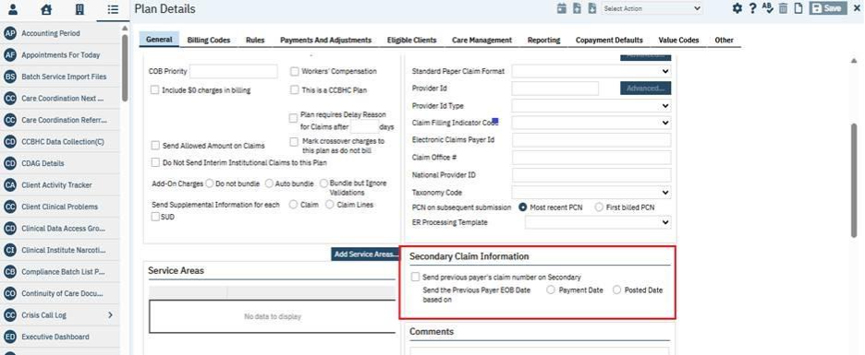
1. Send Previous Payer’s Claim Number on Secondary.
- This is a new checkbox, this will allow users to include the previous payer’s PCCN on secondary E-Claims when selected.
2. Send the Previous Payer EOB Date Based On: Two radio buttons have been added in this field:
- ‘Payment Date’ radio button: When this radio button is selected, the date from the ‘Payment Date’ field in the ‘Payments/Adjustments’ screen will be considered.
- ‘Posted Date’ radio button: When this radio button is selected, it will be considered as the existing functionality i.e., will pull from this field from the ARLedger table.
The Users can now select appropriate adjudication date on secondary claims, ensuring compliance with payer requirements and reducing the risk of timely filing denials.
Note: User can create a plan record with or without using the new section ‘Secondary Claim Information’.
Data Model Changes: A new column ‘SecondaryClaimSendPreviousPayerClaimNumber’ and
‘SecondaryClaimSendPreviousPayerEOBDate’’ included in ‘CoveragePlans table’.

Procedure/Rates

Reference No | Task No | Description
109 | Core Bugs # 128473 | Modified date was getting updated, when user processes the claim and modifies billing codes in Procedure and Plan

Author: Namratha Nagaraj

109. Core Bugs # 128473: Modified date was getting updated, when user processes the claim and modifies billing codes in Procedure and Plan.

Release Type: Fix | Priority: Medium

Navigation Path 1: Administration’ -- 'Procedures/Rates’ quicklink -- Click on ‘Procedure Name’ hyperlink -- ‘Procedure Code details’ -- Enter required details -- Click on ‘Rates/Billing codes’ -- Enter the required value in ‘Standard Billing code’ filed of ‘Standard Billing code’ section -- Click on ‘Insert’ button -- Click on ‘Save’ button.

Navigation Path 2:’Services’ quicklink -- My office’ -- Click on ‘New’button -- ‘Service Detail’ page -- Enter all the required details -- Click on ‘Save’ button.

Navigation Path 03: ‘My Office’ -- ‘Charges/Claims ’quicklink –- Select the ‘ChargeIds’ -- Click on ‘E-Claims’ button -- Click on ‘Process Now’ -- Click on ‘Create Claim File’.

Functionality ‘Before’ and ‘After’ release:

Before this release, here was the behavior. When a user processes the claim and modifies billing codes in Procedure and Plan, the modified date was also getting updated.

With this release the above-mentioned issue is resolved. When users process the claim again and modify billing codes in Procedure and Plan the modified date is not getting updated only billing code is getting updated.

Programs

Reference No | Task No | Description
110 | Core Bugs # 132232 | Program Assignments: Client Program enrollment and discharge records containing time values were not displayed on the Client Assignment list page

Author: Shivakanth Moger

110. Core Bugs # 132232: Program Assignments: Client Program enrollment and discharge records containing time values were not displayed on the Client Assignment list page.

Release Type: Fix | Priority: High

Navigation Path 1: Program Assignments ‘Program’ – 'Program Assignments’ list page.

Navigation Path 2: Program Assignments ‘Program’ – 'Program Assignments’ list page – 'New’ – Select any client – ‘Program Assignment Details’ page – Add ‘Enrolled Date’ and ‘Discharged Date’ field and its time – ‘Save’.

Navigation Path 3: Select client – ‘Programs (Client)’ – 'Programs’ list page – New – ‘Program Assignment Detail’ page – Add ‘Enrolled Date’ and ‘Discharged Date’ field and its time – ‘Save’.

Functionality ‘Before’ and ‘After’ release:

Before this release, here was the behavior. Users were unable to view Program entries on the Program Assignments list page, even though the client was enrolled in a program. This issue occurred when time values were included in the ‘Enrolled Date’ and/or ‘Discharged Date’ fields within the Program Assignment Details page.

With this release, the above-mentioned issue has been resolved. Now, explicit date casting has been implemented for the ‘Requested Date’,‘Enrolled Date’, and ‘Discharged Date’ fields. As a result, client program enrollment or discharge records that includes time components now appear correctly on the 'Program Assignments list page.

Provider contract

Reference No | Task No | Description
111 | Core Bugs # 132487 | Contracted Rates Details: Problem with a trailing space after a modifier.
Author: Renuka Gunashekaran

111. Core Bugs # 132487: Contracted Rates Details: Problem with a trailing space after a modifier.
Release Type: Fix | Priority: Medium
Navigation Path: 'My Office' -- 'Provider Contract' -- Select Provider Hyperlink -- 'Provider' -- 'Provider Contract' -- 'Contracts Rates’ icon' -- 'Contracted rates details' screen
Functionality ‘Before’ and ‘After’ release:
Before this release, when a user selected a billing code with modifiers (e.g., raki aa:bb) while creating a contract rate, the modifier values were saved with an unintended trailing space (e.g., Modifier 1 = 'aa ' and Modifier 2 = 'bb '). These trailing spaces led to issues during the generation of certain internal reports.
With this release, the above-mentioned issue has been resolved. Now, when billing code modifiers are selected while creating contract rates, any trailing spaces are automatically trimmed from the modifier values, ensuring clean data and preventing issues in report generation.

Reception

Reference No | Task No | Description
112 | EII # 130456 | MAT: The Toxicology screen flag icon is implemented in the Reception/Front Desk list page.
113 | EII # 131617 | Reception Flags: Display flags pop-up on mouse hover of the count instead of click event

Author: Niroop Hassan

112. EII # 130456 (Feature - 517904): MAT: The Toxicology screen flag icon is implemented in the Reception/Front Desk list page. {ACTIVE CHANGE}

Release Type: Change | Priority: High

Note: : This is an Active Change, with this implementation Toxicology Screen flag icon (represented by a vial image) is now displayed in the MAT column of the Reception/Front Desk list page for clients who have an active Toxicology Screen flag.
- Hovering over the icon displays a tooltip containing:
- The date and time of the most recent Toxicology Screen Flow Sheet .
- The name of the staff member who logged and saved the entry.
- Clicking the icon redirects the user to the Client Flag Details screen.

Pre-requisite:
1.’Toxicology Screen’ flag is to be present for a client via below path :
Select Client-Client Flags (Client)-Click on new icon-Client Flag Details screen-Select the type as ‘Toxicology screen’ -enter the required details-click on insert-Save.

2. The client must have a service entry which shows up on ‘Reception’ screen.

Navigation Path 1: ‘Administration’ – ‘MAT Configuration’ - ‘MAT Configuration’ page – Select the required ‘Flow Sheet’ template in the ‘Toxicology Screen Flow Sheet’ textbox within the ‘Toxicology Screen’ section – Click on ‘Save’ icon.

Navigation Path 2: Select the client – ‘Flow Sheet’ – Click on ‘New’ icon – ‘Client Template’ popup - Select the above ‘Flow Sheet’ template from the ‘Select Template’ dropdown and click on ‘Ok’ button – ‘New Entry Flow Sheet’ page – Select/Enter required data and click on ‘Save’ icon.

Navigation Path 3: ‘My Office’ – ‘Reception’ – ‘Reception’ list page – Click on the above client ‘Toxicology Screen’ flag icon on the ‘MAT’ column – ‘Client Flag Details’ screen.

Functionality ‘Before’ and ‘After’ release:

Before this release, The Toxicology Screen flag icon was not displayed in the MAT column of the Reception/Front Desk list page for clients who had an active Toxicology Screen flag.

With this Release, the Toxicology Screen flag icon has been implemented in the Reception/Front Desk list page.

1.The Toxicology Screen flag icon (vial image) will be displayed in the MAT column of the Reception/Front Desk list page, if the client has an active Toxicology Screen flag. On click of this icon, it will navigate the user to the Client Flag Details screen.

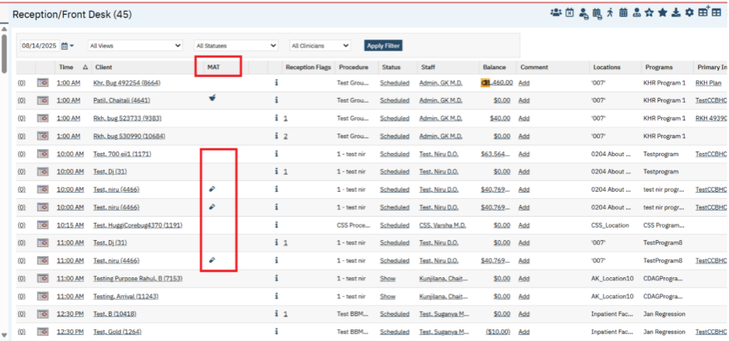

2.When the user hovers over the Toxicology Screen flag icon (vial image) on the Reception/Front Desk list page ,a tooltip displays with the date and time of the most recent Toxicology Screen Flow Sheet, along with the name of the staff member who logged and saved the entry.

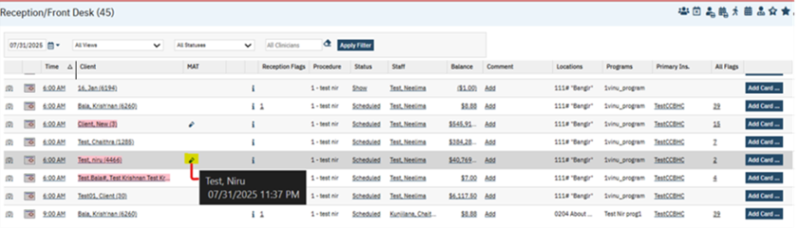

3.If there is no ‘Toxicology Screen’ flow sheet entry, no data will be displayed when hovers over on the ‘Toxicology Screen’ flag icon.

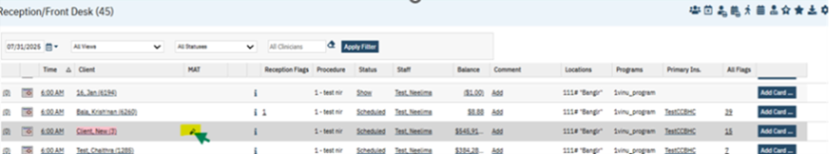

4. The specific flow sheet template will display the date, time, and staff name on hover over the ‘Toxicology Screen’ flag icon and it is determined by the value selected in the ‘Toxicology Screen Flow Sheet’ textbox in the ‘Toxicology Screen’ section under the ‘MAT Configuration’ page.

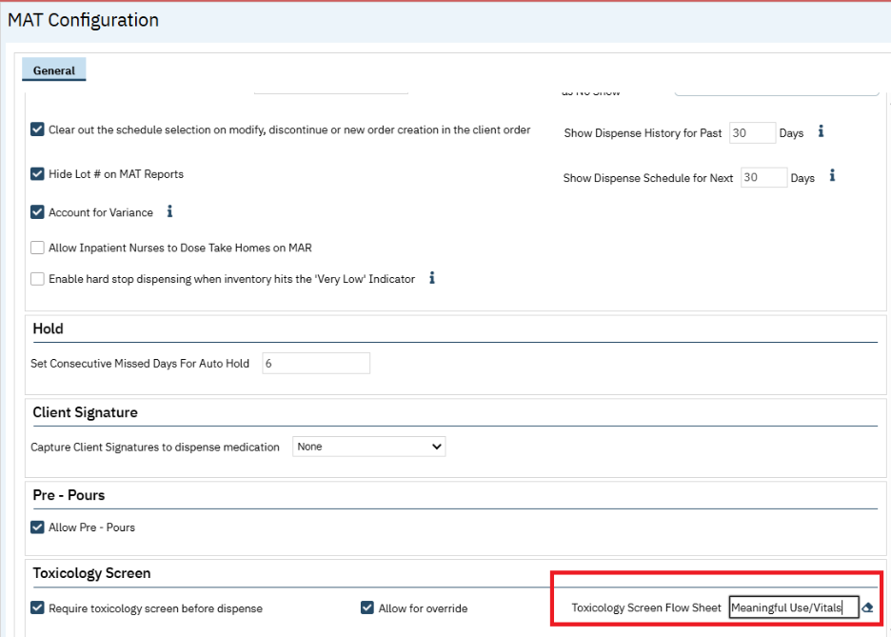

Author: Niroop Hassan

113. EII # 131617 (Feature - 548557): Reception Flags: Display flags pop-up on mouse hover of the count instead of click event.

Author: Niroop Hassan

Release Type: Change | Priority: Urgent

Note: This is a Passive Change. With this implementation, when the users mouse hover over the ‘Reception Flags’ or ‘All Flags’ count hyperlink on the ‘Reception/Front Desk’ screen, a pop-up with flag icons appears. It automatically closes when the cursor moves away. Earlier user needed to click the hyperlink and the information was displayed on opening the this screen.

Navigation Path: ‘My Office’– ‘Reception’ – ‘Reception’ list page – Mouse hover on ‘Reception Flags’ or ‘All Flags’ count hyperlink.

Functionality ‘Before’ and ‘After’ Release:
Before this release, when users navigated to the 'Reception/Front Desk’ screen and clicked the 'Reception Flags' or 'All Flags' count hyperlink, a flag pop-up appeared. Users had to manually close it by clicking the 'Close' icon.

With this Release, the following changes have been implemented in 'Reception/Front Desk’ screen.
- When user mouse hovers on ‘Reception Flags’ or ‘All Flags’ count hyperlink in 'Reception/Front Desk’ ’ screen the flag popup will open.
The flag pop is shown when mouse hovers on ‘All Flags’ count hyperlink.

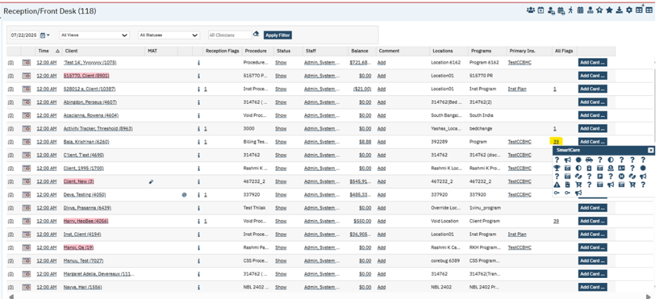

Showing flag pop when mouse hovers on ‘Reception Flags’ count hyperlink.

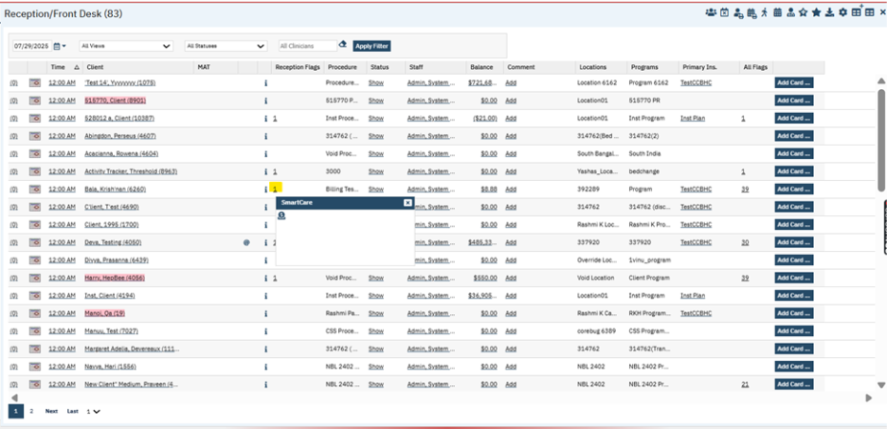

- The flag popup will automatically close when the mouse cursor moves away from it.

Role Definition

Reference No | Task No | Description
114 | Core Bugs # 132433 | In 'Role Definition' screen, the Permissions "Deny All" feature was not working properly.
Author: Niroop Hassan

114. Core Bugs # 132433: In 'Role Definition' screen, the Permissions "Deny All" feature was not working properly.
Navigation Path: ‘Administration’– ‘Role Definition’ - ‘Role Definition’ page – Select ‘Clinical Supervisor’ role and select ‘Image Associations’ as Permission Type and click on ‘Apply Filter’ button – Click on ‘Deny All’ button – Click on ‘Save’ icon – again select ‘Clinical Supervisor’ role and select ‘Image Associations’ as Permission Type and click on ‘Apply Filter’ button
Functionality ‘Before’ and ‘After’ Release:
Before this release, here was the behavior. In the Role Definition screen, for a Role when the user clicked on ‘Deny All’ button and clicked on Save, and again selected the same Role, the permission was granted for all the Permission Items.
With this release, the above-mentioned issue has been resolved. Now, for a Role when the user clicks on ‘Deny All’ button and clicks on Save, and again selects the same Role, the permission is denied for all the Permission Items and Deny All functionality is working as expected.

Rx Application

Reference No | Task No | Description
115 | Core Bugs # 131889 | Medication Management: Dosage & Instruction Updating Issue.
116 | EII # 130925 | Implemented the changes to display Surescripts Message ID on Outbound Prescriber Tab for Troubleshooting

Author: Rajgopal Yajurvedi

115. Core Bugs # 131889: Medication Management: Dosage & Instruction Updating Issue.
Release Type: Fix | Priority: Medium

Pre-Requisite:
User to prescribe the medication via below New Order path
Path: Login to SmartCare Application – Client Search – My Office – Medications – Rx application – Start Page – Patient Summary – New Order button – New Medication Order Page - Select the Drug with starting three letters – Fill all required fields – click on ‘Insert’ button - Search and Select multiple medication - Select the different values - insert the medications – Click on ‘Prescribe’ button – Prescribe page – Click on ‘Prescribe’ button - ‘Patient Summary’ page

Navigation Path : Re-Order Path - Login to SmartCare Application – Client Search – My Office – Medications – Rx application – Start Page – Patient Summary – Select the medication in medication list - Click Re-Order button – Re-Order Medication Page - Select the radio button – Switch to other medication radio rapidly – Click on ‘Modify’ button – instructions are not updated - Click on ‘Prescribe’ button – Prescribe page – Click on ‘Prescribe’ button - ‘Patient Summary’ page

Functionality ‘Before’ and ‘After’ release:

Before this release, here was the behavior. In the Rx Application, on the Re-Order Medication page, when the medication list contains multiple entries, if the user rapidly switches between radio buttons and then clicked the Modify button, the medication instructions and dosage values were incorrectly updated. Specifically, the selected medication's details were overwritten and displayed the instructions and dosage of a different medication, leading to inconsistent and incorrect data being shown.

With this release, the above issue is fixed. Now in the Rx Application, on the Re-Order Medication page, when the user rapidly switches between radio buttons and then clicks the Modify button, the medication instructions and dosage values are now correctly updated to reflect the original prescription values of the selected medication. This resolves the previous issue where values were incorrectly overwritten with data from other medications.

Author: Manjunath Malipatil

116. EII # 130925 (Feature - 540393): Implemented the changes to display Surescripts Message ID on Outbound Prescriber Tab for Troubleshooting.

Note: This is Passive Change.

Release Type: Change | Priority: Urgent

Prerequisite: The data is added in the ‘Outbound Prescriptions’ tab especially Electronically prescribed medication entries.

Navigation Path: ‘My Office’ -- Medication Management -- Start Page (Rx Application) -- Click on ‘Outbound Prescriptions’ Tab

Purpose: To support easier troubleshooting of SureScripts transactions Implemented the SureScripts Message ID on the Outbound Prescriber tab. This identifier will help teams trace specific messages, investigate issues, and validate communication with SureScripts more efficiently.

Functionality ‘Before’ and ‘After’ release:

Before this release, here was the behavior. A ‘Message ID’ column was not there in the ‘Outbound Prescriptions’ tab in the Start Page of RX Application.

With this release, a new column called ‘Message ID’ has been added in the ‘Outbound Prescriptions’ tab in the Start Page of RX Application.

The ‘Outbound Prescriptions’ tab now displays the Surescripts Message ID, allowing users to easily trace individual transactions. This enhancement improves transparency, simplifies troubleshooting, and helps validate communication with Surescripts more efficiently.

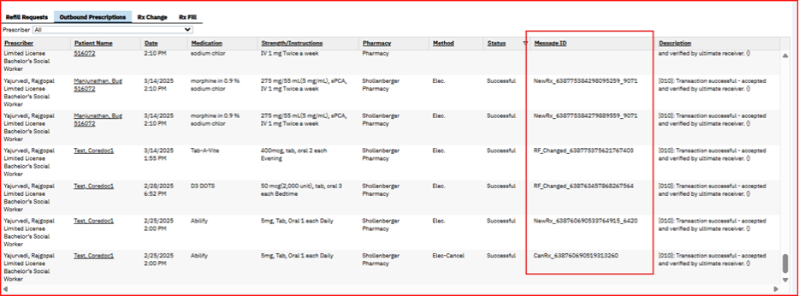

If any prescription fails, it would be easier for the team to investigate the issue and effectively communicate with the Surescripts to get the resolution.

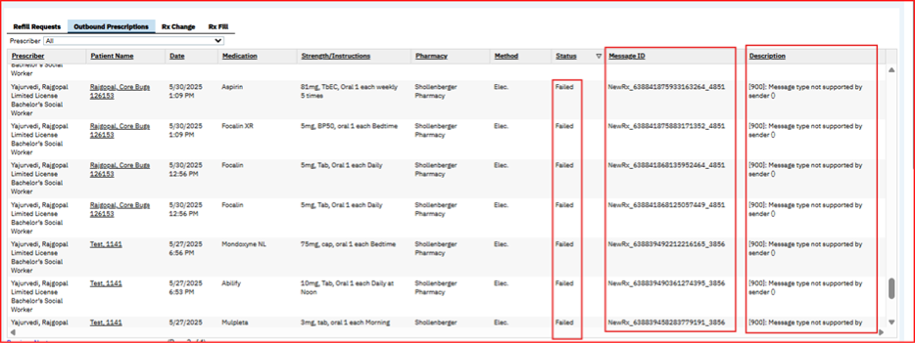

Scanning

Reference No | Task No | Description
117 | Core Bugs # 132302 | Scanning- All Associations filter in the Scanning (My Office) list page is not displayed all associations related documents.
118 | Core Bugs # 132426 | Scanning: Scanned Medical Records Loading/Processing Error.

Author: Tejaswini Srinivas

117. Core Bugs # 132302: Scanning- All Associations filter in the Scanning (My Office) list page is not displayed all associations related documents.

Release Type: Fix | Priority: High

Navigation Path : ‘My office’ -- ‘Scanning’ -- ‘Scanning’ list page -- ‘Scan/Upload’ an Image – Select ‘Client Coverage Plan/ Payment EOB/Provider Authorizations/Authorization Documents for ‘Association with’ --- Save the record --- Select Association as “All Associations” and Scanned Status as “Not Completed,” and click on the ‘Apply Filter’ button.

Functionality ‘Before’ and ‘After’ release:
Before this release, here was the behavior. In the ‘Scanning’ list page, whenever the user filtered with Association as “All Associations” and Scanned Status as “Not Completed”, the list page was not displaying documents for all associations as expected for documents related to the ‘Client Coverage Plan’, ‘Payment EOB’, ‘Provider Authorizations’, and ‘Authorization Documents’ in the ‘Scanning List page’.

With this release, the above-mentioned issue has been resolved. Now, In the ‘Scanning’ list page, when the user filters with Association as “All Associations” and Scanned Status as “Not Completed”, the Scanning List page is correctly displaying the relevant documents in the ‘Scanning List page’.

Author: Shivakanth Moger

118. Core Bugs # 132426: Scanning: Scanned Medical Records Loading/Processing Error.

Release Type: Fix | Priority: Medium

Navigation Path: Scanning (My Office) – ‘Scanned Medical Records’ list page -- click on Created hyperlink for incomplete status
Functionality ‘Before’ and ‘After’ Release:
Before the release, here was the behavior. Users were unable to open scanned or uploaded medical records with an Incomplete status from the Scanned Medical Records page. The screen would remain in a loading state
With this release, the above-mentioned issue has been resolved. Now, the users can access the Upload File Detail page without any loading issues.

Services

Reference No | Task No | Description
119 | Core Bugs # 132307 | Client Name was not Filtered by Status chosen from the ‘Show Only Active Clients’ checkbox on Services Screen.
120 | Core Bugs # 132292 | Services: Validation for Disposition only staff and Work Group displayed when navigating back to Services from unsaved changes
121 | EII # 131598 | Case Rate Component Service Completion Validation is implemented.
122 | Core Bugs # 132342 | Duplicate Diagnoses are initializing to Billing Diagnosis tab.
123 | Core Bugs # 132575 | The ‘IC Cancellation’ reason appeared in the 'Cancel Reason' dropdown list for ‘Service Detail’, ‘Service Note’, and ‘Group Service Detail’ pages.
124 | Core Bugs # 132513 | Service/Notes screen: Invalid validation message displayed when the selected procedure did not allow decimal values.

Author: Niroop Hassan

119. Core Bugs # 132307: Client Name was not Filtered by Status chosen from the ‘Show Only Active Clients’ checkbox on Services Screen.

Release Type: Fix | Priority: Medium

Navigation Path: ‘My Office’ – ‘Services’ – ‘Services’ list page – Uncheck ‘Show Only Active Clients’ checkbox – Select required Inactive Client in ‘Client Name’ textbox and click on ‘Apply Filter’ button.

Functionality ‘Before’ and ‘After’ Release:

Before this release, the user was able to search and only select active clients in the ‘Client Name’ textbox, even when the ‘Show Only Active Clients’ checkbox was unchecked.

With this release, the above-mentioned issue has been resolved. Now, when the ‘Show Only Active Clients’ checkbox is unchecked, both active and inactive clients can be searched and selected from the ‘Client Name’ textbox.

Author: Chaitra Kunjilana

120. Core Bugs # 132292: Services: Validation for Disposition only staff and Work Group displayed when navigating back to Services from unsaved changes.

Release Type: Fix | Priority: Medium

Prerequisite:

System configuration key “TurnOnCareCoordinationWorkflow” value is set to Yes

Navigation Path: Client – Services – Enter the required values – Save – Enter the values in Disposition tab – Navigate to Configuration Keys – Change the “TurnOnCareCoordinationWorkflow” key value to No – Navigate back to Services -- Save

Functionality ‘Before’ and ‘After’ release:
Before this release, when user created a Service by adding the Assigned staff and work group in the Disposition tab and without saving the Service turned off the “TurnOnCareCoordinationWorkflow” Configuration key and navigated back to Services from unsaved changes and on clicked on Save button, the below validation message was displayed.

Validation Message: "Disposition-Only Staff or Work Group can be selected at a time"

With this release, the above-mentioned issue is fixed. Now user can save the service without the above mentioned validation message when “TurnOnCareCoordinationWorkflow” Configuration key is turned off.

Author: Debanjit Das

121. EII # 131598 (Feature - 546861): Case Rate Component Service Completion Validation is implemented.

Note: This is a Passive change.

Release Type: Enhancement | Priority: Urgent

Navigation Path 1: ‘Administration’ – ‘Case Rate’ – ‘Case Rate List’ page -- click on ‘New’ icon – ‘Case Rate Details’ screen.

Navigation Path 2: Client -- ‘Services’ -- ‘Services’ list page -- Click on new icon -- ‘Service Detail’ screen.

Purpose: 'This validation will allow customers the opportunity to review and determine if multiple case rates should be created in the event that the same component service would be included in multiple case rates to prevent double billing of component services.

Functionality ‘Before’ and ‘After’ release:

Before this release, a service completion error was not included when component services results in more than one case rate services.

With this release, a service completion error has been implemented to prevent service completion of case rates when a component service qualifies for the creation of more than one case rate.

The service completion error will be displayed based on the logic below:

- If the component services for a client result in more than one Case Rate being generated, then the system will now display the below service completion error:
Error Message: "One or more component services included in more than one Case Rate."

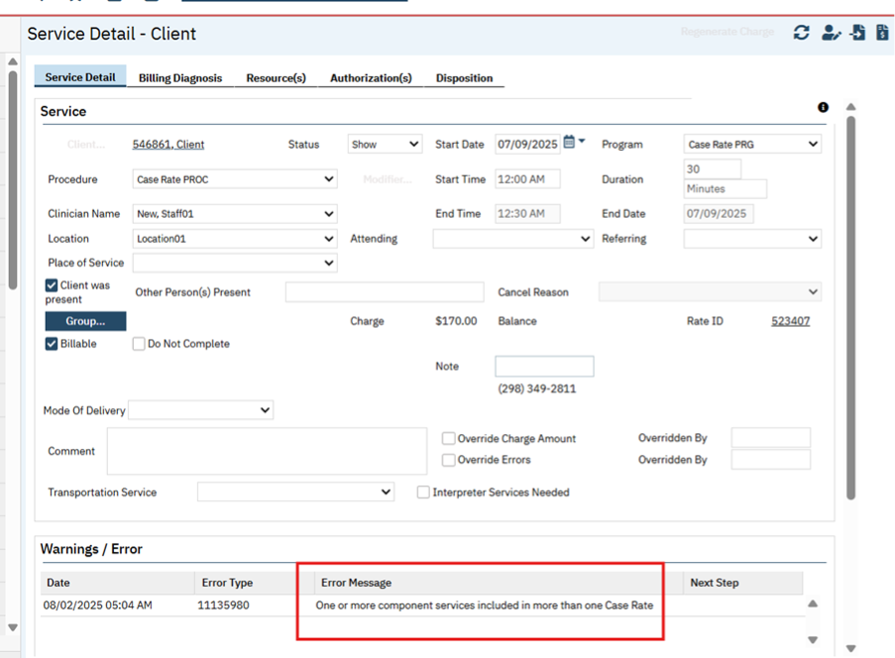

- This error will appear for each of the Case Rate service generated. If the creation of both the Case Rate services is correct, the customer can override this validation by checking the ‘Override Errors’ checkbox in the ‘Service Detail’ screen, and the system will follow existing functionality.

- Additionally, if the creation of only one Case Rate is correct, then on the service that is not desired to be billed, the customer should mark the service as not billable via removal of the ‘Billable’ checkbox on the ‘Service Detail’ screen. Once unchecked, the validations on the remaining services will be cleared during the overnight service completion job step.

- If the component services for a client result in a single Case Rate being generated, then the system will follow existing functionality i.e., no service completion error and the case rate service will be completed successfully.

Data Model changes: A new table 'CaseRateComponentServices' is created.

Author: Chaithra Kunjilana

122. Core Bugs # 132342: Duplicate Diagnoses are initializing to Billing Diagnosis tab.

Release Type: Fix | Priority: Medium
Navigation Path: Client – Services/Notes – New - Select the Procedure related to Psychiatric note -- Enter the required values – Save – Billing Diagnosis Tab – Refresh -- Navigate to Note tab – Enter the required values – Sign

Functionality ‘Before’ and ‘After’ release:

Before this release, here was the behaviour. when the configuration key BILLABLEDIAGNOSISONLY was set to 'Y', signing the initial version of a Psychiatric note with the "No Diagnosis" option selected in the diagnosis tab removed all diagnoses. If subsequent versions of the note were signed after re-adding the same diagnosis code, the Billing Diagnosis tab displayed duplicate entries—even though only one billable and active diagnosis record existed.

With this release, the above-mentioned issue has been resolved. Now, when the configuration key BILLABLEDIAGNOSISONLY is set to 'Y', signing the initial version of a Psychiatric note with "No Diagnosis" selected correctly removes all diagnoses. If the same diagnosis code is re-added and signed in subsequent versions of the note, the Billing Diagnosis tab now displays only a single billable and active record, eliminating the issue of duplicate entries.

Author: Niroop Hassan

123. Core Bugs # 132575: The ‘IC Cancellation’ reason appeared in the 'Cancel Reason' dropdown list for ‘Service Detail’, ‘Service Note’, and ‘Group Service Detail’ pages.

Release Type: Fix | Priority: Medium

Navigation Path 1: ‘Client’ – ‘Services’ – ‘Services’ list page – Click on required Scheduled status ‘DOS’ hyperlink – ‘Service Detail’ page – Change the status from ‘Scheduled’ to ‘Cancel’ - Click on ‘Cancel Reason’ dropdown.

Navigation Path 2: ‘Client’ – ‘Services/Notes’ – ‘Services/Notes’ list page – Click on required Scheduled status ‘DOS’ hyperlink – ‘Service Note’ page – Change the status from ‘Scheduled’ to ‘Cancel’ - Click on ‘Cancel Reason’ dropdown.

Navigation Path 3: ‘My Office’ – ‘Groups’ - ‘Groups’ list page – Click on required Group Name hyperlink – ‘Group Details’ page – Enter required data and click on ‘Save’ icon – Click on ‘Schedule’ tab – Click on ‘New Group Service’ button – ‘Group Service Client’ Popup – Select required data and click on ‘Select’ button – ‘Group Service Detail’ page - Change the status from ‘Scheduled’ to ‘Cancel’ - Click on ‘Cancel Reason’ dropdown.

Functionality ‘Before’ and ‘After’ Release:
Before this release, when the user selected the ‘Cancel Reason’ dropdown on the ‘Service Detail’, ‘Service Note’, and ‘Group Service Detail’ pages, the reason ‘IC Cancellation’ appeared in the 'Cancel Reason' dropdown list.

With this release, the above-mentioned issue has been resolved. Now, the ‘IC Cancellation' reason no longer appears in the 'Cancel Reason' dropdown list on the 'Service Detail', 'Service Note', and 'Group Service Detail' pages.

Author: Suganya Sivakumar

124. Core Bugs # 132513: Service/Notes screen: Invalid validation message displayed when the selected procedure did not allow decimal values.
Prerequisites: The ‘Code Information Allow Decimals (2 places)’ checkbox is not checked in the ‘General’ tab of the ‘Procedure Code Details’ screen.
Navigation Path: 'Client' Search --- Select a Client --- Navigate to 'Services/Notes' Quicklinks --- 'Client' --- 'Service/Note List Page' --- Click on 'New' Icon --- 'Service Note Detail' page --- Select 'Prog/Proc/Loc' values --- Enter all required fields --- Click on 'Save' icon --- Click on 'Sign' button
Functionality ‘Before’ and ‘After’ release:
Before this release, here was the behavior. In the ‘Service/Notes’ screen, when the selected procedure did not allow decimal values, the following validation message was displayed:
Validation Message: “Decimal values are not allowed for duration”
With this release, the above-mentioned issue has been fixed. Now, The validation message has been updated to:
Validation Message: “The selected procedure code is configured to only accept whole numbers in the Duration field" in the service/notes”
This ensures that the selected procedure allows only whole numbers in the ‘Duration’ field.

Services from claims

Reference No | Task No | Description
125 | Core Bugs # 132167 | Service From Claim - Services From Claims "All" hyperlink is Not Working.

Author: Renuka Gunasekaran

125. Core Bugs # 132167: Service From Claim - Services From Claims "All" hyperlink is Not Working.
Release type: Fix | Priority: Medium
Navigation Path: 'My Office' - 'Services from claims' - ‘All' hyperlink - 'Create Service'
Functionality Before and After releases:
Before this release, here was the behavior. "All" hyperlink was not working in Services from Claims screen
With this release, the above-mentioned issue has been resolved. Now, the 'All' hyperlink is working Properly, and on clicking All hyperlink selects all claims and process all the claim lines in the Services from Claims screen.

Services / Notes

Reference No | Task No | Description
126 | Core Bugs # 132221 | The Service/Notes detail screen remains in processing mode when the program is selected first.
127 | Core Bugs # 132519 | User is unable to ‘Sign’ an ‘Encounter Form’ in a service note using ‘Signature Pad’ device in the first attempt.
128 | Core Bugs # 132351 | Service/Notes - Add/View additional staffs added in the popup are not listing in calendar.
129 | Core Bugs # 132418 | Psychiatric Note – Displayed INSERT Statement conflict Errors on Services on sign
130 | Core Bugs # 132251 | When diagnosis is changed in ‘Psychiatric Note’, new dx does not carry into future services
131 | Core Bugs # 132579 | Psychiatric Note: Multiple radio buttons are being selected under ‘Thought Content and Process; Cognition’ portion of the ‘Psychiatric Note’ PDF
132 | EII # 131696 | Changes are implemented to Initialize the Goals and Objectives from the latest ISP to the Service Notes based on the Config Key value set.

Author: Suganya Sivakumar

126. Core Bugs # 132221: The Service/Notes detail screen remains in processing mode when the program is selected first.

Release Type: Fix | Priority: Medium
Pre-requisite:
The Configuration key ServiceNoteDoNotDefaultDate value is set to Y.
Navigation Path: Perform Client Search - Select Client -Navigate to Services/Notes- Client- Click on New icon-Service/Note Detail Page-Select Program/ Procedure / Location -Select Start Date -Enter all required fields- Click on Save icon -Sign the service note.
Functionality ‘Before’ and ‘After’ release:
Before this release, here was the behavior. In the Service Note Detail screen, when the Program was selected first without entering the Start Date of the service, there was endless processing, and the screen became unresponsive.
With this release, the above-mentioned issue has been fixed. Now, when the Program/ procedure/ location values are selected first without entering the start date of the service, there is no Processing delays.
Data Model Changes: No

Author: Ashish Priyadarshi

127. Core Bugs # 132519: User is unable to ‘Sign’ an ‘Encounter Form’ in a service note using ‘Signature Pad’ device in the first attempt.

Release Type: Fix | Priority: Medium
Prerequisites: The ‘Encounter Form’ tab is enabled in the ‘Services/Notes’ screen through the Path:
‘Administration’ – ‘Document Codes’ -- ‘Document Codes’ list page – Search and select any associated note -- Click on ‘Document Name’ hyperlink – Select the ‘Yes’ radio button for the ‘Service Note’ and ‘Save’ the screen – Select ‘Yes’ radio button for ‘Show Encounter Form’.
Navigation Path: ‘Administration’ – ‘Document Codes’ -- ‘Document Codes’ list page – Search and select any associated note -- Click on ‘Document Name’ hyperlink – Select the ‘Yes’ radio button for the ‘Service Note’ and ‘Save’ the screen – Select ‘Yes’ radio button for ‘Show Encounter Form’.
Navigation Path 2: 'Client' search - ‘Services/Notes’ -- 'Services/Notes' list page – Click on ‘New’ icon – Select a ‘Program’ and ‘Procedure’ in ‘Service Note’ screen – Click on ‘Encounter Form’ tab – Click on ‘Save’ button – Click on ‘Sign’ button in the ‘Client Signature’ section – By default ‘Signature Pad’ radio button will be selected in ‘Client Signature’ pop-up window – Connect the ‘Signature Pad’ device with system and ‘Sign’ – Click on ‘Preview’ button and see the signed preview in the pop-up window.
Functionality ‘Before’ and ‘After’ release:
Before this release, users were unable to sign the Encounter Form on the first attempt using the Signature Pad device when clicking the ‘Sign’ button in the ‘Client Signature’ section of the ‘Encounter Form’ tab under ‘Service Note’.
With this release, the issue has been resolved. Users can now successfully sign the ‘Encounter Form’ on the first attempt using the ‘Signature Pad’ device in the ‘Service Note’.

Author: Chaithra Kunjilana

128. Core Bugs # 132351: Service/Notes - Add/View additional staffs added in the popup are not listing in calendar.

Release Type: Fix | Priority: Medium

Navigation Path: ‘Client’ search – ‘Services/Notes’ – Enter the required values – ‘Save’ – Click on the ‘Menu’ option – Select the ‘Add/View Additional staff’ -- Enter the timings of additional staff as per the service time -- Navigate to ‘Staff Calendar’ screen -- Filter with Additional staff.

Functionality ‘Before’ and ‘After’ release:

Before this release, when a user created a service and added additional staff, the ‘Calendar’ screen did not display the Service entry for the additional staff when filters were applied.

With this release, the above issue has been resolved. The ‘Calendar’ screen will now correctly display service entry for additional staff when filters are applied.

Data Model changes: No

Author: Kiran Yogendra

129. Core Bugs # 132418: Psychiatric Note – Displayed INSERT Statement conflict Errors on Services on sign.
Release Type: Fix | Priority: On Fire

Navigation Path: Open a client – Go to ‘Services/Notes’ - New - Select the Procedure Code associated with ‘Psychiatric Note’ – Enter all the required values – Navigate to the ‘Note’ tab – Enter all the required details – Navigate to ‘MSE’ tab – Enter all the required details – Enter all the required tabs details – Click on Sign button – Check if any red errors displayed – Sign the Note - View the PDF.

Functionality ‘Before’ and ‘After’ Release:

Before this release, here was the behaviour. When signing the Psychiatric Note, for some of the clients, the system was displaying the ‘The INSERT statement conflicted with the CHECK constraint’ and ‘The INSERT statement conflicted with the FOREIGN KEY constraint’ red errors.

With this release, the above-mentioned issue has been resolved. Now, users are able to sign the Psychiatric Note successfully without any errors.

Author: Chaithra Kunjilana

130. Core Bugs # 132251: When diagnosis is changed in ‘Psychiatric Note’, new dx does not carry into future services.
Release Type: Fix | Priority: Medium

Navigation Path: ‘Client’ search – ‘Services/Notes’ – Click on ‘New’ icon – Enter the required values and select the Procedure related to ‘Psychiatric Note’ – ‘Save’ – ‘Note’ tab – Add Diagnosis in ‘Diagnosis’ tab – ‘Save’ – ‘Sign’ – create ‘Recurring Service’ – Select the ‘Recurrence Service’ -- Navigate to ‘Service Details’ Screen – Go to ‘Billing Diagnosis’ tab – Refresh Diagnosis.
Functionality ‘Before’ and ‘After’ release:
Before this release, when the user tried to sign the ‘Psychiatric Note’ by adding the new diagnosis in the ‘Diagnosis’ tab and created a ‘Recurring Service’, the newly added ‘Diagnosis’ was not copied/refreshed to the ‘Billing Diagnosis’ tab in the ‘Service Detail’ screen of ‘Recurring Service’.
With this release, the above-mentioned issue has been resolved. Now, ‘Billing Diagnosis’ will not be assigned during the creation of recurring scheduled services. Instead, it will populate only when the service status is updated to "Show" or modify the 'date of service' or Program change or the ‘Refresh Diagnosis’ hyperlink is clicked

Author: Kiran Yogendra

131. Core Bugs # 132579: Psychiatric Note: Multiple radio buttons are being selected under ‘Thought Content and Process; Cognition’ portion of the ‘Psychiatric Note’ PDF.

Release Type: Fix | Priority: Medium

Navigation Path: ‘Client’ -- ‘Services/Notes’ -- ‘Services/Notes’ list Page -- Click on New icon -- Select the Procedure Code associated with the ‘Psychiatric Note’ -- Enter all the required values -- Navigate to the ‘Note’ tab -- MSE tab -- ‘Mental Status Exam’ section -- ‘Thought Content and Process; Cognition’ sub tab -- Enter all the required details -- Click on Save button.

Functionality ‘Before’ and ‘After’ Release:

Before this release, here was the behavior. In the ‘MSE’ tab of the ‘Psychiatric Note’, when the user selected only ‘WNL’ radio button within the ‘Mental Status Exam’ section and signed the Note, both ‘WNL’ and ‘Unable to Assess’ radio buttons being selected and displayed in the ‘Thought Content and Process; Cognition’ portion of the ‘Psychiatric Note’ PDF.

With this release, the above-mentioned issue has been resolved. Now, the only selected radio button under ‘Thought Content and Process; Cognition’ portion of Psychiatric Note ‘MSE’ tab is displayed in the signed the ‘Psychiatric Note’ PDF.

Screenshot to display the selected radio button in the ‘Thought Content and Process; Cognition’ section.

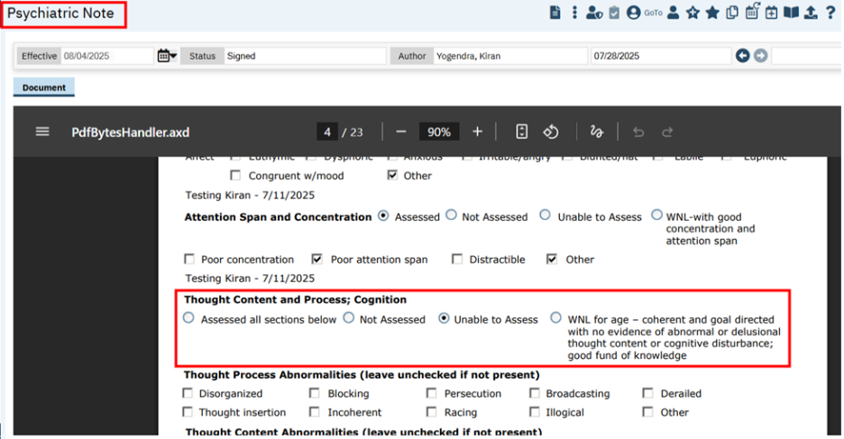

Author: Navyashree Jois

132. EII # 131696 (Feature - 553150): Changes are implemented to Initialize the Goals and Objectives from the latest ISP to the Service Notes based on the Config Key value set.
Note: This is Passive Change.
Release Type: Change | Priority: On Fire
Prerequisite: An ‘Individualized Service Plan’ is signed with valid Goals and Objectives.
Navigation Path 1: Administration -- Configuration Keys -- Search and click on
‘InitializeGoalsAndObjectivesBasedOnProcedureCode’ -- Configuration Key Details
Navigation Path 2: Client -- ‘Services/Notes’ -- ‘Services/Notes’ list page -- Click on New -- ‘Service Note’ -- Select ‘Procedure’ associated with ‘Misc G/O’ Note or ‘Psychiatric Note’ -- Enter the required values -- Go to ‘Note’ tab -- Objectives Addressed by this Service (for Psych Note its under ‘Psychotherapy’ tab) -- Enter the required values – Click on ‘Sign’.
Navigation Path 3: My Office -- ‘Groups’ -- ‘Groups’ list page – Click on New – ‘Group Details’ screen -- Enter the required fields in the ‘General’ tab – Select the ‘Group Note’ associated with ‘Misc G/O’ Note -- Go to ‘Schedule’ tab -- Click on ‘New Group Service’ button -- Schedule the Service -- Add the Staffs & Clients in the Service tab -- Update Service Information under ‘Services’ tab -- Add Diagnosis under ‘Billing Diagnosis’ tab -- Go to ‘Note’ tab -- Add the Group Summary under ‘Group Note’ -- Click on ‘Update My Client Note’ -- Go to ‘Client Note’ -- Enter the required fields -- Objectives Addressed by this Service -- Click on Sign My Notes -- Sign the Group Note.
Purpose: A System Configuration Key is introduced that governs how Goals and Objectives are initialized into the common user control of Service Notes. This key determines whether the Goals and Objectives are initialized from the latest Individualized Service Plan (ISP) while creating Service Notes.
Functionality ‘Before’ and ‘After’ release:
Before this release, here was the behavior. The Goals and Objectives were not initialized into the Note based on the Procedure Code associated with that Service Note.
With this release, a new System Configuration Key called ‘InitializeGoalsAndObjectivesBasedOnProcedureCode’ has been implemented. The initialization of Goals and Objectives from the latest Individualized Service Plan (ISP) into the Service Note is handled by this newly introduced Configuration key.
New Configuration Key Details:
System Config Key: InitializeGoalsAndObjectivesBasedOnProcedureCode
Read Key as: Initialize Goals And Objectives Based On Procedure Code.
Allowed Values: Yes, No
Default Value: No
Modules: SCM Clinical 2/Service Notes
Description: This is a new feature being added to the core product by introducing a System Configuration Key for the Goals and Objectives core common user control.
For any Service Note, where the Goals and Objectives core common user control is used, the initialization takes place as follows.
- If the Key value is set to "No", the Goals and Objectives will be initialized from the latest signed ISP but not based on the Procedure Code as per the existing functionality which is the default behavior.
- If the Key value is set to "Yes", the Goals and Objectives will be initialized from the latest signed ISP based on the Procedure Code.
Note:
- This functionality will not impact any Documents using this core common user control for Goals and Objectives initialization because, for Documents, there is no Procedure Code Concept.
- Existing functionality of pulling the Goals and Objectives based on the program if Vary Care Plan by Program is set up and retained.
- If by chance the value of the key is updated with any value apart from the allowed values, the system will consider the default behavior, i.e. same as the value "No".
Initialization of Goals and Objectives to the Service Notes when Config key value is set as ‘No’:
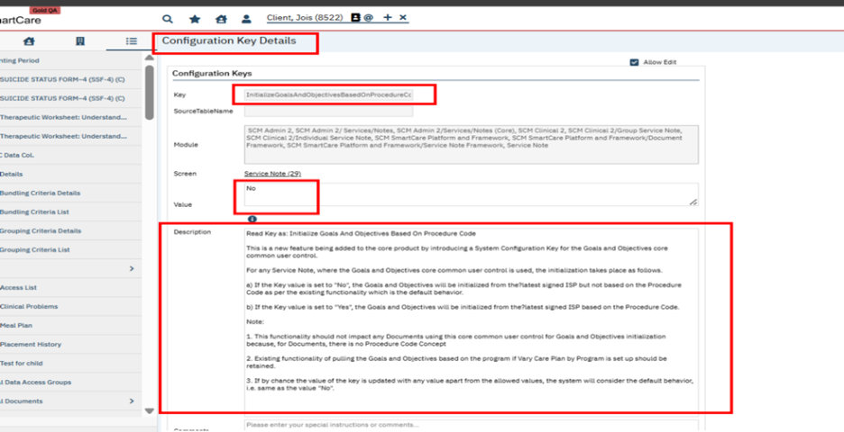

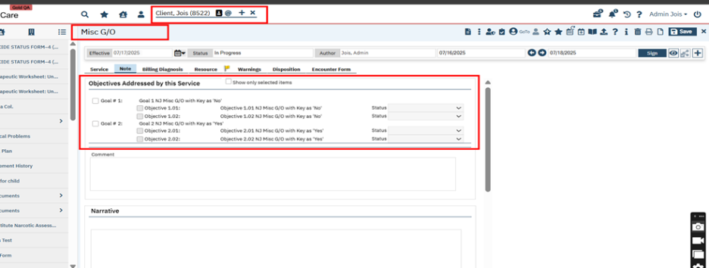

Screenshot for showing selected Goals and Objectives displayed in signed Service Notes PDF:
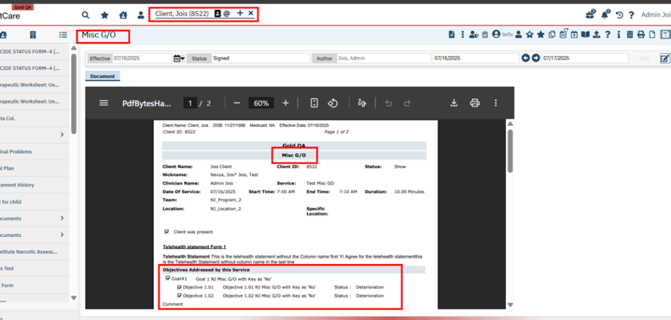

Screenshot for showing config key ‘InitializeGoalsAndObjectivesBasedOnProcedureCode’ is set as ‘Yes’:
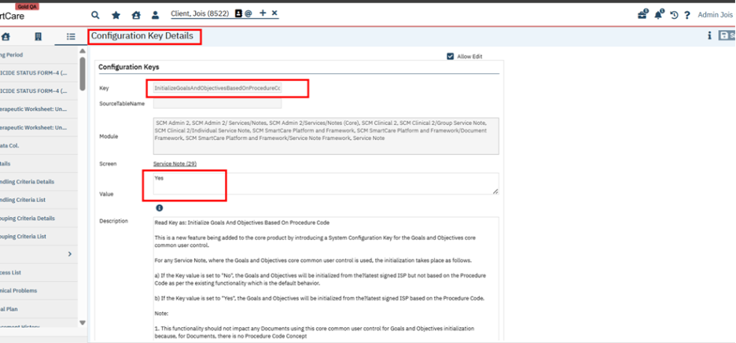

Screenshot to show Objectives mapped to Interventions in the ISP:
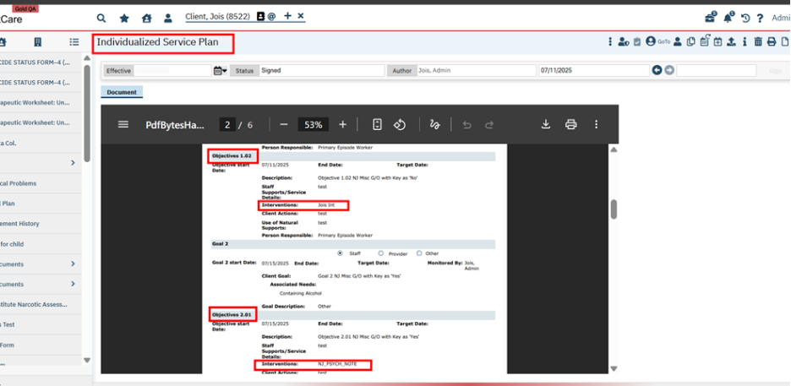

Screenshot to show Procedures mapped to Interventions:
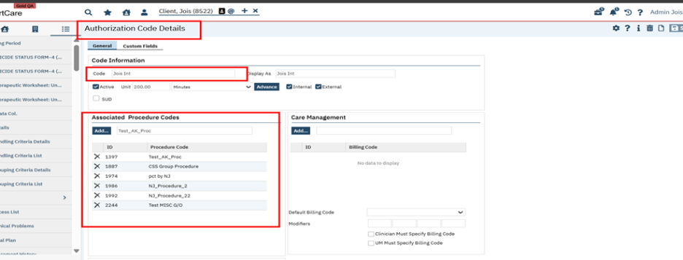

Screenshot for showing initialization of Goals and Objectives to the Service Notes when Config key value is set as ‘Yes’:
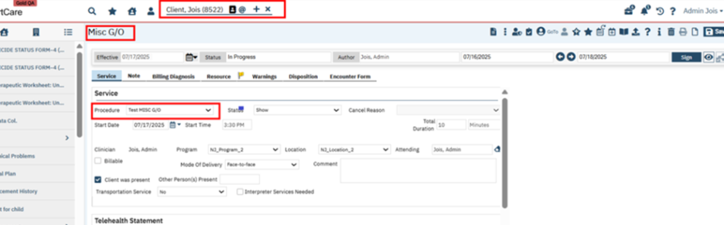

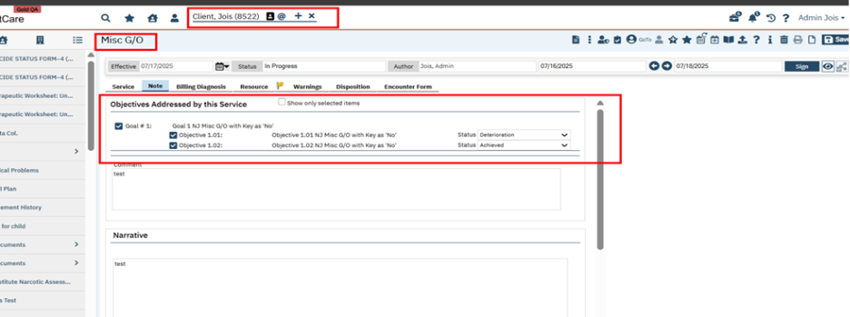

Screenshot for showing initialization of Goals and Objectives to the Group Service Notes when Config key value is set as ‘Yes’:
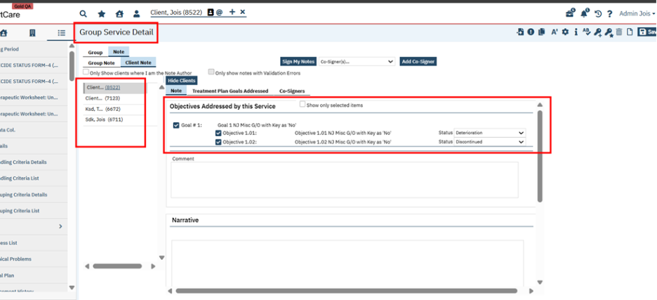

Screenshot for showing Goals and Objectives is not initialized when other procedure is selected (Not mapped to any interventions) when the Config key is set to ‘Yes’:

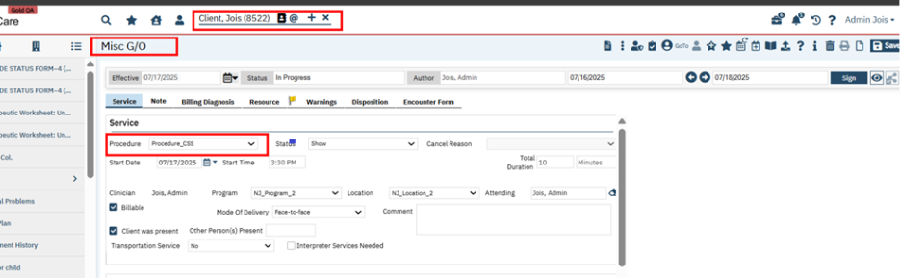

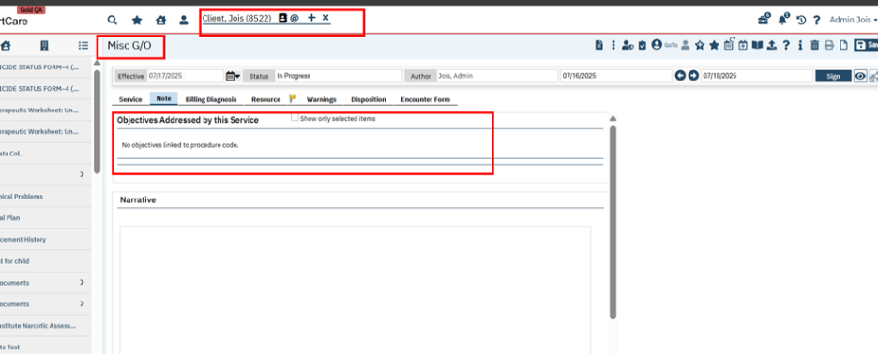

Signature Popup

Reference No | Task No | Description
133 | EII # 130759 | Implemented Saved Signature radio button in Signature Popup.

Author: Akshay Vishwanath

133. EII # 130759 (Feature - 532360): Implemented Saved Signature radio button in Signature Popup. {ACTIVE CHANGE}

Note: This is a Active change
Release Type: Change | Priority: Urgent
Purpose: This enhancement adds the ability to apply a saved physician signature upon signing the following types:
- Document
- Service Note
- Group Services

Prerequisite:

To enable and display the Saved Signature radio button in the Signature Popup, staff must first upload their signature image or electronic signature using one of the following navigation paths:

1: Go search – ‘Staff/User (Administration)’- Select the required staff – Click on ‘Staff Preference’ Tab – ‘Staff Signature’ section – Click on Upload Signature Image - Select Required Image and Upload or Click on Upload Signature Electronic – Capture the Signature either through Signature Pad or Mouse/Pad.
2: Go search – ‘My Preferences (My Office)- ‘Staff Signature’ section – Click on Upload Signature Image - Select Required Image and click on Upload or Click on Upload Signature Electronic – Capture the Signature either through Signature Pad or Mouse/Pad

Workflow:
Navigation Path1: Client – Select any Document – Fill all the required Information – Click on Sign

Navigation Path2: Client -- Go search -- Service/Notes(Client) -- click on New icon --Service Note - Fill all the required Information – Click on Sign

Navigation Path3: Manage Groups/Groups -- Enter the Required values -- Select the Group Note -- Add Client -- Logged in Staff -- Save -- Navigate to Scheduled tab -- Click on New Group Services button -- Enter the Date and select the client and click Ok--In Group Service Detail screen -- Navigate to Group Services tab -- Change the status to Show -- Save -- Group Note tab --Enter the required details --Update My Client Notes -- Go to Client Note tab -- Enter the required values – Sign

Functionality ‘Before’ and ‘After’ release:

Before this release, there was no "Saved Signature" radio button on the Signature Popup.

With this release, a new "Saved Signature" radio button option has been introduced in the Signature Popup.

This enhancement includes the following functionality:

- Automatic Retrieval:
When the Saved Signature radio button is selected, the system will automatically fetch and display the staff member’s saved signature image from:
Staff Details → Staff Preferences → Staff Signature.

- Clear Button Behaviour:
If the Saved Signature radio button is selected, clicking the Clear button will not remove the saved signature image from the popup. This ensures that the saved signature remains intact unless another input method is chosen.

- Scope of Implementation

This feature applies consistently across:
- Staff Signatures
- Staff Co-signatures
- Reviewer Staff Signatures

Note:
- The signature image must be present in the ‘Staff Preference’ tab within the Staff Details screen or ‘My Preferences (My Office) - Staff Signature’ section for this feature to function correctly.
- This enhancement is not applicable on Batch Signature, Rx application and Patient Portal.

Screen Shot of Staff Details screen

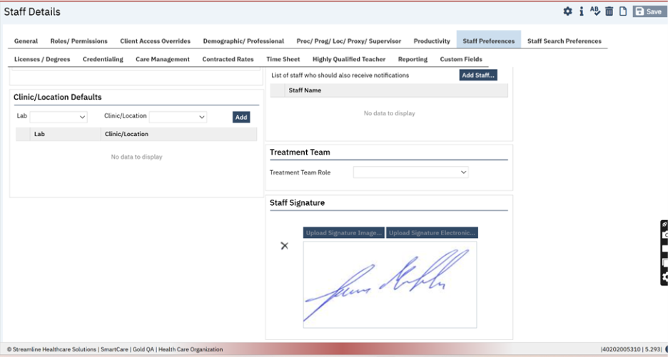

Screen Shot of My Preferences screen

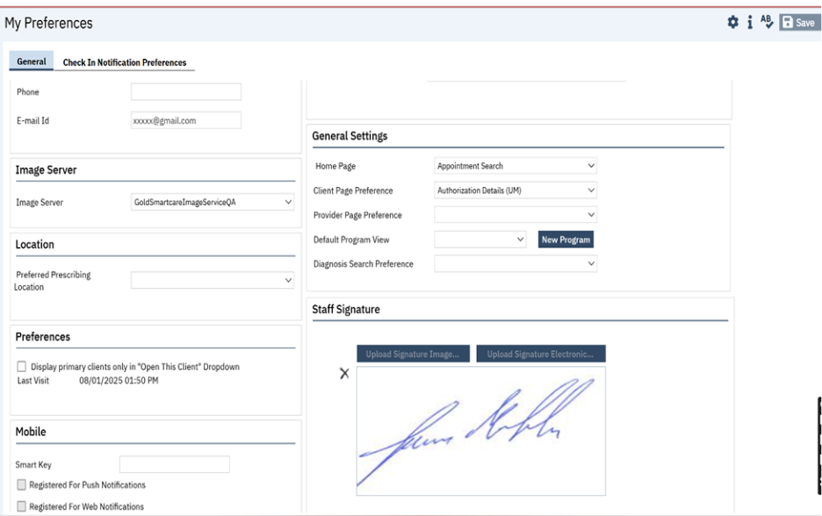

Screenshot of Saved Signature Radio Button Signature Popup

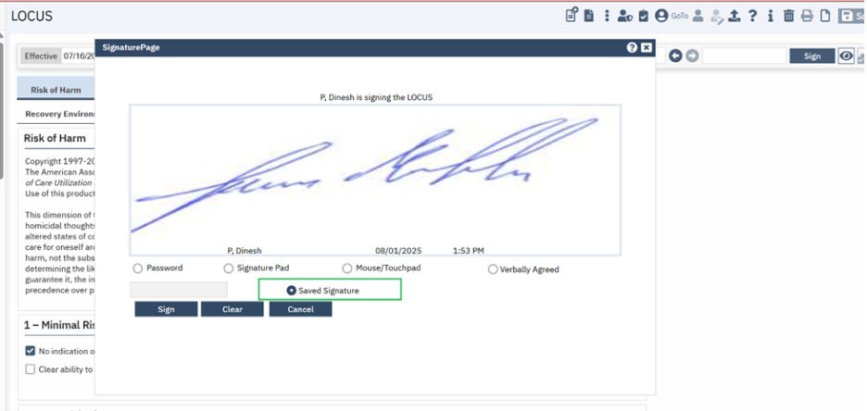

Screen shot of PDF

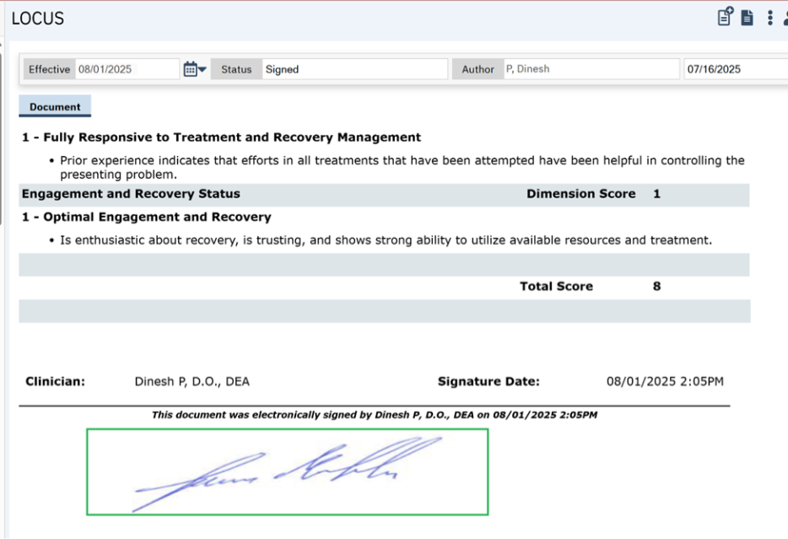

Screenshot of Saved Signature Radio Button in Group Service Signature Popup

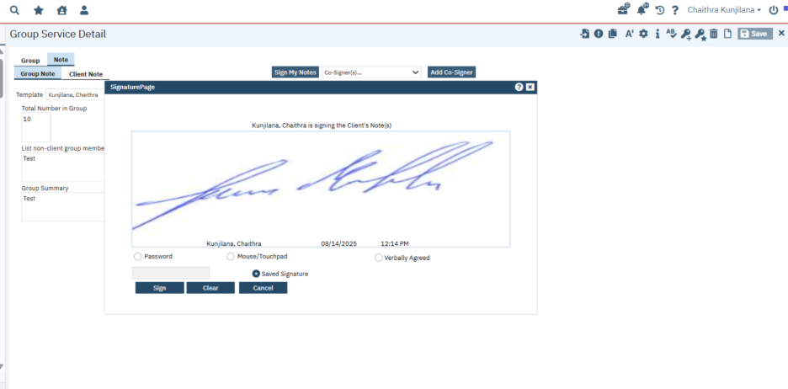

Screenshot of Group Service PDF

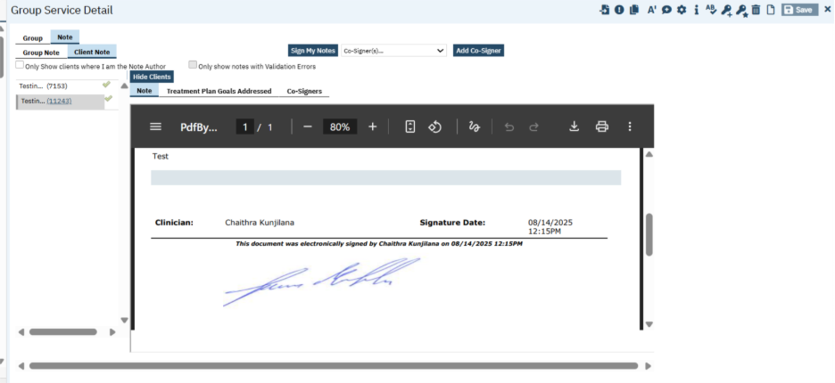

Screenshot of Saved Signature Radio Button in Service Note Signature Popup

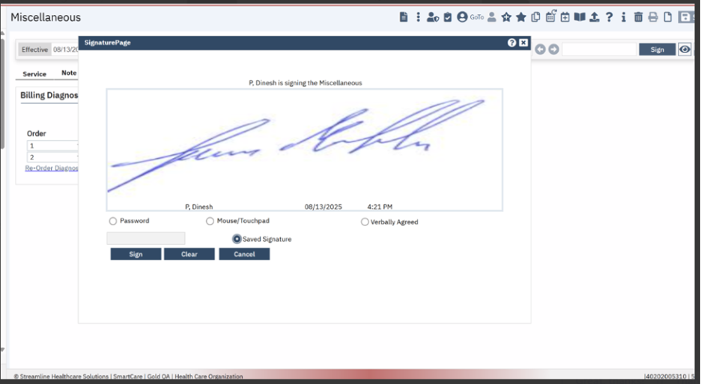

Screenshot of Service Note PDF

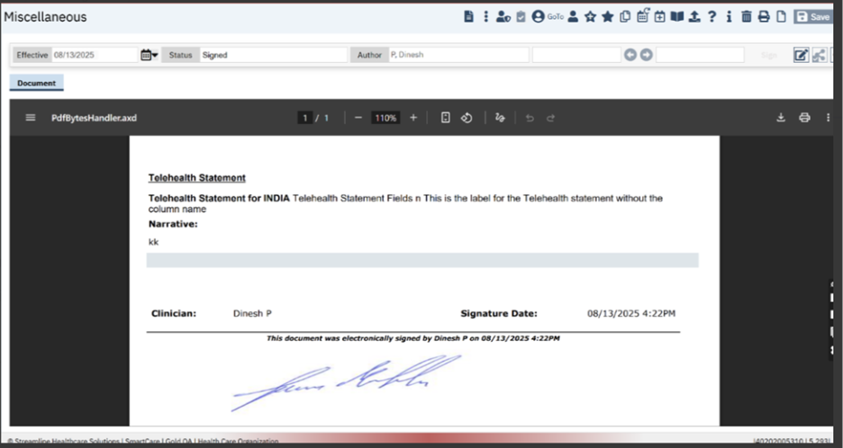

SmartCare Improvements

Reference No | Task No | Description
134 | Core Bugs # 132163 | Services (My Office): Error was displaying when tried to open exported file in .xlsx or .xls format.
135 | Core Bugs # 132087 | Patient Safety Plan Template: the overridden text was not retained once after navigating from any other screens.
136 | Core Bugs # 131875 | Immunization Details: Bold label changes issue
137 | EII # 131858 | Implementation of deletion primary child data from Custom Grid.

Author: Rakesh Naganagoda

134. Core Bugs # 132163: Services (My Office): Error was displaying when tried to open exported file in .xlsx or .xls format.

Release Type: Fix | Priority: Medium

Pre-requisite :

- Set the system configuration key ‘SetFileFormatForExport’ to ‘xlsx' or ‘xls’ format

- In Services list page, Comments column has only numeric values.

Navigation Path: Go Search -- Services( My Office) -- Services (My Office) list page – set filter values – Apply Filter – click on Export icon – Open the exported .xlsx file or .xls file

Functionality ‘Before’ and ‘After’ release:

Before this release, here was the behaviour. In the Services list page, when the user tried to open the exported file, below error was displayed:

Error displayed for .xlsx file: We found a problem with some content in 'Export data.xlsx'. Do you want us to try to recover as much as we can? If you trust the source of this workbook, click Yes

Error displayed for .xls file: The file is corrupt and cannot be opened

With this release, the issue has been resolved. Now, in the Services list page, the exported file is opening without any error

Author: Kiran Tigarimath

135. Core Bugs # 132087: Patient Safety Plan Template: the overridden text was not retained once after navigating from any other screens.

Release Type: Fix | Priority: Medium

Pre-requisite: The "Administrator" checkbox in Staff Details is checked to use the hotkey (Ctrl + Alt + L) for changing label names.

Navigation Path: 'Client' - 'Documents' - 'Patient Safety Plan Template' Document -- New -- override label text using Ctrl + Alt + L

Functionality ‘Before’ and ‘After’ release:

Before this release, here was the behavior. In the Patient Safety Plan Template document, when users attempted to override label text using Ctrl + Alt + L on a page containing two identical labels, the overridden text was not retained once after navigating from any other screens.

With this release, the above-mentioned issue has been resolved. Now, the overridden label text now persists correctly, even after navigating away from and returning to the 'Patient Safety Plan Template' Document.

Author: Kiran Tigarimath

136. Core Bugs # 131875: Immunization Details: Bold label changes issue.

Release Type: Fix | Priority: Medium

Pre-requisite: The "Administrator" checkbox in Staff Details is checked to use the hotkey (Ctrl + Alt + L) for changing label names.

Navigation Path: 'Client' - 'Immunizations' - 'New' - 'Immunization Details' Screen -- New -- Place the cursor on any label -- Press the hotkey combination Ctrl + Alt + L -- Edit Label Title pop-up -- In the New Text field, enter: <b>* </b>Manufacturer, then click OK

Functionality ‘Before’ and ‘After’ release:

Before this release, here was the behavior. When users attempted to bold label text using Ctrl + Alt + L, the bold formatting was not retained after navigating away or refreshing the screen.

With this release, the above-mentioned issue has been resolved. Now, the bolded text is retained correctly, even after navigating away or refreshing the 'Immunization Details' Screen.

Author: Kiran Tigarimath

137. EII # 131858 (Feature - 558921): Implementation of deletion primary child data from Custom Grid.

Note:
- This is a Passive change.
- This implementation is done for specific customers who have the custom implementation.
Release Type: Change | Priority: Urgent

Purpose: This Enhancement will allow the county level environment admins to modify and/or delete Primary data on Custom Grids.

Functionality ‘Before’ and ‘After’ release:

Before this release, here was the behavior. User were unable to delete Primary data (Child table) from County environment (i.e) when the configuration key ‘SetMultitenantSystemPrimaryInstance’ was set to ‘No’.

With this release, a logic is implemented to delete primary child data from Custom Grid as follows:
In a county environment (i.e.) when ‘SetMultitenantSystemPrimaryInstance’ is set to ‘No’, when PrimaryDriven is set to ’Y’ for a table in PrimaryDataSyncTables setup table,
- User cannot delete Primary Data if the table is a parent table (i.e.) If the Primary Key Value of the row is less than AffiliateTableSeedValue and if the table is a parent table, user cannot delete the row, and this is the existing behavior.
- User can delete Primary Data if the table is a child table and if the 'RecordDeleted' column is included in the 'ColumnsToExclude' list (i.e.) If the Primary Key Value of the row is less than AffiliateTableSeedValue and if the table is a child table, the user can delete the row if the 'RecordDeleted' column is included in the 'ColumnsToExclude' list.
- Users can delete the County Data irrespective of the table whether it is a Parent/Child table (i.e.) If the Primary Key Value of the row is greater than AffiliateTableSeedValue irrespective of the table whether it is a Parent/Child table, the users can delete the row, and this is the existing behavior.
In a county environment (i.e.) when ‘SetMultitenantSystemPrimaryInstance’ to ‘No’, when PrimaryDriven is set to ’N’ for a table in PrimaryDataSyncTables setup table, user can delete both Parent and Child data, and this is the existing behavior.
In a Primary environment (i.e.) when ‘SetMultitenantSystemPrimaryInstance’ to ‘Yes’, or in a non-multi-tenant environment (i.e.) when ‘SetMultitenantSystemPrimaryInstance’ to ‘Null’, user can delete both Parent and Child data, and this is the existing behavior.

Staff/Users

Reference No | Task No | Description
138 | Core Bugs # 131757 | Staff Details: “Highly Qualified Teacher" tab not loading due to an HTTP validation request thrown.

Author: Chaitra Kunjilana

138. Core Bugs # 131757 Staff Details: “Highly Qualified Teacher" tab not loading due to an HTTP validation request thrown.

Release Type: Fix | Priority: Medium

Navigation Path: Staff/Users – Search and Select the staff – Navigate to “Highly Qualified Teacher" tab – Search and Select the Course name – Enter other values – Insert -- Save

Functionality ‘Before’ and ‘After’ Release:

Before this release, here was the behavior. When a user tried to load the “Highly Qualified Teacher" tab below HTTP Request Validation Exceptions error message was thrown.

Error Message: A potentially dangerous request. Form value was detected from the client (StaffId="<NOT FOUND>"). System.Web.HttpRequestValidationException: A potentially dangerous Request.Form value was detected from the client (StaffId="<NOT FOUND>").

With this release, the above-mentioned issue is fixed. The post validation for “Highly Qualified Teacher" tab is disabled by adding ValidateRequest="false" at the beginning of the file.

Team Productivity

Reference No | Task No | Description
139 | Core Bugs # 132489 | Team Productivity: Issue with ‘Team Name’ hyperlink.

Author: SaravanKumar Nagarajan

139. Core Bugs # 132489: Team Productivity: Issue with ‘Team Name’ hyperlink.

Release Type: Fix | Priority: High

Navigation Path: Go to search -- Enter ‘Team Productivity (Administration)’ -- Click ‘New’ button -- Enter required details -- Click Insert button and save.

Functionality ‘Before’ and ‘After’ release:
Before this release, here was behavior. The hyperlink of ‘Team Name’ was not navigating to ‘Team Productivity Period Details’ screen, when the ‘Team Productivity Period’s Team Name’ had a single quote in it. Hence, the user was unable to modify those records.

With this release, the above mentioned has been resolved. Now, when a user clicks on the hyperlink for the ‘Team Name’ with single quotes, the system will navigate the user to ‘Team Productivity Period Details’ screen. Additionally, the user will be able to modify and save the changes successfully.

Glossary of System Configuration Keys, Global Codes, Recodes, Data Model Changes

System Configuration Keys
74. DisplayNoShowNotesAndAllowSignatureOnGroupServices
74. DisableNoShowNotes
75. DisplayCDAGSectionInStaffDetails
75. EnableClinicalDataAccessGrouping
77. EnableServiceDropdownConfigurationsInGroupServices
104.RegenerateChargesForServicesWithPayments
105.RegenerateChargesForBilledServices
105.RegenerateChargesForServicesWithPayments
106.RegenerateChargesForBilledServices
106.RegenerateChargesForServicesWithPayments
120.TurnOnCareCoordinationWorkflow
122.BILLABLEDIAGNOSISONLY
126.ServiceNoteDoNotDefaultDate
132.InitializeGoalsAndObjectivesBasedOnProcedureCode
134.SetFileFormatForExport
137.SetMultitenantSystemPrimaryInstance

Global Codes
86. TOXICOLOGYFREQUENCY
86. PHASELEVELOFCARE

Recodes
98. UDSScreeningProcedures
98. UDSGroupVisitsProcedures
98. UDSDispenseMedsProcedures
98. UDSHealthCheckProcedure
98. UDSWICServicesProcedure
98. FQHCHospiceCare
98. FQHCPalliativeCare
99. UDSScreeningProcedures
99. UDSGroupVisitsProcedures
99. UDSDispenseMedsProcedures
99. UDSHealthCheckProcedure
99. UDSWICServicesProcedure

Data Model Changes
88. ToxicologyScreenRequiredBeforeDispense,ToxicologyScreenAllowOverride
ToxicologyScreenFlowSheetId are added to the MATConfigurations table.
108.A new column ‘SecondaryClaimSendPreviousPayerClaimNumber’ and
‘SecondaryClaimSendPreviousPayerEOBDate’’ included in ‘CoveragePlans table’
121.A new table 'CaseRateComponentServices' is created.

