**RELEASE NOTES:**

**Monthly Service Pack – SC.CORE.6.0_1.32.000.2503.013 (March 2025 MSP Part 2)**

Green highlights indicates that the change was deployed in a prior HF, and is already available in PROD

Blue highlights indicates that the change needs to be tested by CalMHSA because it is related to one of your ZD tickets

Yellow highlights were added by Streamline when the release notes were created. They indicate a new change made to the system.

Strikethrough indicates a change that CalMHSA should not test as it is not a part of your subscription set.

**Executive Summary:**

1. Added a **‘Procedure’** column to the Group Service List page. By adding Procedure codes to Group Service List page, the users can quickly see the procedure involved in that group without navigating to other screens which will saves their time. (**EII #127386)**
2. ~~Changes have been implemented in the~~ **~~‘MAT Management Details’~~** ~~screen and~~ **~~‘MAT Configuration’~~** ~~screen for MAT orders, to prevent staff from dispensing from a bottle when the remaining amount is at or below the very low threshold set on the Dispenser Details screen, with configurable behaviour to allow either a hard stop or a warning. (~~**~~EII #130330)~~**
3. Implementation of a new Configuration key to set the number of days for reallocation. This will allow the end users to set the number of reallocation days by themselves and it will be set to 90 days as the default. (**EII #129798)**
4. ~~Created a~~ **~~MAT Pump Transaction Report~~** ~~to capture and track MAT machine pump activities. This report will allow the user to produce a report showing that their daily test dispense has occurred. When using the pump calibration screen, medication is NOT removed from the bottle. (~~**~~EII #124949)~~**
5. Implemented the **"Crisis Time to Treatment Report"**, this report is intended to provide administrators the ability to view a summary of Crisis Service data for the purposes of looking for trends over time and looking for outcome measurements to the ability to treat and follow up with crisis services in a timely. **(EII #130525)**
6. This is an enhancement to identify **No Shows and Take Homes** in the MAR screen. This will change the icon colour that represents a no-show status. This will also be used to address Take Home behaviour on MAR. **(EII #128645)**
7. Added an **insulin sliding scale function to orders/client orders**, to allow for flexibility when administering insulin to client in a MAR program.

When administering medication such as Insulin, prescribers will identify a sliding scale specific to the client**. (EII #128423)**

1. Added the lock and unlock icons to **Inquiry Details** screen. Once an Inquiry is marked as complete status and then saved, it becomes ‘Locked’ by default, but a supervisor can unlock it for editing, if necessary. **(EII #129599)**
2. This enhancement is the ability to add multiple staff members to an appointments/Service that will enhance the scheduling process by automatically notifying all team members when the client arrives. As a result, it will enhance efficiency in both Staff and Client experience during appointment scheduling. **(EII #129382)**

*** ***DISCLAIMER: The document is only available to those customers who have purchased an annual subscription. It is a premium add-on to SmartCare and not included in SmartCare Base Subscription. If you are interested in learning more about this document, please contact your account manager***.

**Abbreviation: EII - Engineering Improvement Initiatives**

**Contents**

TASKS SUMMARY – ‘NEW FUNCTIONLIATY’ RELATED (1) 6

TASKS SUMMARY – ‘CHANGE' RELATED (16) 6

TASKS SUMMARY – ‘DEFECT FIXES’ (54) 6

Functionality-wise Task Details: 9

Financial Assignment 9

71. Core Bugs # 130989: Financial Assignment: Error displayed on Save. 9

Flowsheet 10

72. Core Bugs # 131102: BMIPercentile(Child and Teen) is not calculating correctly when a user creates a flow sheet entry by entering the ‘Height’ and ‘Weight (lb)’ values. 10

~~Foster Care 10~~

~~73. EII # 130262 (Feature - 502321): Changes are added to the Permanency Planning Document. 10~~

~~74. Core Bugs # 131034: The ‘Save’ button remained disabled when users attempt to remove the 'LOC Expiration' date in the ‘Level of Care’ section under 'Placement History Details' page. 11~~

Global Codes 12

75. Core Bugs # 130956: Nightly job adding the record created in the ‘Primary Care Provider’ to the ‘ReferringClinician’ global code category resulting in a duplicate entry of the same record. 12

Group Services 13

76. EII # 127386 (Feature - 356233): Added Procedure Column to the Group Services List Page. 13

77. Core Bugs # 131055: Group Service Detail: Set All buttons are not functioning correctly. 14

78. Core Bugs # 130020: Issues in the Group service details screen. 14

79. Core Bugs # 130697: Services/Notes: unable to error the Individual group service. 15

80. Core Bugs # 130775: Inaccurate UserName in CreatedBy and ModifiedBy columns. 16

81. Core Bugs # 131084: Group Service Details – Performance Degradation due to Dataset XML Generating Duplicate Nodes. 16

Inquiry Details 17

82. EII # 129599 (Feature - 368982): Changes in ‘Inquiry Details’ screen, a new Lock and Unlock functionality will be handled based on new Configuration key and new ‘ButtonUnLock’ permission controls using Role-Level/ Staff-level permission. 17

Key Phrases 22

83. Core Bugs # 131168: Record deleted KeyPhraseKeywords are displaying when hovered mouse on ‘Gold key’ icon in "Add/Edit Key Phrases" pop-up. 22

Letter Templates 22

84. EII # 129873 (Feature - 485631): Spellchecker implemented for the Letter Template. 22

Life Events 24

85. EII # 130458 (Feature - 517908): Implementation to dynamically display Start Time and End Time fields on the Client Life Event screen, based on the new Life Event Setup configuration. 24

86. Core Bugs # 131083: Client Life Events: The Grid size of the list page varies when clicking on Apply filter. 25

Manage Claims 26

87. Core Bugs # 130658: Adjudicating Claim Lines issue. 26

88. Core Bugs # 130968: The ‘Activity’ column is blank in the 'Status and Payment History' section of 'Claim Line Detail' screen. 26

~~Methadone 27~~

~~89. EII # 124949 (Feature - 244352): The MAT Pump Transaction report is implemented. 27~~

~~90. EII # 127705 (Feature - 373849): New changes are added to the Medication Inventory Transaction list page. 29~~

~~91. EII # 128645 (Feature - 440678): Implementation to identify No Shows and Take Homes in the MAR screen. 31~~

~~92. EII # 130330 (Feature - 512752): Changes are added to the ‘MAT Management Details’ and ‘MAT Configuration’ screens. 39~~

~~93. Core Bugs # 130891: Client Orders: Scheduled validation is not displayed when client has 0 take home days while signing the client order and ‘Titration/Taper? Orders. 41~~

~~94. Core Bugs # 130892: Client order: Validation message is displayed when completing titration order. 42~~

~~95. Core Bugs # 130980: MAT: Issues with the MAT No Show Clients Report 42~~

~~96. Core Bugs # 131038: Medication/Lot/Bottle list page: Lot field value is clearing when clicking on Apply filter. 43~~

~~97. Core Bugs # 131045: MAT: Medication/Lot/Bottle Screen Displaying in only Half of the Screen. 43~~

~~98. Core Bugs # 131100: Incorrect Client Flag generated by the system. 43~~

~~99. Core Bugs # 131086: Medication/Lot/Bottle details: Validation message is displayed for the Bottle/Box ID when saving. 44~~

~~100. Core Bugs # 131133: MAT: Bottle Return functionality: Number of bottles to return is showing as None in the popup. 44~~

~~101. Core Bugs # 131206: Global codes: users are unable to add new values to the Global code category. 45~~

~~102. Core Bugs # 131019: MAT Management details: Warning message is not displayed when client has more than 3 No shows. 45~~

My Calendar 46

103. Core Bugs # 130984: “Client is an Adult with Guardian” was displayed, even though the resource entry is not related to Client. 46

Nightly billing job 46

104. EII # 129798 (Feature - 479174): Implementation of a new Configuration key to set the number of days for reallocation. 46

Orders 48

105. EII # 128423 (Feature - 357678): MAR Improvements: Ability to do Sliding Scale Insulin. 48

Payments/Adjustments 70

106. Core Bugs # 130951: Duplicate financial activities data issue in the 'Payments/Adjustments' screen. 70

Plans 71

107. Core Bugs # 131087: Value Code Records Getting Erroneously Updated When Saving Plans by altering the templates from ‘Use Value Codes from Specified Plans’ to ‘Use this plan as template. 71

108. Core Bugs # 130950: The ‘Adjustment Code’ and the 'Auto Adjustment' radio buttons are not populating from the ‘Parent Plan Template file’ in the 'Payments/Adjustments' tab of the 'Plan Details' screen. 72

~~Primary Care 72~~

~~109. Core Bugs # 131211: Primary Care Summary Quick Notes not generating template selection pop-up. 72~~

Procedure/Rates 73

110. EII # 129467 (Feature - 470046): CQM 2025 Reporting Measure updates for DHIT - ASC, DEP- REM-6, and CMS-2 (CDF-AD and CDF-CH). 73

111. Core Bugs # 130949: Services: Error message is displayed when trying to complete a service. 75

Reception 75

112. Core Bugs # 130955: Reception/Front Desk: The ‘Transaction Details’ are not populated in the ‘Comment’ section of the 'Payment Details' page when a credit card transaction is processed successfully in the ‘Reception’ screen. 75

113. Core Bugs # 131134: Reception: color change logic not working. 76

Reports 76

114. EII # 130525 (Feature – 520619): Implementation of a new ‘Crisis Time to Treatment’ Report. 76

115. Core Bugs # 131015: NOMS SPARS Report CSV File error. 81

116. Core Bugs # 130127: Services With Procedure Rate Errors Logic not working when From Unit on the procedure rate is NULL. 81

~~117. Core Bugs # 130978: MAT Medication Dispensing Exception Report is displayed with the edited dose entries even though the medication dispensing was not done. 82~~

~~118. Core Bugs # 131047: MAT Emergency Daily Dispensing Report: The end date filter is not showing the next calendar day. 82~~

119. Core Bugs # 130672: Changes are updated to the ‘UDS Table 9D Patient-Related Revenue’. 83

RWQM 87

120. Core Bugs # 130882: AllowedPreviousAction list stored as Action Name list, not action id list - condition failing. 87

121. Core Bugs # 131116: Issues observed in the RWQM work queue items. 87

Rx Application 88

122. Core Bugs # 130614: Slowness while Opening RX from SC 88

123. Core Bugs # 130733: Rx: PDMP Report not generating. 88

Scanning 89

124. Core Bugs # 130452: Scanning: On Clicking Close(X) to exit out of a scan still saves the scan to SmartCare as a “not associated” document. 89

125. Core Bugs # 131166: The ‘Scanned Medical Record Detail’ and ‘Uploaded File Detail’ screen names are displayed with old label name. 89

Service From Claims 90

126. Core Bugs # 131032: Getting Service Completion error when processing the job. 90

Services 91

127. EII # 129382 (Feature - 446557): Ability to add multiple staff members to an appointment/service. 91

128. Core Bugs # 130501: Regenerate Charge creating duplicate charge amount when exist overlapping AccountingPeriods record. 98

129. Core Bugs # 130923: Services: Automatic Add-on code is not captured when service is completed in one shot. 99

130. Core Bugs # 131175: Out Of Memory error logs are logged in the ‘Service Detail’ screen. 99

131. Core Bugs # 131229: The Charge amount is not updated to $0 when the scheduled service is cancelled from the ‘Service Details’ screen. 100

132. Core Bugs # 131180: Service Note is not generating for MAT medications. 100

Services/Notes 101

133. EII # 130554 (Feature - 522360): E/M Note medications refresh - regardless of DOS. 101

134. EII # 130097 (Feature - 491556): Ability to add multiple staff members to an appointment - Core PDF changes. 103

135. Core Bugs # 131250: Service Note PDF took a long time to load. 104

136. Core Bugs # 131022: Misc G/O Note - Incorrect Validation. 105

137. Core Bugs # 131193: Miscellaneous service note: A red error message is displayed when the user tries to click on 'Save' button. 105

SmartCare Improvements 106

138. EII # 127992 (Feature - 383374): Notifying users that they are accessing SmartCare from non-supported browsers or OS. 106

139. Core Bugs # 131050: Issues while executing "CreateClinicalInformationReconciliationFiles" SQL job. 107

Teds Setup List 108

140. Core Bugs # 131101: Getting an error while adding Program on the ‘Teds Setup Details’ Screen. 108

Treatment Episode 109

141. Core Bugs # 124807: The ‘Treatment Episode’ list page displays all the client records regardless of records that the staff/user have access to. 109

Glossary of System Configuration Keys, Global Codes, Recodes, Data Model Changes. 110

System Configuration Keys 110

Global Codes 110

Recodes 110

Data Model Changes 111

# TASKS SUMMARY – ‘NEW FUNCTIONLIATY’ RELATED (1)

|  |  |  |  |
| --- | --- | --- | --- |
| **Sl. No** | **Task No** | **Summary** | **Module Name** |
| 114 | EII # 130525 | Implementation of a new ‘Crisis Time to Treatment’ Report. | Reports |

# TASKS SUMMARY – ‘CHANGE' RELATED (16)

|  |  |  |  |
| --- | --- | --- | --- |
| **Sl. No** | **Task No** | **Summary** | **Module Name** |
| ~~73~~ | ~~EII # 130262~~ | ~~Changes are added to the Permanency Planning Document.~~ | ~~Foster Care~~ |
| 76 | EII # 127386 | Added Procedure Column to theGroup Services List Page. | Group Services |
| 82 | EII # 129599 | Changes in ‘Inquiry Details’ screen, a new Lock and Unlock functionality will be handled based on new Configuration key and new ‘ButtonUnLock’ permission controls using Role-Level/ Staff-level permission. | Inquiry Details |
| 84 | EII # 129873 | Spellchecker implemented for the Letter Template. | Letter Templates |
| 85 | EII # 130458 | Implementation to dynamically display Start Time and End Time fields on the Client Life Event screen, based on the new Life Event Setup configuration. | Life Events |
| ~~89~~ | ~~EII # 124949~~ | ~~The MAT Pump Transaction report is implemented.~~ | ~~Methadone~~ |
| ~~90~~ | ~~EII # 127705~~ | ~~New changes are added to the Medication Inventory Transaction list page.~~ | ~~Methadone~~ |
| ~~91~~ | ~~EII # 128645~~ | ~~Implementation to identify No Shows and Take Homes in the MAR screen.~~ | ~~Methadone~~ |
| ~~92~~ | ~~EII # 130330~~ | ~~Changes are added to the ‘MAT Management Details’ and ‘MAT Configuration’ screens.~~ | ~~Methadone~~ |
| 104 | EII # 129798 | Implementation of a new Configuration key to set the number of days for reallocation. | Nightly billing job |
| 105 | EII # 128423 | MAR Improvements: Ability to do Sliding Scale Insulin. | Orders |
| 110 | EII # 129467 | CQM 2025 Reporting Measure updates for DHIT - ASC, DEP- REM-6, and CMS-2 (CDF-AD and CDF-CH). | Procedure/Rates |
| 127 | EII # 129382 | Ability to add multiple staff members to an appointment/service. | Services |
| 133 | EII # 130554 | E/M Note medications refresh - regardless of DOS. | Services/Notes |
| 134 | EII # 130097 | Ability to add multiple staff members to an appointment - Core PDF changes. | Services/Notes |
| 138 | EII # 127992 | Notifying users that they are accessing SmartCare from non-supported browsers or OS. | SmartCare improvements |

# TASKS SUMMARY – ‘DEFECT FIXES’ (54)

|  |  |  |  |
| --- | --- | --- | --- |
| **Sl. No** | **Task No** | **Summary** | **Module Name** |
| 71 | Core Bugs # 130989 | Financial Assignment: Error displayed on Save. | Financial Assignment |
| 72 | Core Bugs # 131102 | BMIPercentile(Child and Teen) is not calculating correctly when a user creates a flow sheet entry by entering the ‘Height’ and ‘Weight (lb)’ values. | Flowsheet |
| 74 | Core Bugs # 131034 | The ‘Save’ button remained disabled when users attempt to remove the 'LOC Expiration' date in the ‘Level of Care’ section under 'Placement History Details' page. | Foster Care |
| 75 | Core Bugs # 130956 | Nightly job adding the record created in the ‘Primary Care Provider’ to the ‘ReferringClinician’ global code category resulting in a duplicate entry of the same record. | Global Codes |
| 77 | Core Bugs # 131055 | Group Service Detail: Set All buttons are not functioning correctly. | Group Services |
| 78 | Core Bugs # 130020 | Issues in the Group service details screen. | Group Services |
| 79 | Core Bugs # 130697 | Services/Notes: unable to error the Individual group service. | Group Services |
| 80 | Core Bugs # 130775 | Inaccurate UserName in CreatedBy and ModifiedBy columns. | Group Services |
| 81 | Core Bugs # 131084 | Group Service Details – Performance Degradation due to Dataset XML Generating Duplicate Nodes. | Group Services |
| 83 | Core Bugs # 131168 | Record deleted KeyPhraseKeywords are displaying when hovered mouse on ‘Gold key’ icon in "Add/Edit Key Phrases" pop-up. | Key Phrases |
| 86 | Core Bugs # 131083 | Client Life Events: The Grid size of the list page varies when clicking on Apply filter. | Life Events |
| 87 | Core Bugs # 130658 | Adjudicating Claim Lines issue. | Manage Claims |
| 88 | Core Bugs # 130968 | The ‘Activity’ column is blank in the 'Status and Payment History' section of 'Claim Line Detail' screen. | Manage Claims |
| 93 | Core Bugs # 130891 | Client Orders: Scheduled validation is not displayed when client has 0 take home days while signing the client order and ‘Titration/Taper? Orders. | Methadone |
| 94 | Core Bugs # 130892 | Client order: Validation message is displayed when completing titration order. | Methadone |
| 95 | Core Bugs # 130980 | MAT: Issues with the MAT No Show Clients Report. | Methadone |
| 96 | Core Bugs # 131038 | Medication/Lot/Bottle list page: Lot field value is clearing when clicking on Apply filter. | Methadone |
| 97 | Core Bugs # 131045 | MAT: Medication/Lot/Bottle Screen Displaying in only Half of the Screen. | Methadone |
| 98 | Core Bugs # 131100 | Incorrect Client Flag generated by the system. | Methadone |
| 99 | Core Bugs # 131086 | Medication/Lot/Bottle details: Validation message is displayed for the Bottle/Box ID when saving. | Methadone |
| 100 | Core Bugs # 131133 | MAT: Bottle Return functionality: Number of bottles to return is showing as None in the popup. | Methadone |
| 101 | Core Bugs # 131206 | Global codes: users are unable to add new values to the Global code category. | Methadone |
| 102 | Core Bugs # 131019 | MAT Management details: Warning message is not displayed when client has more than 3 No shows. | Methadone |
| 103 | Core Bugs # 130984 | “Client is an Adult with Guardian” was displayed, even though the resource entry is not related to Client. | My Calendar |
| 106 | Core Bugs # 130951 | Duplicate financial activities data issue in the 'Payments/Adjustments' screen. | Payments/Adjustments |
| 107 | Core Bugs # 131087 | Value Code Records Getting Erroneously Updated When Saving Plans by altering the templates from ‘Use Value Codes from Specified Plans’ to ‘Use this plan as template. | Plans |
| 108 | Core Bugs # 130950 | The ‘Adjustment Code’ and the 'Auto Adjustment' radio buttons are not populating from the ‘Parent Plan Template file’ in the 'Payments/Adjustments' tab of the 'Plan Details' screen. | Plans |
| ~~109~~ | ~~Core Bugs # 131211~~ | ~~Primary Care Summary Quick Notes not generating template selection pop-up.~~ | ~~Primary Care~~ |
| 111 | Core Bugs # 130949 | Services: Error message is displayed when trying to complete a service. | Procedure/Rates |
| 112 | Core Bugs # 130955 | Reception/Front Desk: The ‘Transaction Details’ are not populated in the ‘Comment’ section of the 'Payment Details' page when a credit card transaction is processed successfully in the ‘Reception’ screen. | Reception |
| 113 | Core Bugs # 131134 | Reception: color change logic not working. | Reception |
| 115 | Core Bugs # 131015 | NOMS SPARS Report CSV File error. | Reports |
| 116 | Core Bugs # 130127 | Services With Procedure Rate Errors Logic not working when From Unit on the procedure rate is NULL. | Reports |
| ~~117~~ | ~~Core Bugs # 130978~~ | ~~MAT Medication Dispensing Exception Report is displayed with the edited dose entries even though the medication dispensing was not done.~~ | ~~Reports~~ |
| ~~118~~ | ~~Core Bugs # 131047~~ | ~~MAT Emergency Daily Dispensing Report: The end date filter is not showing the next calendar day.~~ | ~~Reports~~ |
| 119 | Core Bugs # 130672 | Changes are updated to the ‘UDS Table 9D Patient-Related Revenue’. | Reports |
| 120 | Core Bugs # 130882 | AllowedPreviousAction list stored as Action Name list, not action id list - condition failing. | RWQM |
| 121 | Core Bugs # 131116 | Issues observed in the RWQM work queue items. | RWQM |
| 122 | Core Bugs # 130614 | Slowness while Opening RX from SC. | Rx Application |
| 123 | Core Bugs # 130733 | Rx: PDMP Report not generating. | Rx Application |
| 124 | Core Bugs # 130452 | Scanning: On Clicking Close(X) to exit out of a scan still saves the scan to SmartCare as a “not associated” document. | Scanning |
| 125 | Core Bugs # 131166 | The ‘Scanned Medical Record Detail’ and ‘Uploaded File Detail’ screen names are displayed with old label name. | Scanning |
| 126 | Core Bugs # 131032 | Getting Service Completion error when processing the job. | Service From Claims |
| 128 | Core Bugs # 130501 | Regenerate Charge creating duplicate charge amount when exist overlapping AccountingPeriods record. | Services |
| 129 | Core Bugs # 130923 | Services: Automatic Add-on code is not captured when service is completed in one short. | Services |
| 130 | Core Bugs # 131175 | Out Of Memory error logs are logged in the ‘Service Detail’ screen. | Services |
| 131 | Core Bugs # 131229 | The Charge amount is not updated to $0 when the scheduled service is cancelled from the ‘Service Details’ screen. | Services |
| 132 | Core Bugs # 131180 | Service Note is not generating for MAT medications. | Services |
| 135 | Core Bugs # 131250 | Service Note PDF took a long time to load. | Services/Notes |
| 136 | Core Bugs # 131022 | Misc G/O Note - Incorrect Validation. | Services/Notes |
| 137 | Core Bugs # 131193 | Miscellaneous service note: A red error message is displayed when the user tries to click on 'Save' button. | Services/Notes |
| 139 | Core Bugs # 131050 | Issues while executing "CreateClinicalInformationReconciliationFiles" SQL job. | SmartCare improvements |
| 140 | Core Bugs # 131101 | Getting an error while adding Program on the ‘Teds Setup Details’ Screen. | Teds Setup List |
| 141 | Core Bugs # 124807 | The ‘Treatment Episode’ list page displays all the client records regardless of records that the staff/user have access to. | Treatment Episode |

# Functionality-wise Task Details:

# Financial Assignment

|  |  |  |
| --- | --- | --- |
| **Reference No** | **Task No** | **Description** |
| 71 | Core Bugs # 130989 | Financial Assignment: Error displayed on Save. |

**Author:** Namratha Nagaraj

### 71. Core Bugs # 130989: Financial Assignment: Error displayed on Save.

**Release Type:** Fix | **Priority:** High

**Navigation Path**: Financial Assignment (Administration)--Click on ‘New’ button---' Financial Assignment Details’ Page will be opened—Enter all the required details—Click on ‘Save’ button.

**Functionality ‘Before’ and ‘After’ release:**

Before this release, here was the behavior. When the user entered all the details in the Financial Assignment screen and clicked on Save button, the below red error was displayed:

Error: - Financial Assignments- List Page Filters or Revenue Work Queue Management is required.

With this release, the above-mentioned issue has been resolved. Now, the user is able to enter all the details in the Financial Assignment screen and can save successfully without any red error.

# Flowsheet

|  |  |  |
| --- | --- | --- |
| **Reference No** | **Task No** | **Description** |
| 72 | Core Bugs # 131102 | BMIPercentile(Child and Teen) is not calculating correctly when a user creates a flow sheet entry by entering the ‘Height’ and ‘Weight (lb)’ values. |

**Author:** Chaithra Kunjilana

### 72. Core Bugs # 131102: BMIPercentile(Child and Teen) is not calculating correctly when a user creates a flow sheet entry by entering the ‘Height’ and ‘Weight (lb)’ values.

**Release Type:** Fix **| Priority:** Medium

**Navigation Path: ‘**Client’ search – ‘Flowsheet’ – ‘Meaningful Use/Vitals’ – Enter the required values – Enter ‘Height and Weight (lb)’ values -- ‘Save’.

**Functionality ‘Before’ and ‘After’ release:**

Before this release, here was the behavior. When a user created a flow sheet entry by entering the ‘Height’ and ‘Weight (lb)’ values, the BMIPercentile (Child and Teen) was calculated incorrectly.

With this release, the above-mentioned issue is fixed. Now, the BMIPercentile(Child and Teen) calculates correct value.

# ~~Foster Care~~

|  |  |  |
| --- | --- | --- |
| **~~Reference No~~** | **~~Task No~~** | **~~Description~~** |
| ~~73~~ | ~~EII # 130262~~ | ~~Changes are added to the Permanency Planning Document.~~ |
| ~~74~~ | ~~Core Bugs # 131034~~ | ~~The ‘Save’ button remained disabled when users attempt to remove the 'LOC Expiration' date in the ‘Level of Care’ section under 'Placement History Details' page.~~ |

**~~Author:~~** ~~Lakshmi Kumarappan~~

### ~~73. EII # 130262 (Feature - 502321): Changes are added to the Permanency Planning Document.~~

**~~Release Type:~~** ~~Change |~~ **~~Priority:~~** ~~Urgent~~

**~~Prerequisite:~~** ~~A~~~~Permanency Planning document is signed.~~

**~~Navigation Path:~~** ~~Perform ‘Client’ Search –Select Client- Select ‘Permanency Planning Document’ - Click ‘new’ icon - ‘Permanency Planning Document’ detail screen - General tab.~~

**~~Functionality ‘Before’ and ‘After’ release:~~****~~Purpose:~~** ~~The Permanency Planning Grid values from the previously signed Permanency Planning Document need to initialize into the new Permanency Planning Document.~~

~~With this release, the initialization of ‘Permanency Planning Goals' grid fields is happening from the grid of the most recently signed Permanency Planning Document for the associated Client. (The grid is in the Permanency Planning Goals section on the General tab of the Permanency Planning document.)~~

**~~Screenshot:~~**

~~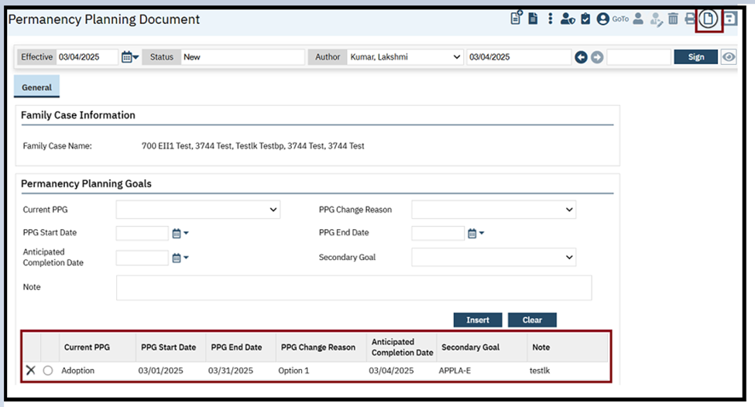~~

**~~Author:~~** ~~Shivakanth Moger~~

### ~~74. Core Bugs # 131034: The ‘Save’ button remained disabled when users attempt to remove the 'LOC Expiration' date in the ‘Level of Care’ section under 'Placement History Details' page.~~

**~~Prerequisite:~~** ~~A saved 'Placement History Details' exists.~~

**~~Release Type:~~** ~~Fix~~ **~~| Priority:~~** ~~Medium~~

**~~Navigation Path 1:~~** ~~‘My Office’ -- ‘Placement History’ – ‘Placement History’ list page – Click on any ‘Start Date’ hyperlink text – ‘Placement History Details’ page.~~

**~~Navigation Path 2:~~** ~~‘Client’ search -- ‘Placement History’ – ‘Client Placement History’ list page – Click on any ‘Start Date’ hyperlink text – ‘Placement History Details’ page.~~

**~~Functionality ‘Before’ and ‘After’ Release:~~**

~~Before this release, here was the behavior. When the users attempted to remove the 'LOC Expiration' date under the ‘Level of Care’ section, the ‘Save’ button remained disabled. Due to this, the users were unable to save changes in the 'Placement History Details' page.~~

~~With this release, the above-mentioned issue has been resolved. Now, the ‘Save’ button is enabled when the users removed the 'LOC Expiration' date under the ‘Level of Care’ section, allowing the users to save changes in the 'Placement History Details' page.~~

# Global Codes

|  |  |  |
| --- | --- | --- |
| **Reference No** | **Task No** | **Description** |
| 75 | Core Bugs # 130956 | Nightly job adding the record created in the ‘Primary Care Provider’ to the ‘ReferringClinician’ global code category resulting in a duplicate entry of the same record. |

**Author**: Sahana Gururaja

### 75. Core Bugs # 130956: Nightly job adding the record created in the ‘Primary Care Provider’ to the ‘ReferringClinician’ global code category resulting in a duplicate entry of the same record.

**Release Type:** Fix**| Priority:** High

**Prerequisite:**

**1.** Add the data in the ‘ReferringClinician’ global code category.

**Path:** ‘Administration’– ‘Global Codes’– search for ‘ReferringClinician’ global code category – click on ‘Category’ hyperlink – global code details screen – enter the ‘Code Name’ as required and add other details and click on ‘Insert’ and ‘Save’ the screen.

2. Add the same record in the ‘Primary Care Providers’ screen.

**Path: ‘**My Office’– ‘Primary Care Providers’– click on ‘New’ icon – ‘Primary Care Provider Details’ screen – enter the ‘Last Name and First Name’ same as added in the ‘ReferringClinician’ global code category and add other details and save the screen.

**Example:** In ‘ReferringClinician’ add a code entry with the name as ‘Kim, David’ with ‘NPI’ value and in the ‘Primary Care Providers Details’ screen. Also add the ‘Last Name and First Name as “Kim David” and add the same NPI value.

3. Run the ‘Nightly Billing Job step “Insert Primary Care Referring Provider”.

**Navigation Path:** NA

**Functionality ‘Before’ and ‘After’ release:**

Before this release, here was the behavior. When ‘ReferringClinician’ global code category and ‘Primary Care Provider’ screen has a record with same last name and first name, when the ‘Nightly Billing Job step “Insert Primary Care Referring Provider” was executed, the job was adding the record created in the ‘Primary Care Provider’ to the ‘ReferringClinician’ global code category, which resulted in a duplicate entry of the same record.

With this release, the above issue has been resolved. Now, the nightly billing job will check records with the ‘Last Name and First Name’ in both ‘ReferringClinican’ global code category and in ‘Primary Care Provider’ screen and will insert the record to the ‘ReferringClinician’ global code category accordingly.

# Group Services

|  |  |  |
| --- | --- | --- |
| **Reference No** | **Task No** | **Description** |
| 76 | EII # 127386 | Added Procedure Column to the Group Services List Page. |
| 77 | Core Bugs # 131055 | Group Service Detail: Set All buttons are not functioning correctly. |
| 78 | Core Bugs # 130020 | Issues in the Group service details screen. |
| 79 | Core Bugs # 130697 | Services/Notes: unable to error the Individual group service. |
| 80 | Core Bugs # 130775 | Inaccurate UserName in CreatedBy and ModifiedBy columns. |
| 81 | Core Bugs # 131084 | Group Service Details – Performance Degradation due to Dataset XML Generating Duplicate Nodes. |

**Author:** Suganya Sivakumar

### 76. EII # 127386 (Feature - 356233): Added Procedure Column to the Group Services List Page.

**Release Type:** Change **| Priority:** Medium

**Navigation Path:** Go Search -- Group Services (My office).

**Functionality ‘Before’ and ‘After’ release:**

**Purpose:** Procedure codes added to Group Service List page can make users quickly see the procedure involved in that group without navigating to other screens, which will save users’ time.

With this release, the below changes are done.

* All Procedure Codes dropdown is added in the Filter section. This dropdown displays the Procedure associated with each group.
* A new column named Procedure is added in the grid section. This column will display the procedure associated for each group.

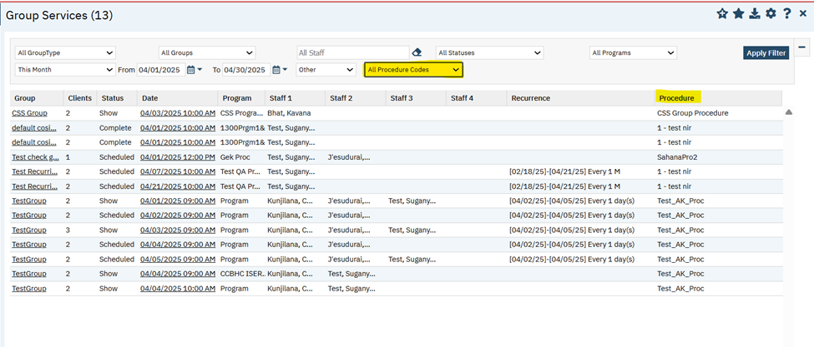

**Author:** Niroop Hassan

### 77. Core Bugs # 131055: Group Service Detail: Set All buttons are not functioning correctly.

**Release Type:** Fix | **Priority:** High

**Navigation Path:** ‘My Office’ - ‘Groups’ - ‘Groups’ list page – Click on ‘New’ icon – ‘Group Details’ page – Enter required data and select multiple clients and click on ‘Save’ icon – Click on ‘Schedule’ tab – Click on ‘New Group Service’ button – ‘Group Service Client Popup’ – Select required data and click on ‘Select’ button – ‘Group Service Detail’ page - ‘Custom Fields’ section.

**Functionality ‘Before’ and ‘After’ release:**

Before this release, here was the behavior. When the user selected the data in ‘Custom Fields’ section in the Group service details screen and then clicked on ‘Set All’ button, the ‘Set All’ functionality was not applied to all the clients.

With this release, the above-mentioned issue has been resolved. Now, when the user selects the data in ‘Custom Fields’ section in the Group service details screen and then clicked on ‘Set All’ button, the ‘Set All’ functionality is applied to all the clients.

**Author:** Suganya Sivakumar

### 78. Core Bugs # 130020: Issues in the Group service details screen.

**Release Type:** Fix | **Priority:** High

**Navigation Path :** My office - Groups - Groups List page - Click on New Icon - Group Detail page - Client section - Add Clients - Enter all the required fields - Click on Save button - Navigate to Schedule tab - Click on New Group Service button -Group Service Clients popup - Select Date of Service and Clients - Click on Select button- Navigate to Group Service Detail Screen - Enter all the required fields in the Service Tab - In the General section - Enter all the required information - Click on Save Button --- In the Service Tab - Click on the Make Recurring Icon - Recurring Services popup - In the Date Range section - Select the Start and the End Date - In the Recurrence Pattern section - select the appropriate values - Click on Create Immediately checkbox - Click on OK button - Navigate to Note tab - Click on Sign Button - Signature popup displays - PDF generated.

**Functionality ‘Before’ and ‘After’ release:**

Before this release, here was the behavior.

1. In the Group service details screen, when the primary clinician was updated, it was reflected in the show and the scheduled services for past date services.
2. In the Calendar, the appointments were also listed with the old primary clinician details, and it was not updated with the new primary clinician details.
3. If a client was removed from the group, it was reflected in the scheduled and show services for Future date services.
4. In the Calendar appointments, it was also listed with the deleted client details that got deleted from the group.

With this release, the above-mentioned issue has been resolved. Now, in the group service detail screen.

1.The New Primary Clinician will get updated on the scheduled and show services that have future date services on the group service details screen.

2. In the calendar, the appointments are updated with the new primary clinician's details.

3.When the Client is removed from the group, client is not reflected in scheduled and show services with a future date.

4. In the Calendar appointments, it is not listed with the deleted client details when it gets deleted from the group.

**Author:** Suganya Sivakumar

### 79. Core Bugs # 130697: Services/Notes: unable to error the Individual group service.

**Release Type:** Fix | **Priority:** Medium

**Navigation Path 1:** My office -Groups- Groups List page - Click on New Icon- Group Detail page - Client section - Add Clients - Enter all the required fields - Click on Save button - Navigate to Schedule tab -- Click on New Group Service button-Group Service Clients popup-Select Date of Service and Clients - Click on Select button-Navigate to Group Service Detail Screen - Enter all the required fields in the Service Tab-In the General section - Enter all the required information -Click on Save Button.

**Navigation Path 2:** Perform Client Search - Select Client- Services/Notes - Service/Note List Page- select the service note created from Navigation path 1-Service Note detail screen -Select the status to Error-Click on Save icon.

**Functionality ‘Before’ and ‘After’ release:**

Before this release, here was the behavior. When the user tried to error the Individual group service from the Service/Notes screen, the validation message popped up and took user back to the original service, with this user was not able to error out the selected service.

With this release, the above-mentioned issue has been resolved. Now, in the Service/Notes screen, the individual group service can be errored out without any repeated validation message.

**Author:** Chaithra Kunjilana

### 80. Core Bugs # 130775: Inaccurate UserName in CreatedBy and ModifiedBy columns.

**Release Type:** Fix | **Priority:** High

**Navigation Path:** My Office – Group Services – Enter the required values – Navigate to Client Note tab – Add Cosigner – Sign the Note.

**Functionality ‘Before’ and ‘After’ release:**

Before this release, here was the behavior. When a user signed the Group Services having a cosigner, the DocumentSignatures table audit columns were updating "UserName”, instead of "UserCode".

With this release, the above-mentioned issue is fixed, and now when a user signs a Group Services having a cosigner, the DocumentSignatures table audit columns will be updated with the "UserCode".

**Author:** Suganya Sivakumar

### 81. Core Bugs # 131084: Group Service Details – Performance Degradation due to Dataset XML Generating Duplicate Nodes.

**Release Type:** Fix **| Priority:** Medium

**Navigation Path: ‘**My office’ --- ‘Groups’ --- ‘Groups List’ page --- Click on ‘New’ Icon --- ‘Group Detail’ page --- ‘Client’ section --- ‘Add Clients’ --- Enter all the required fields --- Click on ‘Save’ button --- Navigate to ‘Schedule’ tab --- Click on ‘New Group Service’ button --- ‘Group Service Clients’ popup --- Select ‘Date of Service’ and ‘Clients’ --- Click on ‘Select’ button.

**Navigation Path 2:** Navigate to ‘Group Service Detail’ Screen --- Enter all the required fields in the ‘Service’ Tab --- In the ‘General’ section --- Enter all the required information --- Click on ‘Save’ Button --- Navigate to ‘Note’ tab --- Click on ‘Sign’ Button --- ‘Signature’ popup displays --- ‘PDF’ generated.

**Functionality ‘Before’ and ‘After’ release:**

Before this release, here was the behavior. In the ‘Group Detail’ screen, the dataset XML was generating duplicate tablelist nodes. This issue led to performance degradation, slowness, and the creation of error log records.

With this release, the above-mentioned issue has been resolved. Now, in the ‘Group Detail’ screen, there is no performance degradation, slowness, and error log records. Additionally, the dataset XML no longer generates any tablelist nodes.

# Inquiry Details

|  |  |  |
| --- | --- | --- |
| **Reference No** | **Task No** | **Description** |
| 82 | EII # 129599 | Changes in ‘Inquiry Details’ screen, a new Lock and Unlock functionality will be handled based on new Configuration key and new ‘ButtonUnLock’ permission controls using Role-Level/ Staff-level permission. |

**Author:** Savitha Siddaraju

### 82. EII # 129599 (Feature - 368982): Changes in ‘Inquiry Details’ screen, a new Lock and Unlock functionality will be handled based on new Configuration key and new ‘ButtonUnLock’ permission controls using Role-Level/ Staff-level permission.

**Note:** A new configuration key ‘AllowLockAndUnlockFunctionalityOnInquiryScreen’ will be set as ‘NO’ as part of this task. This Configuration key will be set as ‘Yes’ only for specific customers.

**Release Type:** Change | **Priority:** Urgent

**NavigationPath 1:** ‘Administration’ - ‘Configuration Keys’ - search the Key in Apply Filter ‘AllowLockAndUnlockFunctionalityOnInquiryScreen’ Key - Give any allowed values – ‘Save’.

**Navigation Path 2: ‘**Administration’ - ‘Role Definition’ - ‘Default Permissions’ for Selected ‘Role’ section – ‘Permission Type’ dropdown – select ‘Screens (new mode)/ Screens (Update mode)’ - select the parent as ‘Inquiry Details’ – Permission item as ‘ButtonUnLock’ and click ‘Apply filter’ button.

**Navigation Path 3: ‘**Administration’ – ‘Staff/User’ - ‘Staff Details’ screen - ‘Role Permission’ tab - ‘Default Permissions’ for Selected ‘Role’ section – ‘Permission Type’ dropdown – select Screens(new mode)/ Screens (Update mode) - select the parent as ‘Inquiry Details’ – ‘Permission item’ as ‘ButtonUnLock’ and click ‘Apply filter’ button.

**Navigation Path 4:** 'Client search popup' – ‘Inquiry (New Client)’ button - 'Inquiry Details' screen – Tool bar – ‘Unlock’ icon.

**Functionality ‘Before’ and ‘After’ release:**

**Purpose:** The user is allowed to lock and unlock the ‘Inquiry Details’ screen is implemented based on new Configuration key and new ‘ButtonUnLock’ permission controls using Role-Level/ Staff-level permission.

With this release, in an ‘Inquiry Details’ screen, a new ‘Lock’ and ‘Unlock’ functionality will be handled based on new Configuration key and a new ‘ButtonUnLock’ permission controls using ‘Role-Level/ Staff-level' permission have been implemented.

**System Configuration Key Details:**

**System Configuration Key**: AllowLockAndUnlockFunctionalityOnInquiryScreen

**Read Key as**: Allow Lock And Unlock Functionality On Inquiry Screen.

**Allowed Values**: Yes, No

**Default Value**: No

**Modules**: SCM Client Intake

**Description**: This is a new feature being added to the core product by introducing a system configuration key.

A) If the key-value is set to “No”, then Inquiry screen won't be having any unlock Icon. This will be the default value of the key as it **drives the existing behaviour.**

B) If the key-value is set to “Yes", then Inquiry screen will have Unlock icon and it will lock the Inquiry once the status is ‘Complete’. Further with required Permission, one can modify the Inquiry.

**Note:**

1. If by chance the value of the key is updated with any value apart from the allowed values, the system will consider the default behaviour, i.e. same as the key value is "No".

**Configuration Key Details screenshot:**

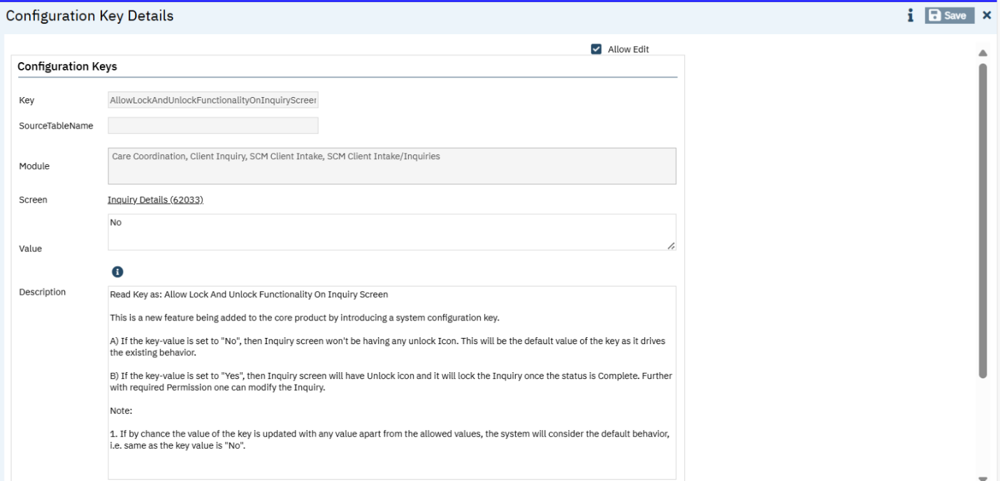

**Screen Permission Controls:**

A new ‘Unlock’ permission item is inserted into ‘ScreenPermissionControls’ table and this ‘ButtonUnLock’ Permission item will appear in the ‘Role Definition’ screen and in the ‘Staff Details’ screen under Permission Type - Screens (new mode) and Screens (Update mode).

The user can use the ‘Role Definition’ screen under the ‘Administration’ and based on ‘Screens (New Mode)’ and ‘Screens (Update Mode)’, the ‘ButtonUnLock’ control permissions will be handled, so that only those who are granted permission can ‘Unlock’ it to allow edits once ‘Inquiry screen’ is locked.

**Screen( New Mode):**

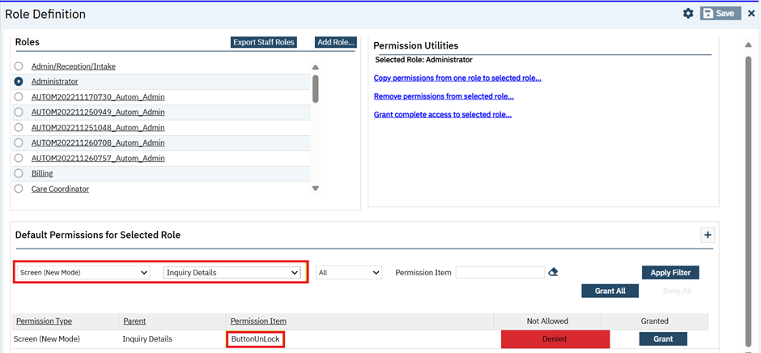

**‘Screens (Update Mode)’:**

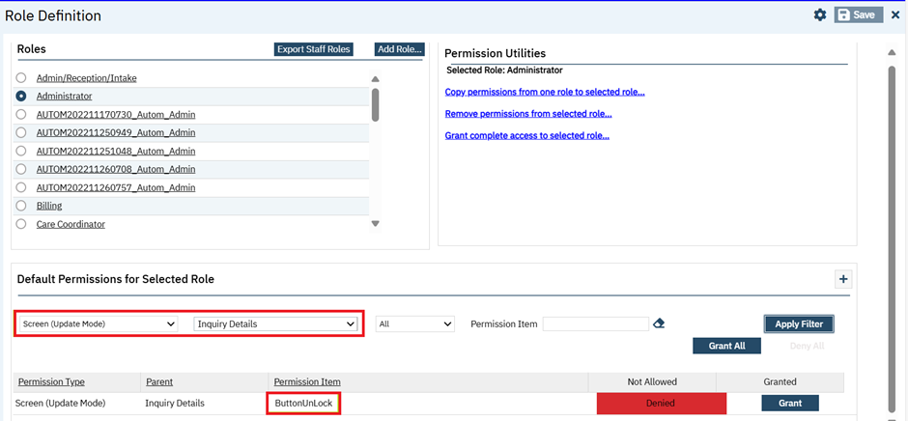

**‘Inquiry Details’ screen:**

* A new Unlock icon (single icon) will be displayed in the ‘Inquiry Details’ screen based on configuration key is set.
* When the inquiry is first opened, it is ‘Unlocked’ and any user can update the screen.
* When the status of Inquiry is changed to ‘Complete’ and the user saves, automatically setting the ‘Inquiry’ screen to ‘Locked’.
* For locked ‘Inquiry Details’ screen, all fields are disabled, and the user can switch between the tabs to view the details.

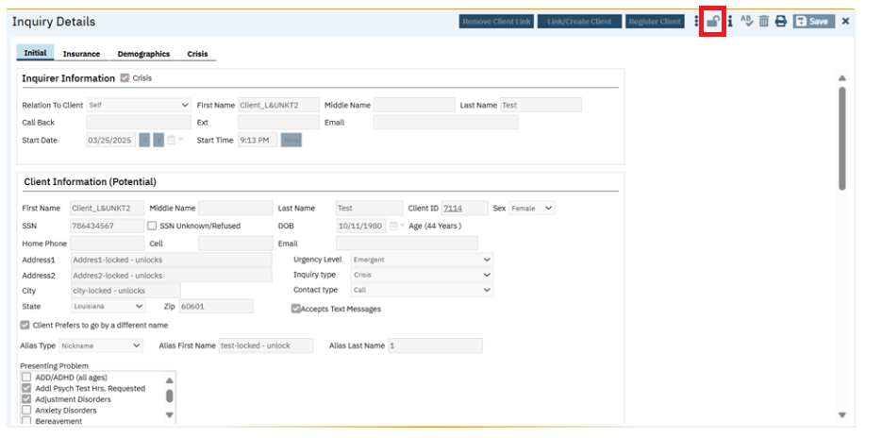

When configuration key ‘AllowLockAndUnlockFunctionalityOnInquiryScreen’ is set as ‘Yes’, and ‘ButtonUnLock’ Permission item is set as ‘Denied’, then in an ‘Inquiry Details’ screen:

* A new ‘Unlock’ icon will be displayed with disabled state and on clicking the ‘Unlock’ icon, no action will be performed.
* Any user will not be able to unlock the ‘Inquiry’ screen until the new permission item is granted.

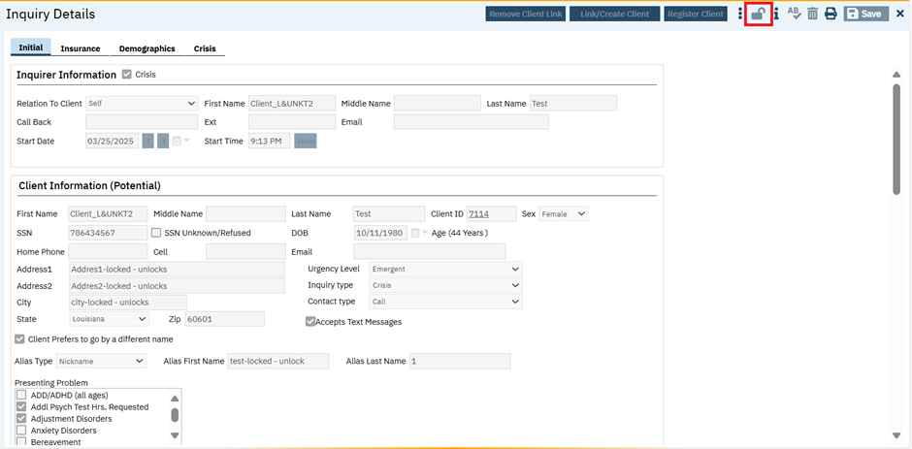

When configuration key ‘AllowLockAndUnlockFunctionalityOnInquiryScreen’ is set as ‘Yes’, and ‘ButtonUnLock’ Permission item is set as ‘Grant’, then in an ‘Inquiry Details’ screen:

* A new ‘Unlock’ icon will be displayed with enabled state and on Clicking the ‘Unlock’ icon, the ‘Inquiry’ screen will get unlocked with enabled fields.
* For an inquiry is completed and locked screen then further:

1. if a System Administrator attempts to unlocks the ‘Inquiry’ to make an edit or modifying the details, then the updated information will not be pushed to ‘Client Information’ screen.

**Note:** if user made any updates to an ‘Inquiry’ after it has been locked for the first time, would not push to ‘Client Information’ screen.

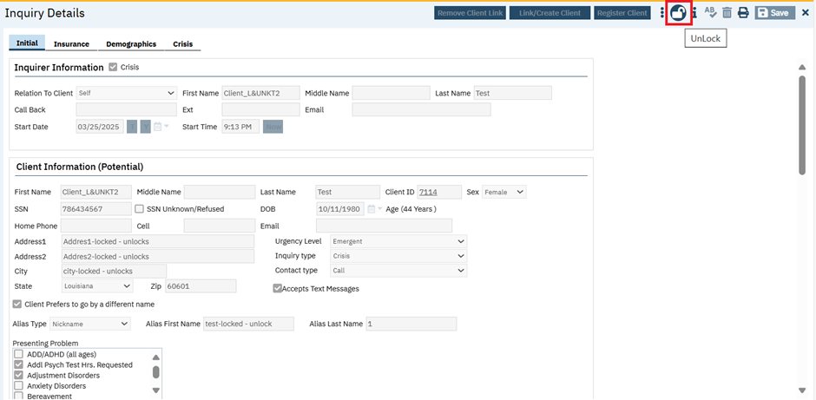

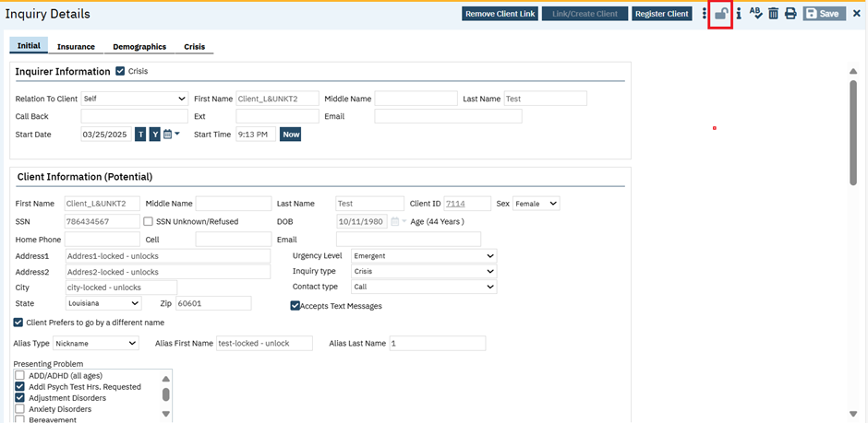

When configuration key ‘AllowLockAndUnlockFunctionalityOnInquiryScreen’ is set as ‘NO’, and ‘ButtonUnLock’ Permission item is set as either ‘Grant’ or ‘Denied’ then,

* Inquiry screen won't be having any unlock Icon. This will be the default value of the key as it drives the existing behaviour.

**Data Model Changes:**

Added new columns ‘InitiallyLocked’, ‘InitiallyLockedBy’, ‘InitiallyLockedDate’, ‘Locked’, ‘LockedBy’, ‘LockedDate’ to the existing table "Inquiries".

# Key Phrases

|  |  |  |
| --- | --- | --- |
| **Reference No** | **Task No** | **Description** |
| 83 | Core Bugs # 131168 | Record deleted KeyPhraseKeywords are displaying when hovered mouse on ‘Gold key’ icon in "Add/Edit Key Phrases" pop-up. |

**Author:** Sunil Belagali

### 83. Core Bugs # 131168: Record deleted KeyPhraseKeywords are displaying when hovered mouse on ‘Gold key’ icon in "Add/Edit Key Phrases" pop-up.

**Release Type:** Fix | **Priority:** Medium

**Navigation Path:** ‘Client’ -- Open any ‘Documents’ or ‘Services/Notes’ -- Click on Ellipse (3 dots) in the tooltip -- Click on ‘Add/Edit Key Phrase’ – ‘Add/Edit Key Phrases’ pop-up -- Hover on Gold Key icon.

**Functionality ‘Before’ and ‘After’ release:**  
  
Before this release, here was the behaviour. When the user hovered mouse on ‘Gold Key’ icon in the ‘Add/Edit Key Phrases’ pop-up, the record deleted KeyPhraseKeywords were displayed under the ‘Available key words.  
   
With this release, the above-mentioned issue has been resolved. Now, when the user hovers mouse on ‘Gold Key’ icon in the ‘Add/Edit Key Phrases’ pop-up, the record deleted KeyPhraseKeywords will not display under the ‘Available key words’.

# Letter Templates

|  |  |  |
| --- | --- | --- |
| **Reference No** | **Task No** | **Description** |
| 84 | EII # 129873 | Spellchecker implemented for the Letter Template. |

**Author:** Kiran Yogendra

### 84. EII # 129873 (Feature - 485631): Spellchecker implemented for the Letter Template.

**Release Type:** Change **| Priority:** Urgent

**Navigation Path:** Login to SmartCare application – Search for ‘Letter Templates’ - Letter Templates list page – Click on ‘New’ icon – Input Template Name – Select the Letter Category – Enter Letter Template Description.

**Functionality ‘Before’ and ‘After’ release:**

**Purpose:** Enabling the Web spellchecker will help users auto-validate spellings on letter templates.

With this release, ‘Enable SCAYT’ plugin has been removed, which was used for checking the spelling and grammar on the ‘Letter Templates’.

Now, **web spellchecker** is enabled to suggest the corrected keywords for the wrongly entered words on the Letter Templates.

**How it works:** Once the web spellchecker is enabled, when the Letter Template is opened, any spelling errors on the template will be highlighted. In order to correct those words, we need to focus the cursor on the word that needs correction, hold the ‘Ctrl’ key (Control Key) and right click to get the suggestions for correction.

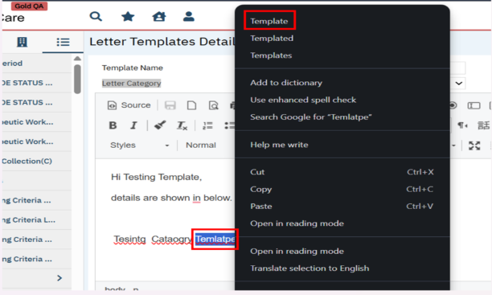

# Life Events

|  |  |  |
| --- | --- | --- |
| **Reference No** | **Task No** | **Description** |
| 85 | EII # 130458 | Implementation to dynamically display Start Time and End Time fields on the Client Life Event screen, based on the new Life Event Setup configuration. |
| 86 | Core Bugs # 131083 | Client Life Events: The Grid size of the list page varies when clicking on Apply filter. |

**Author:** Niroop Hassan

### 85. EII # 130458 (Feature - 517908): Implementation to dynamically display Start Time and End Time fields on the Client Life Event screen, based on the new Life Event Setup configuration.

**Release Type:** Change **| Priority:** Urgent

**Navigation Path:** Administration – ‘Life Events Set Up’ - ‘Life Events Set Up’ list page – Click on ‘New’ icon – ‘Life Events Set Up Details’ page.

**Functionality ‘Before’ and ‘After’ Release:**

**Purpose:** To dynamically display Start Time and End Time fields on the Client Life Event screen, based on the Life Event Setup configuration in 'ShowTimeFields' column.

With this Release, the following has been implemented in Override Field Name Section:

* ‘Start Time’ field has been added with ‘Begin Time’ editable label textbox.
* ‘End Time’ field has been added with ‘End Time’ editable label textbox.
* ‘Show Time Fields’ checkbox option has been added.   
     
   1. "When the checkbox is checked, the 'Start Time' and 'End Time' labels will be displayed dynamically, upon selecting a Life Event in the 'Client Life Event Details' screen.  
     
   2. "If the checkbox is not selected, 'Start Time' and 'End Time' labels on the 'Client Life Events' screen’ will be hidden.

**Data Model Changes:**

* Added columns BeginTimeLabel , EndTimeLabel and ShowTimeFields in LifeEvents table
* Added columns BeginTime and EndTime in ClientLifeEvents table

**Author:** Suganya Sivakumar

### 86. Core Bugs # 131083: Client Life Events: The Grid size of the list page varies when clicking on Apply filter.

**Release Type:** Fix **| Priority:** Medium

**Navigation Path:** Go Search – Select Client - Life Events ( Clients ) - Life Events List page – click on Apply filter.

**Functionality ‘Before’ and ‘After’ Release:**

Before the release, here was the behavior. In the Client Events List page, the grid size varied when the user clicked the 'Apply Filter' button.

With this release, the above-mentioned issue has been resolved. Now, on the List page, the grid size does not vary when the user clicks the 'Apply Filter' button.

# Manage Claims

|  |  |  |
| --- | --- | --- |
| **Reference No** | **Task No** | **Description** |
| 87 | Core Bugs # 130658 | Adjudicating Claim Lines issue. |
| 88 | Core Bugs # 130968 | The ‘Activity’ column is blank in the 'Status and Payment History' section of 'Claim Line Detail' screen. |

**Author:** Renuka Gunasekaran

### 87. Core Bugs # 130658: Adjudicating Claim Lines issue.

**Release Type:** Fix **| Priority:** High

**Navigation Path:** 'My Office' -- 'Claims' -- ‘Claims’ list page -- Select ‘Claim Line’ -- Select 'Adjudicate' from 'Select Action' dropdown.

**Functionality ‘Before’ and ‘After’ release**:

Before this release, here was the behavior. When the same claim line was selected for Adjudication which was already selected and adjudicated by another batch, 'AdjudicationProcessClaimLines' table inserted with duplicate claim lines.

With this release, the above-mentioned issue has been resolved. Now, Duplicate claim lines are not inserted in 'AdjudicationProcessClaimLines' table. When one claim line is adjudicated and inserted into 'AdjudicationProcessClaimLines' table by one batch, another batch will not be inserting the claim line into 'AdjudicationProcessClaimLines' table.

**Author:** Renuka Gunasekaran

### 88. Core Bugs # 130968: The ‘Activity’ column is blank in the 'Status and Payment History' section of 'Claim Line Detail' screen.

**Release Type:** Fix **| Priority:** High

**Navigation Path:** 'My Office' -- 'Claims' – ‘Claim Lines’ List page -- Select 'Denial letter not sent' Status -- Select ‘Insurer’ and ‘Bank accounts’ -- Select ‘Claim Line’ -- Select 'Denial Letter' from ‘Select Action' dropdown -- Create Denial Letter --'Close' popup -- Select same claim line id -- 'Claim Line Detail' screen -- 'Status and Payment History' section -- 'Activity' column.

**Functionality ‘Before’ and ‘After’ release:**

Before this release, here was the behavior. When the user created Denial Letter for the denied claim lines, the ‘Activity’ column was blank and was not updated with any value in the 'Status and Payment History' section of 'Claim Line Detail' screen.

With this release, the above-mentioned issue has been resolved. Now, Global code id '2013' is added in the Global Codes for the Code Category of 'CLAIMLINEACTIVITY'. Now, the Denial Letter activity is updated in the ‘Activity’ column under the 'Status and Payment History' section of 'Claim Line Detail' screen, when the user creates a Denial Letter for Denied Claim Lines.

# Methadone

|  |  |  |
| --- | --- | --- |
| **Reference No** | **Task No** | **Description** |
| ~~89~~ | ~~EII # 124949~~ | ~~The MAT Pump Transaction report is implemented.~~ |
| ~~90~~ | ~~EII # 127705~~ | ~~New changes are added to the Medication Inventory Transaction list page.~~ |
| ~~91~~ | ~~EII # 128645~~ | ~~Implementation to identify No Shows and Take Homes in the MAR screen.~~ |
| ~~92~~ | ~~EII # 130330~~ | ~~Changes are added to the ‘MAT Management Details’ and ‘MAT Configuration’ screens.~~ |
| ~~93~~ | ~~Core Bugs # 130891~~ | ~~Client Orders: Scheduled validation is not displayed when client has 0 take home days while signing the client order and ‘Titration/Taper? Orders.~~ |
| ~~94~~ | ~~Core Bugs # 130892~~ | ~~Client order: Validation message is displayed when completing titration order.~~ |
| ~~95~~ | ~~Core Bugs # 130980~~ | ~~MAT: Issues with the MAT No Show Clients Report.~~ |
| ~~96~~ | ~~Core Bugs # 131038~~ | ~~Medication/Lot/Bottle list page: Lot field value is clearing when clicking on Apply filter.~~ |
| ~~97~~ | ~~Core Bugs # 131045~~ | ~~MAT: Medication/Lot/Bottle Screen Displaying in only Half of the Screen.~~ |
| ~~98~~ | ~~Core Bugs # 131100~~ | ~~Incorrect Client Flag generated by the system.~~ |
| ~~99~~ | ~~Core Bugs # 131086~~ | ~~Medication/Lot/Bottle details: Validation message is displayed for the Bottle/Box ID when saving.~~ |
| ~~100~~ | ~~Core Bugs # 131133~~ | ~~MAT: Bottle Return functionality: Number of bottles to return is showing as None in the popup.~~ |
| ~~101~~ | ~~Core Bugs # 131206~~ | ~~Global codes: users are unable to add new values to the Global code category.~~ |
| ~~102~~ | ~~Core Bugs # 131019~~ | ~~MAT Management details: Warning message is not displayed when client has more than 3 No shows.~~ |

**~~Author:~~** [~~Varsha Patil~~](mailto:gjayanna@streamlinehealthcare.com)

### ~~89. EII # 124949 (Feature - 244352): The MAT Pump Transaction report is implemented.~~

**~~Release Type:~~** ~~Change |~~ **~~Priority:~~** ~~Urgent~~

**~~Navigation Path:~~** ~~My Office’ – ‘My Reports’ – ‘MAT Pump Transaction report’.~~

**~~Functionality ‘Before’ and ‘After’ release:~~****~~Purpose:~~** ~~This report will allow the user to produce a report showing different operations done from the machine.~~

~~With this release, the MAT Pump Transaction report is implemented to capture and track MAT machine pump activities.~~

~~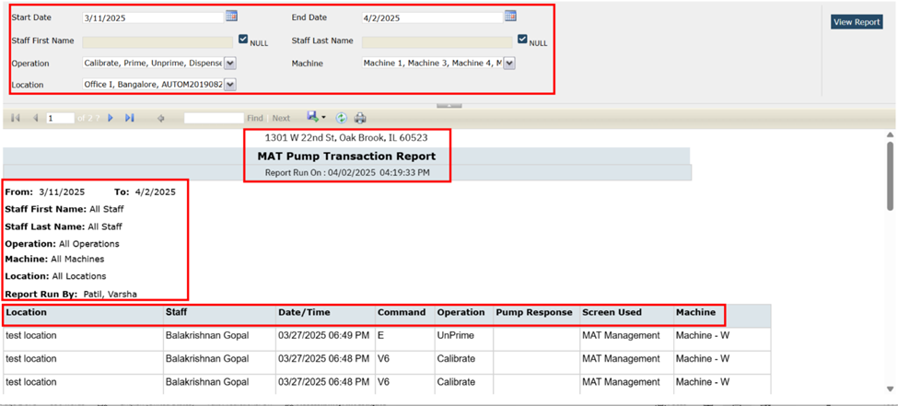~~

**~~Filter Section:~~**

1. ~~Following are the filters present in the report:~~
2. **~~Start Date:~~** ~~This is a Calendar Control~~ ~~field and it is a required field, by default Today’s date will be displayed.~~
3. **~~End Date:~~** ~~This is a Calendar Control field, and it is a required field, by default Today’s date will be displayed.~~

~~3.~~ **~~Staff First Name:~~** ~~This is a textbox field and by default it will be blank and disabled.~~

~~4.~~ **~~Null:~~** ~~This is a checkbox and displayed next to the Staff first Name text field.   
By default, it is checked and pulls all Staff First Names. If Null checkbox is unchecked, user will be able to enter Staff First Name.~~

~~5.~~ **~~Staff Last Name:~~** ~~This is a textbox field and by default it will be blank and disabled.~~

~~6.~~ **~~Null:~~** ~~This is a checkbox and displayed next to the Staff Last Name text field.   
By default, it is checked and pulls all Staff Last Names. If Null checkbox is unchecked, user will be able to enter Staff Last Name.~~

~~7.~~ **~~Operation:~~** ~~This is a multi-select drop down and displays all Mapping for the field MAT Dispenser Detail - User/Operation Log - Operation = Calibrate, Prime, Unprime and Dispense. This is a required field, by default All Operations will be displayed.~~

~~8.~~ **~~Machine:~~** ~~This is a multi-select drop down and Displays all MAT Dispenser - Machine Names. This is a required field, by default All Machines will be displayed.~~

~~9.~~ **~~Location:~~** ~~This is a multi-select drop down and Displays users Location of MAT Dispensing Machine. This is a required field, by default All MAT Locations will be displayed.~~

**~~Header Section:~~** ~~The following Header names are present in the report:~~

1. **~~Address:~~** ~~Displays Agency Address.~~
2. **~~Report Name:~~** ~~Displays report name as MAT Pump Transaction Report.~~
3. **~~Report Run On:~~** ~~This is a label name and displays Date and Time when the report was run/pulled/executed. This will be in MM/DD/YYYY HH:MM:SS AM/PM format.~~

**~~Sub header Section:~~** ~~The Following are the Subheaders are present in the report:~~

1. **~~From:~~** ~~It Displays Start Date chosen for report.~~
2. **~~To:~~** ~~It Displays End Date chosen for report, display on the same line as Start Date.~~
3. **~~Staff First Name:~~** ~~It Lists Staff First Name selected in filter. If no staff is selected, it will display "All Staff".~~
4. **~~Staff Last Name~~**~~: It Lists Staff Last Name selected in filter. If no staff is selected, it will displays "All Staff".~~
5. **~~Operation:~~** ~~It displays Operation option selected for Report from Filter. If no Operation is selected, it will display "All Operations".~~
6. **~~Location:~~** ~~It displays Location option selected for Report from Filter. If no Location is selected, it will display "All Locations".~~
7. **~~Machine:~~** ~~It displays Machine option selected for Report from Filter. If no Machine is selected, it will display "All Machines".~~
8. **~~Report Run By~~**~~: It Prints name of Staff who is logged into SmartCare and generates report.~~

**~~Grid Section:~~** ~~Following are the grid columns present in the report:~~

1. **~~Location:~~** ~~Displays of location(s) selected in the filter. This will display on every page of the report.~~
2. **~~Staff:~~** ~~This report is grouped by Staff Name and displays the Staff First Name and Last Name who performed the pump transaction. (MAT Dispenser Detail - User/Operation Log - Staff for the associated Operation).~~
3. **~~Date/Time:~~** ~~Displays the Date time of associated MAT Dispenser transaction (MAT Dispenser Detail - User/Operation Log - Date for the associated Operation). The Report will be sorted by most recent Date / Time first, for each staff.~~
4. **~~Command:~~** ~~Displays the COMMAND from the MAT Dispenser, which is stored in the MAT tables.~~
5. **~~Operation:~~** ~~Displays Operation from the MAT Dispenser (Prime, Unprime, Calibrate and Dispense).~~
6. **~~Pump Response:~~** ~~Displays PUMP RESPONSE from the MAT Dispenser, which is stored in MAT tables. For 'Prime' and 'Unprime' Operations, this will display blank, since there is no Pump Response for these types of Operations.~~
7. **~~Screen Used:~~** ~~Displays the Screen Used for the COMMAND/OPERATION, which is stored in MAT tables.~~
8. **~~Machine:~~** ~~Displays the MAT Dispenser - Machine Name, for the associated Operation.~~

**~~Data Model Changes:~~** ~~A new column MATDispenserId is added to the MATDispenserAPILog table.~~

**~~Author:~~** ~~Madhu Basavaraju~~

### ~~90. EII # 127705 (Feature - 373849): New changes are added to the Medication Inventory Transaction list page.~~

**~~Release Type:~~** ~~Change |~~ **~~Priority:~~** ~~On Fire~~

**~~Prerequisites:~~**

**~~1:~~** ~~Machine/Window details are created on the MAT Dispenser Screen.~~

**~~2.~~** ~~Client Order is signed and dispensed on the MAT Management details screen with Machine Connected.~~

**~~Navigation Path:~~** ~~My Office - Medication Inventory Transaction’ list page.~~

**~~Functionality ‘Before’ and ‘After’ release:~~****~~Purpose:~~** ~~To allow users to identify the Machine/Window (MAT Dispenser/Machine) that was associated to the Transaction and include that on the Medication Inventory Transaction’ list page.~~

~~With this release, the below changes are implemented in ‘Medication Inventory Transaction’ list Screen.~~

~~The new column ‘Machine’ has been added to the ‘Medication Inventory Transaction’ List page and it will display the 'Machine' name that is associated to the Transaction.~~

* ~~If no 'Machine' is associated, then the column is displayed as blank.~~
* ~~The system will determine the 'Machine' for each Transaction by checking the Transactions that exist between Machine Connection and Machine Disconnection. Once connected, all Transactions will be linked to that Machine, until the Machine is Disconnected.~~

~~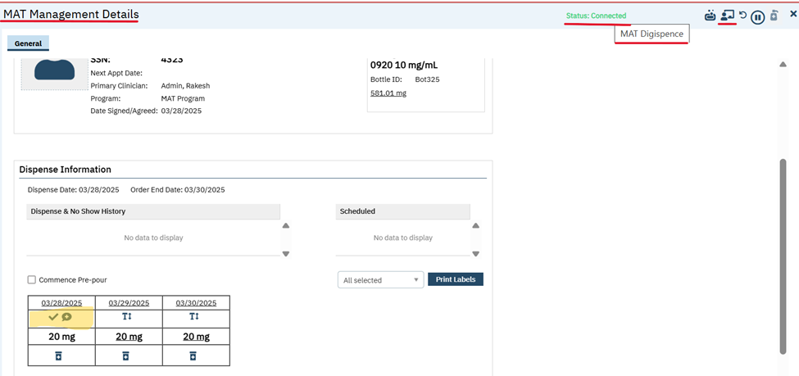~~

**~~Machine connection popup in MAT Management screen:~~**

~~

~~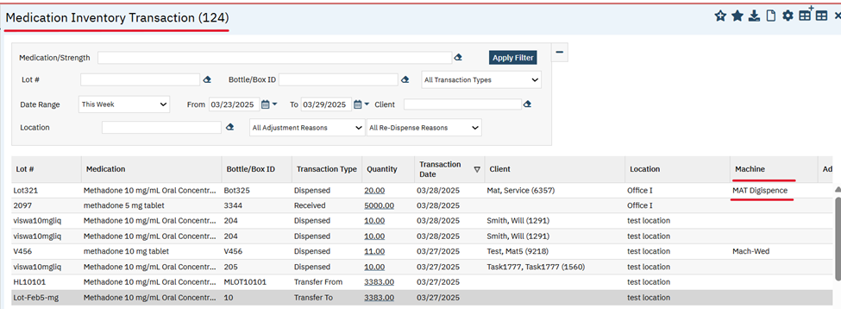~~

**~~Data Model Changes~~**~~: A new column MATDispenserId is added to the MEDICATIONTRANSACTIONS table.~~

**~~Author:~~** ~~Sithara Ponnath~~

### ~~91. EII # 128645 (Feature - 440678): Implementation to identify No Shows and Take Homes in the MAR screen.~~

**~~Release Type:~~** ~~Change~~ **~~| Priority:~~** ~~Urgent~~

**~~Navigation Path 1:~~** ~~‘Administration’ --- ‘Global Codes’ screen --- Select ‘MARSTATUS’ category from the ‘All Categories’ dropdown --- Click on ‘Apply Filter’ button.~~

**~~Navigation Path 2:~~** ~~‘Administration’ --- ‘MAT Configuration’ screen --- ‘Allow Inpatient Nurses to Dose Take Homes on MAR’ checkbox.~~

**~~Navigation Path 3:~~** ~~‘Client’ --- ‘Client Orders’ screen --- Search and select a MAT Order --- Enter value in the field ‘No of Take Home’ for a Take Home order or leave the field blank for Face-to-Face order --- Click on ‘Insert’ button --- Click on ‘Save/Sign’ button to schedule the MAT Order.~~

**~~Navigation Path 4:~~** ~~‘My Office’ --- ‘MAT Management’ list screen --- Filter with the date to get the desired order result --- Connect to the inventory or machine with the same medication strength ---Click on the scheduled MAT Order dispense icon --- ‘MAT Management Details’ screen --- Click on the Take Home icon to dispense the dose.~~

**~~Navigation Path 5:~~** ~~‘Client’ --- ‘Client MAR’ screen --- Filter with the start and end date --- Select a correct shift from the field ‘Select Shift’.~~

**~~Navigation Path 6:~~** ~~‘My Office’ --- ‘MAT Management’ list screen --- Filter with the date to get the desired order result --- Select the ‘Status’ hyperlink --- Select ‘No Show’ from the ‘Current Status’ dropdown and a reason from the ‘Reason’ dropdown in the ‘MAT Current Status Popup’ --- Click on ‘Change’ button.~~

**~~Navigation Path 7:~~** ~~‘My Office’ --- ‘MAT Management’ list screen --- Filter to get the desired order result --- Click on ‘No-Show Bulk Update’ icon to mark the orders to ‘No Show’.~~

**~~Navigation Path 8:~~** ~~‘My Office’ --- ‘MAT Management’ list screen --- Filter with a past date --- Verify the order status marked to ‘No Show’ via Nightly MAR Job’.~~

**~~Functionality ‘Before’ and ‘After’ release:~~**

**~~Purpose:~~** ~~This is an enhancement to the MAR for MAT customers that will identify No Shows and Take Homes..~~

~~With this release, the below changes have been implemented in the ‘Global Codes’, ‘Client MAR’ screen and ‘MAT Configuration’ screen for the MAT orders.~~

* ~~Added ‘No Show’ and ‘Received Take Home’ values in the existing global code ‘MARSTATUS’ which will only be available for MAT Orders.~~

**~~Global Codes Screen~~**

~~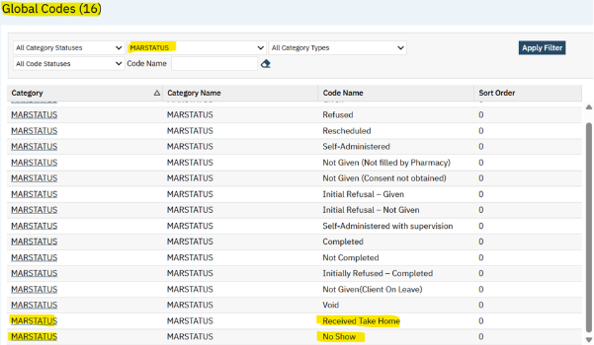~~

* ~~A new checkbox ‘Allow Inpatient Nurses to Dose Take Homes on MAR’ is added in the ‘MAT Configuration’ screen.~~

**~~MAT Configuration Screen~~**

~~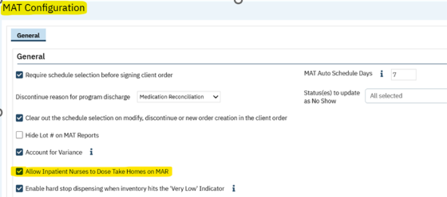~~

* ~~The checkbox~~ **~~‘Allow Inpatient Nurses to Dose Take Homes on MAR’~~** ~~will be unchecked by default in the MAT Configuration screen.~~

* ~~When the checkbox~~ **~~‘Allow Inpatient Nurses to Dose Take Homes on MAR’ is checked~~** ~~and a Take Home is dispensed within the time window from the ‘MAT Management Details screen then,~~
* ~~The Take Home will display the ‘~~**~~Clickable Capsule Icon~~**~~’ on the MAR screen for the MAT Orders and even for the split doses.~~
* ~~A hover text will be displayed as 'Received Take Home' with the Date/Time that the Take Home was dispensed in MM/DD/YYYY HH:MM format.~~

**~~Scheduled MAT Order in the Client MAR screen~~**

~~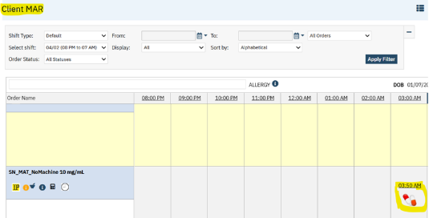~~

**~~Scheduled MAT Order in the MAT Management List screen~~**

~~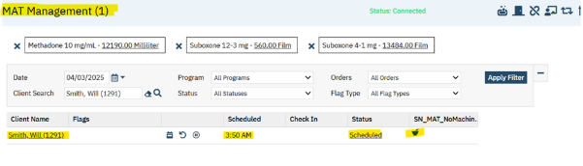~~

**~~Take Home is dispensed in the MAT Management Details screen~~**

~~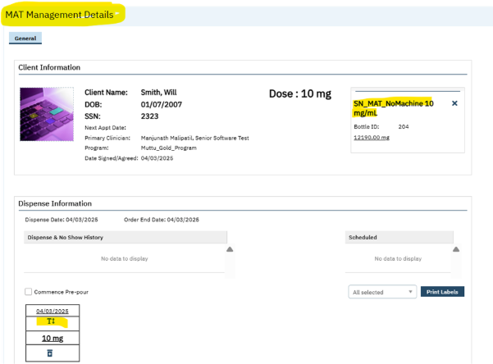~~

~~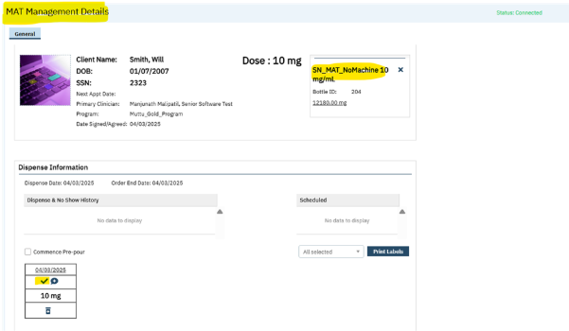~~

**~~Take Home dispensed in the Client MAR screen within the time window shows clickable capsule icon~~**

~~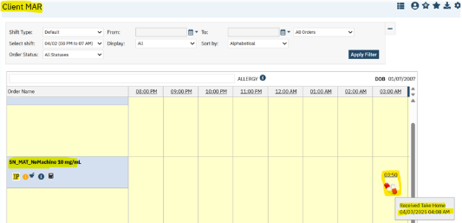~~

~~On clicking ‘~~**~~Clickable Capsule Icon~~**~~’ on the Client MAR screen, it will display as ‘Given’, a ‘Green Check Mark’ with the hyperlink and will display the Staff Name who dispensed the Take Home.~~

~~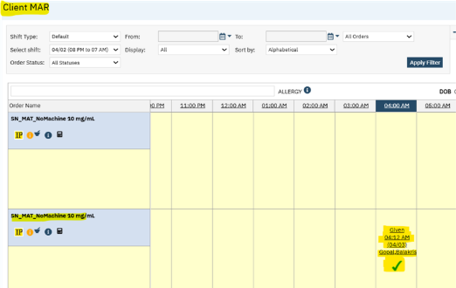~~

~~When the checkbox~~ **~~‘Allow Inpatient Nurses to Dose Take Homes on MAR’ is checked~~** ~~and a Take Home is dispensed outside the time window from the ‘MAT Management Details screen, then, Take Home will display the grey checkmark on the MAR screen as per the existing functionality.~~

~~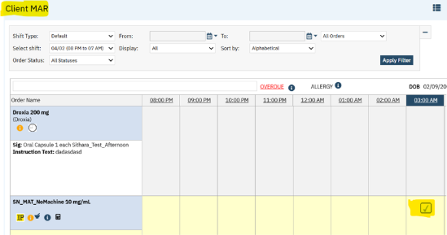~~

~~When the checkbox~~ **~~‘Allow Inpatient Nurses to Dose Take Homes on MAR’ is NOT checked~~** ~~and a Take Home is dispensed within the time window from the ‘MAT Management Details screen, then, Take Home will be displayed as ‘Green Check Mark’ same functionality as given with the hyperlink and will display the Staff Name who dispensed the Take Home.~~

~~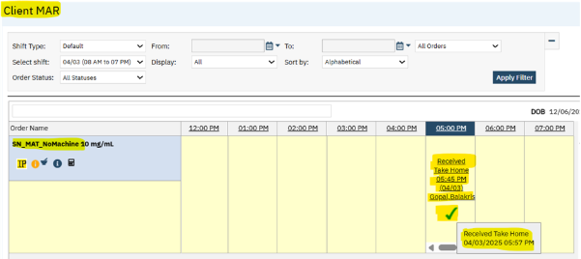~~

* ~~When a scheduled MAT Order is marked as~~ **~~No-Show,~~** ~~when the status is updated manually by staff or via clicking on ‘No Show – Bulk Update’ icon at the top of the MAT Management list page or via Nightly MAR Job, MARSTATUS for the order will also be marked as No Show and will display a new ‘Cross Mark’ icon with the scheduled Date/Time and a hover text ‘No Show’ in the Client MAR screen.~~

* ~~When the MARSTATUS is marked to No Show manually via staff or via bulk update then, the Staff Name will be displayed as entered by who had updated the status or completed the Bulk Update action.~~

**~~‘No Show’ displays in Client MAR screen when updated via manually or bulk update.~~**

~~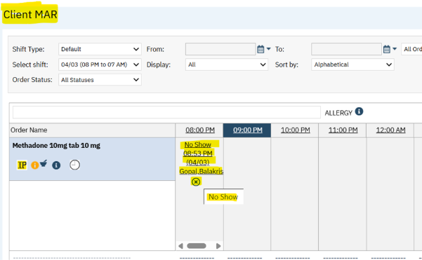~~

* ~~When the MARSTATUS is marked to No Show via Nightly MAR Job then, the Staff Name will not be displayed as entered by i.e., it will be blank.~~

**~~‘No Show’ displays in Client MAR screen when updated via Nightly MAR Job~~**

~~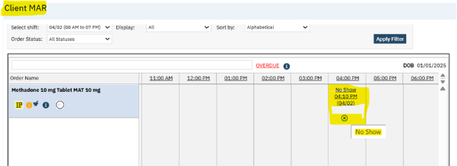~~

**~~Data Model Changes:~~** ~~Added column AllowInpatientNurseToDoseTakeHomesOnMAR in MATConfigurations table~~

**~~Author:~~** ~~Sithara Ponnath~~

### ~~92. EII # 130330 (Feature - 512752): Changes are added to the ‘MAT Management Details’ and ‘MAT Configuration’ screens.~~

**~~Release Type:~~** ~~Change |~~ **~~Priority:~~** ~~On Fire~~**~~Navigation Path 1:~~** ~~‘Administration’ - ‘MAT Configuration’ screen – verify ‘Enable hard stop dispensing when inventory hits the 'Very Low' Indicator.’ checkbox.~~

**~~Navigation Path 2:~~** ~~My Office - ‘MAT Dispenser’ screen - Select a machine –MAT Dispenser Details- Set a value for ‘Very low’ field.~~

**~~Navigation Path 3:~~** ~~‘Client’ - ‘Client Orders’ screen - Search and select a MAT Order - Enter required data - Click on ‘Insert’ button - Click on ‘Save/Sign’ button.~~

**~~Navigation Path 4:~~** ~~‘My Office’ - ‘MAT Management’ list screen –Filter with the Order date- Connect to the machine with the same medication strength as signed client order -Click on the scheduled MAT Order dispense icon - ‘MAT Management Details’ screen- Click on ‘Dispense’ icon - Click on ‘Re-Dispense’ icon (+) icon.~~

**~~Functionality ‘Before’ and ‘After’ release:~~****~~Purpose:~~** ~~This change is needed to prevent partial or incomplete medication dispensing, ensuring the accurate and reliable dose delivery.~~

~~With this release, the below changes have been implemented in the ‘MAT Management Details’ screen and ‘MAT Configuration’ screen for MAT orders.~~

* ~~A new checkbox ‘Enable hard stop dispensing when inventory hits the 'Very Low' Indicator.’ is added under the General section of General tab in the ‘MAT Configuration’ screen with a tooltip information. This checkbox will be unchecked by default.~~

~~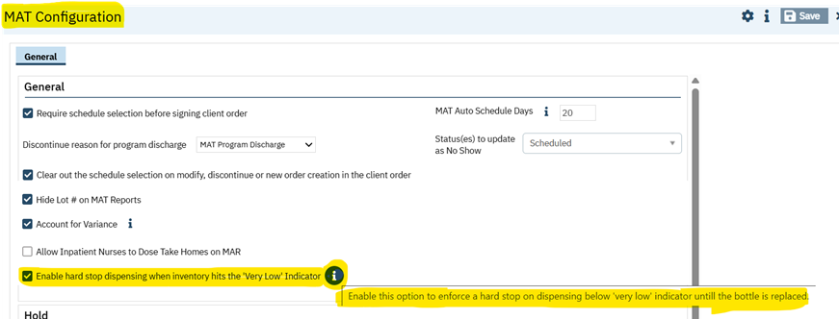~~

* ~~When a machine is connected and the connected bottle’s remaining amount is less than or equal to the ‘Very Low’ amount set in the ‘MAT Dispenser Details’ screen, then a hard stop or a warning message will be displayed in the MAT Management details screen on click of dispense or re-dispense icon if the hard stop configuration is enabled i.e.,~~ **~~‘Enable hard stop dispensing when inventory hits the 'Very Low' Indicator~~**~~.’ checkbox~~ **~~is Checked~~** ~~in the ‘MAT Configuration’ screen.~~

**~~Warning Message:~~** ~~"The remaining amount in the bottle is at or will fall below the "Very Low" threshold, preventing dispensing. Please replace the bottle before proceeding."~~

**~~MAT Dispenser Details screen with a value set for ‘Very Low’.~~**

~~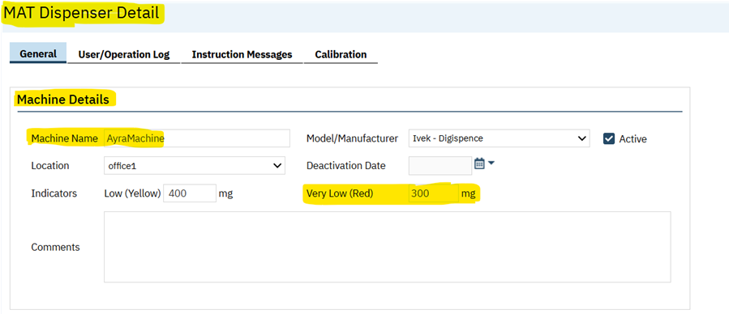~~

**~~MAT Management Details screen displays the warning message when the bottle’s remaining amount falls below Very Low value on dispense.~~**

~~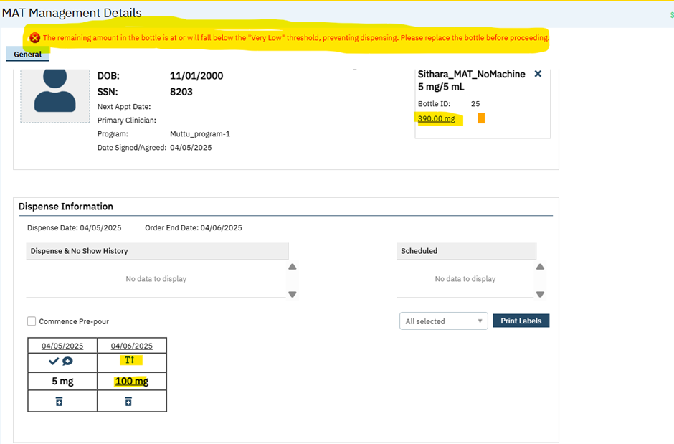~~

**~~MAT Management Details screen displays the warning message when the bottle’s remaining amount falls below Very Low value on re-dispense.~~**

~~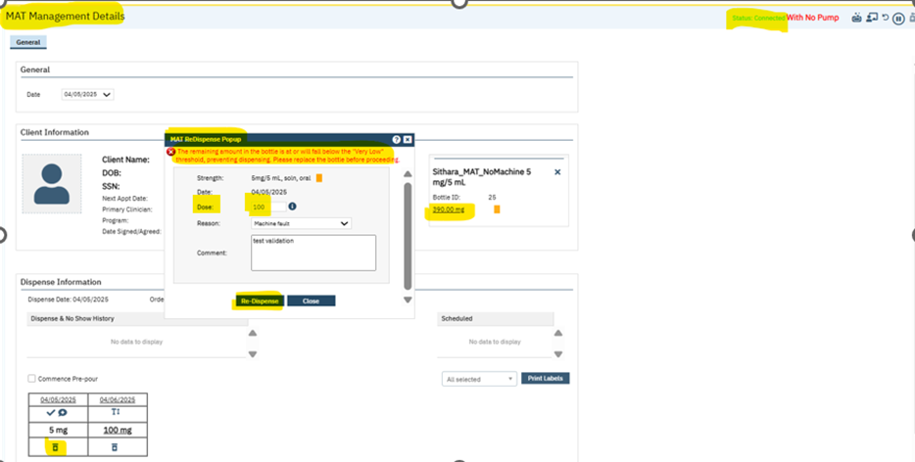~~

* ~~After the bottle is replaced and the remaining quantity is above the Very Low Indicator, the system will automatically clear the hard stop or warning message, and the user will be able to dispense the medication.~~
* ~~When~~ **~~‘Enable hard stop dispensing when inventory hits the 'Very Low' Indicator~~**~~.’ checkbox~~ **~~is not Checked~~** ~~in the ‘MAT Configuration’ screen, the user will be able to continue dispensing below or at the 'Very Low' indicator and won’t be required to change the bottle until a dispense amount exceeds the remaining quantity.~~

**~~Data Model Changes:~~** ~~The new column EnableHardStopDispensingOnVeryLowIndicator is added to MATConfigurations table.~~

**~~Author:~~** ~~Chaitali Patil~~

### ~~93. Core Bugs # 130891: Client Orders: Scheduled validation is not displayed when client has 0 take home days while signing the client order and ‘Titration/Taper? Orders.~~

**~~Release Type:~~** ~~Fix |~~ **~~Priority:~~** ~~High~~

**~~Navigation Path 1:~~** ~~Administration - Orders’ - Orders’ list page - New - Order Details’ screen -Select ‘Medication’ Order Type - Enter the required fields - Select (Medication Assisted Treatment (MAT, Take Home Allowed) = Yes, under ‘Medication Assisted Treatment’ section and display program? is ‘Yes’ for MAT Orders – Save.~~

**~~Navigation Path 2:~~** ~~Administration - Orders’ - Orders’ list page - New - Order Details’ screen -Select ‘Medication’ Order Type - Enter the required fields - Select (Medication Assisted Treatment (MAT, Take Home Allowed) = Yes, under ‘Medication Assisted Treatment’ section and under the Option section Titration/Taper? The radio button is selected with 'Yes’, and display program? is ‘Yes’ for MAT Orders – Save.~~

**~~Navigation Path 3:~~** ~~‘Client’- ‘Client Orders’ - ‘Client Orders’ list page - New - ‘Client Order details’ screen - Select the Order created in Navigation Path 1 - Enter the required fields – select Program – enter the # Of Take Home Days field = ‘0‘ or select ‘Phase/Level of Care’ as Phase 0 – insert order in the grid - click on ‘save’ and sign.~~

**~~Navigation Path 4:~~** ~~‘Client’- ‘Client Orders’ - ‘Client Orders’ list page - New - ‘Client Order details’ screen - Select the Order created in Navigation Path 2- Enter the required fields – select Program – enter the # Of Take-Home Days field = ‘0‘ or select ‘Phase/Level of Care’ as Phase 0 – Click on Titration/Taper? Button to insert first step – add one more step as above - click on ‘save’ and sign.~~

**~~Functionality ‘Before’ and ‘After’ release:~~**

~~Before this release, here was the behavior. When signing the MAT orders and ‘Titration/Taper? Orders in the Client Order screen, if the Take Home days selected as =0 and in the ‘MAT Client level Setup’ Schedule was not selected as per the take home days field, then on sign, the below validation message was not displayed.~~

**~~Validation Message:~~** ~~Please select the days in according to the # of Take-Home Days field.~~

~~With this release, the above-mentioned issue is resolved. Now, when signing the MAT orders and ‘Titration/Taper? Orders in the Client Order screen, if the Take Home days as selected as =0 and in the ‘MAT Client level Setup’ Schedule is not selected as per the take home days field, then on signing, the below validation message is displaying.~~

**~~Validation Message:~~** ~~Please select the days in according to the # of Take Home Days field.~~

**~~Author:~~** ~~Madhu Basavaraju~~

### ~~94. Core Bugs # 130892: Client order: Validation message is displayed when completing titration order.~~

**~~Release Type:~~** ~~Fix |~~ **~~Priority:~~** ~~High~~

**~~Prerequisite:~~** ~~Client Order is signed with MAT Order for the specific date Range.~~

**~~Navigation Path:~~** ~~Go Search-Select Client-Client Orders-Click on new icon-Enter all the required details-Sign.~~

**~~Functionality ‘Before’ and ‘After’ release:~~**

~~Before this release, here was the behavior. When the user tried to complete the titration order, the below validation message was displayed in the Client order screen.~~

**~~Validation Message:~~** ~~Client order exists for the selected range Start date (system date) - End date (system date) and take homes are already dispensed please change the Start Date of the Exception Client Order.~~

~~With this release, the above-mentioned issue is resolved. Now, the above validation is displayed only when the client order is dispensed on or later than the start date of the new client order.~~

**~~Author:~~** ~~Chaitali Patil~~

### ~~95. Core Bugs # 130980: MAT: Issues with the MAT No Show Clients Report~~

**~~Release Type:~~** ~~Fix~~ **~~|~~****~~Priority:~~** ~~High~~

**~~Navigation Path:~~** ~~Go search -- MAT No Show Clients Report’ (My office) -- select the ‘Start Date’ and ‘End Date’ Click on ‘View Report’.~~

**~~Functionality ‘Before’ and ‘After’ release:~~**

~~Before this release, here was the behavior. In~~ **~~‘~~**~~MAT No Show Clients Report’, the ‘Consecutive No Shows up to End Date column’ data was not displayed correctly (Previously when ‘End Date’ was selected, if that matches with the ‘No show dates, then only data was displaying correctly).~~

~~With this release, the above-mentioned issue is resolved. Now, in ‘MAT No Show Clients Report’, the ‘Consecutive No Shows up to End Date column’ data is displaying correctly.~~

**~~Author:~~** ~~Chaitali Patil~~

### ~~96. Core Bugs # 131038: Medication/Lot/Bottle list page: Lot field value is clearing when clicking on Apply filter.~~

**~~Release Type:~~** ~~Fix |~~ **~~Priority:~~** ~~High~~

**~~Navigation Path:~~** ~~Go search- Medication/Lot/Bottle’ (My office) - in ‘lot’ field search with ‘Lot’ -check related searches appeared or not in the dropdown – select lot and click on ‘Apply Filter.~~

**~~Functionality ‘Before’ and ‘After’ release:~~**

~~Before this release, here was the behavior. In the Medication/Lot/Bottle’ list page, when the user attempted to filter in ‘Lot#’ field with the lot no., the related searches did not appear in the dropdown. And the field value was clearing after clicking on apply filter button and the results were not displayed correctly.~~

~~With this release, the above-mentioned issue is resolved. Now, in the Medication/Lot/Bottle’ list page, when the user attempted to filter in ‘Lot#’ field with the lot no, the related searches appeared in the dropdown. And the field value is not cleared after clicking on apply filter button and the results displayed correctly based on the filter criteria.~~

**~~Author:~~** ~~Smriti Srikanth~~

### ~~97. Core Bugs # 131045: MAT: Medication/Lot/Bottle Screen Displaying in only Half of the Screen.~~

**~~Release Type:~~** ~~Fix~~ **~~|~~****~~Priority:~~** ~~High~~

**~~Navigation Path:~~** ~~Login to SmartCare application – Go Search - Medication/Lot/Bottle.~~

**~~Functionality ‘Before’ and ‘After’ release:~~**

~~Before this release, here was the behavior. In the Medication/Lot/Bottle list page, half of the grid was displaying blank.~~

~~With this release, the above-mentioned issues have been fixed, and now, on the Medication/Lot/Bottle list page, data is displayed correctly in the grid.~~

**~~Author:~~** ~~Sithara Ponnath~~

### ~~98. Core Bugs # 131100: Incorrect Client Flag generated by the system.~~

**~~Release Type:~~** ~~Fix~~ **~~| Priority:~~** ~~High~~

**~~Navigation Path 1:~~** ~~Client -- ‘Program Assignments’ -- ‘Program Assignments’ list page – Select any non-MAT program -- ‘Program Assignment Details’ -- Discharge the client from the enrollment.~~

**~~Navigation Path 2:~~** ~~Client -- 'Client Flags' -- 'Client Flags' screen.~~

**~~Functionality ‘Before’ and ‘After’ release:~~**

~~Before this release, here was the behavior. When the client was discharged from the enrolled program (non-MAT program), the system generated incorrect client flag (MAT Pre-pour bottles still not returned to the Inventory) and displayed on the ‘Client Flags’ screen.~~

~~With this release, the above-mentioned issue has been resolved. Now, the system will not generate incorrect flag when the client discharges from the enrolled program.~~

**~~Author:~~** ~~Madhu Basavaraju~~

### ~~99. Core Bugs # 131086: Medication/Lot/Bottle details: Validation message is displayed for the Bottle/Box ID when saving.~~

**~~Release Type:~~** ~~Fix |~~ **~~Priority:~~** ~~Medium~~

**~~Navigation Path:~~** ~~Go search- Medication/Lot/Bottle (My office)- Click on new icon- Medication/Lot/Bottle details page- Enter the values in the Bottle/Box ID text box – click on save.~~

**~~Functionality ‘Before’ and ‘After’ release:~~**

~~Before this release, here was the behavior. In the Medication/Lot/Bottle details screen, when the user tried to enter the details for the Bottle/Box ID field, the below validation message was displayed on click of save Button.~~

**~~Validation Message:~~** ~~Only letters and numbers are allowed.~~

~~With this release, the above-mentioned issue is resolved. Now, in the Medication/Lot/Bottle details screen, when the user enters the details for the Bottle/Box ID field, the above validation message is displayed if the conditions are not met.~~

**~~Author:~~** ~~Madhu Basavaraju~~

### ~~100. Core Bugs # 131133: MAT: Bottle Return functionality: Number of bottles to return is showing as None in the popup.~~

**~~Release Type:~~** ~~Fix~~ **~~| Priority:~~** ~~High~~

**~~Prerequisite:~~** ~~Client order is signed with MAT Order and Take Home is dispensed.~~

**~~Navigation Path:~~** ~~My Office – ‘MAT Management’ list page – Click on Return Take Home Bottles icon in the grid for the respective Client.~~

**~~Functionality ‘Before’ and ‘After’ release:~~**

~~Before this release, here was the behaviour. When Code Name of ‘Given’ MARSTATUS ‘Global Code’ was changed, in 'MAT Management List and Details’ screen, when the user clicked on ‘Return Take Home Bottles’ icon, Number of bottles to return was showing as None in the popup.~~

~~With this release, the above issue has been fixed. Now, in MARSTATUS ‘Global Code’ screen, logic has been added to check the Code instead of CodeName. On clicking of the ‘Return Take Home Bottles’ icon, Number of bottles to return is showing the correct count in 'MAT Management List and Details’ screen.~~

**~~Author:~~** ~~Madhu Basavaraju~~

### ~~101. Core Bugs # 131206: Global codes: users are unable to add new values to the Global code category.~~

**~~Release Type:~~** ~~Fix |~~ **~~Priority:~~** ~~Medium~~

**~~Navigation Path:~~** ~~Administration - ‘Global Codes’ list page – All Categories – ‘Closure Type’ – Click on ‘Closure Type’ Category Hyperlink – Global Code Details.~~

**~~Functionality ‘Before’ and ‘After’ release:~~**

~~Before this release, here was the behavior. In the Global Code details, the users were unable to add new values to the ‘ClosureType’ global code category.~~

~~With this release, the above-mentioned issue is resolved. Now, the users can add new values to the ‘ClosureType’ global code category in the Global code details screen.~~

**~~Author:~~** ~~Madhu Basavaraju~~

### ~~102. Core Bugs # 131019: MAT Management details: Warning message is not displayed when client has more than 3 No shows.~~

**~~Release Type:~~** ~~Fix |~~ **~~Priority:~~** ~~On Fire~~

**~~Prerequisite:~~** ~~The client order is signed with MAT Order.~~

~~.~~

**~~Navigation Path:~~** ~~My Office - ‘MAT Management’ list page - Connect to the Inventory - Click on Dispense Icon - ‘MAT Management Details’ screen.~~

**~~Functionality ‘Before’ and ‘After’ release:~~**

~~Before this release, here was the behavior. In 'MAT Management Details’ screen, When the client had more than 3 No shows, the below warning message was not getting displayed.~~

**~~Warning Message:~~** ~~Client has missed 6 dispense(s).~~

~~With this release, the above-mentioned issue is resolved. Now, the logic has been added to display the warning message when client has No Show for consecutive missed days, in the 'MAT Management Details’ screen.~~

# My Calendar

|  |  |  |
| --- | --- | --- |
| **Reference No** | **Task No** | **Description** |
| 103 | Core Bugs # 130984 | “Client is an Adult with Guardian” was displayed, even though the resource entry is not related to Client. |

**Author:** Chaithra Kunjilana

### 103. Core Bugs # 130984: “Client is an Adult with Guardian” was displayed, even though the resource entry is not related to Client.

**Release Type:** Fix | **Priority:** Medium   
  
**Navigation Path 1:** My Office – Resource Calendar – Select the Values from the drop down – Apply filter – Right click on any of the dates – Click OK on New Entry Type pop up – Enter Values – Click OK.  
**Navigation Path 2:** Staff Calendar/ My Calendar.

**Functionality ‘Before’ and ‘After’ release:**

Before this release, here was the behavior. On creating a resource entry, the key word “Client is an Adult with Guardian” was displayed, even though the resource entry waJayamalinis not related to Client.

With this release, the above-mentioned issue has been resolved. Now, “Client is an Adult with Guardian” is not displayed for the resource entry.

# Nightly billing job

|  |  |  |
| --- | --- | --- |
| **Reference No** | **Task No** | **Description** |
| 104 | EII # 129798 | Implementation of a new Configuration key to set the number of days for reallocation. |

**Author:** Yashas Kyadalappa

### 104. EII # 129798 (Feature - 479174): Implementation of a new Configuration key to set the number of days for reallocation.

**Release Type:** Change | **Priority:** Urgent

**Navigation Path:** Go Search -- ‘Configuration Keys (Administration)’- ‘Configuration Keys List page’ -- search for ‘SetReallocationDaysForNightlyBillingProcesses’ in the ‘Configuration list page’ – click on the key hyperlink -- ‘ConfigurationKey Details’ screen.

**Functionality ‘Before’ and ‘After’ release:**

**Purpose:** Currently when the nightly billing job is deployed, reallocation is set to 90 days. If a customer wants to change the number of reallocation days, they need to have support to do it because we don’t have a way to do it via the user interface.

With the release, the new system configuration key ‘SetReallocationDaysForNightlyBillingProcesses’ has been implemented to set the number of days for reallocation for charge.

**System Configuration Key Details:**

**Key Name:**  SetReallocationDaysForNightlyBillingProcesses

**Read Key as:** Set Reallocation Days For Nightly Billing Processes.

**Default Value: Null**

**Allowed Values:** Numeric Value, Null  
   
**Modules:** SCM Accounting  
   
**Description:**

Read Key as --- This configuration key will determine how many days the system should consider for reallocation days for nightly billing processes.

A) If the key is set to "Null", the system will use the value that is already configured in the nightly billing processes. This will serve as the default value for the key, maintaining the current behavior (Reallocation is set for 90 days).

B) If the key is set to any valid numeric value, the system will use that specific number of days for reallocation in the nightly billing processes.

**Note:**

1. If by chance the value of the key is updated with any value apart from the allowed values, the system will consider the default behavior, i.e. same as the key value being "Null".

**Screenshot for Configuration Key Details:**

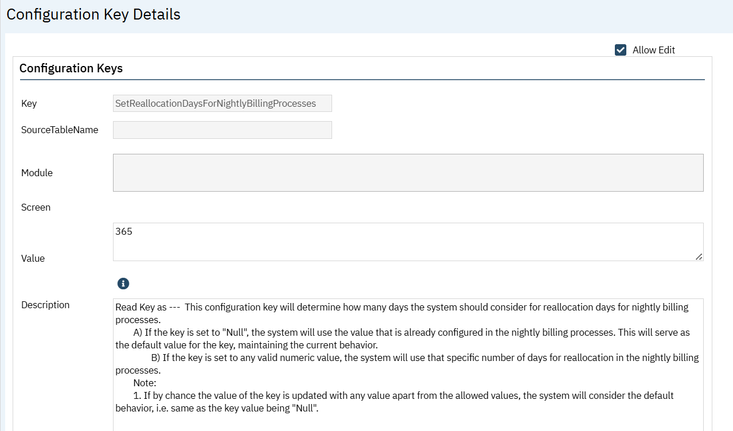

# Orders

|  |  |  |
| --- | --- | --- |
| **Reference No** | **Task No** | **Description** |
| 105 | EII # 128423 | MAR Improvements: Ability to do Sliding Scale Insulin. |

**Author:** Chaitali Patil

### 105. EII # 128423 (Feature - 357678): MAR Improvements: Ability to do Sliding Scale Insulin.

**Note For Adhoc Order:** While creating Adhoc order ‘Insulin Sliding Scale?’, Radio button will not be displayed under the option Section.

**Release Type:** Change **| Priority:** Urgent

**Navigation Path 1:** Go search – ‘Orders’ Admin – Click on ‘New’ – Create one ‘Medication’ Order – under the ‘Option’ section select ‘Add order to ‘MAR’ Radio Button as ‘Yes’ and select Insulin Sliding Scale? Radio button as ‘Yes’- Insulin Sliding Scale section will be displayed – Fill other required field - Save the Order – Click on ‘New’ in the ‘Insulin Sliding Scale’ section – ‘Sliding Scale’ pop up will be displayed – add Scale name and fill other required fields – click on ‘Save and close’ – under the ‘Insulin Sliding Scale’ section- select created ‘Scale Name’ from the dropdown – select ‘Flowsheet’ – select ‘Attribute’- click on Add -Save the Order.

**Navigation Path 2:** Go search -- ‘Order Sets’ – click on new – give the ‘Name of Order Set’ – under the ‘Building Order Set’ section – select Order type as ‘Medication’ – search and select (Navigation path 1) order – click on Add - save the order sets – click on ‘Set Default’ Button – ‘Order Set Defaults’ pop up will be displayed – at below selected (Navigation Path 1 orders) Insulin scale details will be displayed – click on ‘Save and Close’. (When we select this order set in ‘Client Order’ screen, then this insulin scale will be displayed there. When we checked preferences check box for this order Set in Client order screen, then this insulin scale will be displayed there as well.)

**Navigation Path 3:** Perform ‘Client’ Search -- Go search ‘Client Orders’ Client – Click on ‘New’ – search for (Navigation Path1) order – selected (Navigation Path1 orders) Insulin scale details will be displayed - and fill required fields – Insert order in the grid – save and sign the order – in the PDF - Insulin Sliding Scale will be displayed.

**Navigation Path 4:** Perform ‘Client’ Search -- Go search ‘Client MAR’ Client – select appropriate filter and check your order is displayed or not in the ‘Client MAR’ screen- and click on pill icon – ‘MAR Administer window’ will be displayed – in this pop up, Insulin scale details will be displayed which sign in Client Order Screen – select the status as Given – add the Glucose value – dose will be displayed based on the Glucose value – click on ‘Save’ Dose will get administer – back on list page – Click on ‘Given’ or green tick mark – MAR details pop up will be displayed – click on ‘Edit’ or ‘Admin Edit’ – click on (i) icon in front of the dose – then Sliding Scale Pop up will be displayed – and under the Medication History in the Dose column on click on ‘Dose’ hyperlink -Sliding scale pop up will be displayed.

**Navigation Path 5:** Go search ‘Group MAR’ (My Office) – select appropriate filter and check your order is displayed or not in the ‘Group MAR’ screen – and select ‘Pill’ icon - ‘MAR Administer window’ will be displayed – in this pop up, Insulin scale details will be displayed which sign in Client Order Screen – select the status as Given – add the Glucose value – dose will be displayed based on the Glucose value – click on ‘Save’ Dose will get administer – back on list page – Click on ‘Given’ green tick mark – MAR details pop up will be displayed – click on ‘Edit’ or ‘Admin Edit’ – click on (i) icon in front of the dose – then Sliding Scale Pop up will be displayed – and under the Medication History in the Dose column, click on ‘Dose’ hyperlink -Sliding scale pop up will be displayed.

**Navigation Path 6:** Perform ‘Client’ Search -- Go search- Flow sheet (client) – search for the Flowsheet which added in Order set up screen – click on apply filter – check the flowsheet entry for administer dose.

**Functionality ‘Before’ and ‘After’ release:**

**Purpose**: When administering medication such as Insulin, prescribers will identify a sliding scale specific to the client. This is defined at the time of order of the medication and should not require a dose to be entered at the time of ordering. Once ordered, and being administered on the MAR, the user will need to be able to quickly reference the sliding scale that was defined on the client order.

With this release, the insulin sliding scale functionality is implemented to orders/client orders/Client MAR/ Group MAR screen.

**1: Below Functionality implemented in the Order (Admin) screen.**

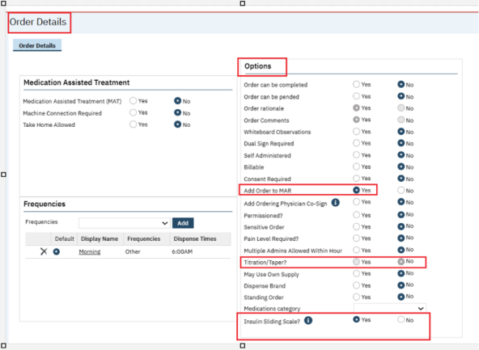

- In the Orders Details screen under the Options section, ‘Insulin Sliding Scale?’ Radio button is added only for the ‘Medication’ types of orders. When the Order type is selected as ‘Medication’, then only this ‘Insulin Sliding Scale?’ Radio buttons will be displayed.

- When the users select this ‘Insulin Sliding Scale?’ Radio button as ’Yes’, then 'Insulin Sliding Scale' section will be displayed in the Order Details screen.

- ‘Taper/Titration?’ will not be allowed for the Insulin orders. When the user selects the ‘Insulin Sliding Scale?’ radio buttons as ’Yes’, then the system will disable the ‘Taper/Titration?’ radio button and default to 'No'.

- When ‘Insulin Sliding Scale?’ radio button is set as 'No', then current existing administer functionality will not be changed in Client MAR and Group MAR Screen and for those order ‘Insulin Sliding Scale' section will not be displayed.

- In front of the ‘Insulin Sliding Scale’ radio button, Information (i) Icon will be displayed. On hover on this icon, the below information will be displayed.

**Hover Message:** 'When marked as 'Y' the Insulin Sliding Scale section will be present in Order Details and will not require a dose on client order entry. Dispensing on the MAR will display the MAR Details Pop up where Glucose and Dose will be required. When 'N' is selected, the system functionality will not change.'

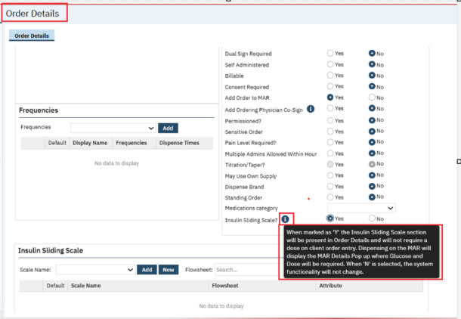

**The Below Fields are present in the Insulin Sliding Scale section in the ‘Order Details’ screen:**

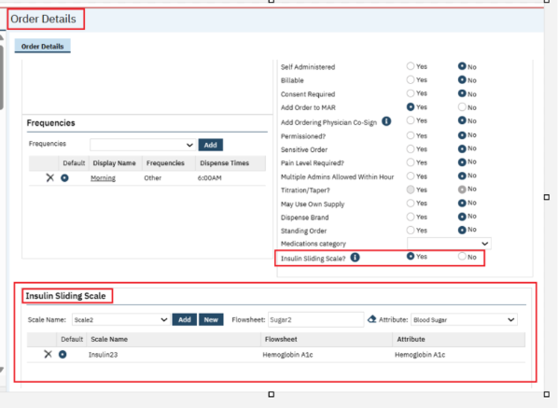

**Scale Name**: This is a dropdown field, in Scale Name dropdown will display the list of associated Sliding scales that are created in the Insulin sliding scale pop up. This section will be displayed only when Option - 'Insulin Sliding Scale' are set to 'Yes'.

**New:** When user clicks on New button, ‘Insulin Sliding Scale' Pop Up will be displayed. And the users can create the insulin scale as per clients need.

**Flowsheet:** This is the Searchable text field, in this fields all ‘Active Flow Sheets will be displayed. This is the required field, if the flowsheet is not selected, on save, the Standard Validation Message will be displayed. Users can search for any active flowsheet in this field.

**Attribute:** This is the dropdown field. Attribute will be displayed in the dropdown when the flowsheet is selected. If the flowsheet is not selected, then the Attribute dropdown will be displayed blank.in this Attribute dropdown only those attributes displayed which are associated to the selected flowsheet. The Flowsheet and Attribute selection will be used to determine where to push the 'Glucose' field value when entered on MAR Administration. This is the required field, if the Attribute is not selected, on save, Standard Validation message will be displayed.

**Add:** This is a button, when a value is selected in the 'Scale Name' field, Flowsheet’ and ‘Attributes’, then on clicking ‘Add' button, the selected scale gets inserted into the Insulin Sliding Scale Grid.

**Delete:** This is the button, on clicking this button, the inserted scale will get deleted from the Insulin Sliding Scale Grid.

**Default:** This is the radio button, when default radio button is selected, then associated insulin sliding scale will be displayed when the linked order is selected in client orders screen. At a time, only one row will have default radio button selected. If only one row exists, then on save for that row, the default radio button get saved.

**Scale Name:** This field will display name of Insulin sliding scale which was added. Scale Name will be displayed with hyperlinked, and when selected, the 'Sliding Scale' pop up will be open with associated data for that sliding scale.

**Flowsheet:** The selected flowsheet will be displayed in this column.

**Attribute:** The selected ‘Attribute ‘will be displayed in this column.

**Only one row can be selected with Default radio button**

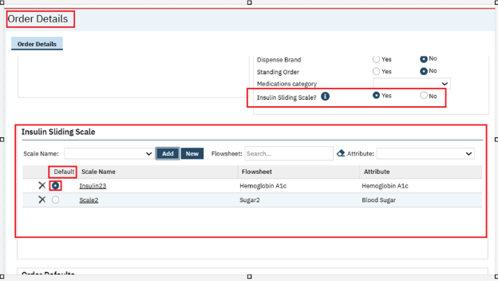

**2. Sliding Scale Pop Up Details:**

**On click of the ‘New’ Button under the ‘Insulin Sliding Scale’ section, the Sliding Scale Pop Up will be displayed,** and in this pop-up, user can create the ‘Insulin scale’ as per client need, and below fields are present in this pop-up.

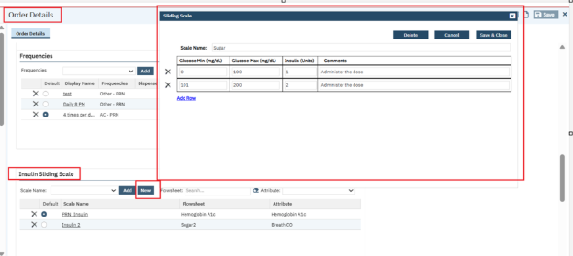

**Delete:** This is a button. On clicking delete button, created Insulin scale will get deleted.

**Cancel:** This is a button. On clicking Cancel button, pop up will close same as clicking on close icon.

**Save & Close:** This is a button. On clicking on **Save & Close** button, the added Insulin scale data in this pop up will get saved and pop up will be closed.

**Scale Name**: This is a text filed and users can add the Scale name Like (Humalog low dosing Sliding Scale). This is the required field, when the scale name is not added, on ‘Save & Close’, standard Validation Message will be displayed.

**Glucose Min (mg/dL):** This is a required field. If row is present, then the value must be entered. In this field only ‘Numeric’ value will be accepted. If the value is not entered in this field, then Standard Validation Message will be displayed.

The user will NOT have the ability to overlap values in a single row for the Glucose Min and Glucose Max fields, AND user will NOT have the ability to overlap values from multiple rows.

**Example:**

**Incorrect Set Up:**

Row 1: Min - 0, Max - 100

Row 2: Min - 99 - 100

Row 3: Min - 101 - 101

**Correct Set Up:**

Row 1: Min - 0 Max - 100

Row 2: Min - 101, Max - 200

Row 3: Min - 201, Max – 300

**Glucose Max (mg/dL): T**his is the required field. If row is present, then value must be entered. In this field only ‘Numeric’ value will be accepted. If the value is not entered in this field, then Standard Validation Message will be displayed.

The user will NOT have the ability to overlap values in a single row for the Glucose Min and Glucose Max fields, AND user will NOT have the ability to overlap values from multiple rows.

**Example:**

**Incorrect Set Up:**

Row 1: Min - 0, Max 100

Row 2: Min - 99 - 100

Row 3: Min - 101 - 101

**Correct Set Up:**

Row 1: Min - 0 Max - 100

Row 2: Min - 101, Max - 200

Row 3: Min - 201, Max – 300

**Insulin (Units): T**his is the required field. If row is present, then value must be entered. In this field only ‘Numeric’ value will be accepted. If the value is not entered in this field, then Standard Validation Message will be displayed.

**Comments:** This is the text field. This is not a required field; The users can enter any comment or instruction in this field.

**Add Row**: This is the Hyperlink. On clicking on Add Row hyperlink, one row will be added in the grid. Up to 8 rows will be allowed without the need to scroll. If more than 8 rows are added in this pop up, then the vertical scroll bar will be displayed to view all the information.

**Sliding scale with Scroll bar:**

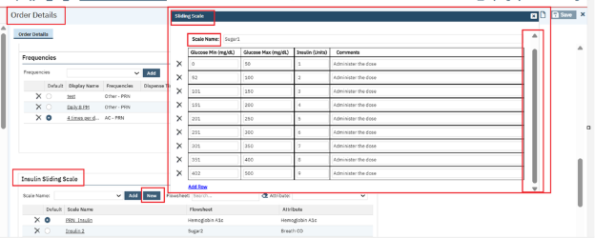

**3: Below changes implemented in Order Sets (Admin) screen under the Order Set Default pop up:**

In Order Set Details screen, if the selected medication is set up with 'Insulin Sliding Scale' = 'Yes’ in the Order Details screen, then the Scale Name, and Scale Grid will be displayed in the Order Set Default pop up.

On clicking Set Default button in the Order Set Details screen, Order Set Defaults pop up will be displayed. In this below pop up after clicking on Save & Close button, this scale details will be displayed only in Client Order details screen. If details are not saved here, this scale details will not be displayed in Client Order Details screen.

**Order Sets Default pop up.**

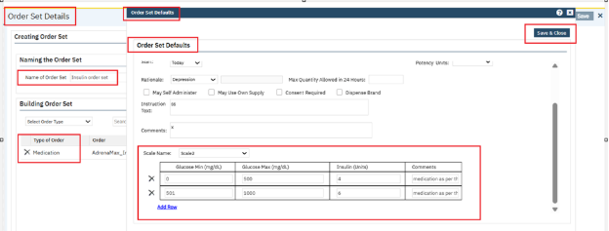

Selecting a value from this screen or updating the Scale Grid will be the default value when this order set is selected in Client Order details screen.

When the above Order Set is selected in the Client Order screen under the order set tab, then Insulin Sliding scale section will be displayed with **‘Scale Name’ and Scale grid.**

**Scale Name:** This is the dropdown field, in this dropdown the available insulin sliding scales will be displayed that were created from the Order Details (admin) screen or modified in Order Set screen. Selecting a value will auto populate into the Scale Grid.

In Order details if 2 scales were added, the scale that was selected as ‘Default’, then that Default insulin sliding Scale will be displayed when the linked order is selected in the client orders screen. But in Dropdown both insulin sliding Scale names will be displayed, if users want to select another insulin sliding scale, they can select from this ‘Scale Name’ dropdown. According to the insulin sliding scale details Scale grid will be displayed.

**Scale Grid:** In this scale grid data will be displayed which we have added in the Order Details screen or in the order sets screen .in this Scale Grid (Glucose Min (mg/dL)’, ‘Glucose Max (mg/dL)’, Insulin (Units)’ and ‘Comments’ column will be displayed also ‘Add Row’ hyperlink will be displayed)

Once values are populated from the Order Details (admin), all fields will be enabled for the end user to adjust as needed.

**Note:** the user will NOT have the ability to overlap values in a single row for the Glucose Min and Glucose Max fields, AND user will NOT have the ability to overlap values from multiple rows.

**Example:**

**Incorrect Set Up:**

Row 1: Min - 0, Max 100

Row 2: Min - 99 - 100

Row 3: Min - 101 - 101

**Correct Set Up:**

Row 1: Min - 0 Max - 100

Row 2: Min - 101, Max - 200

Row 3: Min - 201, Max - 300

Users are allowed to add additional rows with the 'Add Row' link, and delete rows with the Delete function in the Client Order screen under the Order Set tab.

**Note:** If a Default Scale Name is selected in Order Set Defaults, then this will be auto populated when the order set is selected. The user will have the ability to edit as needed.

**Screen shot when created orders set selected in the Client Order screen:**

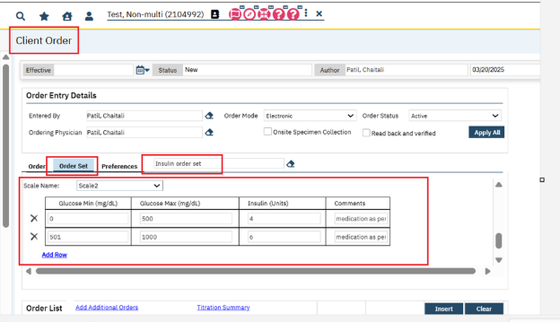

**4: For insulin medication below changes have been implemented in Client Order details screen for the Order tab:**

In the Order Details the screen, the Insulin Sliding scale order is created. When selecting same order in Client Order screen which has the Insulin sliding Scale, then ‘insulin sliding scale’ section will be displayed in the Client Order screen.

While ordering Insulin scale orders in the Client Orders screen, then ‘Dose’ filed is not a required filed. validation for dose field had been removed.

When dispensing this medication on the Client MAR and in Group MAR, and selecting the 'administer' icon, will display the MAR Details pop up to allow the staff to provide the 'Dose' of the medication given.

**Below are the fields present in the Sliding Scale section in the Client Order details screen.**

**Scale Name:** This is the dropdown field and will display the available insulin sliding scales that were created from the Order Details (admin) screen. Selecting a value will auto populate into the Scale Grid.

In Order Details if 2 scales are added, the scale selected as ‘Default’ then this Default insulin sliding Scale will be displayed when the linked order is selected in the client orders screen. But in Dropdown both insulin sliding Scale names will be displayed, if users want to select another insulin sliding scale, they can select from this ‘Scale Name’ dropdown. According to the insulin sliding scale details Scale grid will be displayed.

**Scale Grid:** In this scale grid data will be displayed which was added in the Order details screen. In this Scale Grid, (‘Glucose Min (mg/dL)’, ‘Glucose Max (mg/dL)’, ‘Insulin (Units)’ and ‘Comments’ column will be displayed also ‘Add Row’ hyperlink will be displayed)

Once values are populated from the Order Details (admin), all fields will be enabled for the end user to adjust as needed.

**Note:** the user will NOT have the ability to overlap values in a single row for the Glucose Min and Glucose Max fields, AND user will NOT have the ability to overlap values from multiple rows.

**Example:**

**Incorrect Set Up:**

Row 1: Min - 0, Max 100

Row 2: Min - 99 - 100

Row 3: Min - 101 - 101

**Correct Set Up:**

Row 1: Min - 0 Max - 100

Row 2: Min - 101, Max - 200

Row 3: Min - 201, Max - 300

Th end users are allowed to add additional rows with the 'Add Row' link, and delete rows with the Delete function.in the Client order screen under the Order tab.

**Screen shot: In Order Details screen default scale details for order ‘Acular _Insulin’**

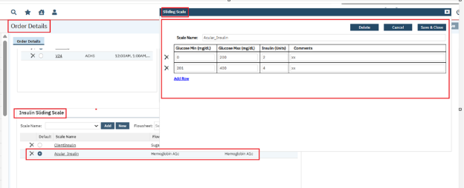

**In client Order screen when same order is selected:**

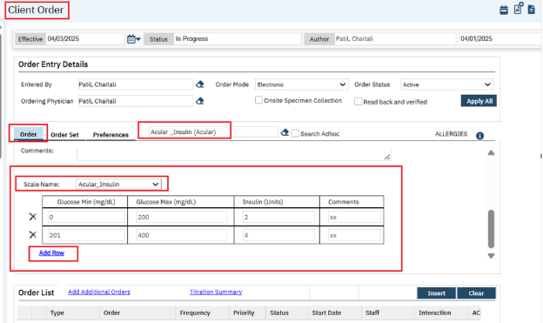

**In Order details screen if two insulin sliding scale are added, then in the client order details screen both insulin sliding scale will be displayed in the Scale Name dropdown.**

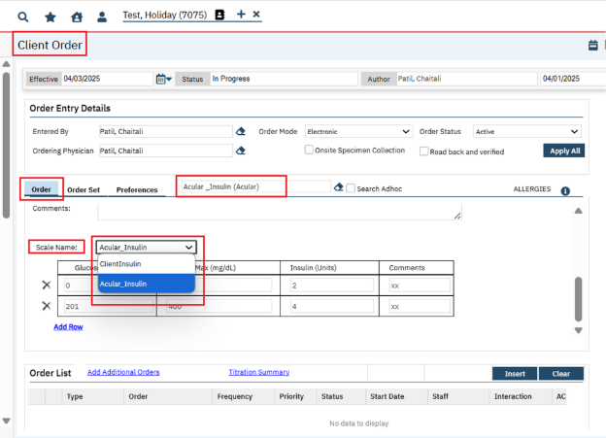

**5: For insulin medication, the below changes have been implemented in Client Order details screen under the Preferences tab:**

When in the Client Order Details screen, for insulin order if the Preferences’ checkbox is checked, then on save, same order will be displayed in the ‘Preferences’ tab with ‘Scale Name’ and ‘Scale Grid’.

**Scale Name:** This is a dropdown field and this dropdown will display the available insulin sliding scales, that were created from the Order Details (admin) screen. Selecting a value will auto populate into the Scale Grid.

In Order Details, if 2 scales were added, the scale which is selected as ‘Default’, then this default insulin sliding Scale will be displayed when the linked order is selected in the client orders screen. But in dropdown both insulin sliding Scale names will be displayed, if users want to select another insulin sliding scale, they can select from this ‘Scale Name’ dropdown. According to the insulin sliding scale details Scale grid will be displayed.

**Scale Grid:** In the scale grid data will be displayed which was added in the Order Details screen. In this Scale Grid (‘Glucose Min (mg/dL)’, ‘Glucose Max (mg/dL)’, ‘Insulin (Units)’ and ‘Comments’ column will be displayed also ‘Add Row’ hyperlink will be displayed)

Once values are populated from the Order Details (admin), all fields will be enabled for the end user to adjust as needed.

**Note:** the user will NOT have the ability to overlap values in a single row for the Glucose Min and Glucose Max fields, AND user will NOT have the ability to overlap values from multiple rows.

**Example:**

**Incorrect Set Up:**

Row 1: Min - 0, Max 100

Row 2: Min - 99 - 100

Row 3: Min - 101 - 101

**Correct Set Up:**

Row 1: Min - 0 Max - 100

Row 2: Min - 101, Max - 200

Row 3: Min - 201, Max - 300

Allowing the end user to add additional rows with the 'Add Row' link, and delete rows with the Delete function.in the Client order screen under the Order tab.

**Preference check box is checked**

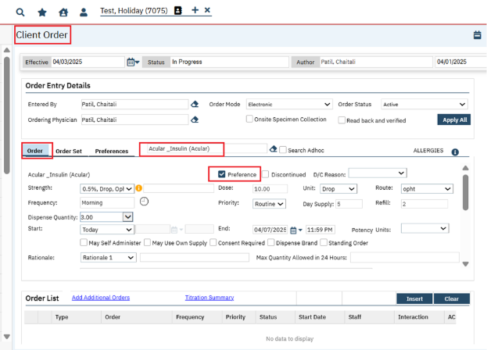

**Insulin Scale Details:**

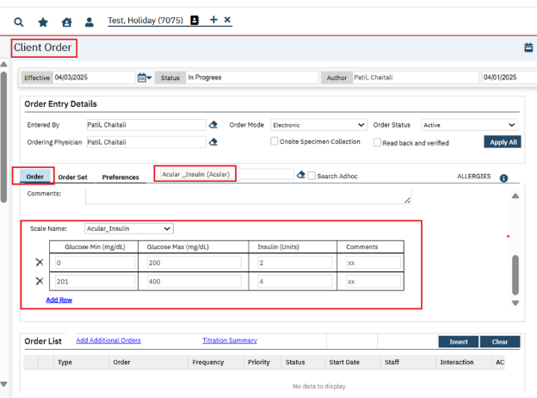

**After Saving the same order will be displayed in the Preferences tab:**

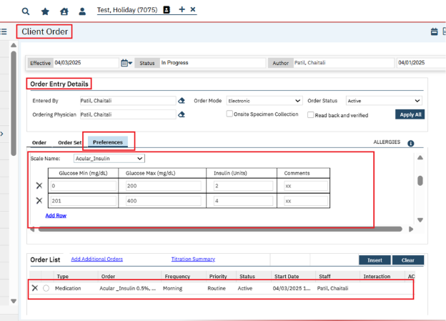

When the Order is Sign with Insulin Scale then in the PDF, the Insulin Scale details will be displayed.

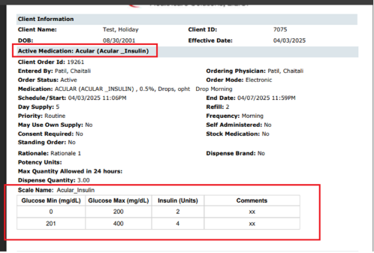

**6: For Insulin medication below functionality has been implemented in Client MAR Screen.**

After signing the insulin sliding scale medication in the Client Order screen, those medications will be displayed in the ‘Client MAR’ and ‘Group MAR’ screen.

**Administration (Pill) Icon:** In the Client MAR screen, when selecting an administration (Pill) Icon for a medication that has an insulin sliding scale (from client orders) will not auto administer the medication. Instead, the MAR Administer window (same window as PRN workflow) will open. This window will show the Insulin (medication linked to the sliding scale) and will enabled to be entered.

**Screenshot: Pill icon**

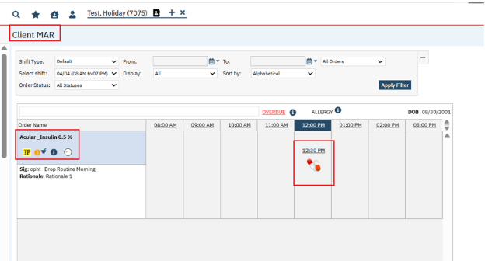

**On click on pill icon, the below window will be displayed from here user can administer the insulin medication (MAR Administration Window)**

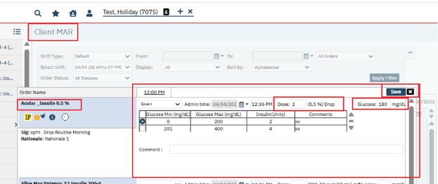

In the MAR Administer window, a new ‘Glucose’ field have added.

**Glucose:** The Glucose field will accept only Numeric value. This field will be displayed when the medication was created from a client order with an insulin sliding scale. If the field is present, then a value must be entered in order to save entry. When entering a value, the system will auto select the correct row of the insulin sliding scale based on the range of 'Glucose Min (mg/dL) and 'Glucose Max (mg/dL)’. Once the Glucose value is entered, then in the Dose field Insulin Unit will be displayed automatically. Also, Dose field is a required field.

**Sliding Scale:** In the MAR Administer window, Sliding Scale will be displayed from client orders. This will allow the user to override the system generated selection from the entry of the 'Glucose' field.

'When Insulin Sliding Scale is marked as 'Yes' in Order Details screen, the Insulin Sliding Scale section will be displayed in Order Details and will not require a dose on Client Order entry. Dispensing on the MAR will display the MAR Details Pop up where Glucose and Dose will be required. When 'No' is selected, the system functionality will not change.'

**6: For Insulin medication, the below functionality has been implemented in the ‘MAR Details’ pop up:**

After administering the medication in Client MAR screen, for that Administer dose ‘Green Tick’ will be displayed, on clicking ‘Green Tick’ or on ‘Given’ hyperlink MAR Details pop up will be displayed. The below changes have been implemented in MAR Details pop up.

**Dose (i) icon:** Added an information Icon next to ‘Dose’ field, this icon will be displayed ONLY when the medication has a sliding scale. Selecting this icon will open a 'Sliding Scale' pop up. This information icon will be enabled only when 'Edit' or 'Admin Edit' is selected. If users want to make changes in the sliding scale, they can make the changes from this pop up.

**Dose:** In this field display the dose that was entered at time of administration for this MAR record. This will Only enable when 'Edit' or 'Admin Edit' is selected.

If dose is enabled and value is changed, then the system will adjust the Sliding Scale radio button if the updated value does not fall into the same numeric span as the original value. This field will accept only the ‘Numeric’ values.

**Glucose:** In this field display the Glucose that was entered at time of administration for this MAR record. This field will be enabled only enable when 'Edit' or 'Admin Edit' is selected. This field will accept only the ‘Numeric’ values.

If edited, the flowsheet record that was created for the linked administration we be updated with the latest value

**Example:** If user administered Insulin at 9am, and entered the glucose of 180, and realized this was incorrect, and user selected edit at 9:30am to update the value to 189, then will display only 1 flowsheet entry for the updated value of 189 in the Flow sheet client screen

**Sliding Scale Grid:** On clicking Dose (i) icon 'Sliding Scale' pop-up will be displayed. In this Sliding scale grid will display the Insulin Sliding Scale for the MAR Administration. This will show the defaulted row that was selected at the time of administration for this MAR record. This grid will be enabled when 'Edit' or 'Admin Edit' is selected.

If enabled, allow the user to update the selected row as needed based on the Glucose value.

**Close:** If users make changes in the sliding scale, then click on close button the pop will be closed. **‘Update’** button should be clicked to save the changes. If the user does not click on the Update button, then modified changes will not get saved.

**Note:** The Save button is removed from the 'Sliding Scale' pop-up. To save the modified changes the ‘Update’ button should be clicked

**Screen shot on click on information (i) Icon Sliding Scale Pop up will be displayed**

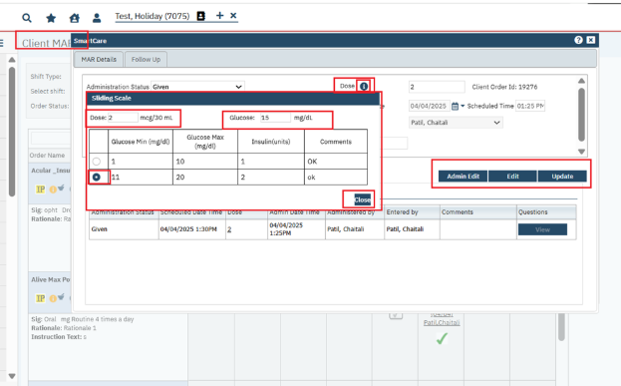

**Dose Column:** Dose column will be displayed under the Medication History section. In this Dose column, the ‘Dose’ will be hyperlinked for any administration record that has an insulin sliding scale. Selecting the dose hyperlink will open the Sliding Scale Pop up to view the information for that administration record. User cannot modify the details in this pop up

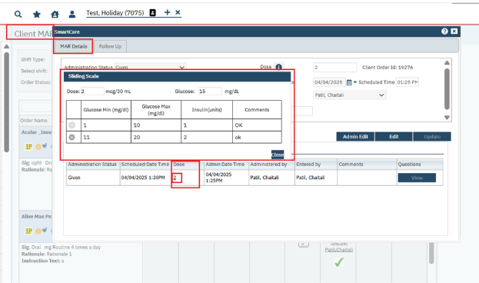

**Note:** In Client MAR, Insulin Medication orders will not be displayed in the Administration (smart care) popup.

Client MAR:

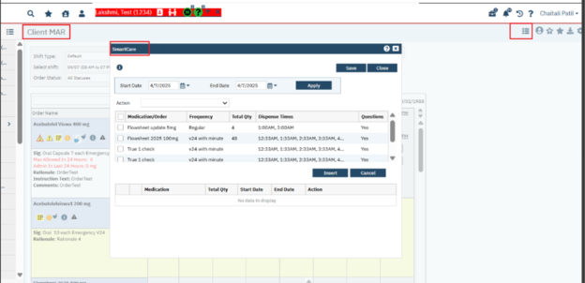

**Flowsheet Entry created in Flow sheet Client screen: for every administration from the Client MAR and Group MAR as well.**

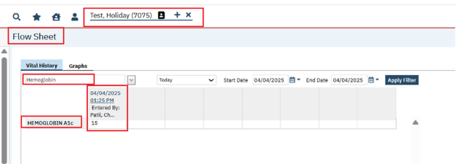

**6: For Insulin medication, the below functionality has been implemented in the ‘Group MAR’ pop up:**

After administering the medication in Group MAR screen, for the Administered dose ‘Green Tick’ will be displayed. On clicking on ‘Green Tick’ or on ‘Given’ hyperlink, MAR Details pop up will be displayed. In that Pop up below changes we have implemented Same Administration functionality as ‘Client MAR’ has been implemented in ‘Group MAR’ for Insulin types of orders.

**Group MAR Screen shot: Pill icon**

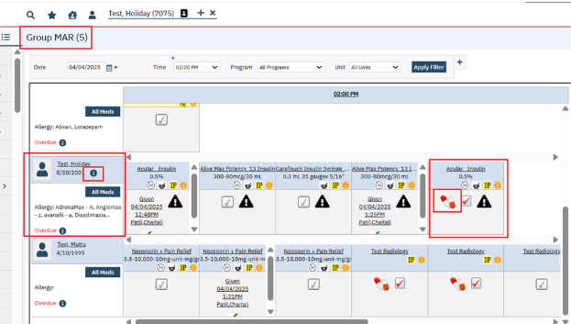

**On clicking on pill icon, the below pop up will be displayed. Here user can administer the Insulin Medication**

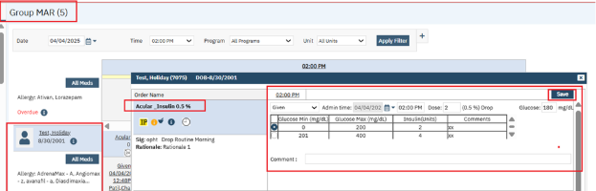

**MAR Details Pop up:**

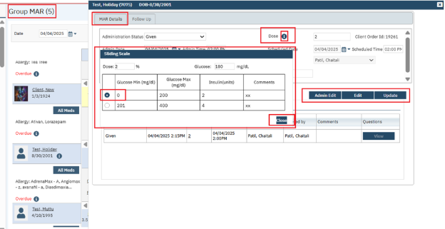

**Medication History Dose column changes:**

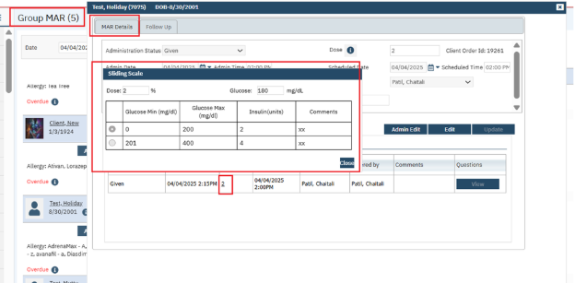

**Client Name** **Hyperlink**: Clicking on Client Name hyperlink will now navigate user to the 'Client MAR' when selected.

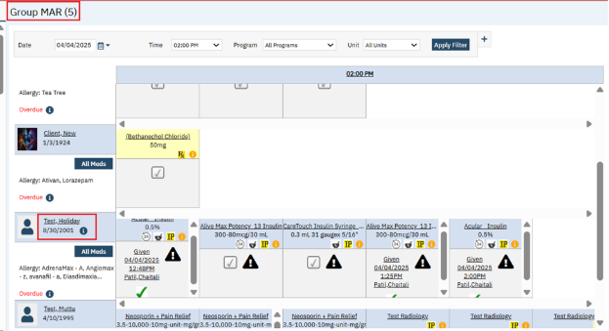

**(i)Icon**: This Icon will be displayed when the client has an active client order medication that has 'Insulin Sliding Scale' = Y.

On the hover of the icon, will display the following text:

**Hover Text:** Client is prescribed an insulin medication. To administer, please navigate client MAR by selecting the client name hyperlink.

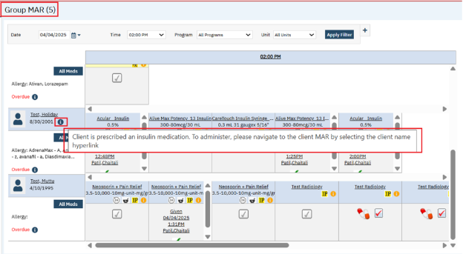

**Note:** In the Group MAR screen, using ‘All Meds’ button, the user can’t administer the Insulin Medication orders.

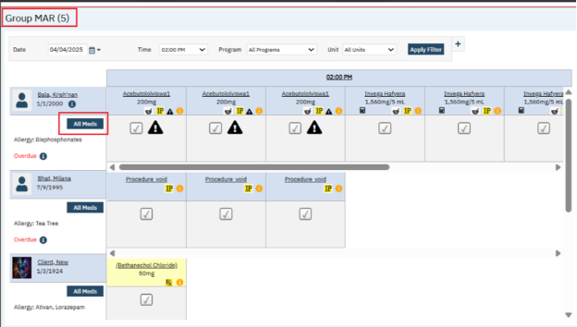

**Data Model Changes:**

Added below new tables:

SlidingScales  
 SlidingScaleScales  
 ClientOrderSlidingScales  
 OrderSlidingScales  
 OrderSetAttributeDefaultSlidingScales

Added column InsulinSlidingScale in Orders table  
 Added columns ClientOrderSlidingScaleId, Glucose in MedAdminRecords table

Added columns ClientOrderSlidingScaleId , Glucose in MedAdminRecordHistory table

# Payments/Adjustments

|  |  |  |
| --- | --- | --- |
| **Reference No** | **Task No** | **Description** |
| 106 | Core Bugs # 130951 | Duplicate financial activities data issue in the 'Payments/Adjustments' screen. |

**Author:** Debanjit Das

### 106. Core Bugs # 130951: Duplicate financial activities data issue in the 'Payments/Adjustments' screen.

**Release Type:** Fix **| Priority:** Medium

**Navigation Path:** My Office **--** 'Payments/Adjustments' -- 'Payments/Adjustments' list page.

**Functionality ‘Before’ and ‘After’ release:**

Before this release, here was the behavior. The data was accumulated in the user session due to duplicate financial activities. This was consuming server memory and out of memory errors were displayed in the 'Payments/Adjustments' screen.

With this release, the above-mentioned issue has been resolved. Now, the performance of 'Payments/Adjustments' screen is optimized.

# Plans

|  |  |  |
| --- | --- | --- |
| **Reference No** | **Task No** | **Description** |
| 107 | Core Bugs # 131087 | Value Code Records Getting Erroneously Updated When Saving Plans by altering the templates from ‘Use Value Codes from Specified Plans’ to ‘Use this plan as template. |
| 108 | Core Bugs # 130950 | The ‘Adjustment Code’ and the 'Auto Adjustment' radio buttons are not populating from the ‘Parent Plan Template file’ in the 'Payments/Adjustments' tab of the 'Plan Details' screen. |

**Author:** Yashas Kyadalappa

### 107. Core Bugs # 131087: Value Code Records Getting Erroneously Updated When Saving Plans by altering the templates from ‘Use Value Codes from Specified Plans’ to ‘Use this plan as template.

**Release Type:** Fix **| Priority:** High

**Prerequisite:**

1. Coverage Plan is saved with value codes with suitable data under value codes tab of plan detail screen.

**Path:** ‘Administration’ -- ‘Billing Setup’ -- ‘Plans’ -- ‘Plans’ list Page – click on plan name hyperlink or new button ‘Plans Details’ screen -- click on ‘Value Codes’ tab and fill all mandatory fields with suitable billing and revenue codes with procedure rate Id, then save the coverage plan.

**Navigation Path:** ‘Administration’ -- ‘Billing Setup’ -- ‘Plans’ -- ‘Plans’ list Page – click on plan name hyperlink or new button ‘Plans Details’ screen.

**Functionality ‘Before’ and ‘After’ release:**

Before this release, here was the behavior. The value codes were copied from the different coverage plan’s value codes by using the ‘Use Value Codes From Specified Plans’ template, then changed the template to ‘Use this plan as template’, then selected and saved the value codes. The selected ‘Payer Type’ in different coverage plan was automatically updating to the ‘Payer Type’ of the copying value code’s coverage plan.

With the release, the above-mentioned issue has been resolved. Now whenever user copies the value codes from different coverage plans value codes by using ‘Use Value Codes From Specified Plans’ template and ‘Use this plan as template’, the payer Type in different coverage plan is not updating from the Payer Type of copying value code’s coverage plan.

**Author:** Debanjit Das

### 108. Core Bugs # 130950: The ‘Adjustment Code’ and the 'Auto Adjustment' radio buttons are not populating from the ‘Parent Plan Template file’ in the 'Payments/Adjustments' tab of the 'Plan Details' screen.

**Release Type**: Fix | **Priority**: High

**Navigation Path:** 'Administration' -- Plan Details’ screen -- 'Payment/Adjustments' tab.

**Functionality ‘Before’ and ‘After’ release:**

Before this release, here was the behavior. In the 'Payments/Adjustments' tab of the 'Plan Details' screen, the ‘Adjustment Code’ and the 'Auto Adjustment' radio buttons were not populating from the ‘Parent Plan Template file’.

With this release, the above-mentioned issue has been resolved. Now, the ‘Adjustment Code’ and the 'Auto Adjustment' radio buttons are populated from the ‘Parent Plan Template file’ under the 'Payments/Adjustments' tab of the 'Plan Details' screen.

# ~~Primary Care~~

|  |  |  |
| --- | --- | --- |
| **~~Reference No~~** | **~~Task No~~** | **~~Description~~** |
| ~~109~~ | ~~Core Bugs # 131211~~ | ~~Primary Care Summary Quick Notes not generating template selection pop-up.~~ |

**~~Author:~~** ~~Shivakanth Moger~~

### ~~109. Core Bugs # 131211: Primary Care Summary Quick Notes not generating template selection pop-up.~~

**~~Release Type~~**~~: Fix |~~ **~~Priority~~**~~: High~~

**~~Navigation Path:~~** ~~‘Client’ search -- ‘Client Summary (Primary Care)’ – ‘Client Summary (Primary Care)’ page.~~

**~~Functionality ‘Before’ and ‘After’ Release:~~**

~~Before this release, here was as the behavior. Clicking the ‘Quick Notes’ hyperlink, opened the Medical Progress Note, instead of the Template/Sub-Template pop-up in the Client Summary.~~

~~With this release, the above-mentioned issue has been resolved. Now, clicking the ‘Quick Notes’ hyperlink opens a pop-up to select a template or sub-template in the Client Summary, before navigating to the Medical Progress Note.~~

# Procedure/Rates

|  |  |  |
| --- | --- | --- |
| **Reference No** | **Task No** | **Description** |
| 110 | EII # 129467 | CQM 2025 Reporting Measure updates for DHIT - ASC, DEP- REM-6, and CMS-2 (CDF-AD and CDF-CH). |
| 111 | Core Bugs # 130949 | Services: Error message is displayed when trying to complete a service. |

**Author:** Boovendiran Chinnusamy

### 110. EII # 129467 (Feature - 470046): CQM 2025 Reporting Measure updates for DHIT - ASC, DEP- REM-6, and CMS-2 (CDF-AD and CDF-CH).

**Release Type**: Change | **Priority**: On Fire

**Navigation Path:** ‘Procedure/Rates (Administration)’ – CQM Configurations tab – Click on Search and search for Concept codes – Select the Required measures – Click on Save and then Click Close.

**Functionality ‘Before’ and ‘After’ release:**

**Purpose:** To ensure that the data we are sending to CQM solutions is current, with the measure updates released for CCBHC_2024 and eCQM 2025.

With this release, in Procedure/Rates – CQM Configurations, New Measures for 2025 Reporting has been added for Measure ID CMS-2, ASC and DEP-REM-6.

**Author:** Lavanya Shivakumar

### 111. Core Bugs # 130949: Services: Error message is displayed when trying to complete a service.

**Release Type**: Fix | **Priority**: Medium

**Prerequisites:**   
1.Ensure that client age is set to greater than 19.  
2.Age Group is selected in the Rates/Billing codes tab in the Procedure/Rates screen through the **below path:**    
Go Search - Procedure/Rates (Administration)- Select any procedure hyperlink- Rates/Billing codes tab—Click on Age Group ... select the Group name from the Select Age Group pop up-Click on save-close.

**Navigation Path:** Go search –Services (Client)-Select the procedure (which has the Age Group selection)-Enter all the required fields- Complete the service.

**Functionality ‘Before’ and ‘After’ release:**

Before this release, here was the behavior. When selecting the “Age Group>19” under the “Rates/Billing Codes” tab in the procedure/Rates screen and if the client’s age was greater than 19, the below error message was displayed in the service details when completing a service.

**Error Message:** "Unable to find a matching rate for the selected procedure".

With this release, the above-mentioned issue is resolved. Now, when selecting the “Age Group>19” under the “Rates/Billing Codes” tab in the procedure/Rates screen and if the client’s age is greater than 19, the above error message is not displayed in the service details when completing a service.

# Reception

|  |  |  |
| --- | --- | --- |
| **Reference No** | **Task No** | **Description** |
| 112 | Core Bugs # 130955 | Reception/Front Desk: The ‘Transaction Details’ are not populated in the ‘Comment’ section of the 'Payment Details' page when a credit card transaction is processed successfully in the ‘Reception’ screen. |
| 113 | Core Bugs # 131134 | Reception: color change logic not working. |

**Author:** Niroop Hassan

### 112. Core Bugs # 130955: Reception/Front Desk: The ‘Transaction Details’ are not populated in the ‘Comment’ section of the 'Payment Details' page when a credit card transaction is processed successfully in the ‘Reception’ screen.

**Release Type:** Fix **| Priority:** Urgent

**Navigation Path:** ‘My Office’ – ‘Reception/Front Desk’ - ‘Reception/Front Desk’ list page – Click on required balance hyperlink – ‘Client Payment’ popup – Select the ‘PTM Method’ as ‘Credit Card’ and enter required amount in ‘Total $ Paid’ textbox – Click on ‘Credit Card Processing’ tab – Select required mode and click on ‘Start transaction’ button and make the payment.

**Functionality ‘Before’ and ‘After’ Release:**

Before this release, here was the behavior. The ‘Transaction Details’ were not populated in the ‘Comment’ section of the 'Payment Details' page when a credit card transaction was processed from the ‘Reception’ screen.

With this release, the above-mentioned issue has been resolved. Now, the ‘Transaction Details’ are populated in the ‘Comment’ section of the 'Payment Details' page when a payment is made via credit card under ‘Reception’ screen.

**Author:** Niroop Hassan

### 113. Core Bugs # 131134: Reception: color change logic not working.

**Release Type:** Fix **| Priority:** Medium

**Navigation Path:** ‘My Office’– ‘Reception/Front desk’ - ‘Reception/Front desk’ list page – Click on ‘New Arrival’ icon – ‘Arrival Details’ page – Select the required data and click on ‘Save’ icon.

**Functionality ‘Before’ and ‘After’ release:**

Before this release, here was the behavior. In the Reception screen, the color change logic (to change the color from White > Yellow > Red) for Arrivals was not functioning correctly.

With this release, the above-mentioned issue has been resolved. Now, the color change logic (to change the color from White > Yellow > Red) for Arrivals is functioning correctly.

# Reports

|  |  |  |
| --- | --- | --- |
| **Reference No** | **Task No** | **Description** |
| 114 | EII # 130525 | Implementation of a new ‘Crisis Time to Treatment’ Report. |
| 115 | Core Bugs # 131015 | NOMS SPARS Report CSV File error. |
| 116 | Core Bugs # 130127 | Services With Procedure Rate Errors Logic not working when From Unit on the procedure rate is NULL. |
| ~~117~~ | ~~Core Bugs # 130978~~ | ~~MAT Medication Dispensing Exception Report is displayed with the edited dose entries even though the medication dispensing was not done.~~ |
| ~~118~~ | ~~Core Bugs # 131047~~ | ~~MAT Emergency Daily Dispensing Report: The end date filter is not showing the next calendar day.~~ |
| 119 | Core Bugs # 130672 | Changes are updated to the ‘UDS Table 9D Patient-Related Revenue’. |

**Author:** Abhishek Naik

### 114. EII # 130525 (Feature – 520619): Implementation of a new ‘Crisis Time to Treatment’ Report.

**Release Type:** New Functionality | **Priority:** Urgent   
   
**Prerequisites:**

Configure the ‘Crisis Service’ through the below **path:** ‘Administration’ – ‘Procedures/Rates’ – Click ‘Procedure’ hyperlink – ‘CQM Configurations’ tab - search Concept ‘DYNAMIC4’ – ‘Save’.

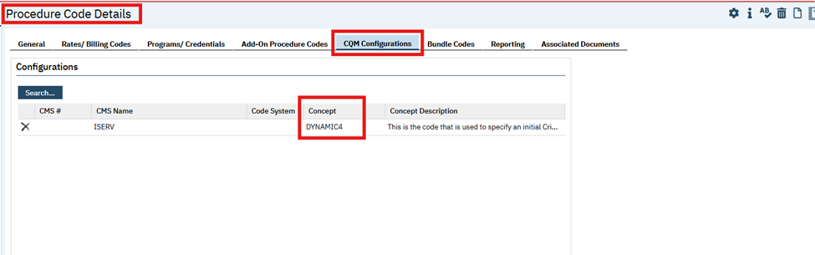

**Navigation Path 1:** 'My Office’ – ‘Crisis Time to Treatment Report’.

**Navigation Path 2:** ‘Client’ search – ‘Service/Notes’ – ‘Create ‘Service’.

**Navigation Path 3:** ‘Client’ search – ‘Contact Note’ – Click on ‘New’ icon - Add required fields and ‘Save’.

**Functionality ‘Before’ and ‘After’ release:**

**Purpose:** 'With the new Crisis Call Log, there are now two places the user can capture Crisis Services beginning. A summary of both workflows will help administrators to track the trends over time for crisis Services..

With this release, a new report ‘Crisis Time to Treatment Report’ is implemented with the following functionality:

Crisis service created with ‘Show’ or ‘Complete’ status will be displayed in the report based on the date range of filters. Also, the Crisis service will not display if another ‘Crisis service’ exists within 24 hours.

The ‘Crisis Call logs’ will not be displayed in the report if another ‘crisis call logs exist within 24 hours.

***‘Crisis Time to Treatment Report’ details:***

**‘Filter’ section Screenshot:**

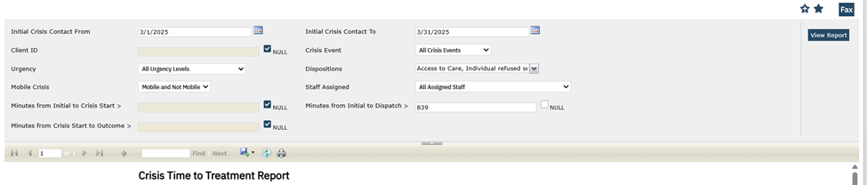

**Filter section:**

* **Initial Crisis Contact From:** This is a ‘Date Control’ field and a required field, by default it will be displayed blank. The ‘Crisis Service’ or ‘Call Log’ records from the entered date will be reflected in the report.
* **Initial Crisis Contact To:** This is a ‘Date Control’ field and a required field,bydefault it will be displayed blank. The ‘Crisis Service’ or ‘Call Log’ records till the entered date will be reflected in the report.
* **Client ID:** This is a Textbox. By default, this field will be blank, and users will be able to enter the Client ID. It is not a required field.
* **Crisis Event:** All active codes from the Global Code ‘CRISISEVENTTYPE’ will be populated in this dropdown. This is a required field.
* **Urgency:** It is a Drop down, All active codes from the Global Code ‘URGENCYLEVEL will be populated in this dropdown. This is a required field.
* **Dispositions:** It is a Multiselect Dropdown, All active codes from the Global Code ‘INQUIRYDISPOSITION‘ will be populated in this dropdown. This is a multi-select dropdown and a required field.
* **Mobile Crisis:** It is a single select dropdown with ‘Mobile’, ‘Not Mobile’, ‘Mobile and Not Mobile’ dropdown options. Default value will be ‘Mobile and Not Mobile’.
* **Staff Assigned:** This is a Dropdown,All active staff with Staff List Permission of 'Clinician' OR 'Crisis Staff' will be displayed in the dropdown. Default value will be ‘All Assigned Staff’
* **Minutes from Initial to Crisis Start >:** This is a Textbox, it allows only Numeric value but not decimal value, Report for column ‘Minutes from Initial to Crisis Start' with values greater than the added field value will be pulled in the report.

**Example:** If value added in the ‘Minutes from Initial to Crisis Start >:’ is 50, then report will only pull the value with more than 50 for the column ‘Minutes from Initial to Crisis Start'.

* **Minutes from Initial to Dispatch >:** This is a Textbox, it allows only Numeric value but not decimal value, Report for column ‘Minutes from Initial to Dispatch >’with values greater than the added field value will be pulled in the report.

**Example:** If value added in the ‘Minutes from Initial to Dispatch >:’ is 50, then report will only pull the value with more than 50 for the column ‘Minutes from Initial to Dispatch’

* **Minutes from Crisis Start to Outcome >:** This is a Textbox, it allows only Numeric value but not decimal value, Report for column ‘Minutes from Crisis Start to Outcome’ with values greater than the added field value will be pulled in the report.

**Example:** If value added in the ‘Minutes from Crisis Start to Outcome >:’ is 50, then the report will only pull the value with more than 50 for the column ‘Minutes from Crisis Start to Outcome’

**View Report:** It's a button, when user clicks on this button, the detail report will be displayed.

**Header Section:**

* **Average Minutes from Initial Contact to Crisis Start:** This is label field**,** Average of all the values in the column ‘Minutes from Initial to Crisis Start’ will be computed.
* **Average Minutes from Initial Contact to Dispatch:** This is label field,Average of all the values in the column ‘Minutes from Initial to Dispatch’will be computed.
* **Average Minutes from Crisis Start to Outcome:** This is label field, Average of all the values in the column ‘Minutes from Initial to Crisis ‘Minutes from Crisis Start to Outcome’.
* **Average Days from Initial Contact to First DOS After:** This is label field,Average difference between ‘First DOS After Crisis Start’ and ‘Initial Contact Date’ will be computed with values present in both columns in this field.
* **Average Days from Initial Contact to First Follow Up Contact:** This is label field,Average difference between ‘First Follow Up Contact’ and ‘Initial Contact Date’ will be computed with values present in both columns in this field.

**Grid Section:**

* **Client ID:** This is a label field,Client ID for Crisis service/Call log will be displayed. This column will be blank if the client is not associated with the call log.
* **Last Name:** This is a label field, Last Name of the Client for Crisis service/Call log will be displayed. This column will be blank if the client is not associated with the call log.
* **First Name:** This is a label field, First Name of the Client for Crisis service/Call log will be displayed. This column will be blank if the client is not associated with the call log.
* **Crisis ID:** This is a label field, ServiceID will be displayed if it is a Crisis service and Call log ID will be displayed in case of Crisis Call log.
* **Initial Contact Date:** This is a label field, Date added in the field ‘Client first communicated issues related to current crisis Date:’ in the crisis service section of service details screen will be displayed.

* **Initial Contact Time:** This is a label field, Time added in the field ‘Client first communicated issues related to current crisis Date:’ in the crisis service section of service details screen will be displayed.

* **Minutes from Initial to Crisis Start:** This is a label field, Difference between Crisis Start Date/Time columns and Initial Contact Date/Time Columns will be displayed. Differences will be displayed in minutes.

* **Minutes from Initial to Dispatch:** This is a label field, Difference between Dispatch Date/Time columns and Initial Contact Date/Time Columns will be displayed. Differences will be displayed in minutes.

* **Minutes from Crisis Start to Outcome:** This is a label field, Difference between Outcome Date/Time Columns and Crisis Start Date/Time Columns will be displayed. Differences will be displayed in minutes.

* **Crisis Event Type:** This is a label field, Value selected under ‘Crisis Event Type’ multi-select dropdown in the Crisis Call log details screen will be displayed in this column. For Crisis Services, this field will be blank. If there are more than one Crisis Event Type, it will display comma separated.
* **Mobile:** This is a label field, Value selected for ‘Mobile’ checkbox in the Crisis Call log details screen will be displayed in this column. If the checkbox is selected, then value will be ‘Y’ in the report else ‘N’. For Crisis Services, this field will be blank.
* **Urgency:** This is a label field, Value selected under ‘Urgency Level’ dropdown in the Crisis Call log details screen will be displayed in this column. For Crisis Services, this field will be blank.
* **Disposition:** This is a label field, Dispositions added in the Crisis Call log details screen will be displayed in this column. If there are more than one Disposition, it will display comma separated. For Crisis Services, this field will be blank.
* **First DOS After Crisis Start:** This is a label field, This column will display the date of first non-crisis service created after the Crisis service/ Call log.
* **First Follow Up Contact:** This is a label field, This column will display the date of first Contact Note created for a Client after the Crisis service/ Call log.

* **Dispatch Date:** This is a label field, Date added in the field ‘Dispatch Date’ in the Crisis Call Log details screen will be displayed. This field will be blank for Crisis Service.
* **Dispatch Time:** This is a label field, Date added in the field ‘Dispatch Time’ in the Crisis Call Log details screen will be displayed. This field will be blank for Crisis Service.

* **Crisis Start Date:** This is a label field, Date of Service added in the Service Details screen will display in this column. Incase of Crisis Call log, the first Date of Service with CQM configurations set will display.
* **Crisis Start Time:** This is a label field, Time of Service added in the Service Details screen will display in this column. In the case of Crisis Call log, the first Date of Service with CQM configurations set will display.

* **Outcome Date:** This is a label field, Date added in the field ‘Outcome Date’ in the Crisis Call Log details screen will be displayed. This field will be blank for Crisis Service.
* **Outcome Time:** This is a label field, Date added in the field ‘Outcome Time’ in the Crisis Call Log details screen will be displayed. This field will be blank for Crisis Service.
* **Age at Initial Contact:** This is a label field,

1. For Crisis Service,the difference between Date of Service and Client’s DOB is calculated to display the value in this column.
2. For Crisis Call Log,the difference between Call Date and Client’s DOB is calculated to display the value in this column.

* **Staff Assigned:** This is a label field, For Crisis Service, Clinician Name will display. Staff Assigned field value in the Crisis Call Log details screen will display in case of Crisis Call log.

**Author:** Dinesh Ponnuswamy

### 115. Core Bugs # 131015: NOMS SPARS Report CSV File error.

***DISCLAIMER: The document is only available to those customers who have purchased an annual subscription. It is a premium add-on to SmartCare and not included in SmartCare Base Subscription.  If you are interested in learning more about this document, please contact your account manager.***

**Release Type:** Fix | **Priority:** Medium

**Navigation Path:** Login to SmartCare -- My Office -- My Works -- My Reports -- NOMS Reporting List Page -- ‘Create Batch Submission’ on the Action Dropdown -- File was Stored in the SFTP Path.

**Functionality ‘Before’ and ‘After’ release:**

Before this release, here was the behavior. The NOMS CSV file type was ‘UTF-8 with BOM,’ and the ‘QA Only’ field value in the CSV file, was blank.

With this release, the CSV file type has been modified to ‘UTF-8,’ and the ‘QA Only’ field value has been set to ‘0’.

**Author:** Saravanakumaar Nagarajan

### 116. Core Bugs # 130127: Services With Procedure Rate Errors Logic not working when From Unit on the procedure rate is NULL.

**Release Type:** Fix | **Priority:** High

**Navigation Path 1:**Go to Procedure / Rates (Administration) and search for require procedure then click procedure hyperlink.

**Navigation Path 2**: Click ‘Rates/Billing Codes’ tab in Procedure Code Details screen – Enter Charge -- Select charge type ‘Per 15(7/7)’ – Click and map the Programs, Locations, Staff, Client –Enter Standard Billing Code and modifiers – Standard Revenue Code and save-- then close**.**

**Navigation Path 3:**Go to services - Create service (Create a service with using different program, get one error message like “Unable to find a matching rate error").

**Navigation Path 4:** Go to ‘My Reports (My Office)’ -- Search ‘Services with procedure rate errors’.

**Functionality ‘Before’ and ‘After’ release:**

Before this release, here was the behavior. Services With Procedure Rate Errors report was not working, when From Unit on the procedure rate was NULL.

With this release, the above issue has been resolved. Services with procedure rate errors report is working correctly. In the report, the ‘Rate Attribute Matches’ program column will display as ‘N.’

**~~Author:~~** ~~Sithara Ponnath~~

### ~~117. Core Bugs # 130978: MAT Medication Dispensing Exception Report is displayed with the edited dose entries even though the medication dispensing was not done.~~

**~~Release Type:~~** ~~Fix |~~ **~~Priority:~~** ~~High~~

**~~Prerequisite:~~** ~~Client order is signed with MAT Order.~~

**~~Navigation Path 1:~~** ~~Go search-'MAT Management' (My Office) - Click on 'Dispense' icon of the MAT Order - 'MAT Management Details' screen - 'Dispense Information' section - Click on Dosage 'mg' to edit - 'MAT Edit Dosage Pop-up' - Edit the Dose or Dose Type - Click on 'Update' icon.~~

**~~Navigation Path 2:~~** ~~Go Search - 'MAT Medication Dispensing Exception Report'- Enter a 'Dispense Start Date' and Dispense End Date' - Click on 'View Report' button.~~

**~~Functionality ‘Before’ and ‘After’ release:~~**

~~Before this release, here was the behavior. The MAT Medication Dispensing Exception Report was displayed with edited dose entries even though the medication dispensing was not done.~~

~~With this release, the above-mentioned issue is resolved. Now, the MAT Medication Dispensing Exception Report is displaying with the edited entries once the medication doses are dispensed.~~

**~~Author:~~** ~~Sithara Ponnath~~

### ~~118. Core Bugs # 131047: MAT Emergency Daily Dispensing Report: The end date filter is not showing the next calendar day.~~

**~~Release Type:~~** ~~Fix |~~ **~~Priority:~~** ~~High~~

**~~Prerequisite:~~** ~~Client order is signed with MAT Order.~~

**~~Navigation Path:~~** ~~Go search-Client- MAT Emergency Daily Dispensing Report - Enter Start and End Date - Click on ‘View Report’ button.~~

**~~Functionality ‘Before’ and ‘After’ release:~~**

~~Before this release, here was the behavior. In the MAT Emergency Daily Dispensing Report, the end date filter was not defaulted to the next calendar day and if the client had Face to Face and Take-Home doses, then the report was displayed with only face-to-face doses for the dispense date (Date selected in the Date Filter).~~

~~With this release, the above-mentioned issue is resolved. Now, in the MAT Emergency Daily Dispensing Report, the End date filter is defaulted to the next calendar day and if the client has Face to Face and Take-Home doses, then the report is displayed with face to face and all the take home doses.~~

**Author:** Santhosh Krishnegowda

### 119. Core Bugs # 130672: Changes are updated to the ‘UDS Table 9D Patient-Related Revenue’.

**Release Type:** Change | **Priority:** High.

**Navigation Path:** My Office’ -- UDS Table 9D Patient-Related Revenue’ report.

**Functionality ‘Before’ and ‘After’ release:**

**Purpose:** To provide data on patient service revenue, including charges, collections, and adjustments by payer type; sliding fee discounts; and bad debt write-offs for patients, who received services during the reporting year.

With this release, the ‘UDS Table 9D Patient-Related Revenue’ report is updated to provide data on patient service revenue, including charges, collections, and adjustments by payer type; sliding fee discounts; and bad debt write-offs for patients who received services during the reporting year. The following changes are made to the ‘UDS Table 9D Patient-Related Revenue’ report.

**Report Details:**

**Title 1:** Table 9D: Patient Service Revenue

**Title 2: ‘Reporting period’:** This will display **‘**January 1, XXXX through December 31, XXXX’ and the year will change to match the Reporting CY selected in the filter.

**Grid Columns:**

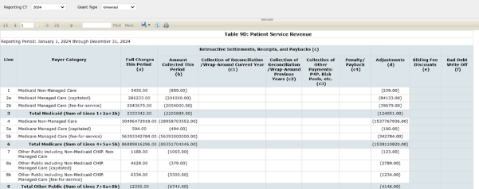

1. **Line:** This willdisplay line numbers of payer category
2. **Payer Category:** This willdisplay payer category name for respective line number.
3. **Full Charges This Period (a):** This willdisplay total charges for services created for the FQHC patients in each payer category (Grid Rows) during the reporting period.
4. **Amount Collected This Period (b):** This willdisplay total payments made for charges on the services created for the FQHC patients in each payer category (Grid Rows) during the reporting period.
5. **Retroactive Settlements, Receipts, and Paybacks (c):** This is aParent label for Grid Columns and this will be blank.
6. **Collection of Reconciliation/ Wraparound Current Year (c1):** This is aParent label for Grid Columns and this will be blank.
7. **Collection of Reconciliation/ Wraparound Previous Years (c2):** This is aParent label for Grid Columns and this will be blank.
8. **Collection of Other Payments: P4P, Risk Pools, etc. (c3):** This is aParent label for Grid Columns and this will be blank.
9. **Penalty/ Payback (c4):** This is aParent label for Grid Columns and this will be blank.
10. **Adjustments (d):** This willdisplay the total of adjustments made on charges for the services created for FQHC patients in each payer category (Grid Rows) during the reporting period selected in the Reporting CY filter. This will Consider ARLedgers with LedgerType = 4203
11. **Sliding Fee Discounts (e):** This will display the total of adjustments made on charges for the services created for FQHC patients during the reporting period selected in the Reporting CY filter, where the payer category is mapped to Self-pay. It will consider AR Ledgers with Ledger Type = 4203 and where the Adjustment Code is mapped to the Adjustments in Recode Category = 'UDSTable9DSlidingFeeAdjCodes'. It will calculate only for Grid row line 13.
12. **Bad Debt Write-Off (f):** This will display the total of adjustments made on charges for the services created for FQHC patients during the reporting period selected in the Reporting Year CY, where the payer category is mapped to Self-pay. It will consider AR Ledgers with Ledger Type = 4203 and where the Adjustment Code is mapped to the Adjustments in Recode Category = ‘UDSBadDebtWriteOffAdjCodes’. It will calculate only for Grid row line 13.

**Grid Rows:**

1. Line 1- **Medicaid Non-Managed Care:** This will Calculate Grid Columns a, b, and d for this Grid Row for charges associated with plans tagged as "Medicaid Non-Managed Care" per Payer Code in Plan Details > Reporting > Coverage Plan Payer Code (OR) Plan Details > General > Payer > "<Add/Modify Payer>" > Payer Code dropdown.’
2. Line 2a **- Medicaid Managed Care (capitated):** This will Calculate Grid Columns a, b, and d for this Grid Row for charges associated with plans tagged as "Medicaid Managed Care (capitated)" per Payer Code in Plan Details > Reporting > Coverage Plan Payer Code (OR) Plan Details > General > Payer > "<Add/Modify Payer>" > Payer Code dropdown
3. Line 2b- **Medicaid Managed Care (fee-for-service):** This will Calculate Grid Columns a, b, and d for this Grid Row for charges associated with plans tagged as "Medicaid Managed Care (fee-for-service)" per Payer Code in Plan Details > Reporting > Coverage Plan Payer Code (OR) Plan Details > General > Payer > "<Add/Modify Payer>" > Payer Code dropdown
4. Line 3 - **Total Medicaid (Sum of Lines 1+2a+2b):** This will display the sum of Lines 1 + 2a + 2b
5. Line 4 - **Medicare Non-Managed Care:** This will Calculate Grid Columns a, b, and d for this Grid Row for charges associated with plans tagged as "Medicare Non-Managed Care" per Payer Code in Plan Details > Reporting > Coverage Plan Payer Code (OR) Plan Details > General > Payer > "<Add/Modify Payer>" > Payer Code dropdown.
6. Line 5a **- Medicare Managed Care (capitated):** This willCalculate Grid Columns a, b, and d for this Grid Row for charges associated with plans tagged as "Medicare Managed Care (capitated)" per Payer Code in Plan Details > Reporting > Coverage Plan Payer Code (OR) Plan Details > General > Payer > "<Add/Modify Payer>" > Payer Code dropdown
7. Line 5b - **Medicare Managed Care (fee-for-service):** This will Calculate Grid Columns a, b, and d for this Grid Row for charges associated with plans tagged as "Medicare Managed Care (fee-for-service)" per Payer Code in Plan Details > Reporting > Coverage Plan Payer Code (OR) Plan Details > General > Payer > "<Add/Modify Payer>" > Payer Code dropdown.
8. Line 6 **- Total Medicare (Sum of Lines 4 + 5a + 5b):** This will Display the Sum of Lines 4 + 5a + 5b
9. Line 7 **- Other Public including Non-Medicaid CHIP. Non Managed Care:** This willCalculate Grid Columns a, b, and d for this Grid Row for charges associated with plans tagged as "Other Public including Non-Medicaid CHIP. Non Managed Care" per Payer Code in Plan Details > Reporting > Coverage Plan Payer Code (OR) Plan Details > General > Payer > "<Add/Modify Payer>" > Payer Code dropdown.
10. Line 8a - **Other Public including Non-Medicaid CHIP. Managed Care (capitated):** This will Calculate Grid Columns a, b, and d for this Grid Row for charges associated with plans tagged as "Other Public including Non-Medicaid CHIP. Managed Care (capitated)" per Payer Code in Plan Details > Reporting > Coverage Plan Payer Code (OR) Plan Details > General > Payer > "<Add/Modify Payer>" > Payer Code dropdown.
11. Line 8b **- Other Public including Non-Medicaid CHIP. Managed Care (fee-for-service):** This will Calculate Grid Columns a, b, and d for this Grid Row for charges associated with plans tagged as "Other Public including Non-Medicaid CHIP. Managed Care (fee-for-service)" per Payer Code in Plan Details > Reporting > Coverage Plan Payer Code (OR) Plan Details > General > Payer > "<Add/Modify Payer>" > Payer Code dropdown
12. Line 9-**Total Other Public (Sum of Lines 7 + 8a + 8b):** This will Display the Sum of Lines 7 + 8a + 8b
13. Line 10 - **Private Non-Managed Care:** Calculate Grid Columns a, b, and d for this Grid Row for charges associated with plans tagged as "Private Non-Managed Care" per Payer Code in Plan Details > Reporting > Coverage Plan Payer Code (OR) Plan Details > General > Payer > "<Add/Modify Payer>" > Payer Code dropdown
14. Line 11a - **Private Managed Care (capitated):** This will Calculate Grid Columns a, b, and d for this Grid Row for charges associated with plans tagged as "Private Non-Managed Care (capitated)" per Payer Code in Plan Details > Reporting > Coverage Plan Payer Code (OR) Plan Details > General > Payer > "<Add/Modify Payer>" > Payer Code dropdown
15. Line 11b - **Private Managed Care (fee-for-service):** This will Calculate Grid Columns a, b, and d for this Grid Row for charges associated with plans tagged as "Private Non-Managed Care (fee-for-service)" per Payer Code in Plan Details > Reporting > Coverage Plan Payer Code (OR)Plan Details > General > Payer > "<Add/Modify Payer>" > Payer Code dropdown
16. Line 12 - **Total Private (Sum of Lines 10+11a+11b):** This will display the Sum of Lines 10 + 11a + 11b
17. Line 13 - **Self-Pay:** This will Calculate Grid Columns a, b, d, e, and f for this Grid Row for charges associated with plans tagged as "Self-Pay" per Payer Code in Plan Details > Reporting > Coverage Plan Payer Code (OR)Plan Details > General > Payer > "<Add/Modify Payer>" > Payer Code dropdown
18. Line 14- **TOTAL (Sum of Lines 3+6+9+12+13):** This will Display the Sum of Lines 3 + 6 + 9 + 12 + 13 for Grid Columns a-f.
19. **Comments (Max 4000 characters):** This is a label.

**Recode categories used for mapping payer category to payer codes.**

**Medicaid:** These fields are mapped to the CharacterCodeID(Payercode) in their  
 respective categories.

xMedicaidNonManagedCare(UDSTable9D)

xMedicaidManagedCareCapitated(UDSTable9D)

xMedicaidManagedCareFeeForService(UDSTable9D)

**Medicare:** These fields are mapped to the CharacterCodeID(Payercode) in their  
 respective categories.

xMedicareNonManagedCare(UDSTable9D)

xMedicareManagedCareCapitated(UDSTable9D)

xMedicareManagedCareFeeForService (UDSTable9D)

**Other Public:** These fields are mapped to the CharacterCodeID(Payercode) in their  
 respective categories.

xOtherPublicNonMedicaidCHIPNonManagedCare(UDSTable9D)

xOtherPublicNonMedicaidCHIPManagedCareCapitated(UDSTable9D)

xOtherPublicNonMedicaidCHIPManagedCareFeeForService(UDSTable9D)

**Private:** These fields are mapped to the CharacterCodeID(Payercode) in their  
 respective categories.

xPrivateNonManagedCare(UDSTable9D)

xPrivateManagedCareCapitated(UDSTable9D)

xPrivateManagedCareFeeForService(UDSTable9D)

**Self-Pay:** These fields are mapped to the CharacterCodeID(Payercode) in their  
 respective categories.

xSelfPay(UDSTable9D).

**UDSTable9DSlidingFeeAdjCodes:** These fields are mapped to the IntergerCodeID(AdjustmentCode)

**UDSTable9DBadDebtWriteOffAdjCodes:** These fields are mapped to the IntergerCodeID(AdjustmentCode)

**Recode Details:**

**Recode Category:** UDSTable9DBadDebtWriteOffAdjCodes

**Description:** To display the total adjustments made to charges for services included in the UDS Patient-Related Revenue FQHC Report, where the AdjustmentCode is mapped to Adjustments – Bad Debt Write-Off.

**Mapping Entity:** ARLedger.AdjustmentCode

**Recode Category:** UDSTable9DSlidingFeeAdjCodes

**Description:** To display the total adjustments made to charges for services included in the UDS Patient-Related Revenue FQHC Report, where the AdjustmentCode is mapped to Adjustments – Sliding Fee Discounts.  
**Mapping Entity:** ARLedger.AdjustmentCode

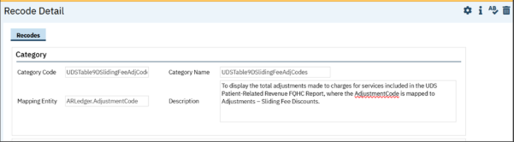

# RWQM

|  |  |  |
| --- | --- | --- |
| **Reference No** | **Task No** | **Description** |
| 120 | Core Bugs # 130882 | AllowedPreviousAction list stored as Action Name list, not action id list - condition failing. |
| 121 | Core Bugs # 131116 | Issues observed in the RWQM work queue items. |

**Author:** Namratha Nagraj

### 120. Core Bugs # 130882: AllowedPreviousAction list stored as Action Name list, not action id list - condition failing.

**Release Type:** Fix **| Priority:** Medium

**Navigation Path 1:** Actions (Administration) -- Click on ‘New’ button -- 'Action Details’ Page will be opened -- Enter all the required details -- Click on ‘Only Allowed for Charge Status’ button -- Select required ‘Charge Status’ -- Click on ‘Save’ button.

**Navigation Path 2:** Financial Assignment (Administration) -- Click on ‘New’ button -- Financial Assignment Details’ Page will be opened -- Enter all the required details -- Click on ‘Save’ button.

**Navigation Path 3:** RWQM Rules (Administration) -- Click on ‘New’ button -- 'RWQM Rule Details’ Page will be opened -- Enter all the required details -- Click on ‘Charge Filters’ tab -- Click on ‘Include Charges with the Following Action(s)’ button -- Select the ‘Action created in Navigation Path 01’ -- Click on ‘Save’ button.

**Functionality ‘Before’ and ‘After’ release:**

Before this release, here was the behavior. When a user ran a nightly billing job after the above mentioned set up (As mentioned in the navigation paths), there was an error.

With this release the above-mentioned issue is Resolved. Now the user can run the nightly billing job without any error.

**Author:** Namratha Nagraj

### 121. Core Bugs # 131116: Issues observed in the RWQM work queue items.

**Release Type:** Fix **| Priority:** Medium

**Navigation Path:** RWQM Rules (Administration)-Click on ‘New’ button-'RWQM Rule Details’ Page —Enter all the required details- Click on ‘Save’ button.

**Functionality ‘Before’ and ‘After’ release:**

Before this release, here was the behavior. When the user ran the nightly billing job( ssp_SCCreateRWQMWorkQueueItems), the below issues were observed:

1.For the same Charge ID, RWQM Rule ID was duplicated.

2.The balance amount for the charge exceeded the charge amount and it was not showing in the ledger entries screen.

3.Clients that have multiple clients contact notes were duplicated in the RWQM work queue.

With this release, the above-mentioned issue is resolved as below:

1.For the same Charge ID, RWQM Rule ID is not duplicated.

2.The balance amount for the charge exceeded the charge amount, that is showing in the ledger entries screen.

3. Now, the user can run the nightly billing job(ssp_SCCreateRWQMWorkQueueItems) without any duplicate entries in the RWQM work Queue.

# Rx Application

|  |  |  |
| --- | --- | --- |
| **Reference No** | **Task No** | **Description** |
| 122 | Core Bugs # 130614 | Slowness while Opening RX from SC. |
| 123 | Core Bugs # 130733 | Rx: PDMP Report not generating. |

**Author:** Rajgopal Yajurvedi

### 122. Core Bugs # 130614: Slowness while Opening RX from SC

**Release Type:** Fix **| Priority:** Medium

**Navigation Path:** Login to SmartCare Application - ‘Client’ – ‘Medication Management Rx’ link – Rx Application – ‘Patient Summary’ screen.

**Functionality ‘Before’ and ‘After’ release:**

Before this release, here was behavior. The Rx application was taking longer time to load from the SmartCare application.

With this release, the above-mentioned issues have been resolved. Now, the Rx Application is not taking more time to load from the SmartCare application.

**Author:** Manjunath Malipatil

### 123. Core Bugs # 130733: Rx: PDMP Report not generating.

**Release Type:** Fix | **Priority:** Medium

**Navigation Path:** Login to Rx Application -- Click on Patient Search – Perform patient Search and select a patient – In Patient Summary screen click on PMP Button.

**Functionality ‘Before’ and ‘After’ release:**

Before This release, here was the Behavior. When the user Clicked on PMP Button in the Patient Summary screen, PMP Report was not generated due to</error>' tag in the Report response message. Also, the below mentioned Error message was displayed in the Patient Summary screen.

**Error Message:** "An Error Occurred. Please Contact your System Administrator"

With this release, the above-mentioned issue has been resolved. Now, PMP Report is generated without any errors when the user Clicks on PMP Button in the ‘Patient Summary’ screen.

# Scanning

|  |  |  |
| --- | --- | --- |
| **Reference No** | **Task No** | **Description** |
| 124 | Core Bugs # 130452 | Scanning: On Clicking Close(X) to exit out of a scan still saves the scan to SmartCare as a “not associated” document. |
| 125 | Core Bugs # 131166 | The ‘Scanned Medical Record Detail’ and ‘Uploaded File Detail’ screen names are displayed with old label name. |

**Author:** Tejashwini Srinivas

### 124. Core Bugs # 130452: Scanning: On Clicking Close(X) to exit out of a scan still saves the scan to SmartCare as a “not associated” document.

**Release Type:** Fix **| Priority:** High

**Navigation Path: ‘**My office’ -- ‘Scanning’ – ‘Scan/Upload’ an Image – Select ‘No’ on the Popup -- ‘View’ the ‘Scanned Medical Records List’ page.

**Functionality ‘Before’ and ‘After’ release:**  
  
Before this release, here was the behavior. When the users clicked on "Scan/Upload New Images" and subsequently selected the ‘Close (x)’ button, a below pop-up window would appear with the message:

**Message:** "Do you want to complete the document?" This pop-up offered "Yes", "No" and "Cancel" options.

However, even if the user selected "No", the document would still be saved as a "Not Associated" scan document.

Moreover, if the user selected ‘No’ and then clicked on the Close (x) button, they remained on the same page instead of navigating to the List page.

With this release, the above-mentioned issues have been resolved. Now, clicking "Yes" will save the document entry. If "No" is clicked, the scanned document will not be saved as "Not Associated". Additionally, clicking the "Close (x)" button will navigate the user back to the List page.

**Author:** Lavanya Gowdru

### 125. Core Bugs # 131166: The ‘Scanned Medical Record Detail’ and ‘Uploaded File Detail’ screen names are displayed with old label name.

**Release Type:** Fix **| Priority:** High

**Navigation Path:** Client -- Scanning’ -- Scan/Upload the records --- Observe the ‘Scanned Medical Record Detail’ and ‘Upload File Detail’ screen.

**Functionality ‘Before’ and ‘After’ release:**

Before this release, here was the behavior. When the user Scanned/Uploaded the records under Client, the ‘old’ label name was associated with ‘Scanned Medical Record Detail’ and ‘Upload File Detail’ screen names.

With this release, the above-mentioned issue has been resolved. Now, the ‘old’ label name has been removed and the ‘Scanned Medical Record Detail’ and ‘Upload File Detail’ screen names are displayed correctly when the user Scans/Uploads the records under Client.

# Service From Claims

|  |  |  |
| --- | --- | --- |
| **Reference No** | **Task No** | **Description** |
| 126 | Core Bugs # 131032 | Getting Service Completion error when processing the job. |

**Author:** Renuka Gunasekaran

### 126. Core Bugs # 131032: Getting Service Completion error when processing the job.

**Release Type:** Fix **| Priority:** Medium

**Prerequisite:** Added separate unit for billing code using the below **path:**  
'Administration' -- 'Billing Code' – click on Code hyperlink -- 'Billing Code Details' Screen -- 'Billing Code Modifiers' tab -- Select ‘Billing code modifier’ – enter 'Unit' – ‘Select PCM Charge Type' -- Click On 'Insert' and ‘Save’.

**Navigation Path 1:** 'My Office' -- 'Claims' -- Select Claim and claim Type('P'/'I'/'PP'/'PI') -- 'Claim Entry’ Screen -- Select Provider/Insurer with billing code which has PCM charge type set up -- Save with required fields -- Select created ‘Claim Line’ -- 'Claim Line Detail' Screen – Select 'Adjudicate' from 'Select Action' – Select 'Pay' from 'Select Action'.

**Navigation Path 2:** 'My Office' -- 'Services from claims' -- 'Services from claims' list page -- Select Claim Line Id -- Click on 'Create Service' icon.

**Functionality ‘Before’ and ‘After’ release**:

Before this release, here was the behavior. When the user processed the job to complete the service, the below mentioned Service completion error was displayed due to the Date TimeIn/Date TimeOut was not calculated properly when processed the ‘service from claim’ for the claims which has the billing code with PCMChargeType set up.

**Error Message:** "Duration does not match the DateTimeIn/DateTimeOut. End date does not equal Start date."

With this release, the above-mentioned issue has been resolved. Now, Date TimeIn/Date Timeout is calculating properly when ‘Service From Claims’ is processed for the claims which have the billing code with PCMChargeType set up and the user can complete the service without any error.

# Services

|  |  |  |
| --- | --- | --- |
| **Reference No** | **Task No** | **Description** |
| 127 | EII # 129382 | Ability to add multiple staff members to an appointment/service. |
| 128 | Core Bugs # 130501 | Regenerate Charge creating duplicate charge amount when exist overlapping AccountingPeriods record. |
| 129 | Core Bugs # 130923 | Services: Automatic Add-on code is not captured when service is completed in one short. |
| 130 | Core Bugs # 131175 | Out Of Memory error logs are logged in the ‘Service Detail’ screen. |
| 131 | Core Bugs # 131229 | The Charge amount is not updated to $0 when the scheduled service is cancelled from the ‘Service Details’ screen. |
| 132 | Core Bugs # 131180 | Service Note is not generating for MAT medications. |

**Author:** Suganya Sivakumar

### 127. EII # 129382 (Feature - 446557): Ability to add multiple staff members to an appointment/service.

**Release Type:** Change | **Priority:** Urgent

**Navigation Path 1:** My Office --- New Calendar Entry Quick Links **---** Select the particular date --- Click on the selected timing slot --- New Entry popup displays --- Select New Calendar Entry Radio button --- Click on OK button --- In Scheduler Event popup --- Enter all the required fields --- Added New Section --- Add Additional Staff section --- Enter all the required fields --  Click on Ok button.

**Navigation Path 2:** Perform Client Search --- Select Client --- Navigate to Services/Notes Quick Links --- Client Menu --- Service/Note List Page --- Click on New Icon --- Service Note detail page --- Select Prog/Proc/Loc values --- From Right Most menus --- Click on Select Action icon --- Select Add/View Additional Staff  Action --- Add/View Additional Staff Popup displays --- Enter all the required information --- Click on Save --- Sign the Service Note.

**Functionality ‘Before’ and ‘After’ release:**

**Purpose:** To provide an ability to add multiple staff to appointments/Service will enhance the scheduling process by automatically notifying all team members when a client arrives. As a result, it will enhance efficiency in both Staff and Client experience during appointment scheduling.

With this release, a functionality is implemented to allow multiple staff members to be added to an Appointment /Service. Staff members who are on appointment, will be notified when a client arrives.

**Scheduler Event Popup:**

1. The ‘Add Additional Staff’ section has been added in the Scheduler Event Popup.
2. Below are the following fields in the Add Additional Staff section.

* **Staff Name** – It is a Typeable Searchable Textbox field. The Name of the Staff member who attends the appointment with the main Clinician will be displayed here..
* **Start Time** – Enter the Start Time of the Additional Staff member.
* **End Time** - Enter the End Time of the Additional Staff member. When the User enters the End Time, then the system calculates the duration and auto-updates the “Duration in Minutes” field.
* **Duration in Minutes** – The total duration that the Staff took to complete the service. If the user enters a duration, then the system will auto calculate the end time and auto–update the “End Time” field.
* **Total Travel Duration** – This field displays the total travel time that additional staff took to reach to Service Centre.

1. There are two buttons present in the ‘Add Additional Staff’ section:

* **Insert**:

1. It inserts the additional Staff information on Click .

2. While inserting the staff information, the system will check for the Start Time entered for the additional Clinician. If the Start Time exceeds or is beyond the actual Start Time of the appointment, then the validation message will be displayed.

Validation Message - “The start time for the additional staff does not lie between the start and end time of the event."

* **Clear** – On Click it clears the additional Staff information.
* **Modify** – When user selects an existing record, this button will display, which is used to modify the existing Additional staff details.

**Additional Staff Grid:**

1. This section has the Additional Staff details inserted in the grid.

2. Two Radio buttons are present in each row to provide Delete and Selection options in the Additional Staff section.

3. Additional Staff can be deleted or modified from this section if needed.

* Select Radio button – On click of the button, it displays the staff details to the user, so they can modify the details if required.
* Delete Radio button – On click of the button, it displays the confirmation message.

**Confirmation message:**

"Do you want to remove the Additional Staff from this Appointment?"

        - On click of "OK", the system will delete the staff and remove from the current appointment.

        - On click of "Cancel", the system will exit from the pop-up.

**Service/Notes:**

1. ‘Add/View Additional Staff’ action has been added to the Select Action dropdown list in the Service/Notes screen.
2. It displays a pop-up “Add/View Additional Staff” when clicked on the action.

1. When a user adds a service on the main screen and opens this pop-up, if they try to add staff without saving the main service, system will display the following validation message on the Service screen.**Validation Message** - " Please save the Service."

1. Below are the following fields in the Add Additional Staff section.

* Staff Name – It is a Typeable Searchable Textbox field. This field displays the Name of the Staff member who attends the appointment with the main Clinician.
* Start Time – User can Enter the Start Time of the Additional Staff member.
* End Time – User can Enter the End Time of the Additional Staff member. When the User enters the End Time, then the system auto-calculates the duration and auto-updates the “Duration in Minutes” field.
* Duration in Minutes – The total duration that the Staff took to complete the service. If the user enters a duration, then the system auto-calculate the end time and auto–updates the “End Time” field.
* Total Travel Duration – The total travel time that additional staff took to reach to Service Centre.

1. There are Four buttons present in the Add/View Additional Staff section

* **Insert**:

1**.** On Click of i**t, this inserts the additional Staff information.**

2**.** While inserting the staff information, the system will check for the Start Time entered for the additional Clinician. If the Start Time exceeds or is beyond the actual Start Time of the appointment, then the validation message will be displayed.

**Validation Message** - “The start time for the additional staff does not lie between the start and end time of the event."

* **Clear –** On Click it clears the additional Staff information.
* **Modify –** When user selects the existing record, this button will display, which is used to modify the existing Additional staff details.
* **Save/Close –** It will save the Additional Staff and close the pop-up to return to the Service screen.
* **Cancel –** On click the system will exits from the Pop-up and return to the Service screen.

1. **Additional Staff section –**

1. It has the Additional Staff details inserted in the grid.

2. Two Radio buttons are present in each row to provide the Delete and Selection options in the Additional Staff section.

3. Additional Staff can be deleted or modified from this section if needed.

* Select Radio button – On click of the button, it displays the staff details to the user, so they can modify the details if required.
* Delete button – On click of the button, it displays the confirmation message.

Confirmation message:

     "Do you want to remove the Additional Staff from this Appointment?"

        - On click of "OK", deletes the staff and removes from the current appointment.

        - On click of "Cancel", it exits from the pop-up.

7. When the Additional Staff are added to the Appointment, there are some screens and widgets that have some impact.

1. Check In Notification: When the client checks in/arrives for an appointment, all added Additional staff will be notified.

2. Staff Calendar: The Additional Staff scheduled service will appear as a service entry on the calendar

3. Dashboard (Widgets): The scheduled service will appear in the following widgets.

    i) Appointments for Today.

   ii) Services for Today with Past Scheduled.

  iii) Services for Today.

 iv) Documented Service Tools – When completion of the service, the Total time/duration that additional staff were present during the appointment will be counted towards their productivity.

**Author:** Debanjit Das

### 128. Core Bugs # 130501: Regenerate Charge creating duplicate charge amount when exist overlapping AccountingPeriods record.

**Release Type:** Fix | **Priority:** High

**Navigation Path:** 'Client' -- Services -- Click on 'Regenerate Charge' button in 'Service Details' screen.

**Functionality ‘Before’ and ‘After’ release:**

Before this release, here was the behavior. When an overlapping accounting period existed and Regenerate Charge was used for a completed service, then the amount reversed in the regenerated charge was doubled, causing incorrect entries in the 'Ledger Entries' screen.

With this release, the above-mentioned issue has been resolved. Now, if an overlapping accounting period exists in the system, the regenerate charge will not be doubled and the reversed amount will be displayed correctly.

**Author:** Suganya Sivakumar

### 129. Core Bugs # 130923: Services: Automatic Add-on code is not captured when service is completed in one shot.

**Release Type:** Fix **| Priority:** Medium

**Navigation Path 1:** Go search -Administration- Procedure/Rates- Procedure/Rates List page - Click on New icon - Procedure code details screen -Enter all the required fields - Click on Save.

**Navigation Path 2:** Go search -Administration- Procedure/Rates- Procedure/Rates List page - Search another Procedure Code- Procedure Code detail screen- Add-On Procedure Codes tab- Add-On Procedure Codes section - Select a Procedure (created from Navigation path 1) - Click on Save.

**Navigation Path 3:** Go search –Administration- Automatic Add-on Codes - Automatic Add-On Codes List Page-Click on New icon - Automatic Add On Code Details screen-In Services with Procedure Code dropdown, select the procedure which is created from (Navigation Path 1)-In the Should have Add on Code dropdown (select the procedure which is added in the Navigation Path 2)- Click on Save.

**Navigation Path 4:** Perform Client Search -Select Client - Services - Click on new icon - Service Detail Page - Select the Program, Procedure, and Location - Enter all the required fields -Set Status to Complete status - Click on Save.

**Functionality ‘Before’ and ‘After’ release:**

Before this release, here was the behavior. In the Service detail screen, the Automatic Addon codes were not captured when the service was completed in one shot.

With this release, the above-mentioned issue is resolved. Now, the Automatic Addon codes are captured when the service is completed in one shot in the service detail screens.

**Author:** Suganya Sivakumar

### 130. Core Bugs # 131175: Out Of Memory error logs are logged in the ‘Service Detail’ screen.

**Release Type:** Fix **| Priority:** Medium

**Navigation Path: ‘**Client’ search --- Select a ‘Client’ --- Navigate to ‘Services’ --- ‘Client’ --- Click on ‘New’ Icon --- ‘Service Detail’ Page --- Select the ‘Program’, ‘Procedure’, and ‘Location’ --- Enter all the required fields --- click on ‘Save’ icon.

**Functionality ‘Before’ and ‘After’ release:**

Before this release, here was the behavior. The multiple out-of-memory exceptions are logged in error logs while performing a load test in the ‘Service Detail’ screen.

With this release, the above-mentioned issue has been fixed. Now, no out of memory exceptions are logged in error logs while performing a load test in the ‘Service Detail’ screen.

**Author:** Chaithra Kunjilana

### 131. Core Bugs # 131229: The Charge amount is not updated to $0 when the scheduled service is cancelled from the ‘Service Details’ screen.

**Release Type:** Fix **| Priority:** High

**Navigation Path: ‘**Client’ search -- ‘Services’ – Select any scheduled service which has Charge amount – Select ‘Cancel’ – Provide the ‘Cancel’ reason -- ‘Save’.

**Functionality ‘Before’ and ‘After’ release:**

Before this release, here was the behavior. When the user cancelled the scheduled Service from the ‘Service Details’ screen, the charge amount was not updated to $0.

With this release, the above-mentioned issue is fixed. Now, the charge amount will be updated to $0 when the user cancels the scheduled service from the ‘Service Details’ screen.

**Author:** Suganya Sivakumar

### 132. Core Bugs # 131180: Service Note is not generating for MAT medications.

**Release Type:** Fix | **Priority:** Medium

**Prerequisites:**

1.Client 1 and Client 2 exist with the prescribed MAT medications.   
2. Excecute the ssp_SCCreateMatServices job.   
3. Again, add more medications to Client 1 for the same prescription.   
4.Execute the ssp_SCCreateMatServices job.   
   
**Navigation Path:** Select Client-Select Service/Notes list page.

**Functionality ‘Before’ and ‘After’ release:**

Before this release, here was the behavior. The billable Service Note was not generated when the clinician prescribes MAT medications for the existing prescriptions.

With this release, the above-mentioned issue has been resolved. Now, the billable Service Note is generated when the clinician prescribes the MAT Medications for the existing prescriptions.

**Data Model Changes:** A new column ClientMedicationScriptDrugId is added Matservices table.

# Services/Notes

|  |  |  |
| --- | --- | --- |
| **Reference No** | **Task No** | **Description** |
| 133 | EII # 130554 | E/M Note medications refresh - regardless of DOS. |
| 134 | EII # 130097 | Ability to add multiple staff members to an appointment - Core PDF changes. |
| 135 | Core Bugs # 131250 | Service Note PDF took a long time to load. |
| 136 | Core Bugs # 131022 | Misc G/O Note - Incorrect Validation. |
| 137 | Core Bugs # 131193 | Miscellaneous service note: A red error message is displayed when the user tries to click on 'Save' button |

**Author:** Navyashree Jois

### 133. EII # 130554 (Feature - 522360): E/M Note medications refresh - regardless of DOS.

**Release Type:** Change **| Priority:** Urgent

**Prerequisites:** At least one medication is prescribed to the selected client before signing the Note.

**Navigation Path:** Open a client – Search for ‘Services/Notes’ - New - select the procedure associated with ‘Psychiatric Note’ - Enter the required values – Go to Note tab – Enter the required values – Sign the Service Note.

**Functionality ‘Before’ and ‘After’ release:**

**Purpose:** The purpose of this Medications Refresh is to provide the staff the ability to refresh the medication list with the most up-to-date information for the current version of Psychiatric Note.

With this release, the following scenarios are implemented for Psychiatric Note.

1. On the click of the sign of an initial version of the Psych Note document, the 'Medications - Current Medications’ section will automatically refresh the section with the most recent data, and this will apply only to the initial version of the Note.
2. For any subsequent versions of the Psych Note, if the user selects the 'Refresh' button in the 'Medications - Current Medications' section, it will display the pop-up message as below.

**Pop-up Message:** 'Refreshing will update this section with the latest data. Do you want to proceed?'

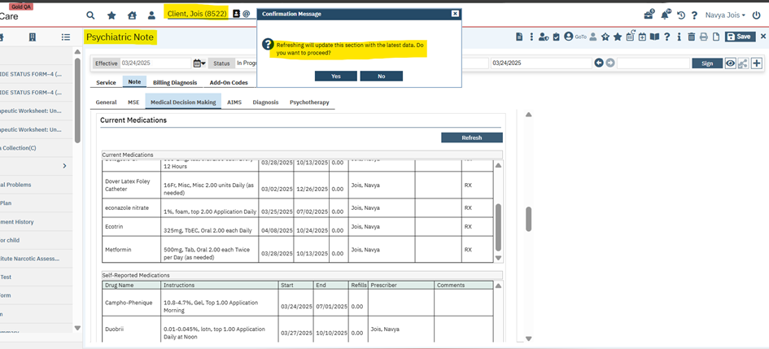

If confirmed with ‘Yes’, the updated Medication Data will get initialized, else the Note will be directly signed with the Medications of the last signed version.

**Screenshot for the Medications list in the initial version:**

**Screenshot for showing on clicking of ‘Refresh’ button current or self-reported medications regardless of the effective date of the document in the initial version of Psychiatric Note:** A screenshot of a computer

**Screenshot for showing Medications Listed in Signed Psychiatric Note PDF:**

**Author:** Kishor Buddareddy

### 134. EII # 130097 (Feature - 491556): Ability to add multiple staff members to an appointment - Core PDF changes.

**Release Type:** Change **| Priority:** Urgent

**Navigation Path:** Client – Services/Notes.

**Functionality ‘Before’ and ‘After’ release:**

**Purpose:** Previously, the system did not support adding multiple or additional staff members to an appointment/Service. With this feature, the system will allow various staff members to be notified when a client arrives for their appointment.

With this release, newly implemented ‘Additional Staff’ Section is added in the PDF along with sub headers as per the design. This section will display after service information in the PDF.

Following the newly added fields in the PDF;

**Section Name:** Additional Staff

**Sub Headers:**

1. Staff Name – Will display Additional Staff details that is added under the newly added action item "Add Additional Staff" in the service tool bar.
2. Start Time
3. End Time
4. Duration
5. Total Travel Duration

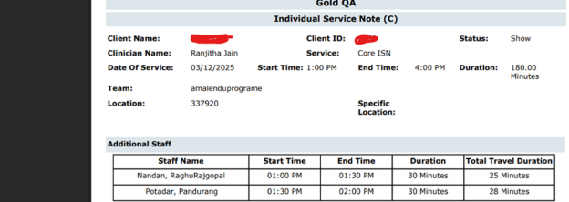

**Note:**

If there are no additional staff added to the service note, then the whole section will not be displayed.

**Author:** Niroop Hassan

### 135. Core Bugs # 131250: Service Note PDF took a long time to load.

**Release Type:** Fix | **Priority:** Medium

**Navigation Path:** ‘Client’– ‘Services/Notes’ - ‘Services/Notes’ list page – Click on ‘New’ icon – ‘Service Note’ page – Select/Enter the required fields and click on ‘Save’ icon – Click on ‘Sign’ icon – ‘Signature Page’ popup – Sign the document.

**Functionality ‘Before’ and ‘After’ release:**

Before this release, here was the behavior. When the user signed the Service Note, the Service Note PDF took a long time to load.

With this release, the above-mentioned issue has been resolved. Now the Service Notes PDF is loading in minimal time.

**Author:** Navyashree Jois

### 136. Core Bugs # 131022: Misc G/O Note - Incorrect Validation.

**Release Type:** Fix | **Priority:** High

**Prerequisites:** An ‘Care Plan’ with active Goals and Objectives is signed for a Client.

**Navigation Path:** Open a client – Go to ‘Services/Notes’ - New - Select the Procedure Code associated with the ‘Misc G/O Note’ – Enter all the required values – Go to Note tab – Enter all the required values – Sign the Service Note.

**Functionality ‘Before’ and ‘After’ release:**

Before this release, here was the behavior. When the user tried to sign the 'Misc G/O' note, the below validation message was displayed, even though a value was selected in the 'Status' dropdown (Note tab) of the 'Misc G/O' note.

**Validation message:** Note - Care Plan Objectives Addressed by this Service - Status is required for the selected Goals and Objectives

With this release, the above-mentioned has been resolved. Now, when the user signs the 'Misc G/O' note by selecting the value in the 'Status' dropdown (Note tab), the validation message is not displayed.

**Author:** Kiran Tigarimath

### 137. Core Bugs # 131193: Miscellaneous service note: A red error message is displayed when the user tries to click on 'Save' button.

**Release Type:** Fix | **Priority:** High

**Navigation Path:** 'Client' search - 'Services/Notes' - Click on 'New' icon - Miscellaneous Service Note' Screen.  
  
**Functionality ‘Before’ and ‘After’ release:**  
  
Before this release, here was the behavior. The below-mentioned red error message was displayed when the user tried to ‘Save’ the details in 'Miscellaneous' Service notes.  
  
**Error Message:** "Please select any option from Initial,Update or Annual"  
  
With this release, the above-mentioned issue is resolved. Now, the user can save the details in ‘Miscellaneous' Service notes without any red error message being displayed.

# SmartCare Improvements

|  |  |  |
| --- | --- | --- |
| **Reference No** | **Task No** | **Description** |
| 138 | EII # 127992 | Notifying users that they are accessing SmartCare from non-supported browsers or OS. |
| 139 | Core Bugs # 131050 | Issues while executing "CreateClinicalInformationReconciliationFiles" SQL job. |

**Author:** Rakesh Naganagoda

### 138. EII # 127992 (Feature - 383374): Notifying users that they are accessing SmartCare from non-supported browsers or OS.

**Release Type:** Change **| Priority:** Urgent

**Navigation Path: Log in** to SmartCare application with different browsers and different Operating System (OS).

**Functionality ‘Before’ and ‘After’ release:**

**Purpose**: To notify a user that he/she is using a non-supported browser or OS so that they can login using a Supported Browser and OS.

With this release, the below mentioned message has been implemented in the SmartCare SSO login page to notify the users that they are using a non-supported browser or OS, so that they can login using a Supported Browser and OS.

**Message**: "You are using an unsupported Browser or Operating System. Please log in using Microsoft Edge or Google Chrome on Windows or Mac OS for the best SmartCare experience" to be displayed to the user on the login screen. This is not a hard stop validation. Users can still continue to log in and proceed.

**This functionality is implemented for the SmartCare SSO login page.**

The details like Browser and OS used for accessing the SmartCare application will be logged into the Table "StaffLoginHistory". These details are logged in irrespective of whether the Browser/OS used is supported or non-supported.

**Note**: Following are the browsers supported by Streamline

**Google Chrome** - Latest Version and the prior version.

**Microsoft Edge** - Latest Version and the prior version.  
   
**Screenshot of the Message displaying in the SSO Login Page using Firefox browser:** 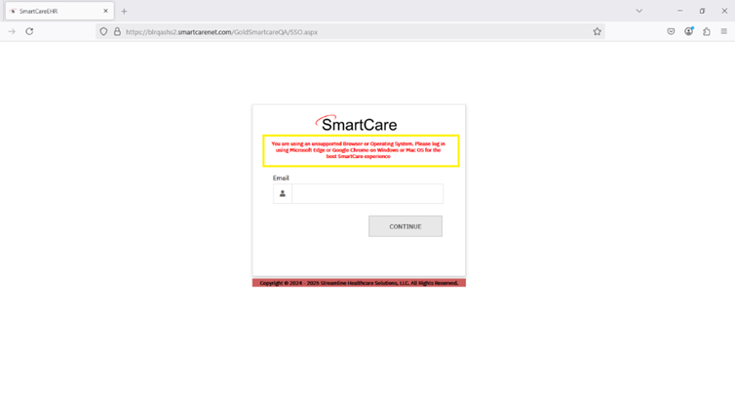

**Screenshot of the Message displayed in the SSO Login Page using Opera browser:**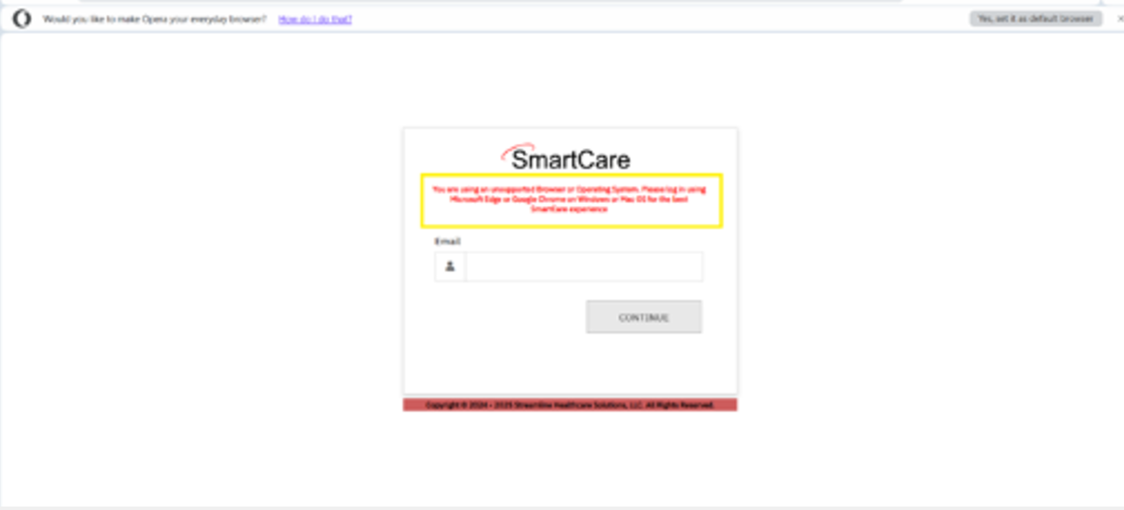

**Author:** Pavithra Sajjan

### 139. Core Bugs # 131050: Issues while executing "CreateClinicalInformationReconciliationFiles" SQL job.

**Release Type:** Fix **| Priority:** Medium

**Navigation Path:** Open SQL – Run ‘CreateClinicalInformationReconciliationFiles’ job.

**Functionality ‘Before’ and ‘After’ release:**

Before this release, here was the behaviour. This recode category "MUReconciliationService" was missing, so all the unwanted services were creating after running SQL ‘CreateClinicalInformationReconciliationFiles’ job.

With this release, the above mentioned has been resolved. Now, the recode category "MUReconciliationService" is added, so the unwanted services are not creating after running the SQL ‘CreateClinicalInformationReconciliationFiles’ job.

# Teds Setup List

|  |  |  |
| --- | --- | --- |
| **Reference No** | **Task No** | **Description** |
| 140 | Core Bugs # 131101 | Getting an error while adding Program on the ‘Teds Setup Details’ Screen. |

**Author:** Boovendiran Chinnusamy

### 140. Core Bugs # 131101: Getting an error while adding Program on the ‘Teds Setup Details’ Screen.

**Release Type:** Fix | **Priority:** High

**Navigation Path:** 'My Office' -- ‘TEDS Setup List’ -- ‘TEDS Setup List’ list page – click on new icon – ‘Teds Setup Details’ Screen – Select ‘Episode Type’ – Select ‘Service Type’ -- Enter ‘Priority’ – select ‘Active’ checkbox – Select ‘Programs’ – Click on Save.

**Functionality ‘Before’ and ‘After’ release:**

Before this release, here was the behaviour. In the ‘Teds Setup Details’ Screen, when the user clicked on save by selecting ‘Episode Type’, ‘Service Type’ and without selecting ‘Programs’, the saved ‘Episode Type ID’ was not displayed on the ‘Teds Setup List’ page. Due to this, the user was unable to add the programs into respective Episode Type ID. If the user tried to add the programs for the same ‘Episode Type’ and ‘Service Type’, the below mentioned error message was displayed in the ‘Teds Setup Details’ Screen.

***Error Message:*** *‘Service Type and Episode Combination already exists’*

With this release, the above-mentioned issue has been resolved. Now, when the user clicks on save by selecting ‘Episode Type’, ‘Service Type’ and without selecting ‘Programs’ in the ‘Teds Setup Details’ Screen, ‘Episode Type ID’ will be displayed on the ‘Teds Setup List’ page. The user can add ‘programs’ for the same ‘Episode Type’ and ‘Service Type’ through the ‘Episode Type ID’.

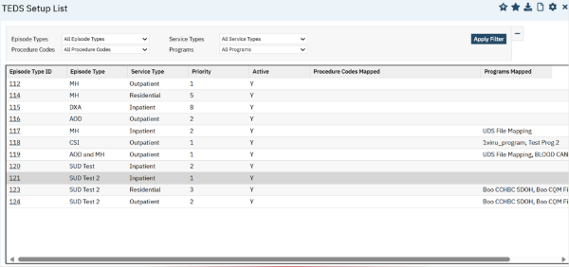

# Treatment Episode

|  |  |  |
| --- | --- | --- |
| **Reference No** | **Task No** | **Description** |
| 141 | Core Bugs # 124807 | The ‘Treatment Episode’ list page displays all the client records regardless of records that the staff/user have access to. |

**Author:** Sithara Ponnath

### 141. Core Bugs # 124807: The ‘Treatment Episode’ list page displays all the client records regardless of records that the staff/user have access to.

**Release Type:** Fix | **Priority:** High

**Navigation Path 1:** ‘Client’ search – Select a client – Search for ‘Treatment Episode’ - Click on ‘New’ icon to create a Treatment Episode – Enter required fields --- Click on ‘Save’ button.

**Navigation Path 2:** ‘Administration’ – ‘Staff/Users’ – ‘Staff/Users’ list page – Search and select a staff – ‘Client Access Overrides’ tab – ‘Denied Clients’ section – Click on ‘Add to List’ button for adding clients – Select the client --- Click on ‘Save’ button.

**Navigation Path 3:** My Office’ - Search for ‘Treatment Episode’ screen -- ‘Treatment Episode' list page.

**Functionality ‘Before’ and ‘After’ release:**

Before the release, here was the behavior. The ‘Treatment Episode’ list page was displayed all the client records regardless of records that the staff/user have access to.

With this release, the above-mentioned issue has been resolved. Now, ‘Treatment Episode’ list page displays only those records that the staff/user has access to the particular client. If the staff/user doesn’t have access to a particular client, then that client related records will not be displayed.

# Glossary of System Configuration Keys, Global Codes, Recodes, Data Model Changes.

### System Configuration Keys

82: ‘AllowLockAndUnlockFunctionalityOnInquiryScreen’

104. 'SetReallocationDaysForNightlyBillingProcesses'

### Global Codes

75. 'ReferringClinician'

88. 'CLAIMLINEACTIVITY'

91. 'MARSTATUS'

100. 'MARSTATUS'

101. 'ClosureType'

114. 'CRISISEVENTTYPE'

114. 'URGENCYLEVEL'

114. 'INQUIRYDISPOSITION'

### Recodes

119. 'UDSTable9DSlidingFeeAdjCodes'

119. UDSBadDebtWriteOffAdjCodes’

119. 'UDSTable9DBadDebtWriteOffAdjCodes'

119. 'xMedicaidNonManagedCare'

119. ’xMedicaidManagedCareCapitated’

119. ’xMedicaidManagedCareFeeForService’

119. ’xMedicareNonManagedCare’

119. ’xMedicareManagedCareCapitated’

119. ’xMedicareManagedCareFeeForService’

119. ’xOtherPublicNonMedicaidCHIPNonManagedCare’

119. ’xOtherPublicNonMedicaidCHIPManagedCareCapitated’

119. ’xOtherPublicNonMedicaidCHIPManagedCareFeeForService’

119. ’xPrivateNonManagedCare’

119. ’xPrivateManagedCareCapitated’

119. ’xPrivateManagedCareFeeForService’

119. ’xSelfPay’

139. 'MUReconciliationService'

### Data Model Changes

82. Added new columns ‘InitiallyLocked’, InitiallyLockedBy’, ‘InitiallyLockedDate’, ‘Locked’, ‘LockedBy’, ‘LockedDate’ to the existing table Inquiries.

85. Added columns BeginTimeLabel, EndTimeLabel and ShowTimeFields in LifeEvents table and added columns BeginTime and EndTime in ClientLifeEvents table

89. A new column MATDispenserId is added to the MATDispenserAPILog table.

90. A new column MATDispenserId is added to the MEDICATIONTRANSACTIONS table.

91. Added column AllowInpatientNurseToDoseTakeHomesOnMAR in MATConfigurations table.

92. The new column EnableHardStopDispensingOnVeryLowIndicator in MATConfigurations table.

105. Added new tables: SlidingScales, SlidingScaleScales, ClientOrderSlidingScales, OrderSlidingScales, OrderSetAttributeDefaultSlidingScales.

Added column InsulinSlidingScale in Orders table, Added columns ClientOrderSlidingScaleId, Glucose in MedAdminRecords table and Added columns ClientOrderSlidingScaleId , Glucose in MedAdminRecordHistory table.

132. A new column ClientMedicationScriptDrugId is added Matservices table.