RELEASE NOTES: 04/24/2025
Monthly Service Pack – SC.CORE.6.0_1.32.000.2503.013 (March MSP 2025 Part 1)
Green highlights indicates that the change was deployed in a prior HF, and is already available in PROD
Blue highlights indicates that the change needs to be tested by CalMHSA because it is related to one of your ZD tickets
Yellow highlights were added by Streamline when the release notes were created. They indicate a new change made to the system.
Strikethrough indicates a change that CalMHSA should not test as it is not a part of your subscription set.

Executive Summary:
- A new document called “CAMS SUICIDE STATUS FORM (SSF-5)" has been implemented. This is to understand the route that causes suicidal thoughts in the client session by session in a single document. The first session is for initial assessment and treatment planning, the interim session focuses on treating suicidal drivers and treatment plan updates and the final session is to complete the outcome or disposition. (EII #128720)
- Implemented the ‘Forgot User Name’ process sending expired link in email. This is to enhance the "Forgot Username" functionality to ensure compatibility with modern email security tools while maintaining security. This will allow multiple clicks on the link within the expiry period, as pre-clicking by email security tools currently invalidates the link. (EII #129899)
- CDAG logic modification has been implemented in the ‘Agency/Program Discharge’ document. This is to restrict users from performing discharge of programs that are not in their current CDAG profile, client-enrolled programs list, or staff-associated programs list. (EII #130539)
- A new ‘Documents Linked to Domain List’ screen has been implemented to create, modify and map Domains and Needs > Goals> Objectives. (EII #123654)
- 'Link Document to Domain' tab has been implemented to link Domains to Documents from Document Codes Detail screen. (EII #126097)

- Added 2420C Loop to claim format rules into the claim format configuration screen. This will provide the ability to the end user to properly populate 837P & 837I Claims. (EII #128771)
- Implemented the ‘Crisis call log details and list page’ screen, which provides the ability to efficiently document the caller’s demographic data, indicates if the person in crisis is already a client within the organization, and documents the crisis that is occurring. (EII #130346 & 130348)
- This enhancement is the ability to support a way of sending separate pay to provider details in 837 institutional claims. Insurance companies are requiring the billing staff to have the submitted claims match what Medicaid has on their PML file, in order to receive payment. (EII #128307)

- Implementation of Medication and Cost tabs are done in the Individualized Service Plan document.
- Medications tab: The client can see the full treatment plan as well as a list of the current medications as of the treatment plan effective date.
- Cost tab: The cost breakdown will give the required information on the potential cost of services, meeting the NSA requirements.
(EII #129584)

*** DISCLAIMER: The document is only available to those customers who have purchased an annual subscription. It is a premium add-on to SmartCare and not included in SmartCare Base Subscription. If you are interested in learning more about this document, please contact your account manager.
Abbreviation: EII - Engineering Improvement Initiatives

Contents

TASKS SUMMARY – ‘NEW FUNCTIONALITY' RELATED (2) 6
TASKS SUMMARY – ‘CHANGE' RELATED (28) 6
TASKS SUMMARY – ‘DEFECT FIXES’ (40) 8
Functionality-wise Task Details: 10
Accounts Receivable / AR 10
1. Core Bugs # 130842: The “Unit” and “ChargeRateId” did not appear for services created through the ‘Bed Assignment’ process in the ‘Service Details’ screen and ‘Services (My Office)’ page. 10
2. Core Bugs # 130912: Optimize ViewCaseRateSetupServices by moving to function. 10
Appointment Search 11
3. EII # 130277 (Feature - 503650): Enhancement to the date filters on Appointment Search (My Office). 11
Appointments table 12
4. EII # 130693 (Feature - 525219): Added a new ‘NotificationInboundStatus’ Column to ‘Appointments’ Table. 12
Authentication/Authorization 13
5. EII #130090 (Feature - 491259): Forgot Username process logic is implemented to allow multiple clicks on the link within the expiry period. 13
6. EII # 130241 (Feature - 500490): Changes to Service Request screen. 13
7. Core Bugs # 130730: Audit Trail Issue. 18
8. Core Bugs # 131127: Security Questions and two factor authentication pop up not appearing for Staff. 18
9. Core Bugs # 131159: Authorization Details: Any data entered in the ‘Narrative’ field of the ‘Custom Fields’ tab disappears upon modifying the authorizations. 19
Automatic add on codes 19
10. Core Bugs # 130763: The SP ‘ssp_PMServicesDetailPostUpdate’ took more time to execute. 19
Batch Claim Upload 20
11. Core Bugs # 131234: An error message is displayed when uploading a batch claim file in the 'Batch Claim Direct Entry' screen. 20
Bed board 20
12. Core Bugs # 131226: Bedboard - Time Not pushing to Client Programs for Admissions or Discharges. 20
Bed Census 21
13. Core Bugs # 131011: Residential Screen – The ‘Non-Billable’ checkbox is automatically checked in the ‘Inpatient Activity Detail’ screen, if the ‘Client’ is on Leave and has provided reasons in the ‘Attendance’ screen. 21
Charges/Claims 22
14. EII # 127558 (Feature - 366627): Implementation of "Show All Charges" as a drop-down item to allow users to filter specific ids with clarity. 22
15. EII # 128307 (Feature - 398012): Changes are implemented for the UB04 claim format in the Claim Format Configuration Page. 26
16. EII # 128771 (Feature – 454170): Added Data Source, Date Values at Format Fields, Claim Format Configurations, Claims Provider Overrides (837 P, 837 I) 30
17. Core Bugs # 130695: A Claim Processing Error when using Select " All in on Page" checkbox. 35
18. Core Bugs # 130746: The box numbers 58, 59 and 60 are pulling unrelated client information in the ‘UB04’ paper claims. 36
19. Core Bugs # 130911: Allow 'U' in ClientSex and InsuredSex fields in claims. 36
142. Core Bugs # 131198: [Case Rate] - Insert Functionality Issues. 36
Claim Lines 38
20. EII # 130399 (Feature – 514814): The ‘Claims’ list page is modified to dynamically display Custom Fields. 38
Client Flags 38
21. Core Bugs # 130944: Client flags: The Due date is not calculated correctly. 39
22. Core Bugs # 131110: Client Flags screen not loading data quickly. 39
23. Core Bugs # 131085: Percentage is not updated accurately when flag is manually completed in Tracking widget SmartView. 39
Client Information (C) 40
24. Core Bugs # 131088: Client Information: The ‘Provider Name’ dropdown is not Populating on Edit. 40
Client Orders 40
25. EII # 128363 (Feature - 401507): Added a confirmation message popup in ‘Client Orders Details’ screen. 41
26. Core Bugs #130925: Client Order: clicking on Titration Order summary link displays blank Titration Step popup. 42
Client Programs 42
27. Core Bugs #131000: Getting an error when trying to discharge the client from Program. 42
Client Search 43
28. Core Bugs # 131258: Client Search pop up: client records not displayed on searching by SSN number. 43
Clinical Data Access Grouping (CDAG) 43
29. EII # 129899 (Feature - 488275): Implemented CDAG logic to Associated Documents Pop-up in My Documents and Client Documents List page and Scan/Upload modules. 43
30. Core Bugs # 131099: A red error was displayed while opening the Documents. 48
CM Events 48
31. Core Bugs # 130866: Provider Agency Staff Person able to Sign ‘Enrollment Form Event’ on the ‘Events’ screen. 48
Compliance CCBHC 49
32. EII # 130344 (Feature - 484409): Changes are added to the Service Notes (Crisis Note) screen. 49
33. EII # 130346 (Feature - 484320): Implemented Crisis Call Log Details screen. 52
34. EII # 130348 (Feature - 484405): Implemented Crisis Call Log List page screen. 62
Contactless Checkin 64
35. Core Bugs # 131132: Contactless Checkin: System is changing to incorrect date when user enters the ‘Date of Birth’ without dashes. 64
Core Assessment 65
36. EII # 127152 (Feature - 344111): Configurable RDL: Save & Upload. 65
37. EII # 130324 (Feature - 512299): Added validation: Only one diagnosis tab can be enabled per Assessment Groupings. 65
38. EII # 128988 (Feature - 466344): Logic to save Domain/Needs and pull same to Needs List. 65
39. EII # 130293 (Feature - 504019): Integration of ‘PECFAS’ document as a Tab into Core Assessment document. 66
40. EII # 130294 (Feature – 504020): Standardization of National Outcome Measures (NOMs) Standalone document to make compatible with Core Assessment. 66
41. EII # 130281(Feature - 503861): Standardization of Core TEDS Data Set Standalone document to make compatible with Core Assessment. 66
42. EII # 130708 (Feature - 522437): Core Assessment: Add Presenting Problem on General Tab. 67
CQM Solutions 67
43. Core Bugs # 130929: CQM Solutions: CMS 155 - the Numerator value was not updating. 67
Dashboard 67
44. Core Bugs # 131066: Dashboard: Widgets moving issue. 68
Direct Messaging 68
45. Core Bugs # 131295: Direct messaging: Button relabeled from '...' to 'Client...'. 68
Document Codes 68
46. EII # 130213 (Feature - 498561): A new ‘Medication’ and ‘Cost’ Checkbox are added with the ‘Configurable Tabs’ field in ‘Care Plan Details’ section of the 'Document Code Detail’ screen. 69
47. EII # 126097 (Feature – 310356): Implementation of 'Link Document to Domain' tab in 'Document Codes Detail' screen. 71
48. EII # 130287 (Feature - 503894): To initialize the ‘Description’ field text from ‘Document Code Details’ to the ‘Needs List’ tab of ‘Core Assessment’ and ‘Needs’ tab under ‘ISP document’. 74
Documents 77
49. EII # 128720 (Feature - 447271): Implemented a new Documents called ‘CAMS SUICIDE STATUS FORM (SSF-5)’. 77
50. EII # 130464 (Feature - 478355): CAMS SSF-4 Fields Cannot Capture Needed Data. 107
51. EII # 129584 (Feature - 475119): ISP document is updated to display the ‘Medication’ and ‘Cost’ tabs. 109
52. EII # 130450 (Feature - 513961): Initialization of the Intervention ‘Details’ textbox value from the recently signed Individualized service Plan (ISP) document. 113
53. EII # 130539 (Feature - 284766): Implementation of CDAG logic modification in the Agency/Program Discharge document. 115
54. EII # 130426 (Feature - 497946): ‘Release of Information(C)’ document labels and fields are updated. 118
55. Core Bugs # 131039: Cosigner adding issue when Staff ID matches the current Client ID. 122
56. Core Bugs # 130852: My Documents: The system takes more time to load the document PDF when non authored users try to access 'In Progress' status documents from the ‘My Documents’ list page. 123
57. Core Bugs # 130907: Error message in the PDF for Letter document. 123
58. Core Bugs # 130910: Effective date issue in the document when changing a Date Prior to Today. 123
59. Core Bugs # 130936: SUD Treatment Plan: The 'Authorization Codes' associated with the Client’s assigned Programs were displayed regardless of the Programs linked to the ‘Vary Care Plan by Program’. 124
60. Core Bugs # 130940: ‘Core Incident Report’: the user’s name displayed in the respective drop downs though user access is deleted in the Recode set up. 125
61. Core Bugs # 131121: Nursing Assessment - Admit Date not displaying correctly. 126
62. Core Bugs # 131141: PDFs of documents have wrong information in header. 127
63. Core Bugs # 130913: Error on EM Signature pop up screen. 127
64. Core Bugs # 130943: Direct messaging is not a usable tool. 128
Documents Linked to Domains 128
65. EII # 123654 (Feature - 246642): A new ‘Documents Linked to Domain List’ screen is implemented to create, modify and map Domains and Needs. 128
Dynamic Forms (DFA) 133
66. Core Bugs # 130947: The ‘Multiline’ textbox in the DFA Document is cleared upon Saving. 133
67. Core Bugs # 131037: ‘Prospective Review SUD’ Document :"Summary" fields issue. 134
68. Core Bugs # 131174: Getting an error message while creating list page forms. 134
E MAR 134
69. Core Bugs # 131097: Group MAR screen. 135
Electronic Remittance 135
70. Core Bugs # 131124: The payment and adjustment for each service are wrongly posted for services with the same ‘Claim Line Item Id’. 135
Glossary of System Configuration Keys, Global Codes, Recodes, Data Model Changes. 136
System Configuration Keys 136
Global Codes 136
Recodes 137
Data Model Changes 137

TASKS SUMMARY – ‘NEW FUNCTIONALITY' RELATED (2)

Sl. No | Task No | Summary | Module Name
49 | EII # 128720 | Implemented a new Documents called ‘CAMS SUICIDE STATUS FORM (SSF-5)’ | Documents
65 | EII # 123654 | A new ‘Documents Linked to Domain List’ screen is implemented to create, modify and map Domains and Needs. | Documents Linked to Domains

TASKS SUMMARY – ‘CHANGE' RELATED (28)

Sl. No | Task No | Summary | Module Name
3 | EII # 130277 | Enhancement to the date filters on Appointment Search (My Office). | Appointment Search
4 | EII # 130693 | Added a new ‘NotificationInboundStatus’ Column to ‘Appointments’ Table. | Appointments table
5 | EII # 130090 | Forgot Username process logic is implemented to allow multiple clicks on the link within the expiry period. | Authentication/Authorization
6 | EII # 130241 | Changes to Service Request screen. | Authentication/Authorization
14 | EII # 127558 | Implementation of "Show All Charges" as a drop-down item to allow users to filter specific ids with clarity. | Charges/Claims
15 | EII # 128307 | Changes are implemented for the UB04 claim format in the Claim Format Configuration Page. | Charges/Claims
16 | EII # 128771 | Added Data Source, Date Values at Format Fields, Claim Format Configurations, Claims Provider Overrides (837 P, 837 I). | Charges/Claims
20 | EII # 130399 | The ‘Claims’ list page is modified to dynamically display Custom Fields. | Claim Lines
25 | EII # 128363 | Added a confirmation message popup in ‘Client Orders Details’ screen. | Client Orders
29 | EII # 129899 | Implemented CDAG logic to Associated Documents Pop-up in My Documents and Client Documents List page and Scan/Upload modules. | Clinical Data Access Grouping
32 | EII # 130344 | Changes are added to the Service Notes (Crisis Note) screen. | Compliance CCBHC
33 | EII # 130346 | Implemented Crisis Call Log Details screen. | Compliance CCBHC
34 | EII # 130348 | Implemented Crisis Call Log List page screen. | Compliance CCBHC
36 | EII # 127152 | Configurable RDL: Save & Upload. | Core Assessment
37 | EII # 130324 | Added validation: Only one diagnosis tab can be enabled per Assessment Groupings. | Core Assessment
38 | EII # 128988 | Logic to save Domain/Needs and pull same to Needs List. | Core Assessment
39 | EII # 130293 | Integration of ‘PECFAS’ document as a Tab into Core Assessment document. | Core Assessment
40 | EII # 130294 | Standardization of National Outcome Measures (NOMs) Standalone document to make compatible with Core Assessment. | Core Assessment
41 | EII # 130281 | Standardization of Core TEDS Data Set Standalone document to make compatible with Core Assessment. | Core Assessment
42 | EII # 130708 | Core Assessment: Add Presenting Problem on General Tab. | Core Assessment
46 | EII # 130213 | A new ‘Medication’ and ‘Cost’ Checkbox are added with the ‘Configurable Tabs’ field in ‘Care Plan Details’ section of the 'Document Code Detail’ screen. | Document Codes
47 | EII # 126097 | Implementation of 'Link Document to Domain' tab in 'Document Codes Detail' screen. | Document Codes
48 | EII # 130287 | To initialize the ‘Description’ field text from ‘Document Code Details’ to the ‘Needs List’ tab of ‘Core Assessment’ and ‘Needs’ tab under ‘ISP document’. | Document Codes
50 | EII # 130464 | CAMS SSF-4 Fields Cannot Capture Needed Data. | Documents
51 | EII # 129584 | ISP document is updated to display the ‘Medication’ and ‘Cost’ tabs. | Documents
52 | EII # 130450 | Initialization of the Intervention ‘Details’ textbox value from the recently signed Individualized service Plan (ISP) document. | Documents
53 | EII # 130539 | Implementation of CDAG logic modification in the Agency/Program Discharge document. | Documents
54 | EII # 130426 | ‘Release of Information(C)’ document labels and fields are updated. | Documents

TASKS SUMMARY – ‘DEFECT FIXES’ (40)
Sl. No | Task No | Summary | Module Name
1 | Core Bugs # 130842 | The “Unit” and “ChargeRateId” did not appear for services created through the ‘Bed Assignment’ process in the ‘Service Details’ screen and ‘Services (My Office)’ page. | Accounts Receivable / AR
2 | Core Bugs # 130912 | Optimize ViewCaseRateSetupServices by moving to function. | Accounts Receivable / AR
7 | Core Bugs # 130730 | Audit Trail Issue. | Authentication/Authorization
8 | Core Bugs # 131127 | Security Questions and two factor authentication pop up not appearing for Staff. | Authentication/Authorization
9 | Core Bugs # 131159 | Authorization Details: Any data entered in the ‘Narrative’ field of the ‘Custom Fields’ tab disappears upon modifying the authorizations. | Authentication/Authorization
10 | Core Bugs # 130763 | The SP ‘ssp_PMServicesDetailPostUpdate’ took more time to execute. | Automatic add on codes
11 | Core Bugs # 131234 | An error message is displayed when uploading a batch claim file in the 'Batch Claim Direct Entry' screen. | Batch Claim Upload
12 | Core Bugs # 131226 | Bedboard - Time Not pushing to Client Programs for Admissions or Discharges. | Bed board
13 | Core Bugs # 131011 | Residential Screen – The ‘Non-Billable’ checkbox is automatically checked in the ‘Inpatient Activity Detail’ screen, if the ‘Client’ is on Leave and has provided reasons in the ‘Attendance’ screen. | Bed Census
17 | Core Bugs # 130695 | A Claim Processing Error when using Select " All in on Page" checkbox. | Charges/Claims
18 | Core Bugs # 130746 | The box numbers 58, 59 and 60 are pulling unrelated client information in the ‘UB04’ paper claims. | Charges/Claims
19 | Core Bugs # 130911 | Allow 'U' in ClientSex and InsuredSex fields in claims. | Charges/Claims
21 | Core Bugs # 130944 | Client flags: The Due date is not calculated correctly. | Client Flags
22 | Core Bugs # 131110 | Client Flags screen not loading data quickly. | Client Flags
23 | Core Bugs # 131085 | Percentage is not updated accurately when flag is manually completed in Tracking widget SmartView. | Client Flags
24 | Core Bugs # 131088 | Client Information: The ‘Provider Name’ dropdown is not Populating on Edit. | Client Information ©
26 | Core Bugs # 130925 | Client Order: clicking on Titration Order summary link displays blank Titration Step popup. | Client Orders
27 | Core Bugs # 131000 | Getting an error when trying to discharge the client from Program. | Client Programs
28 | Core Bugs # 131258 | Client Search pop up: client records not displayed on searching by SSN number. | Client Search
30 | Core Bugs # 131099 | A red error was displayed while opening the Documents. | Clinical Data Access Grouping
31 | Core Bugs # 130866 | Provider Agency Staff Person able to Sign ‘Enrollment Form Event’ on the ‘Events’ screen. | CM Events
35 | Core Bugs # 131132 | Contactless Checkin: System is changing to incorrect date when user enters the ‘Date of Birth’ without dashes. | Contactless Checkin
43 | Core Bugs # 130929 | CQM Solutions: CMS 155 - the Numerator value was not updating. | CQM Solutions
44 | Core Bugs # 131066 | Dashboard: Widgets moving issue. | Dashboard
45 | Core Bugs # 131295 | Direct messaging: Button relabeled from '...' to 'Client...'. | Direct Messaging
55 | Core Bugs # 131039 | Cosigner adding issue when Staff ID matches the current Client ID. | Documents
56 | Core Bugs # 130852 | My Documents: The system takes more time to load the document PDF when non authored users try to access 'In Progress' status documents from the ‘My Documents’ list page. | Documents
57 | Core Bugs # 130907 | Error message in the PDF for Letter document. | Documents
58 | Core Bugs # 130910 | Effective date issue in the document when changing a Date Prior to Today. | Documents
59 | Core Bugs # 130936 | SUD Treatment Plan: The 'Authorization Codes' associated with the Client’s assigned Programs were displayed regardless of the Programs linked to the ‘Vary Care Plan by Program’. | Documents
60 | Core Bugs # 130940 | ‘Core Incident Report’: the user’s name displayed in the respective drop downs though user access is deleted in the Recode set up. | Documents
61 | Core Bugs # 131121 | Nursing Assessment - Admit Date not displaying correctly. | Documents
62 | Core Bugs # 131141 | PDFs of documents have wrong information in header. | Documents
63 | Core Bugs # 130913 | Error on EM Signature pop up screen. | Documents
64 | Core Bugs # 130943 | Direct messaging is not a usable tool. | Documents
66 | Core Bugs # 130947 | The ‘Multiline’ textbox in the DFA Document is cleared upon Saving. | Dynamic Forms (DFA)
67 | Core Bugs # 131037 | ‘Prospective Review SUD’ Document :"Summary" fields issue. | Dynamic Forms (DFA)
68 | Core Bugs # 131174 | Getting an error message while creating list page forms. | Dynamic Forms (DFA)
69 | Core Bugs # 131097 | Group MAR screen. | E MAR
70 | Core Bugs # 131124 | The payment and adjustment for each service are wrongly posted for services with the same ‘Claim Line Item Id’. | Electronic Remittance
142 | Core Bugs # 131198 | [Case Rate] - Insert Functionality Issues. | Charges/Claims

Functionality-wise Task Details:

Accounts Receivable / AR

Reference No | Task No | Description
1 | Core Bugs # 130842 | The “Unit” and “ChargeRateId” did not appear for services created through the ‘Bed Assignment’ process in the ‘Service Details’ screen and ‘Services (My Office)’ page.
2 | Core Bugs # 130912 | Optimize ViewCaseRateSetupServices by moving to function.

Author: Roopa Hemanna

1. Core Bugs # 130842: The “Unit” and “ChargeRateId” did not appear for services created through the ‘Bed Assignment’ process in the ‘Service Details’ screen and ‘Services (My Office)’ page.
Release Type: Fix| Priority: High
Prerequisites Nightly billing job "Create Bed Services’ (ssp_SCCreateServicesBedAssignments) is executed.
Navigation Path: N/A
Functionality ‘Before’ and ‘After’ release:
Before this release, here was the behaviour. The “Unit” and “ChargeRateId” did not appear for services created through the ‘Bed Assignment’ process in the ‘Service Details’ screen and ‘Services (My Office)’ page.
With this release, the above-mentioned issue has been resolved. The “Unit” and “ChargeRateId” now appear for services created through the ‘Bed Assignment’ process in the ‘Service Details’ screen and ‘Services (My Office)’ page.

Author: Roopa Hemanna

2. Core Bugs # 130912: Optimize ViewCaseRateSetupServices by moving to function.

Release Type: Fix | Priority: Medium

Prerequisites: Ensure that the Case Rate is configured with multiple CaseRateSetups and that a large number of active Case Rate records are available.

Navigation Path: ssp_SCJobToCreateCaseRateServices’ job.

Functionality ‘Before’ and ‘After’ release:
Before this release, here was the behavior. The ‘ssp_SCJobToCreateCaseRateServices’ job was getting stuck when a Case Rate had multiple CaseRateSetups, causing the job to run for an extended period without completing.

With this release, the above-mentioned issue has been resolved. Now, the ‘ViewCaseRateSetupServices’ is optimized by transitioning to a function, which has enhanced the performance of the ssp_SCJobToCreateCaseRateServices job.

Appointment Search

Reference No | Task No | Description
3 | EII # 130277 | Enhancement to the date filters on Appointment Search (My Office).

Author: Niroop Hassan

3. EII # 130277 (Feature - 503650): Enhancement to the date filters on Appointment Search (My Office).
Release Type: Change | Priority: Urgent

Navigation Path: ‘My Office’ – ‘Appointment Search’ – ‘Appointment Search’ page.

Functionality ‘Before’ and ‘After’ Release:
Purpose: The change is necessary to improve the clarity of the Appointment Search screen and make the filter criteria more intuitive for users.

With this Release, the following changes have been implemented:

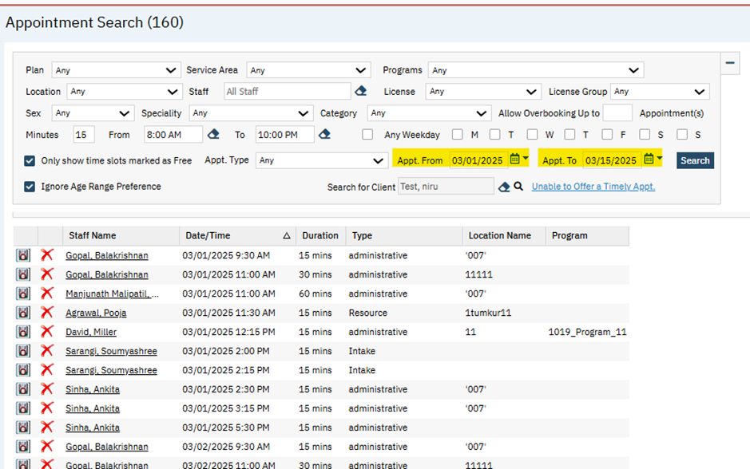

- The ‘Start Date’ filter label has been changed to ‘Appt. From’ and the current date is set as the default date.

- The new textbox ‘Appt. To’ has been added with a calendar control option in the ‘Filter’ section.
- The default value for the 'Appt. To' field is set to 15 days after the 'Appt. From' date.
- If the user-entered Appointment date span is more than 15 days, the following validation will be displayed: " Please adjust the Appointment From and To dates as it cannot be more than 15 days."
- The selected filter dates are retained even after the results are displayed, unless the user manually adjusts the dates and reapplies the filter.
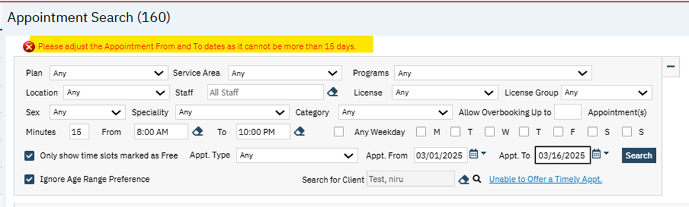

Appointments table

Reference No | Task No | Description
4 | EII # 130693 | Added a new ‘NotificationInboundStatus’ Column to ‘Appointments’ Table.
Author: Chaithra Kunjilana

4. EII # 130693 (Feature - 525219): Added a new ‘NotificationInboundStatus’ Column to ‘Appointments’ Table.
Release Type: Change | Priority: Medium
Navigation Path: N/A
Functionality ‘Before’ and ‘After’ release:
Purpose: Changes are applied to support future Appointment Notification Status from Vendors that support inbound notifications.
With this release, a new column 'NotificationInboundStatus’ is added to the ‘Appointments’ Table.
Note: There are no changes in UI as per this release.
In conjunction with Appointment Notifications, when the Notification Vendor sends out an appointment notification to a client and the vendors service supports the client being able to confirm or cancel the appointment, this column 'NotificationInboundStatus’ will be used to store the 'Client Confirmed' status.
Data Model changes: A new Column 'NotificationInboundStatus’ is added to the ‘Appointments’ table.

Authentication/Authorization

Reference No | Task No | Description
5 | EII # 130090 | Forgot Username process logic is implemented to allow multiple clicks on the link within the expiry period.
6 | EII # 130241 | Changes to Service Request screen.
7 | Core Bugs # 130730 | Audit Trail Issue.
8 | Core Bugs # 131127 | Security Questions and two factor authentication pop up not appearing for Staff.
9 | Core Bugs # 131159 | Authorization Details: Any data entered in the ‘Narrative’ field of the ‘Custom Fields’ tab disappears upon modifying the authorizations.

Author: Sunil Belagali

5. EII #130090 (Feature - 491259): Forgot Username process logic is implemented to allow multiple clicks on the link within the expiry period.
Release Type: Change | Priority: Urgent

Navigation Path: SmartCare Login Page – click on ‘Forgot your Username’.

Functionality ‘Before’ and ‘After’ release:
Purpose: Forgot Username process logic is implemented to allow multiple clicks on the link within the expiry period.
Before this release, here was the behaviour. When the user tried to get the username by clicking on ‘Forgot your Username’ hyperlink on the login page, the "Get Your Username" link in the received email was accessible only once within the email expiry period. After the first click on that link, the link was expired irrespective of email expiry period.
With this release, the above-mentioned issue has been resolved. Now, when the user tries to get the username by clicking on ‘Forgot your Username’ hyperlink on the login page, the "Get Your Username" link in the received email is allowed to use multiple times within the email expiry period. The link will be expired only after the email expiry period, irrespective of number of clicks.

Author: Lakshmi Kumarappan

6. EII # 130241 (Feature - 500490): Changes to Service Request screen.
Release Type: Change | Priority: Urgent
Navigation Path: ‘Client’ search – ‘Service Request Review/Approval List’ Screen.
Functionality ‘Before’ and ‘After’ release:
Purpose: When the Justification field is updated by the requestor and sent back to the approver, the changes to the field are not initialized to the Justification field on the Approval tab. So with this implementation, when a requester adds additional information to the Justification field via the Request tab, that new information initializes to the Approval tab upon saving.

With this release, the following changes are added to the Service Request Review/Approval Detail screen:
1. The user modifies the justification text in the 'Request' tab, the change will be reflected in the 'Approval' tab.
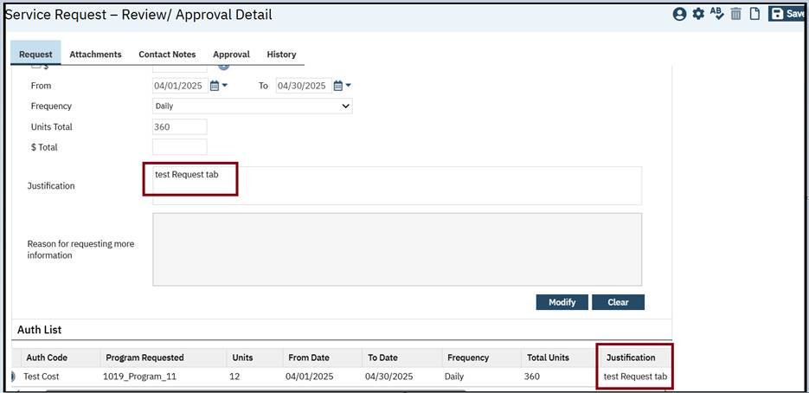
2. The justification text on the Request tab will be displayed in the Approval tab when the Request Status = Submitted or Re-submitted and saved successfully.

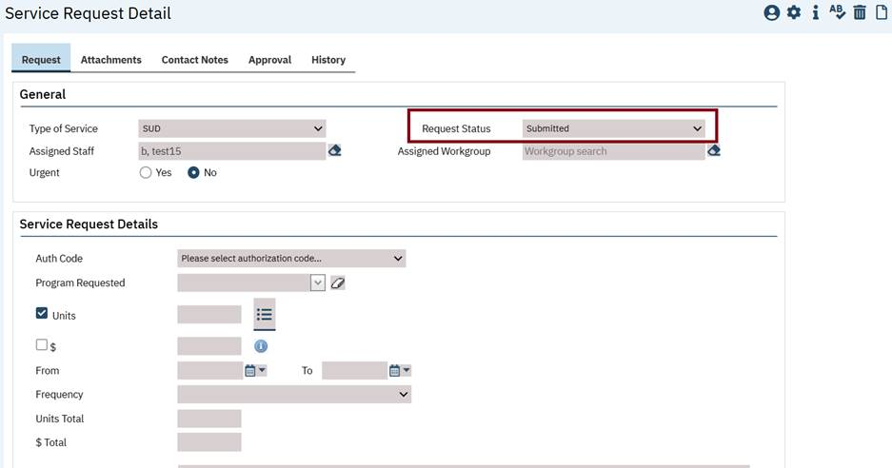
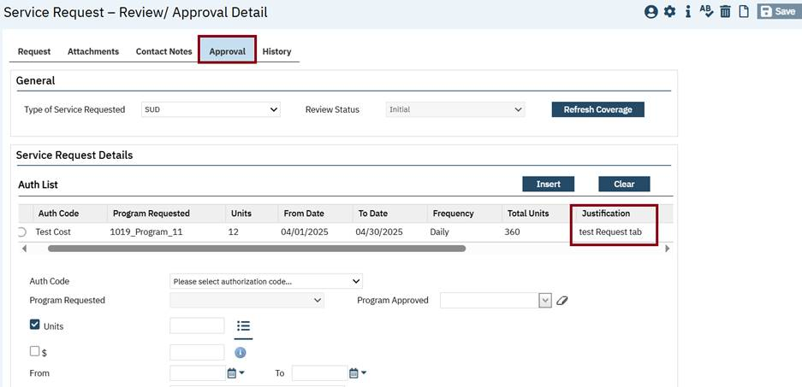
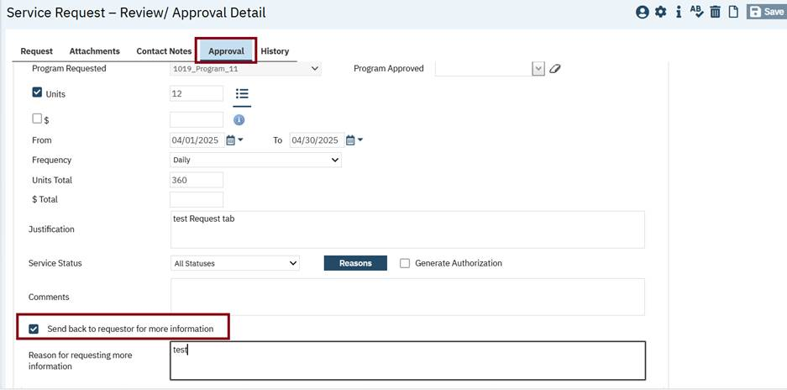
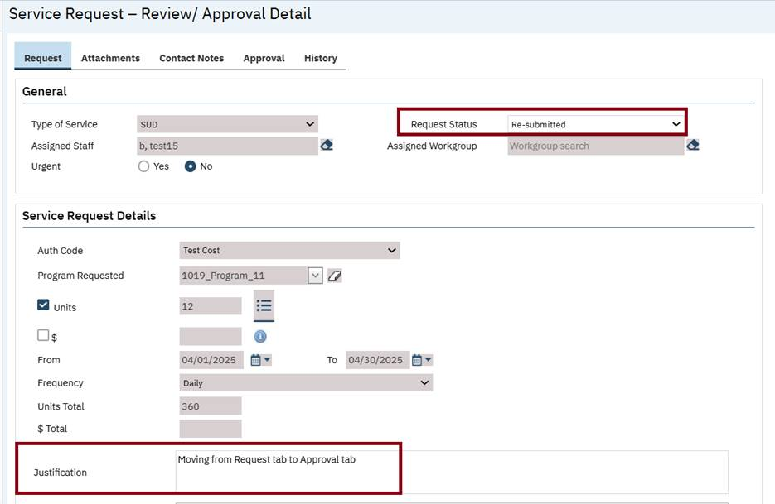
Note: The data initialization for the justification text box will always be from the Request tab to the Approval tab (never from the Approval tab to the Request tab) and text is entered in the justification text box in the Approval tab will be overridden, if the justification text is updated in the Request tab.

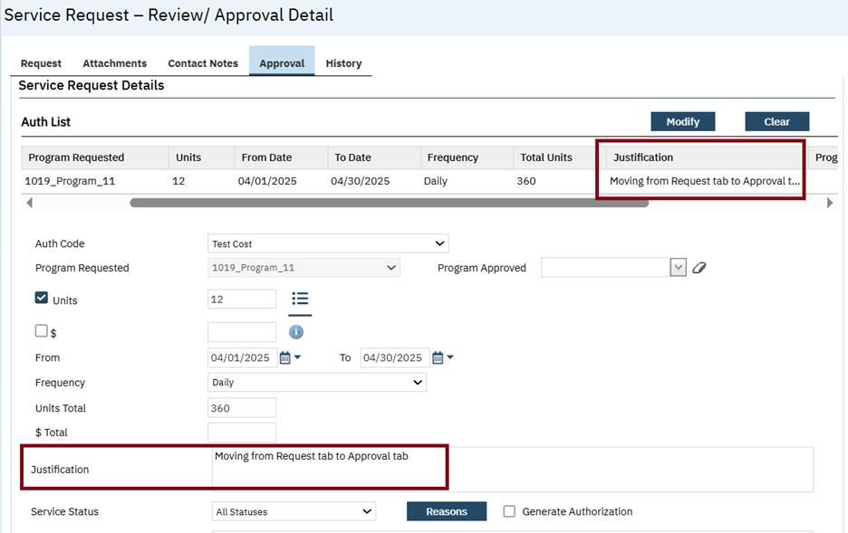
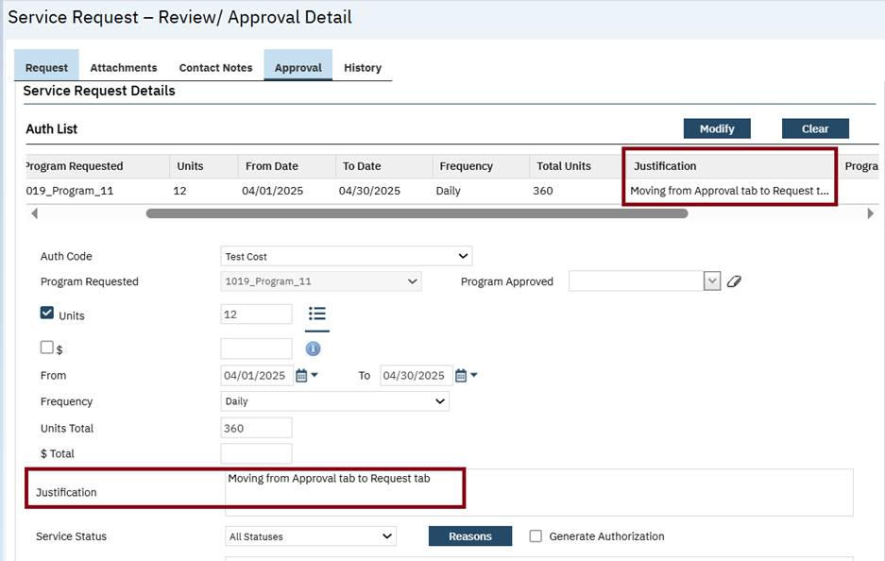
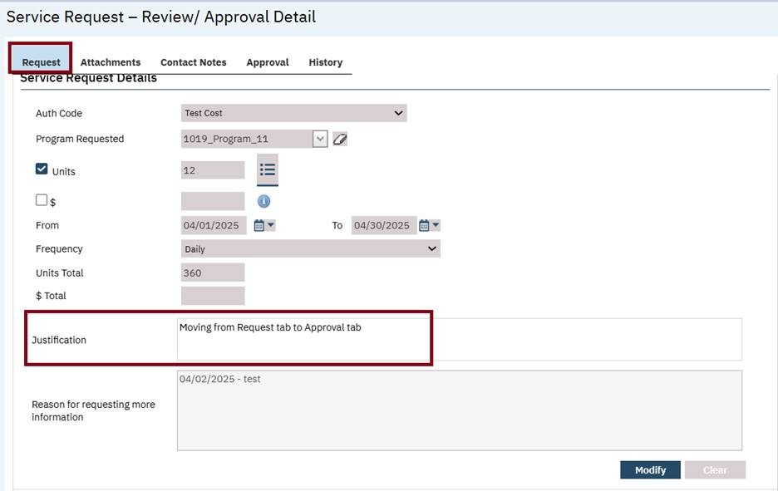

Author: Kiran Tigarimath

7. Core Bugs # 130730: Audit Trail Issue.
Release Type: Fix | Priority: High

Navigation Path: Login to SmartCare application.
Functionality ‘Before’ and ‘After’ release:
Before this release, here was the behavior. The logout time was being updated in the StaffLoginHistory table even when the session was still active.
With this release, the above-mentioned issue has been resolved. Now, the logout time is updating properly in the StaffLoginHistory table only after the end of session.

Author: Kiran Tigarimath

8. Core Bugs # 131127: Security Questions and two factor authentication pop up not appearing for Staff.

Release Type: Fix | Priority: High
Prerequisite: Set 'EnableMobileTFA' configuration key to 'Yes' under 'Configuration keys'.
Navigation Path: Login to SmartCare application.
Functionality ‘Before’ and ‘After’ release:
Before this release, here was the behavior. When two factor authentication was enabled and the user tried to login to SmartCare application, Security Questions popup and two factor authentication popup was not displayed for a staff after resetting the security questions.
With this release, the above-mentioned issue is resolved. Now, the users are prompted with security questions popup for selection along with two factor authentication while logging into the SmartCare application.

Author: Abhishek Naik

9. Core Bugs # 131159: Authorization Details: Any data entered in the ‘Narrative’ field of the ‘Custom Fields’ tab disappears upon modifying the authorizations.

Release Type: Fix | Priority: High
Navigation Path: ‘Client’ search – ‘Authorization’ – ‘Authorization Details’ screen -- ‘Custom Fields’ tab.
Functionality ‘Before’ and ‘After’ Release:
Before this release, here was the behavior. In the ‘Authorization Details’ screen, any data entered in the ‘Narrative’ field of the ‘Custom Fields’ tab would disappear upon modifying the authorizations.
With this release, the above-mentioned issue has been resolved. Now, the data added in the ‘Narrative’ field of the ‘Custom Fields’ tab in the ‘Authorization’ screen is saved correctly when modifying the authorizations.

Automatic add on codes

Reference No | Task No | Description
10 | Core Bugs # 130763 | The SP ‘ssp_PMServicesDetailPostUpdate’ took more time to execute.

Author: Yashas Kyadalappa

10. Core Bugs # 130763: The SP ‘ssp_PMServicesDetailPostUpdate’ took more time to execute.
Release Type: Fix | Priority: Medium
Navigation Path: N/A
Functionality ‘Before’ and ‘After’ release:
Before this release, there was a behavior. While doing the load test in an environment, the Stored Procedure (SP) 'ssp_PMGetNextBillablePayer' took more run time and eventually ended up in time out error in the ‘ssp_PMServicesDetailPostUpdate’ sp.
With this release, the above mentioned issue has been resolved now. We have optimized the performance of the ‘ssp_PMServicesDetailPostUpdate’ sp and as a part of this task executed the regression scenarios for automatic add on codes without any issues.

Batch Claim Upload

Reference No | Task No | Description
11 | Core Bugs # 131234 | An error message is displayed when uploading a batch claim file in the 'Batch Claim Direct Entry' screen.

Author: Renuka Gunasekaran

11. Core Bugs # 131234: An error message is displayed when uploading a batch claim file in the 'Batch Claim Direct Entry' screen.
Release Type: Fix| Priority: High
Navigation Path: 'My Office' -- 'Batch Claim Direct Entry' -- 'Upload' icon -- Select provider -- Choose Batch claim upload template file -- 'Upload' button.
Functionality ‘Before’ and ‘After’ release:
Before this release, here was the behavior. When the user attempted to upload the batch claim template file on the 'Batch Claim Direct Entry' screen, the following error message was displayed.
Error Message: 'File upload failed. Please verify the values entered in Excel sheet.'
With this release, the above-mentioned issue is fixed. Now, in the 'Batch Claim Direct Entry' screen, the Batch claim file is uploaded successfully without any errors being displayed.

Bed board
Reference No | Task No | Description
12 | Core Bugs # 131226 | Bedboard - Time Not pushing to Client Programs for Admissions or Discharges.

Author: Chaithra Kunjilana

12. Core Bugs # 131226: Bedboard - Time Not pushing to Client Programs for Admissions or Discharges.
Release Type: High | Priority: Medium
Navigation Path 1: My Office – Bedboard – Admit/ Discharge the client.
Navigation Path 2: Clients – Programs – Click on the Enrolled Status hyper link – Check the Enrolled Time.
Functionality ‘Before’ and ‘After’ release:
Before this release, here was the behavior. When the user admitted or discharged a client from Bedboard screen, only enrolled date was copied to Enrolled Date field in the Client Programs.
With this release, the above-mentioned issue has been resolved. Now the enrolled date and time is copied to the Enrolled date field in the Client Programs.

Bed Census

Reference No | Task No | Description
13 | Core Bugs # 131011 | Residential Screen – The ‘Non-Billable’ checkbox is automatically checked in the ‘Inpatient Activity Detail’ screen, if the ‘Client’ is on Leave and has provided reasons in the ‘Attendance’ screen.

Author: Suganya Shivakumar

13. Core Bugs # 131011: Residential Screen – The ‘Non-Billable’ checkbox is automatically checked in the ‘Inpatient Activity Detail’ screen, if the ‘Client’ is on Leave and has provided reasons in the ‘Attendance’ screen.

Release Type: Fix | Priority: Medium
Navigation Path 1: ‘My Office’ --- ‘Residential’ --- ‘Bed Census List’ page --- From right-topmost icons --- Click on ‘Attendance’ Icon --- ‘Bed Attendance’ Popup displays --- In ‘Bed Attendance’ section --- From ‘Present Columns’ -- select ‘No’ option – Select ‘Leave Reasons from’ dropdown --- Click on ‘Save’ and ‘Close’ Icon.
Navigation Path 2: ‘Bed Census List’ page --- Click on ‘Client with On Leave’ status --- ‘Inpatient Activity Details’ screen --- In ‘Activity’ section --- Ensure ‘Non-Billable checkbox’ is checked.
Functionality ‘Before’ and ‘After’ release:
Before this release, here was the behavior. In the ‘Residential’ screen, if the ‘Client’ was on Leave and had provided reasons in the ‘Attendance’ screen, the ‘Non-Billable’ checkbox was automatically checked in the ‘Inpatient Activity Detail’ screen.
With this release, the above-mentioned issue has been fixed. Now, the ‘Non-Billable’ checkbox is no longer automatically checked in the ‘Inpatient Activity Detail’ screen, when the ‘Client’ goes on leave and specifies the reasons in the ‘Attendance’ screen.

Charges/Claims

Reference No | Task No | Description
14 | EII # 127558 | Implementation of "Show All Charges" as a drop-down item to allow users to filter specific ids with clarity.
15 | EII # 128307 | Changes are implemented for the UB04 claim format in the Claim Format Configuration Page.
16 | EII # 128771 | Added Data Source, Date Values at Format Fields, Claim Format Configurations, Claims Provider Overrides (837 P, 837 I).
17 | Core Bugs # 130695 | A Claim Processing Error when using Select " All in on Page" checkbox.
18 | Core Bugs # 130746 | The box numbers 58, 59 and 60 are pulling unrelated client information in the ‘UB04’ paper claims.
19 | Core Bugs # 130911 | Allow 'U' in ClientSex and InsuredSex fields in claims.
142 | Core Bugs # 131198 | [Case Rate] - Insert Functionality Issues.

Author: Arpita Biradar

14. EII # 127558 (Feature - 366627): Implementation of "Show All Charges" as a drop-down item to allow users to filter specific ids with clarity.
Release Type: Change | Priority: Urgent
Navigation Path: My Office’ -- ‘Charges/Claims’ -- ‘Charges/Claims’ list page.
Functionality ‘Before’ and ‘After’ release:
Purpose: This is needed so that the users do not have to filter the list multiple times to see charges, that are in each of the statuses for the same date range, Service ID, Charge ID, Process ID, Batch etc.

With the release, a new dropdown option called “Show All Charges” is implemented in the charges drop-down in the Charges/Claims list page.
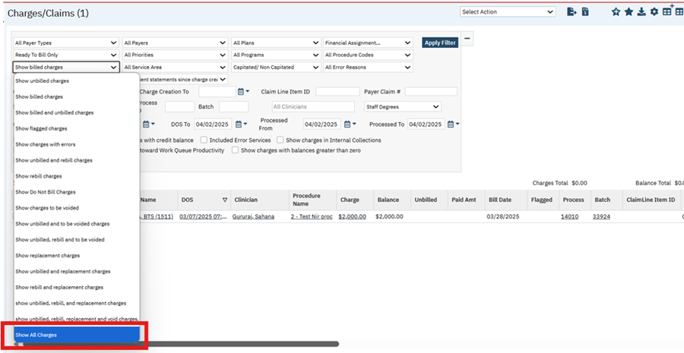
- While filtering with the “Show All Charges” option, selecting at least one of the following fields is mandatory.
- Claim Line Item ID
- Payer Claim #
- Service ID
- Charge ID
- Process ID
- Batch
- DOS From and DOS To.
If none of the fields are selected, then the validation message will be displayed.
- If any of the above field or fields are not entered when filtering with “Show All Charges” option then the system will throw a validation message as: “Please enter at least one of the following: Claim Line Item ID, Payer Claim #, Service ID, Charge ID, Process ID, Batch, DOS From and DOS To"
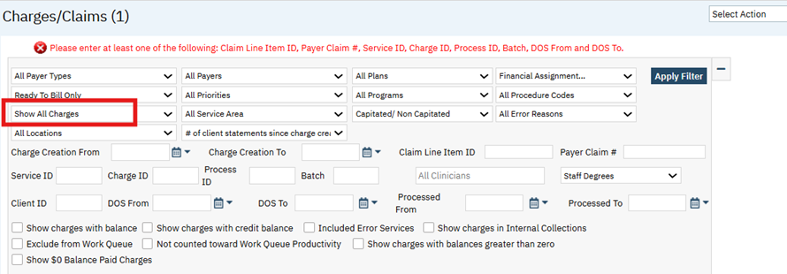
- When filtering with “Show All Charges” option, if only ‘DOS From’ is entered and ‘DOS To’ is left blank, then the system will display the validation message as: "Please enter DOS To field."
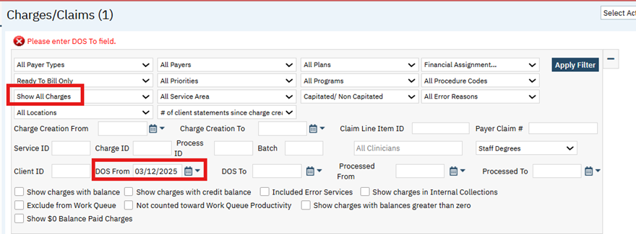

- When filtering with “Show All Charges” option, if only ‘DOS To’ is entered and ‘DOS From’ is left blank, then the system will display a validation message as: "Please enter DOS From field."
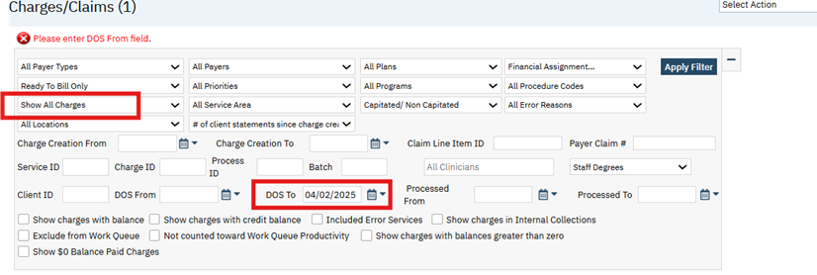
Note: Irrespective of whether the other required filters ( Claim Line Item ID, Payer Claim #, Service ID, Charge ID, Process ID, Batch”) are entered or not, the validation message will be displayed if either ‘DOS From’ or ‘DOS To’ is left blank.

- When filtering with “Show All Charges” option, if the user enters ‘DOS From’ and ‘DOS To’ such that the difference between them is more than 90 days (> 90 days), then the system will display a warning message to indicate that the date span is large and the number of results it could retrieve may affect the performance for all users. They will still have the option to proceed with that OR choose not to and adjust the dates.
Warning message: "The DOS From and To date span is more than 90 days. The filter results could be large and may affect the performance of the system for all users. Do you want to proceed?" with ‘Yes’ and ‘No’ buttons.
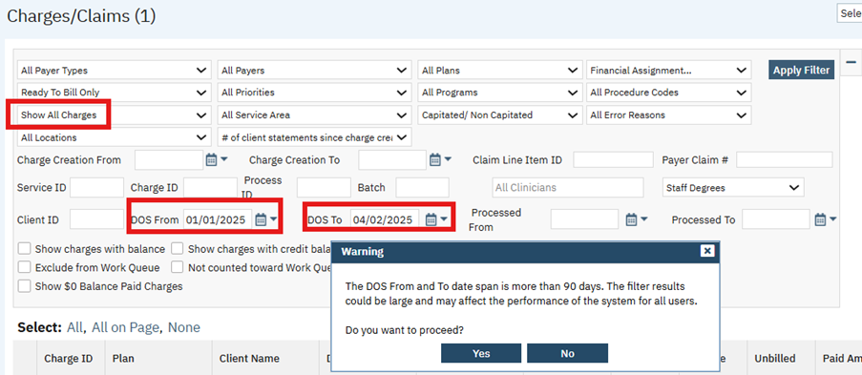
Note: The warning message will not be displayed if any other required filters (Claim Line Item ID, Payer Claim #, Service ID, Charge ID, Process ID, Batch) is entered along with the DOS From and DOS To having span more than 90 days.

- When filtering with “Show All Charges” option and the ‘Processed From’ and ‘Processed To’ Dates, the system will display only the processed(billed) charges during that From and To Date.

- When ‘Show All Charges’ is selected in the Charges dropdown and the user enters any of the required filters such as: Claim Line Item ID, Payer Claim #, Service ID, Charge ID, Process ID, Batch,
DOS From and DOS To", then the grid will display the charge records based on the filter criteria applied.
Ex: Select ‘Show All Charges’ in the Charges dropdown and enter the required Batch ID in the Batch field and click on the Apply Filter button, then the charge records based on the filter applied will be displayed.
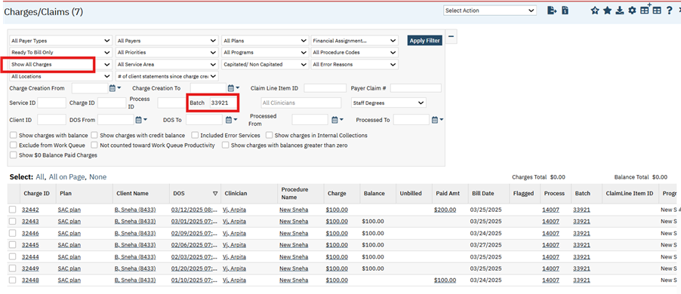
Author: Namratha Nagraj

15. EII # 128307 (Feature - 398012): Changes are implemented for the UB04 claim format in the Claim Format Configuration Page.
Release Type: Change | Priority: Urgent

Navigation Path 01: ‘Administration’ -Programs’ -Click on ‘New’ button—Enter required details—
Click on ‘Details’ button in the Address section- Enter required details -Click on ‘Save’ button.

Navigation Path 02: ‘Administration’-Locations’ -Click on ‘New’ button—Enter required details—
Click on ‘Details’ button in the Address section- Enter required details -Click on ‘Save’ button.

Navigation Path 03: ’Administration’-'Plans’-Click on ‘New’ button—'Plan Details’ Page— Enter all the required details— Select ‘UB04‘ from the ‘Standard Paper Claim Format’—Click on ‘Save’ button.
Navigation Path 04: ’Administration’-'Claims Format Configuration (s)’- Click on Claim Format Id hyperlink—'Claims Format Configuration Details’ page — Enter all the required details— Click on ‘Rules’ tab—Enter the required details in ‘General Set up’ section- Click on ‘Save’ button.
Navigation Path 05:’Services (Client)-Services List Page-Click on ‘New’ button -‘Service Detail’ Page-Enter all the required details—Click on ‘Save’ button.
Navigation Path 06: ‘My Office’ - ‘Charges/Claims’ -Select the ‘Charge Id’ – Click on ‘Paper-Claims’ button- Click on ‘Process Now’ – Click on ‘Create Claim File’.
Functionality ‘Before’ and ‘After’ release:
Purpose : To allow the user to configure via the Claim format configuration for the UB04 claim format.
With this release, the following change has been implemented in Claim Format Configuration Page.

In the Claim Format Configuration Details screen, under the General Set up Section of Rules tab, the following values have been made functional in the Format Fields dropdown.

Box 1 Address1
Box 1 City
Box 1 State
Box 1 Zip
Box 1 Name
Box 1 Phone
Box 2 City
Box 2 State
Box 2 Zip
Box 2 Name

I . If the Box 1 format fields are selected and UB04 Claims are processed, the Address will be fetched from respective values selected in the Data Source (Program and Location).

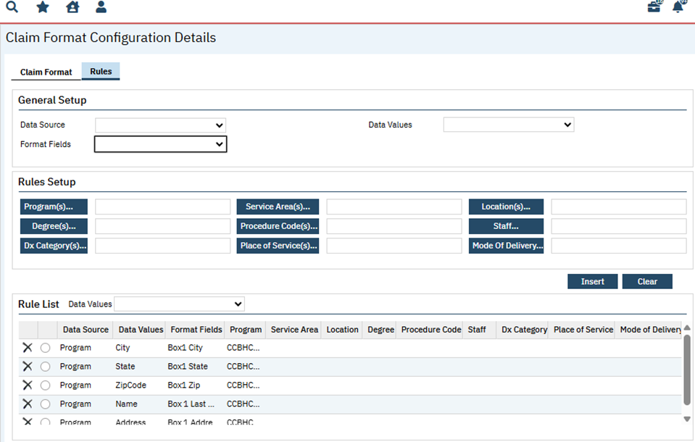
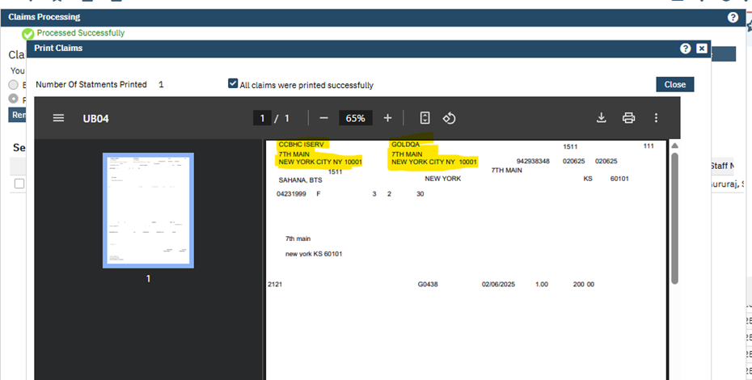

II. If the Box 2 format fields are selected and UB04 Claims are processed, the Address will be fetched from respective values selected in the Data Source (Program and Location).
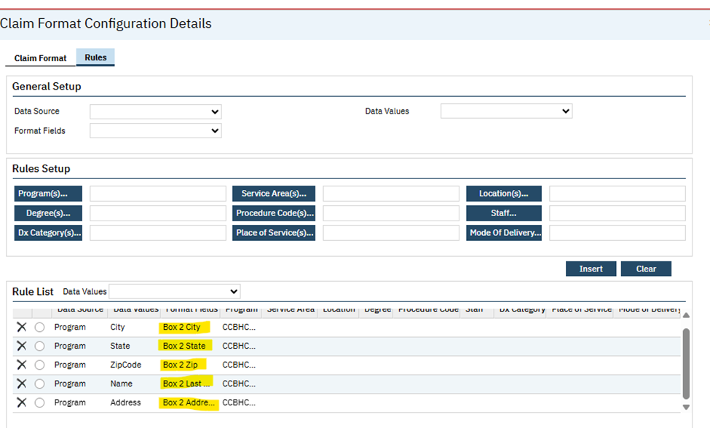

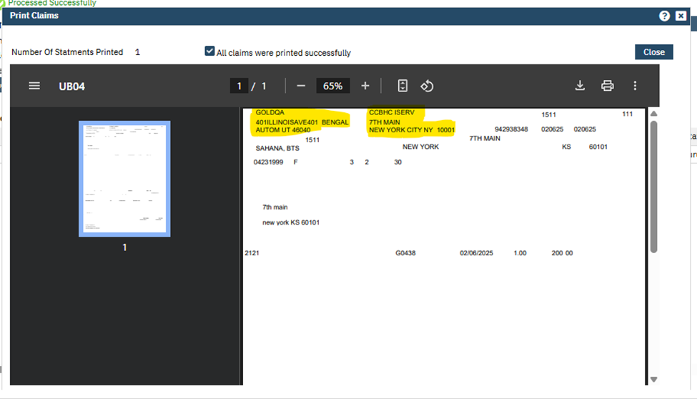

III. If the Box 1 and Box 2 format fields are selected and UB04 Claims are processed, the Address will be fetched from respective values selected in the Data Source (Program and Location).

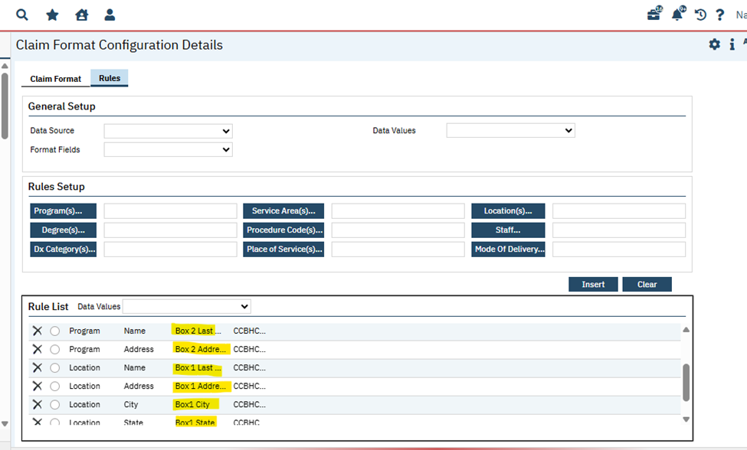
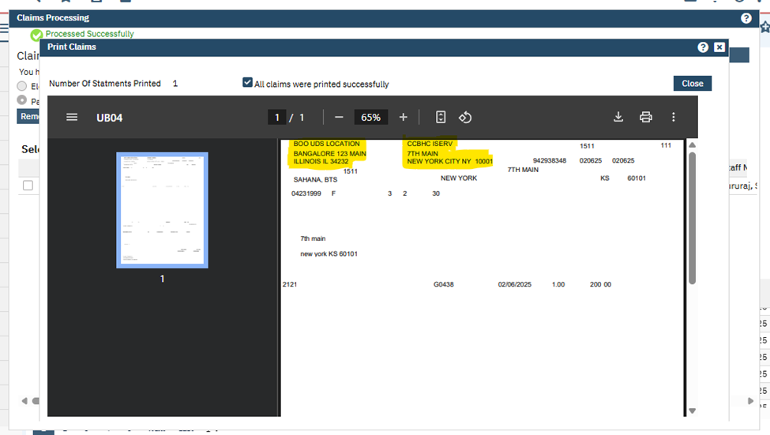

Author: Saravanakumaar Nagarajan

16. EII # 128771 (Feature – 454170): Added Data Source, Date Values at Format Fields, Claim Format Configurations, Claims Provider Overrides (837 P, 837 I)
Release Type: Change | Priority: Urgent
Prerequisites:
1. In the Plan Details screen, select the “837 Professional” format from the ‘Standard E-claim Format’ drop-down. Path: 'My Office' – ‘Plans’– click on the plan name hyperlink ‘Plan Details’ screen -- select ‘837 Professional’ claim format from the ‘Standard E Claim Format’ drop-down Save the Screen. Format Fields: 2310E-NM1-03 Service Facility Last Name / Organization Name.
2. Add a Rules with new ‘Format Fields’ in the “Claim Format Configuration Details” screen through the mentioned Path: Administration - Claims Format Configurations– Click on the 837 Professional ‘Claim FormatId’ hyperlink -- Claims Format Configurations Details – Rules tab – Select the required combinations of Data Source, Data Values and select the newly added “Format Fields” – Insert/Modify – Save.
3. In the Plan Details screen, select the “837 Institutional” format from the ‘Standard E-claim Format’ drop-down. Path: 'My Office' – ‘Plans’– click on the plan name hyperlink ‘Plan Details’ screen-- select ‘837 Institutional” claim format from the ‘Standard E Claim Format’ drop-down Save the Screen.
4. Add a Rules with new ‘Format Fields’ in the “Claim Format Configuration Details” screen through the below-mentioned Path:
Administration - Claims Format Configurations– Click on the 837 Institutional ‘Claim FormatId’ hyperlink -- Claims Format Configurations Details – Rules tab – Select the required combinations of Data Source, Data Values and select the newly added “Format Fields” – Insert/Modify – Save.

Navigation Path 1: Go Search – Claims Provider Override Details (Administrator) -- Claims Provider Override Details– For (Claim Line Service Facility: Supported on Professional (Loop 2420C)) – Select Program for professional claims.

Navigation Path 2: Go Search – Claims Provider Override Details (Administrator) – Claims Provider Override Details– For (Claim Service Facility: Supported on Institutional (Loop 2310E) and Professional (Loop 2310C) ) – Select Program for Institutional claims.

Navigation Path 3: Go Search – Claims Format Configuration(s)(Administration) – Claim Format tab – Rules tab.

Navigation Path 4: Go Search – Create Services – Generate Service.

Navigation Path 5: Go Search – Charges & Claims – Generate Claim.

Functionality ‘Before’ and ‘After’ Release:
Purpose: To send service line format fields on both E claims (837 Professional and 837 Institutional).

With this release, some format fields have been added on both 837 Institutional and 837 Professional claim files through the ‘Claim Provider Overrides’ screen and through the ‘Claim Format Configuration’ screen.
- Added new global subcodes to the “CLAIMFORMATTYPE” global code category and those will be displayed in the “Format Fields” dropdown of both ‘837 professional(2420C)’ claim formats under ‘Rules’ tab of ‘Claim Formats Configuration Details’’ screen.
The value configured in the ‘Claim Provider Override' screen for professional:
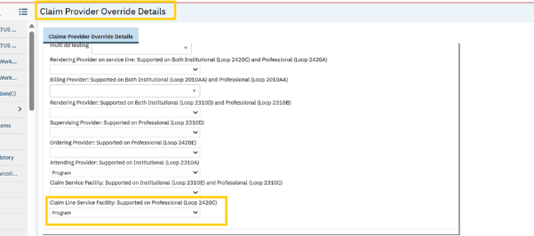
A) Below are the options added in the ‘Format Field’ dropdown of 837 professional claim format,
a. 2420C-NM1-03 Service Line Service Facility Last Name / Organization Name
b. 2420C-NM1-09 Service Line Service Facility NPI
c. 2420C-N3 & N4 Varies - Service Line Service Facility Address 1
d. 2420C-N3 & N4 Varies -Service Line Service Facility Address 2
e. 2420C N4 - 01 Service Line Service Facility City
f. 2420C N4 - 02 Service Line Service Facility State
g. 2420C N4 - 03 Service Line Service Facility Zip

Screen Shot of options added in “837 Professional” Claim Format
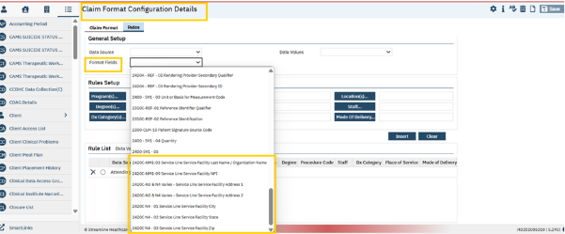
Scenario:
When the user configures a value in “Claim Line Service Facility supported on Professional (Loop 2420C) field under the ‘Claim format configuration’ screen, then on the claim file, the “NM1*77 (service line service facility segment) will be displayed in the professional claim files accordingly as per the given values in the claim format configuration screen.
Screen Shot of options added format fields in “837 Professional”:
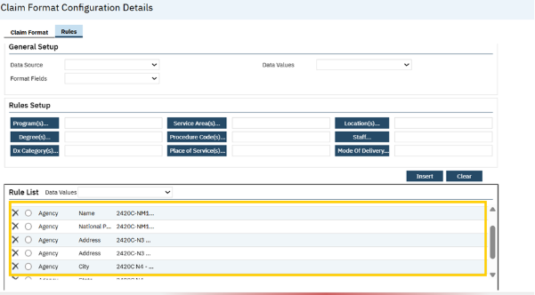
The Output on claim 837 Professional.
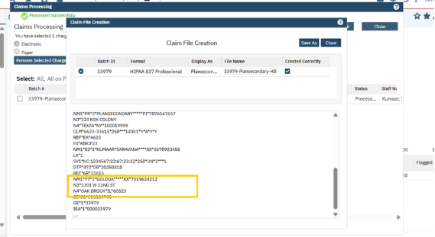
- Added a new global subcodes to the “CLAIMFORMATTYPE” global code category and this will be displayed in the “Format Fields” dropdown ‘837 Institutional (2310E)’ claim formats under ‘Rules’ tab of ‘Claim Formats Configuration Details’’ screen.

The value configured in the ‘Claim Provider Override' screen for Institutional:
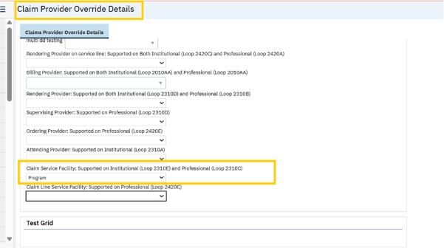
A) Below are the options added in the ‘Format Field’ dropdown of 837 Institutional claim format,
a) 2310E-NM1-03 Service Facility Last Name / Organization Name
b) 2310E-NM1-09 Service Facility NPI
c) 2310E-N3 & N4 Varies - Service Facility Address 1
d) 2310E-N3 & N4 Varies - Service Facility Address 2
e) 2310E N4 - 01 Service Facility City
f) 2310E N4 - 02 Service Facility State
g) 2310E N4 - 03 Service Facility Zip
Screen Shot of options added in “837 Institutional” Claim Format
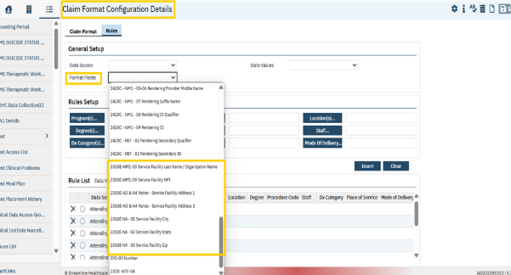
Scenario:
When the user configures a value in the “Claim service facility supported on Institutional (Loop 2310E) under the ‘Claim Provider override’ screen, then on the claim file, the “NM1*77 (Service Facility)” will be displayed in 837 Institutional claim files per the given value in ‘Claim Provider Override’ screen.

Screen Shot of options added format fields in “837 Institutional”
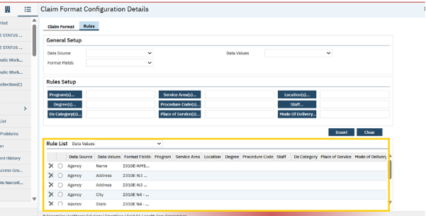
The Output on file 837 I claim
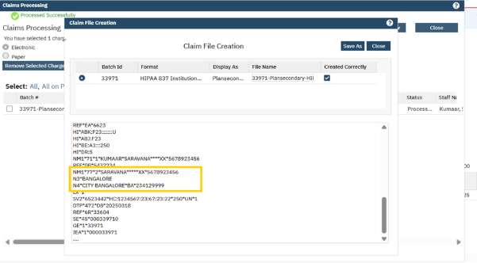

Author: Debanjit Das

17. Core Bugs # 130695: A Claim Processing Error when using Select " All in on Page" checkbox.
Release Type: Fix | Priority: High
Navigation Path: ‘My Office’– ‘Charges/Claims’– and click on ‘E Claim’ button – click on ‘Process Now’ button in the ‘Claim Processing’ pop-up screen.
Functionality ‘Before’ and ‘After’ release:
Before this release, here was the behaviour. When the user selected the 'All on Page' in the 'Claims Processing' pop up screen and clicked on 'Remove Selected Charges From Batch' button, then a following error message appeared.
Error Message: “You have selected
*!!**!!* ##STARTPAGERESPONSEVALUE## ##ENDPAGEREPONSEVALUE##
Charges to be processed with a total amount of undefined”
With this release, the above-mentioned issue has been resolved. Now, the above error message does not appear, when the user clicks on the 'Remove Selected Charges From Batch' button after selecting the 'All on Page' in the 'Claims Processing' pop up screen. The selected charges from Batch will be removed as intended.

Author: Yashas Kydalappa

18. Core Bugs # 130746: The box numbers 58, 59 and 60 are pulling unrelated client information in the ‘UB04’ paper claims.
Release Type: Fix| Priority: High

Navigation Path: My Office’ -- ‘Charges/Claims’ -- ‘Charges/Claims’ list page -- Select the Claim -- ‘Paper-claim’ button -- ‘Process Now’ button -- Print Claim.

Functionality ‘Before’ and ‘After’ release:

Before this release, here was the behavior. When the user tried to process multiple charge ID’s for ‘UB04’ paper claim in a single batch, the box numbers 58, 59 and 60 were pulling unrelated client information in the ‘UB04’ paper claim.

With this release, the above-mentioned issue has been resolved. Now, unrelated client information is not pulled under box number 58, 59 and 60, when the user processes the multiple charge ID’s for ‘UB04’ paper claim in a single batch.

Author: Rinki kumari

19. Core Bugs # 130911: Allow 'U' in ClientSex and InsuredSex fields in claims.
Release Type: Fix | Priority: High
Navigation Path 1: ‘Client’ -- Client information -- Demography -- Sex (Male, Female, Not Listed).
Navigation Path 2: ‘Client’ -- ‘Services’ -- ‘Services’ list page -- Click on the ‘New’ icon -- Enter all the details -- Complete the service.
Navigation Path 3: 'My Office' -- 'Charges/Claims' banner -- Select the Charge Id and click on ‘E-Claim’ button (institutional claim) -- Generate the claim file.
Functionality ‘Before’ and ‘After’ release:
Before this release, here was the behavior. In Claims screen, when the user used Not Listed for ‘Sex’ field (sex =Not Listed) in client demographics, the below mentioned error was displayed. It was allowing only for Male and Female global codes values.
Error: “Subscriber Sex missing. Please check Client or Client Contacts”
With this release, the above issue has been resolved. Now user is able to process the claim successfully even though sex is “Not Listed”.

Author: Roopa Hemanna

142. Core Bugs # 131198: [Case Rate] - Insert Functionality Issues.
Release Type: Fix | Priority: High

Prerequisites: Ensure bulk insertion of multiple records, followed by a single save action, in the Case Rate List grid within the Case Rate Setup section on the Case Rate Details screen.
Navigation Path: ‘Administration’ – Case Rate List – click on New button – or – click on existing Case Rate Id hyperlink – Case Rate Details – General – Case Rate Service – Case Rate Setup – Case Rate List grid.

Functionality ‘Before’ and ‘After’ release:
Before this release, here was the behavior. Multiple issues were identified with the multi-insert functionality on the Case Rate Details screen.
- While adding two or more Insert values, the selections were incorrectly combined across different Inserts.

- The values inserted were only reflected on the front end and were not reliably saved to the database.

- Several functional issues were identified:

  - Inserting a second row auto-populated previously checked selections.
  - Saving multiple Inserts did not consistently write data to the CaseRateSetupProcedureCodes table.
  - The behavior resulted in only a visual (front-end) representation of multiple selections, with no corresponding data saved in the backend.
  - When creating a Case Rate and inserting two or more rows, the users intermittently encountered the following error message when attempting to save:
“Deleted row information cannot be accessed through the row.”

- After executing ssp_SCJobToCreateCaseRateServices, the system displayed combined selections across Inserts instead of maintaining distinct values.

- Two CaseRateSetupIDs were created, each with a single corresponding row in the CaseRateSetupProcedureCodes table.

- The front end showed two checkboxes for a single CaseRateSetupProcedureCodes entry, while the backend correctly stored only one.

With this release, the above-mentioned issues related to the multi-insert functionality in the Case Rate Details screen have been resolved. Bulk insertion of multiple records, followed by a single save action, now functions as intended.

- Insert values are now managed independently, ensuring that selections are not combined across multiple Inserts.
- Data integrity has been improved, with all inserted records now reliably saved to the database, ensuring alignment between the front-end display and backend table.
- The following functional issues have been addressed:
- Previously selected values are no longer auto populated when adding a new row.
- Multiple Inserts now correctly persist data in the CaseRateSetupProcedureCodes table.
- The front end now accurately reflects the actual state of the data stored in the backend.
- The error “Deleted row information cannot be accessed through the row” no longer occurs when saving Case Rates with multiple rows. The users can now save successfully without interruption.
- Execution of ssp_SCJobToCreateCaseRateServices now maintains distinct selections for each Insert, preventing unintended data merging.
- CaseRateSetupIDs and their related CaseRateSetupProcedureCodes records are created and stored as expected.
- The checkbox display on the front end is now correctly synchronized with backend data, eliminating duplication and mismatches.

Claim Lines

Reference No | Task No | Description
20 | EII # 130399 | The ‘Claims’ list page is modified to dynamically display Custom Fields.
Author: Renuka Gunasekaran

20. EII # 130399 (Feature – 514814): The ‘Claims’ list page is modified to dynamically display Custom Fields.
Note: This change is specific to the customer who has customization logic in their environment.
Release Type: Change | Priority: On Fire
Navigation Path: My Office’ -- ‘Claims’ -- ‘Claims’ list page.
Functionality ‘Before’ and ‘After’ release:
Purpose: The ‘Claims’ list page is modified to dynamically display Custom Fields.
With this release, the below 2 Custom Fields are implemented on the ‘Claims’ list page grid section. The Custom Fields will be displayed on this list page based on the custom stored procedure in the respective database.
‘Claims’ List page: The below mentioned columns will be displayed on the ‘Claims’ list page.
-TM Check Number: This column will display ‘TM Check Number’ from the ‘Custom Fields’ tab of ‘Claim Line Detail’ screen.
-TM Check Date: This column will display ‘TM Check Date’ from the Custom Filed tab of ‘Claim Line Detail’ screen.

Client Flags

Reference No | Task No | Description
21 | Core Bugs # 130944 | Client flags: The Due date is not calculated correctly.
22 | Core Bugs # 131110 | Client Flags screen not loading data quickly.
23 | Core Bugs # 131085 | Percentage is not updated accurately when flag is manually completed in Tracking widget SmartView.
Author: Girish Jayanna

21. Core Bugs # 130944: Client flags: The Due date is not calculated correctly.
Release Type: Fix | Priority: Medium
Navigation Path 1: Go search- Administration – ‘Tracking Protocols’.
Navigation Path 2: Client search – Select a client- Client Flags- Click on new icon- Client flag details.
Functionality ‘Before’ and ‘After’ release:
Before this release, here was the behavior. If the tracking protocol was set up to determine the due date for recurring flags using the PreviousCompletedDate, but the flag was using the End Date, then the flag end date was used for ending the flag, instead of using the PreviousCompletedDate.
With this release, the above-mentioned issue is resolved. Now, the due date is calculated correctly using PreviousCompletedDate only, when the flag is removed/ended from the Client Flag Detail screen and from Patient Lists/Reminders.

Author: Girish Jayanna

22. Core Bugs # 131110: Client Flags screen not loading data quickly.
Release Type: Fix | Priority: Medium
Navigation Path: Go Search -- Client Flags (My Office).
Functionality ‘Before’ and ‘After’ release:
Before this release, here was the behavior. The client Flags screen was not loading data quickly, and it continued to process when the user filtered for specific data.
With this release, the above - mentioned has been resolved. The code is modified to address the performance issue by creating a temporary table to store ClientNoteAssignedUsers records. Now, the Client Flags screen is loading data quickly.

Author: Girish Jayanna

23. Core Bugs # 131085: Percentage is not updated accurately when flag is manually completed in Tracking widget SmartView.

Release Type: Fix | Priority: High
Prerequisite: In the Client Flag Details, complete few flags manually.
Navigation Path: Dashboard – click on SmartView icon ‘Client Tracking’ SmartView.
Functionality ‘Before’ and ‘After’ release:
Before this release, here was the behavior. The SmartView widget "Client Tracking" flags were removed that were manually completed, resulting in an inaccurate percentage of completed tasks.
If the flags are completed manually, they were marked as Inactive; however, in the ClientTracking SmartView, only active flags were displayed, so manually completed flags were not displayed.
With this release, the above-mentioned issue has been resolved. Now, inactive flags that are manually completed are also taken into account and are displaying an accurate percentage of completed flags in tracking widget SmartView.

Client Information (C)

Reference No | Task No | Description
24 | Core Bugs # 131088 | Client Information: The ‘Provider Name’ dropdown is not Populating on Edit.

Author: Sachin Ranganathappa

24. Core Bugs # 131088: Client Information: The ‘Provider Name’ dropdown is not Populating on Edit.

Release Type: Fix | Priority: Medium
Navigation Path: ‘Client’ search – ‘Client Information’ -- ‘External Referral’ tab – ‘Referral Information’ Sub-Tab – ‘Provider Name’ Dropdown.
Functionality ‘Before’ and ‘After’ release:
Before this release, here was the behavior. When a user attempted to edit an already added referral, the ‘Provider Name’ dropdown field was not displaying the originally added referrals. This resulted in the empty dropdown, preventing the user from saving the edits.
With this release, the above-mentioned issue has been resolved. The ‘Provider Name’ dropdown field now correctly displays the originally added referrals when a user edits an existing referral. The users can now save their edits without any issue.

Client Orders

Reference No | Task No | Description
25 | EII # 128363 | Added a confirmation message popup in ‘Client Orders Details’ screen.
26 | Core Bugs # 130925 | Client Order: clicking on Titration Order summary link displays blank Titration Step popup.

Author: Smruthi Srikanth

25. EII # 128363 (Feature - 401507): Added a confirmation message popup in ‘Client Orders Details’ screen.
Note:
- This new implementation is applicable for ALL Order Types.
- This is applicable only for MODIFYING an Order and not for NEW Orders.
Release Type: Change | Priority: Medium
Prerequisite: Client has a signed Client Order.
Navigation Path: Login to ‘SmartCare’ Application – ‘Client’ search – Select a client – Search for ‘Client Orders’ - Click on ‘New’ icon - Select the required client order in ‘Client Order Selection’ Popup.

Functionality ‘Before’ and ‘After’ release:
Purpose: Previously, when the users were modifying the existing Client Order by adding current/past date, but did not select discontinue checkbox; then the existing client order was discontinuing, and new Client order was getting created with the same end date and status as active. To avoid this, now a confirmation message popup is displaying when the users modify existing client orders by adding end date as current/past date.

With this release, when the user modifies the existing Client Order by adding end date as current/past date, then the confirmation message popup will be displayed in ‘Client Orders Details’ screen. The ‘Confirmation Message’ popup displays for all order types.
Note: The ‘Confirmation Message’ popup will display only when users are modifying signed client order.

Screenshot of the ‘Confirmation Message’ Popup

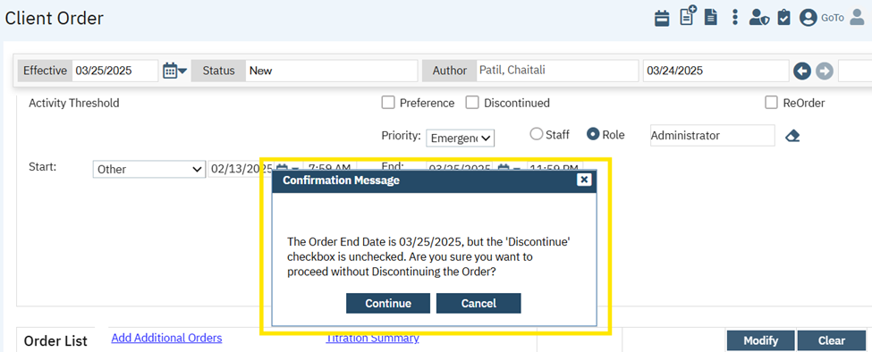
- ‘Confirmation Message’ Popup displays the message as "The Order End Date is <End Date Value>, but the 'Discontinue' checkbox is unchecked. Are you sure you want to proceed without Discontinuing the Order?"

- ‘Confirmation Message’ Popup contains ‘Continue’ and ‘Cancel’ button.

- When the ‘Continue’ button is clicked, the modified client order will display in the grid.

- When the ‘Cancel’ button is clicked, the ‘Confirmation Message’ popup will not display, and modified client order will not be inserted in the grid.

Author: Smruthi Srikanth

26. Core Bugs #130925: Client Order: clicking on Titration Order summary link displays blank Titration Step popup.
Release Type: Fix | Priority: Medium
Navigation Path: Client Search - Select a Client - Client Orders – Client Orders Details Page.
Functionality ‘Before’ and ‘After’ release:
Before this release, here was the behavior. When the user clicked on the Titration Summary link in the Client Order Details page, blank Titration Step popup was displayed and the screen was taking time to load.
With this Release, the above-mentioned issue has been resolved. Now, the user is able to view message "No titration summary is available for display" in the Titration Step popup when clicking on Titration Summary link in Client Order Details page. The blank Titration Step popup is not displayed now, when there is no titration data available.

Client Programs

Reference No | Task No | Description
27 | Core Bugs # 131000 | Getting an error when trying to discharge the client from Program.

Author: Smruthi Srikanth

27. Core Bugs #131000: Getting an error when trying to discharge the client from Program.

Release Type: Fix | Priority: High
Navigation Path: Client -- Programs – ‘Programs’ list page -- Select any enrolled program -- ‘Program Assignment Details’ screen -- Select ‘Discharged’ from Current Status dropdown -- Click on Save.
Functionality ‘Before’ and ‘After’ release:
Before this release, here was the behaviour. In the ‘Program Assignment Details’ screen, when the user tried to discharge the client from Program, the below-mentioned error message was displayed.

Error message: 50000 50000 512 ** Subquery returned more than 1 value. This is not permitted when the subquery follows =, != , <, <= , >, >= or when the subquery is used as an expression .** ssp_SCMATPrePourFlagCreationNi 64 16 1 ssp_SCMATPrePourFlagCreationNi 168 16 1 ssp_DiscontinueClientOrderOnPr 92 16 * 1

With this Release, the above-mentioned issue has been resolved. Now, the user can discharge the client from Program in ‘Program Assignment Details’ screen without any error.

Client Search

Reference No | Task No | Description
28 | Core Bugs # 131258 | Client Search pop up: client records not displayed on searching by SSN. number

Author: Sachin Ranganathappa

28. Core Bugs # 131258: Client Search pop up: client records not displayed on searching by SSN number.
Release Type: Fix| Priority: Urgent
Navigation Path: Login to SmartCare’ - ‘Client search’- Client Search pop up -- ‘Type SSN number’ press Enter Key on the keyboard.
Functionality ‘Before’ and ‘After’ release:
Before this release, here was the behavior. When the user searched for the client by entering the SSN number and on hitting the 'Enter' key on the keyboard, the SSN number that was entered was cleared, the search result was not occurring and received a red error message saying, "Please Enter Search Criteria".

With this release the above-mentioned issue has been resolved. Now, when the user searches for the client using SSN number and hitting the 'Enter' key on the keyboard, the system fetches matching client records and red error message is not displaying.

Clinical Data Access Grouping (CDAG)

Reference No | Task No | Description
29 | EII # 129899 | Implemented CDAG logic to Associated Documents Pop-up in My Documents and Client Documents List page and Scan/Upload modules.
30 | Core Bugs # 131099 | A red error was displayed while opening the Documents.

Author: Sachin Ranganathappa

29. EII # 129899 (Feature - 488275): Implemented CDAG logic to Associated Documents Pop-up in My Documents and Client Documents List page and Scan/Upload modules.
Note: We have 2 scenarios -CDAG ON and CDAG OFF.
CDAG ON configuration is as below:
1. System configuration key “DisplayCDAGSectionInStaffDetails” value is set to ‘Yes’.
2. System configuration key ‘EnableClinicalDataAccessGrouping’ value is set to ‘Yes’
Note: CDAG ON functionality is implemented for a specific customer. If you have Primary and County type of setup and would like to use these functionalities, please get in touch with Streamline Support.

CDAG OFF configuration is as below and this is the default behaviour:
1. System configuration key “DisplayCDAGSectionInStaffDetails” value is set to ‘No’.
2. System configuration key ‘EnableClinicalDataAccessGrouping’ value is set to ‘No’.

Release Type: Change | Priority: Urgent
Navigation Path 1: ‘Client Search’ - ‘Select Client’ – Go Search -- ‘Documents (Client)’ – click on ‘Add’ link.
Navigation Path 2: Go Search -- ‘My Document (My office)’ – click on ‘Add’ link.
Navigation Path 3: ‘Client Search’ - Select Client – Go Search -- ‘Scanning (Client)’ – Upload new document – Save -- click on ‘Associate document’ link.
Functionality ‘Before’ and ‘After’ release:
Purpose: Providing customers with the ability to sort and/or filter documents by Client Program on the Associated Documents Pop-up in My Documents and Client Documents List page and Scan/Upload modules.

With this release, the ‘Program’ dropdown filter when CDAG is turned On and ‘Program’ Searchable textbox when CDAG is turned Off is implemented in Associated Documents Pop-up – Filter section and also ‘Program’ column is implemented in Associated Documents Pop-up – Grid in the below screens.
- Client Document List Page
- My Document List Page
- Scan/Upload module

Documents (Client): Associated Documents Pop-up – Filter
When CDAG is turned ON;

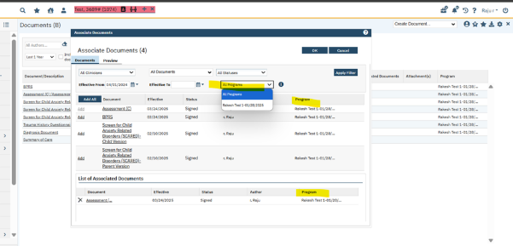
A new ‘Program’ dropdown filter is added to filter the records based on program and the user can see the programs associated. It will pull the programs that are common across the selected CDAG profile, client enrolled, and program associations in staff details.

Also, a new column named ‘Program’ is added in the Associated Documents Pop-up – Grid to display the associated program with the respective document/service note.

When CDAG is turned OFF,
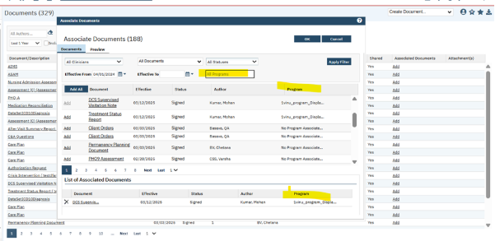
A new ‘Program’ Searchable textbox is added to filter the records through which user can search the Individual Program.

Also, a new column named ‘Program’ is implemented in the Associated Documents Pop-up – Grid to display the associated program with the respective document/service note and any document where program is not associated then 'No Program associated' will be displayed.
My Document (My office): Associated Documents Pop-up – Filter
When CDAG is turned ON,
A new ‘Program’ drop down filter is added to filter the records based on program and see programs associated. It will pull the programs that are common across the selected CDAG profile, client enrolled, and program associations in staff details.

Also, a new column named ‘Program’ is added in the Associated Documents Pop-up – Grid to display the associated program with the respective document/service note.
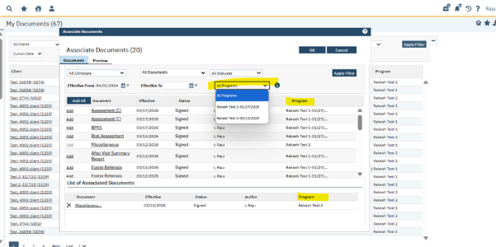
When CDAG is turned OFF,
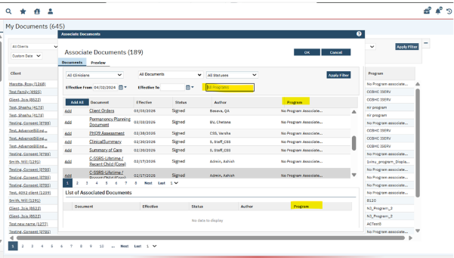
A new Program searchable textbox is added to filter the records through which user can search the Individual Program.

Also, a new column named ‘Program’ is added in the Associated Documents Pop-up – Grid to display the associated program with the respective document/service note and any document where program is not associated, then 'No Program associated' will be displayed.

Scan/Upload: Associated Documents Pop-up – Filter
When CDAG is turned ON,

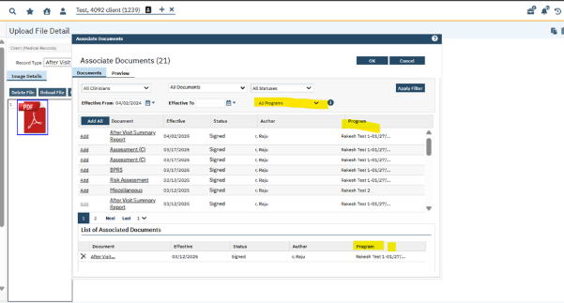
A new ‘Program’ dropdown filter is added to filter the records based on program and see programs associated. It will pull the programs that are common across the selected CDAG profile, client enrolled, and program associations in staff details.

Also, a new column named ‘Program’ is implemented in the Associated Documents Pop-up – Grid to display the associated program with the respective document/service note.

When CDAG is turned OFF,
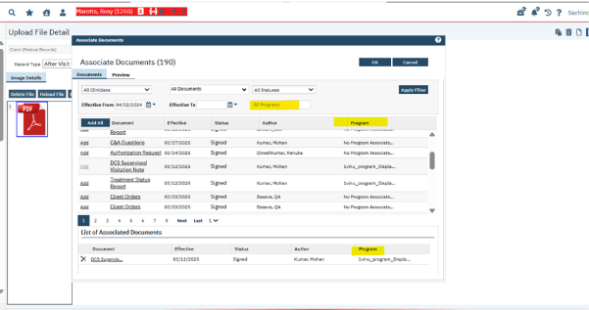
A new ‘Program’ Searchable textbox is added to filter the records through which user can search the Individual Program.

Also, a new column named ‘Program’ is added in the Associated Documents Pop-up – Grid to display the associated program with the respective document/service note and any document where program is not associated then 'No Program associated' will be displayed.

Author: Sunil Belagali

30. Core Bugs # 131099: A red error was displayed while opening the Documents.
Note: This functionality is implemented for a specific customer. If you have Primary and County type of setup and would like to use these functionalities, please get in touch with Streamline Support.

Release Type: Fix | Priority: Medium
Prerequisite:

1. System configuration key “DisplayCDAGSectionInStaffDetails” value is set to ‘Yes’.
2. System configuration key ‘EnableClinicalDataAccessGrouping’ value is set to ‘Yes’.

Navigation Path: Login to SmartCare application -- Client – Documents.

Functionality ‘Before’ and ‘After’ release:
Before this release, here was the behaviour. When there was a space in the Key value of System configuration key 'ClientAccessRuleDaysAfterProgramDischarge' and the user tried to create/open any Document for the client, a red error was displayed.
Red error : "245 Conversion failed when converting the varchar value"
With this release, the above-mentioned issue has been resolved. Now the code has been optimised to handle the space in Key value of System configuration key 'ClientAccessRuleDaysAfterProgramDischarge' and no such error is displayed while creating/opening any Document.

CM Events
Reference No | Task No | Description
31 | Core Bugs # 130866 | Provider Agency Staff Person able to Sign ‘Enrollment Form Event’ on the ‘Events’ screen.
Author: Annapurna Bhalke

31. Core Bugs # 130866: Provider Agency Staff Person able to Sign ‘Enrollment Form Event’ on the ‘Events’ screen.

Release Type: Fix | Priority: High

Navigation Path 1: 'Administration' -- ‘Staff/Users’ – ‘Staff Details’ -- ‘Roles/Permissions’ tab – Grant/Deny permission for the ‘Sign’ for ‘Events’.

Navigation Path 2: Client – ‘CM Events’ – ‘CM Events’ list page -- ‘Click on new’ -- Events screen – Select ‘Enrollment Form Event’ from ‘Event’ dropdown -- Enter the requirement details – click on ‘Save’ – Click on ‘Sign’ button.

Functionality ‘Before’ and ‘After’ release:
Before this release, here was behavior. The user (Provider agency staff) who did not have permission to the Sign button and when navigated to ‘Events’ screen from unsaved changes, the sign button was enabled for the ‘Enrollment Form Event’.

With this release, the above-mentioned issue has been resolved. Now, when the user navigates to ‘Events’ screen from unsaved changes, the Sign button will be always disabled for the users (Provider agency staff) who does not have permission to the Sign button.

Compliance CCBHC

Reference No | Task No | Description
32 | EII # 130344 | Changes are added to the Service Notes (Crisis Note) screen.
33 | EII # 130346 | Implemented Crisis Call Log Details screen.
34 | EII # 130348 | Implemented Crisis Call Log List page screen.
Author: Lakshmi Kumarappan

32. EII # 130344 (Feature - 484409): Changes are added to the Service Notes (Crisis Note) screen.
Release Type: Change | Priority: Urgent

Navigation Path 1: 'Administration’ -- ‘Global codes’ -- ‘Global code Details’ screen.
Navigation Path 2: ‘Client’ -- ‘Service/Notes’ -- click ‘new’ icon -- ‘Service/Notes’ detail screen -- select Procedure as Crisis, program, and Location – ‘Crisis Note’ screen will be displayed.

Functionality ‘Before’ and ‘After’ release:

Purpose: This implementation is done to 'To meet CCBHC Crisis.
With this release, a new ‘Note’ tab is implemented in the Service note (Crisis Note) and new global codes 'CrisisAssCompleted' and 'CrisisCoordiSteps' have been added.

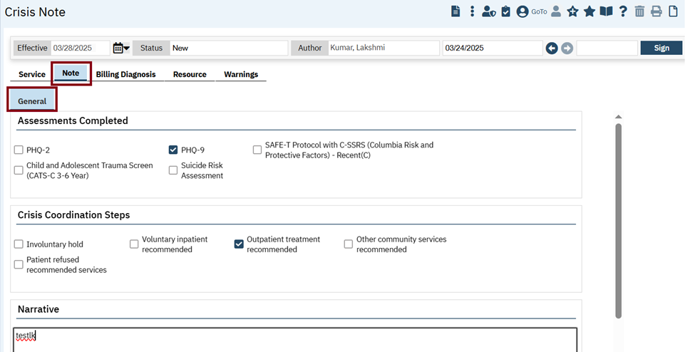
Crisis Note:
The ‘Note’ tab is added newly with ‘General’ subtab in the ‘Crisis Note’. The ‘Note’ tab contains the following sections.
- Assessments Completed
- Crisis Coordination Steps
- Narrative
‘Assessments Completed’ section: This section has the following checkboxes:
- PHQ-2
- PHQ-9
- SAFE-T Protocol with C-SSRS(Columbia Risk and Protective Factors) -Recent(C)
- Child and Adolescent Trauma Screen (CATS-C 3-6 Year)
- Suicide Risk Assessment

Note: When the user signed the document, DocumentCodeID with effective date = Service date, then it will auto select the associated check mark on the Assessments Completed section of the Note tab.
‘Crisis Coordination Steps’ section: This section has the following checkboxes
- Involuntary hold
- Voluntary inpatient recommended
- Outpatient treatment recommended
- Other community services recommended
- Patient refused recommended services

‘Narrative’ section: This is a Text area.

Global code Details:
Category Code : CrisisAssCompleted
Category Name: CrisisAssCompleted
Description: Global Codes in this list will be used to define different Assessments used in a Crisis setting. For example PHQ-2, PHQ9, etc.
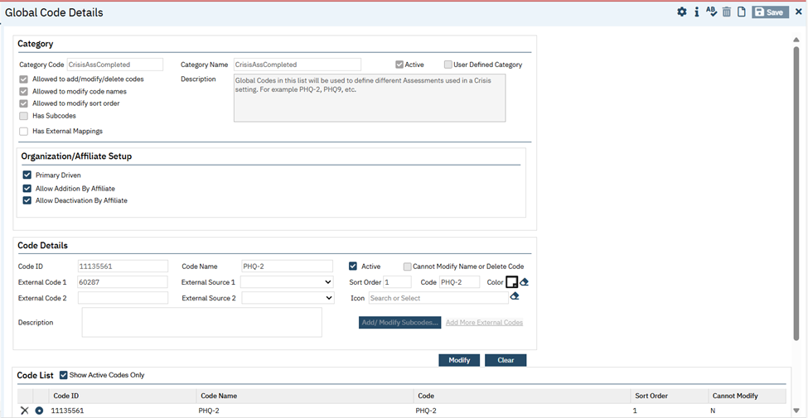
Global code Details:
Category Code: CrisisCoordiSteps
Category Name: CrisisCoordiSteps
Description: Global Codes in this list will be used to define specific coordination steps that have been completed within a Crisis setting.
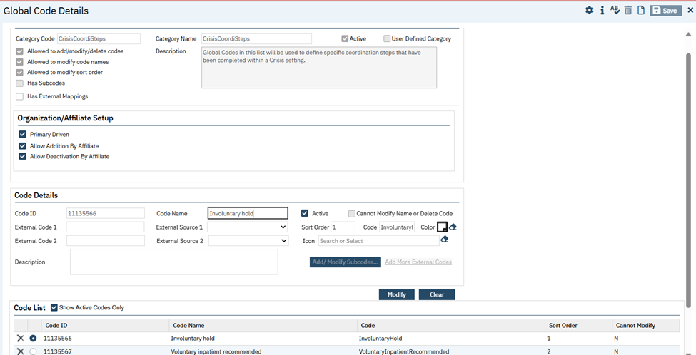

Data Model Changes:
- Added ‘DocumentCrisisNotes’, ‘DocumentCrisisCompletedAssessments’, and ‘DocumentCrisisCoordinationSteps’ tables.

Author: Lakshmi Kumarappan

33. EII # 130346 (Feature - 484320): Implemented Crisis Call Log Details screen.
Release Type: Change | Priority: Urgent
Navigation Path: ‘Go’ search --- ‘Crisis Call Log (My Office)’ Screen --- Click ‘New’ icon --- ‘Crisis Call Log Details’ screen.
Functionality ‘Before’ and ‘After’ release:
Purpose: To provide the ability to efficiently document the caller’s demographic data. Also to indicate if the person in crisis, is already a client with the organization, and to document the crisis that is occurring.

With this release, a new ‘Crisis Call Log Details’ Screen is created. It has General and Follow Up tabs.
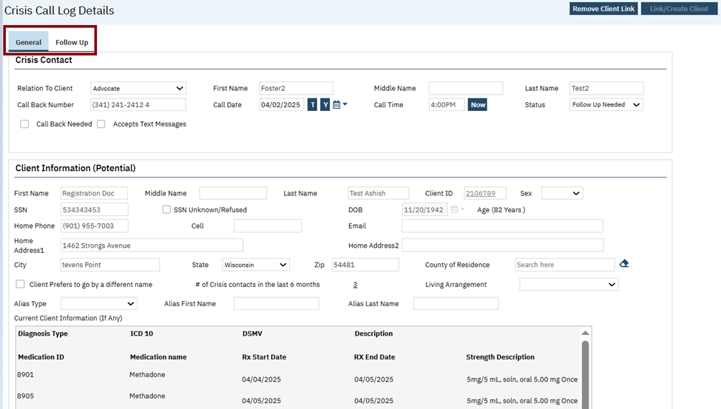
- In the toolbar, two buttons will be displayed. They are Remove Client Link and Link/Create Client
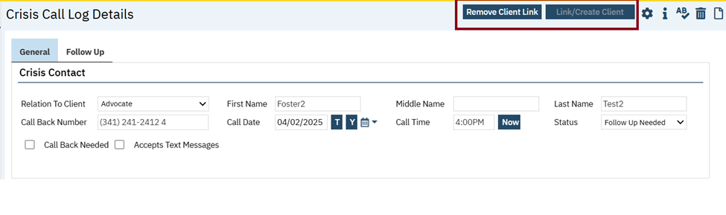
- Remove Client Link button:
1. If there is not a client ID present in the Client Information (Potential) - Client ID field, then this button will be disabled.
2. When a client ID is present in the Client Information (Potential) - Client ID field, then this button will be enabled.
3. When 'Remove Client Link' is selected, a pop up will be displayed to notify the user that the link is going to be removed.

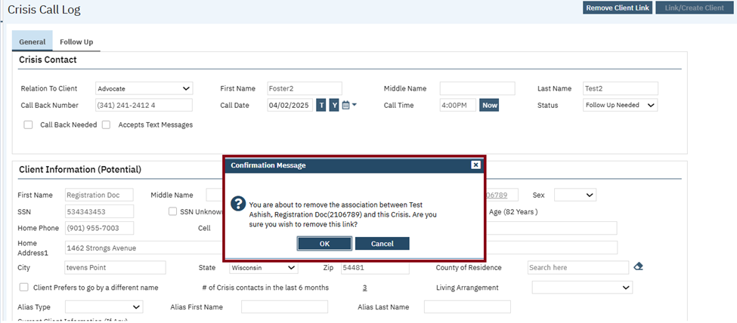
- Link/Create Client button:
1. When selecting this button, Client search pop up will be displayed.
2. In the client search pop up, the Client First Name, Last Name, DOB, and SSN will be initialized if provided from the Client Information (Potential) section.
3. If a record is selected in the Client search a pop up, then the selected record’s client ID and other information will be initialized to the Crisis Call Log.
General Tab:
The General tab is displayed with the following sections:
- Crisis Contact
- Client Information (Potential)
- Crisis Information
- Risks
- Crisis Outcome Determination
- Disposition
1.The Crisis Contact section has the following fields:
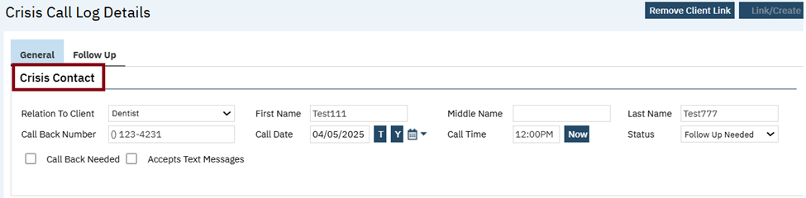
1. Relation To Client: This is the dropdown field, and the values are loaded from the Existing global code: RELATIONSHIP.
2. First Name: This is a text box field and will display the first name of the caller.
3. Middle Name: This is a text box field and will display the middle name of the caller.
4. Last Name: This is a text box field and will display the last name of the caller.
5. Call Back Number: This is a text box field and will display phone number
6. Call Date: This is a Date control field. Selecting 'T' will default the field to logged in date (today). Selecting 'Y' will default the field to Day before logged in date.
7. Call Time: It will display the time. Selecting the 'Now' button will default the field to the current time.
8. Status: This is the dropdown field and will display with In Progress, Follow Up Needed, Complete and the values are loaded from the New Global Code: CRISISSTATUS.
When 'Complete' is selected, all fields on the Crisis call log will be disabled.
9. Call Back Needed: It is checkbox.
10. Accepts Text Messages: It is checkbox.
2.Client Information (Potential) has following fields:

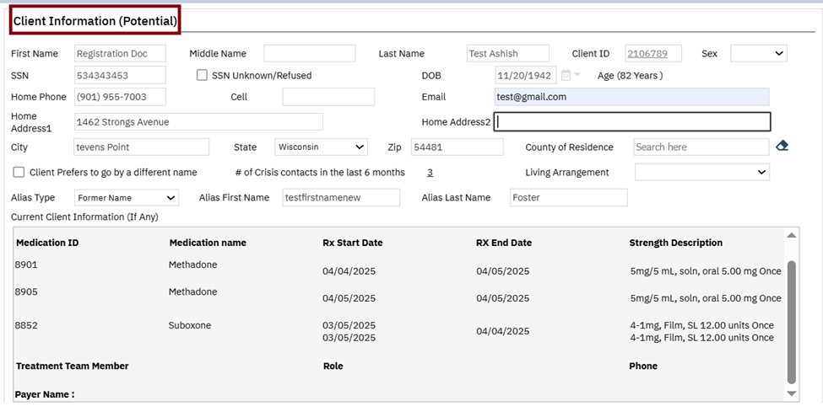
1. First Name: This is a text field and will display the first name of the client. If the client ID is linked, then the value will initialize from Client First Name from Client Information - General Tab - First Name Field
2. Middle Name: This is a text field and will display the middle name of the client. If client ID is linked, then the value will initialize from Client Middle Name from Client Information - General Tab - Middle Name Field
3. Last Name: This is a text field and will display the last name of the client. If client ID is linked, then the value will initialize from Client Last Name from Client Information - General Tab - Last Name Field
4. Client ID: It will display the id of the client. Client Id will initialize from Client Information - General Tab - Client ID field when a client record is linked.
5. Sex: This is dropdown and will display the value Male or female and the values are loaded from the Existing global code: SEX. The values will be initialized from Client Information - Demographics Tab - Sex field when a client record is linked.
6. SSN: It will display the SSN number of client. When client is linked SSN will initialize from Client Information - General Tab - SSN field
7. SSN Unknown/Refused: It is check mark.
8. DOB: This is a Date control field. when a client record is linked, the value will initialize from Client Information - Demographics Tab - Date of Birth field
9. Age: It will display the age of the client, and it is read only field
10. Home Phone: It will display the phone number of the client. When a client record is linked, value will initialize from Client Information - General Tab -Phone field where type = Home. If a record is added or updated, the updated values will be pushed back to Client Information C - General Tab on save.
11. Cell: It will display the mobile phone number of the client. When a client record is linkeCell Phone value will be initialize from Client Information - General Tab -Phone field where type = Mobile. If record is added or updated, the updated value will be pushed back to Client Information C - General Tab on save.
12. Email: It will display the email address of the client. When a client record is linked, Email will be initialized from Client Information - General Tab - Email field. If the record is added or updated, the updated valued will be pushed back to Client Information C - General Tab on save.
13. Home Address 1: It will display the row 1 street address of the client. When a client record is linked, the value will be initialized from Client Information - General Tab - Street (row 1) field. If the record is added or updated, the updated values will be pushed back to Client Information C - General Tab on save.
14. Home Address 2: It will display the row 2 street address of the client. When a client record is linked, the value will be initialized from Home Address 2 from Client Information - General Tab - Street (row 2) field. If the record is added or updated, the updated values will be pushed back to Client Information C - General Tab on save.
15. City: It will display the name of the city of the client. When a client record is linked, the value will initialize from Client Information - General Tab - City field. If the record is added or updated, the updated values will be pushed back to Client Information C - General Tab on save.
16. State: It will display the name of State of the client and the values are loaded from the StateFIPS Configuration Key. when a client record is linked, the values will initialize from Client Information - General Tab - State field. If the record is added or updated, the updated values will be pushed back to Client Information C - General Tab on save.
17. Zip: It will display the Zip code of the client. When a client record is linked, the value will be initialized from Client Information - General Tab - Zip field. If record is added or updated, the updated values will be pushed back to Client Information C - General Tab on save.
18. County of Residence: It is searchable text, and the values are loaded from the CountyFIPS Configuration Key. when a client record is linked, the value will be initialized from Client Information - Demographic Tab - County of Residence field
19. Client prefers to go by a different name: It is check mark.
20. # of Crisis contacts in the last 6 months: It is hyperlink which display the count of the client. When there is a linked client ID, the number of Crisis Call log records will be displayed that are linked to the client ID based on the Event Date. On selecting this hyperlink, details screen will be saved then navigate the user back to the list page, and pre-filter for the last 6 months and the client ID that was present on the newly created Crisis Call log details in which the user is navigating from.
21. Living Arrangement: This is the dropdown, and the values are loaded from the Existing global code: LIVINGARRANGEMENT. when a client record is linked, the value will be initialized from Client Information - Demographic Tab - Living field. If record is added or updated, the updated values will be pushed back to Client Information C - General Tab on save.
22. Alias Type: This is the dropdown and the values are loaded from the Existing global code: ALIASTYPE. If a client ID is linked, the Type will be displayed from Client Information C - Alias Tab that has the check mark of 'Chosen Name' selected. If more than one value exists on the client record, the latest value will be displayed
23. Alias First Name: It will display the first name of the alias of the client. If a client ID is linked, the First Name will be displayed from Client Information C - Alias Tab that has the check mark of 'Chosen Name' selected. If more than one value exists on the client record, then the latest value will be displayed
24. Alias Last Name: It will display the last name of the alias of the client. If a client ID is linked, the Last Name will be displayed from Client Information C - Alias Tab that has the check mark of 'Chosen Name' selected. If more than one value exists on the client record, then the latest value will be displayed
25. Current Client Information (If Any): It is read only text and will display the information of current client.
When a client ID if linked, the following information will be displayed from the client chart:
Active DX, Active Medications, Current Treatment Team Members and their roles.
Format of this section:
DX:
Diagnosis Type, ICD 10, DSMV, Description (as the Core Assessment History section on general tab)
Medication:
Medication ID, Medication name, Rx Start Date, RX End Date, Strength Description (Same formatting as the Core Assessment History section on general tab).
Treatment Team Member - name of all active treatment team member will be displayed
Role - the role assigned to the treatment team member will be displayed
Phone - treatment team members phone number will be displayed
Payer Name - Pull from client's active cover plans with COB = 1 and display the Name of the payer.
3.Crisis Information has following fields:
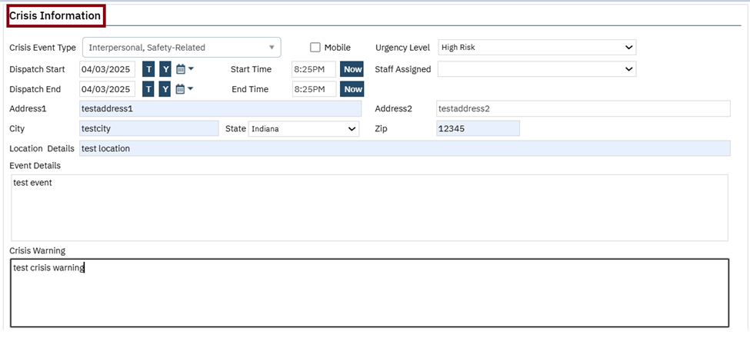
1. Crisis Event Type: This is Multi-Select dropdown and the values are loaded from the New Global Code: CRISISEVENTTYPE and the values are Mental Health,Substance Use, Interpersonal, Safety-Related, Social or Environmental, Trauma-Related, Medical/Health, Legal, Community, Other.
2. Mobile: It is check mark.
3. Urgency Level: This is the dropdown and the values are loaded from the New Global Code: CRISISURGENCYLEVEL and the values are Immediate/Urgent, High Risk, Moderate Risk and Low Risk.
4. Dispatch Start: This is a Date control field. Selecting 'T' will default the field to logged in date (today). Selecting 'Y' will default the field to Day before logged in date. This will be required field when Mobile checkbox is selected
5. Start Time: It will display the time. Selecting the 'Now' button will default the field to the current time. This will be required field when Mobile checkbox is selected
6. Dispatch End: This is a Date control field. Selecting 'T' will default the field to logged in date (today). Selecting 'Y' will default the field to = Day before logged in date. This will be required field when Mobile checkbox is selected and status = Complete
7. End Time: It will display the time. Selecting the 'Now' button will default the field to the current time This will be required field when Mobile checkbox is selected and status = Complete
8. Staff Assigned: This is the dropdown, which will display the name of the staff. Note: Created permission under staff list called 'Crisis Staff'.
9. Address 1: It will display row 1 street address.
10. Address 2: It will display row 2 street address.
11. City: It will display the name of the city.
12. State: It will display the name of State, and the values are loaded from the StateFIPS Configuration Key
13. Zip: It will display the Zip code.
14. Location Details: This will display the details of the location.
15. Event Details: This will display the details of the event.
16. Crisis Warning: This will display the crisis warning.
4. Risks section has following fields:

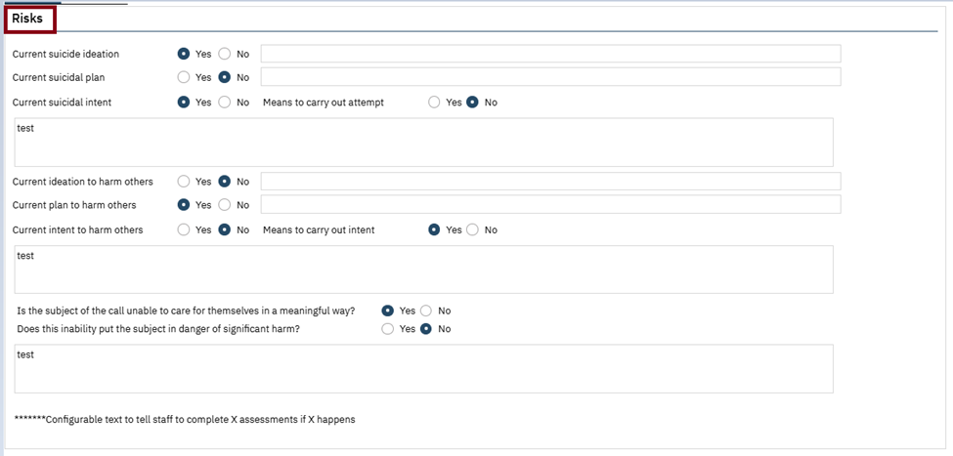
1. Current Suicide Ideation: It is a radio button and displays with “Yes” or “No” options. A text box is provided for staff to enter the data
2. Current Suicidal Plan: It is a radio button and displays with “Yes” or “No” options. A text box is provided for staff to enter the data
3. Current Suicidal Intent: It is a radio button and displays with “Yes” or “No” options.
4. Means to carry out attempt: It is a radio button and displays with “Yes” or “No” options.
5. Current ideation to harm others: It is a radio button and displays with “Yes” or “No” options. A text box is provided for staff to enter the data
6. Current plan to harm others: It is a radio button and displays with “Yes” or “No” options. A text box is provided for staff to enter the data
7. Current intent to harm others: It is a radio button and displays with “Yes” or “No” options.
8. Means to carry out intent: It is a radio button and displays with “Yes” or “No” options.
9. Is the subject of the call unable to care for themselves in a meaningful way?: It is a radio button and displays with “Yes” or “No” options.
10. Does this inability put the subject in danger of significant harm?: It is a radio button and displays with “Yes” or “No” options.
5.Crisis Outcome Determination section has following fields:
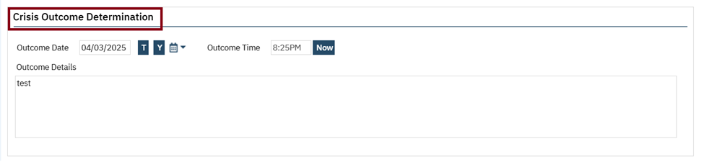
1. Outcome Date: This is a Date control field. Selecting 'T' will default the field to logged in date (today). Selecting 'Y' will default the field to Day before logged in date.
2. Outcome Time: It will display the time. Selecting the 'Now' button will default the field to the current time
3. Outcome Details: It is text area and which will display outcome details.
6. Disposition section has been added:
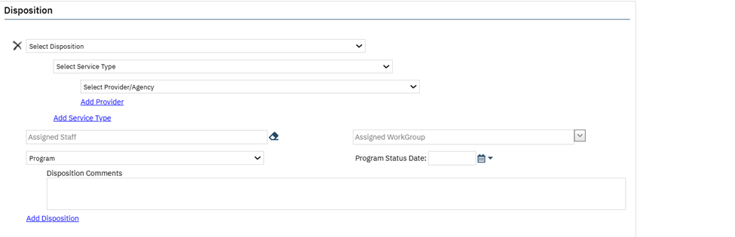
1. Select Disposition: It is the dropdown which initializes the value from global codes.
2. Select Service type: It is the dropdown which initializes the value from global codes.
3. Select Provider/Agency: It is dropdown which initializes the value from global codes.
4. Add Provider: This is a hyperlink. Clicking Add Provider hyperlink will add one more Provider/Agency
5. Add Service Type: This is a hyperlink. Clicking Add Service Type hyperlink will add one more Select Service Type and Provider/Agency dropdown and Add Provider hyperlink
6. Assigned Staff: It is a typeable search textbox and will display the active staff list.
7. Assigned Workgroup: It is Searchable drop down and will display Active WorkGroup.
8. Program: It is the dropdown and will display all active Program.
9. Program Status Date: This is a Date control field.
10. Disposition Comments – It is text box.
Add Disposition: This is a hyperlink. Clicking Disposition hyperlink will add one more Disposition section
2. Follow Up tab:
The Follow Up tab is displayed with below sections:
- Crisis Follow Up
- Crisis Follow Up List
Crisis Follow Up section has following fields:
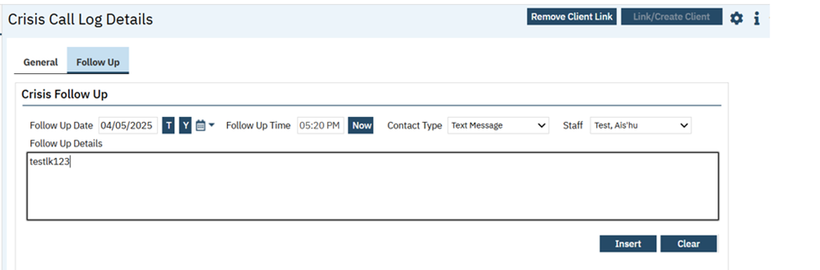
1. Follow Up Date: This is a Date control field. Selecting 'T' will default the field to logged in date (today). Selecting 'Y' will default the field to = Day before logged in date.

2. Follow Up Time: It will display the time. Selecting the 'Now' button will default the field to the current time
3. Contact Type: This is dropdown which has the value Phone and Text Message and the values are loaded from the New Global Code: CRISISFOLLOWUPTYPE
4. Staff: This is dropdown, which will display the name of the staff. The Staff list is based on permission
Note: Created permission under staff list called 'Crisis Staff'.
5. Follow Up Details: This is the text area which will provide details of Follow Up.
6. Insert: This is a button which will insert the follow up data
7. Clear: This is a button which will clear the follow up data
Crisis Follow Up List section has following fields:

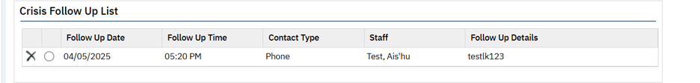
1. Follow Up Date: It will display the date of follow up in the grid.
2. Follow Up Time: It will display the time of follow up in the grid.
3. Contact Type: It will display the value phone or Text message in the grid.
4. Staff: It will display the name of the staff in the grid.
5. Follow Up Details: It will display details of Follow Up in the grid.
Data Model Changes: Added new table CrisisCallLog, CrisisFollowUps, CrisisEventTypes

Author: Lakshmi Kumarappan

34. EII # 130348 (Feature - 484405): Implemented Crisis Call Log List page screen.
Release Type: Change | Priority: Urgent

Navigation Path: Go Search – ‘Crisis Call Log (My Office)’ Screen.

Functionality ‘Before’ and ‘After’ release:

Purpose: To provide the ability to efficiently document the caller’s demographic data. Also to indicate if the person in crisis, is already a client with the organization, and document the crisis that is occurring.

With this release, a new Crisis Call Log list page Screen is created. It has filter section and grid section.

The Filter Section:
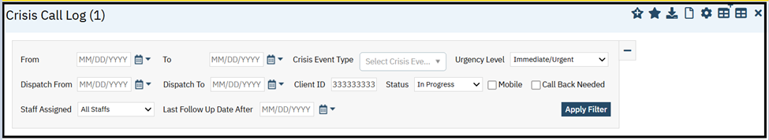
1. From- This is a Date control field.

2. To- This is a Date control field.

3. Crisis Event Type– This is multi-select dropdown and will display the values associated with the New Global Code: CRISISEVENTTYPE.

4. Urgency Level– This is dropdown and will display the values associated with the New Global Code: CRISISURGENCYLEVEL.

5. Dispatch From- This is a Date control field.

6. Dispatch To- This is a Date control field.

7. Client ID – This is textbox which will accept only numeric value.

8. Status– This is dropdown and will display the values associated with the New Global Code: CRISISSTATUS

9. Mobile – This is checkbox. When selected, records that have the 'Mobile' check mark checked will be
displayed in the grid.

10. Call Back Needed– This is checkbox. When selected, records that have the ‘Call Back Needed' check mark checked will be displayed into the grid.

11. Staff Assigned – This is dropdown. If value is entered, records that have the selected staff = Staff Assigned field will be displayed.
.
12. Last Follow Up Date After - This is a Date control field.

The Grid fields:

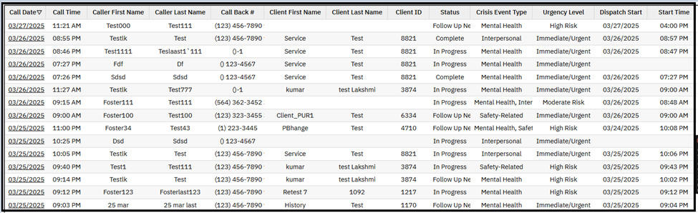
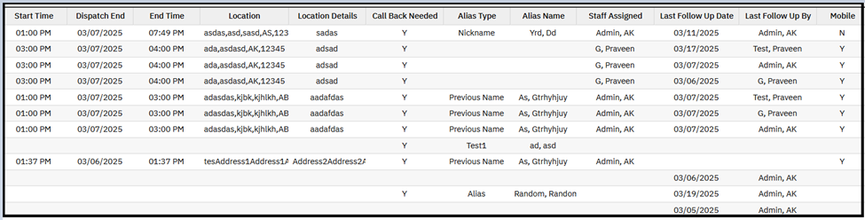
1. Call Date: This column is a hyperlink on clicking will navigate to Crisis Call Log Details screen.

2. Call Time: This column will display the time of Crisis Call Log.

3. Caller First Name This column will display the first name of the caller.

4. Caller Last Name: This column will display the Last name of the caller.

5. Call Back #: This column will display the phone number of the caller.

6. Client First Name: This column will display the first name of the client.

7. Client Last Name: This column will display the Last name of the client.

8. Client ID: This column will display the client id.

9. Status: This column will display the status of the caller.

10. Crisis Event Type: This column will display the event type values. If multiple crisis event types, then display them separated by commas.

11. Urgency Level: This column will display the level of urgency.

12. Dispatch Start: This column will display the start date of the dispatch.

13. Start Time: This column will display the start time of the dispatch.

14. Dispatch End: This column will display the end date of the dispatch.

15. End Time: This column will display the end time of the dispatch.

16. Location: This column will display the address from the crisis information section. All location fields (Address 1, Address 2, City, State, Zip) will be combined from the Criris Information section.

17. Location Details: This column will display the location details from the crisis information section.

18. Call Back Needed: This column will display Y or N.

19. Alias Type: This column will display the type of alias.

20. Alias Name: This column will display the alias name of the client.

21. Staff Assigned: This column will display the name of the assigned staff.

22. Last Follow Up Date: This column will display the date of follow up.

23. Last Follow Up By: This column will display the name of the staff.

24. Mobile: This column will display the value as Y or N.

Data Model Changes:
DM changes added in Engineering Improvement Initiatives- NBL(I): 130346 [Feature Id: 484320]

Contactless Checkin

Reference No | Task No | Description
35 | Core Bugs # 131132 | Contactless Checkin: System is changing to incorrect date when user enters the ‘Date of Birth’ without dashes.
Author: Chaithra Kunjilana

35. Core Bugs # 131132: Contactless Checkin: System is changing to incorrect date when user enters the ‘Date of Birth’ without dashes.
Release Type: Fix | Priority: Medium

Navigation Path: ‘Contactless checkin’ – ‘Enter name’ – ‘Date of Birth (eg: 07231976)’

Functionality ‘Before’ and ‘After’ release:

Before this release, here was the behavior. When a user entered their ‘Date of Birth’ without dashes in the ‘Contactless check-in’ screen, the system changed it to an incorrect date.

With this release, the above-mentioned issue is fixed. Now, when a user enters their ‘Date of Birth’ without dashes in the ‘Contactless check-in’ screen, it is correctly displayed.

Core Assessment

Reference No | Task No | Description
36 | EII # 127152 | Configurable RDL: Save & Upload.
37 | EII # 130324 | Added validation: Only one diagnosis tab can be enabled per Assessment Groupings.
38 | EII # 128988 | Logic to save Domain/Needs and pull same to Needs List.
39 | EII # 130293 | Integration of ‘PECFAS’ document as a Tab into Core Assessment document.
40 | EII # 130294 | Standardization of National Outcome Measures (NOMs) Standalone document to make compatible with Core Assessment.
41 | EII # 130281 | Standardization of Core TEDS Data Set Standalone document to make compatible with Core Assessment.
42 | EII # 130708 | Core Assessment: Add Presenting Problem on General Tab.

Author: Harika Rajendran

36. EII # 127152 (Feature - 344111): Configurable RDL: Save & Upload.
Note: This MSP includes some code related to the development of the new Core Assessment. However, the screens and documents associated with it have been marked as disabled for now, as the Core Assessment is still in Beta. These documents should not be used at this stage. Due to the current state of this functionality, additional details that are typically included in the release notes are not provided at this time.
Author: Harika Rajendran

37. EII # 130324 (Feature - 512299): Added validation: Only one diagnosis tab can be enabled per Assessment Groupings.
Note: This MSP includes some code related to the development of the new Core Assessment. However, the screens and documents associated with it have been marked as disabled for now, as the Core Assessment is still in Beta. These documents should not be used at this stage. Due to the current state of this functionality, additional details that are typically included in the release notes are not provided at this time.

Author: Harika Rajendran

38. EII # 128988 (Feature - 466344): Logic to save Domain/Needs and pull same to Needs List.
Note: This MSP includes some code related to the development of the new Core Assessment. However, the screens and documents associated with it have been marked as disabled for now, as the Core Assessment is still in Beta. These documents should not be used at this stage. Due to the current state of this functionality, additional details that are typically included in the release notes are not provided at this time.

Author: Praveen Gangadhara

39. EII # 130293 (Feature - 504019): Integration of ‘PECFAS’ document as a Tab into Core Assessment document.
Note: This MSP includes some code related to the development of the new Core Assessment. However, the screens and documents associated with it have been marked as disabled for now, as the Core Assessment is still in Beta. These documents should not be used at this stage. Due to the current state of this functionality, additional details that are typically included in the release notes are not provided at this time.

Author: Veena Santosh

40. EII # 130294 (Feature – 504020): Standardization of National Outcome Measures (NOMs) Standalone document to make compatible with Core Assessment.
Note: This MSP includes some code related to the development of the new Core Assessment. However, the screens and documents associated with it have been marked as disabled for now, as the Core Assessment is still in Beta. These documents should not be used at this stage. Due to the current state of this functionality, additional details that are typically included in the release notes are not provided at this time.

Author: Akshay Vishwanath

41. EII # 130281(Feature - 503861): Standardization of Core TEDS Data Set Standalone document to make compatible with Core Assessment.
Note: This MSP includes some code related to the development of the new Core Assessment. However, the screens and documents associated with it have been marked as disabled for now, as the Core Assessment is still in Beta. These documents should not be used at this stage. Due to the current state of this functionality, additional details that are typically included in the release notes are not provided at this time.

Author: Annapurna Bhalke

42. EII # 130708 (Feature - 522437): Core Assessment: Add Presenting Problem on General Tab.
Note: This MSP includes some code related to the development of the new Core Assessment. However, the screens and documents associated with it have been marked as disabled for now, as the Core Assessment is still in Beta. These documents should not be used at this stage. Due to the current state of this functionality, additional details that are typically included in the release notes are not provided at this time.

CQM Solutions

Reference No | Task No | Description
43 | Core Bugs # 130929 | CQM Solutions: CMS 155 - the Numerator value was not updating.

Author: Pavitra Sajjan

43. Core Bugs # 130929: CQM Solutions: CMS 155 - the Numerator value was not updating.

Release Type: Fix | Priority: High
Navigation Path 1: Login to Application – Select Client – Flow Sheet – Meaningful Use/Vitals as drop down – Apply Filter -- New - Enter the Details – Save.
Navigation Path 2: Go Search -- Health Data Element(Administration) – Select Health Data Element ‘Height’ -- Creating Vitals/Labs -- in LOINC Code field enter 8302-2 - Save.
Navigation Path 3: Login to CQM – Create Report – Enter text in the Description text box – Begin Date – End Date – Select CQM Update Year - Select BLRSmartCareRegression check box – Select Override all provider pre-selected measures check box – Select Measures as CMS 155 - Click on Queue Report – View Results – Check for Numerator Column.
Functionality ‘Before’ and ‘After’ release:
Before this release, here was the behaviour. The user created Meaningful Use/Vitals Flow Sheet and in the Health Data Elements for Height, LOINC Code ‘8302-2’ was entered. On running CMS 155 measure in CQM solutions, the Numerator value was not updating.
With this release, the above mentioned issue has been fixed. Now, when a Meaningful Use/Vitals Flow Sheet is created and in the Health Data Elements for Height, LOINC Code ‘8302-2’ is entered, On running CMS 155 measure in CQM solutions, the Numerator value is updating.

Dashboard

Reference No | Task No | Description
44 | Core Bugs # 131066 | Dashboard: Widgets moving issue.

Author: Kiran Tigarimath

44. Core Bugs # 131066: Dashboard: Widgets moving issue.
Release Type: Fix | Priority: Medium
Navigation Path: 'My Office' - 'Dashboard'

Functionality ‘Before’ and ‘After’ release:

Before this release, here was the behavior. The users were unable to move around widgets on the 'Dashboard' screen.

With this release, the above-mentioned issue is resolved. Now, the users can move widgets around on the 'Dashboard' screen without any issues.

Direct Messaging

Reference No | Task No | Description
45 | Core Bugs # 131295 | Direct messaging: Button relabeled from '...' to 'Client...'.

Author: Kiran Tigarimath

45. Core Bugs # 131295: Direct messaging: Button relabeled from '...' to 'Client...'.
Release Type: Fix | Priority: Medium
Navigation Path: 'My Office' - 'Direct Messaging' list page - 'Direct Message' Screen -- select any record by clicking on Subject hyperlink -- Direct Message -- Attachments section.
Functionality ‘Before’ and ‘After’ release:
With this release, relabeled button from '...' to 'Client...' under 'Direct Message' screen.

Document Codes

Reference No | Task No | Description
46 | EII # 130213 | A new ‘Medication’ and ‘Cost’ Checkbox are added with the ‘Configurable Tabs’ field in ‘Care Plan Details’ section of the 'Document Code Detail’ screen.
47 | EII # 126097 | Implementation of 'Link Document to Domain' tab in 'Document Codes Detail' screen.
48 | EII # 130287 | To initialize the ‘Description’ field text from ‘Document Code Details’ to the ‘Needs List’ tab of ‘Core Assessment’ and ‘Needs’ tab under ‘ISP document’.

Author: Akshay Vishwanath

46. EII # 130213 (Feature - 498561): A new ‘Medication’ and ‘Cost’ Checkbox are added with the ‘Configurable Tabs’ field in ‘Care Plan Details’ section of the 'Document Code Detail’ screen.

Release Type: Change | Priority: High
Navigation Path 1: ‘Administration’ -- ‘Document Codes’ – ‘Document Codes’ list page – ‘Care Plan’ document – ‘Document Code Detail’ screen – ‘Care Plan Details’ section.
Navigation Path 2: ‘Administration’ -- ‘Document Codes’ – ‘Document Codes’ list page – ‘IndividualServicePlanMCO’ document – ‘Document Code Detail’ screen – ‘Care Plan Details’ section.
Functionality ‘Before’ and ‘After’ release:
Purpose: To add the cost tab will allow Streamline to meet the needs of the No Surprises Act.
With this release, a new ‘Medication’ and ‘Cost’ checkboxes have been added with ‘Configurable Tabs’ field in the ‘Care Plan Details’ section of the 'Document Code Detail’ screen.
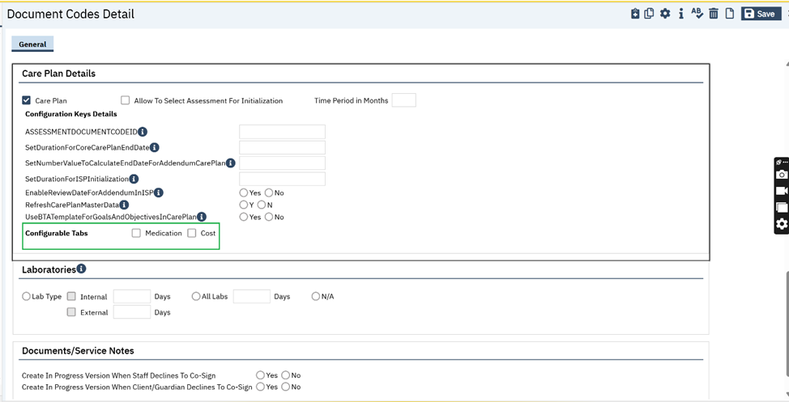
‘Configural Tabs’ section:
- Medication checkbox
- Cost checkbox
Medication Checkbox: When ‘Medication’ checkbox is checked, ‘Medication’ tab will be enabled in the Care Plan document. (Medication tab functionality is implemented as part of the feature -475119 / EII -129584)
Cost checkbox: If the ‘Cost’ Checkbox is checked, ‘Add Disclaimer’ button will be enabled.
Add Disclaimer button screenshot
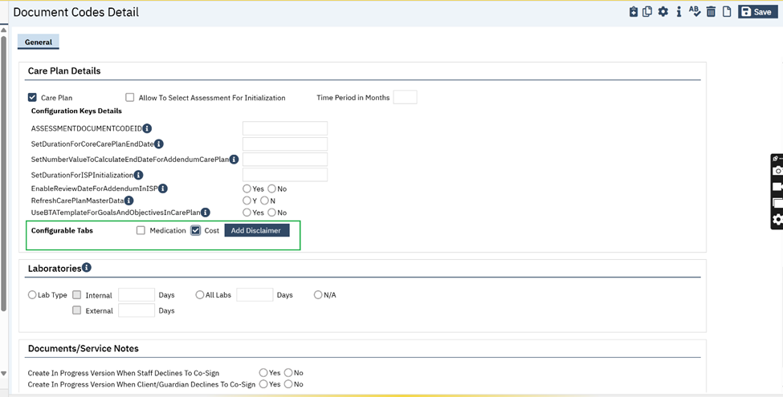
On clicking the ‘Add Disclaimer’ button, the ‘Disclaimer’ Popup will be enabled and maximum of 1000 characters limit data can be added and saved.
Disclaimer Popup screenshot
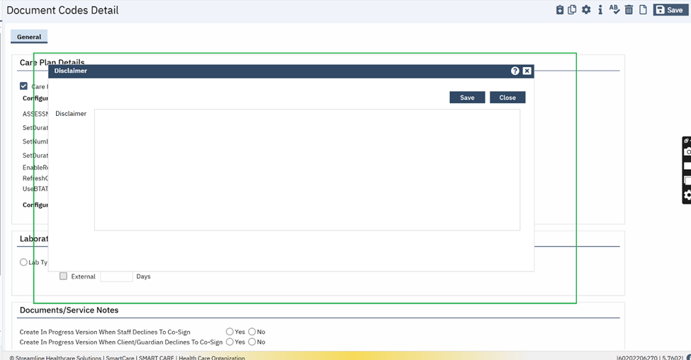
Data Model Changes: The new Columns ‘CarePlanMedication’,’CarePlanCost’ and ‘CarePlanDisclaimer’ are added in existing table ‘DocumentCodes’.

Author: Santosh Huggi

47. EII # 126097 (Feature – 310356): Implementation of 'Link Document to Domain' tab in 'Document Codes Detail' screen.
Release Type: Change | Priority: Urgent
Navigation Path: 'Administration’ – ‘Document Codes’ – ‘Document Codes’ list page – search for required ‘Document Name’ and click on hyperlink of ‘Document Name’ - ‘Document Codes Detail’ screen – ‘General’ tab – ‘Details’ section – ‘Link Document To Domain’ radio button field.
Functionality ‘Before’ and ‘After’ release:
Purpose: The user will link Domains to Documents from Document Codes Detail screen.
With this release, in ‘Document Codes Detail’ screen, under ‘General’ tab, the new radio button field named ‘Link Document To Domain’ has been implemented with ‘Yes’ and ‘No’ options.
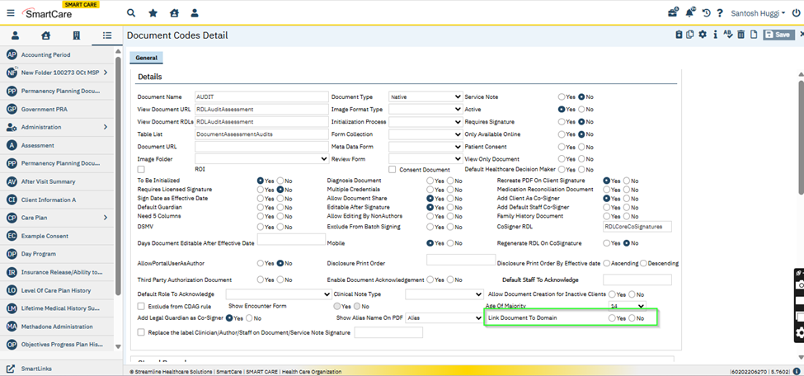
If the "Yes" option is selected, then a new tab "Link Document To Domain" will be displayed.
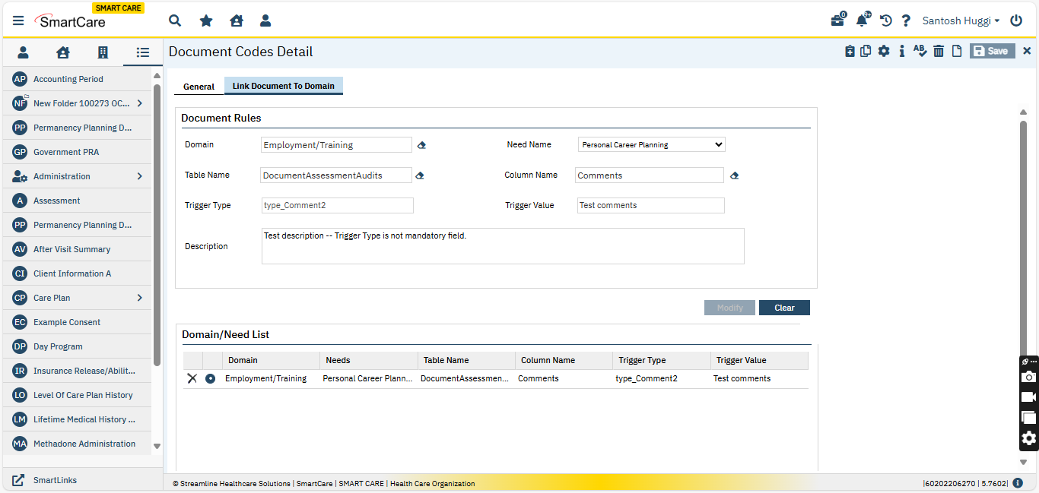

Note: The "Link Document to Domain" radio buttons (Yes and No) is disabled for additional document codes in the Document Codes detail screen under the General tab. The following document codes have been disabled.
- Care Plan (Include copies)
- Individual Service Plan - MCO
- Assessment (C) (Include copies)
- Risk Assessment (Core)
- Functioning and Symptoms
This functionality enables users to define rules for linking a document to a specific domain, with detailed configurations for "Domain", "Need Name", "Table Name", "Column Name", "Trigger Type", "Trigger Value" and "Description".
The "Link Document To Domain" tab is displayed with Document Rules section.
The following fields are present in the ‘Document Rules’ section:
Domain: This is a Typeable Search Textbox field, upon searching for the text it will auto-populate all existing and newly created domain names with matching search text. This is a required field, when user tried to insert the records without entering the value in this field the validation message displayed as ‘Domain is required’. The Eraser icon is displayed next to the field.
Need Name: This is a Dropdown field, it displays only need names linked to the selected domain. This is a required field, when user tried to insert the records without selecting the value for this dropdown field the validation displayed as ‘Need Name is required’.
Table Name: This is a Typeable Search Textbox field, upon searching for the text it will auto-populates with all table names associated with the selected document with search text. This is a required field, when user tried to insert the records without entering the value in this field the validation displayed as ‘Table Name is required’. The Eraser icon is displayed next to the field.
Column Name: This is a Typeable Search Textbox field, upon searching for the text it auto-populates with column names in tables associated with the document with search text. This is a required field, when user tried to insert the records without entering the value in this field the validation displayed as ‘Column Name is required’. The Eraser icon is displayed next to the field.
Trigger Type: This is a Read-only Textbox field. It displays the data type based on the value selected for ‘Column Name’ field.
Trigger Value: This is a Textbox field.
- Rules:
  - If a specific trigger value is provided, the need will be created only if the trigger value matches the value in the specified column.
  - If left blank/NULL, the need will be created for any value in the column.
- Validation:
  - For "YOrN" type, only accepts "Y" or "N" values. If other than “Y” or “N” any other value is entered, then the validation will be displayed as “Trigger Value does not match with Trigger Type”.
  - For "GlobalCode(int)" type, it will only accept numeric values. If other than numeric, any values are entered then the validation will be displayed as “Trigger Value does not match with Trigger Type”
  - For "Varchar" type, it will accept any value.

Control Restrictions on Insert:
The following controls are permitted to insert the Trigger Value:
The Multi-Select Drop Down List, CheckBox, Radio Button, Drop Down List and Typeable Search dropdown controls, Text box.
When the user tries to insert any other controls the validation message will be displayed.
Validation Message: "This control not eligible consider for Needs".
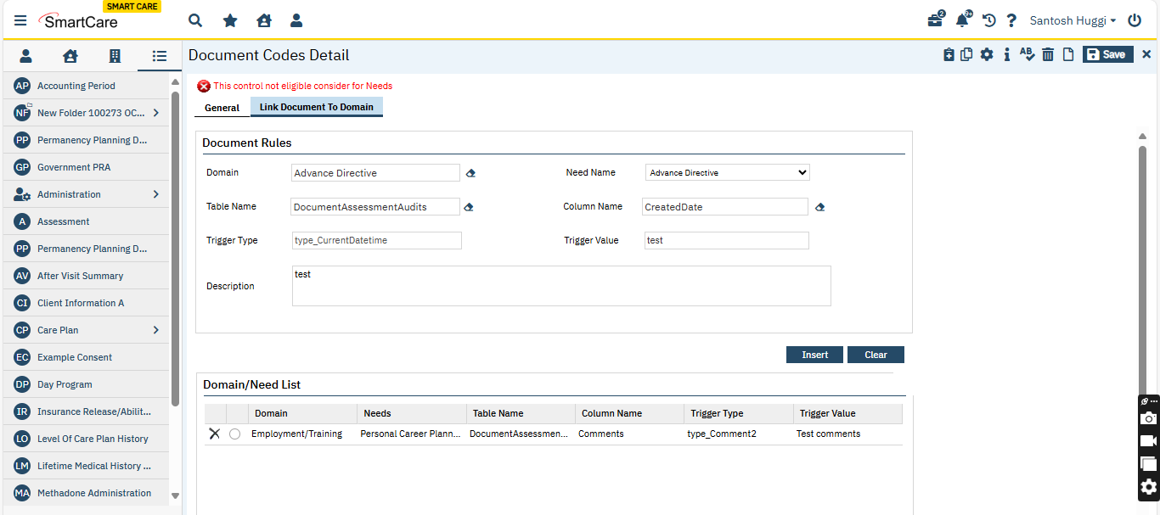
Description: This is the text area field and users can enter the comment. This is a required field, when the user tried to insert the records without entering the value in this field, then the validation displayed as ‘Description is required’.
Insert: Upon clicking on the Insert button, the entered data in the above fields will be inserted into the Domain/Need List Grid.
Clear : It will clear the entered data in the above fields.
Domain/Need List Grid: The grid will be displayed with the following header names along with the radio button and delete icon.
- Domain
- Needs
- Table Name
- Column Name
- Trigger Type
- Trigger Value

The ‘Modify’ button for the inserted records is permanently disabled. If the user wants to make changes, they will delete the record and insert a new one in Domain/Need List grid.
Delete: upon clicking on delete(‘x’), it will delete the selected record.

Data Model Changes:

1.The new column ‘DocumentCodeCarePlanDomainMapping’ is added in the ‘DocumentCodes’ table.
2.The new table ‘DocumentCodeCarePlanDomains’ is created.

Author: Annapurna Bhalke

48. EII # 130287 (Feature - 503894): To initialize the ‘Description’ field text from ‘Document Code Details’ to the ‘Needs List’ tab of ‘Core Assessment’ and ‘Needs’ tab under ‘ISP document’.
Note: This MSP includes some code related to the development of the new Core Assessment. However, the screens and documents associated with it have been marked as disabled for now, as the Core Assessment is still in Beta. These documents should not be used at this stage.
Release Type: Change | Priority: Urgent
Navigation Path: ‘Client’ search -- Select/Create Client - Search ‘Document Codes (Details)’ –‘Select a document’ -- ‘Apply Filter’ - ‘General’ tab –Select ‘Link Document to Domain’ radio button as ‘Yes’ -- then the ‘Link Document to Domain’ tab will be enabled.
Functionality ‘Before’ and ‘After’ release:
Purpose: To initialize the ‘Description’ field text in the ‘Core Assessment’ documents and ISP (Individualized Service Plan) document.
With this release, the following changes are implemented.
‘Document Codes Detail’ page -- ‘Link Document to Domain’ tab:
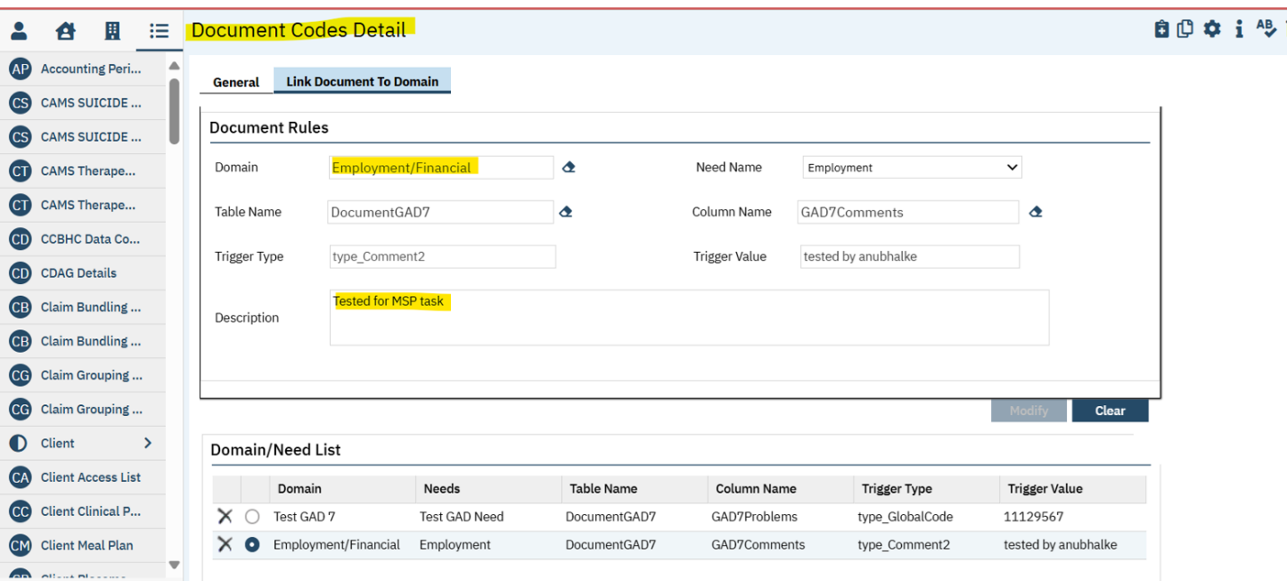
Description textbox field:
If the setup is completed on the ‘Document Code Detail’ page, any text entered in the 'Description' textbox will be inserted and displayed in the ‘Need List’ tab of the ‘Core Assessment’.
Additionally, when saving the ‘Core Assessment’ document, the text from the ‘Description’ text field will also appear in the ‘Needs’ tab under the ‘ISP document’ too.
Description Format:
The Description value is as below:
"Need Name <value>" "<Description value of Setup>".
- Example: For Indicated/Referred Level = "Level 1" and Description Value = "Test123", the final value will be:
"Need Name Level 1 "Test123".
Note:
a. Description value is "Need Name "<value>" "<Description value of Setup>"" . Example: In "Indicated/Referred Level "Level 1" "Test123".
b. On saving the ‘Core Assessment’ document, the ‘Domain/Needs’ details which are saved in the Document Codes Detail => 'Link Document To Domain' tab into ‘careplanneeds’ table based on the setup done in the ‘Document Code Detail’ page.
‘Description’ field from ‘Document Code Details’ will be initialized to the ‘Needs List’ tab of ‘Core Assessment’:

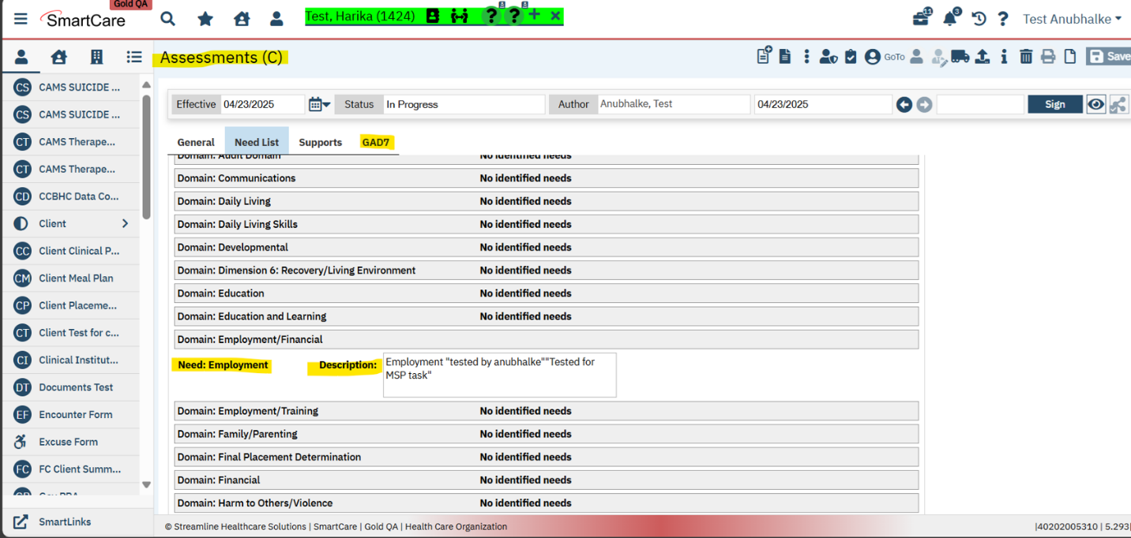
ISP document screenshot:
- On Saving of Core Assessment, ‘Description’ field from ‘Document Code Details’ will be initialized to the ‘Needs’ tab of ‘ISP Document’:
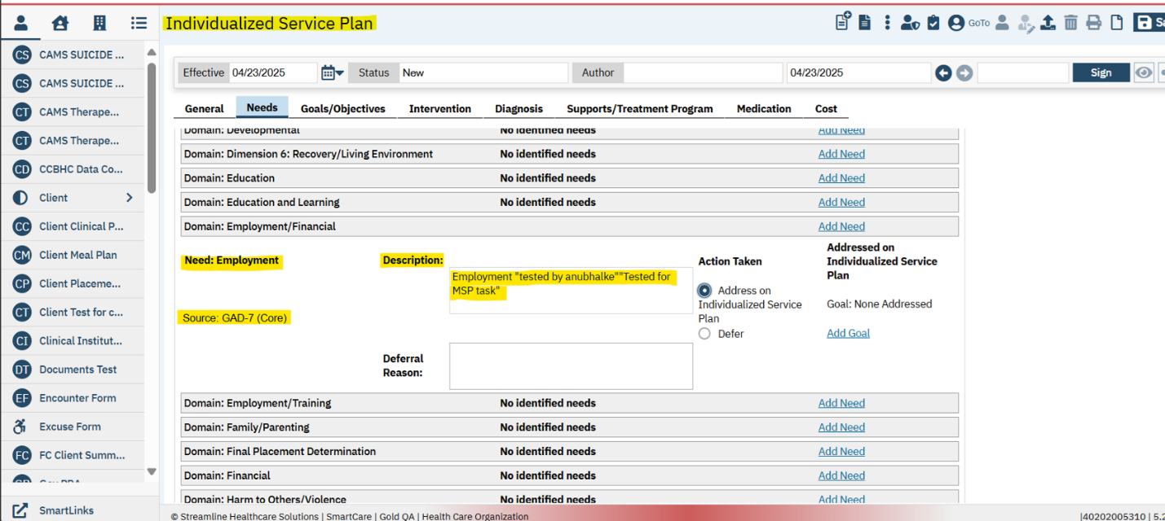

Documents

Reference No | Task No | Description
49 | EII # 128720 | Implemented a new Documents called ‘CAMS SUICIDE STATUS FORM (SSF-5)’.
50 | EII # 130464 | CAMS SSF-4 Fields Cannot Capture Needed Data.
51 | EII # 129584 | ISP document is updated to display the ‘Medication’ and ‘Cost’ tabs.
52 | EII # 130450 | Initialization of the Intervention ‘Details’ textbox value from the recently signed Individualized service Plan (ISP) document.
53 | EII # 130539 | Implementation of CDAG logic modification in the Agency/Program Discharge document.
54 | EII # 130426 | ‘Release of Information(C)’ document labels and fields are updated.
55 | Core Bugs # 131039 | Cosigner adding issue when Staff ID matches the current Client ID.
56 | Core Bugs # 130852 | My Documents: The system takes more time to load the document PDF when non authored users try to access 'In Progress' status documents from the ‘My Documents’ list page.
57 | Core Bugs # 130907 | Error message in the PDF for Letter document.
58 | Core Bugs # 130910 | Effective date issue in the document when changing a Date Prior to Today
59 | Core Bugs # 130936 | SUD Treatment Plan: The 'Authorization Codes' associated with the Client’s assigned Programs were displayed regardless of the Programs linked to the ‘Vary Care Plan by Program’
60 | Core Bugs # 130940 | ‘Core Incident Report’: the user’s name displayed in the respective drop downs though user access is deleted in the Recode set up
61 | Core Bugs # 131121 | Nursing Assessment - Admit Date not displaying correctly
62 | Core Bugs # 131141 | PDFs of documents have wrong information in header
63 | Core Bugs # 130913 | Error on EM Signature pop up screen
64 | Core Bugs # 130943 | Direct messaging is not a usable tool

Author: Sachin Ranganathappa

49. EII # 128720 (Feature - 447271): Implemented a new Documents called ‘CAMS SUICIDE STATUS FORM (SSF-5)’.
DISCLAIMER: The document is only available to those customers who have purchased an annual subscription. It is a premium add-on to SmartCare and not included in SmartCare Base Subscription. If you are interested in learning more about this document, please contact your account manager.
Note : CAMS Suicide status form SSF-4 is updated to the latest version CAMS Suicide Status Form SSF-5, so going forward everyone needs to be using SSF-5.
Release Type: New Functionality | Priority: Urgent

Navigation Path: ‘Client Search’ - ‘Select Client’ – ‘CAMS SUICIDE STATUS FORM (SSF-5)’ - Enter all the required details-Click on sign.

Functionality ‘Before’ and ‘After’ release:
Purpose: To understand the route causes for suicidal thoughts in the client, session by session in a single document. The first session is for initial assessment and treatment planning; the interim session focuses on treating suicidal drivers and treatment plan updates; and the final session is to complete the outcome or disposition.

With this release, a new Document called ‘CAMS SUICIDE STATUS FORM (SSF-5)’ has been implemented along with initializations and the required validations.

‘CAMS SUICIDE STATUS FORM (SSF-5)’ document has a ‘General’ tab along with two sections namely - ‘Information’ and ‘Type’ sections.
‘Information’ section has below been the fields as mentioned:
- Date: This is a Date Control field.
- Time: This is a Text Box field.

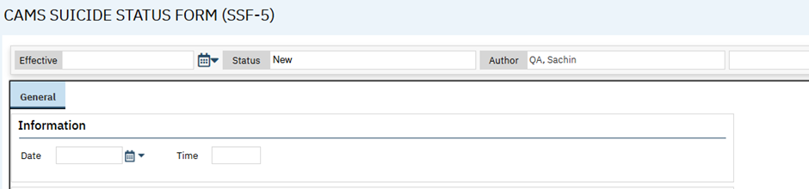

‘Type’ section has the below mentioned radio button options
- Initial Session
- Tracking/Updating Interim Session
- Outcome/Disposition Final Session
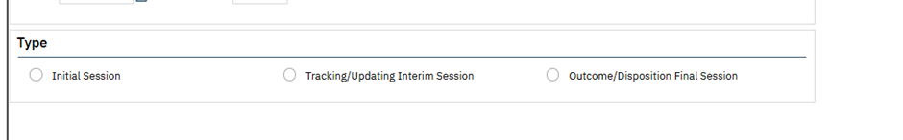
On selecting the ‘Initial Session’ radio button in ‘Type’ selection, the below sections will display:
- Section A (Client)
- Section B (Clinician)
- Section C (Clinician)
- Stabilization Plan
- Section D (Clinician Post Session Evaluation)
- DIAGNOSTIC IMPRESSIONS/DIAGNOSIS (DSM/ICD DIAGNOSES)

‘Section A (Client)’ section has 6 Row and 2 Column table namely – ‘Rank’ and ‘Rate and fill out each item according to how you feel right now. Then rank in order of importance 1 to 5 (1 = most important to 5 = least important)’
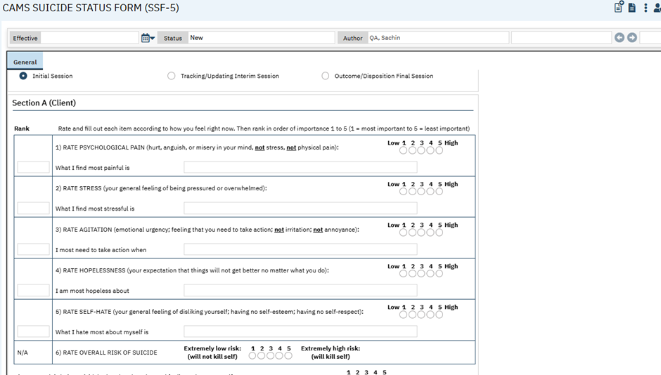

- ‘Rank’: This column has a text box in each row to enter ranks except for the sixth row for sixth-row default with 'N/A'.
- ‘Rate and fill out each item according to how you feel right now. Then rank in order of importance 1 to 5 (1 = most important to 5 = least important)’: This column has with the below fields.
1) RATE PSYCHOLOGICAL PAIN (hurt, anguish, or misery in your mind, not stress, not physical pain): This is a radio button, and it has the following values

    - 1
    - 2
    - 3
    - 4
    - 5

What I find most painful is: This is a Text Box field
2) RATE STRESS (your general feeling of being pressured or overwhelmed): This is a radio button, and it has the following values

    - 1
    - 2
    - 3
    - 4
    - 5

What I find most stressful is: This is a Text Box field
3) RATE AGITATION (emotional urgency; feeling that you need to take action; not irritation; not annoyance): This is a radio button, and it has the following values
    - 1
    - 2
    - 3
    - 4
    - 5
What I most need to take action when: This is a Text Box field.
4) RATE HOPELESSNESS (your expectation that things will not get better no matter what you do): This is a radio button, and it has the following values
    - 1
    - 2
    - 3
    - 4
    - 5
I am most hopeless about: This is a Text Box field.
5) RATE SELF-HATE (your general feeling of disliking yourself; having no self-esteem; having no self-respect): This is a radio button, and it has the following values:
    - 1
    - 2
    - 3
    - 4
    - 5
What I hate most about myself is: This is a Text Box field.
6) RATE OVERALL RISK OF SUICIDE: This is a radio button, and it has the following values:

    - 1
    - 2
    - 3
    - 4
    - 5
With 1 being Extremely low risk: (will not kill self) and 5 being Extremely high risk: (will kill self)
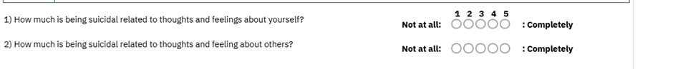
- How much is being suicidal related to thoughts and feelings about yourself? This is a radio button, and it has the following values:
    - 1
    - 2
    - 3
    - 4
    - 5
2) How much is being suicidal related to thoughts and feeling about others?: This is a radio button, and it has the following values:
    - 1
    - 2
    - 3
    - 4
    - 5
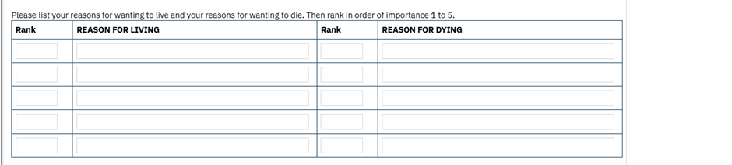
Please list your reasons for wanting to live and your reasons for wanting to die. Then rank in order of importance 1 to 5.: This field has a table with 4 columns. Column header namely (Rank, REASONS FOR LIVING, Rank and REASONS FOR DYING)

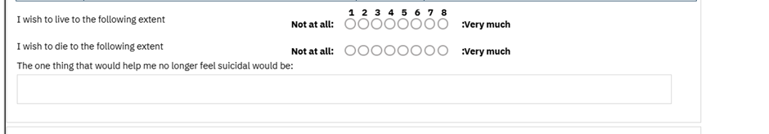
- I wish to live to the following extent: This is a radio button, and it has the following values. With 1 being Not at all and 8 being Very much)
    - 1
    - 2
    - 3
    - 4
    - 5
    - 6
    - 7
    - 8
- I wish to die to the following extent: This is a radio button, and it has the following values (With 1 being Not at all and 8 being Very much)
    - 1
    - 2
    - 3
    - 4
    - 5
    - 6
    - 7
    - 8
- The one thing that would help me no longer feel suicidal would be: This is the Text Area field.

‘Section B (Clinician)’: this section contains the below fields:
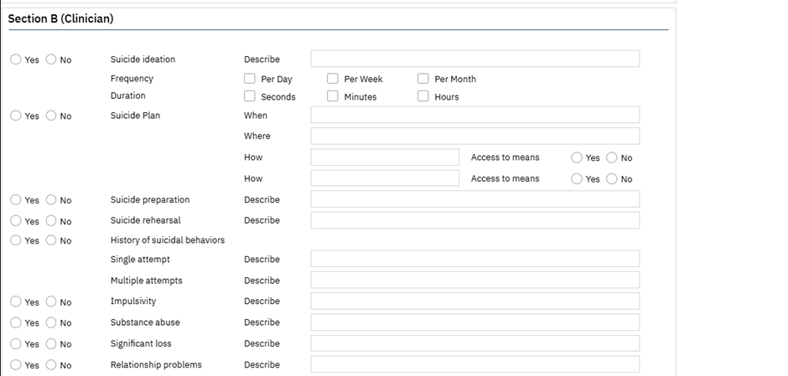
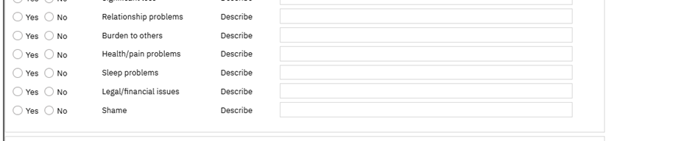
- Suicide ideation: This is a radio button, and it has the following values.

- Yes
- No
- Describe: This is a Text Box field.
- Frequency: This is a check box, and it has the following values.
- Per day
  - Per week
  - Per month

- Duration: This is a check box, and it has the following values.
  - Seconds
  - Minutes
  - Hours
- Suicide plan: This is a radio button, and it has the following values.
- Yes
- No
- When: This is a Text Box field.
- Where: This is a Text Box field.
- How: This is a Text Box field.
- Access to means: This is a radio button, and it has the following values.
- Yes
- No
- How: This is a Text Box field.
- Access to means: This is a radio button, and it has the following values.
- Yes
- No
- Suicide preparation: This is a radio button, and it has the following values.
- Yes
- No
- Describe: This is a Text Box field.
- Suicide rehearsal: This is a radio button, and it has the following values.
- Yes
- No
- Describe: This is a Text Box field.
- History of suicidal behaviors: This is a radio button, and it has the following values.
- Yes
- No
- Single attempt: It’s a field label
- Describe: This is a Text Box field.
- Multiple attempts: It’s a field label
- Describe: This is a Text Box field.
- Impulsivity: This is a radio button, and it has the following values.
- Yes
- No
- Describe: This is a Text Box field.
- Substance abuse: This is a radio button, and it has the following values.
- Yes
- No
- Describe: This is a Text Box field.
- Significant loss: This is a radio button, and it has the following values.
- Yes
- No
- Describe: This is a Text Box field.
- Relationship problems: This is a radio button, and it has the following values.
- Yes
- No
- Describe: This is a Text Box field.
- Burden to others: This is a radio button, and it has the following values.
- Yes
- No
- Describe: This is a Text Box field.
- Health/pain problems: This is a radio button, and it has the following values.
- Yes
- No
- Describe: This is a Text Box field.
- Sleep problems: This is a radio button, and it has the following values.
- Yes
- No
- Describe: This is a Text Box field.
- Legal/financial issues: This is a radio button, and it has the following values.
- Yes
- No
- Describe: This is a Text Box field.
- Shame: This is a radio button, and it has the following values.
- Yes
- No
- Describe: This is a Text Box field.

‘Section C (Clinician)’: this section contains the table, has 5 columns. The column header namely (Problem #, Problem Description, Goals and Objectives, Interventions and Duration)
- TREATMENT PLAN: The information is displayed on top of the table section
- Problem #: This file is auto filled with sl no.
- Problem Description: This is a Text Box field.
- Goals and Objectives: This is a Text Box field.
- Interventions: This is a Text Box field.
- Duration: This is a Text Box field.

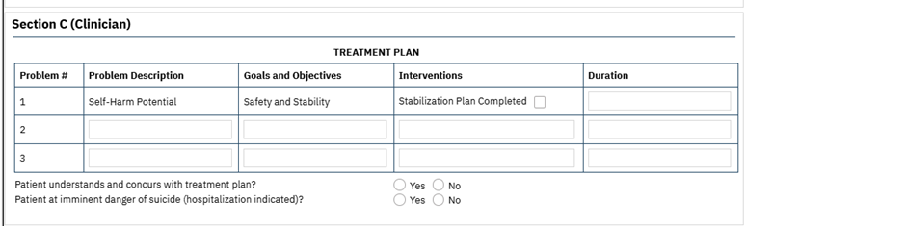
By Default, 1st row with the below data:
Problem #: 1
Problem Description: Self-Harm Potential
Goals and Objectives: Safety and Stability.
Interventions: Stabilization Plan Completed (Checkbox)

Duration: This is a Text Box field

- Patient understands and concurs with treatment plan?: This is a radio button, and it has the following values.
- Yes
- No
- Patient at imminent danger of suicide (hospitalization indicated)?: This is a radio button, and it has the following values.
- Yes
- No

‘Stabilization Plan’: this section contains the below fields.
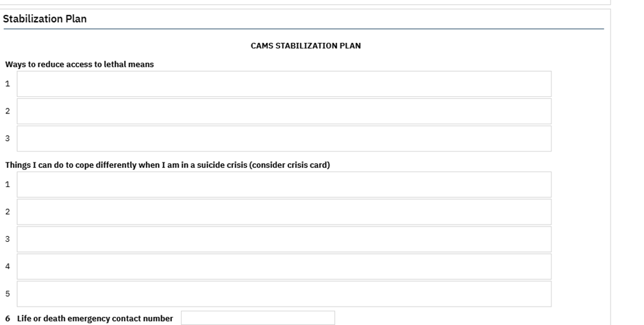

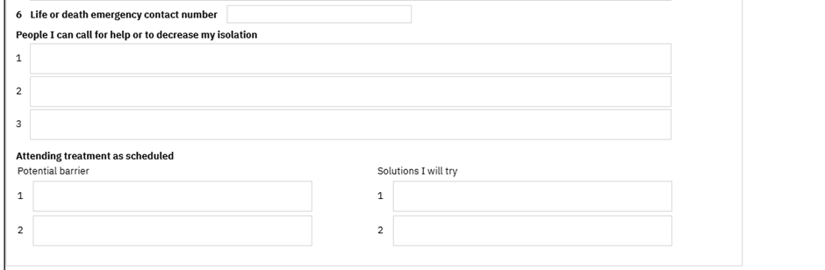
- CAMS STABILIZATION PLAN: This is a Header Text.
- Ways to reduce access to lethal means: This field has three text Areas and with a label as Sequence numbers.
- Things I can do to cope differently when I am in a suicide crisis (consider crisis card): This field has five text Areas and with a label as Sequence numbers.
- 6. Life or death emergency contact number: This is a Text Box field
- People I can call for help or to decrease my isolation: This field has three text Areas and with a label as Sequence numbers.
- Attending treatment as scheduled: This is a Label Text and has the below 2 columns
- Potential barrier: This field has two text Areas and with a label as Sequence numbers.
- Solutions I will try: This field has two text Areas and with a label as Sequence numbers.

‘Section D (Clinician Post Session Evaluation)’: this section contains the below fields.
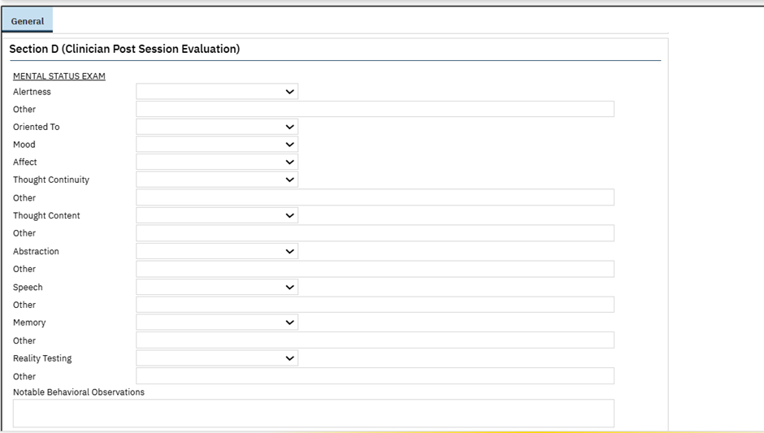
- Mental Status Exam: This is a Header Text
- Alertness: This is dropdown, and it has the following values and is driven from global code 'CSSF5ALERTNESS'
- Alert
- Drowsy
- Lethargic
- Stuporous
Other: This is a Text Box field
- Oriented To: This is dropdown, and it has the following values and is driven from global code 'CSSF5ORIENTEDTO'
- Person
- Place
- Time
- Reason for Evaluation
- Mood: This is dropdown, and it has the following values and is driven from the global code 'CSSF5MOOD'
- Euthymic
- Elevated
- Dysphoric
- Agitated
- Angry
- Affect: This is dropdown, and it has the following values and is driven from the global code 'CSSF5AFFECT'
- Flat
- Blunted
- Constricted
- Appropriate
- Labile
- Thought Continuity: This is dropdown, and it has the following values and is driven from the global code 'CSSF5CONTINUITY'
  - Clear & Coherent
  - Goal-Directed
  - Tangential
  - Circumstantial
Other: This is a Text Box field
- Thought Content: This is dropdown, and it has the following values and is driven from the global code 'CSSF5CONTENT'
- WNL
- Obsessions
- Delusions
- Ideas Of Reference
- Bizarreness
- Morbidity
Other: This is a Text Box field
- Abstraction: This is dropdown, and it has the following values and is driven from global code 'CSSF5ABSTRACTION'
- WNL
- Notably Concrete
Other: This is a Text Box field
- Speech: This is dropdown, and it has the following values and is driven from global code 'CSSF5SPEECH'
- WNL
- Rapid
- Slow
- Slurred
- Impoverished
- Incoherent
Other: This is a Text Box field
- Memory: This is dropdown, and it has the following values and is driven from the global code 'CSSF5MEMORY'
- Grossly Intact
Other: This is a Text Box field
- Reality Testing: This is dropdown, and it has the following values and is driven from the global code 'CSSF5REALITYTEST'
- WNL
Other: This is a Text Box field.
- Notable Behavioral Observations: This is a Text Area field.
DIAGNOSTIC IMPRESSIONS/DIAGNOSIS (DSM/ICD DIAGNOSES): this section contains the below fields.
- Diagnosis: This is the Type able Search Text Box.
- Date: This is Date Control.
- Add: This is a button next to the diagnosis.
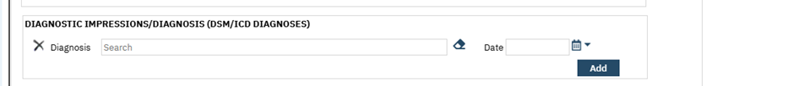
Upon clicking on the "Add Diagnosis" button, the diagnosis that was searched for needs will be added.

- On clicking Add button, if the data is not entered, it shows the validation that needs to select the diagnosis
- Delete button will be displayed to delete the current diagnosis.

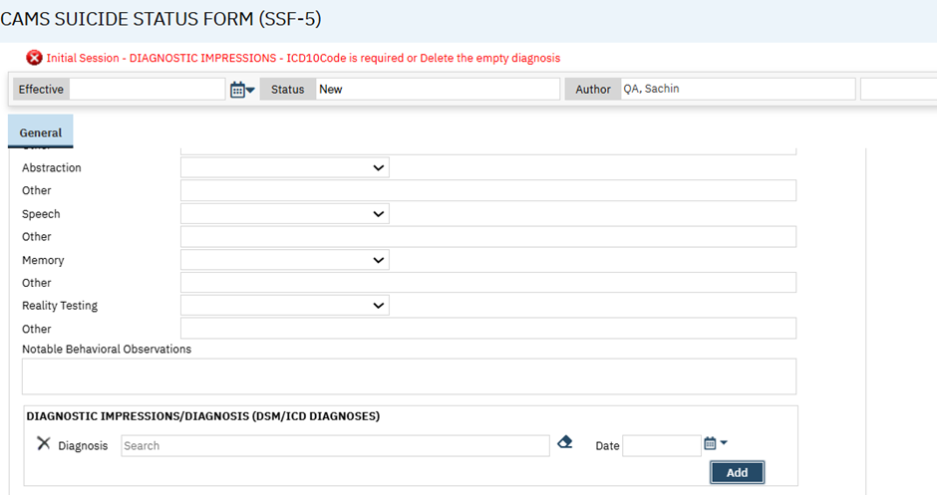
- “Clinical Judgment: Concern about Patient’s Relative Stability.”(check and explain): This is Radio Button, and it has the following values.
- None
- Mild
- Moderate
- Serious
- Extreme

Explanation: This is Text Area field, it will display only upon selection of any radio button for the field “Clinical Judgment: Concern about Patient’s Relative Stability.”(check and explain)
- Case Notes: This is Text Area field.
- Next Appointment Scheduled: This is Text Box field.
- Treatment Modality: This is Text Box field.
- CAMS-care, LLC hereby grants you a non-exclusive, non-transferable license to use the SSF within your organization for clinical and research purposes, including for diagnosis and treatment. You agree not to modify or create derivative works of the SSF.: This is label visible only in the UI, not in the PDF.
- The SSF should only be used by persons who have been properly trained. You may obtain training through the following: https://cams care.com/training/?utm_source=referral&utm_campaign=Streamline&utm_medium=ehr This hyperlink visible only in the UI, not in the PDF.
- From David Jobes, Managing Suicidal Risk: A Collaborative Approach, Third Edition © 2023 by The Guilford Press. www.guilford.com.: This disclaimer visible in both UI and PDF.

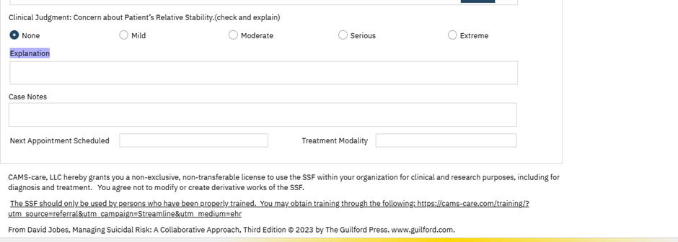

Once after entering all the required fields in the document, the user can sign the document, and the PDF will be generated and Sections A, B, and C are printed in the pdf.

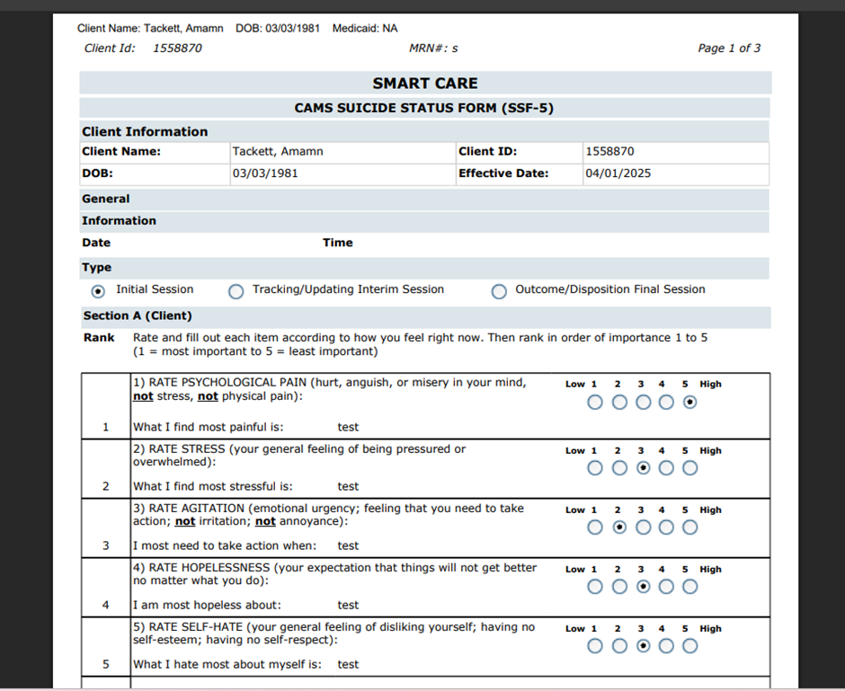
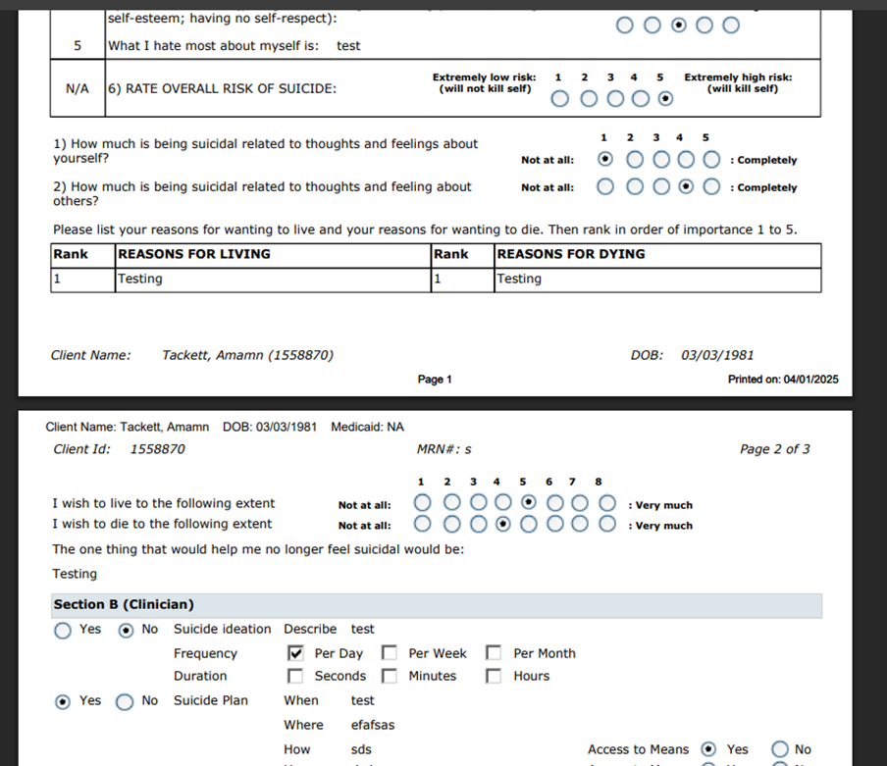

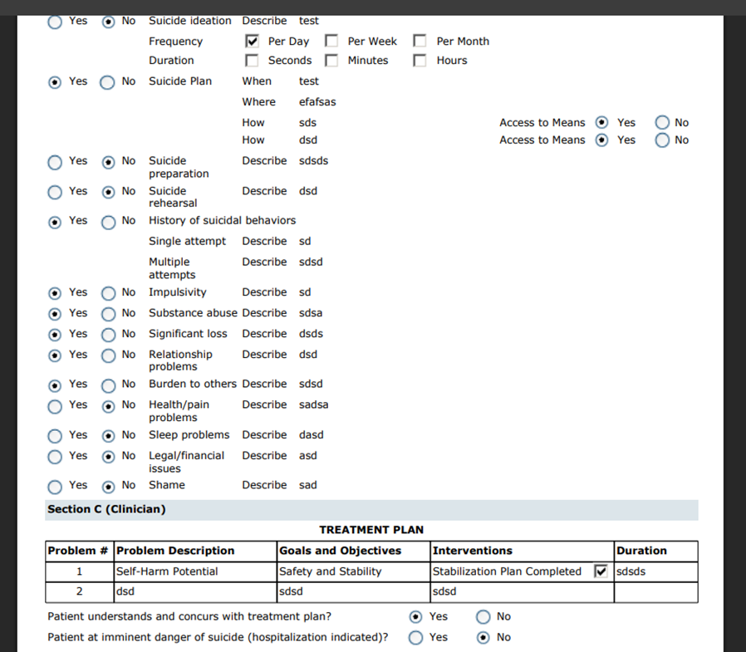

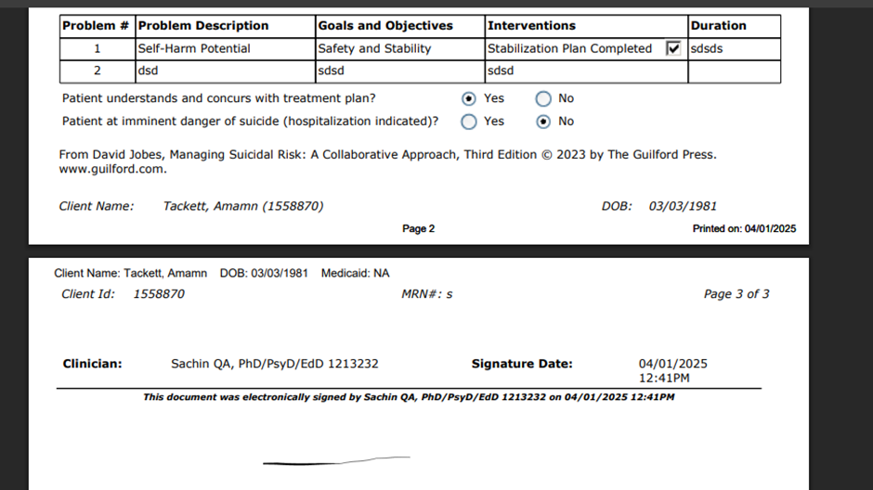
II. On selecting the ‘Tracking/Updating Interim Session’ radio button in ‘Type’ selection, the below sections will display:
- Section A (Client)
- Section B (Clinician)
- Section C (Clinician Post Session Evaluation)
- DIAGNOSTIC IMPRESSIONS/DIAGNOSIS (DSM/ICD DIAGNOSES)

‘Section A (Client)’: this section contains the below fields.
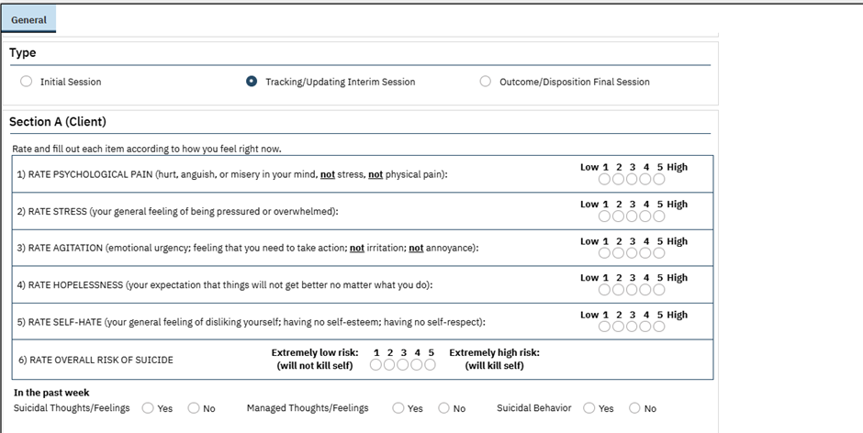
- Rate and fill out each item according to how you feel right now.: This is a Label.
1). RATE PSYCHOLOGICAL PAIN (hurt, anguish, or misery in your mind, not stress, not physical pain): This is a radio button, and it has the following values.
    - 1
    - 2
    - 3
    - 4
    - 5
2) RATE STRESS (your general feeling of being pressured or overwhelmed): This is a radio button, and it has the following values.
    - 1
    - 2
    - 3
    - 4
    - 5
3) RATE AGITATION (emotional urgency; feeling that you need to take action; not irritation; not annoyance): This is a radio button, and it has the following values.
    - 1
    - 2
    - 3
    - 4
    - 5
- 4) RATE HOPELESSNESS (your expectation that things will not get better no matter what you do): This is a radio button, and it has the following values.
    - 1
    - 2
    - 3
    - 4
    - 5
- 5) RATE SELF-HATE (your general feeling of disliking yourself; having no self-esteem; having no self-respect): This is a radio button, and it has the following values.
    - 1
    - 2
    - 3
    - 4
    - 5
- 6) RATE OVERALL RISK OF SUICIDE: This is a radio button, and it has the following values.
    - 1
    - 2
    - 3
    - 4
    - 5
With 1 being Extremely low risk: (will not kill self) and 5 being Extremely high risk: (will kill self)

- In the past week: This is a Label
- Suicidal Thoughts/Feelings: This is radio button, and it has the following values.
- Yes
- No
- Managed Thoughts/Feelings: This is radio button, and it has the following values.
- Yes
- No
- Suicidal Behavior: This is radio button, and it has the following values.
- Yes
- No

‘Section B (Clinician)’: this section contains the below fields.
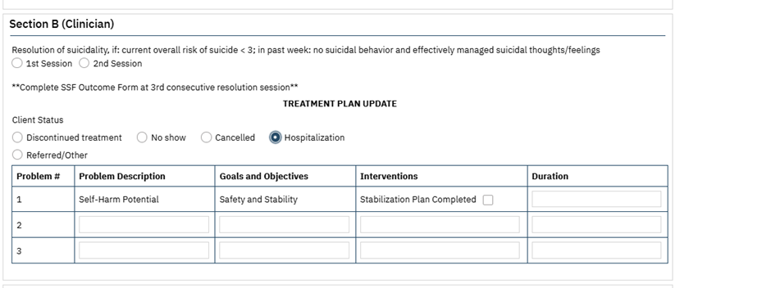

- Resolution of suicidality, if: current overall risk of suicide < 3; in past week: no suicidal behavior and effectively managed suicidal thoughts/feelings with radio buttons 1st session and 2nd session
- **Complete SSF Outcome Form at 3rd consecutive resolution session**
- TREATMENT PLAN UPDATE: This is a Header Text.
- Client Status: This is radio button, and it has the following values.
- Discontinued treatment
- No show
- Cancelled
- Hospitalization
- Referred/Other (If Referred/Other is selected, text box will be displayed)
- 5 columns will be displayed with Column header namely (Problem #, Problem Description, Goals and Objectives, Interventions and Duration)
- TREATMENT PLAN: The information is displayed on top of the table section
- Problem #: This field is auto filled with sl no
- Problem Description: This is a Text Box field
- Goals and Objectives: This is a Text Box field
- Interventions: This is a Text Box field
- Duration: This is a Text Box field
By Default, 1st row with the below data
- Problem #: 1
- Problem Description: Self-Harm Potential.
- Goals and Objectives: Safety and Stability.
- Interventions: Stabilization Plan Completed (Checkbox).
- Duration: This is a Text Box field.

‘Section C (Clinician Post Session Evaluation)’: this section contains the below fields.

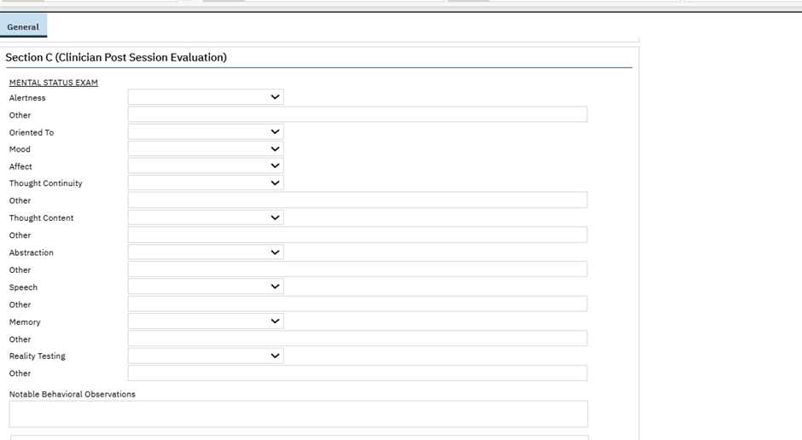

- Mental Status Exam: This is a Header Text
- Alertness: This is dropdown, and it has the following values and will be driven from global code 'CSSF5ALERTNESS'
- Alert
- Drowsy
- Lethargic
- Stuporous
Other: This is a Text Box field.
- Oriented To: This is dropdown, and it has the following values and is driven from global code 'CSSF5ORIENTEDTO'
- Person
- Place
- Time
- Reason for Evaluation
- Mood: This is dropdown, and it has the following values and is driven from the global code 'CSSF5MOOD'
- Euthymic
- Elevated
- Dysphoric
- Agitated
- Angry
- Affect: This is dropdown, and it has the following values and is driven from the global code 'CSSF5AFFECT'
- Flat
- Blunted
- Constricted
- Appropriate
- Labile
- Thought Continuity: This is dropdown, and it has the following values and is driven from the global code 'CSSF5CONTINUITY'
  - Clear & Coherent
  - Goal-Directed
  - Tangential
  - Circumstantial
Other: This is a Text Box field
- Thought Content: This is dropdown, and it has the following values and is driven from the global code 'CSSF5CONTENT'
- WNL
- Obsessions
- Delusions
- Ideas Of Reference
- Bizarreness
- Morbidity
Other: This is a Text Box field
- Abstraction: This is dropdown, and it has the following values and is driven from global code 'CSSF5ABSTRACTION'
- WNL
- Notably Concrete
Other: This is a Text Box field
- Speech: This is dropdown, and it has the following values and is driven from global code 'CSSF5SPEECH'
- WNL
- Rapid
- Slow
- Slurred
- Impoverished
- Incoherent
Other: This is a Text Box field
- Memory: This is dropdown, and it has the following values and is driven from the global code 'CSSF5MEMORY'
- Grossly Intact
Other: This is a Text Box field
- Reality Testing: This is dropdown, and it has the following values and is driven from the global code 'CSSF5REALITYTEST'
- WNL
Other: This is a Text Box field
- Notable Behavioral Observations: This is a Text Area field

DIAGNOSTIC IMPRESSIONS/DIAGNOSIS (DSM/ICD DIAGNOSES): this section contains the below fields.
- Diagnosis: This is the Type able Search Text Box
- Date: This is Date Control
- Add: This is a button next to the diagnosis.
- Upon clicking on the "Add Diagnosis" button, the diagnosis that was searched for needs will be added.
- Delete button will be displayed to delete the current diagnosis.
- On clicking Add button, if the data is not entered, it shows the validation that needs to select the diagnosis

- “Clinical Judgment: Concern about Patient’s Relative Stability.”(check and explain): This is radio button, and it has the following values.
- None
- Mild
- Moderate
- Serious
- Extreme

- Explanation: This is Text Area field, It will display only upon selection of any radio button for the field “Clinical Judgment: Concern about Patient’s Relative Stability.”(check and explain)
- Case Notes: This is Text Area field.
- Next Appointment Scheduled: This is Text Box field.
- Treatment Modality: This is Text Box field.
- CAMS-care, LLC hereby grants you a non-exclusive, non-transferable license to use the SSF within your organization for clinical and research purposes, including for diagnosis and treatment. You agree not to modify or create derivative works of the SSF.: This is label visible only in the UI, not in the PDF.
- The SSF should only be used by persons who have been properly trained. You may obtain training through the following: https://cams-care.com/training/?utm_source=referral&utm_campaign=Streamline&utm_medium=ehr: This hyperlink visible only in the UI, not in the PDF.
- From David Jobes, Managing Suicidal Risk: A Collaborative Approach, Third Edition © 2023 by The Guilford Press. www.guilford.com.: This disclaimer visible in both UI and PDF. This disclaimer should be printed only on the last page of the PDF, before the author's signature.

Once after entering all the required fields in the document, the user can sign the document, and the PDF will be generated and Sections A and B should only print in the pdf.

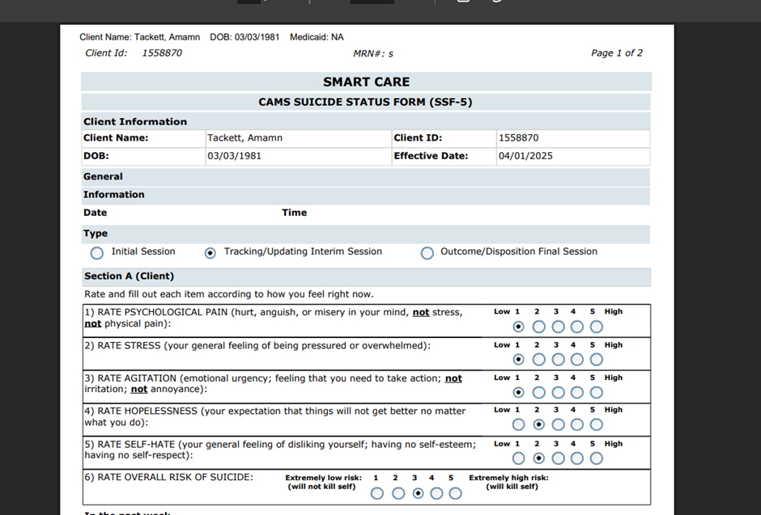
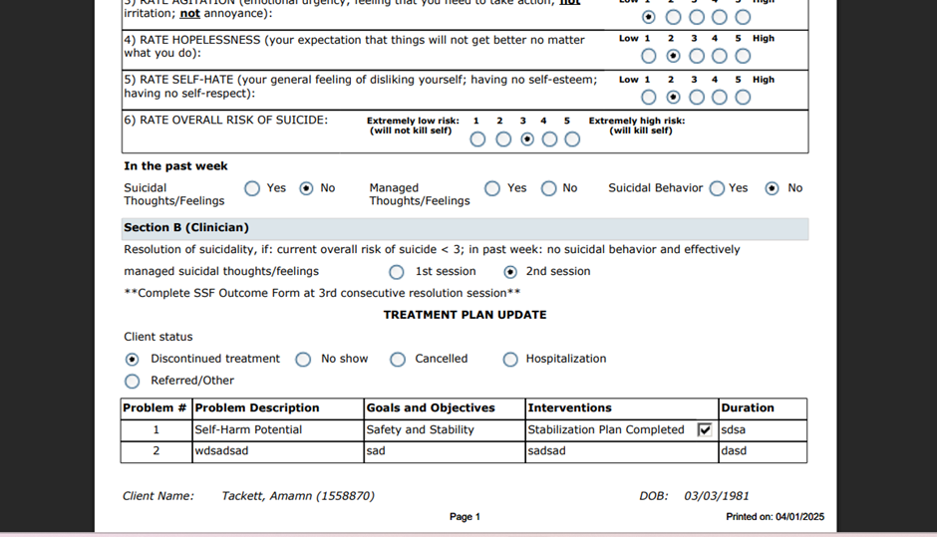
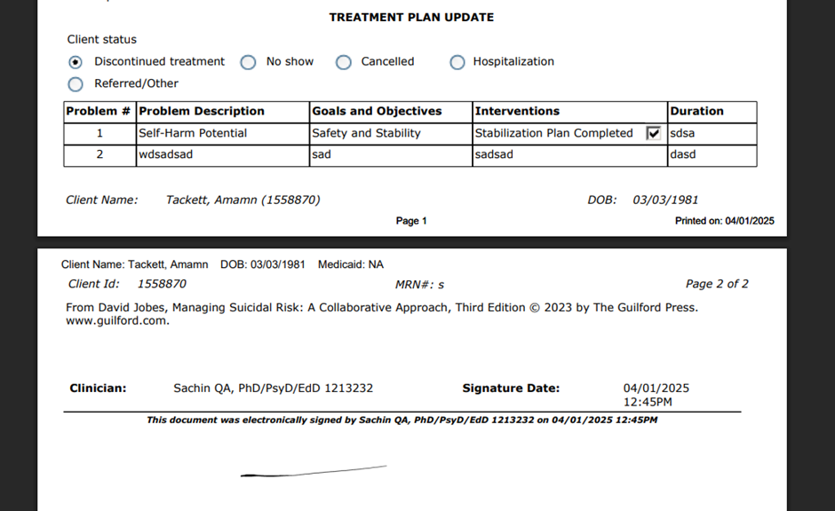

III. On selecting the ‘Outcome/Disposition Final Session’ radio button in ‘Type’ selection, the below section will display:
- Section A (Client)
- Section B (Clinician)
- Section C (Clinician Post session Evaluation)
- DIAGNOSTIC IMPRESSIONS/DIAGNOSIS (DSM/ICD DIAGNOSES)

‘Section A (Client)’: this section contains the below fields.
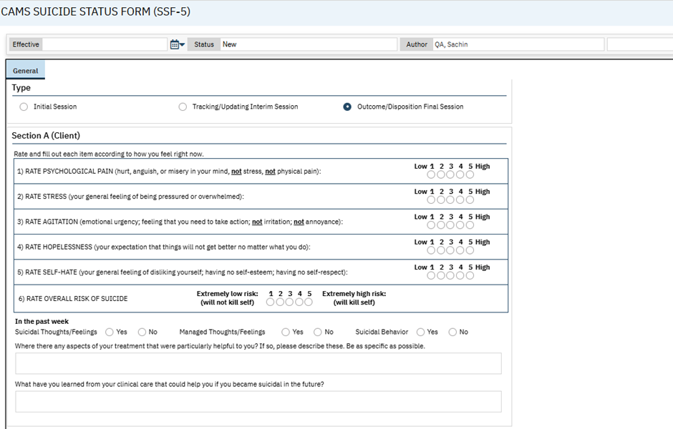
Rate and fill out each item according to how you feel right now.: This is a Label
- RATE PSYCHOLOGICAL PAIN (hurt, anguish, or misery in your mind, not stress, not physical pain): This is a radio button, and it has the following values.
    - 1
    - 2
    - 3
    - 4
    - 5
2) RATE STRESS (your general feeling of being pressured or overwhelmed): This is a radio button, and it has the following values.
    - 1
    - 2
    - 3
    - 4
    - 5
3) RATE AGITATION (emotional urgency; feeling that you need to take action; not irritation; not annoyance): This is a radio button, and it has the following values.
    - 1
    - 2
    - 3
    - 4
    - 5
4) RATE HOPELESSNESS (your expectation that things will not get better no matter what you do): This is a radio button, and it has the following values.
    - 1
    - 2
    - 3
    - 4
    - 5
5) RATE SELF-HATE (your general feeling of disliking yourself; having no self-esteem; having no self-respect): This is a radio button, and it has the following values.
    - 1
    - 2
    - 3
    - 4
    - 5
6) RATE OVERALL RISK OF SUICIDE: This is a radio button, and it has the following values.
    - 1
    - 2
    - 3
    - 4
    - 5
With 1 being Extremely low risk: (will not kill self) and 5 being Extremely high risk: (will kill self)

- In the past week: This is a Label
- Suicidal Thoughts/Feelings: This is radio button, and it has the following values.
- Yes
- No
- Managed Thoughts/Feelings: This is radio button, and it has the following values.
- Yes
- No
- Suicidal Behavior: This is radio button, and it has the following values.
- Yes
- No
- Where there any aspects of your treatment that were particularly helpful to you? If so, please describe these. Be as specific as possible.: This is Text Area.
- What have you learned from your clinical care that could help you if you became suicidal in the future?: This is Text Area.

‘Section B (Clinician)’: this section contains the below fields.
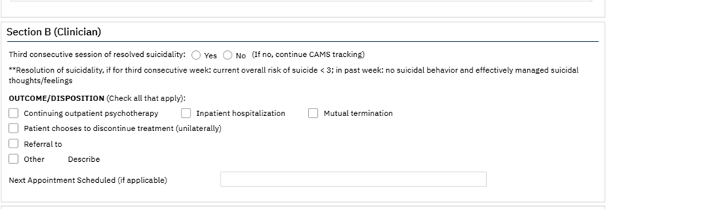
- Third consecutive session of resolved suicidality:
This is Radio Button, and it has the following values.
- Yes
- No

(If no, continue CAMS tracking)
**Resolution of suicidality, if for third consecutive week: current overall risk of suicide < 3; in past week: no suicidal behavior and effectively managed suicidal thoughts/feelings:
- OUTCOME/DISPOSITION (Check all that apply): This is Checkbox, and it has the following values.
- Continuing outpatient psychotherapy
- Inpatient hospitalization
- Mutual termination
- Patient chooses to discontinue treatment (unilaterally)
- Referral to: Text box will display when selecting the check box
- Other.
- Describe: Text box will display when selecting the other check box
- Next Appointment Scheduled (if applicable): This is Text Box

‘Section C (Clinician Post Session Evaluation)’: this section contains the below fields.
- MENTAL STATUS EXAM: This is a Header Text
- Alertness: This is dropdown, and it has the following values and will be driven from global code 'CSSF5ALERTNESS'
- Alert
- Drowsy
- Lethargic
- Stuporous
Other: This is a Text Box field
- Oriented To: This is dropdown, and it has the following values and is driven from global code 'CSSF5ORIENTEDTO'
- Person
- Place
- Time
- Reason for Evaluation
- Mood: This is dropdown, and it has the following values and is driven from the global code 'CSSF5MOOD'
- Euthymic
- Elevated
- Dysphoric
- Agitated
- Angry
- Affect: This is dropdown, and it has the following values and is driven from the global code 'CSSF5AFFECT'
- Flat
- Blunted
- Constricted
- Appropriate
- Labile
- Thought Continuity: This is dropdown, and it has the following values and is driven from the global code 'CSSF5CONTINUITY'
  - Clear & Coherent
  - Goal-Directed
  - Tangential
  - Circumstantial
Other: This is a Text Box field
- Thought Content: This is dropdown, and it has the following values and is driven from the global code 'CSSF5CONTENT'
- WNL
- Obsessions
- Delusions
- Ideas Of Reference
- Bizarreness
- Morbidity
Other: This is a Text Box field
- Abstraction: This is dropdown, and it has the following values and is driven from global code 'CSSF5ABSTRACTION'
- WNL
- Notably Concrete
Other: This is a Text Box field
- Speech: This is dropdown, and it has the following values and is driven from global code 'CSSF5SPEECH'
- WNL
- Rapid
- Slow
- Slurred
- Impoverished
- Incoherent
Other: This is a Text Box field
- Memory: This is dropdown, and it has the following values and is driven from the global code 'CSSF5MEMORY'
- Grossly Intact
Other: This is a Text Box field
- Reality Testing: This is dropdown, and it has the following values and is driven from the global code 'CSSF5REALITYTEST'
- WNL
Other: This is a Text Box field
- Notable Behavioral Observations: This is a Text Area field

DIAGNOSTIC IMPRESSIONS/DIAGNOSIS (DSM/ICD DIAGNOSES): this section contains the below fields.
- Diagnosis: This is the Type able Search Text Box
- Date: This is Date Control
- Add: This is a button next to the diagnosis.

Delete button will be displayed to delete the current diagnosis.
Upon clicking on the "Add Diagnosis" button, the diagnosis that was searched for needs will be added.
On clicking Add button, if the data is not entered, it shows the validation that needs to select the diagnosis

- “Clinical Judgment: Concern about Patient’s Relative Stability.”(check and explain): This is radio button, and it has the following values.
- None
- Mild
- Moderate
- Serious
- Extreme

- Explanation: This is Text Area field, its will display only upon selection of any radio button for the field “Clinical Judgment: Concern about Patient’s Relative Stability.”(check and explain)
- Case Notes: This is Text Area field
- Next Appointment Scheduled: This is Text Box field
- Treatment Modality: This is Text Box field
- CAMS-care, LLC hereby grants you a non-exclusive, non-transferable license to use the SSF within your organization for clinical and research purposes, including for diagnosis and treatment. You agree not to modify or create derivative works of the SSF.: This is label visible only in the UI, not in the PDF.
- The SSF should only be used by persons who have been properly trained. You may obtain training through the following: https://cams-care.com/training/?utm_source=referral&utm_campaign=Streamline&utm_medium=ehr: This hyperlink visible only in the UI, not in the PDF.
- From David Jobes, Managing Suicidal Risk: A Collaborative Approach, Third Edition © 2023 by The Guilford Press. www.guilford.com.: This disclaimer visible in both UI and PDF. This disclaimer is printed only on the last page of the PDF, before the author's signature,

Once after entering all the required fields in the document, the user can sign the document, and the PDF will be generated, and Sections A and B should only print in the pdf.

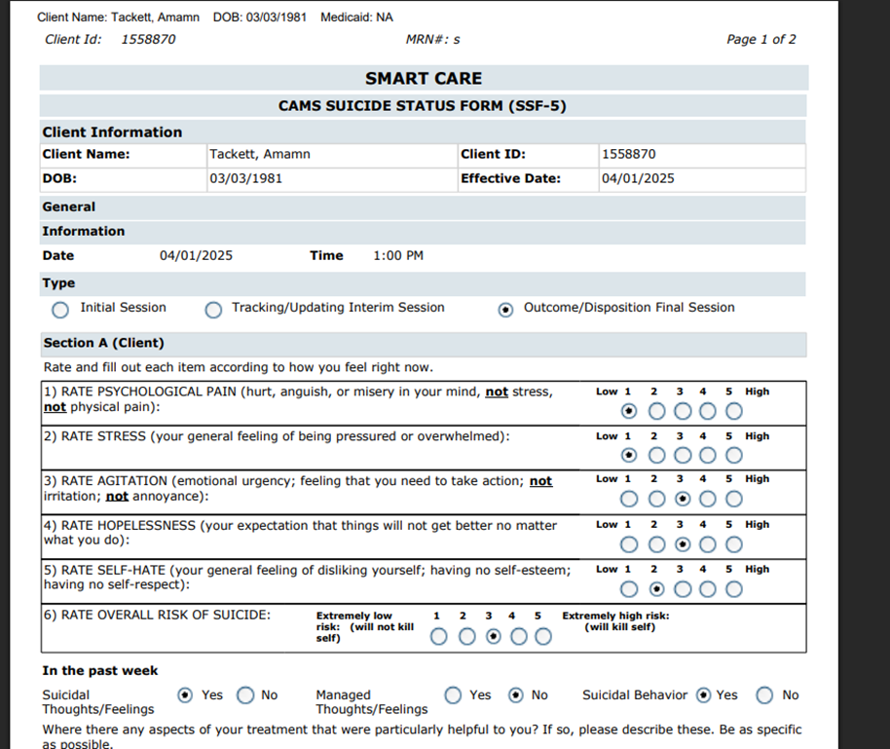
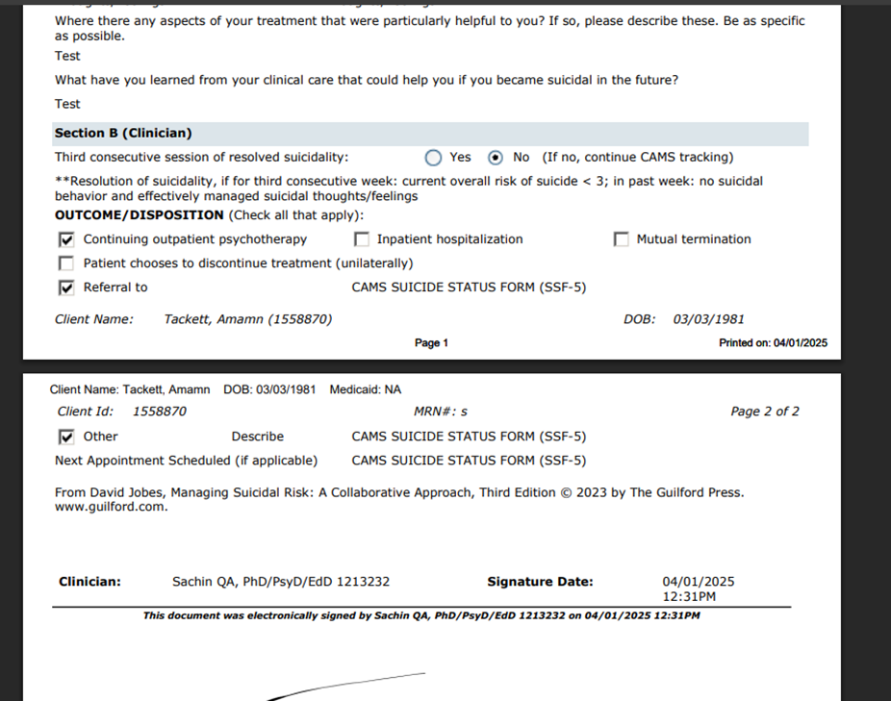
Data Model Changes:
Added below New Table:
DocumentCAMSSuicideStatusForm5
DocumentCAMSSSF5InitialSessions
DocumentCAMSSSF5InitialSessionReasons
DocumentCAMSSSF5InitialSessionTreatmentPlans
DocumentCAMSSSF5InitialSessionStabilizationPlans
DocumentCAMSSSF5InterimSessions
DocumentCAMSSSF5FinalSessions
DocumentCAMSSuicideStatusForm5DiagnosisICD10Codes

Author: Sachin Ranganathappa

50. EII # 130464 (Feature - 478355): CAMS SSF-4 Fields Cannot Capture Needed Data.
DISCLAIMER: The document is only available to those customers who have purchased an annual subscription. It is a premium add-on to SmartCare and not included in SmartCare Base Subscription. If you are interested in learning more about this document, please contact your account manager.
Release Type: Change | Priority: Urgent
Navigation Path: ‘Client Search’ - ‘Select Client’ – ‘CAMS SUICIDE STATUS FORM–4 (SSF-4)’ - Enter all the required details-Click on sign.
Functionality ‘Before’ and ‘After’ release:
Purpose: To Capture the Needed data for 'CAMS SUICIDE STATUS FORM–4 (SSF-4)' document.
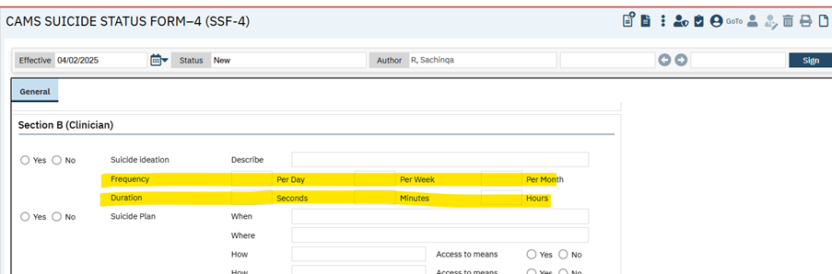
- The above fields in the 'CAMS SUICIDE STATUS FORM–4 (SSF-4)' document are replaced to Numeric Textboxes for Checkboxes.
  - ‘Frequency’ – ‘Per Day’, ‘Per Week’, ‘Per Month’ Response Options are converted to Numeric Textboxes for Checkboxes and restrict the column to a maximum length of 9 digits.
  - ‘Duration’ – ‘Seconds’, ‘Minutes’ and ‘Hours’ Response Options are converted to Numeric Textboxes for Checkboxes and restrict the column to a maximum length of 9 digits.

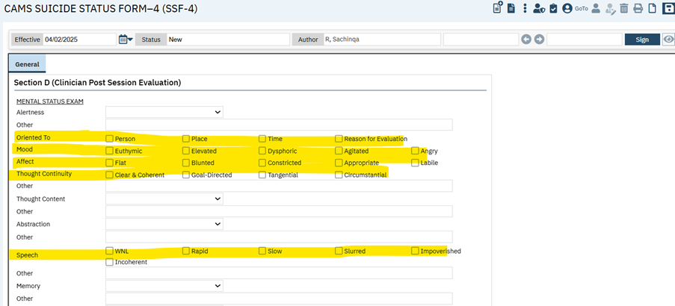
- The above fields in the 'CAMS SUICIDE STATUS FORM–4 (SSF-4)' document is replaced to Checkbox for Single Select Dropdown.
  - Oriented To – Values are driven from the existing global code 'CSSF4ORIENTEDTO'
  - Mood - Values are driven from the existing global code ‘CSSF4MOOD’
  - Affect - Values are driven from the existing global code ' CSSF4AFFECT'
  - Thought Continuity - Values are driven from the existing global code ' CSSF4CONTINUITY'
  - Speech – Values are driven from the existing global code ' CSSF4SPEECH'

Data Model changes:
- Added below New Tables
- DocumentCAMSSSF4Speeches
- DocumentCAMSSSF4Orientations
- DocumentCAMSSSF4ThoughtContinuities
- DocumentCAMSSSF4Moods
- DocumentCAMSSSF4Affects
- Added ‘FrequencyPerDay’, ‘FrequencyPerWeek’, ‘FrequencyPerMonth’, ‘DurationInSeconds’, ‘DurationInMinutes’, ‘DurationInHours’ columns to ‘DocumentCAMSSSF4InitialSessions’ table.

Author: Rakesh Gangadhar

51. EII # 129584 (Feature - 475119): ISP document is updated to display the ‘Medication’ and ‘Cost’ tabs.
Note: These changes are not implemented to ‘Individualized Service Plan (ISP) - MCO' document.
Release Type: Change | Priority: Urgent
Navigation Path 1: Administration -- ‘Document Codes’ – ‘Document Codes’ list page -- Filter by name Care Plan -- ‘Document Codes Detail’ screen -- ‘Care Plan Details section’ -- Check the ‘Care Plan’ checkbox -- Check the ‘Medication’ and ‘Cost’ checkbox.
Navigation Path 2: Client – ‘Individualized Service Plan’ -- ‘Individualized Service Plan’ (ISP) document.
Functionality ‘Before’ and ‘After’ release:
Purpose: The cost breakdown will give the required information on the potential cost of services, meeting the NSA requirements.
With this release, the ‘Medication’ and ‘Cost’ tabs will be displayed in the ‘Individualized Service Plan’ document when the ‘Medication’ and ‘Cost’ checkboxes are checked in the ‘Document Codes Detail’ screen.
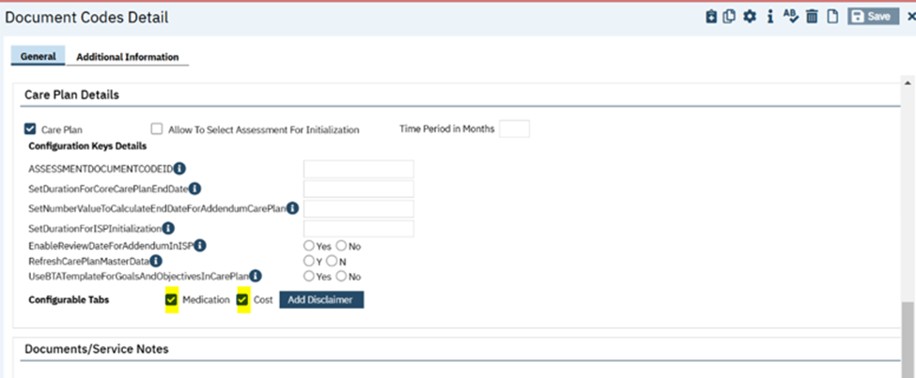
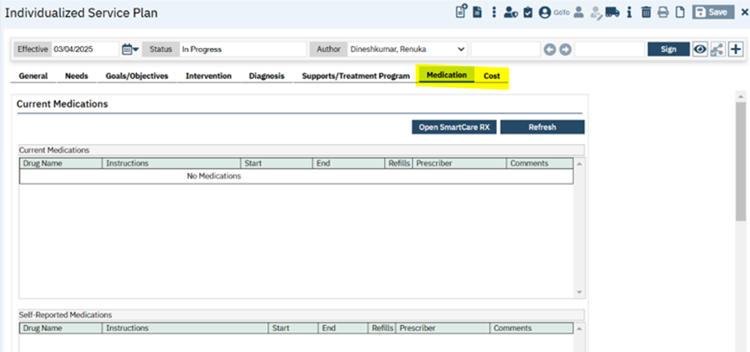
‘Medication’ tab:
- This tab will be hidden, and this will be displayed only when the ‘Medication’ checkbox is selected in the ‘Document Codes Detail’ screen. This tab will display all the medication information of the client. The user can add/modify medication through the ‘Open SmartCare RX’ button.
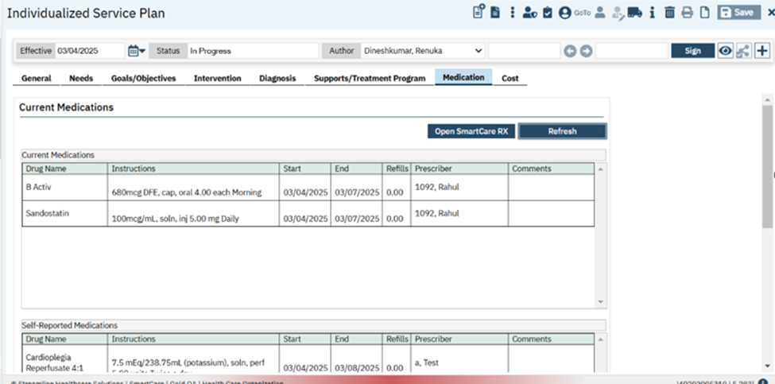
‘Cost’ tab:
- This tab will be hidden, this tab will be displayed only when the Cost checkbox is selected in the ‘Document Codes Detail’ screen. This tab has the following sections and fields.
‘Cost- Interventions’ section:
- In this section, the text will be initialized from ‘Disclaimer’ Popup of the ‘Document Codes Detail’ screen only when Disclaimer Popup has text value.
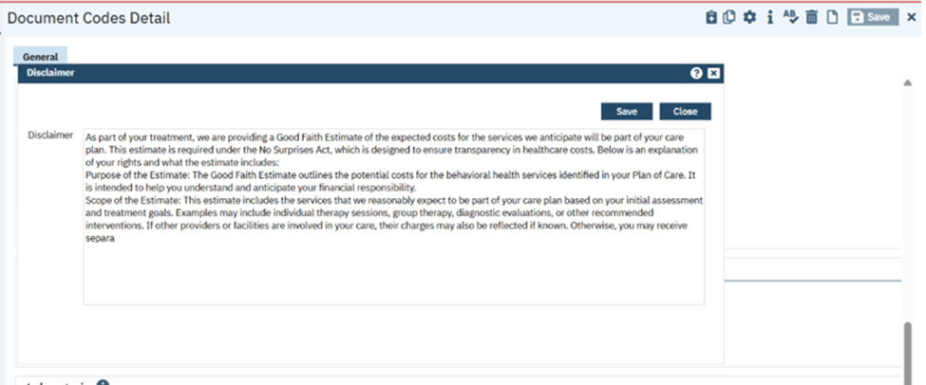
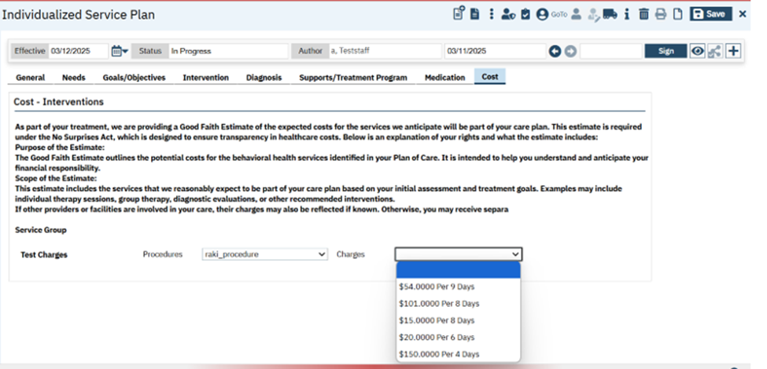
‘Service Group’ label: The fields will be hidden by default.
- When Authorization codes are checked and saved in the interventions tab, then only the selected authorization code will be displayed with ‘Procedure’ and ‘Charges’ dropdowns under ‘Service Group’ label.
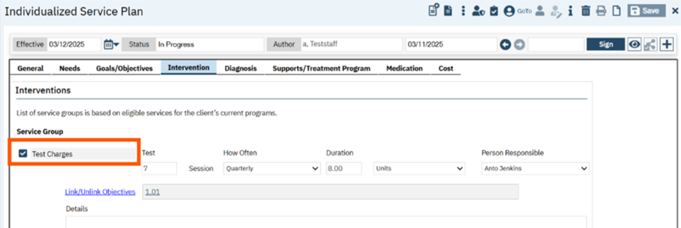
‘Procedures’ dropdown: This dropdown pulls all the ‘Procedure Codes’ associated Authorization Codes after saves from Intervention tab.
‘Charges’ dropdown: This dropdown pulls all the ‘Charges’ of the selected Procedure Code from the Procedures dropdown.
Note: If Authorization codes are unchecked in the intervention tab and saved, then Authorization codes will be removed from the service group section.
‘Medication’ tab PDF:
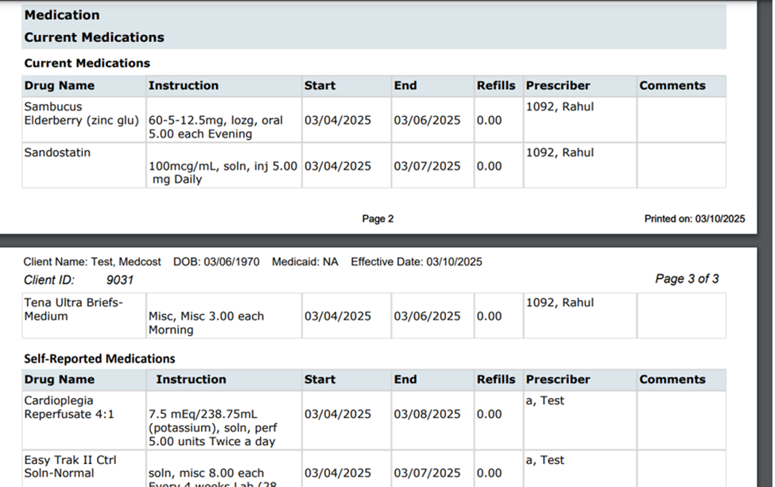
‘Cost’ tab PDF:
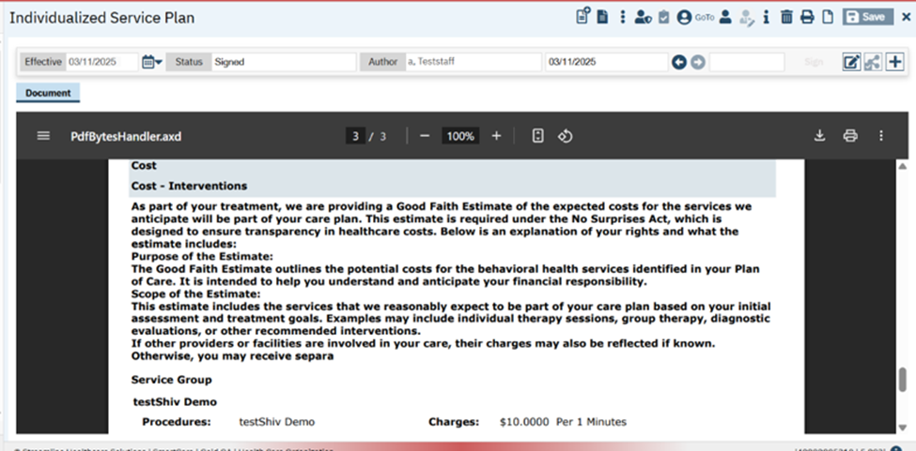
Data Model Change: Columns ‘ProcedureCodeId’ and ‘ProcedureRateId’ are included in ‘CarePlanPrescribedServices’ table.

Author: Rakesh Gangadhar

52. EII # 130450 (Feature - 513961): Initialization of the Intervention ‘Details’ textbox value from the recently signed Individualized service Plan (ISP) document.

Release Type: Change | Priority: Urgent

Prerequisite: An Individualized Service Plan is signed with the Intervention 'Details' field information.
Navigation Path: Go Search-Select Client – ‘Individualized Service Plan' – ‘Intervention’ sub -tab.
Functionality ‘Before’ and ‘After’ release:
Purpose: ISP contains all historical and current information about the individual’s needs and support plans. Initialization of Intervention tab to the new ISP document will assist the provider to give consistent and effective care without service gaps or misinterpretation of needs.
With this release, the 'Details' text box from the Intervention tab is initialized with the information entered from the last signed 'Individualized Service Plan' document.
Initialization of the ‘Details’ text box from the Intervention tab from the last sign ISP document.
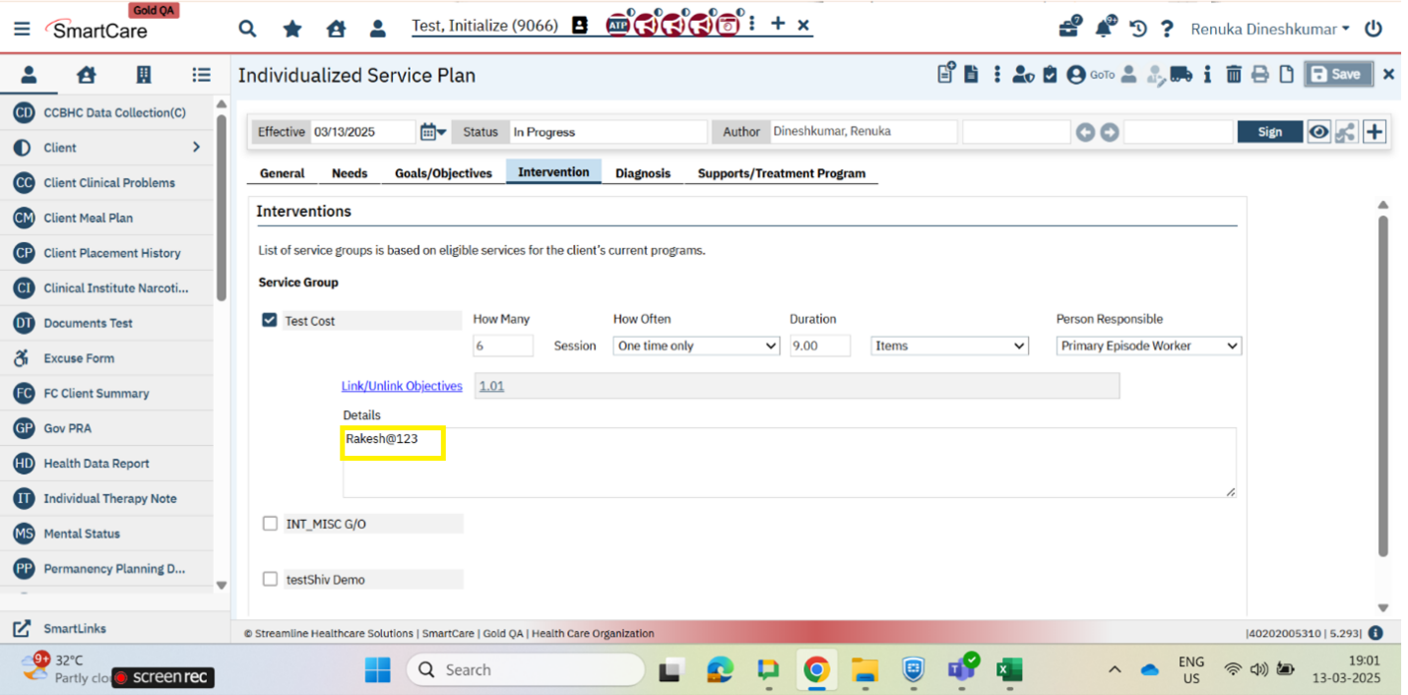

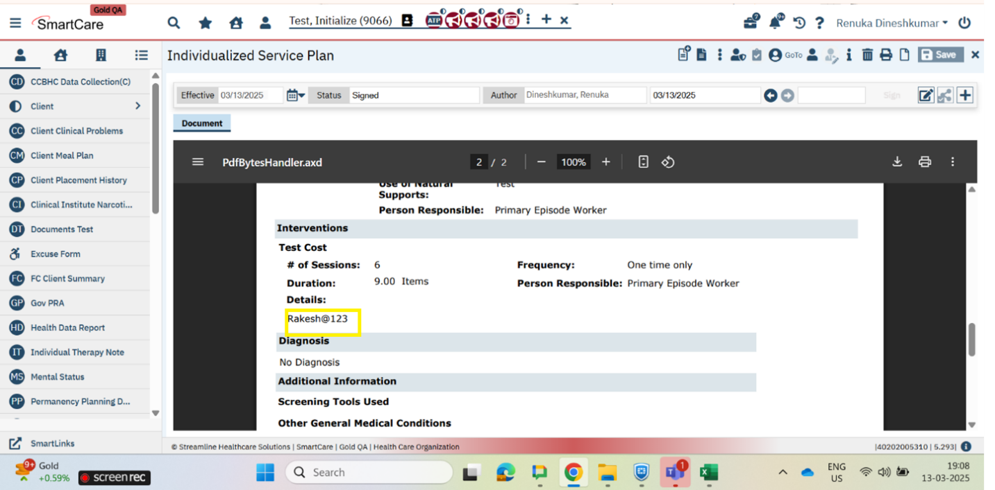

Initialization when multiple interventions are selected.
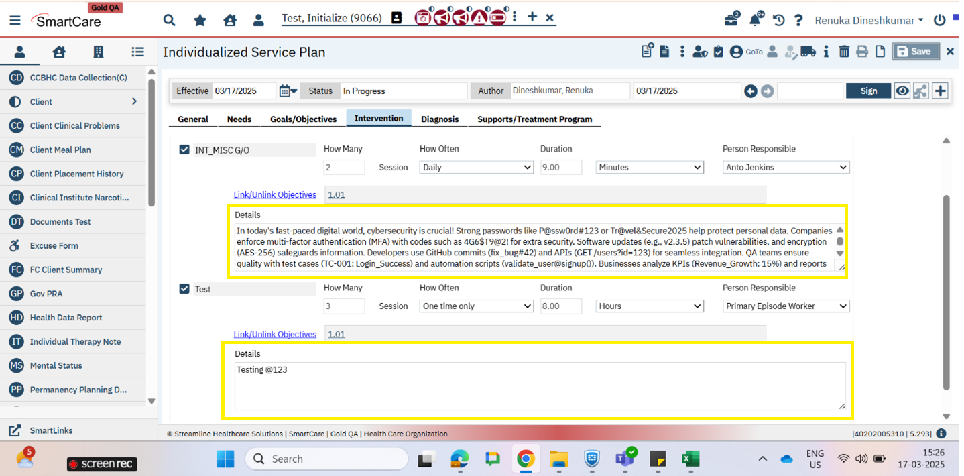

Author: Veena Santosh

53. EII # 130539 (Feature - 284766): Implementation of CDAG logic modification in the Agency/Program Discharge document.
Note: This functionality is implemented for a specific customer. If you have Primary and County type of setup and would like to use these functionalities, please get in touch with Streamline Support.

Release Type: Change | Priority: Urgent
Prerequisite:
- The System configuration key “DisplayCDAGSectionInStaffDetails” value is set to ‘Yes’.
- The System configuration key ‘EnableClinicalDataAccessGrouping’ value is set to ‘Yes’.
- Some programs are enrolled for the selected client from the selected CDAG group.
Navigation Path: Client search – Select the client –‘Go Search’ – Open the ‘Agency/Program Discharge’ document.
Functionality ‘Before’ and ‘After’ release:
Purpose: Restricting the users from performing discharge of the Programs that are not in the logged-in staff’s current CDAG profile and Client-enrolled Programs list and Staff-associated Programs list.
With this release, in ‘Agency/Program Discharge’ document in ‘Program Actions’ section, the below mentioned logic is implemented.
--The programs will display only when they are present in the logged-in staff’s current CDAG profile and Client-enrolled Programs list and Staff-associated Programs list.
--The Programs will be hidden if they are not in the logged-in staff’s selected CDAG profile, client-enrolled programs list and staff-associated programs list.
CDAG group with programs: Agency_discharge1, Agency_discharge2, Agency_discharge3, Agency_discharge4, Agency_discharge5
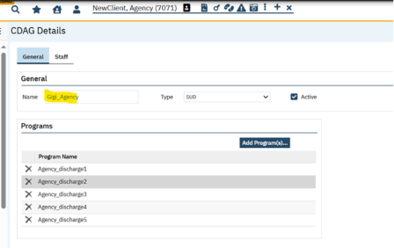
Staff Enrolled programs: Agency_discharge1, Agency_discharge2, Agency_discharge3
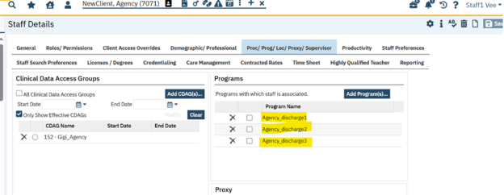
Client Enrolled programs: Agency_discharge1, Agency_discharge2, Agency_discharge5
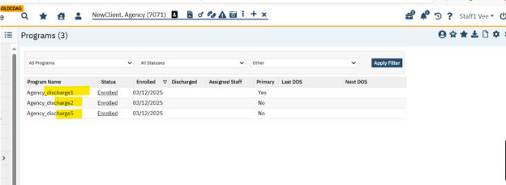
Program Actions section of Agency/Program Discharge program.
Agency_discharge3, Agency_discharge4 and Agency_discharge5 are hidden.
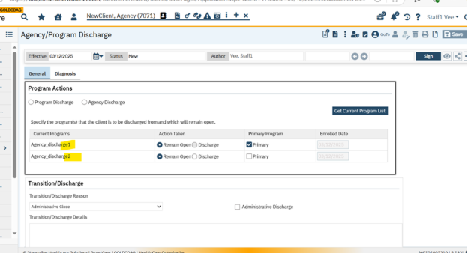
- User will be able to perform the ‘Program Discharge’ without any logic change.
- When users try to perform the ‘Agency Discharge’ :
- If there are no hidden programs in the Program Actions section based on the CDAG rule , then the system will allow ‘Agency Discharge’.
- If there are hidden programs in Program Actions section based on the CDAG rule, then it will perform Program Discharge on save or sign. It will toggle back to Program Discharge, and all the visible programs will be auto selected as Discharge, and all the functionality pertaining to ‘Program Discharge’ will be triggered.
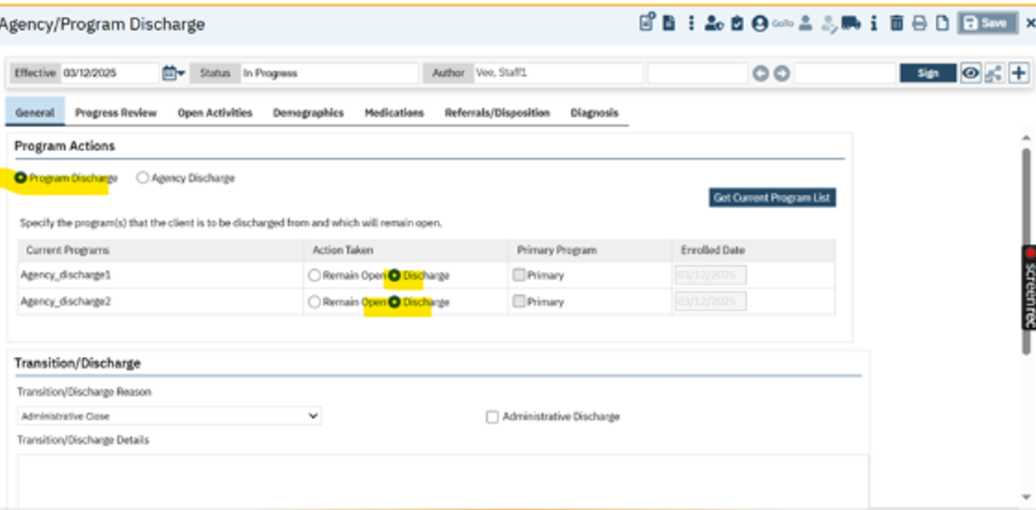

Author: Praveen Gangadhara

54. EII # 130426 (Feature - 497946): ‘Release of Information(C)’ document labels and fields are updated.

Release Type: Change | Priority: Urgent
Navigation Path: Client – ‘Release of Information’ -- ‘Release of Information’ document.
Functionality ‘Before’ and ‘After’ release:
Purpose: To enhance the existing ‘Release of Information(C)’ screen in SmartCare.
With this release, some of the ‘Release of Information(C)’ document labels and fields have been updated. If the user changes the labels using Ctrl+Alt+L, the updated label will be displayed in PDF.
Note: If no changes are made, the existing text will be displayed as default.

The following changes have been updated in the ‘Release of Information’ document.
‘Release To/Release From’ section:
- The textbox field label has been changed from ‘Release To/From’ to ‘Release To/Obtain From’.
- A new ‘Legal Authority’ dropdown will be displayed with below mentioned values:
- Deceased
- Guardian
- Authorized Legal
- Representative
- Power of Attorney
- Power of Attorney
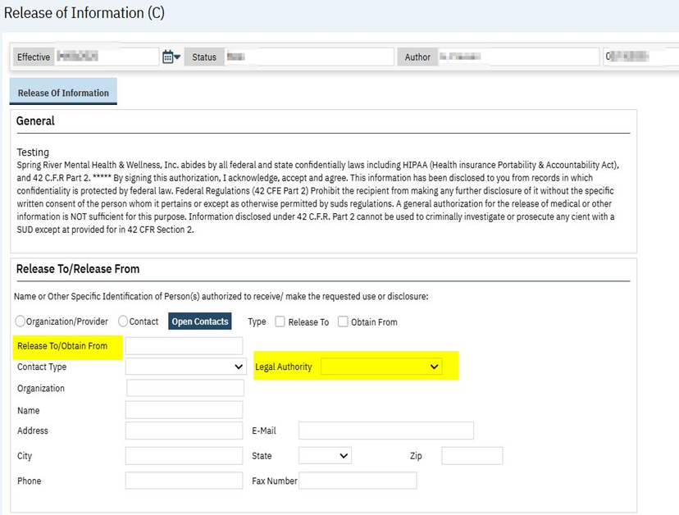
‘Purpose of Disclosure’ section:
- The checkbox has been changed from ‘Process insurance/third part claims (Substance Abuse Remittance Only)’ to ‘Process insurance/third party claims’.
- The checkbox has been changed from ‘Care Coordination’ to ‘Treatment/Care Coordination’.
- The checkbox has been changed from ‘HIE(Health Information Exchange)’ to “Quality Improvement”.
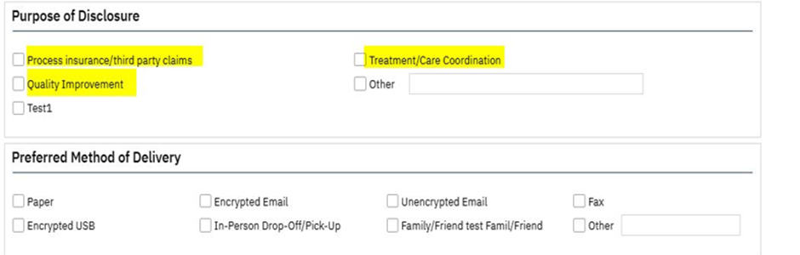
‘Expiration’ section:

- The label is changed to ‘If nothing marked - one(1) year from date signed’ to “If nothing is marked, the authorization will expire one (1) year from date signed. If you would like to specify a different expiration date, then do so by selecting one of the alternative options below or using the “end date” box below”.

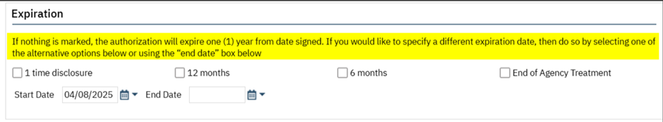
‘Information to be Used or Disclosed’ section:
- Header label is changed to ‘Information to be Disclosed’.
- The label is changed from ‘The information that can be disclosed under this authorization includes the following, if available’ to “The information that can be disclosed under this authorization consists of the following, if available:”
- The ‘Legal Documents’ checkbox has been removed.

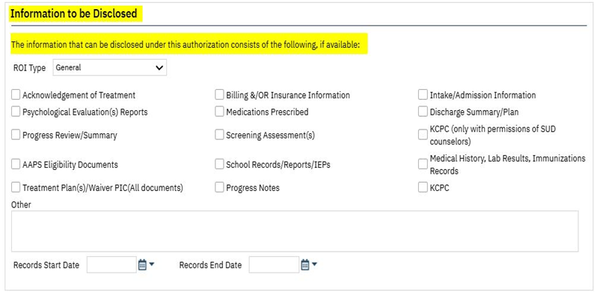
‘Additional Information’ section:
- The header label is changed to ‘Information about HIV/AIDs and Substance Abuse Treatment’.
- The label is changed from ‘Please note – The records released may contain alcohol and drug abuse information and/or information about Human Immunodeficiency Virus (HIV), Acquired Immunodeficiency Syndrome (AIDS), and AIDS Related Complex (ARC).’ to “Information about HIV/AIDs status and treatment for Substance Abuse will not be released without your specific permission. Do you authorize these releases of information to the person / organization listed above?”
- The ‘Alcohol/Drug Abuse’ field checkboxes are replaced with radio buttons.
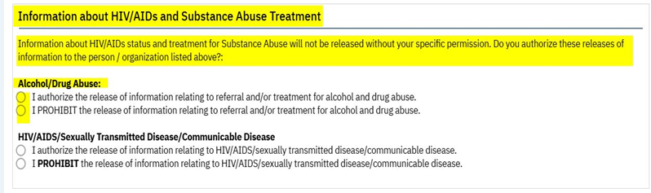
The changes will be reflected on the PDF of the ‘Release of Information(C)’ document.
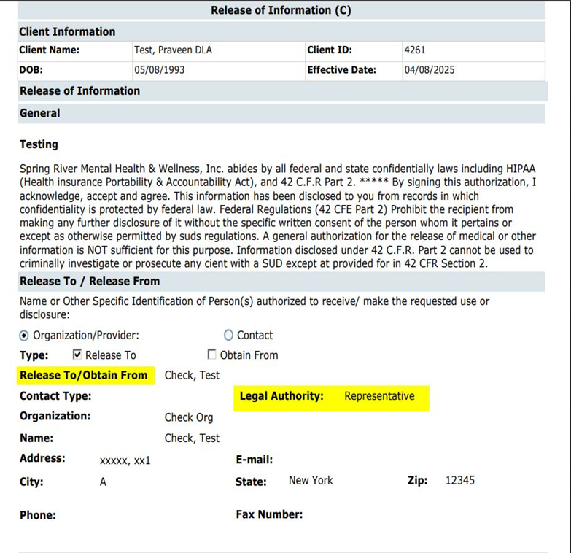
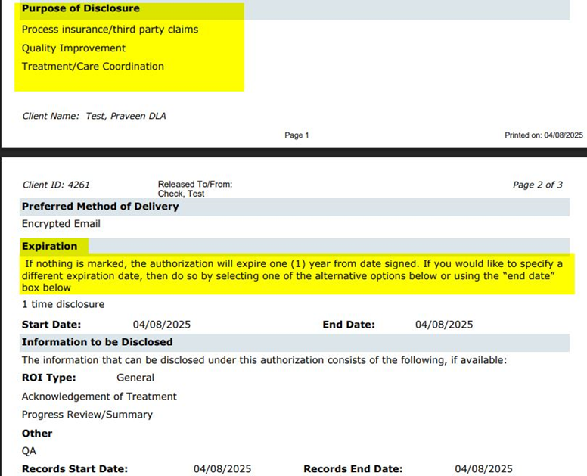
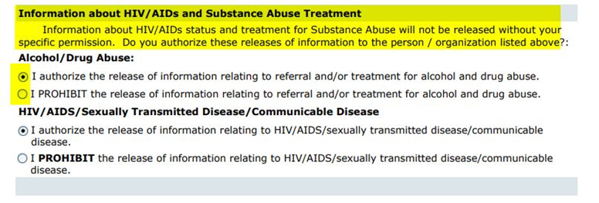
Data Model Change: New column ‘ReleaseLegalAuthority’ included
in ‘DocumentReleaseOfInformations’ table.

Author: Rakesh Nagangouda

55. Core Bugs # 131039: Cosigner adding issue when Staff ID matches the current Client ID.
Release Type: Fix | Priority: High
Navigation Path: Login to SmartCare application – Client – Documents – Sign any Documents – Co Sign the signed Documents.
Functionality ‘Before’ and ‘After’ release:
Before this release, here was the behavior. When the Staff ID matches the current Client ID, the cosigner dropdown incorrectly treats the staff as a client and displays client details instead of staff details.
With this release, above mentioned issue has been fixed. Now, the issue has been fixed by adding an extra validation check that also verifies the Client Name. So now, the system will only consider it as a client if both the Client ID and Client Name match.

Author: Ramya Nagaraj

56. Core Bugs # 130852: My Documents: The system takes more time to load the document PDF when non authored users try to access 'In Progress' status documents from the ‘My Documents’ list page.
Release Type: Fix | Priority: Medium
Navigation Path: My Office’ -- ‘My Documents’ -- ‘My Documents’ list page.
Functionality ‘Before’ and ‘After’ release:
Before this release, here was the behavior. When non authored users tried to access 'In Progress' status documents from ‘My Documents’ list page, the system was taking more time to load the document PDF.
With this release, the above-mentioned issue has been resolved. The stored procedure logic is optimized to improve performance. Now, non-authored users can access 'In Progress' status document's PDF without slowness.
Author: Sunil Belagali

57. Core Bugs # 130907: Error message in the PDF for Letter document.
Release Type: Fix | Priority: High
Navigation Path: Go Search –Documents (Document type configured as Letter)– Enter the details – Save – Sign.
Functionality ‘Before’ and ‘After’ release:
Before this release, here was the behavior. When the user signed a letter document (document type = 14), the below error message was displayed:
Error: "PDF is not available for this document. Please contact system administrator."
With this release, the above-mentioned issue has been resolved. Now, when the user signs a letter document, PDF is generating without any error.

Author: Rakesh Naganagoda

58. Core Bugs # 130910: Effective date issue in the document when changing a Date Prior to Today.
Release Type: Fix | Priority: Medium
Prerequisite: Document code 'Sign Date as Effective Date' is set to 'Yes' through path:
Administration -- ‘Document Codes’ -- click on new – ‘Document Codes Detail’ screen -- Set the field 'Sign Date as Effective Date' as 'Yes'.
Navigation Path: Client – Documents -- Open any document – Sign the Document by giving effective date as Date Prior to present date -- Edit and sign the same document by giving effective date as Date Prior to present date.
Functionality ‘Before’ and ‘After’ release:
Before this release, here was the behavior. When the user signed the second version of the document by changing the date to Date prior to today, the document was saved with the Date prior to today instead of effective date (Todays date), even though the 'Sign Date as Effective Date' was set to 'Yes'.
With this release, the above-mentioned issue has been resolved. Now, the second version of the document will be saved with Effective date as today’s date, when the user signs the document by changing the date to Date prior to today.

Author: Rakesh Gangadhar

59. Core Bugs # 130936: SUD Treatment Plan: The 'Authorization Codes' associated with the Client’s assigned Programs were displayed regardless of the Programs linked to the ‘Vary Care Plan by Program’.
Release Type: Fix | Priority: High
Prerequisite: A copy of ‘Individualized Service Plan’ to be created as ‘SUD Treatment Plan’ through the below paths:
- Document Codes – Search and select ‘Individualized Service Plan’ – Document Codes Details screen – create new document code details screen with same details of Individualized Service Plan with new name as ‘SUD Treatment Plan’ -- Save.
- Go Search – Programs (Administration) – new – check ‘Vary Care Plan By’ checkbox – select value as ‘SUD Treatment Plan; in the dropdown next to the check box – Save.
- Go Search – Screens (Administration) -- Search and select ‘Individualized Service Plan’ – Screen Details – create new screen with same details of Individualized Service Plan with new name as ‘SUD Treatment Plan’ – Save – Refresh Shared tables.
- Go Search – Quick links -- Search and select ‘Individualized Service Plan’ – Quicklink details – create new Quick links with same details of Individualized Service Plan with new name as ‘SUD Treatment Plan’ – Save.
- Go Search – Staff/Users – select logged in staff – Staff Details screen – Roles/Permissions tab – give permission for the newly created screens – Save – Refresh Shared tables.
Navigation Path 1: Search’ -- ‘Configuration Keys (Administration)’ --‘SetInitializationOfCarePlanVarybyProgram’.
Navigation Path 2: ‘Client Search’ – ‘SUD Treatment Plan’.
Functionality ‘Before’ and ‘After’ release:
Before this release, here was the behavior. The 'Authorization Codes' associated with the Client’s assigned Programs were displayed in the ‘SUD Treatment Plan’ Intervention tab, regardless of the Programs linked to the ‘Vary Care Plan by Program’.
With this release, the above mentioned issue has been fixed. Now, a new Configuration Key, ‘SetInitializationOfCarePlanVarybyProgram,’ has been introduced. This key allows the user to decide whether to pull interventions only from the client’s enrolled programs that are linked to 'Vary Care Plan by Program' when the Configuration Key value is set to ‘Yes.’
System Configuration Key details:
SystemConfigKey: SetInitializationOfCarePlanVarybyProgram
Read Key as: Set Initialization Of Care Plan Vary by Program.
Allowed Values: Yes, No
Default Value: No
Modules: SCM Clinical 3
Description:
This is a new feature being added to the core product by introducing a system configuration key to allow the user to decide whether the initialization of Care Plan document in which the client’s enrolled programs that are linked only to 'Vary Care Plan by Program'.
1.) If the key value is set to “No”, this will be the Default value of the key as it drives the below existing behavior.
a. If all the client enrolled programs are linked with the "Vary Care plan by Program" flag, then it will pull the interventions on care plan document based on the "Care Plan Vary by Program" logic.
b. If any client enrolled programs are not linked with "Vary Care plan by Program" flag, then it will be working on the existing logic (Displays the Authorization associated to the Procedure that is mapped to a Program of Program Type set up in a recodes name "CAREPLANPROGRAMTYPE").
c. If some of the client enrolled programs are linked with "Vary Care plan by Program" flag and some are not linked with "Vary Care plan by Program" flag, then it will display interventions based on the above 2 logics.
2) If the key value is set to 'Yes', pull interventions from the client’s enrolled programs that are linked only to 'Vary Care Plan by Program'.
Note:
1. If by chance the value of the key is updated with any value apart from the allowed values, the system will consider the default behavior, i.e. same as the key value being "No".

Author: Tejaswini Srinivas

60. Core Bugs # 130940: ‘Core Incident Report’: the user’s name displayed in the respective drop downs though user access is deleted in the Recode set up.
Release Type: Fix | Priority: High
Prerequisite:
The access right is deleted for AdministratorNotified and Manager recodes through the below paths:
Path 1: Administration - Recodes - Open the 'AdministratorNotified' recode - Select the respective access rights record - Delete by clicking on 'X' icon - The respective record will be deleted.
Path 2: Administration - Recodes - Open the ‘Manager’ recode - Select the respective access rights record - Delete by clicking on 'X' icon - The respective record will be deleted.
Navigation Path: – ‘Client’ – ‘Documents’ – ‘Core Incident Report’
Functionality ‘Before’ and ‘After’ release:
Before this release, here was the behavior. The delete check was not functioning for the ‘MANAGER’ and ‘AdministratorNotified’ recodes and the users were still displayed in the respective drop downs for ‘Core Incident Report’, even though the access was deleted from the recodes.
With this release, the above-mentioned issue has been resolved. Now, once the user access is deleted in the Recode set up, the user’s name will not be displayed in the respective drop downs.

Author: Sunita Biradar

61. Core Bugs # 131121: Nursing Assessment - Admit Date not displaying correctly.
DISCLAIMER: The document is only available to those customers who have purchased an annual subscription. It is a premium add-on to SmartCare and not included in SmartCare Base Subscription. If you are interested in learning more about this document, please contact your account manager.
Release Type: Fix | Priority: High

Prerequisite: Client has enrolled with multiple Episodes.

Navigation Path: ‘Client’ search – Select a Client-Navigate to ‘Nursing Assessment(c)’

Functionality ‘Before’ and ‘After’ release:

Before this release, here was the behavior. When the user signed the Nursing Assessment document, ‘Admit Date’ was showing previous Episode Date in PDF document.
With this release, the above-mentioned issue has been resolved. Now,
- Admit Date label has been renamed to ‘Episode Start Date’ in the Nursing Assessment PDF.

- ‘Episode Start Date’ is displaying current Episode Date in the PDF.

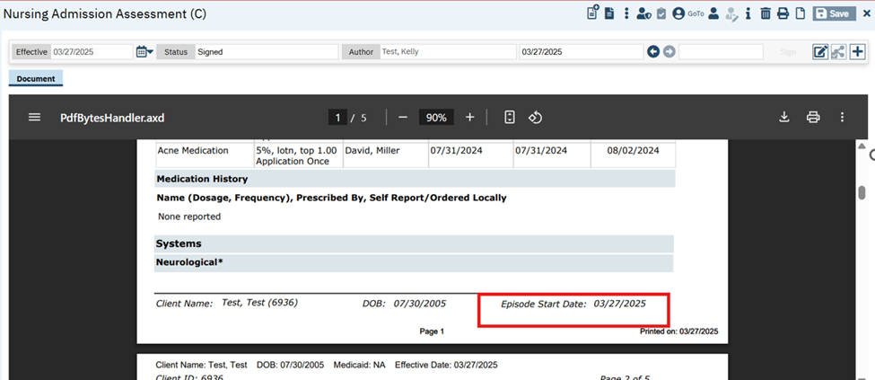

Author: Sunita Biradar

62. Core Bugs # 131141: PDFs of documents have wrong information in header.
Release Type: Fix | Priority: Medium
Prerequisite: Ensure that Below mentioned Configuration keys Values is set as ‘Yes’.
ShowOrganizationNameOnMainPDFReport
ShowCustomerLogoOnPDF
Navigation Path: ‘Client’ search – Select a Client – Navigate to Respective Document - Sign the Document- View the PDF
Functionality ‘Before’ and ‘After’ release:
Before this release, here was the behaviour. Organization logo and name were displayed incorrectly in the signed PDF documents.
With this release, the above-mentioned issue has been resolved. Now the user is able to view the correct Organization and Logo in the signed PDF documents.

Author: Smruthi Srikanth

63. Core Bugs # 130913: Error on EM Signature pop up screen.
Release Type: Fix | Priority: Medium
Navigation Path 1: Search for any Client – ‘My Calendar (My Office)’ - Create ‘New Primary care Entry’.
Navigation Path 2: Search for any Client – ‘Client summary (Primary Care)’ – Click on ‘Quick Note status’ under the ‘Visit’ Section – Select required ‘Template’ – Click on the Sign button for Medical Progress Note document.
Functionality ‘Before’ and ‘After’ release:
Before this release, here was the behavior. The users were not able to sign the “Medical Progress Note’ document as they were getting a red error in the EM Sign Note popup screen.
Error Message: Column ‘EMCode’ does not allow nulls.
With this release, the above-mentioned issue has been resolved. Now, the users are able to sign the “Medical Progress Note’ document without any error.

Author: Chaitali Patil

64. Core Bugs # 130943: Direct messaging is not a usable tool.
Release Type: Fix | Priority: Medium
Navigation Path: Go search- Diagnosis document – add some details in the document – click on Save – in tool bar section click on Reconciliation icon – Reconciliation popup will display.
Functionality ‘Before’ and ‘After’ release:
Before this release, here was the behavior. In Reconciliation pop up, added details were not displayed completely, due to pop up width issue. Also, labels were not added for the Dropdown.
With this release, the above-mentioned issue is resolved. Now, the Reconciliation pop up width is increased, as well as the below label names are added for the dropdown.
1 Dropdown: 'File Name'
2 Dropdown: 'Reconciliation Type'

Documents Linked to Domains

Reference No | Task No | Description
65 | EII # 123654 | A new ‘Documents Linked to Domain List’ screen is implemented to create, modify and map Domains and Needs.

Author: Harika Rajendran

65. EII # 123654 (Feature - 246642): A new ‘Documents Linked to Domain List’ screen is implemented to create, modify and map Domains and Needs.
Release Type: New Functionality | Priority: Medium
Navigation Path: Administration -- 'Documents Linked to Domain List’ -- 'Documents Linked to Domain List’ page

Functionality ‘Before’ and ‘After’ release:

Purpose: 1. User will be able add/modify and map Domains->Needs->Goals->Objectives within Smart Care.
2. User will link Domains to Documents from Document Codes Detail screen.
3. User will be able to track Domain and Documents linkage by List page.

With this release, a new list page named ‘Documents Linked to Domain List’ has been implemented to add/modify and map Domains, Needs, Goals, and Objectives within Smart Care.
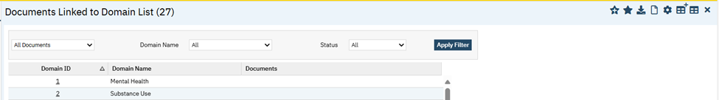
‘Documents Linked to Domain List’ Page: This list page will display the Domains based on the selected filter.

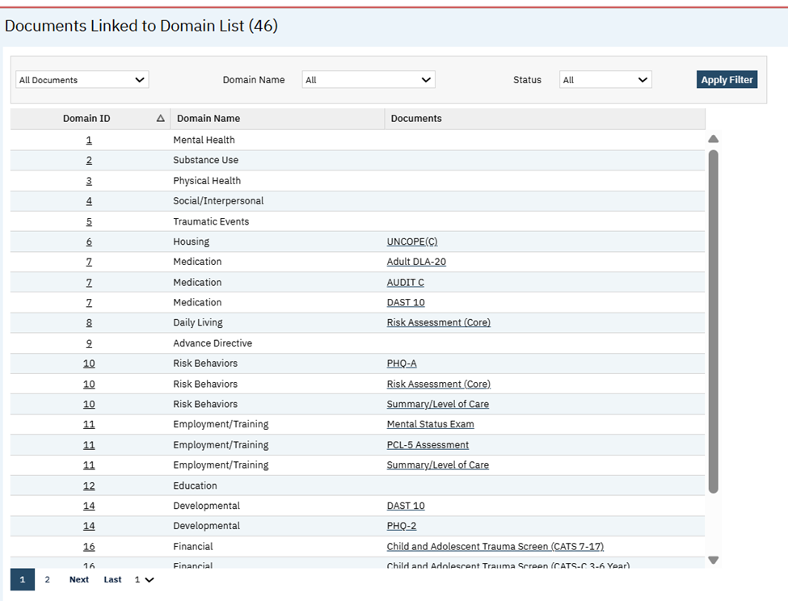
Filter Section:
- All Document: This is a dropdown field and pulls all the Documents list.
- Domain Name: This is a dropdown field and pulls all the Domain names from Care Plan Domains.
- Status: This is a dropdown field with options Active, Inactive, All.
Grid Section:
- Domain ID: This column displays all the Domian IDs. On click of hyperlink will navigate to respective Domain Details page.
- Domain Name: This column displays the Domian names.
- Documents: This column displays selected documents. The document link will be displayed only when Domain is mapped to respective document. Else, the blank field will be displayed. On click of hyperlink, the application will navigate to ‘General’ tab of ‘Document Code Details’ screen.

Note:
1. Multiple Domains can be mapped to the same document.
2. Multiple Documents can be mapped to the same Domain.
3. All created Domains will be displayed and will be navigated to respective Domain Details from Domain ID.
4. In Document Column, blank value will be displayed if the respective Domain is not mapped to any Document.
‘Domain Details’ Screen:
‘Domain Details’ screen will be displayed when the user clicks on a new icon on the ‘Documents Linked to Domain List’ page.
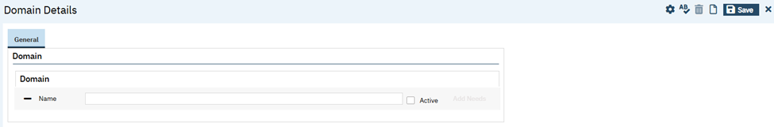
Note:
- This detail page is template-based detail page.
- Template hierarchy is Domain->Need->Goals->Objectives.
Example: For Domain-1, Need- 1.01, Goal-1.01.01, Objective-1.01.01.01. If another new Need is added, then Need- 1.02, Goal-1.02.01, Objective-1.02.01.01.
3. One Care plan domain might have multiple Needs, One Need can have multiple Goals, and One Goal can have multiple Objectives.
‘Domain’ Section:
Name: This is a textbox filed. This field allows the user to enter alphanumeric characters (Varchar (250 characters)).
Active: This is a check box. If this checkbox is unchecked, child level all fields along with 'Add Needs' button will be greyed out.
Add Needs: This is a Button. On Click of 'Add Needs' button it will allow users to add multiple Needs for a Domain. This will work as the hierarchical order (Domain->Need) i.e., Needs Template will be displayed.
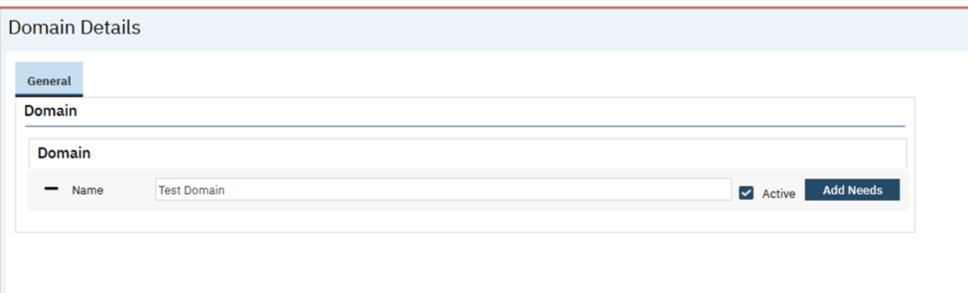
‘Needs’ Template:
Name: This is a Textbox filed. This field allows the user to enter alphanumeric characters (Varchar (250 characters)).
Active: This is a check box. If this checkbox is unchecked, child level all fields along with 'Add Goals' button will be greyed out.
- If user clicks delete icon of Need, system will delete Need along with respective Goals and Objectives also.
Example: If the user deletes current Goal, replace current numbering by previous one
Add Goals: This is a button. On Click of 'Add Goals' button it will allow users to add multiple Goals for a Need. This will work as the hierarchical order (Domain->Need->Goals) i.e., Goals Template will be displayed.
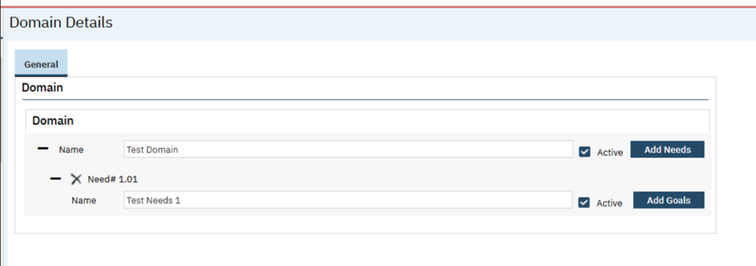
‘Goals’ Template:
Name: This is a Textbox filed. This field allows the user to enter alphanumeric characters (Varchar (250 characters)).
Active: This is a check box. If this checkbox is unchecked, child level all fields along with 'Add Objectives' button will be greyed out.
- If user clicks delete icon of Goals, the system will delete the Goal along with respective Objectives also.
Example: If the user deletes current Goal, replace current numbering by previous one.
Add Objectives: This is a Button. On Click of 'Add Objectives' button it will allow users to add multiple Objectives for a Goals. This will work as the hierarchical order (Domain->Need->Goals->Objectives) i.e., Objectives Template will be displayed.
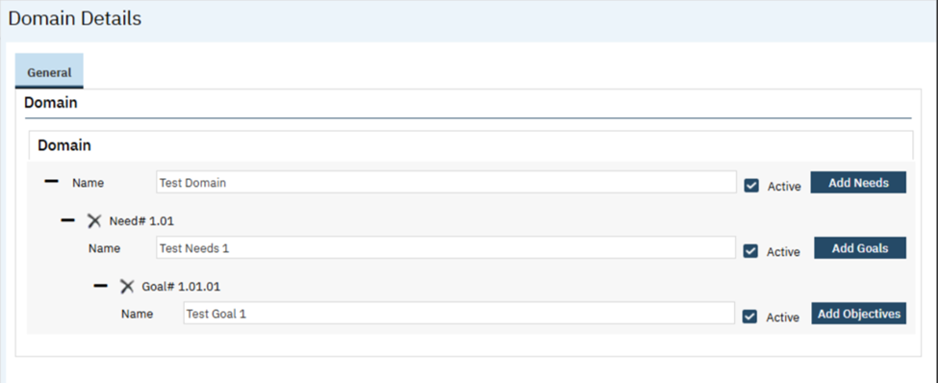
‘Objectives’ Template:
Name: This is a Textbox filed. This field allows the user to enter alphanumeric characters (Varchar (250 characters)).
Active: This is a Checkbox. The user will be allowed to uncheck the Active checkbox.
- If the user clicks delete icon of Objectives, the system will delete the Goal.
Example: If the user deletes current Goal, replace current numbering by previous one
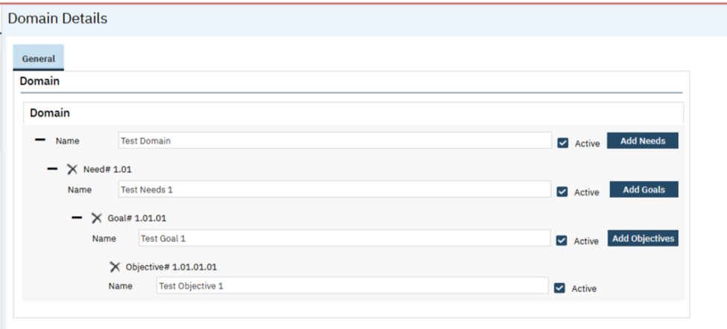
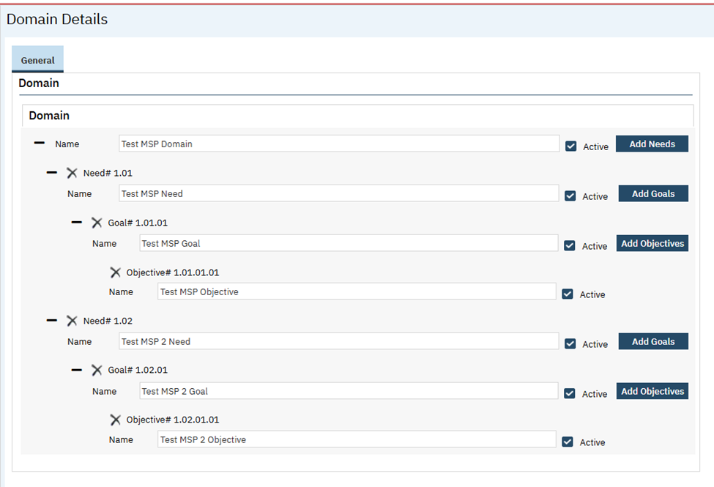
Data Model Changes:
- A new column ‘Active’ included in ‘CarePlanDomains’ table.
- New columns ‘Active’ and ‘NeedNumber’ included in ‘CarePlanDomainNeeds’ table.
- New columns ‘Active’ and ‘GoalNumber’ included in ‘CarePlanDomainGoals’ table.
- New column ‘Active’ and ‘ObjectiveNumber’ included in ‘CarePlanDomainObjectives’ table.

Dynamic Forms (DFA)

Reference No | Task No | Description
66 | Core Bugs # 130947 | The ‘Multiline’ textbox in the DFA Document is cleared upon Saving.
67 | Core Bugs # 131037 | ‘Prospective Review SUD’ Document :"Summary" fields issue.
68 | Core Bugs # 131174 | Getting an error message while creating list page forms.

Author: Sunil Belagali

66. Core Bugs # 130947: The ‘Multiline’ textbox in the DFA Document is cleared upon Saving.
Release Type: Fix | Priority: High
Navigation Path: Login to ‘SmartCare’ application – ‘Client’ search – Open any DFA Document that has ‘Multiline’ Textbox– Enter the details - ‘Save’.
Functionality ‘Before’ and ‘After’ release:

Before this release, here was the behavior. When a user entered data in the ‘Multiline’ Textbox of any ‘DFA Document’ and clicked on ‘Save’, the data entered was not retained in the ‘Multiline’ textbox.

With this release, the above-mentioned issue has been resolved. Now, when a user enters data in the ‘Multiline’ Textbox of any ‘DFA Document’ and clicks on ‘Save’, the entered data will be retained in the ‘Multiline’ textbox.

Author: Rakesh Naganagouda

67. Core Bugs # 131037: ‘Prospective Review SUD’ Document :"Summary" fields issue.
Release Type: Fix | Priority: High

Prerequisite: Set the configuration key ‘SHOWASAMSUMMARY’ as ‘Yes’.

Navigation Path 1: Login to SmartCare application -- Administration -- Configuration Key -- Set configuration key ‘SHOWASAMSUMMARY’ to Yes.

Navigation Path 2: Login to SmartCare application -- Client -- ‘Prospective Review SUD’ Document Screen -- Navigate to the tabs.
Functionality ‘Before’ and ‘After’ release:

Before this release, here was the behavior. Even though the user had set the configuration key ‘SHOWASAMSUMMARY’ to ‘No’, the Summary fields were shown in the “Dimension 5”, "Dimension 6" and the "Final Determination" tab of the "Prospective Review SUD" Document.

With this release, above mentioned issue has been fixed. Now, in the "Prospective Review SUD" Document summary fields are shown only when the value ‘Yes’ is set for the ‘SHOWASAMSUMMARY’ configuration key.

Author: Kiran Tigarimath

68. Core Bugs # 131174: Getting an error message while creating list page forms.
Release Type: Fix | Priority: On Fire
Navigation Path: 'Administration' - 'Forms' - 'New' - 'DFA Editor' Screen – ‘Form Items’ section.
Functionality ‘Before’ and ‘After’ release:

Before this release, here was the behavior. In the 'Form Items' section of the 'DFA Editor' screen, when the user tried to insert the records without filling the 'Item Column Name' and 'Add Custom Column' fields for creating list page forms, the below-mentioned red error message was getting displayed.
Error Message: "Item Column Name Or Add Custom Column is required for the selected Item Type"
With this release, the above-mentioned issue is resolved. Now, the user can create list page forms without filling the 'Item Column Name' and 'Add Custom Column' fields, on the 'DFA Editor' screen.

E MAR

Reference No | Task No | Description
69 | Core Bugs # 131097 | Group MAR screen.

Author: Madhu Basavaraju

69. Core Bugs # 131097: Group MAR screen.
Release Type: Fix | Priority: Medium
Pre-requisite: Client Orders must be signed.
Navigation Path: My Office’ -- ‘Group MAR’.
Functionality ‘Before’ and ‘After’ release:
Before this release, here was the behavior. In the Group MAR screen, the Client’s Name column and the Medication/Order Row were not inline, making the screen unusable and when user scrolled down the column and row begin to shift to the point where it was not readable. This was creating a patient safety risk.
With this Release, above mentioned issue has been resolved. Now, in the Group MAR screen, the Client’s Name column and the Medication/Order Row are displaying inline.

Electronic Remittance

Reference No | Task No | Description
70 | Core Bugs # 131124 | The payment and adjustment for each service are wrongly posted for services with the same ‘Claim Line Item Id’.

Author: Sahana Gururaj

70. Core Bugs # 131124: The payment and adjustment for each service are wrongly posted for services with the same ‘Claim Line Item Id’.
Release Type: Fix | Priority: Medium

Prerequisites: Processed 835 file grouped by the same “Claim Line Item Id”.
Navigation Path: ‘My Office’ – ‘Payments/Adjustments’ -- Click on ‘Electronic Remittance’ Icon –‘Electronic Remittance’ popup -- click on the required ‘Import File ID’ hyperlink – Select 835 file grouped by same ‘Claim Line Item Id’ -- 'Electronic Remittance File Details’ pop-up -- click on 'Process File' button -- click on 'Save' button and click on 'Close' button.
Functionality ‘Before’ and ‘After’ release:
Before this release, here was the behavior. When an 835 file was processed for the charges which were grouped by the same “Claim Line Item Id”, the payment and adjustment for each service were wrongly posted and were not divided as expected for each service.
With this release, the above-mentioned issue has been resolved. Now, the system will divide and post the payments/adjustments amount for each service’s that are in the same Claim Line items.
Example: There are 3 services grouped by the same claim line item Ids.
Payment from 835 file is $180, with an adjustment of $120. When an 835 file is processed, the system will divide the payment of $180 equally to all 3 services ($60 each). And the adjustment of $120 will also be split equally for each service, which is $40.

Glossary of System Configuration Keys, Global Codes, Recodes, Data Model Changes.

System Configuration Keys
8. 'EnableMobileTFA'
29. DisplayCDAGSectionInStaffDetails
29. EnableClinicalDataAccessGrouping
30. 'DisplayCDAGSectionInStaffDetails'

30. ‘EnableClinicalDataAccessGrouping’

30. 'ClientAccessRuleDaysAfterProgramDischarge'

53. EnableClinicalDataAccessGrouping

53. 'DisplayCDAGSectionInStaffDetails'

59. ‘SetInitializationOfCarePlanVarybyProgram’

62. ShowOrganizationNameOnMainPDFReport
62. ShowCustomerLogoOnPDF
67. ‘SHOWASAMSUMMARY’

Global Codes
16. CLAIMFORMATTYPE
32. 'CrisisAssCompleted'
32. 'CrisisCoordiSteps'

33. RELATIONSHIP
33. CRISISSTATUS

33. SEX
33. LIVINGARRANGEMENT
33. ALIASTYPE

33. CRISISEVENTTYPE
33. CRISISURGENCYLEVEL
33. CRISISFOLLOWUPTYPE
34. CRISISEVENTTYPE
34. CRISISURGENCYLEVEL
34. CRISISSTATUS
49. CSSF5ALERTNESS
49. CSSF5ORIENTEDTO
49. CSSF5MOOD
49. CSSF5AFFECT
49. CSSF5CONTINUITY
49. CSSF5CONTENT
49. CSSF5ABSTRACTION
49. CSSF5SPEECH
49. CSSF5MEMORY
49. CSSF5REALITYTEST
50. CSSF4ORIENTEDTO
50. CSSF4MOOD
50. CSSF4AFFECT
50. CSSF4CONTINUITY
50. CSSF4SPEECH

Recodes
59. CAREPLANPROGRAMTYPE
60. AdministratorNotified

Data Model Changes

4. A new Column 'NotificationInboundStatus’ is added to the ‘Appointments’ table.
32. Added ‘DocumentCrisisNotes’, ‘DocumentCrisisCompletedAssessments’, and ‘DocumentCrisisCoordinationSteps’ tables.
33. Added new table CrisisCallLog, CrisisFollowUps, CrisisEventTypes

46. The new Columns ‘CarePlanMedication’,’CarePlanCost’ and ‘CarePlanDisclaimer’ are added in existing table ‘DocumentCodes’.

47. New column ‘DocumentCodeCarePlanDomainMapping’ is added in the ‘DocumentCodes’ table and new table ‘DocumentCodeCarePlanDomains’ is created.

49. Added new tables - DocumentCAMSSuicideStatusForm5, DocumentCAMSSSF5InitialSessions, DocumentCAMSSSF5InitialSessionReasons, DocumentCAMSSSF5InitialSessionTreatmentPlans, DocumentCAMSSSF5InitialSessionStabilizationPlans, DocumentCAMSSSF5InterimSessions, DocumentCAMSSSF5FinalSessions, DocumentCAMSSuicideStatusForm5DiagnosisICD10Codes

50. Added new tables - DocumentCAMSSSF4Speeches, DocumentCAMSSSF4Orientations, DocumentCAMSSSF4ThoughtContinuities, DocumentCAMSSSF4Moods, DocumentCAMSSSF4Affects
Added ‘FrequencyPerDay’, ‘FrequencyPerWeek’, ‘FrequencyPerMonth’, ‘DurationInSeconds’, ‘DurationInMinutes’, ‘DurationInHours’ columns to ‘DocumentCAMSSSF4InitialSessions’ table

51. Columns ‘ProcedureCodeId’ and ‘ProcedureRateId’ are included in ‘CarePlanPrescribedServices’ table.

54. New column ‘ReleaseLegalAuthority’ included in ‘DocumentReleaseOfInformations’ table.

65. New column ‘Active’ included in ‘CarePlanDomains’ table, New columns ‘Active’ and ‘NeedNumber’ included in ‘CarePlanDomainNeeds’ table, New columns ‘Active’ and ‘GoalNumber’ included in ‘CarePlanDomainGoals’ table, New column ‘Active’ and ‘ObjectiveNumber’ included in ‘CarePlanDomainObjectives’ table.

