RELEASE NOTES:
Monthly Service Pack – SC.CORE.6.0_1.31.000.2502.010 (Feb MSP Part 2)
Green highlights indicates that the change was deployed in a prior HF, and is already available in PROD
Blue highlights indicates that the change needs to be tested by CalMHSA because it is related to one of your ZD tickets
Yellow highlights were added by Streamline when the release notes were created. They indicate a new change made to the system.
Strikethrough indicates a change that CalMHSA should not test as it is not a part of your subscription set.

Executive Summary:
- The Changes are added to the ‘Mental Status Exam’ tab of the Psychiatric Note to enhance usability and flexibility to the Psychiatric Note MSE tab. (EII #130059)
- The changes are implemented to improve the visibility of the ‘Appointments For Today’ and ‘Services for Today with Past Scheduled’ widgets by displaying the full text of the Client Name/Description when widgets are enlarged. (EII #130232)
- Previously, the DFA Multi-tab Document control did not support Service Notes. The change is done to make the control to be compatible with Service Notes. (EII #124048)
- The user will transferring the medication from one bottle to another, so they do not run out of medication. There is only ever one transfer per bottle. With this change the users will not do more than one 'Transfer in' in a day for the same bottle. (EII #127712)
- Implemented a ‘FQHC Programs’ dropdown option in the Filter section for all UDS reports for better filtering of the records. (EII #129595)
- A Flag Details Pop-up window is added for ‘Action’ dropdown in the ‘Patient List/Reminders’ List Page to check whether the user can perform creating flag and removing flag with validation messages in ‘Patient List/Reminders’ List Page. (EII #129885)
- The bottle transfer (user connection, connected med hyperlinks, etc.) option is available on the MAT Management Details dispensing screen. This will enable the MAT customers will be able to accurately track their MAT Medication Inventory. (EII #129962)
- Sometimes while changing the bottle in the middle of a pour, the air will be detected in the lines. To clear this air bubble, the data changes are added for the pump calibration reporting in MAT screen. (EII #130268)
- The changes are implemented in ‘Global Code Details’ screen and a new ‘External Code Mapping List’ and 'External Code Mapping UI Details' screens are implemented. With this change, the user can be able to map data for ExternalMappings table using User interface through ‘Global Code Details’ screen, ‘External Code Mapping List’, and 'External Code Mapping UI Details' screen. (EII #124052)
- The changes are done in the ‘Payments/Adjustments’ Details screen and implemented a new “Deposit Report” report, to introduce a Deposit Date as part of payment records in SmartCare. (EII #129866 & EII #130047)
- A new Detail Page and a List Page are created in order to set up the Telehealth Statement. When the Service Note/Group Service belonging to Telehealth is signed, the Telehealth Statement set up in the new Detail page to be reflected in the PDF before the Signature section. The Group Note states that how many clients participated in a Service. This update will make sure that our records align with the Telemedicine regulations. (EII #129550 and EII # 129552)
*** DISCLAIMER: The document is only available to those customers who have purchased an annual subscription. It is a premium add-on to SmartCare and not included in SmartCare Base Subscription. If you are interested in learning more about this document, please contact your account manager.
Abbreviation: EII - Engineering Improvement Initiatives

Contents

TASKS SUMMARY – ‘NEW FUNCTIONLIATY’ RELATED (4) 6
TASKS SUMMARY – ‘CHANGE' RELATED (21) 6
TASKS SUMMARY – ‘DEFECT FIXES’ (50) 7
Functionality-wise Task Details: 9
Dynamic Forms (DFA) 9
76. Core Bugs # 130774: Multi-Column DFA Form Sections Not Working in Custom Fields/Preview Tab. 9
77. Core Bugs # 130795: FormHTML No Longer Fills When Loading PDF or Navigating Tab to Tab in Documents. 10
78. Core Bugs # 130571: DFA formatting issue 10
E MAR 11
79. Core Bugs # 130747: Client MAR: PRN medications were greyed out. 11
Electronic Remittance 11
80. Core Bugs # 130839: 835 posting adjustment error 11
Global Codes 13
81. Core Bugs # 130819: Unable to Modify and Delete the ‘High Blood Pressure’ and ‘Diabetes’ code names for ‘AXHealthIssues’ Category Code. 13
82. Core Bugs # 130260: 'MEMBERCOPAY ' global code id missing for globalcode category ClientFeeType 13
Goal Plan 14
83. EII # 127593 (Feature - 368391): Added a checkbox to Goal Plan activities to prevent a client order getting created. 14
84. EII # 128340 (Feature - 399466): Implemented logic to discontinue the client order based on Recode setup. 15
Grievances 16
85. Core Bugs # 130621: Unable to rename the field names on the Grievance Details screen using HotKeys. 17
Group Service Note 17
86. EII # 129550 (Feature - 355953): Changes are applied to display ‘Telehealth Statement’ in the ‘Service Note’ & ‘Group Note PDFs. 17
Inquiry Details 20
87. Core Bugs # 130808: Client Search pop up: ‘SSN’ field allowing to enter alpha character Q. 20
Release Type: Fix | Priority: High 20
Lab Results Review 20
88. Core Bugs #130562: SSP_SCMostRecentLabWidget – Optimization 20
Manage Global Codes 21
89. EII # 124052 (Feature - 207106): Changes are implemented in ‘Global Code Details’ screen and a new ‘External Code Mapping List’ and 'External Code Mapping UI Details' screens. 21
Manage Reception Views 32
90. Core Bugs # 130691: Reception Views (Administration) stuck at processing when modifying view list. 32
91. Core Bugs # 130900: The client's Arrival data is still displayed on the 'Arrival' list page when the client is denied/restricted. 33
Manage Screens 33
92. EII # 128836 (Feature - 464177): Added two new fields and renamed existing fields in the ‘Stored Procedure’ section of ‘General’ tab of Screen Details. 33
Manage Staff 34
93. Core Bugs # 130531: Getting an error while clicking on ‘Save’ after editing the ‘Fax’ field. 34
Messages 35
94. Core Bugs # 130054: Duplicate unsaved changes are created when clicking the Forward button in the Messages screen. 35
Messages Interface 35
95. Core Bugs: 130850: The Order Information is not displayed in the ‘Message Interface Detail’ screen. 35
Methadone 36
96. EII # 129977 (Feature - 489587): New changes are implemented to the ‘MAT Configuration’ and ‘Medication Inventory Transaction’ Screens. 36
97. EII # 130268 (Feature - 502900): MAT: implemented Clear bubble functionality. 44
98. EII # 130367 (Feature - 514175): Changes are added to the ‘MAT Dispensing by Bottle’ report. 48
99. EII # 130283 (Feature - 503880): MAT: Command ‘m4’ to will be sent to API machine to attempt to clear the air bubbles. 50
100. EII # 127712 (Feature - 373961): Changes are implemented to the ‘MAT Bottle Transaction (mg) Report’. 51
101. EII # 129962 (Feature - 489564): Changes are implemented to the MAT Management Details Screen. 57
102. Core Bugs # 130702: MAT Management Details screen: After ‘Bypass’ hold in the MAT management details screen, the red message was displayed on the screen. 64
103. Core Bugs # 130845: The system is continuously processed when dispensing the Medication by checking ‘Commence Pre-Pour’ Checkbox. 65
My Reports 66
104. EII # 130047 (Feature - 383926): Implemented a new “Deposit Report” report. 66
NOMS 69
105. Core Bugs # 130780: Getting an error when selecting the Diagnosis Code F31.9 in the National Outcome Measures (NOMs) document. 69
106. Core Bugs # 130903: Unable to open NOMs Reporting List Page. 70
Order Entry 70
107. Core Bugs # 130838: Getting error when saving the ‘MAT Configuration’ screen. 71
Orders 71
108. EII # 128803 (Feature - 456827): Orders: Implemented a functionality to convert an 'Adhoc Order' to a 'Regular Order' and revert it, with Permission functionality. 71
109. Core Bugs # 130687: Lab Results Widget Showing Dates out of Order. 75
Patient Lists/Reminders 76
110. EII # 129885 (Feature - 487401): Added a Flag Details Pop-up window for ‘Action’ dropdown in the ‘Patient List/Reminders’ List Page. 76
111. EII # 129869 (Feature - 468430): Added Filters and Updated Action Dropdown in Patient List/Reminders List Page. 78
112. Core Bugs # 130857: Client Lists/Reminders does not export when the user clicks on the ‘Seen/Not Seen in 'x' days’ radio button by using ‘Apply Filter’. 82
Payments/Adjustments 83
113. EII # 129866 (Feature- 483345): Changes in the ‘Payments/Adjustments’ Details screen. 83
114. Core Bugs # 130832: Payment/Adjustments - Unable to click "Yes" on confirmation message. 86
Plans 86
115. EII # 128497 (feature - 430466): Plan Details: Front End: To Add options to either send the most recent PCN or the one from first billed claim. 86
116. Core Bugs # 130932: Value Code Records Getting Updated When Saving Plans. 87
Procedure/Rates 88
117. Core Bugs # 130731: Performance issue observed in 'Ready to Bill' step in the Nightly Billing job 88
Provider Contracts 88
118. Core Bugs # 130724: Provider Summary shows expired contract expiration. 88
Reception 89
119. EII # 129999 (Feature - 489848): Added Mode of Delivery on Front Desk/Reception Screen 89
120. Core Bugs # 130848: Reception: Column Configurations won't sort properly. 91
Reports 91
121. EII # 129595 (Feature – 475600): Implemented a ‘FQHC Programs’ dropdown option in the Filter section for all UDS reports. 91
122. Core Bugs # 130548: Productivity Details Report: column data not displaying correctly 92
123. Core Bugs # 130639: ‘UDS Table 6B Details -Section E’ Report Showing Duplicate rows for some patients. 93
RWQM 93
124. Core Bugs # 130630: RWQM Work Queue: RWQM Action Popup Is Blank. 93
Rx Application 94
125. Core Bugs # 130678: Edge Case Bug - Medication Management and the 'Administrator' Checkbox 94
126. Core Bugs # 130728: When a user clicks on the ‘Insert’ button on the Add Medication Page, the ‘End Date’ value was not acceptable and the appropriate validation message is not displayed. 95
127. Core Bugs # 130807: Rx: Prescription preview screen does not load the data 95
Screens 96
128. EII # 127493 (Feature - 364129): Implemented Configurable option at screen level for setting up delete confirmation message. 96
Services 97
129. Core Bugs # 130085: A red error was getting displayed in the Service Detail screen. 97
130. Core Bugs # 130618: Mode of Delivery is not updated in the Services. 97
131. Core Bugs # 130674: Bed services are created for the same day admit and discharge by considering the Client Inpatient Visit Admit Date. 98
132. Core Bugs # 130689: Unable to search for service Id’s that are larger than 9 digits. 101
133. Core Bugs # 130790: Getting error when 'Create Bed Services' job is executed. 101
Services/Notes 102
134. EII # 124048 (Feature - 452162): Ability to Create Multi tab DFA for Service Notes 102
135. EII # 129552 (Feature - 473562): Implemented a new ‘Details’ and ‘List’ Screen in order to set up the ‘Telehealth Statement’. 104
136. EII # 130059 (Feature - 490549): Changes are added to the ‘Mental Status Exam’ tab of the Psychiatric Note. 115
137. Core Bugs # 130682: Service/Notes – The Encounter form was missing from the signed PDF document. 118
138. Core Bugs # 130568: A red error was displayed on clicking the Note tab in the Psychiatric Note. 119
139. Core Bugs # 130608: Current Life Events were not shown on the ‘Individual Service Note’. 119
140. Core Bugs # 130666: Support Service Note Error message. 120
141. Core Bugs # 130769: Client Signature details are not getting copied to the New Service when the document is moved to the newly copied Service. 121
142. Core Bugs # 130846: Service Notes are not completed or signed off. The radio buttons are changed to checkboxes. 121
143. Core Bugs # 130756: Tab Order Issue in "SA Initial Treatment Plan" Screen. 122
SmartCare Improvements 123
144. EII # 127164 (Feature - 351279): Changes on the SmartCare Cryptography key Library. 123
SmartView 123
145. Core Bugs # 130778: The ‘Client Medications’ are displayed in duplicates under the ‘SmartView’ window, and the count does not match the ‘Medication’ List page. 123
Summary of Care Document 124
146. Core Bugs # 130802: The system is not generating ‘CCDA XML with Clinical Note information’ which is attached to the ‘USCDI document’. 124
Telehealth 125
147. Core Bugs # 130707: A new blank browser window appears when clicking Save. 125
148. Core Bugs # 130713: The ‘Telehealth Meeting Details’ for the other clients in the group are deleted when any one of the client services within the ‘Group Service’ was marked as 'Cancel'. 126
149. Core Bugs # 130865: Meeting Details are not removed from the Outlook Calendar when deleting the Telehealth Meeting details for service with Microsoft Teams Provider. 126
Widgets 127
150. EII # 130232 (Feature - 499179): Changes are implemented to improve the visibility of the ‘Appointments For Today’ and ‘Services for Today with Past Scheduled’ widgets by displaying the full text of the Client Name/Description when widgets are enlarged. 127
Glossary of System Configuration Keys, Global Codes, Recodes, Data Model Changes. 129
System Configuration Keys 129
Global Codes 129
Recodes 129
Data Model Changes 129

TASKS SUMMARY – ‘NEW FUNCTIONLIATY’ RELATED (4)
Sl. No | Task No | Summary | Module Name
89 | EII # 124052 | Changes are implemented in ‘Global Code Details’ screen and a new ‘External Code Mapping List’ and 'External Code Mapping UI Details' screens | Manage Global Codes
104 | EII # 130047 | Implemented a new “Deposit Report” report | My Reports
121 | EII # 129595 | Implemented a ‘FQHC Programs’ dropdown option in the Filter section for all UDS reports | Reports
135 | EII # 129552 | Implemented a new ‘Details’ and ‘List’ Screen in order to set up the ‘Telehealth Statement’ | Services/Notes

TASKS SUMMARY – ‘CHANGE' RELATED (21)

Sl. No | Task No | Summary | Module Name
83 | EII # 127593 | Added a checkbox to Goal Plan activities to prevent a client order getting created | Goal Plan
84 | EII # 128340 | Implemented logic to discontinue the client order based on Recode setup | Goal Plan
86 | EII # 129550 | Changes are applied to display ‘Telehealth Statement’ in the ‘Service Note’ & ‘Group Note PDFs | Group Service Note
92 | EII # 128836 | Added two new fields and renamed existing fields in the ‘Stored Procedure’ section of ‘General’ tab of Screen Details | Manage Screens
96 | EII # 129977 | New changes are implemented to the ‘MAT Configuration’ and ‘Medication Inventory Transaction’ Screens | Methadone
97 | EII # 130268 | MAT: implemented Clear bubble functionality | Methadone
98 | EII # 130367 | Changes are added to the ‘MAT Dispensing by Bottle’ report | Methadone
99 | EII # 130283 | MAT: Command ‘m4’ to will be sent to API machine to attempt to clear the air bubbles | Methadone
100 | EII # 127712 | Changes are implemented to the ‘MAT Bottle Transaction (mg) Report’ | Methadone
101 | EII # 129962 | Changes are implemented to the MAT Management Details Screen | Methadone
108 | EII # 128803 | Orders: Implemented a functionality to convert an 'Adhoc Order' to a 'Regular Order' and revert it, with Permission functionality | Orders
110 | EII # 129885 | Added a Flag Details Pop-up window for ‘Action’ dropdown in the ‘Patient List/Reminders’ List Page | Patient Lists/Reminders
111 | EII # 129869 | Added Filters and Updated Action Dropdown in Patient List/Reminders List Page | Patient Lists/Reminders
113 | EII # 129866 | Changes in the ‘Payments/Adjustments’ Details screen | Payments/Adjustments
115 | EII # 128497 | Plan Details: Front End: To Add options to either send the most recent PCN or the one from first billed claim | Plans
119 | EII # 129999 | Added Mode of Delivery on Front Desk/Reception Screen | Reception
128 | EII # 127493 | Implemented Configurable option at screen level for setting up delete confirmation message | Screens
134 | EII # 124048 | Ability to Create Multi tab DFA for Service Notes | Services/Notes
136 | EII # 130059 | Changes are added to the ‘Mental Status Exam’ tab of the Psychiatric Note | Services/Notes
144 | EII # 127164 | Changes on the SmartCare Cryptography key Library | SmartCare Improvements
150 | EII # 130232 | Changes are implemented to improve the visibility of the ‘Appointments For Today’ and ‘Services for Today with Past Scheduled’ widgets by displaying the full text of the Client Name/Description when widgets are enlarged | Widgets

TASKS SUMMARY – ‘DEFECT FIXES’ (50)
Sl. No | Task No | Summary | Module Name
76 | Core Bugs # 130774 | Multi-Column DFA Form Sections Not Working in Custom Fields/Preview Tab | Dynamic Forms (DFA)
77 | Core Bugs # 130795 | FormHTML No Longer Fills When Loading PDF or Navigating Tab to Tab In Documents | Dynamic Forms (DFA)
78 | Core Bugs # 130571 | DFA formatting issue | Dynamic Forms (DFA)
79 | Core Bugs #130747 | Client MAR: PRN medications were grayed out | E MAR
80 | Core Bugs#130839 | 835 posting adjustment error | Electronic Remittance
81 | Core Bugs # 130819 | Unable to Modify and Delete the ‘High Blood Pressure’ and ‘Diabetes’ code names for ‘AXHealthIssues’ Category Code | Global Codes
82 | Core Bugs # 130260 | 'MEMBERCOPAY ' global code id missing for globalcode category ClientFeeType | Global Codes
85 | Core Bugs # 130621 | Unable to rename the field names on the Grievance Details screen using HotKeys | Grievances
87 | Core Bugs # 130808 | Client Search pop up: ‘SSN’ field allowing to enter alpha character Q | Inquiry Details
88 | Core Bugs # 130562 | SSP_SCMostRecentLabWidget - Optimization | Lab Results Review
90 | Core Bugs # 130691 | Reception Views (Administration) stuck at processing when modifying view list | Manage Reception Views
91 | Core Bugs # 130900 | The client's Arrival data is still displayed on the 'Arrival' list page when the client is denied/restricted | Manage Reception Views
93 | Core Bugs # 130531 | Getting an error while clicking on ‘Save’ after editing the ‘Fax’ field | Manage Staff
94 | Core Bugs # 130054 | Duplicate unsaved changes are created when clicking the Forward button in the Messages screen | Messages
95 | Core Bugs # 130850 | The Order Information is not displayed in the ‘Message Interface Detail’ screen | Messages Interface
102 | Core Bugs # 130702 | MAT Management Details screen: After ‘Bypass’ hold in the MAT management details screen the red message was displayed on the screen | Methadone
103 | Core Bugs # 130845 | The system is continuously processed when dispensing the Medication by checking ‘Commence Pre-Pour’ Checkbox | Methadone
105 | Core Bugs # 130780 | Getting an error when selecting the Diagnosis Code F31.9 in the National Outcome Measures (NOMs) document | NOMS
106 | Core Bugs # 130903 | Unable to open Noms Reporting List Page | NOMS Reporting
107 | Core Bugs # 130838 | Getting error when saving the ‘MAT Configuration’ screen | Order Entry
109 | Core Bugs # 130687 | Lab Results Widget Showing Dates out of Order | Orders
112 | Core Bugs # 130857 | Client Lists/Reminders does not export when the user clicks on the ‘Seen/Not Seen in 'x' days’ radio button by using ‘Apply Filter’ | Patient Lists/Reminders
114 | Core Bugs # 130832 | Payment/Adjustments - Unable to click "Yes" on confirmation message | Payments/Adjustments
116 | Core Bugs # 130932 | Value Code Records Getting Updated When Saving Plans | Plans
117 | Core Bugs # 130731 | Performance issue observed in 'Ready to Bill' step in the Nightly Billing job | Procedure/Rates
118 | Core Bugs # 130724 | Provider Summary shows expired contract expiration | Provider Contracts
120 | Core Bugs # 130848 | Reception: Column Configurations won't sort properly | Reception
122 | Core Bugs # 130548 | Productivity De tails Report: column data not displaying correctly | Reports
123 | Core Bugs # 130639 | UDS Table 6B Details -Section E’ Report Showing Duplicate rows for some patients | Reports
124 | Core Bugs # 130630 | RWQM Work Queue: RWQM Action Popup Is Blank | RWQM
125 | Core Bugs # 130678 | Edge Case Bug - Medication Management and the 'Administrator' Checkbox | Rx Application
126 | Core Bugs # 130728 | When a user clicks on the ‘Insert’ button on the Add Medication Page, the ‘End Date’ value was not acceptable and the appropriate validation message is not displayed | Rx Application
127 | Core Bugs # 130807 | Rx: Prescription preview screen does not load the data | Rx Application
129 | Core Bugs #130085 | A red error was getting displayed in the Service Detail screen | Services
130 | Core Bugs # 130618 | Mode of Delivery is not updated in the Services | Services
131 | Core Bugs # 130674 | Bed services are created for the same day admit and discharge by considering the Client Inpatient Visit Admit Date | Services
132 | Core Bugs # 130689 | Unable to search for service Id’s that are larger than 9 digits | Services
133 | Core Bugs # 130790 | Getting error when 'Create Bed Services' job is executed | Services
137 | Core Bugs # 130682 | Service/Notes – The Encounter form was missing from the signed PDF document | Services/Notes
138 | Core Bugs # 130568 | A red error was displayed on clicking the Note tab in the Psychiatric Note | Services/Notes
139 | Core Bugs # 130608 | Current Life Events were not shown on the ‘Individual Service Note’ | Services/Notes
140 | Core Bugs # 130666 | Support Service Note Error message | Services/Notes
141 | Core Bugs # 130769 | Client Signature details are not getting copied to the New Service when the document is moved to the newly copied Service | Services/Notes
142 | Core Bugs # 130846 | Service Notes are not completed or signed off. The radio buttons are changed to checkboxes | Services/Notes
143 | Core Bugs # 130756 | Tab Order Issue in "SA Initial Treatment Plan" Screen | Services/Notes
145 | Core Bugs # 130778 | The ‘Client Medications’ are displayed in duplicates under the ‘SmartView’ window, and the count does not match the ‘Medication’ List page | SmartView
146 | Core Bugs # 130802 | The system is not generating ‘CCDA XML with Clinical Note information’ which is attached to the ‘USCDI document’ | Summary of Care Document
147 | Core Bugs # 130707 | A new blank browser window appears when clicking Save | Telehealth
148 | Core Bugs # 130713 | The ‘Telehealth Meeting Details’ for the other clients in the group are deleted when any one of the client services within the ‘Group Service’ was marked as 'Cancel’ | Telehealth
149 | Core Bugs # 130865 | Meeting Details are not removed from the Outlook Calendar when deleting the Telehealth Meeting details for service with Microsoft Teams Provider | Telehealth

Functionality-wise Task Details:

Dynamic Forms (DFA)

Reference No | Task No | Description
76 | Core Bugs # 130774 | Multi-Column DFA Form Sections Not Working in Custom Fields/Preview Tab.
77 | Core Bugs # 130795 | FormHTML No Longer Fills When Loading PDF or Navigating Tab to Tab In Documents.
78 | Core Bugs # 130571 | DFA formatting issue.

Author: Rakesh Naganagoda

76. Core Bugs # 130774: Multi-Column DFA Form Sections Not Working in Custom Fields/Preview Tab.

Release Type: Fix | Priority: Medium

Navigation Path 1: Login to SmartCare application – Administration – ‘Forms’ Screen – Select any forms – DFA Editor screen and Preview tab.

Navigation Path 2: Login to SmartCare application – Client – Open the document from go search which is selected in ‘Forms’ screen.
Functionality ‘Before’ and ‘After’ release:

Before this release, here was the behavior. In the custom fields/Preview tab, when the user creates a DFA form, which had a multi column layout, instead it was displayed as single column layout.

Screen shot for Before Release:
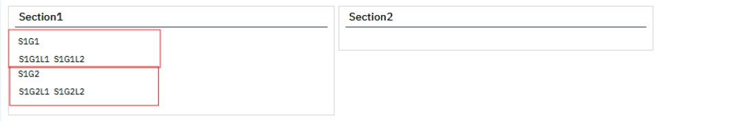
With this release, the above-mentioned issue is resolved. Now, in the Custom fields/Preview tab, the user is able to view DFA form in multi column layout.

Screen shot for After Release:
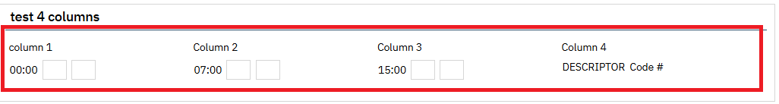

Author: Kiran Tigarimath

77. Core Bugs # 130795: FormHTML No Longer Fills When Loading PDF or Navigating Tab to Tab in Documents.

Release Type: Fix | Priority: Medium

Navigation Path: 'Client' - 'Documents'.

Functionality ‘Before’ and ‘After’ release:

Before this release, here was the behavior. When a user tried to load signed PDF or navigating tab to tab in documents, FormHTML records were not logged in 'Forms' table.

With this release, the above-mentioned issue has been resolved. Now, the FormHTML records are logging in 'Forms' table when a user loads a signed PDF or navigating tab to tab in documents.

Author: Sunil Belagali

78. Core Bugs # 130571: DFA formatting issue
Release Type: Fix | Priority: On Fire

Navigation Path: Administration – DFA Editor – ‘DFA Editor’ screen – ‘DFA Entries’ tab – Enter all the required details – Click on Save – Click on ‘Preview’ tab.

Functionality ‘Before’ and ‘After’ release:

Before this release, here was the behavior. In the ‘DFA Editor’ screen, when the user tried to preview the DFA Form by clicking on the ‘Preview’ tab after saving the data, the DFA Form Layout was displayed in incorrect format.

With this release, the above-mentioned issue has been resolved. Now, the DFA Form Layout displayed in the correct format when the user previews the DFA Form by clicking on the ‘Preview’ tab in the ‘DFA Editor’ screen.

E MAR

Reference No | Task No | Description
79 | Core Bugs # 130747 | Client MAR: PRN medications were grayed out

Author: Madhu Basavaraju

79. Core Bugs # 130747: Client MAR: PRN medications were greyed out.
Release Type: Fix | Priority: Medium
Navigation Path: Go Search-Select Client-Client MAR.
Functionality ‘Before’ and ‘After’ release:
Before this release, here was the behavior. When the user attempted to administer a PRN medication at midnight, all the PRN medications were grayed out and not able to document the medication details.
With this release, the above-mentioned issue is resolved. Now, when the user attempts to administer a PRN medication at midnight, the user can document the medications given after midnight on the Client MAR screen.

Electronic Remittance

Reference No | Task No | Description
80 | Core Bugs # 130839 | 835 posting adjustment error

Author: Sahana Gururaj

80. Core Bugs # 130839: 835 posting adjustment error
Release Type: Fix | Priority: Medium

Prerequisites:

1. The Client has the collect upfront copay details added in the ‘Client Fee’ record with the ‘Self Pay’ check box selected.

2. Process an 835 file that has the Co-Pay details (Both CAS*CO*45 segment and CAS*PR*3 segment in 835 file).

Navigation Path: ‘My Office’ -- ‘Payments/Adjustments’ – Click on ‘Electronic Remittance’ Icon – click on the required ‘Import file Id’ hyperlink – 'Electronic Remittance File Details’ pop-up – click on 'Process file' button -- click on 'Save' button and click on 'Close' button – once the file is processed – go to ‘Ledger Screen’ of the required serviced - check the adjustment amounts for which 835 file is processed.

Functionality ‘Before’ and ‘After’ release:

Before this release, here was the behavior. When processing an 835 file, the adjustment amount was not posted as expected when a client had a copay. The system was posting the adjustment amount (CO*45) by misusing it with the client co pay amount (PR*3).

Example:

Client Fee = $100
From the 835 file,
Charge Amount -- $1000
Paid amount--- $600
CO-45--- $300
PR-3---$100
When the 835 file is processed, the system posts the adjustment as below:

Paid amount --- $600
CO-45---Only $200 was posted instead of $300
PR*3 -- $100 (client Co-Pay)

With this release, the above-reported issue has been fixed, and now the system will post the adjustment amount as expected from the 835 file, when a client has a copay details.

Example:

Client Fee = $100
Charge Amount -- $1000
From the 835 file
Paid amount--- $600
CO-45--- $300
PR-3---$100
When the 835 file is processed, the system will post the amount as expected per the 835 file.

Paid--- $600
CO-45 -- $300
PR *3 -- $100 (client Co-Pay)

Global Codes

Reference No | Task No | Description
81 | Core Bugs # 130819 | Unable to Modify and Delete the ‘High Blood Pressure’ and ‘Diabetes’ code names for ‘AXHealthIssues’ Category Code.
82 | Core Bugs # 130260 | 'MEMBERCOPAY ' global code id missing for globalcode category ClientFeeType.

Author: Annapurna Bhalke

81. Core Bugs # 130819: Unable to Modify and Delete the ‘High Blood Pressure’ and ‘Diabetes’ code names for ‘AXHealthIssues’ Category Code.

Release Type: Fix | Priority: Medium
Navigation Path 1: Administration’ -- ‘Global Codes’ -- ‘Global Codes’ list page -- Search ‘AXHealthIssues’ Category -- Click on category hyperlink for ‘High Blood Pressure’ Code name -- ‘Global Code Details’ screen.
Navigation Path 2: Administration’ -- ‘Global Codes’ -- ‘Global Codes’ list page -- Search ‘AXHealthIssues’ Category -- Click on category hyperlink for ‘Diabetes’ Code name -- ‘Global Code Details’ screen.
Functionality ‘Before’ and ‘After’ release:
Before this release, here was the behavior. In the ‘Global Code Details’ screen, the user was unable to Modify and Delete the ‘High Blood Pressure’ and ‘Diabetes’ code names for ‘AXHealthIssues’ Category Code.
With this release, the above-mentioned issue has been resolved. Now, the user can Modify and Delete the ‘High Blood Pressure’ and ‘Diabetes’ Code names for the ‘AXHealthIssues’ category code in the ‘Global Code Details’ screen.

Author: Renuka Gunasekaran

82. Core Bugs # 130260: 'MEMBERCOPAY ' global code id missing for globalcode category ClientFeeType

Release Type: Fix | Priority: High
Navigation Path: 'Administration' - 'Global Codes' - 'ClientFeeType' Category.
Functionality ‘Before’ and ‘After’ release:
Before this release, here was the behavior. 'MEMBERCOPAY' global code id was missing under the category ClientFeeType.
With this release, the above-mentioned issue has been resolved. Now, MEMBERCOPAY (GlobalCodeID: 9450) is added under the category ClientFeeType.

Goal Plan

Reference No | Task No | Description
83 | EII # 127593 | Added a checkbox to Goal Plan activities to prevent a client order getting created
84 | EII # 128340 | Implemented logic to discontinue the client order based on Recode setup
Author: Girish Jayanna

83. EII # 127593 (Feature - 368391): Added a checkbox to Goal Plan activities to prevent a client order getting created.

Release Type: Change | Priority: Urgent

Navigation Path1: Client Search – ‘Goal Plan’.

Navigation Path2: Client Search – ‘Client Order’.

Functionality ‘Before’ and ‘After’ release:

Purpose: Added checkbox to Goal Plan activities to prevent a client order getting created and the subsequently appearing on the Activity Tracker screens.

With this release, a checkbox called ‘Do Not Display on Activity Tracker’ is implemented in the Activity Section of the Goal Plan.

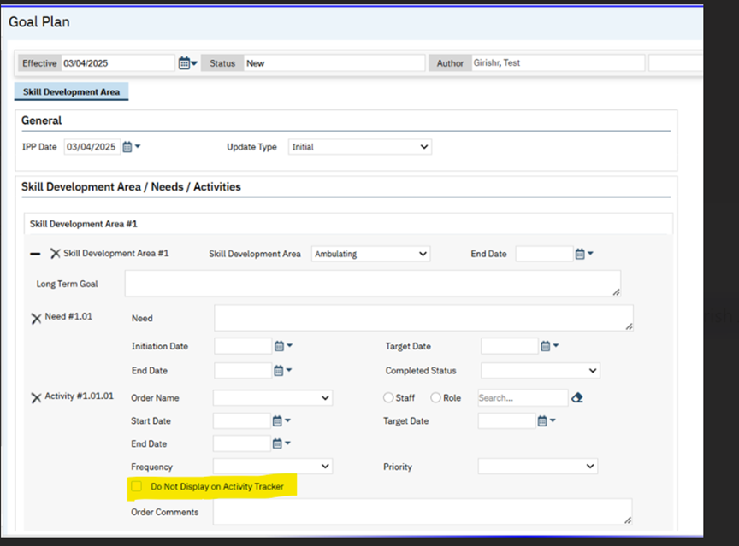

1.If the checkbox is selected, client order for the associated Activity will not get generated.

2.By default, checkbox will be not selected.

3.The checkbox will only be editable for newly added activities and will be disabled on sign of the Goal Plan for both selected and non-selected check marks.

4.The data in the Goal Plan will be initialized from the last signed client Goal Plan.

Author: Girish Jayanna

84. EII # 128340 (Feature - 399466): Implemented logic to discontinue the client order based on Recode setup.

Release Type: Change | Priority: Urgent

Navigation Path 1: Client Search – ‘Goal Plan’ -- Enter the details -- sign the Goal Plan with any Activity 'Review Status' by Recode Setup.

Navigation Path 2: Client Search – ‘Client Order’.

Functionality ‘Before’ and ‘After’ release:
Purpose: When a goal plan reviewer status was ‘discontinued’, the Client Order was getting discontinued. Now, the customers want client order to get discontinued for other review status which is mapped to the Recode Setup.
With this release, a logic is implemented to discontinue the client order when the Goal Plan document is signed with any Activity 'Review Status', which is mapped to the Recode Setup done.

A new Recode called ‘SetDiscontinuedForClientOrder’ is added to determine which Review Status of 'Goal Plan' will update the Order Status to be Discontinued in the respective Client Order.

Please see the screen shots below for more details:
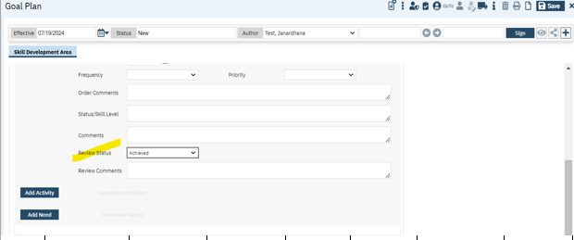
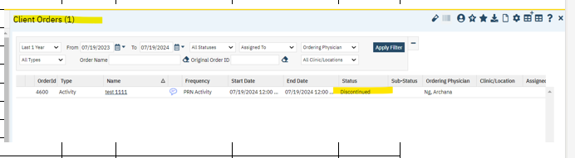
By default, the Recode release script will include Code Name = 'Discontinued'.

Grievances

Reference No | Task No | Description
85 | Core Bugs # 130621 | Unable to rename the field names on the Grievance Details screen using HotKeys.

Author: Kiran Yogendra

85. Core Bugs # 130621: Unable to rename the field names on the Grievance Details screen using HotKeys.

Release Type: Fix | Priority: High
Navigation Path: ‘Client’ Search - Select a client – Go Search – ‘Grievances (My Office)’ – click on ‘New’ – ‘Grievances’ dropdown – Select the ‘value’ – Mouse hover on the label names and hit hotkey ’Cltr+Alt+l’ on the keyboard – Rename the label – Click on Save button.
Functionality ‘Before’ and ‘After’ release:
Before this release, here was the behavior. In the Grievances Details screen, the users were unable to rename and save field labels using the shortcut hotkey ‘Ctrl+Alt+l’.
With this release, the above-mentioned issue has been resolved. Now all the field names can be renamed and saved using the ‘Ctrl+Alt+l’ shortcut key in the Grievances Details screen.

Group Service Note

Reference No | Task No | Description
86 | EII # 129550 | Changes are applied to display ‘Telehealth Statement’ in the ‘Service Note’ & ‘Group Note PDFs.

Author: Navyashree Jois

86. EII # 129550 (Feature - 355953): Changes are applied to display ‘Telehealth Statement’ in the ‘Service Note’ & ‘Group Note PDFs.

Release Type: Change| Priority: Urgent

Prerequisites:
- Telehealth Statement is created using DFA Editor.
- Using the above Telehealth Statement, the ‘Procedure/Location/Mode of Delivery’ is configured under ‘Telehealth Statement Detail’ Page.

Navigation Path 1: ‘Client’ search -- Open a client – Search for ‘Services/Notes’ - Click on ‘New’ icon - select any of the ‘Procedure’ or ‘Location’ or ‘Mode Of Delivery’ associated with ‘Telehealth Statement’ –Check if ‘Telehealth Statement’ Section is displayed - Enter the required values – Go to ‘Note’ tab – Enter the required values – ‘Sign’ the Service Note.

Navigation Path 2: ‘Client’ search -- Open a client – Go to ‘Groups(My Office)’ – Click on ‘New’ icon – Enter the required fields in the ‘General’ tab – Go to ‘Schedule’ tab – Click on ‘New Group Service’ – Schedule the ‘Service’- Add the ‘Staffs & Clients’ in the ‘Service’ tab - ‘Update Service Information’ under ‘Service’ tab - Check if ‘Telehealth Statement’ Section is displayed for selected ‘Clients’ – ‘Add Diagnosis’ under ‘Billing Diagnosis’ tab – Go to ‘Note’ tab – Add the ‘Group Summary’ under ‘Group Note’ – Click on ‘Update’ my Client Note – Go to ‘Client Note’ – Enter the required fields – Click on ‘Sign’ my Notes - ‘Sign’ the Group Note.

Functionality ‘Before’ and ‘After’ release:

Purpose: The telehealth documentation standards is to ensure that patient consent is properly obtained and
documented, services are accurately recorded as telehealth encounters, and providers maintain clear, accessible records for compliance and post-payment review. These standards also ensure patients have the option for traditional visits and that providers follow protocols for situations requiring in-person care.

With this release, the following changes have been implemented for ‘Service Note’ & ‘Group Note PDFs.
1. If the ‘Service Note/Group Service’ belonging to ‘Telehealth Statement’ is signed, the ‘Telehealth Statement’ will be reflected in the ‘PDF’ before the ‘Signature’ section.

Screenshot for showing the ‘Telehealth Statement’ section based on selected.
‘Procedure/Location/Mode of Delivery’ under ‘Service’ tab of ‘Service Notes’:
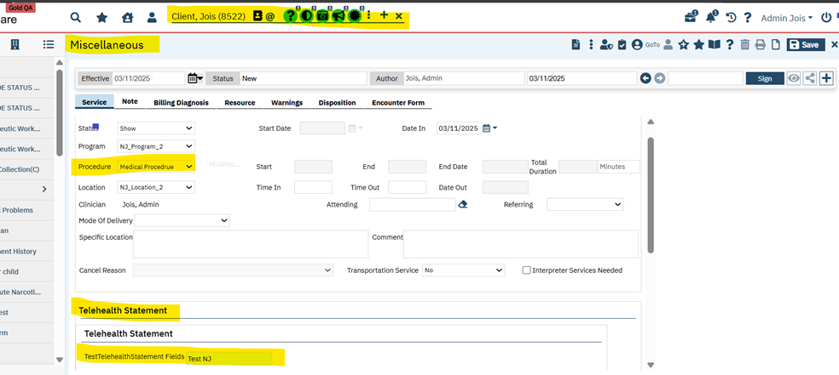
Screenshot for showing ‘Telehealth Statement’ section reflected in the ‘Signed Service Note PDF’:
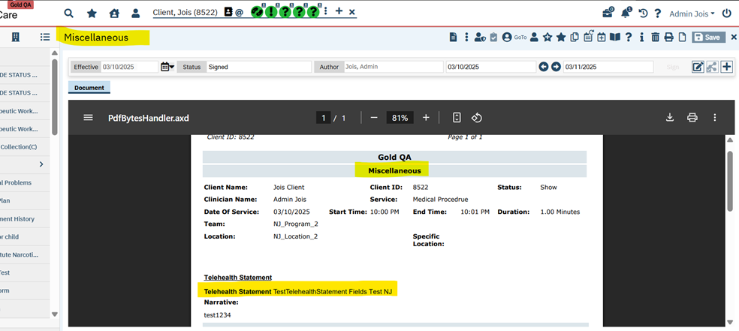

2. If the ‘Group Service’ is signed, “Total number of participants in the Group Service: <Number>” will be displayed on the ‘PDF’ below the ‘Service’ section of the ‘Client Notes’ that are marked as "Show”.

Screenshot for showing the ‘Telehealth Statement’ section based on selected.
‘Procedure/Location/Mode of Delivery’ under ‘Service Information’ tab of ‘Group Service’:

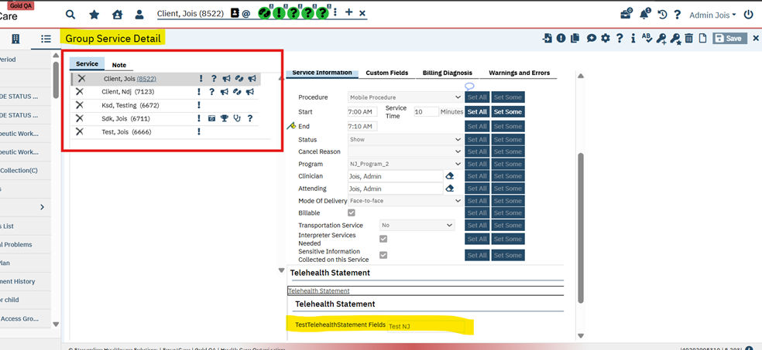

Screenshot for showing ‘Total number of participants in the Group Service’ and ‘Telehealth Statement’ section reflected on the Signed Group Service Note PDF whose Status is marked ‘Show’:

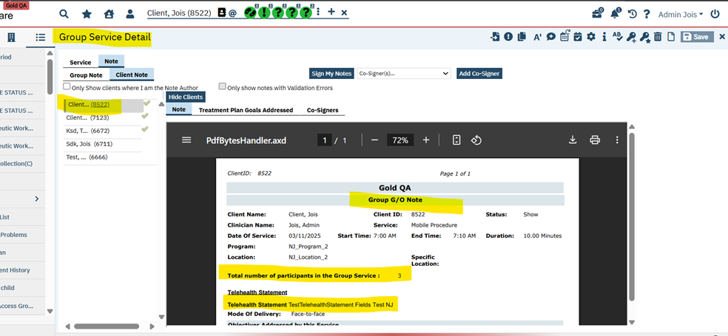

The ‘Number’ shows the number of ‘Service Notes’ that are signed for that ‘Group Service’.

Note: The PDF will reflect only the number of ‘Service Notes’ that are signed for any given time. If some Notes are signed at a later point of time, the count of these Notes will not get reflected in the ‘PDF’ of the Notes which are signed earlier.

Example: When a group service having 3 clients is scheduled, if only 2 clients shows up at 10AM and the 2 Notes are marked as "Show", the PDF of these 2 Notes will show the total participants as 2. If the 3rd client shows up at 12 AM, the PDF of this Note will show the total participants as 3. But the PDF of the 2 Notes which were signed at 10AM will still show the total participants as 2 because PDF refresh of these Notes will not happen.

Inquiry Details

Reference No | Task No | Description
87 | Core Bugs # 130808 | Client Search pop up: ‘SSN’ field allowing to enter alpha character Q.

Author: Praveen Gangadhar

87. Core Bugs # 130808: Client Search pop up: ‘SSN’ field allowing to enter alpha character Q.

Release Type: Fix | Priority: High
Navigation Path 1: Client Search pop-up – Perform three-way search (FirstName, LastName and SSN) – Now remove last number and replace with alphabet like ‘Q’ – Click on ‘Inquiry (New Client)’ – Observe the ‘SSN’ field.
Navigation Path 2: In ‘Inquiry Details’ – Fill all mandatory detail – Click on ‘Link Client’ - Perform three-way search (FirstName, LastName and SSN) – Now remove last number and replace with alphabet like ‘Q’ – Click on create client and observe new client created with an ‘SSN’ field with alpha character.
Functionality ‘Before’ and ‘After’ release:
Before this release, here was the behavior. In Client Search pop-up of ‘Inquiry Details’ screen, the users were allowed create new ‘Client’ with alpha character Q in the ‘SSN’ field.
With this release, the above-mentioned issue has been resolved. Now in Client Search pop-up of ‘Inquiry Details’ screen, the users are not allowed to enter ‘SSN’ field with alpha character Q.

Lab Results Review

Reference No | Task No | Description
88 | Core Bugs # 130562 | SSP_SCMostRecentLabWidget - Optimization

Author: Chaitali Patil

88. Core Bugs #130562: SSP_SCMostRecentLabWidget – Optimization

Release Type: Fix | Priority: Medium

Navigation Path 1: Administration -- Orders -- Click on ‘New’ – Select ‘Lab’ order type – Health Data Template - fill all required fields - Click on save.

Navigation Path 2: Perform Client search -- Go search – ‘Client Orders’ Client – Click on new -- select above (Navigation path 1) order -- fill all required field –Click on Insert – Click on ‘Save’ – Sign the order -- Navigate back to the list page -- click on Order name hyperlink – Navigate to ‘Lab Result’ tab –select ‘Result Date’ and observation and fill other required fields—click on insert -- Change the order status Which are included in the (LABWIDGETDRSTATUS) Recode category – like ‘Result Obtained’, ‘Nurse Reviewed’ – Save.

Navigation Path 3: Go Search-Dashboard- ‘Lab Result’ widget – and verified Widget is loading fine and only latest 50 records will be displayed in this widget.
Functionality ‘Before’ and ‘After’ release:
Before this release, here was the behavior. While loading the ‘Lab Result Widget’ on the dashboard, due to huge amount of data, the system was taking always 15 to 20 seconds to load.

With this release, the above-mentioned issue has been resolved. Now, ‘Lab Result Widget’ is loading fine and in this widget latest 50 records are displayed.

Manage Global Codes

Reference No | Task No | Description
89 | EII # 124052 | Changes are implemented in ‘Global Code Details’ screen and a new ‘External Code Mapping List’ and 'External Code Mapping UI Details' screens
Author: Savitha Siddaraju

89. EII # 124052 (Feature - 207106): Changes are implemented in ‘Global Code Details’ screen and a new ‘External Code Mapping List’ and 'External Code Mapping UI Details' screens.
Release Type: New Functionality | Priority: Medium
Navigation Path 1: Administrator’ -- ‘Global Codes’ -- ‘Global Codes’ list page -- click on ‘Category’ hyperlink -- ‘Global Code Details’ screen.
Navigation Path 2: Administrator’ -- 'External Code Mapping List’ -- 'External Code Mapping List’ page.
Navigation Path 3: ‘Administrator’ --'External Code Mapping List’ -- 'External Code Mapping List’ page -- Click on ‘New’ icon -- 'External Code' pop up will display -- Select Mapping Criteria as ‘Global Codes’ radio button -- Select ‘Category code’ value -- Click on ‘OK’ button -- ‘External Code Mapping UI Details' screen.
Navigation Path 4: Administrator’ -- 'External Code Mapping List’ -- 'External Code Mapping List’ page -- Click on ‘New’ icon -- 'External Code' pop up will display -- Select Mapping Criteria as ‘Table Information’ radio button -- Select ‘Table Name’ value -- Click on ‘OK’ button -- ‘External Code Mapping UI Details' screen.
Functionality ‘Before’ and ‘After’ release:
Purpose: The user can map data for ExternalMappings table, using User interface through ‘Global Code Details’ screen, ‘External Code Mapping List’, and 'External Code Mapping UI Details' screen.
With this release, the new changes have been implemented in ‘Global Code Details’ screen and ‘External Code Mapping List’ and 'External Code Mapping UI Details' screens with the required validations and initializations.
‘Global Code details’ screen: The following changes have been implemented.
- In ‘Category’ section, a ‘Has External Mappings’ checkbox has been added, and it is unchecked by default.
- In ‘Code Details’ section, a ‘Add More External Codes’ hyperlink has been added, which is disabled by default.
- This hyperlink will be enabled only when the user saves the screen by checking 'Has External Mappings' checkbox.
- On clicking ‘Add More External Codes’ hyperlink, it navigates to the 'External Code Mapping UI Details' screen.
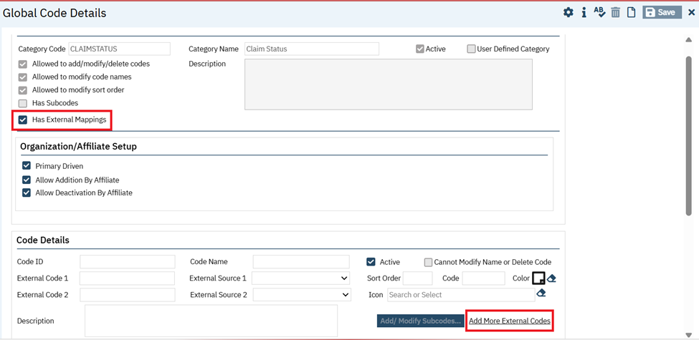
A ‘Message’ popup will be displayed with an OK button, If either ‘External Code 1’ or ‘External Code 2’ has a blank value and when the user clicks on ‘Add More External Codes’ hyperlink.
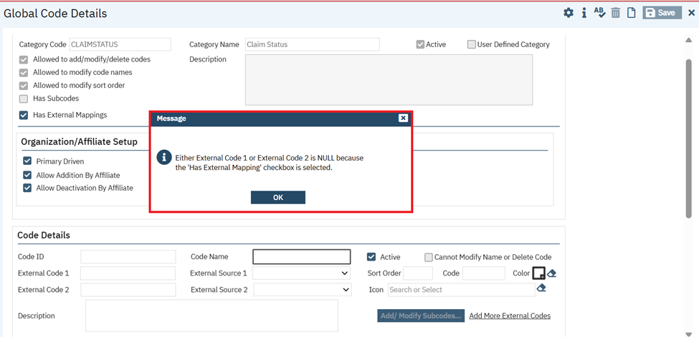
Navigating to ‘External Code Mapping UI Details’ screen from ‘External Code Mapping List’ screen:
In the ‘External Code Mapping List’ page, when clicked on ‘new’ icon, it will display 'External Codes' pop-up message which contains ‘Select Mapping Criteria’ with below mentioned two radio buttons with ‘OK’ and ‘Cancel’ buttons.
- Global Codes
- Table Information
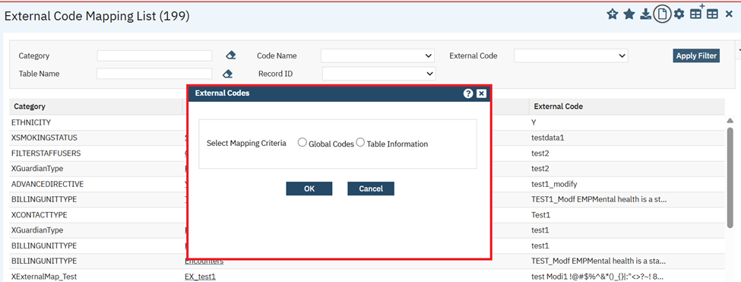
Note: In ‘External Code Mapping UI Details screen’ on click of ‘New’ icon, the same 'External Codes' pop up will be displayed.

In External Codes popup, when user did not any select mapping criteria and on click of OK button, the validation message will be displayed as “Please Select Mapping Criteria.”
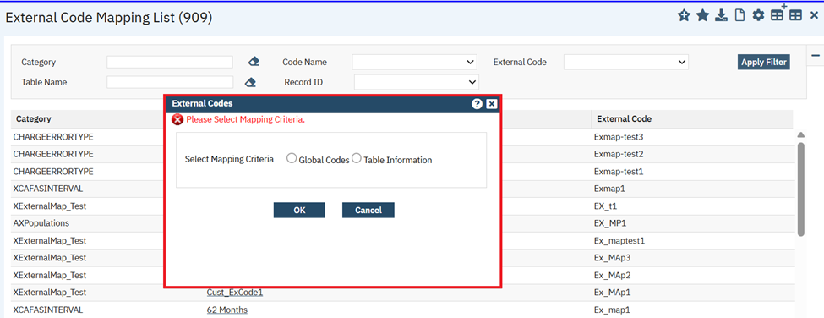
‘Global codes’ radio button selection in ‘External Codes’ popup of ‘External Code Mapping List’ page:

On selection of ‘Global codes’ radio button, the ‘Category Code’ Typeable search textbox field will be displayed, and it Pull all Category Codes available in Global Code Screen. This field will be hidden by default.
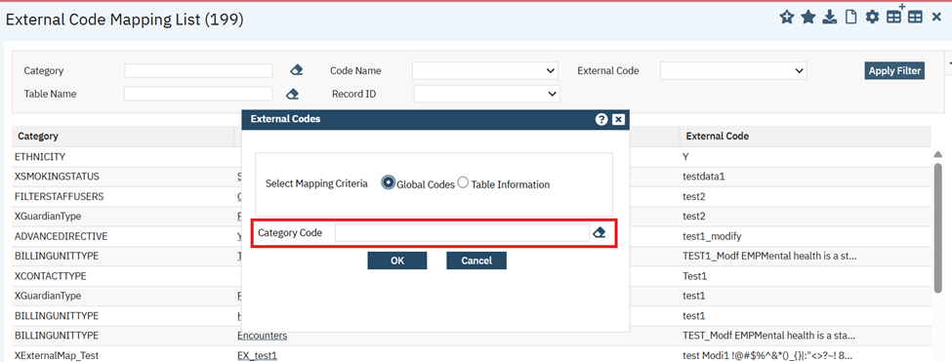

When user clicks on ‘Ok’ button, without selecting ‘Category Code’ then the validation message will be displayed as ‘Please Select Category Code.’

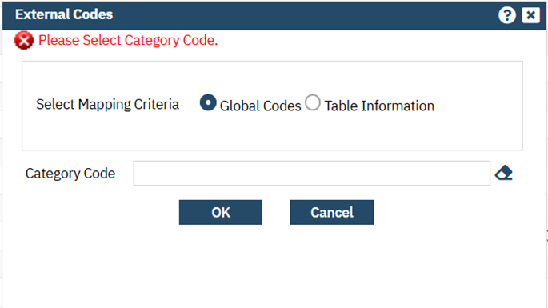

Once ‘Category code’ is selected and the user clicks on ‘OK’ button in ‘External code’ popup, it navigates to ‘External Code Mapping UI Details’ screen.
‘External Code Mapping UI Details’ screen: This screen contains a ‘General’ tab with below mentioned sections:
  - Global Codes
  - External Codes
  - External Codes List
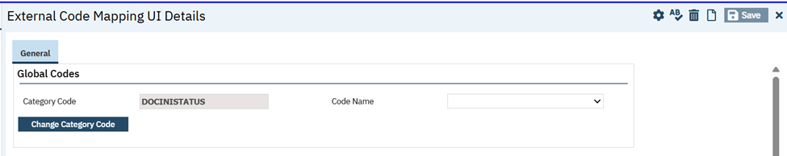

‘Global codes’ section: This section has the following fields.

- Category Code: This is Typeable search textbox which is disabled, and value will be initialized only when category code value is selected from 'External Codes' Pop up.
- Code Name: This is dropdown field which pulls all the Code Names of associated Category Code. IF Code Name is not selected and on click of ‘Insert’ button then the validation message will be displayed as “Please select Code Name “
- Change Category Code: This is a button. On click of this button a new pop up 'External Code' will be displayed.
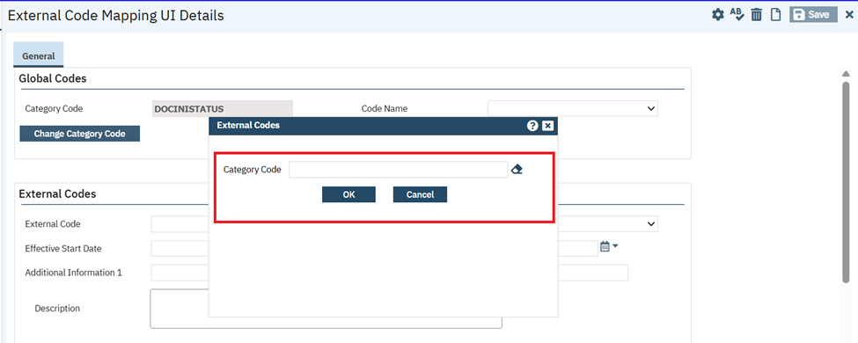

A new 'External Codes' popup which contains fields and buttons mentioned below.
- Category Code: This is a Typeable search textbox field, which Pulls all active Global Code Category.
- OK and Cancel button:
- Once user select ‘Category Code’ and on click of OK button, popup will be closed and selected ‘Category Code’ value will be displayed in ‘Category Code’ field of ‘Global Codes’ section.
- On click of CANCEL button, the 'External Code' popup will be closed.
- In ‘External Codes’ popup, when user did not select any Category Code on click of OK button, the validation message will be displayed as “Please Select Category Code.”

When the user clicks on ‘Change Category Code’ button without saving the 'External Code Mapping UI Details' screen, then the confirmation message popup will be displayed as 'Are you sure change without Save?' with ‘Ok’ and ‘Cancel’ button.
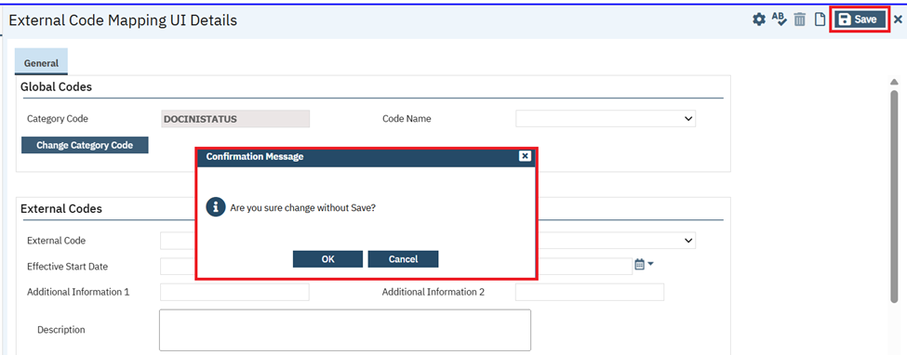

‘External Codes’ section: This section has the following fields.

- External Code: This is Text Box field, and it is required when ‘Record Code’ field is blank.
- Record Code: This is a dropdown field. It Pulls all Code Names of associated Category Code and it is required when ‘External Code’ field is blank.
- It will initialize the same value selected in the ‘Code Name’ dropdown field in ‘Global Codes’ section.
- On Insert or Modify button, Record Code’ and ‘Code Name’ will be same. If ‘Record Code’ and ‘Code Name’ values do not match, then the validation message will be displayed as ‘Record Code and Code Name not matching’.

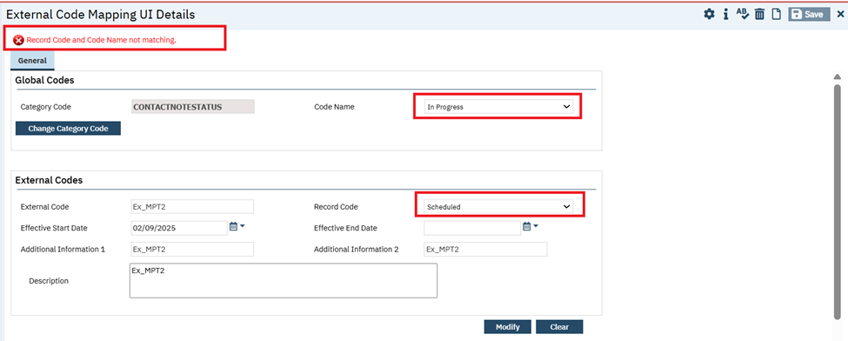
- When ‘External Code’ and ‘Record Code’ field are blank, and on click of insert button then the validation message will be displayed as “Please enter ExternalCode or select Record Code.”

- Effective Start Date: This is Date control textbox field.
- If Date is not selected and on click of insert button then the validation message will be displayed as “Please enter Effective Start Date.”
- Effective End Date: This is Date control textbox field.
- Additional Information 1: This is textbox field.
- Additional Information 2: This is textbox field.
- Description: This is text area field.

The below mentioned buttons will be displayed under ‘External Codes’ section.

- Insert button: This will allow user to insert the new records into ‘External Codes List’ grid. Category Code, Code Name, External Code, Record Code, Effective Start Date are required fields to insert.
- Modify button: On selection of record user will be allowed to modify all fields except the 'Category Code' field.
- Clear button: On click of the ‘Clear’ button, it will erase all the field values except the 'Category Code' field.

‘External Codes List’ grid section:

- Inserted records will be displayed in this grid.
- This grid contains these columns ‘External Code’, ‘Record Code’, ‘Effective Start/End Date’, ‘Additional Information 1’, ‘Additional Information 2’, ’Description.’
- The user is allowed to edit and modify the values for the selected record from grid.
- The user is allowed to delete the record in the grid.
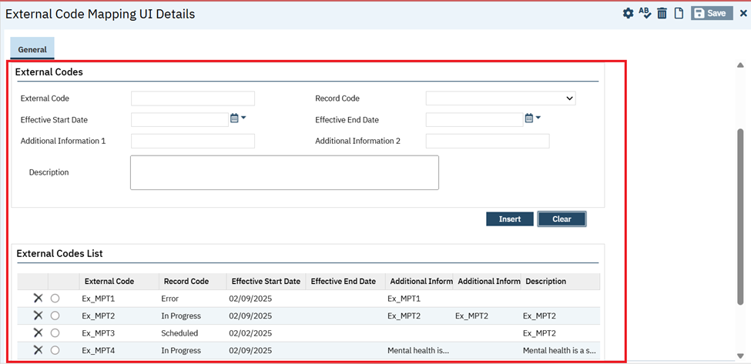

‘Table information’ radio button selection in ‘External Codes’ popup of ‘External Code Mapping List’: On click of new icon ‘External Codes’ popup will be displayed.

On selection of ‘Table Information’ radio button, the ‘Table Name’ Typeable search textbox field will be displayed, and it will pull all the active ‘Table names’ within SmartCare. This field will be hidden by default.
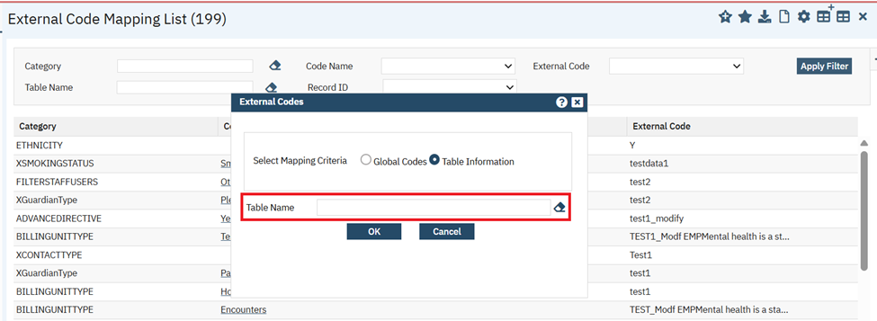

When user clicks on ‘Ok’ button without selecting ‘Table Name’ value, then the validation message will be displayed as ‘Please Select Table Name.’
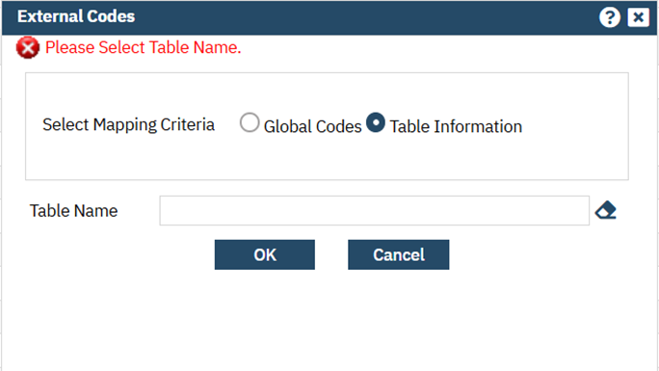
Once ‘Table Name’ is selected and clicks on ‘OK’ button in the ‘External codes’ popup, it navigates to ‘External Code Mapping UI Details’ screen.
‘External Code Mapping UI Details’ screen: This screen has the following sections.

- Table Information
- External Codes
- External Codes List
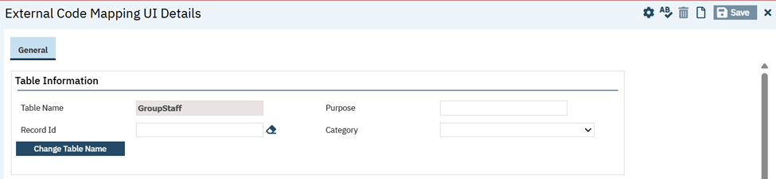
‘Table Information’ section: This section has the following fields.

- Table Name: This is Typeable search textbox field which is disabled and values will be initialized only when ‘Table Name’ value is selected from 'External Codes' Pop up.
- Purpose: This is the Text Box field.
- Record Id: This is a Typeable search textbox field, which Pulls all Record Id based on ‘Table Name’ value.
- IF Record Id’ is not selected and on click of insert button then the validation message will be displayed as “Please enter Record Id.”

- Category: This is Dropdown field, which Pulls values from table ‘ExternalMappings’ => Category values.
- IF ‘Record Id’ is not selected and on click of insert button then the validation message will be displayed as “Please select Category “.

- Change Table Name: This is a button, on click of this button a new pop up 'External Codes' will be displayed.
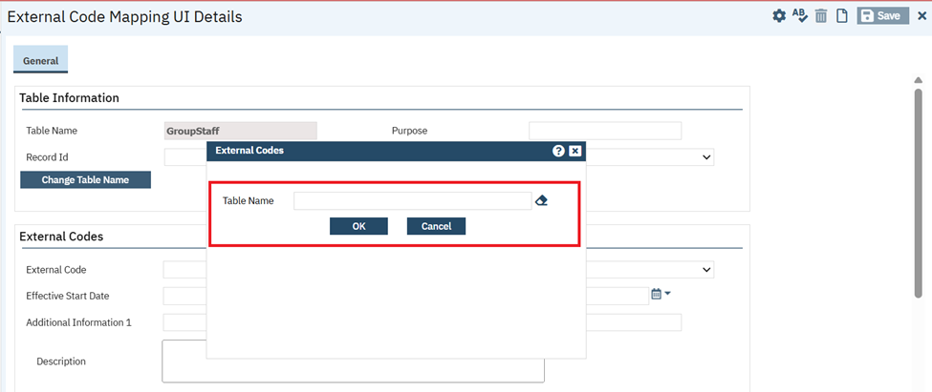
A new 'External Code' popup has the following fields.
- Table Name: This is Typeable search textbox field, which Pull all the active Table names within SmartCare.
- ‘OK’ and ‘Cancel’ button:
- When user selects ‘Table Name’ and on click of ‘OK’ button, popup will be closed and selected ‘Table Name’ will be displayed in ‘Table Name’ field of ‘Table Information’ section
- On click of CANCEL button, the 'External Code' popup will be closed.
- In ‘External Codes’ popup, when user did not select ‘Table Name’ and clicked on OK button, the validation message will be displayed as “Please Select Table Name.”

When user clicks on ‘Change Table Name’ button without saving the 'External Code Mapping UI Details' screen, then confirmation message popup will be displayed as 'Are you sure change without Save?' with ‘Ok’ and ‘Cancel’ button.
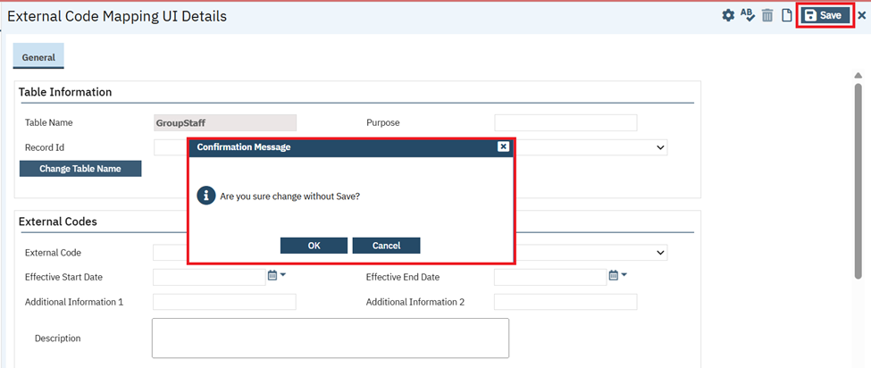
‘External Codes’ section: This section has the following fields.

- External Codes: This is Text Box field, and it is required when ‘Record Code’ field is blank.
- Record Code: This is a dropdown field. It Pulls all Categories and it is required when ‘External Code’ field is blank.
- It will initialize the same value selected in the ‘Category’ dropdown field of the ‘Table information’ section.
- When ‘External Code’ and ‘Record Code’ field are blank, and on click of ‘Insert’ button then the validation message will be displayed as “Please enter ExternalCode or select Record Code.”

- Effective Start Date: This is Date control textbox field.
- If Date is not selected and on click of Insert button then the validation message will be displayed as “Please enter Effective Start Date.”

- Effective End Date: This is Date control textbox field.
- Additional Information 1: This is textbox field.
- Additional Information 2: This is the textbox field.
- Description: This is the text area field.

The below mentioned buttons will be displayed under ‘External Codes’ section.

- ‘Insert’ button: This will allow user to insert the new records into ‘External Codes List’ grid.
- Table Name, Record Id, Category, External Code, Record Code, Effective Start Date are required fields to insert.
- ‘Modify’ button: on selection of record allowed user to modify all fields except the 'Table Name' field.
- ‘Clear’ button: On click of the ‘Clear’ button, it will erase all the field values except the 'Table Name' field.

‘External Codes List’ grid:
- Inserted records will be displayed in this grid.
- This grid contains these columns ‘External Code’, ‘Record Code’, ‘Effective Start/End Date’, ‘Additional Information 1’, ‘Additional Information 2’, ’Description.’
- The user is allowed to edit and modify the values for the selected record from grid.
- The user is allowed to delete the record in the grid.
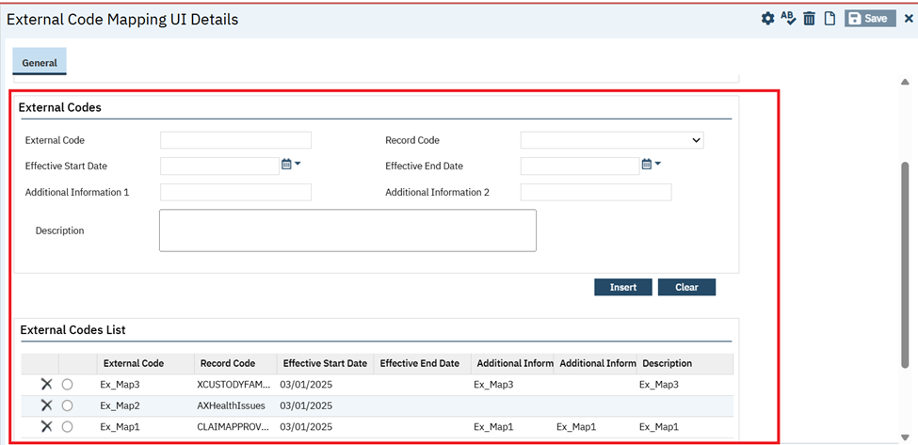
‘External Code Mapping List’ page:
The below-mentioned filters and columns will be displayed on this list page.
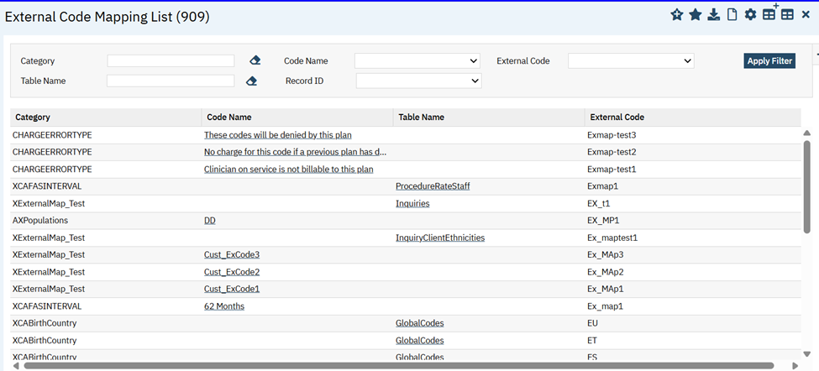
- Category: This is a Typeable search textbox filter, which Pulls Categories of Global Codes. This filter will be Disable when Table Name filter value is selected.

- Code Name: This is a dropdown filter, which Pulls Code names-based selection of Global Code Category. This filter will be Disable when Table Name filter value is selected

- Table Name: This is a Typeable search textbox filter, pulls all the active Table names within SmartCare. This filter will be Disable when Category filter value is selected.

- Record ID: This is a dropdown filter which Pulls Record ID values
- If a Category is selected, the associated Record ID for that category will be pulled from the ‘ExternalMappings’ table.
- If a Table Name is selected, the associated Record ID for that table will be pulled from the ‘ExternalMappings’ table.

- External Code: This is a dropdown filter which pulls External Codes based selection of Code Name.
Grid section: This section has the following columns.
- ‘Category’ column: It will display Global Code ‘Category’ selected from Filter.
- ‘Code Name’ column: It will display the Code Names of selected Category Code with hyperlink and on click of hyperlink will be navigated to ‘External Code Mapping UI Details’ screen.
- ‘Table Name’ column: It will display the Table Names of selected Category Code with hyperlink and on click of hyperlink will be navigated to ‘External Code Mapping UI Details’ screen.
- ‘External Code’ column: It will display the External Codes of selected Code Name

Data Model Changes:

- New ‘GlobalCodeId’ and ‘MappingType’ columns included in ‘ExternalMappings’ table.
- New ‘IsExternalMappings’ column included in ‘GlobalCodeCategories’ table.

Manage Reception Views

Reference No | Task No | Description
90 | Core Bugs # 130691 | Reception Views (Administration) stuck at processing when modifying view list.
91 | Core Bugs # 130900 | The client's Arrival data is still displayed on the 'Arrival' list page when the client is denied/restricted.
Author: Niroop Hassan

90. Core Bugs # 130691: Reception Views (Administration) stuck at processing when modifying view list.

Release Type: Fix | Priority: Medium

Navigation Path: Go Search – Reception Views – select a view and modify required data and click on 'Modify' button.

Functionality ‘Before’ and ‘After’ release:
Before this release, here was the behavior. In the Reception Views screen, when the user selected a record in Reception View List section and does any modification and clicked on Modify button, continuous processing icon was displayed.

With this release, the above mentioned has been resolved. Now, User is able to modify the selected Reception View List without any performance issues.

Author: Niroop Hasssan

91. Core Bugs # 130900: The client's Arrival data is still displayed on the 'Arrival' list page when the client is denied/restricted.
Release Type: Fix | Priority: High
Navigation Path: ‘My Office’ – ‘Arrivals’ - ‘Arrivals’ list page – Click on ‘New’ icon – Select the required client and required data and click on ‘Save’ icon.
Navigation Path 2: Go Search -- ‘Staff/Users’ - ‘Staff/Users’ list page – Click on required staff name hyperlink – ‘Staff Details’ page – Click on ‘Client Access Overrides’ tab – Click on ‘Add To List’ button in ‘Denied Clients’ section and select the above selected client and click on ‘Select’ button.
Functionality ‘Before’ and ‘After’ release:
Before this release, here was the behavior. Even though the client is denied or restricted, the client's Arrival data was still displayed on the 'Arrival' list page.
With this release, the above-mentioned issue has been resolved. Now the denied client's Arrival data is no longer displayed on the 'Arrival' list page.

Manage Screens

Reference No | Task No | Description
92 | EII # 128836 | Added two new fields and renamed existing fields in the ‘Stored Procedure’ section of ‘General’ tab of Screen Details

Author: Veena Santosh

92. EII # 128836 (Feature - 464177): Added two new fields and renamed existing fields in the ‘Stored Procedure’ section of ‘General’ tab of Screen Details.

Release Type: Change | Priority: Urgent

Navigation Path: Go Search — Screens (Administration) – click on hyperlink under ‘Screen Name’ – Screens Details – Stored Procedure section – Enter the data and ‘Save’ – data is saved.

Functionality ‘Before’ and ‘After’ release:

Purpose: When a user deletes something from any screen (this is applicable to any screen where delete functionality exists), need to provide Validation/Warning that they are about to delete and call out dependencies they should take into consideration before confirming deletion. If it’s a validation, the user cannot proceed with the deletion. If it’s a warning, the user requires to confirm whether they want to delete.

With this release, in the ‘Stored Procedure’ section of the Screen Details page, the below mentioned changes are made.

Below mentioned fields labels are renamed.

1) “Validation Update” to “Validation On Save”.
2) “Warning Update” to “Warning On Save” .
3) “Validation Complete” to “Validation On Sign”.
4) “Warning Complete” to “Warning On Sign”.
5) “Post Update” to “Post Update On Sign”.

Two New Fields are added in ‘Stored Procedure’ section. For “Create Copy” icon, these 2 fields are considered for creating copy.
1) Validation On Delete— Text Box.
2) Warning On Delete – Text Box.

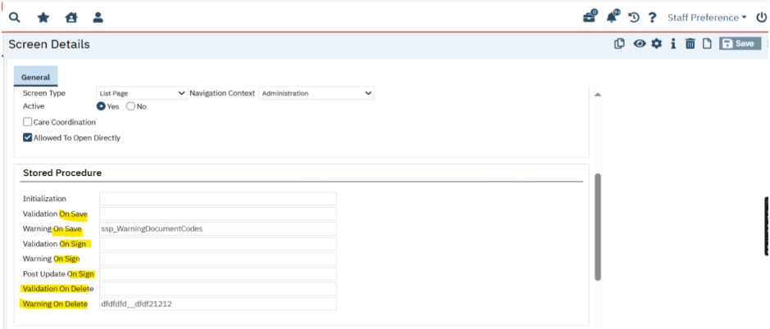

Data Model Changes:

Added New columns WarningStoredProcedureDelete, ValidationStoredProcedureDelete in Screens table.

Manage Staff

Reference No | Task No | Description
93 | Core Bugs # 130531 | Getting an error while clicking on ‘Save’ after editing the ‘Fax’ field

Author: Niroop Hassan

93. Core Bugs # 130531: Getting an error while clicking on ‘Save’ after editing the ‘Fax’ field.

Release Type: Fix | Priority: Medium

Navigation Path: ‘Administration’ – ‘Staff/Users’ - ‘Staff/Users’ list page -- Click on required staff name hyperlink -- ‘Staff Details’ page -- ‘General’ tab -- ‘Staff’ section -- Enter any special character and delete it in ‘FAX’ field -- Click on ‘Save’ icon.

Functionality ‘Before’ and ‘After’ Release:

Before this release, here was the behavior. In the ‘Staff Details’ screen, when the user deleted the special character in the ‘Fax’ field and clicked on the 'Save' icon, the following error message was displayed.

Error Message: "Please enter a valid Fax Number."

With this release, the above-mentioned issue has been resolved. Now, an error message is not displayed when the user deletes the special character in the ‘Fax’ field and clicks on the 'Save' icon in the ‘Staff Details’ screen.

Messages

Reference No | Task No | Description
94 | Core Bugs # 130054 | Duplicate unsaved changes are created when clicking the Forward button in the Messages screen

Author: Sachin Ranganathappa

94. Core Bugs # 130054: Duplicate unsaved changes are created when clicking the Forward button in the Messages screen.

Release Type: Fix | Priority: Medium

Navigation Path: ‘My Office’ -- ‘Messages’ – ‘Messages’ screen -- Create Messages -- close the screen – navigate back to ‘Messages’ screen from unsaved changes -- ‘Select Message’ – Click on ‘Forward’ button.

Functionality ‘Before’ and ‘After’ release:

Before this release, here was the behaviour. When the user Navigated to ‘Messages’ screen from unsaved changes and clicked on ‘Forward’ button for any Message, then the duplicate unsaved changes were created.

With this release, the above-mentioned issue has been resolved. Now, the duplicate unsaved changes are not created when the user Navigates to ‘Messages’ screen from unsaved changes and clicks on ‘Forward’ button for any Message.

Messages Interface

Reference No | Task No | Description
95 | Core Bugs # 130850 | The Order Information is not displayed in the ‘Message Interface Detail’ screen.

Author: Jagadeesh Raju

95. Core Bugs: 130850: The Order Information is not displayed in the ‘Message Interface Detail’ screen.

Release Type: Fix | Priority: High

Navigation Path 1: Client -- ‘Client Orders’ – ‘Client Orders’ list page – click on new icon --‘Client Order’ screen – Enter all the required details -- Click on 'Save’ – Click on ‘Sign'
Navigation Path 2: Administration – ‘Messages Interface’ -- ‘Messages Interface’ list page –click on ID link – ‘Message Interface Detail’ screen

Functionality ‘Before’ and ‘After’ release:

Before this release, here was the behaviour. When the user tried to generate HL7 ORM outbound message by signing the Client Order, the Order Information was not displayed under ‘Order Information’ section in the ‘Message Interface Detail’ screen.

With this release, the above-mentioned issue has been resolved. Now, the Order information is displayed under ‘Order Information’ section in the ‘Message Interface Detail’ screen, when the user generates HL7 ORM outbound message by signing Client Order.

Methadone

Reference No | Task No | Description
96 | EII # 129977 | New changes are implemented to the ‘MAT Configuration’ and ‘Medication Inventory Transaction’ Screens.
97 | EII # 130268 | MAT: implemented Clear bubble functionality.
98 | EII # 130367 | Changes are added to the ‘MAT Dispensing by Bottle’ report.
99 | EII # 130283 | MAT: Command ‘m4’ to will be sent to API machine to attempt to clear the air bubbles.
100 | EII # 127712 | Changes are implemented to the ‘MAT Bottle Transaction (mg) Report’.
101 | EII # 129962 | Changes are implemented to the MAT Management Details Screen.
102 | Core Bugs # 130702 | MAT Management Details screen: After ‘Bypass’ hold in the MAT management details screen the red message was displayed on the screen
103 | Core Bugs # 130845 | The system is continuously processed when dispensing the Medication by checking ‘Commence Pre-Pour’ Checkbox
Author: Madhu Basavaraju

96. EII # 129977 (Feature - 489587): New changes are implemented to the ‘MAT Configuration’ and ‘Medication Inventory Transaction’ Screens.

Release Type: Change | Priority: Urgent
Prerequisite: Medication Inventory is created in the ‘Medication/Lot/Bottle’ screen.
Navigation Path 1: ‘Administration’ - ‘MAT Configuration’ – General Tab – ‘General’ section – Select ‘Account for Variance’ checkbox – Save.

Navigation Path 2: ‘Administration’ - ‘Global Codes’ – ‘Global Codes’ List page – Select MEDTRANSACTIONREASON value in the ‘All Categories’ dropdown field – Click on ‘Apply Filter’ - Click on ' MEDTRANSACTIONREASON ' hyperlink - ‘Global Code Details’ page.

Navigation Path 3: ‘Administration’ - ‘Recodes’ – ‘Recodes’ List page – Select ‘SetReasonsForNegativeAdjustments’ value in the ‘All Recodes Category’ field - Click on ‘Apply Filter’ - Click on ' ‘SetReasonsForNegativeAdjustments’ hyperlink - ‘Recode Detail’ page.

Navigation Path 4: My Office - Medication Inventory Transaction’ list page - Click on the ‘New’ - Medication Inventory Transaction Detail’ page – select Medication/Strength – Select Transaction Type – Reason – Enter required fields – Save.
Functionality ‘Before’ and ‘After’ release:
Purpose: 1. To allow users to enter greater Quantity than remaining Quantity in bottle for Transfer To transactions, and system will capture the excess Quantity as 'Variance' for Inventory tracking and reporting.

2. Added option to enter Actual Measured Quantity, and system to auto-calculate and determine the Variance.
With this release, In MAT module, additional functionality has been implemented in the ‘MAT Configuration’ and ‘Medication Inventory Transaction’ Screens.
- ‘MEDTRANSACTIONREASON’ Global Code: A new ‘Variance’ Code has been added.

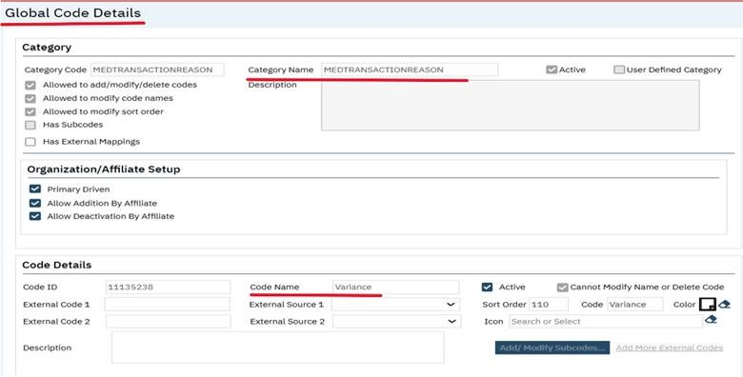
2.‘SetReasonsForNegativeAdjustments’ Recode:

a. This new Recode is used to determine which GlobalCode values to be considered negative adjustments in the Medication Inventory Transaction screen.

b. Use MEDTRANSACTIONREASON global code.
c. When user selects a Reason that is included in this Recode, the system will subtract the Quantity from the remaining balance as a negative adjustment.
d. If the user removes the "-" from the Quantity field, the system will add it back when user clicks Save.
Note: If this Recode has been end dated by specifying the From Date and To Date, it will be considered as Inactive.
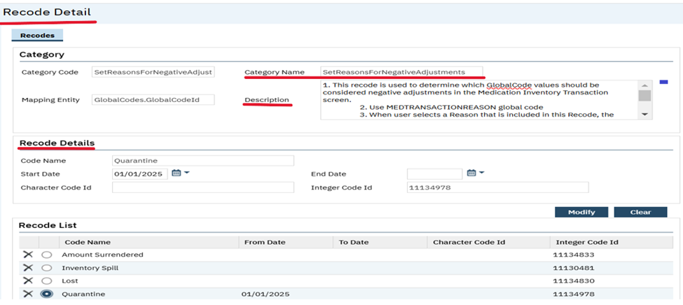

3.MAT Configuration: A new ‘Account for Variance’ checkbox with ‘Info’ icon has been added in the General section.
- When this checkbox is checked, when there is a Quantity entered that is greater value than the remaining Quantity in bottle, on click of Save for a ‘Transfer To’ transaction, the system will display the Variance Warning Popup (instead of existing hard-stop Quantity validation).
- When this checkbox is checked, then Variance will be available in the Reason dropdown for Adjustment transactions.
- When this checkbox is NOT checked, keep existing functionality with Quantity validation for Transfer To transactions and do not show Variance in Reason dropdown field for Adjustment transactions.
- ‘Information’ icon: On hover the following message will be displayed.
Transfer To transactions: The system will allow for a Quantity greater than remaining balance and will auto-create a Variance transaction to balance the bottle to zero Quantity.
Adjustment transactions: When user selects Variance, the system will auto-display the Quantity as the difference between the remaining balance and the Actual Measured Quantity.
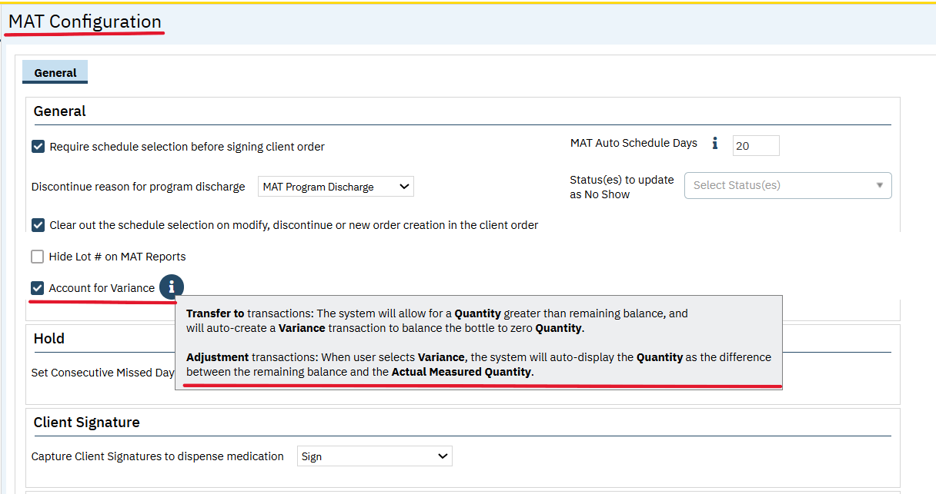
4.Medication Inventory Transaction Details:
Reason: This field has been moved to next to ‘Transaction Type’ field.
A new ‘Variance’ is added to the existing MEDTRANSACTIONTREASON global code.

a. For the Adjustment Transaction Type:
- This Reason will be displayed only when new ‘Account for Variance’ checkbox is checked in ‘MAT Configuration’ screen. Else, this will not be displayed.
- When ‘Variance’ Reason is selected, the Quantity field value will be cleared out and disable/grayed out and display the new ‘Actual Measured Quantity’ field.

b. For the ‘Transfer To’ Transaction Type:
- The system will display with new Variance global code value in the backend and auto-creates ‘Variance’ Adjustment Transactions for ‘Transfer To’ Transactions.
Note: In the Bottle Mgs Dispensed and Transferred Report, the Variance % column will take Variance Quantity divided by the Initial Quantity.
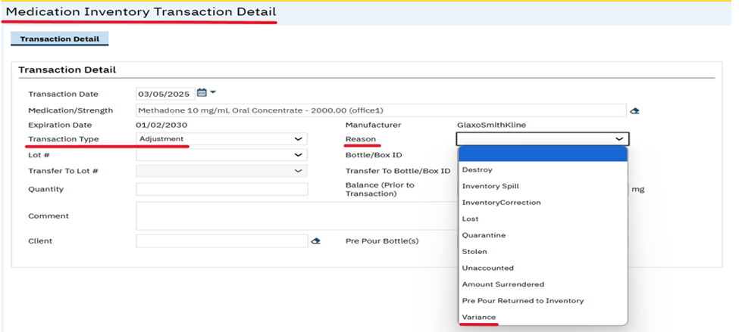

Quantity: If the selected ‘Reason’ value is included in new SetReasonsForNegativeAdjustments Recode, negative value will be displayed in the ‘Quantity’ field and will subtract from remaining balance.
- If user clears out the negative value in the Quantity field, upon click of Save, system will place the 'negative/minus' sign back in the Quantity field and will subtract that value from the remaining balance.
- For the Adjustment Transaction Type:
- When new Account for Variance checkbox is NOT checked in MAT Configuration screen, then the existing functionality is retained.
- When new ‘Account for Variance’ checkbox is checked in ‘MAT Configuration’ screen, for ‘Variance’ Reason, the Quantity field will be cleared out, disable, and gray out and Subtracts the remaining Quantity in bottle from the value entered in new ‘Actual Measured Quantity’ field and push this value to the Quantity field.

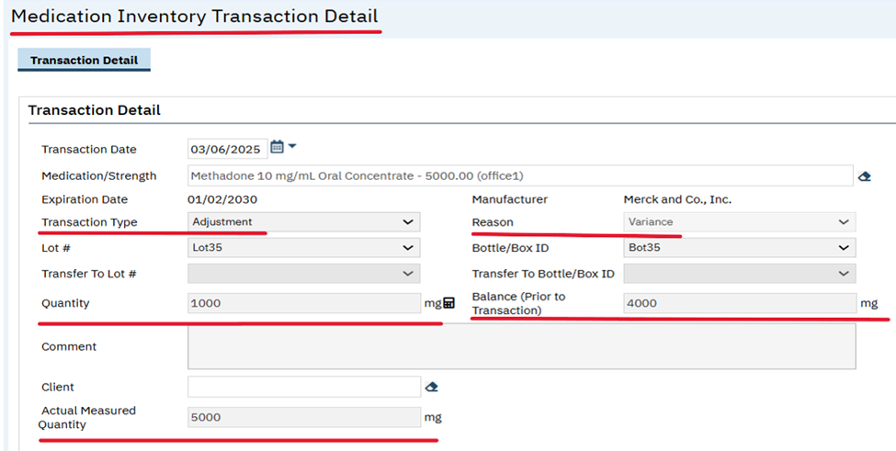

- For the ‘Transfer To’ Transaction Type:
- When new Account for Variance checkbox is NOT checked in MAT Configuration screen, then the existing functionality is retained.
- When new ‘Account for Variance’ checkbox is checked in ‘MAT Configuration’ screen,
- Quantity field will allow value that is equal to or larger value than the remaining Quantity in bottle without any validation.
- When the Quantity value is lesser than the remaining Quantity in bottle displays
Validation Message: "The Quantity entered is less than the remaining Quantity in bottle. Please adjust the Quantity for the Transfer To transaction and the system will close the bottle."

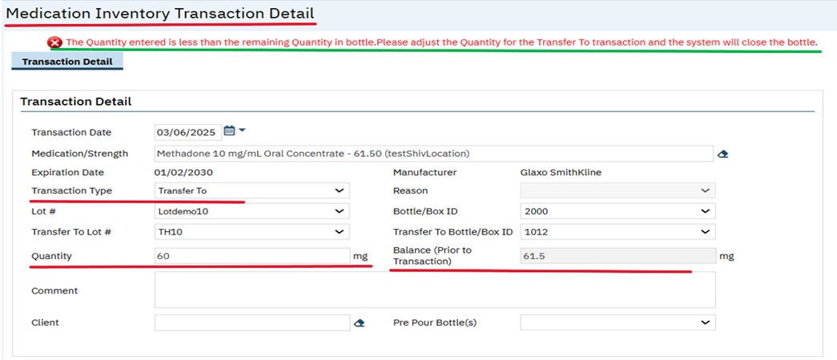

Balance (Prior to Transaction): This is a new field that has been added next to the Quantity field.
It will be grayed out and disabled for all Transaction Types.
This field is non editable and Auto-display the remaining balance in mg for the selected Bottle/Box ID, as of current Date/Time which provides information to the user.
On click of 'Save', the system will maintain the value in this field for this saved record. If any other Transactions happen after 'Save', when a user opens a New Transaction Detail, the new current balance in mg, as of current Date/Time will display in the new record.

Actual Measured Quantity: Textbox with the associated 'Unit' as footer (mg or mL)
- This is a new required field added below the Client field.
- When ‘new’ Account for Variance’ checkbox is checked in MAT Configuration screen, for ‘Adjustment’ Transaction Type and ‘Variance’ Reason selected, System will subtract the remaining Quantity in bottle from the ‘Actual Measured Quantity’ value and will push the value to the Quantity field.
- When ‘new ‘Account for Variance’ checkbox is unchecked in MAT Configuration screen, this field will be hidden, regardless of Transaction Type.

Pre-Pour Date: This field has been moved to the bottom of the left column, underneath ‘Client’ field.
Pre-Pour By: This field has been moved to the bottom of the right column, underneath ‘Actual Measured Quantity’ field.
Pre Pour Bottle(s): This field has been moved to the very bottom of the left column, underneath the new location of the Pre Pour Date field (since Pre Pour Date field will not exist simultaneously with Pre Pour Bottles(s) field, it will display underneath Client field).
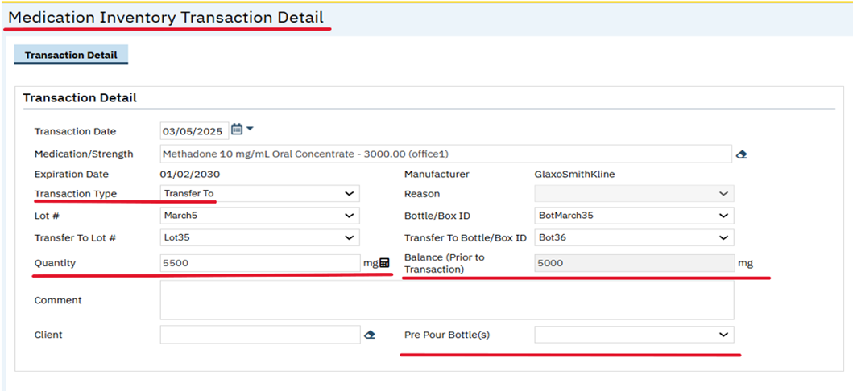

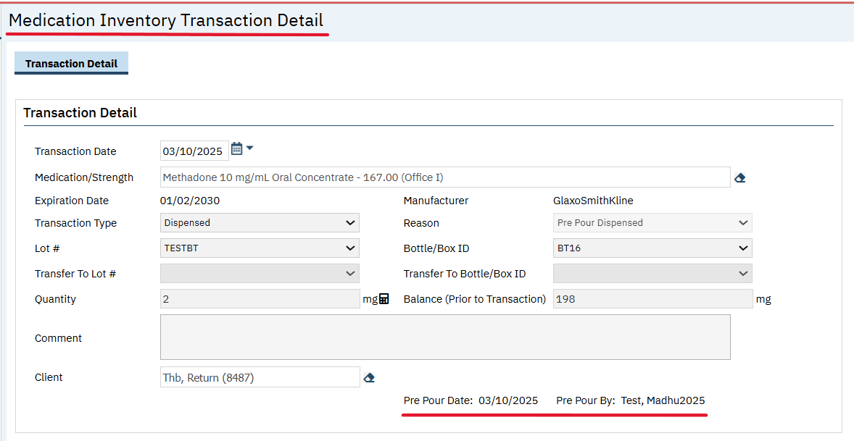

Variance Warning popup: When a new Account for Variance’ checkbox is checked in the MAT Configuration Screen, for ‘Transfer To’ transaction, If Quantity value entered is greater than the remaining Quantity in bottle, on click of Save, the ‘Variance Warning Popup’ will be displayed.
In the ‘Variance Warning Popup’:
<Message> Label: A warning message to be displayed as: The Quantity you are transferring exceeds the remaining Quantity in the bottle. The system will create a Variance transaction to reconcile the remaining balance to zero.
‘Are you sure you want to proceed?’ Checkbox: Unchecked by Default. When this checkbox is checked, OK button will be enabled.

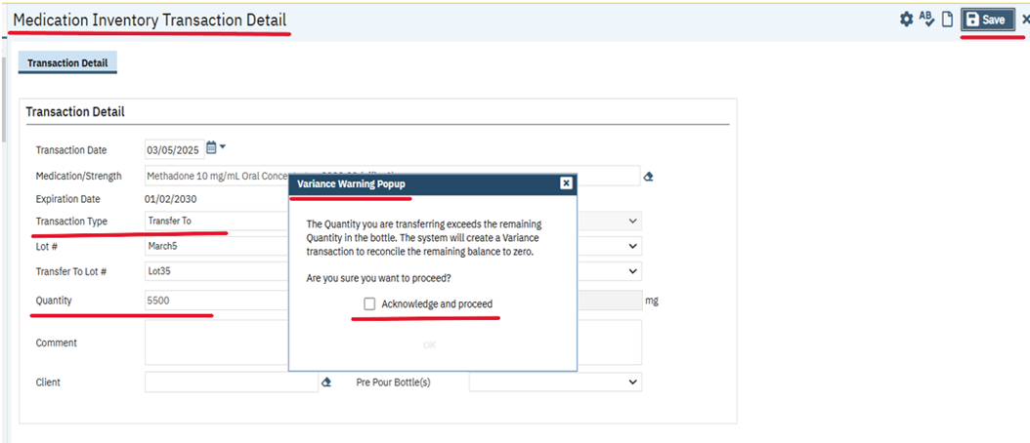

‘OK’ button: On click of ‘OK’ button, proceeds with saving the updates, by auto-creating ‘Adjustment’ Transaction Type with the Reason ‘Variance’ for ‘Quantity’ that will balance the bottle to zero Quantity with Transaction Date, Location, Created By, and Created Date will match the Transfer To transaction data.
‘Close’ button: On click of ‘Close’, it returns to previous screen and will not proceed with 'Save'.

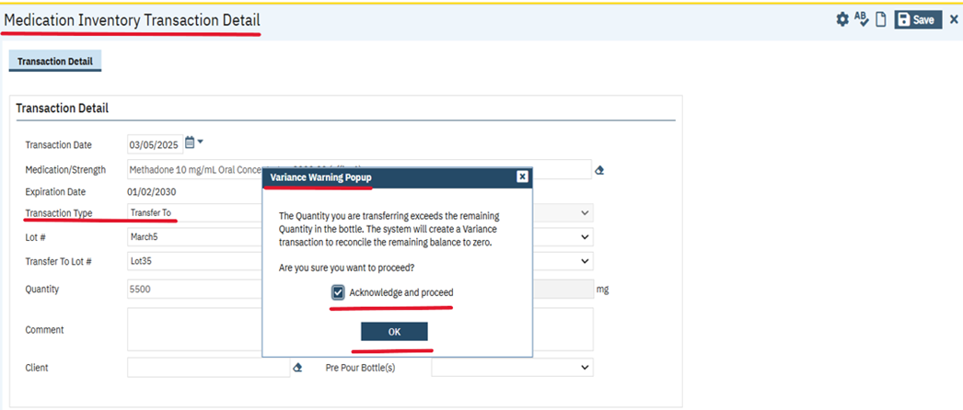

5.‘Medication Inventory Transaction’ List page:
- ‘Actual Measured Quantity’: A new column has been added, and it will display the 'Actual Measured Quantity' value from the associated transaction.

This column will not be displayed By Default. The users need to create a view of their own to start seeing this column.
- ‘All Adjustment Reasons’ dropdown field: In the Filter section ‘Variance’ Reason has been added.
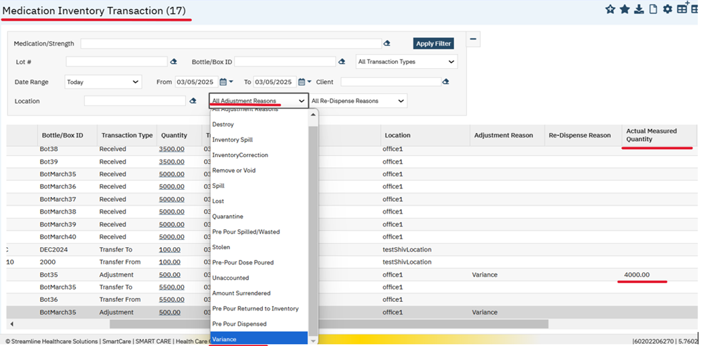

Data Model Changes:
1. A New column AccountForVariance is added to the ‘MATConfigurations’ Table.
2. A new columns ActualQuantity, QuantityBalancePriorToTransaction,VarianceMedicationTransactionId are added to the MedicationTransactions table.

Author: Chaitali Patil

97. EII # 130268 (Feature - 502900): MAT: implemented Clear bubble functionality.

Release Type: Change | Priority: Urgent
Prerequisite: Machine must be connected via below path:
Navigation Path 1: ‘My Office’ ‘MAT Management ‘list page – Click on Connect User Icon - ‘Connection details’ pop up will be displayed – Select ‘Machine’ – Select Medication – select ‘lot’, ‘Bottle’, ‘Quantity’- click on ‘Verified’ check box – click on ‘Connect’-click on ‘ok’ – Machine will be connected successfully.

Navigation Path 2: ‘My Office’ - ‘MAT Management ‘list page – click on clear bubbles icon.

Navigation Path 3: ‘My Office’ - ‘MAT Management ‘list page – click on dispense (Cup) icon – Mat Management Details page - click on clear bubbles icon.
Functionality ‘Before’ and ‘After’ release:
Purpose: Sometimes while changing the bottle in the middle of a pour, the air will be detected in the lines. To clear that air bubble, this clear bubble functionality is implemented.
With this release, the following implementation has been done in the MAT Management list screen and MAT Management details screen and in the toolbar the ‘Clear Bubbles’ button/icon has been added with Hover text as "Clear Bubbles".
MAT Management List Page:
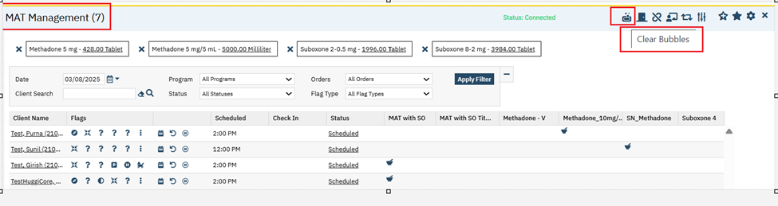

On click of "Clear Bubbles" button, the ‘Possible Air in pump line’ pop up will be displayed with Yes and No buttons.

Confirmation Message: "The Pump has detected air in lines! Would you like to clear the bubbles?"

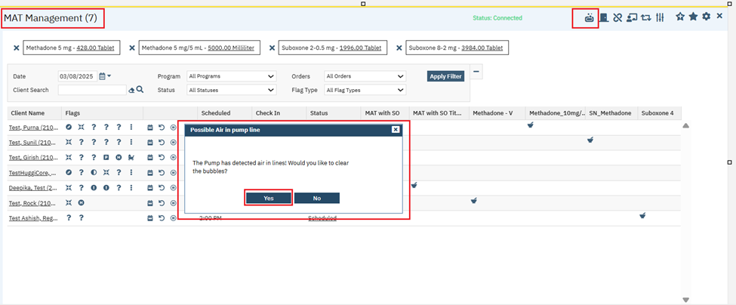
Yes: On click of ‘Yes’, it will call the Clear bubble command(m4,b) of the Methaspense and then pop up will be displayed with confirmation message.
Confirmation Message: " Was line cleared?".
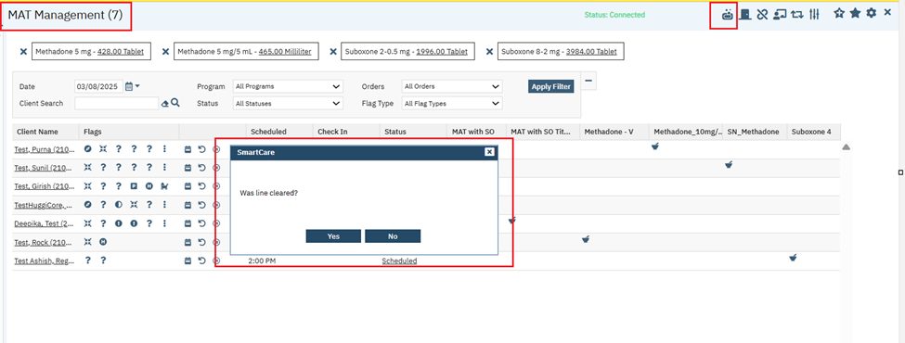
Yes: On click of ‘Yes’ button, the pop up will be closed.
No: If user clicks on ‘No’ button in the above Pop up, then the previous pop up will be open again and user able to perform the action.
2: Screen shots for MAT Management details screen: The above functionality has been implemented in the MAT Management details screen as well.
In the toolbar of the MAT Management details screen, the ‘Clear Bubbles’ button has been added with Hover text as "Clear Bubbles".
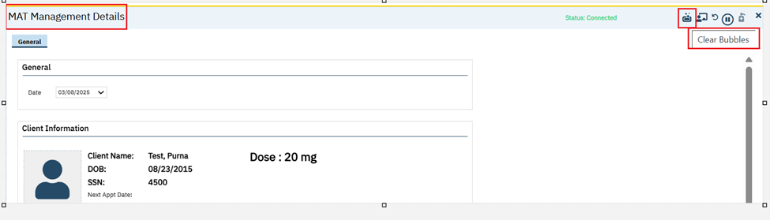
On click of this "Clear Bubbles" button, the ‘Possible Air in pump line’ pop up will be displayed with Yes and No buttons.
Confirmation Message: "The Pump has detected air in lines! Would you like to clear the bubbles?"
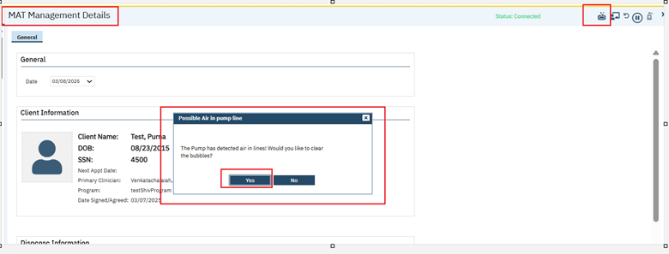
Yes: On click of ‘Yes’, it will call the Clear bubble command(m4,b) of the Methaspense and then the below pop up will be displayed with confirmation message.
Confirmation Message: " Was line cleared?".
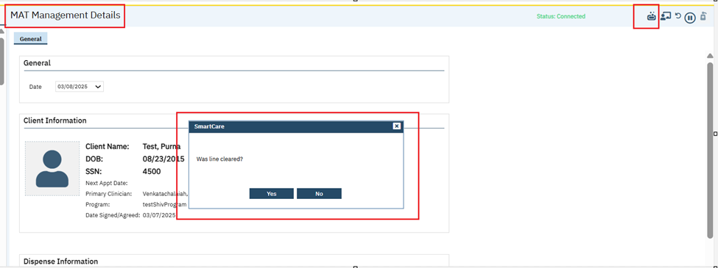
Yes: On click of ‘Yes’ button, the pop up will get closed.
No: If user clicks on ‘No’ button in above Pop up, then the previous pop up will be open again and user able to perform the action.
The "Clear Bubbles" icon will be in Disabled mode in the MAT Management list screen and MAT Management details screen, when ‘Machine’ is not connected.
MAT Management list screen:
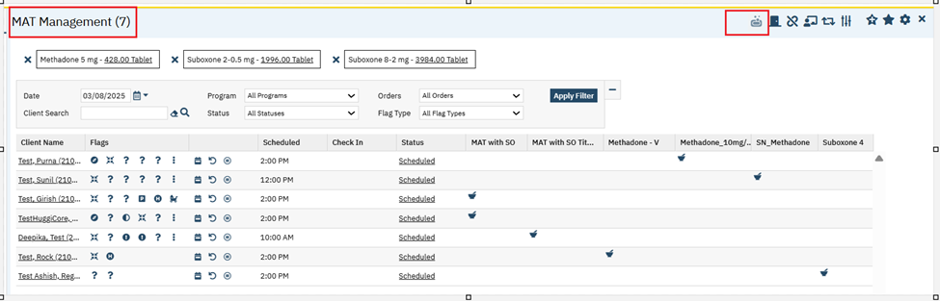
MAT Management details screen:
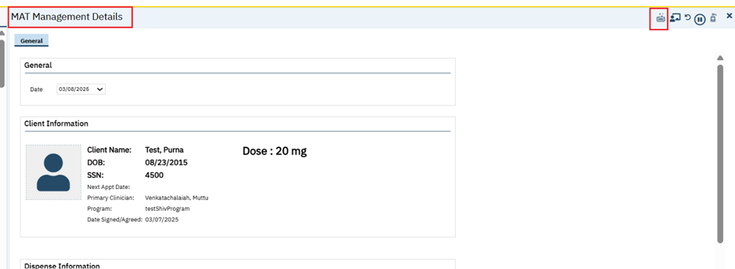
Note: The Clear bubbles functionality will work only with ‘Methaspense’ machine. This will not work with ‘Digispense’ machine.

Author: Smruthi Srikanth

98. EII # 130367 (Feature - 514175): Changes are added to the ‘MAT Dispensing by Bottle’ report.

Release Type: Change | Priority: Urgent

Prerequisite:
1. Create a client and assign MAT location through the below mentioned path:
Go Search – Client Information – Mat tab – In Location Setup section select the required Location Type, Location, Start and/or End Date – Insert and Save.
2. Client must have MAT Medication scheduled and dispensed.
Navigation Path: My Office – ‘MAT Dispensing by Bottle’ Report – Select the Filters - Click on ‘View Report’.
Functionality ‘Before’ and ‘After’ release:
Purpose: If in the case the Client has two Active Locations, then the system will choose the Location that is NOT the Home Clinic Location.
With this release, the following changes are implemented to the ‘MAT Dispensing by Bottle’ Report,
1.In the location column of the report, if a client has two active locations, the Home Clinic location will not be displayed, and Jail County/Jail City location will be displayed.
For e.g.: If a client has two MAT Locations – Home Clinic and Jail-City, then Jail-City will be displayed in the location column of the report.
2.If Client is present in only Home Clinic location, then Home Clinic location will be displayed in the location column of the report.
Screenshot of Client having 2 MAT Location- Home Clinic and Jail City
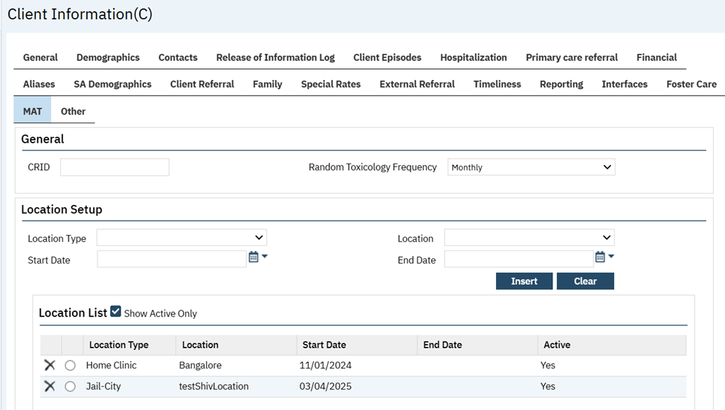
Screenshot of ‘MAT Dispensing by Bottle’ Report for Client having 2 MAT Location- Home Clinic and Jail City
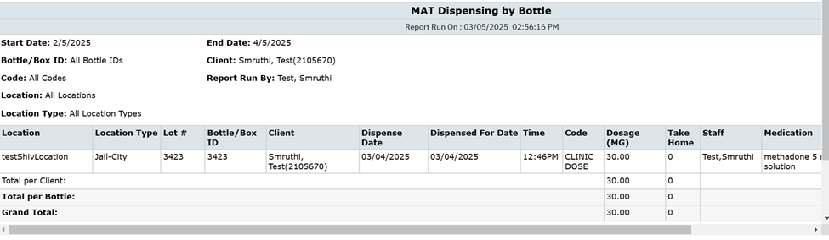
Screenshot of Client having Home Clinic as MAT Location.
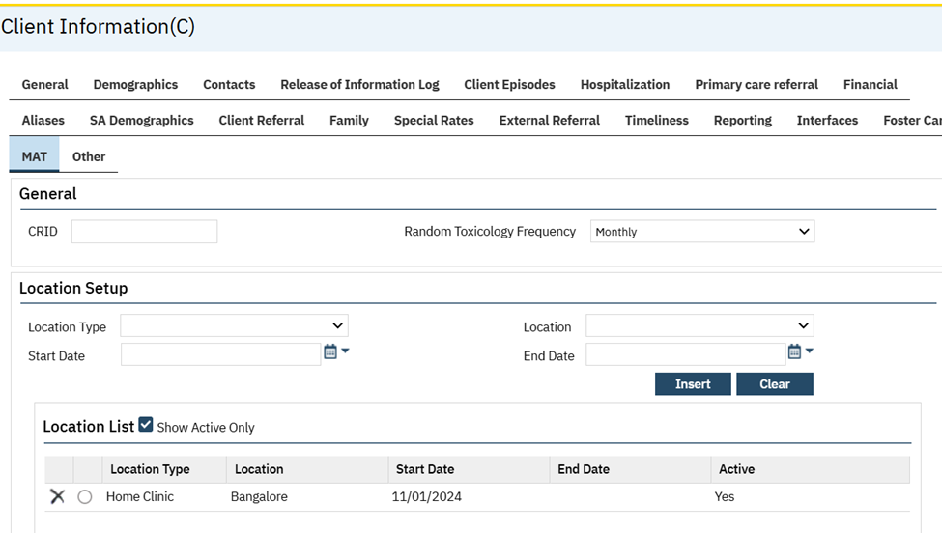
Screenshot of ‘MAT Dispensing by Bottle’ Report for Client having Home Clinic as MAT Location.
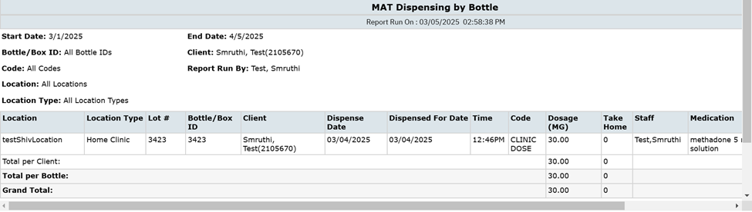

Author: Madhu Basavaraju

99. EII # 130283 (Feature - 503880): MAT: Command ‘m4’ to will be sent to API machine to attempt to clear the air bubbles.

Release Type: Change | Priority: Urgent

Prerequisite: Signed MAT client order exists.

Navigation Path: ‘My Office’ – ‘MAT Management’ list page – Click on ‘Connect User’ icon – Machine Connection popup – Enter the Connection Details’ – Click on ‘Connect’- Cancel - Click on ‘Dispense’ icon for the ‘Client’ Medication to be dispensed – ‘MAT Management Details’ screen.

Functionality ‘Before’ and ‘After’ release:

Purpose: To send Command ‘m4’ to API machine to attempt to clear the air bubbles.

With this release, the Methadone API changes related to ‘Clear Bubbles’ has been implemented.

Methadone API is designed to communicate between SmartCare App and Medication Dispenser Machine (Methaspense), when it detects air in the lines.

Clear Bubbles: Command ‘m4’ will be sent to API machine to attempt to clear the air bubbles and the response will be captured in the Data Base.

Data Model Changes: Added table MATDispenserAPILog

Author: Shivakanth Moger

100. EII # 127712 (Feature - 373961): Changes are implemented to the ‘MAT Bottle Transaction (mg) Report’.

Release Type: Change | Priority: Urgent

Navigation Path: My Office’ - ‘MAT Bottle Transaction (mg) Report’ report – Enter the ‘Transaction Start Date’, ‘Transaction End Date’, ‘Location’, ‘Bottle/Box ID’, ‘Medication Type’ and click on the ‘View Report’ button.

Functionality ‘Before’ and ‘After’ release:
Purpose: The user will transferring the medication from one bottle to another, so they do not run out of medication. There is only one transfer per bottle. The users will not do more than one 'Transfer in' in a day for the same bottle.

With this release, the following changes have been implemented for the existing ‘MAT Bottle Transaction (mg) Report’ report.

Filter Section:

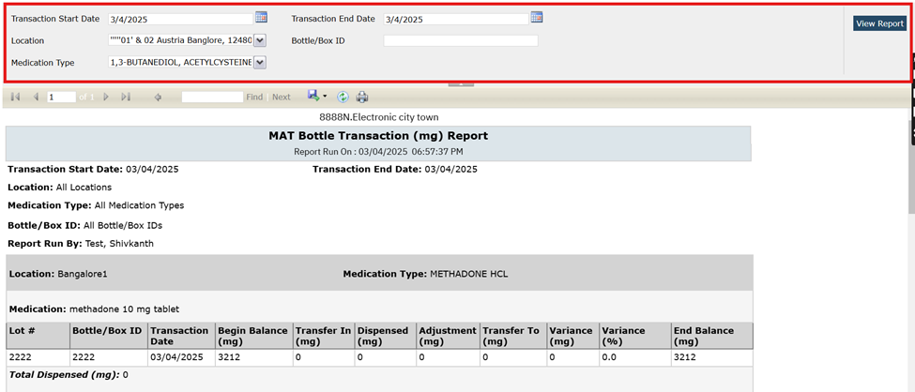

Transaction Start Date: This is a Date Control field, the label name is replaced from ‘Start Date’ to ‘Transaction Start Date’. It will display the Transaction data from the selected Date Range. By default, today's date will be displayed. This is a required field.
Transaction End Date: This is a Date Control field, the label name is replaced from ‘End Date’ to ‘Transaction End Date’. It will display the Transaction data from the selected Date Range. By default, today's date will be displayed. This is a required field.

Location: This is the multi-select drop-down and displays All Active locations. By default, All Locations will be displayed. This is a required field.

Bottle/Box ID: The label name is replaced from ‘Bottle ID’ to ‘Bottle/Box ID’. This is typable text box allows users to search and select a 'Bottle/Box ID' value from the Medication Inventory Transaction screen, like-match. (Enter a few digits and search for like-bottles). By default, blank will be displayed.

Medication Type: This is a multi-select drop-down and by default displays all the Medication Types. This is the GenericName and list all the Generic Names of MAT Medications.
EX: METHADONE HCL.

Header Section:

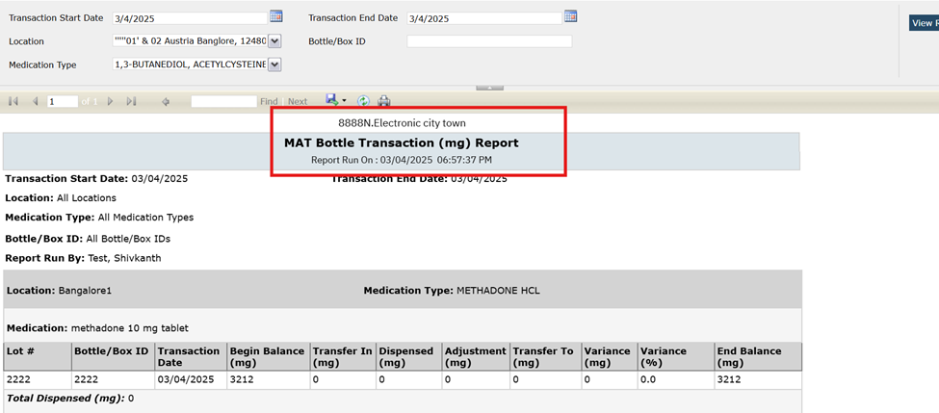

Address: This is the read-only label and displays the Agency Address.

Report Name: This will display the report name as ‘MAT Bottle Transaction (mg) Report’. The Report Name will be displayed on every page of the report.

Report Run On: This will display the Date and Time of the report is executed and it will be displayed in the MM/DD/YYYY HH:MM: SS AM/PM format.

Subheader section:
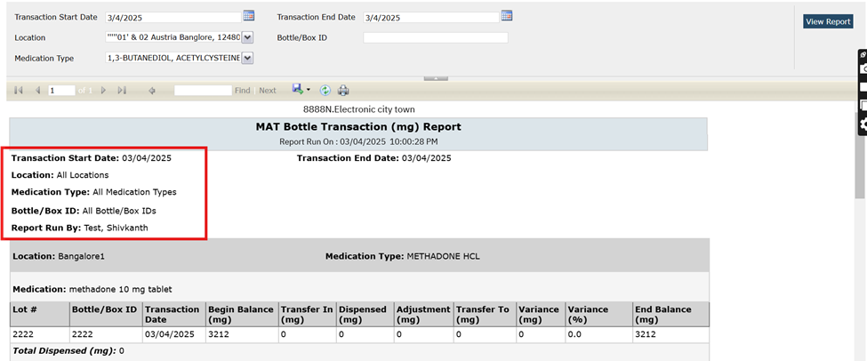

Transaction Start Date: This is a read only label and it will display the Transaction Start Date selected from the Filter.

Transaction End Date: This is a read only label and it will display the Transaction End Date selected from the Filter.

Location: This will list the Locations selected in the filter with comma-separated and by default All Locations will be displayed.

Bottle/Box ID: The field name is relabeled from ‘Box ID’ to ‘Bottle/Box ID’ field. This will display the 'Bottle/Box ID' values selected from the Filter and if none is selected then ‘All Bottle/Box IDs’ will be displayed.

Medication Type: This will display the Medication Type values selected from the Filter and if none is selected then ‘All Medication Types’ will be displayed.

Report Run By: This will display the name of the Staff who is logged into SC and generates the report.

Grid Header Grouping section:
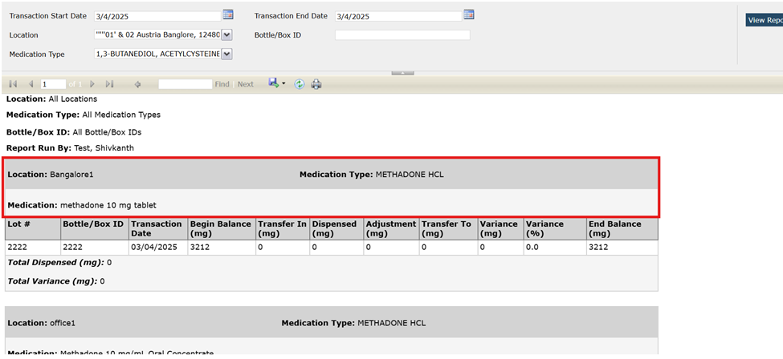

Medication Type: This is a read-only label, it will display the generic name of the MAT medication, showing one medication type per group.

Location: This is a read-only label and displays the list of the locations in the inventory for the bottles with associated transaction and displaying one location per grid header grouping.

Medication: This is read-only label and displays the list of medication names and strengths for all MAT medication bottles with transactions during the selected date range, displaying one medication name and strength per group.

Grid section:

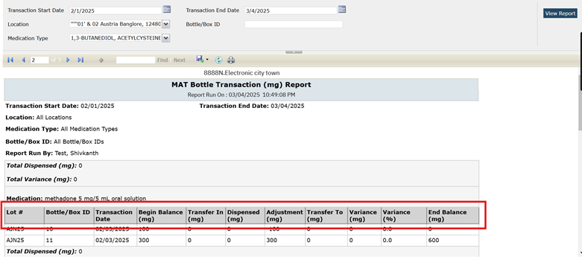

Lot #: This is the column header.

If the "Hide Lot # on MAT Reports" checkbox is not checked on the MAT Configuration screen, then in the report it will display the Lot # column for the associated Bottle/Box ID that had the transaction.

If the "Hide Lot # on MAT Reports" checkbox is checked on the MAT Configuration screen, then Lot # column will be concealed in the Report and on the PDF.

Bottle/Box ID: This will display the Bottle/Box ID of each MAT medication that matches the grid header and sub header groupings that had transactions during the filtered date range.

Transaction Date: This will display the transaction date and sort by date and the most recent is first. Each row will display one transaction date per Bottle/Box ID for every date in the selected range.

Begin Balance (mg):

1.This displays the quantity in mg for the Bottle/Box ID at the beginning of the transaction date, before any transactions for that date.

2. This will be the same quantity as the ending balance (mg) from the previous transaction date.

3.If there is a 'Received' transaction for that date, the system will display the quantity for that received transaction.

Transfer In (mg):
1. This displays the total/sum quantity in mg for any 'Transfer To' transaction that matches the Bottle/Box ID with the "Transfer To Lot #" and "Transfer To Bottle/Box ID" fields.

2. If there are no matching 'Transfer To' transactions for this transaction date, then it will display blank.

Dispensed (mg):

1) This displays the total/sum quantity in mg dispensed per Bottle/Box ID for the selected date, including all Dispense and Re-dispense transactions.

2) If there are no Dispense or Re-dispense transactions for the Bottle/Box ID on the transaction date, then it will display blank.

3) Since all Dispenses are negative transactions, then 'minus (-)’ is placed in front of the value.

Adjustment (mg):

1) This displays the sum/total quantity in mg for all Adjustment transactions for the Bottle/Box ID on the associated date, excluding those with MEDTRANSACTIONREASON = Variance. (It will not include Variance transaction quantities in this sum/total.)

2) If there are no Adjustment transactions for the Bottle/Box ID on the transaction date, then it will display blank.

3) If the Adjustment is a negative transaction, then ‘minus (-)’ is placed in front of the value.

Transfer To (mg):
1. This displays the sum/total quantity for the Bottle/Box ID's Transfer Out transactions on the associated transaction date.
2.If there are no Transfer Out transactions for the associated Transaction Date, for the associated Bottle/Box ID, then it will display blank.
3) Since all Transfer Outs are negative transactions, then 'minus (-)' is placed in front of the value.

Variance (mg):

1.) This Displays the sum/total quantity in mg for all Adjustment transactions with Reason = Variance, for the associated Bottle/Box ID, for the associated transaction date.

2) If there are no Variance Transactions for the associated Transaction Date, for the associated Bottle/Box ID, then it will display Blank.

Variance (%):
1) Divide the quantity in mg of the Adjustment transaction with Reason = Variance for the associated Bottle/Box ID, for the associated transaction date by the initial quantity in mg for that same Bottle/Box ID, regardless of the transaction date.

2) Round the result to the nearest tenth.

3) If there are no Adjustment transactions with Reason = Variance for the associated Bottle/Box ID, for the associated transaction date, then it will display blank.
Examples:
A variance percentage of 1.1144 will be displayed as 1.1.
A variance percentage of 1.155 will be displayed as 1.2.

End Balance (mg)

1)This displays the quantity for the Bottle/Box ID at the end of the transaction date, after all transactions for that date.

2)This will be the same quantity as the begin balance (mg) for the next transaction date.

Grid Sub footer section:

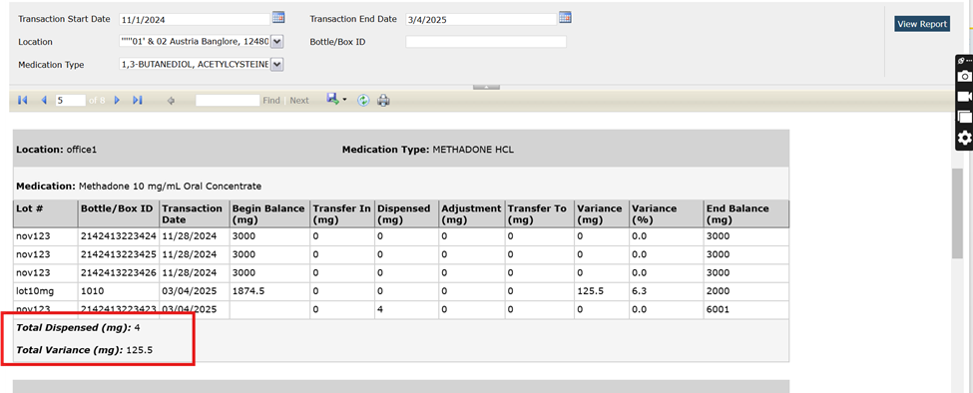

Total Dispensed (mg): This is a read-only label and displays the total dispensed quantity (mg) for all items under the associated grid header and sub header groupings at the bottom. This will not display a negative sign in front of the value.

Total Variance (mg): This is a read-only label and displays the total quantity in mg for all Adjustment transactions with Reason = Variance, that are listed under the associated grid header and sub-header groupings at the bottom.

Grid Footer:

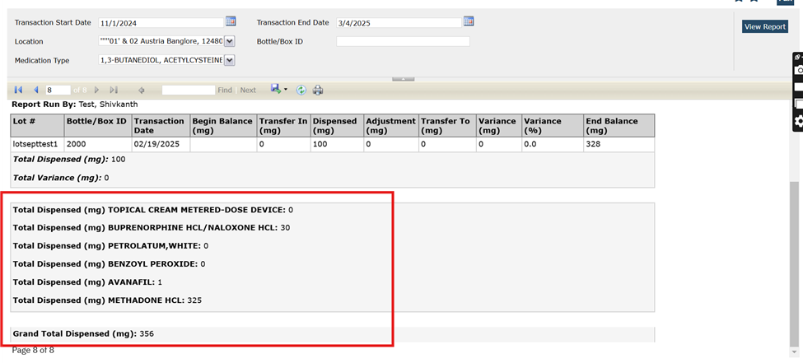

Total Dispensed <GENERICNAME> (mg):

1)This is read-only label and displays the total quantity in mg for each <GENERICNAME> by summing the dispensed (mg) amount.

2)This will list each medication type in the report and displays at the bottom after all data groupings.

3)Displays one row per medication type (GenericName).

Grand Total Dispensed(mg): It displays the total sum of all dispensed amounts (mg) for all medication types as the last row of the report and the negative sign will not display in front of the value.

Author: Sithara Ponnath

101. EII # 129962 (Feature - 489564): Changes are implemented to the MAT Management Details Screen.

Release Type: Change | Priority: On Fire

Navigation Path 1: ‘Client’ - ‘Client Orders’ screen -‘New’ icon - ‘Select a MAT Order or Suboxone Order’ - Enter required data - Click on ‘Insert’ button - Click on ‘Save/Sign’ button.

Navigation Path 2: MAT Management (My Office) - Filter with date to view the required MAT Orders/Suboxone Orders- Click on ‘Dispense’ icon - ‘MAT Management Details’ screen.

Functionality ‘Before’ and ‘After’ release:

Purpose: To make bottle transfer more efficient, the user connection related fields also be added to the MAT Management Details screen.

With this release, the below changes have been implemented in the ‘MAT Management Details’ screen.

- A connection icon with a hover text ‘Connect User’ has been added at the right top of the screen where a staff/user will be able to access user connection and inventory functions in the ‘MAT Management Details’ screen.

MAT Management List screen displays the MAT /Suboxone orders, clicking on the dispense icon takes user to the MAT Management Details Screen.

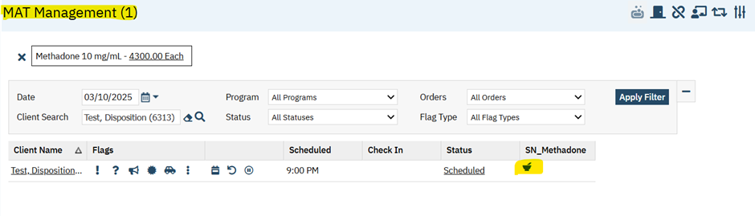
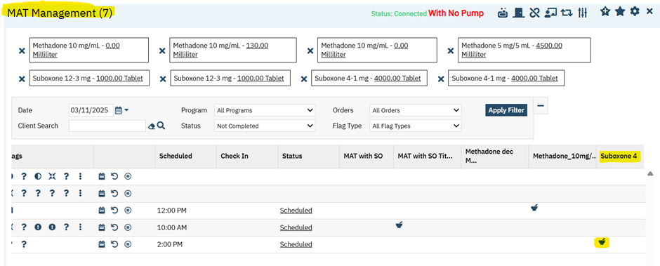

‘Connection Icon’ in the MAT Management Details screen.

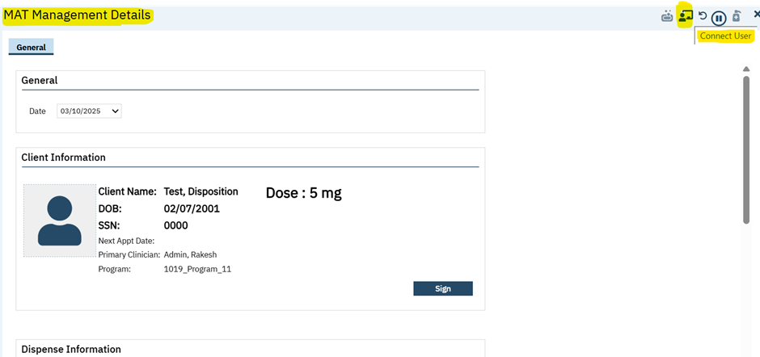

- If the staff has connected to a machine, a status ‘Connected’ will be displaying in the MAT Management Details screen.
When a ‘Machine’ is connected successfully, it shows ‘Connected’ status in the MAT Management Details screen.

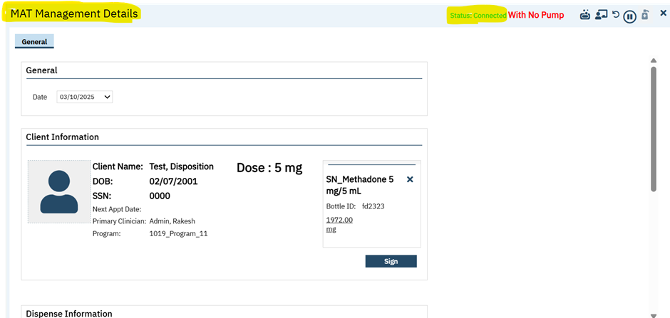

- ‘With No Pump’ status will be displayed in the ‘MAT Management Details’ screen, if that option is selected in the ‘MAT Management List’ page.
‘With No Pump’ displays in MAT Management Details Screen.

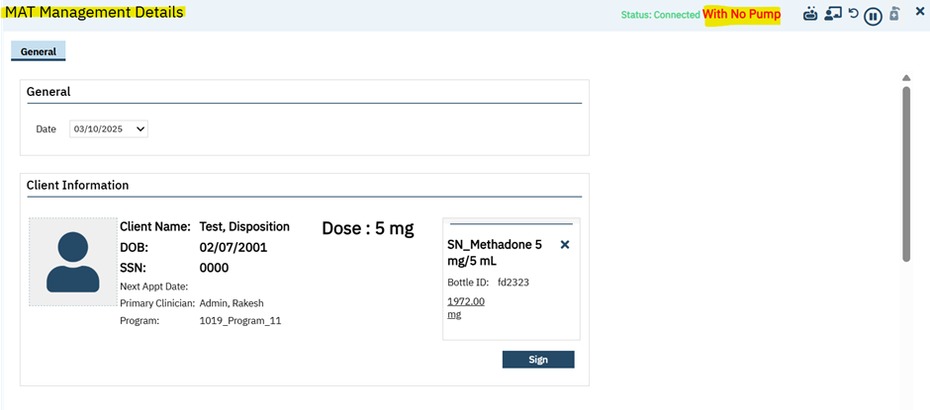

- The standard connection details pop-up will be displayed on click of connection icon.
- The machines will be loaded in the connection pop-up which are in current client order medication's location.
Connection pop-up which loads the machine based on the selected medication’s location.

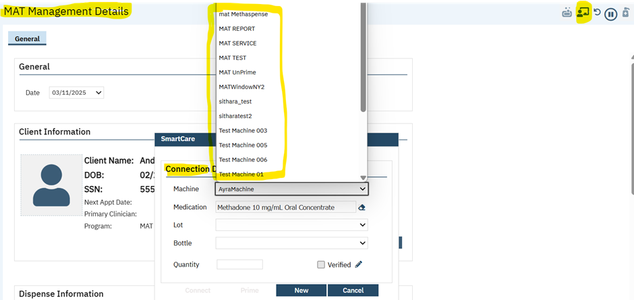

- For a ‘Methadone’ order, when the user clicks on connection icon in the MAT Management Details screen then, the medication dropdown will dynamically display the medication currently connected for dispensing with the same strength specified in the signed client order.

MAT Medication name shows in the Pop-Up with same strength
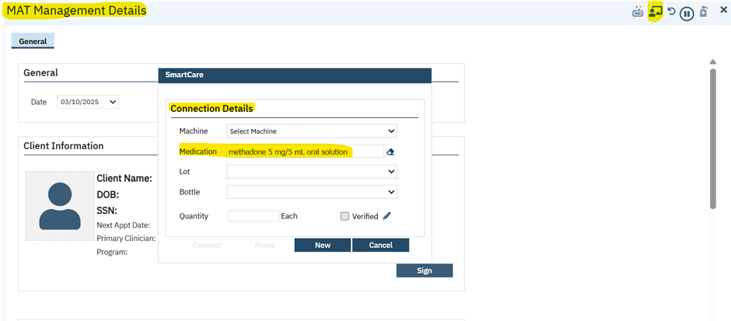

- On change of machine selection, medication name will not be cleared from connection the pop-up.
- If the Order is NOT a ‘Machine Connection Required’, then machine dropdown will be disabled.

‘Machine’ dropdown is disabled in the connection pop-up.
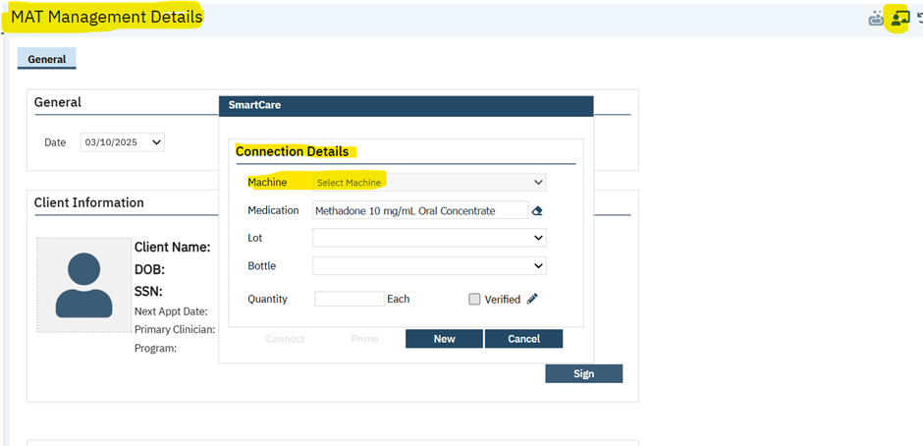

- For a ‘Suboxone’ order, it will display all the related suboxone orders or connections available for selection in the medication dropdown of connection pop-up.

Available ‘Suboxone Medication’ names showing in the Connection Pop-Up
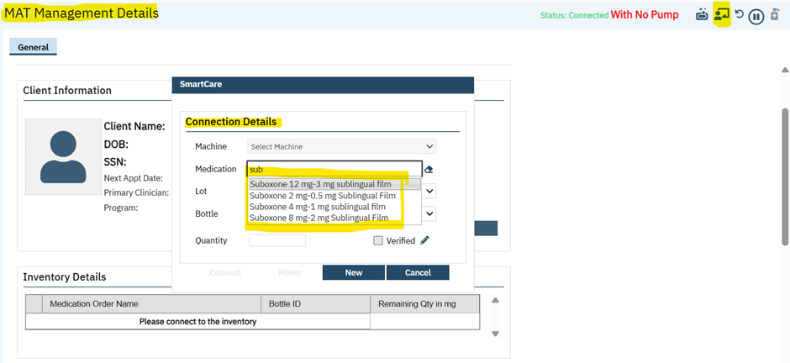

- When ‘Methadone’ is connected:
- The ‘Methadone’ medication will be displayed in the Client Information: ‘Methadone Box’ with a hyperlink under the milligrams(mg) and clicking on the ‘mg’ hyperlink will redirect to the ‘Medication Inventory Transaction Detail’ screen.
Methadone Box shows medication details and the mg with hyperlink.

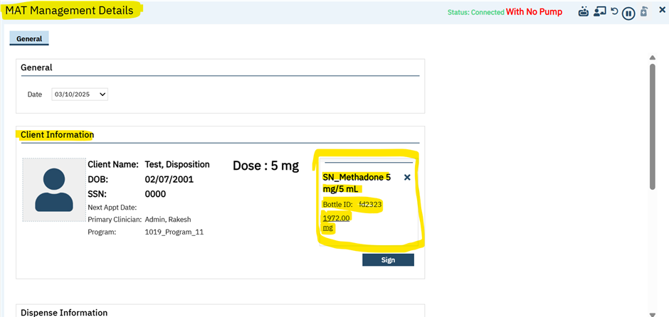

On clicking of ‘mg’ hyperlink, it takes user to the ‘Medication Inventory Transaction Detail’ screen.

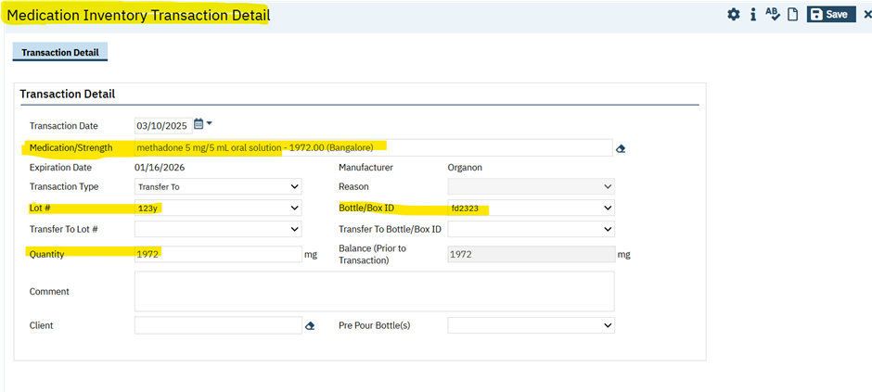

- Closing the ‘Medication Inventory Transaction Detail’ screen will take user back to the ‘MAT Management Details’ screen.
- Disconnect icon(X) is added in the methadone box and clicking on this (X) icon will disconnect the medication connection.
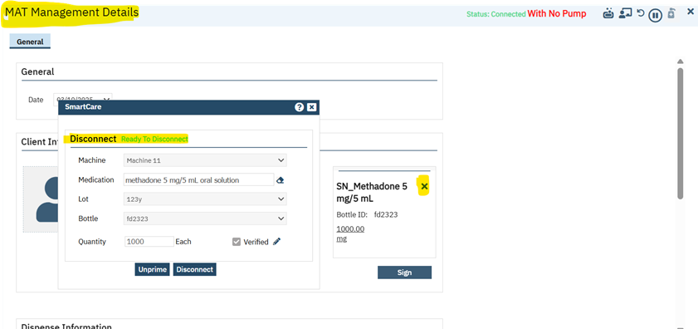

- When the ‘Suboxone’ is connected:
- Suboxone medication will be displayed under the ‘Inventory Details’ grid. A hyperlink under the ‘milligram(mg)’ is added and clicking on the ‘mg’ hyperlink will redirect to the ‘Medication Inventory Transaction Detail’ screen.
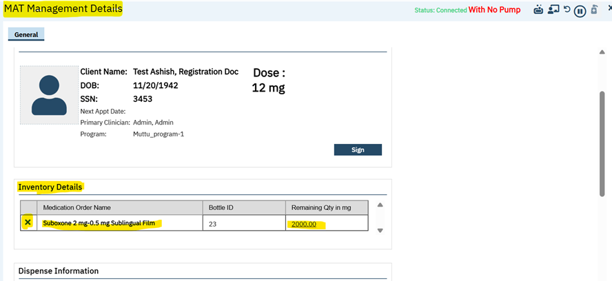

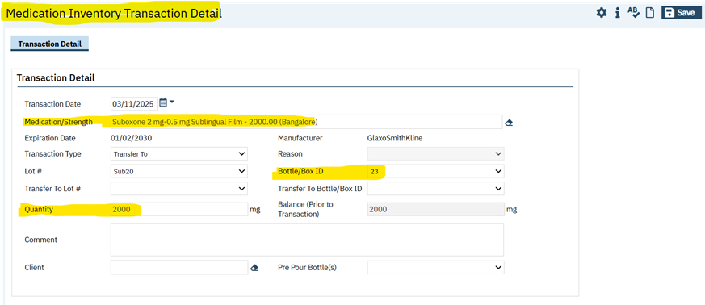

- Closing the ‘Medication Inventory Transaction Detail’ screen will take user back to the ‘MAT Management Details’ screen.
- Added a new column ‘Disconnect icon(X)’ in the inventory details grid and clicking on this (X) icon will disconnect the medication connection.
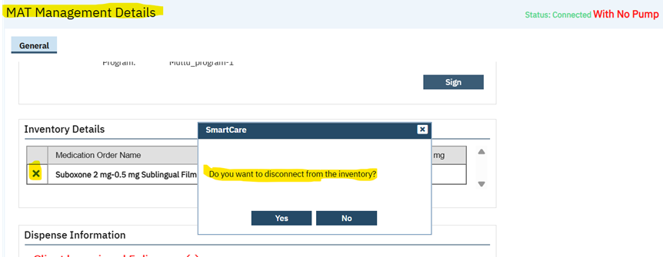

- ‘Received’ option is hidden from the ‘Transaction Type’ dropdown in the ‘Medication Inventory Transaction’ screen.
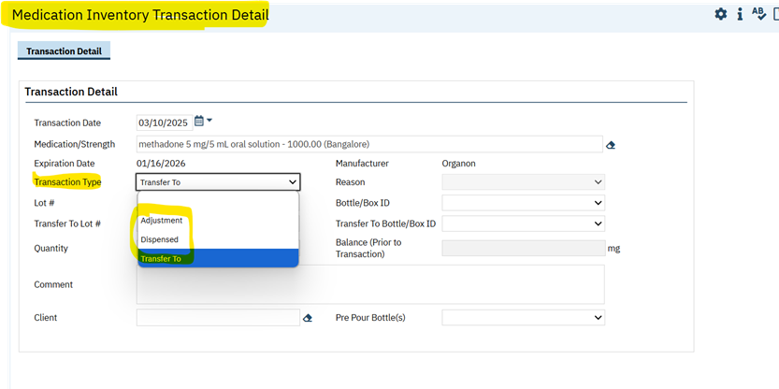

Author: Chaitali Patil

102. Core Bugs # 130702: MAT Management Details screen: After ‘Bypass’ hold in the MAT management details screen, the red message was displayed on the screen.

Release Type: Fix | Priority: High

Navigation Path 1: Administration - Orders’ - ‘Orders’ list page - New - ‘Order Details’ screen -
Select ‘Medication’ Order Type - Enter the required fields - Select (Medication Assisted Treatment
(MAT), Machine Connection Required, Take Home Allowed) = Yes, under ‘Medication Assisted
Treatment’ section and display program? Must be ‘Yes’ for MAT Orders – Save.

Navigation Path 2: My Office – ‘Medication/Lot/Bottle’ list page – New - ‘Medication/Lot/Bottle
Details’ screen - Enter the required fields – Enter Location - Insert – Save.

Navigation Path 3: ‘Client’- ‘Client Orders’ - ‘Client Orders’ list page - New - ‘Client Order details’
screen - Select the Order created in Navigation Path 1 - Enter the required fields – select Program –
Insert –click on ‘save’ and ‘Sign’.

Navigation Path 4: ‘My office’ – MAT Holds List – click on ‘New’ – fill required field – Insert – save.

Navigation Path 5: ‘My Office’ - ‘MAT Management ‘list page – Select the Order (Navigation path 3)
and click on ‘Dispense icon’ – MAT Management Details – Red message will be displayed for Hold - Click on ‘Bypass’ icon – ‘Bypass Hold for Dispense’ pop up will be displayed – add comment – Click on ‘Continue’ – Red message should not be displayed once bypass the hold.

Functionality ‘Before’ and ‘After’ release:

Before this release, here was the behavior. After ‘Bypass’ hold in the MAT management details screen, the red message was still displaying on the screen for that day.

Message: You cannot dispense to this patient because they currently have a hold in place due to Reason: Previous bills not cleared, Auto Hold (Missed consecutive days).

With this release, the above-mentioned issue has been resolved. Now, after ‘Bypass’ hold in the MAT management details screen, the red message is not displayed on the screen for that day, but the message will be displayed on the next day.

Author: Madhu Basavaraju

103. Core Bugs # 130845: The system is continuously processed when dispensing the Medication by checking ‘Commence Pre-Pour’ Checkbox.

Release Type: Fix | Priority: High

Prerequisite:
- ‘Allow Pre-Pours’ checkbox is checked in the ‘MAT Configuration’.
- The client order is signed with MAT Order.

Navigation Path: My Office -- ‘MAT Management’ list page -- Connect to the Inventory -- Click on Dispense Icon -- ‘MAT Management Details’ screen – Select ‘Commence Pre-pour’ Checkbox in the ‘Dispense Information’ section -- Click on ‘Dispense’ Icon.

Functionality ‘Before’ and ‘After’ release:

Before this release, here was the behavior. In 'MAT Management Details’ screen, when the user checked ‘Commence Pre-Pour’ checkbox and clicked on the ‘Dispense’ icon, the system was continuously processing.

With this release, the above-mentioned issue has been resolved. Now, the user can dispense the Medication by checking ‘Commence Pre-Pour’ Checkbox in the 'MAT Management Details’ screen.

My Reports

Reference No | Task No | Description
104 | EII # 130047 | Implemented a new “Deposit Report” report

Author: Arpita Biradar

104. EII # 130047 (Feature - 383926): Implemented a new “Deposit Report” report.

Release Type: New | Priority: Urgent

Navigation Path: ‘My Office’ – ‘My Reports’ – In the search text box enter “Deposit Report” and click on ‘Apply Filter’ button – the report will be displayed in the ‘Grid’ section – Click on ‘Report Name’ hyperlink – report will be opened in a new URL window – enter the required data in the ‘Filter’ section and click on ‘View’ report button.

Functionality ‘Before’ and ‘After’ Release:

Purpose: To introduce a ‘Deposit Date’ as part of payment records in SmartCare.

With this release, a new report “Deposit Report” has been implemented where it is able to run a Deposit Report, and which displays the payment deposit data.

If Payments are created by entering the ‘Deposit Date’, then that payments can be reconciled by deposit date as required.

The “Deposit Report” contains with the below-mentioned fields:

Filter Section: In the filter section, the below parameters will be displayed.

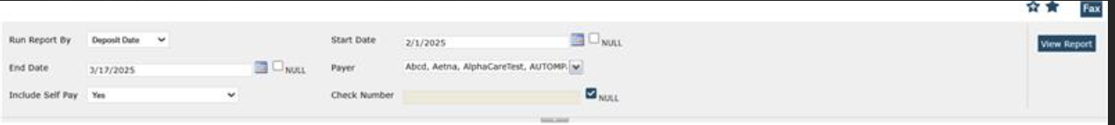
1. Run Report By: This is a Drop-down field, with a parameter option as ‘Payment Date’ or ‘Deposit Date’.

a. When end users run a report using the date filters, the user need to select ‘Payment date’ or the ‘Deposit date’ as needed. This filter will drive the logic for the dates used in the report.

This is a required field.

Note: If this field is left blank, the following warning message is displayed:

Warning Message: “Please enter a value for the parameter 'Run Report By'. The parameter cannot be blank”.

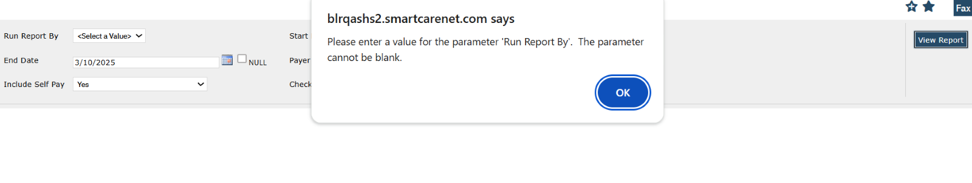

2. Start Date: This field with the ‘Calendar’ option is added. For the entered ‘Start Date’ the report will display the payments and associated details in the report based on the ‘Deposit Date’ or ‘Payment Date’ selected in the run report by filter.

a. The date will be displayed in the format of “MM/DD/YYYY”. This is an optional field.

3. End Date: This field with the ‘Calendar’ option is added. For the entered ‘End Date’, the report will display the payments and associated details in the report based on the ‘Deposit Date’ or ‘Payment Date’ selected in the run report by filter.

a. The date will be displayed in the format of “MM/DD/YYYY”

This is an optional field.

4. Payer: This is a Multi-select Drop-Down field, the records will be displayed based on the ‘Payers’ selected.

a. The ‘Payer’ dropdown will have the option such as ‘Select All’ and with all the active Payers created in the application.

5. Include Self-Pay: This is a Drop-Down field with the options as ‘Yes’ or ‘No’ and the records will be displayed based on the option selected. This field controls whether self-payments should be included in the report or not.

i. On selecting ‘Yes’ option from the dropdown, it includes self-payments in the report.

ii. On selecting ‘No’ option from the dropdown, it does not include self-payments in the report.

6. Check Number: This is a Text-box field, the records will be displayed based on the check number entered. It allows Alpha-Numeric values.

Note: When a user enters an invalid check number in this filter and clicks on ‘View Report’ button, the report will be blank.

Header Section: On selecting the required data in the filter section and clicking the ‘View Report’ button, the below-mentioned fields will be displayed with the respective information.
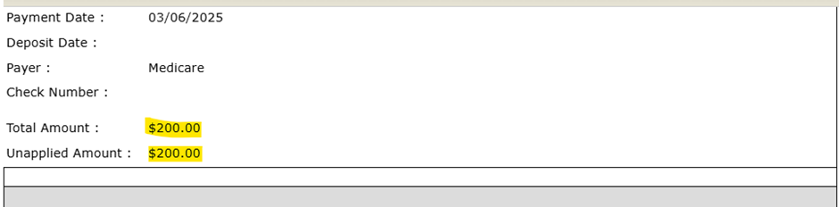

1. Payment Date: This field will display the ‘Payment Date’ from the Payment records fetched by the report based on the filter applied.

a. The ‘Payment Date’ will be displayed in the format of “MM/DD/YYYY”

2. Deposit Date: This field will display the ‘Deposit Date’ from the Payment records fetched by the report based on the filter applied.

a. The ‘Payment Date’ will be displayed in the format of “MM/DD/YYYY”

b. If the payment does not have a deposit date, then the column will be blank.

3. Payer: This field will display the Payer for which the Payment is created based on the filter applied.

a. If there a Self-Pay Payment made, then the Payer will be displayed as ‘Self-Pay’ for those records.

4. Check Number: This field will display the associated ‘Check Number’ for the respective payment record.

a. If the payment does not have the ‘Check Number’, then the column will be blank.

b. It will display the information for the payment that is associated to the Ref # entered.

5. Total Amount: It will display the ‘Total Amount’ of the Payment.

6. Unapplied Amount: If there is any ‘Unapplied Amount’ for the Payment record then that amount will be displayed by this field.

a. If there is no ‘Unapplied Amount’, then this field will display as $0.00.

Note: If the entire amount of the check is ‘Unapplied’, (i.e. when total amount is equal to the unapplied amount) the entire grid section will not be displayed.

Grid section: On selecting the required data in the filter section and clicking the ‘View Report’ button, the below-mentioned fields will be displayed with the respective information.

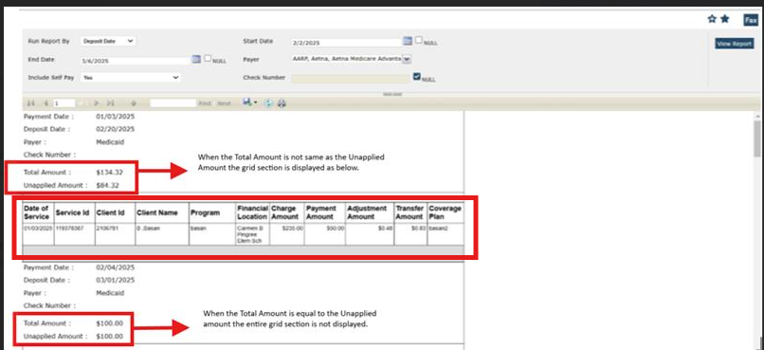

- Date of Service: This column will display the ‘Date of Service’ in the MM/DD/YYYY format.

- Service ID: This column will display the ‘Service ID’ associated to the service.

- Client ID: The column will display the ‘Client ID’ associated with the particular service for which the payment is posted.

- Client Name: The column will display the name of the Client for whom the service is created.
- The ‘Client Name’ will be displayed in the format of “Last Name, First Name”.

- Program: The column will display the name of the Program associated to the service.

- Financial Location: The column will display the ‘Financial Location’ for payment records.

- Charge Amount: The column will display the ‘Charge Amount’ for the individual service line.

- Payment Amount: The column will display the ‘Payment Amount’ for the individual service line.

- Adjustment Amount: The column will display the ‘Adjustment Amount’ for the individual service line.

- If there is no ‘Adjustment Amount’ for the Payment record, then the column will display as $0.00.

- If the ‘Adjustment Amount’ is in negative, then the column will display the amount in brackets which indicates a negative value.
- Transfer Amount: The column will display the ‘Transfer Amount’ for the individual service line.

- If there is no ‘Transfer Amount’ for the Payment record, then the column will display
as $0.00

- If the ‘Transfer Amount’ is in negative, then the column will display the amount in brackets which indicates a negative value.
Note: Each line in the grid is specific to the charge the payment was posted to. When an amount is transferred to the next payer, that secondary payer transfer should not appear in the report.

- Coverage Plan: The column will display the ‘Coverage Plan’ Name.
- For Self-Pay payments this column will be left blank.

NOMS

Reference No | Task No | Description
105 | Core Bugs # 130780 | Getting an error when selecting the Diagnosis Code F31.9 in the National Outcome Measures (NOMs) document
106 | Core Bugs # 130903 | Unable to open NOMs Reporting List Page.

Author: Pavitra Sajjan

105. Core Bugs # 130780: Getting an error when selecting the Diagnosis Code F31.9 in the National Outcome Measures (NOMs) document.
DISCLAIMER: The document is only available to those customers who have purchased an annual subscription. It is a premium add-on to SmartCare and not included in SmartCare Base Subscription. If you are interested in learning more about this document, please contact your account manager.
Release Type: Fix | Priority: High

Navigation Path: Client – ‘National Outcome Measures (NOMs)’ – ‘Diagnosis’ tab – Enter the Diagnosis Code and select the Diagnosis Code in the ‘Code’ textbox -- Select all the fields -- Click on Insert.

Functionality ‘Before’ and ‘After’ release:

Before this release, here was the behaviour. In the ‘Diagnosis’ tab of the ‘National Outcome Measures (NOMs)’ document, when the user selected the diagnosis ‘Code’= F31.9, the following error was displayed.

Error Message: Invalid DX code.

With this release, the above-mentioned issue has been resolved. Now, the user can select the Diagnosis Code F31.9 without an error in the ‘National Outcome Measures (NOMs)’ document.

Author: Sonia Lakshmikanthan

106. Core Bugs # 130903: Unable to open NOMs Reporting List Page.
DISCLAIMER: The document is only available to those customers who have purchased an annual subscription. It is a premium add-on to SmartCare and not included in SmartCare Base Subscription. If you are interested in learning more about this document, please contact your account manager.
Release Type: Fix | Priority: Medium

Navigation Path: My Office - NOMS Reporting List Page.

Functionality ‘Before’ and ‘After’ release:

Before this release, here was the behavior. In the National Outcome Measures (NOMs) document, the following fields: Systolic blood pressure, Diastolic blood pressure, Weight, Height and Breath CO for smoking status were accepting alphanumeric values and displaying the below red error while trying to open the NOMS Reporting List Page.

Error message: 50000*****8114*****Error converting data type varchar to float. *****ssp_NOMSSPARSCandidateProcess*****417*****16*****5*****ssp_NOMSSPARSCandidateProcess*****2649*****16*****1

With this release, the above-mentioned issues have been resolved. Now, in National Outcome Measures (NOMs) document, the following fields: Systolic blood pressure, Diastolic blood pressure, Weight, Height and Breath CO for smoking status is no longer accepting alphanumeric values and no red error is displaying while opening the NOMS Reporting List Page.

Order Entry

Reference No | Task No | Description
107 | Core Bugs # 130838 | Getting error when saving the ‘MAT Configuration’ screen.

Author: Varsha Patil

107. Core Bugs # 130838: Getting error when saving the ‘MAT Configuration’ screen.

Release Type: Fix | Priority: High

Navigation Path: ‘Administration’ -- ‘MAT Configuration’ screen – Enter the value in 'MAT Auto Schedule Days' field – Enter required details – Click on ‘Save’

Functionality ‘Before’ and ‘After’ release:

Before this release, here was the behavior. In the ‘MAT Configuration’ screen, when the user changed the value of 'MAT Auto Schedule Days' field and clicked ‘Save’, the below-mentioned error was displayed.

Error message: 'column' argument cannot be null. Parameter name: column

With this release, the above-mentioned issue has been resolved. Now, when the user changes the value of 'MAT Auto Schedule Days' field and clicks ‘Save’, the data is saved in the ‘MAT Configuration’ screen without an error.

Orders

Reference No | Task No | Description
108 | EII # 128803 | Orders: Implemented a functionality to convert an 'Adhoc Order' to a 'Regular Order' and revert it, with Permission functionality
109 | Core Bugs # 130687 | Lab Results Widget Showing Dates out of Order

Author: Shivakanth Moger

108. EII # 128803 (Feature - 456827): Orders: Implemented a functionality to convert an 'Adhoc Order' to a 'Regular Order' and revert it, with Permission functionality.

Release Type: Change| Priority: Urgent

Prerequisites: An Adhoc type order is required.
Path: ‘Orders’ -- ‘Orders’ list page – select the 'Adhoc Orders' checkbox and click on the 'Apply Filter' button - click on the 'Order Name' hyperlink text where 'Adhoc Order' column marked as Yes.

Navigation Path 1: ‘Administration’ -- ‘Staff/Users’ list page -- ‘Staff Details’ -- ‘Roles/ Permissions’ tab -- ‘Permission’ section -- Select the Permission Type as ‘Screens’ -- Enter as 'btnAdhocOrders' in the 'Permission Item' field -- Click the ‘Apply Filter’ button.

Navigation Path 2: ‘Orders’ -- ‘Orders’ list page -- click on New or select Adhoc order name hyperlink text – ‘Order Details’ screen.

Functionality ‘Before’ and ‘After’ Release:

Purpose: Introducing a functionality to the Order Setup screen that will allow users to convert an 'Adhoc Order' to a 'Regular Order' and Revert, with Permission functionality.

With this release, the below-mentioned change has been implemented in the ‘Order Details’ on permission-based:

- 'Convert Adhoc Order to a Regular Order' Icon:

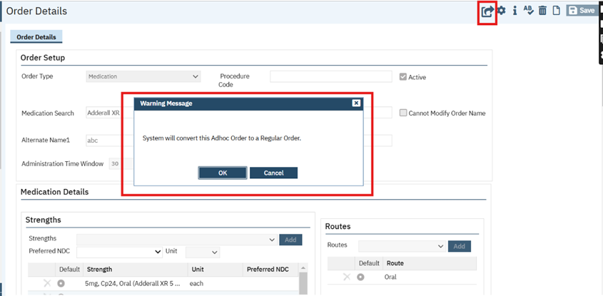

- Tool bar-Icon has been added in the Order Details screen. On clicking on the ‘'Convert Adhoc Order to a Regular Order' icon, the warning message pop-up will be displayed with message: ‘System will convert this Adhoc Order to a Regular Order.’
- OK button: On clicking OK button, 'Adhoc Order’ will be converted to a ‘Regular Order' and the 'Convert Adhoc Order to a Regular Order' icon will be replaced with another new icon 'Convert Regular Order to a Adhoc Order' icon. This new icon will appear after saving the Order Details page. It will not appear for new pages.
- Cancel button: On Click of the Cancel button, the control remains in the same screen.

- Convert Regular Order to a Adhoc Order Icon:

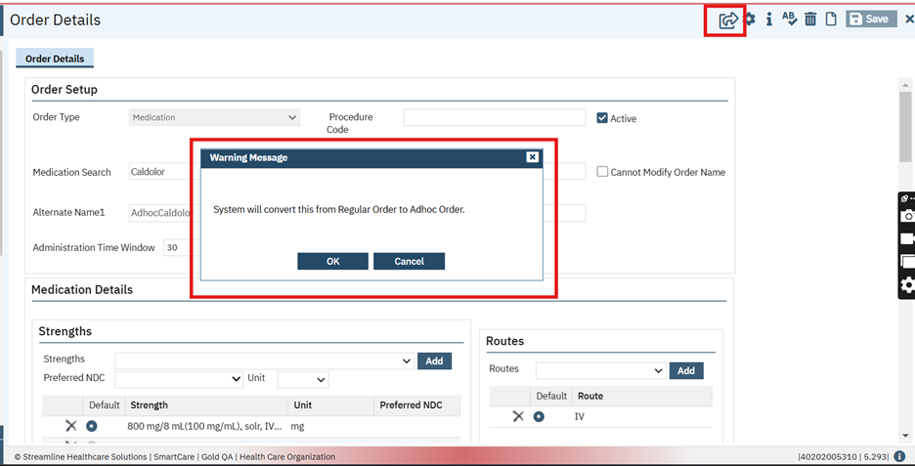

- Tool bar icon has been added in the Order Details screen. On clicking of the ‘'Convert Regular Order to a Adhoc Order' icon, the warning message pop-up will be displayed : System will convert this Adhoc Order to a Regular Order.
- OK button: On clicking OK button, 'Adhoc Order’ will convert to a ‘Regular Order' and the 'Convert Regular Order to a Adhoc Order' icon will be replaced with another new icon ‘Convert Adhoc Order to a Regular Order' icon . This new icon will appear after saving the Order Details page. It will not appear for new pages.
- If an Order exists with the same name, a validation message will be displayed as "Order Name already exists. Please change the Order Name."

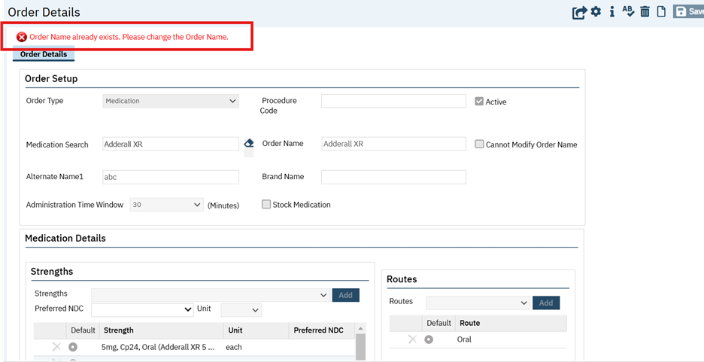

- Cancel button: On Click of the Cancel button, the control remains in the same screen.

In the Staff Details Screen, the below mentioned permissions are added:

To Create Adhoc Orders Permission Type:
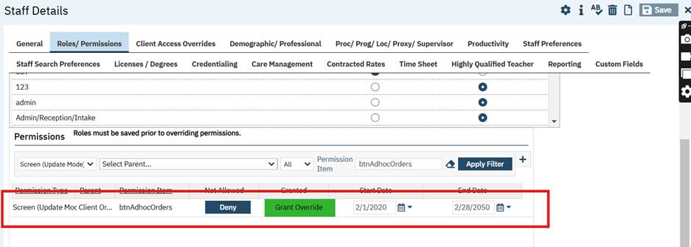
- The permission can be provided in Staff Details screen -- Roles/Permission tab – Permission section. By default, permission will be denied.
- When the permission is granted: Any users with this Permission as Granted will be allowed to access the Client Order Screen -- Order tab -- ‘Create Adhoc Order' button.
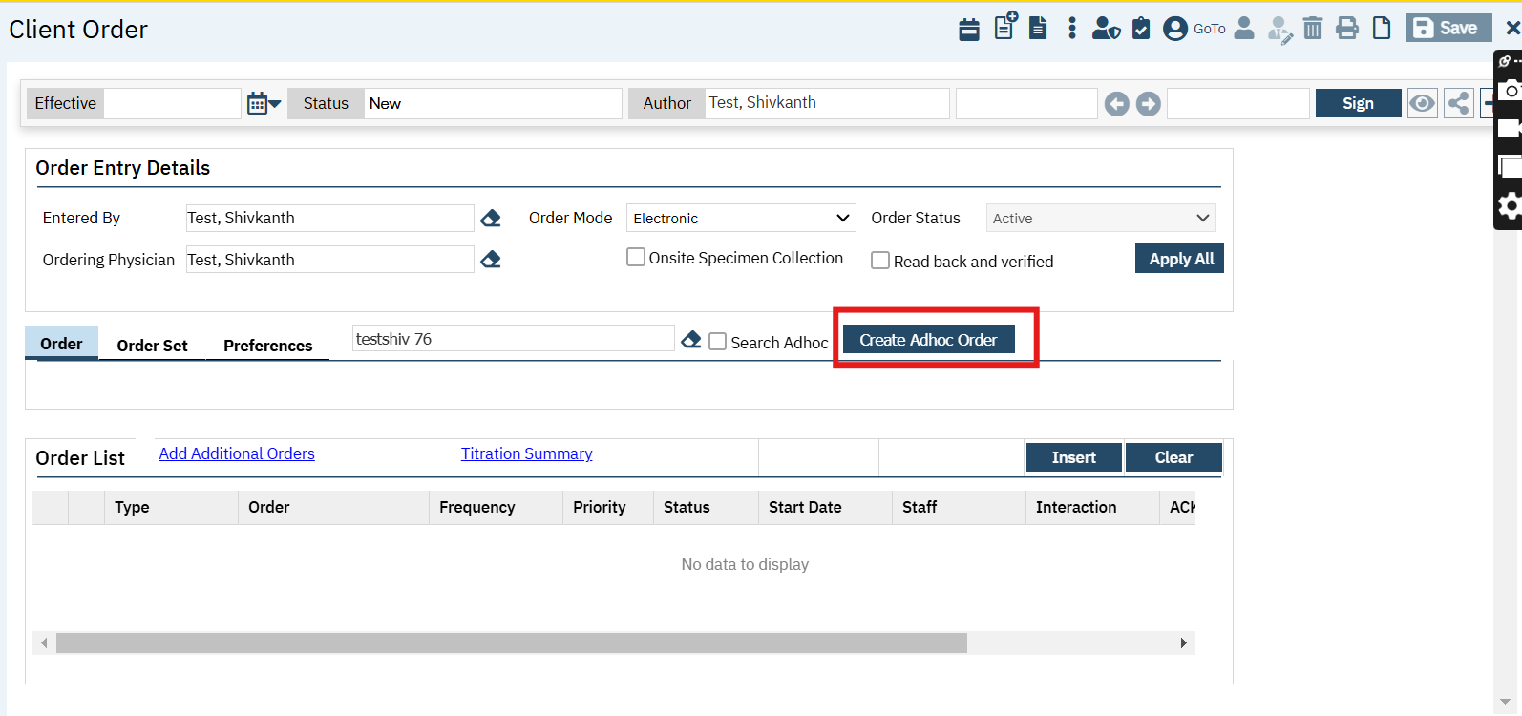
- When the permission is not granted: Any users with this Permission as Not Granted, will not be allowed access to the 'Create Adhoc Order' button (will be disabled/grayed out)
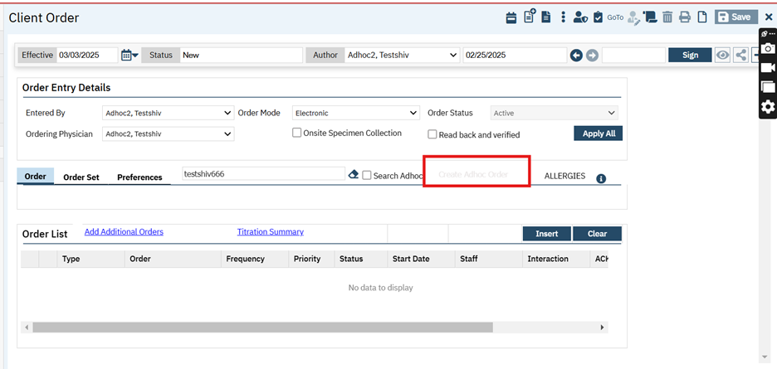
Convert/Revert Adhoc Order Permission Type:
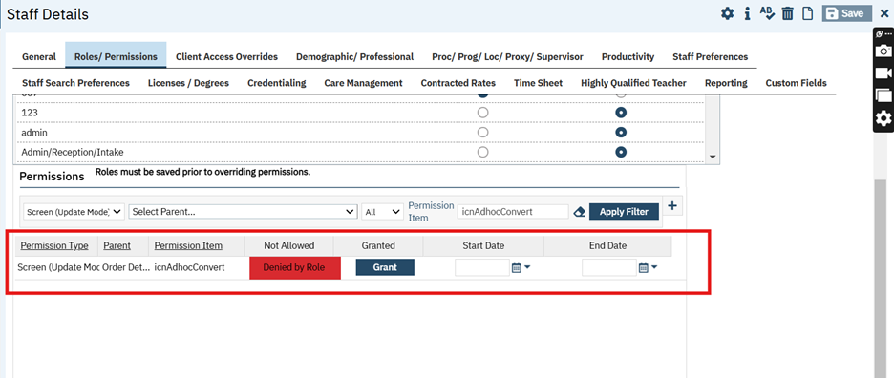
- The permission can be provided in Staff Details screen -- Roles/Permission tab – Permission section. By default, permission will be denied.
- When permission is granted: Any users with permission granted, will be able to see the ‘Convert Adhoc Order to a Regular Order’ and ‘Convert Regular Order to a Adhoc Order’ icons available on the Order Details screen (Toolbar Icon).

Data Model Change: Added a new table ‘OrderAdhocHistory’.

Author: Sithara Ponnath

109. Core Bugs # 130687: Lab Results Widget Showing Dates out of Order.

Release Type: Fix | Priority: Medium

Navigation Path: Go Search - Dashboard (My Office) -- Lab Results Widget.

Functionality ‘Before’ and ‘After’ release:

Before this release, here was the behavior. The 'Lab Results’ Widget in the Dashboard screen was not sorting records correctly by date.

With this release, the above-mentioned issue has been resolved. The records are now sorting by the 'Date Received'(in descending order) in the 'Lab Results Widget'.

Patient Lists/Reminders

Reference No | Task No | Description
110 | EII # 129885 | Added a Flag Details Pop-up window for ‘Action’ dropdown in the ‘Patient List/Reminders’ List Page
111 | EII # 129869 | Added Filters and Updated Action Dropdown in Patient List/Reminders List Page
112 | Core Bugs # 130857 | Client Lists/Reminders does not export when the user clicks on the ‘Seen/Not Seen in 'x' days’ radio button by using ‘Apply Filter’

Author: Girish Jayanna

110. EII # 129885 (Feature - 487401): Added a Flag Details Pop-up window for ‘Action’ dropdown in the ‘Patient List/Reminders’ List Page.

Release Type: Change | Priority: High

Navigation Path: ‘Client’ Search – ‘Patient List/Reminders’ List Page – ‘Filter’ section -- ‘Action’ dropdown.

Functionality ‘Before’ and ‘After’ release:

Purpose: To check whether the user can perform creating flag and removing flag with validation messages in ‘Patient List/Reminders’ List Page.

With this release, the "Create a Client Flag" and "Remove a Client Flag" have been implemented under the ‘Action’ dropdown of the ‘Patient List/Reminders’ List Page.

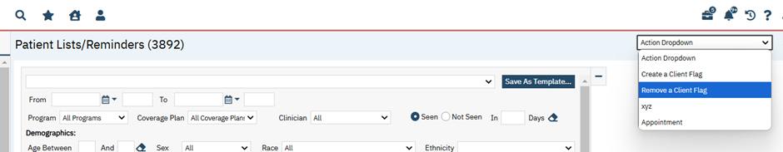

1. The ‘Flag Details’ pop-up window is displayed when clicking on 'Create a Client Flag" and 'Remove a Client Flag" under the ‘Action’ Dropdown of the ‘Patient List/Reminders’ List Page.

2. The ‘Flag Details’ pop-up window will have an 'x" in the top right-hand corner so the user can close the pop-up window.

3. The ‘Flag Details’ pop-up window will have an 'Apply’ and ‘Cancel’ button in the bottom right-hand corner of the pop-up window so that the user can apply their changes or cancel them.
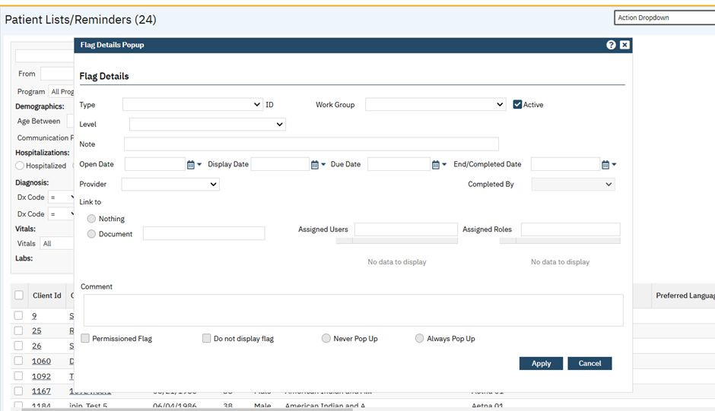
4. When the user clicks on the “Apply” button after adding a client flag, the below validation message popup will display with the warning message "Flags created successfully”.
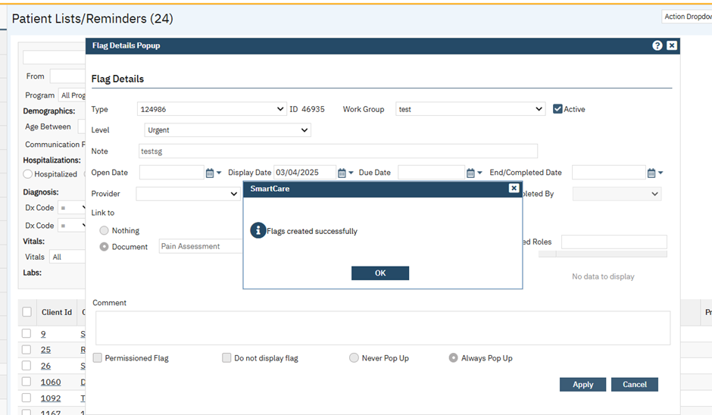
5. When the user removes a flag from ‘Client Flag Details’ and that flag does not exist on one or multiple clients selected in the list page, the below validation message will display.

Validation message: “Flag removed successfully on [x] out of [x] clients. Flag did not exist on some clients”

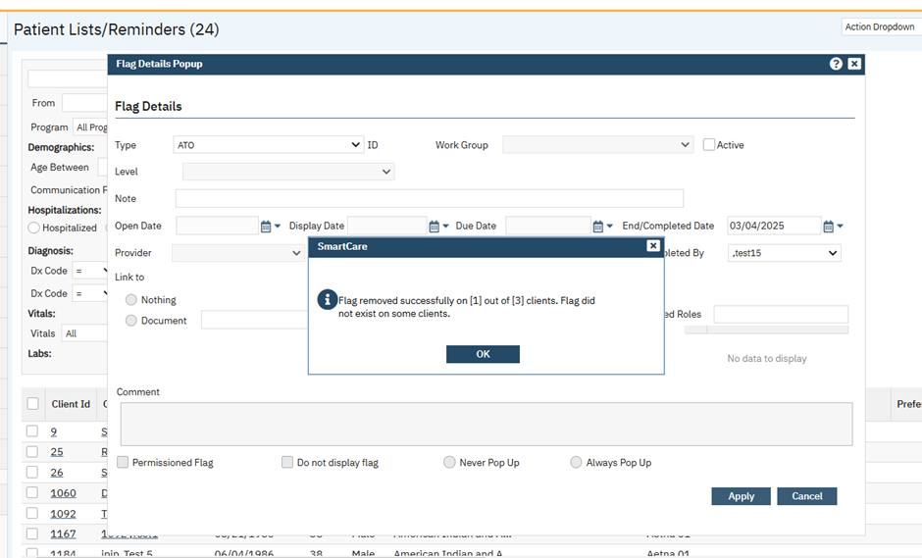

6. When “Remove Client Flag” action is selected under ‘Action’ dropdown, the flag details screen will only have ‘Type’, ‘Active’ checkbox, ‘End/Completed’ Date, and ‘Completed By’ fields enabled and all other fields will be disabled with no values populated.

7. After the user completes the client flag action and clicks on 'Apply' button, the system will complete/end all client flag records of the selected clients, with respect to the selected flag type.

Author: Ramya Nagaraj

111. EII # 129869 (Feature - 468430): Added Filters and Updated Action Dropdown in Patient List/Reminders List Page.

Release Type: Change | Priority: Urgent

Navigation Path: ‘My Office’ – ‘Patient Lists/Reminders’.

Functionality ‘Before’ and ‘After’ release:
Purpose: New filters – Coverage Plan, Zip Code, Flag Type are added to ‘Patient Lists/Reminders’ list page for better filtering options.

As part of this enhancement, new filters are introduced to ‘Patient Lists/Reminders’ list page.

Below are the filters that have been added newly.

1. Coverage Plan dropdown: It displays all active Coverage plan names. All Coverage Plans is the default
value set in this filter. It filters clients based on active Coverage Plans.
2. Zip Code textbox: It filters clients based on the zip code set in the Home Address section in Client
Information C screen.
3. Flag Type dropdown: It displays all active Flag names. It filters by clients who currently have a Flag
Type assigned. ‘All Flags’ is the default value set in this filter dropdown.

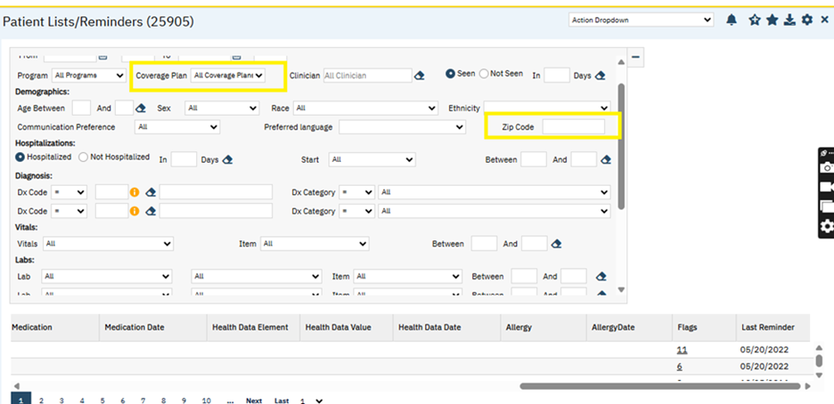

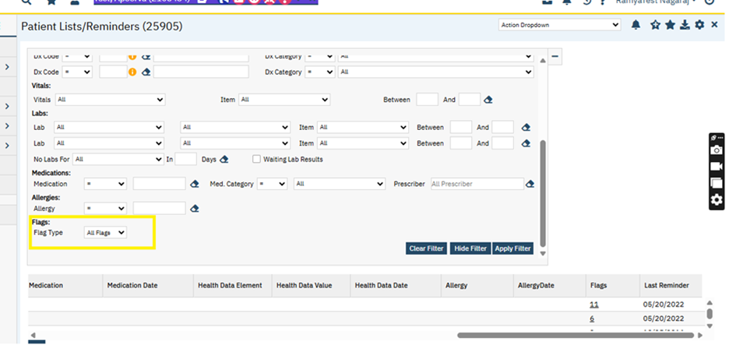
Also below new columns added into the grid .

1. Coverage Plan: Displays active coverage plan name for client. If client has multiple active coverage plans it displays all the plan names with comma separated.

2. Zip Code: It displays client's zipcode from Client Information > General > Zip Code in the Home
Address section.
3. Flags: Displays the number of active flags on the client for the From and To Dates the report has ran for.
When hovered over the number in the flags cell, a tool tip will display the flag icons that are active on
the client.

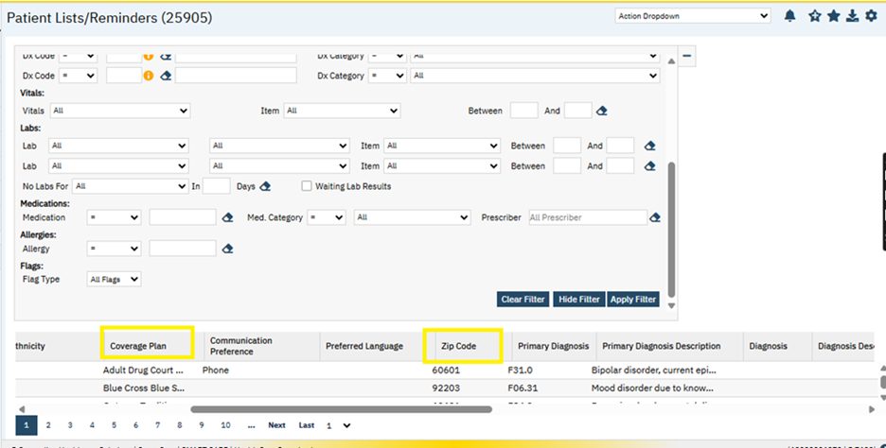

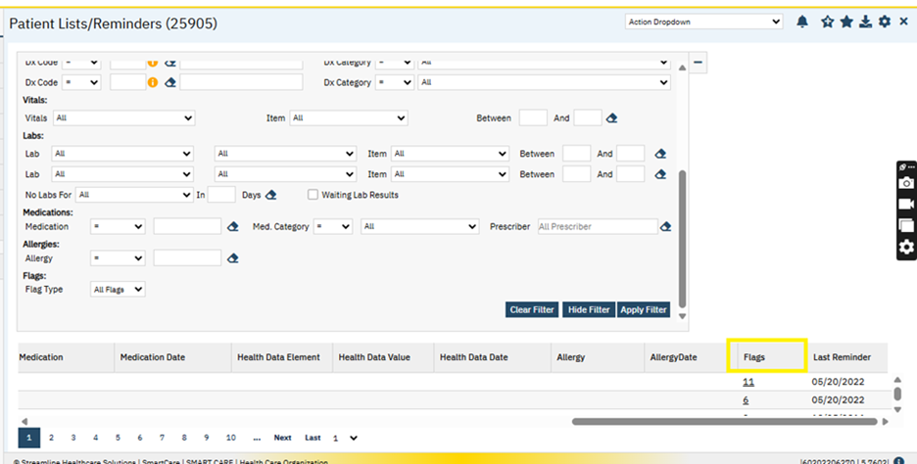

‘Patient Preference’ label is renamed to ‘Communication Preference’ in the Filter panel.

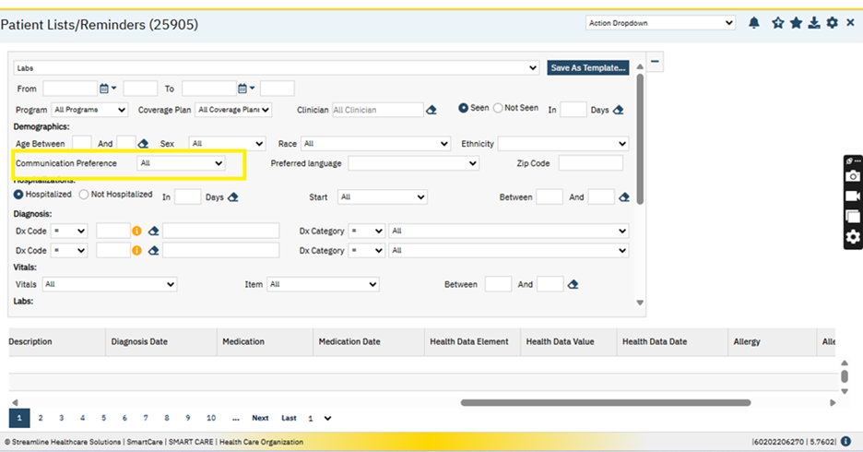
Existing filters are relocated in the filter panel. Similarly existing columns in the grid are relocated.

Below new labels are added into filter panel.

Demographics , Hospitalizations , Diagnosis , Vitals , Labs , Medications , Allergies , Flags .

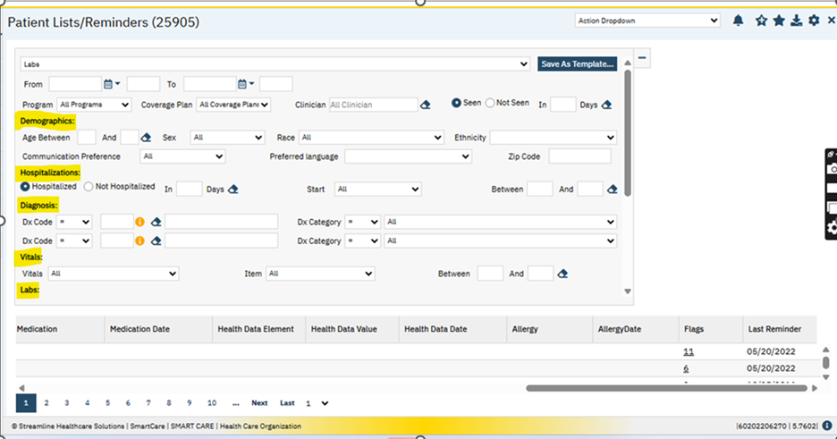

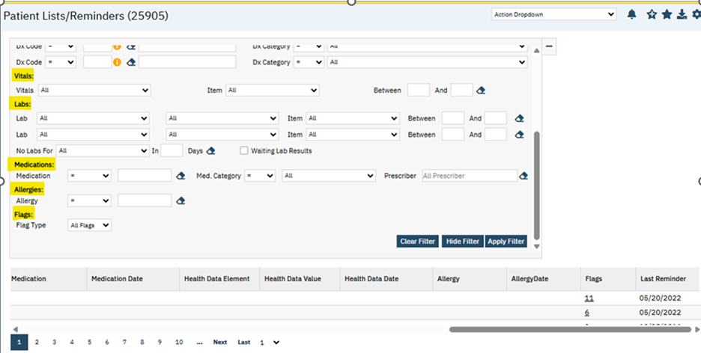

Also ‘Type of Reminder’ dropdown has been renamed to ‘Action Dropdown’.

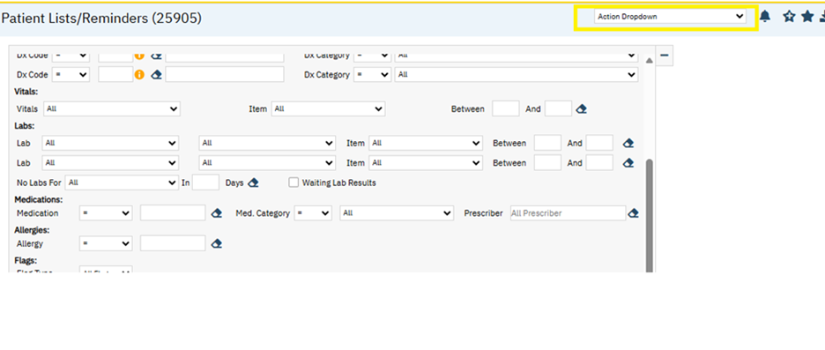

Author: Akshay Vishwanath

112. Core Bugs # 130857: Client Lists/Reminders does not export when the user clicks on the ‘Seen/Not Seen in 'x' days’ radio button by using ‘Apply Filter’.

Release Type: Fix | Priority: Medium

Navigation Path: Go Search – ‘Client Lists/Reminders’/ ‘Patient Lists/Reminders’ screen – Click on ‘Export’.

Functionality ‘Before’ and ‘After’ release:

Before this release, here was the behavior. The ‘Export’ button was not working when the user selected the ‘Seen/Not Seen in 'x' days’ radio button and clicked on ‘Apply Filter’.

With this release, the above-mentioned issue has been resolved. Now, the ‘Export’ button is working when the user selects the ‘Seen/Not Seen in 'x' days’ radio button and clicks on ‘Apply Filter’.

Payments/Adjustments

Reference No | Task No | Description
113 | EII # 129866 | Changes in the ‘Payments/Adjustments’ Details screen.
114 | Core Bugs # 130832 | Payment/Adjustments - Unable to click "Yes" on confirmation message.

Author: Arpita Biradar

113. EII # 129866 (Feature- 483345): Changes in the ‘Payments/Adjustments’ Details screen.

Release Type: Change | Priority: Urgent

Navigation Path 1: ‘My Office’ – ‘Payments/Adjustments’ – Payments/Adjustments list page.

Navigation Path 2: ‘My Office’ – ‘Payments/Adjustments’ – Click on ‘New EOB/Payment/Adjustment‘ button.

Navigation Path 3: ‘My Office’ – ‘Payments/Adjustments’ – Click on ‘Electronic Remittance’ button – Click on the hyperlink for the file that has to be imported.

Functionality ‘Before’ and ‘After’ release:

Purpose: To introduce a Deposit Date as part of payment records in SmartCare.

With this release, the following changes have been implemented.

1. Added a new field ‘Deposit Date’ to ‘Payment/Adjustment Details’ pop-up screen under ‘Activity’ tab under ‘Activity’ section.

When ‘Deposit Date’ is entered for the payments posting, it will be displayed for the respective payment records.
Screenshot for ‘Deposit date’ field in Payment/Adjustment Details pop-up screen:

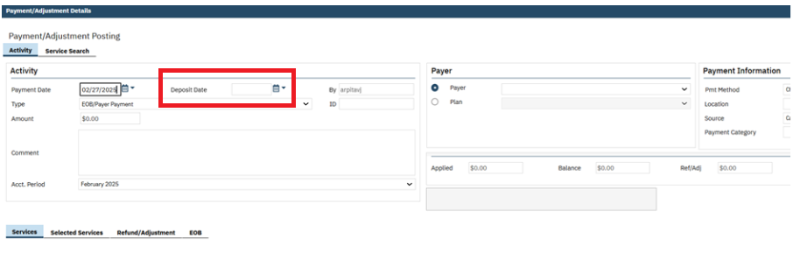
2. ‘Date’ field is changed to ‘Payment Date’ for the ‘Payment/Adjustment Details’ pop-up screen under the ‘’Activity tab under the ‘Activity’ section.

a. The field will continue to function as it currently does with initializing today's date.

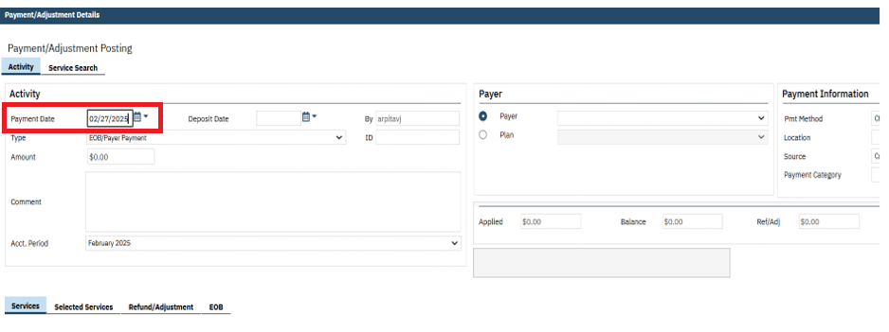

b. If the ‘Payment Date’ field is left blank and clicks on ‘Update’ button, the below validation message is displayed:

Validation Message: "Please select Payment Date.”

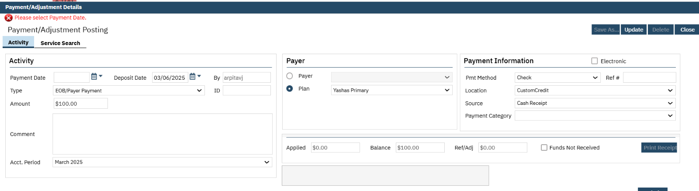
3. Added a new field ‘Deposit Date,’ to Electronic Remittance File Details, under File Details tab under File Data section.

a. When the users will manually enter the ‘Deposit Date’, when importing the 835 file for posting. It will pull the ‘Deposit Date’ into the ‘Deposit Date’ column for the respective ‘Payments/Adjustments’ record.
b. When the 835 file is processed through the Nightly billing job, it will create ‘Payments/Adjustments’ record and pulls the ‘Deposit Date’ into the ‘Deposit Date’ column in the Payment/Adjustment list page.

Screenshot for ‘Deposit date’ field in Electronic Remittance File Details pop-up screen:

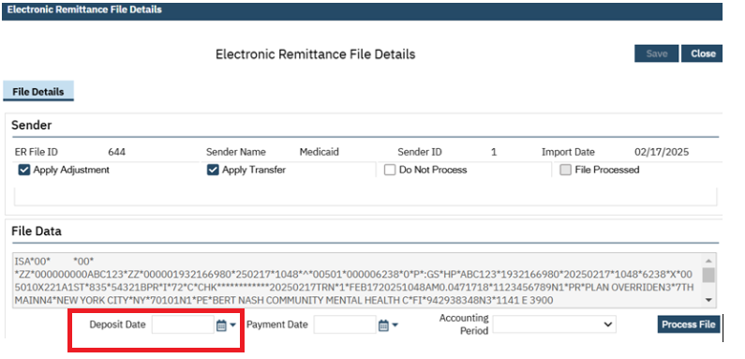

4.‘Payment/Adjustment’ list page:

- ‘Deposit Date’ field is added to the grid section of the ‘Payment/Adjustment’ list page.
- This list page has configurable columns, and the ‘Deposit Date’ field is added to the list of columns that are available for configuration.
- The ‘Deposit Date’ column is inserted after the ‘Ref/Adj Amt’ column and is displayed after the ‘Ref/Adj Amt’ column.
- The ‘Deposit Date’ column can be sorted ascending to descending.
- The new ‘Deposit Date’ column is exportable like the other columns on the list pages.

Screenshot for ‘Deposit Date’ column in Payment/Adjustment list page:

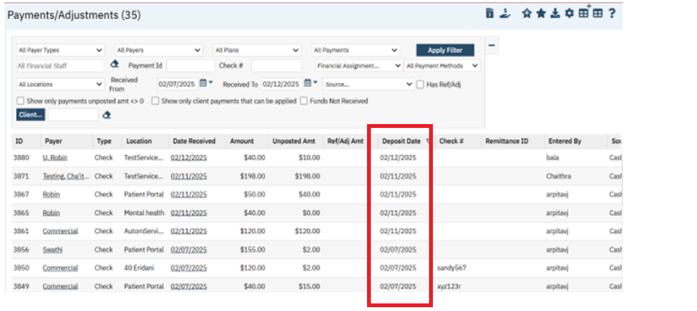

Data Model Changes:

A ‘DepositDate’ column is added to ‘Payments’ and ‘ERFiles’ table.

Author: Kiran Tigarimath

114. Core Bugs # 130832: Payment/Adjustments - Unable to click "Yes" on confirmation message.

Release Type: Fix | Priority: Medium

Navigation Path: 'My Office' - 'Payment/Adjustments' list page - 'Run the payment' - click on Close button.

Functionality ‘Before’ and ‘After’ release:

Before this release, here was the behavior. In 'Payment/Adjustments Details' screen, the user was not able to click ‘Yes' button in the Close Confirmation popup once after successfully running a Credit card payment transaction.

With this release, the above-mentioned issues have been resolved. Now, the user is able to click 'Yes' button in the Close Confirmation popup once after successfully running credit card payment transaction in 'Payment/Adjustments Details' screen.

Plans

Reference No | Task No | Description
115 | EII # 128497 | Plan Details: Front End: To Add options to either send the most recent PCN or the one from first billed claim.
116 | Core Bugs # 130932 | Value Code Records Getting Updated When Saving Plans

Author: Roopa Hemanna

115. EII # 128497 (feature - 430466): Plan Details: Front End: To Add options to either send the most recent PCN or the one from first billed claim.

Release Type: Change | Priority: Urgent

Navigation Path: ‘Administration’ -- ‘Plan’ -- click on ‘New’ button – or -- click on existing ‘Plan Name’ hyperlink -- ‘Plan Details’ screen -- ‘Genera’ tab -- ‘Claim Information’ section.

Functionality ‘Before’ and ‘After’ release:

Purpose: To add options to either send the most recent PCN or the one from the first billed claim.

With this release, the following functionalities have been implemented in Plan Details screen:
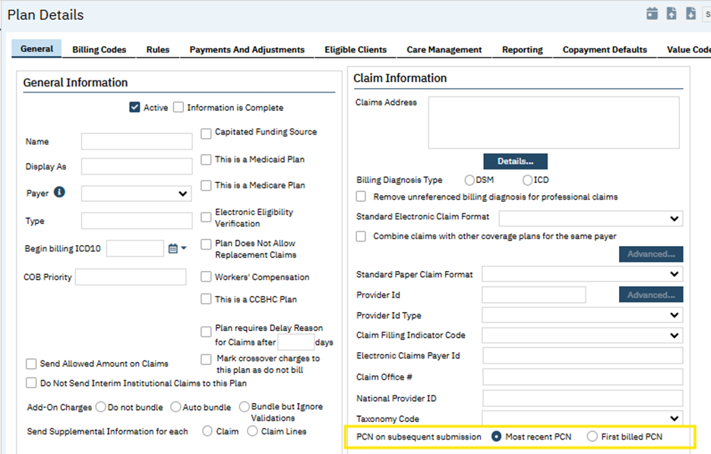

- A new field "PCN on subsequent submission" has been added in the Claim Information section of the General tab on the Plan Details screen.

- New radio button options have been provided, allowing the selection of either "Most recent PCN" or "First billed PCN".

- By default, the "Most recent PCN" radio button will be selected for plans.

- The PCN on the Claim will be determined based on the configuration set at the Plan level, allowing the users to choose whether the PCN for secondary claims billed under the Plan is sent from the first billed claim (instead of the most recent claim which is the current functionality).

Data Model Changes: New Column "SubsequentClaimPCNOption" added in Table "CoveragePlans".

Author: Yashas Kydalappa

116. Core Bugs # 130932: Value Code Records Getting Updated When Saving Plans.
Release Type: Fix | Priority: High
Prerequisite:
Coverage Plan is saved with value codes with a suitable data under value codes tab of Plan Details through the Path:
Go Search -- ‘Plans’-- ‘Plans’ list page – click on plan name hyperlink or new button -- ‘Plans Details’ screen -- click on ‘Value Codes’ tab and fill all mandatory fields with suitable billing and revenue codes with procedure rate Id and save the coverage plan.
Navigation Path: Go Search -- ‘Plans’ -- ‘Plans’ list page – click on plan name hyperlink or new button -- ‘Plans Details’ screen.
Functionality ‘Before’ and ‘After’ release:
Before this release, here was the behavior. When the value codes were copied from the different coverage plan’s value codes by using the ‘Use Value Codes from Specified Plans’ template, the selected ‘Payer Type’ in different coverage plan was automatically updating to the ‘Payer Type’ of the first coverage plan.
With this release, the above-mentioned issue has been resolved. Now, whenever on copying the value codes from different coverage plans value codes by using ‘Use Value Codes from Specified Plans’ template, the payer Type in different coverage plan is not getting updated from the Payer Type of first coverage plan.

Procedure/Rates

Reference No | Task No | Description
117 | Core Bugs # 130731 | Performance issue observed in 'Ready to Bill' step in the Nightly Billing job

Author: Debanjit Das

117. Core Bugs # 130731: Performance issue observed in 'Ready to Bill' step in the Nightly Billing job
Release Type: Fix | Priority: Medium
Navigation Path: N/A
Functionality ‘Before’ and ‘After’ release:
Before this release, here was the behavior. The 'Ready to Bill' step in the Nightly billing job was not completing or taking lot of time to complete due to a bad execution of the plan in the SQL server.
With this release, the above-mentioned issue was resolved. Now, the Nightly billing job is optimized, and the performance is improved.

Provider Contracts

Reference No | Task No | Description
118 | Core Bugs # 130724 | Provider Summary shows expired contract expiration.

Author: Renuka Gunasekaran

118. Core Bugs # 130724: Provider Summary shows expired contract expiration.

Release Type: Fix | Priority: High

Navigation Path: 'My Office' -- 'provider Contract' -- Select Provider hyperlink -- Select 'Provider Summary’.

Functionality ‘Before’ and ‘After’ release:

Before this release, here was the behavior. In 'Provider Summary' screen, 'Contract Expiration date' was displaying the random contract expiration date which was linked with provider in 'provider Summary' screen.
With this release, the above-mentioned issue has been fixed and in 'Provider Summary' screen, 'Contract Expiration date' is Displaying the nearest future date or if there is no future date, then the recent past due date of the contract which is linked with the provider.

Reception

Reference No | Task No | Description
119 | EII # 129999 | Added Mode of Delivery on Front Desk/Reception Screen.
120 | Core Bugs # 130848 | Reception: Column Configurations won't sort properly

Author: Niroop Hassan

119. EII # 129999 (Feature - 489848): Added Mode of Delivery on Front Desk/Reception Screen

Release Type: Change | Priority: Urgent

Navigation Path: ‘My Office’ – ‘Reception/Front Desk’ - ‘Reception/Front Desk’ list page – Click on ‘New Column Configuration’ icon – ‘Mode Of Delivery’ option.

Functionality ‘Before’ and ‘After’ Release:

Purpose: Added ‘Mode Of Delivery’ column on Reception/Front Desk screen, so staff would know which “Mode Of Delivery” the appointment has, without going to a different screen.

With this Release, the following change has been implemented in Front Desk/Reception Screen:

1. ‘The "Mode Of Delivery" (MOD) field has been added in the List Page Configurations pop up in the ‘Original’ view, but it will not be visible by default in Front Desk/Reception Screen. Mode Of Delivery field will remain inactive or hidden in the ‘Original’ view of the Configuration option pop-up.
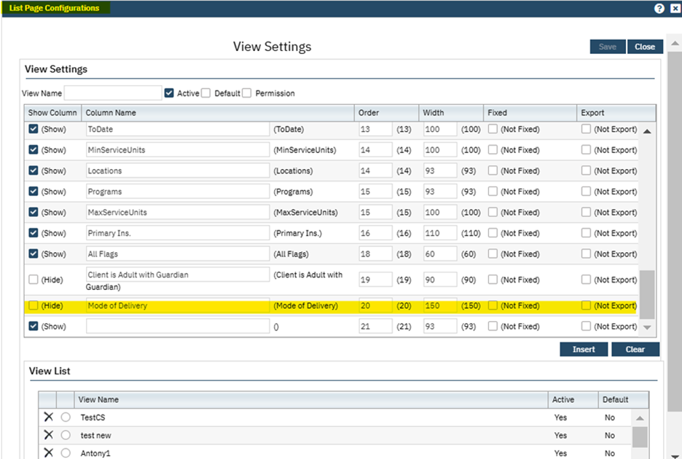

2. Users are allowed to enable the field to be displayed on the Front Desk/Reception Screen, either in their original view or customized view.

3. When the Mode Of Delivery field is displayed, it will remain blank for Arrivals and Primary Care Appointments, as it is not applicable to these service types.

‘All Mode Of Delivery’ Filter section:

1. This field will be displayed only when ‘Mode Of Delivery’ column is present in the selected view (Original or customized view).

2. If the Mode Of Delivery column is not active/hidden in the selected view, then filter will automatically be hidden.

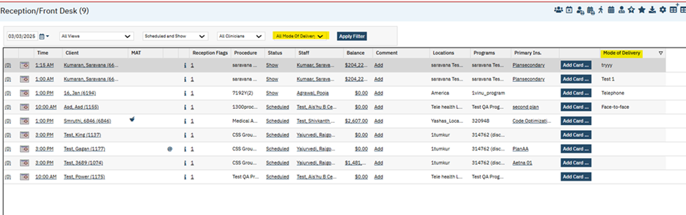

Author: Niroop Hassan

120. Core Bugs # 130848: Reception: Column Configurations won't sort properly.

Release Type: Fix | Priority: High

Navigation Path: ‘My Office’ menu – ‘Reception/Front Desk’ - ‘Reception/Front Desk’ list page – Click on ‘New Column Configurations’ icon – ‘List Page Configurations’ popup – Select the required view radio button and modify ‘MAT’ column order number – Click on ‘Modify’ button – Click on ‘Save’ button.

Functionality ‘Before’ and ‘After’ Release:

Before this release, when the user attempted to modify the order number of the 'MAT' column, the order change did not apply correctly.

With this release, the above-mentioned issue has been resolved, and the user can now modify the order number of the 'MAT' column.

Reports

Reference No | Task No | Description
121 | EII # 129595 | Implemented a ‘FQHC Programs’ dropdown option in the Filter section for all UDS reports
122 | Core Bugs # 130548 | Productivity De tails Report: column data not displaying correctly
123 | Core Bugs # 130639 | UDS Table 6B Details -Section E’ Report Showing Duplicate rows for some patients

Author: Santhosh Krishnegowda

121. EII # 129595 (Feature – 475600): Implemented a ‘FQHC Programs’ dropdown option in the Filter section for all UDS reports.
Release Type: New| Priority: On Fire
Navigation Path 1: ‘My Office’ – ‘UDS Table Patients by ZIP Code’

Navigation Path 2: ‘My Office’ – ‘UDS Table 3A Patients by Age and Sex’

Navigation Path 3: ‘My Office’ – ‘UDS Table 4 Selected Patient Characteristics

Navigation Path 4: ‘My Office’ – ‘UDS Table 3B Demographic Characteristics

Navigation Path 5: ‘My Office’ – ‘UDS Table 6A Selected Diagnoses and Services Rendered

Navigation Path 6: ‘My Office’ – ‘UDS Table 6B Quality Of Care Measures

Navigation Path 7: ‘My Office’ – ‘UDS Table 7 Health Outcomes and Disparities

Navigation Path 8: ‘My Office’ – ‘UDS Table 5 Staffing and Utilization

Navigation Path 9: ‘My Office’ – ‘UDS Table 9D Patient-Related Revenue

Navigation Path 10: ‘My Office’ – ‘UDS Table 6B Details - Section C

Navigation Path 11: ‘My Office’ – ‘UDS Table 6B Details - Section E

Navigation Path 12: ‘My Office’ – ‘UDS Table 6B Details - Section A and B

Navigation Path 13: ‘My Office’ – ‘UDS Table 6B Details - Section D

Navigation Path 14: ‘My Office’ – ‘UDS Table 6B Details - Section F

Navigation Path 15: ‘My Office’ – ‘UDS Table 6B Details - Section M

Navigation Path 16: ‘My Office’ – ‘UDS Table 6B Details - Section G

Navigation Path 17: ‘My Office’ – ‘UDS Table 6B Details - Section I

Navigation Path 18: ‘My Office’ – ‘UDS Table 6B Details - Section J

Navigation Path 19: ‘My Office’ – ‘UDS Table 6B Details - Section K

Navigation Path 20: ‘My Office’ – ‘UDS Table 6B Details - Section H

Navigation Path 21: ‘My Office’ – ‘UDS Table 6B Details - Section L Line 21

Navigation Path 22: ‘My Office’ – ‘UDS Table 6B Details - Section L Line 21a
Functionality ‘Before’ and ‘After’ release:

Purpose: This enhancement is to add a Program filter to all UDS reports. Report needs to follow staff client access rules, including CDAG so that the logged in user running the report can only see the records permissioned to that user.

With this release, FQHC Programs’ filter has been implemented to all UDS reports which display Programs that have Programs Details > Reporting Tab > FQHC checkbox selected.

‘FQHC Programs’ is a multiselect dropdown with ‘All FQHC Programs’ option. By Default, all ‘FQHC programs’ are selected. This will allow FQHC customers to filter clients by ‘FQHC program’.

Author: Chaitali Patil

122. Core Bugs # 130548: Productivity Details Report: column data not displaying correctly
Release Type: Fix | Priority: High
Prerequisite: To display the data in the report, Create the data below through the path:
Supervision Hierarchy -- Team Productivity -- Productivity Target/offset - Staff Target (Use same program in all places) --then create the Service and complete the service with the past date.
After this set up Execute this Job SP in DB - ssp_SCCalculateOpenPeriodProductivityMetrics
Navigation Path: Go search – ‘Productivity Details Report’ (My Office) – select the required fields and click on ‘View Report’.
Functionality Before and After Release:
Before this release, here was the behavior. In the Productivity Details Report, as per the filter selection, ‘Team Target to Date’ and ‘Team Hours to Date’ column data were not displayed correctly.
With this release, the above-mentioned issue has been resolved. Now as per the filter selection, ‘Team Target to Date’ and ‘Team Hours to Date’ column data is displaying correctly

Author: Ravindra Pitta

123. Core Bugs # 130639: ‘UDS Table 6B Details -Section E’ Report Showing Duplicate rows for some patients.
Release Type: Fix | Priority: High.

Navigation Path: My Office -- UDS Table 6B Details - Section E’ Report.
Functionality ‘Before’ and ‘After’ release:
Before this release, here was the behavior. In the ‘UDS Table 6B Details -Section E’ report, duplicate entries/records were displayed for some patients.
With this release, the above-mentioned issue has been resolved. Now, the duplicate entries/records are not displayed in the ‘UDS Table 6B Details -Section E’ report.

RWQM

Reference No | Task No | Description
124 | Core Bugs # 130630 | RWQM Work Queue: RWQM Action Popup Is Blank

Author: Namratha Nagraj

124. Core Bugs # 130630: RWQM Work Queue: RWQM Action Popup Is Blank.

Release Type: Fix | Priority: High

Navigation Path: Go Search bar -- RWQM Work Queue (My Office) -- Select the ‘Charge Ids’ -- Click on ‘Queue Actions’ dropdown -- Select ‘Apply Action from Another item’ -- RWQM Action pop up will be displayed.

Functionality ‘Before’ and ‘After’ release:

Before this release, here was the behaviour. In RWQM Work Queue screen, when a user selected the multiple charges and clicked on ‘Queue Actions’ dropdown and selected ‘Apply Action from Another item’, the RWQM Action pop-up was displayed blank.

With this release, the above-mentioned issue is Resolved. Now when a user selects multiple charges and clicks on ‘Queue Actions’ dropdown and selects ‘Apply Action from Another item’, the RWQM Action pop-up will be displayed with Work Queue Items grid with its respective columns.

Rx Application

Reference No | Task No | Description
125 | Core Bugs # 130678 | Edge Case Bug - Medication Management and the 'Administrator' Checkbox
126 | Core Bugs # 130728 | When a user clicks on the ‘Insert’ button on the Add Medication Page, the ‘End Date’ value was not acceptable and the appropriate validation message is not displayed
127 | Core Bugs # 130807 | Rx: Prescription preview screen does not load the data

Author: Manjunath Mallipatil

125. Core Bugs # 130678: Edge Case Bug - Medication Management and the 'Administrator' Checkbox

Release Type: Fix | Priority: Medium

Prerequisite:

- The Value of the Configuration key ‘DisplayStaffAsTypeableSearchTextBox’ is set to ‘Yes’.
- Administrator (Enables the Administration Tab) Check box is checked for the Non-Prescriber in the Staff Details Screen General tab Access Rights Section.

Navigation Path: Login to SmartCare application as non-prescriber – search and select a client – Medication Management (Client) --- In Patient Summary Screen, Click On New Button – Search and select the Prescriber from the Typeable search Prescriber field --- Search and select the medication – click on Titrate Button.

Functionality ‘Before’ and ‘After’ release:

Before this release, here was the behavior. When a Non-Prescriber Selected any other Prescriber by Searching the name of the Prescriber in Typeable Search Text field of Prescriber, when the user tried to Titrate the medication, an error message is displayed.

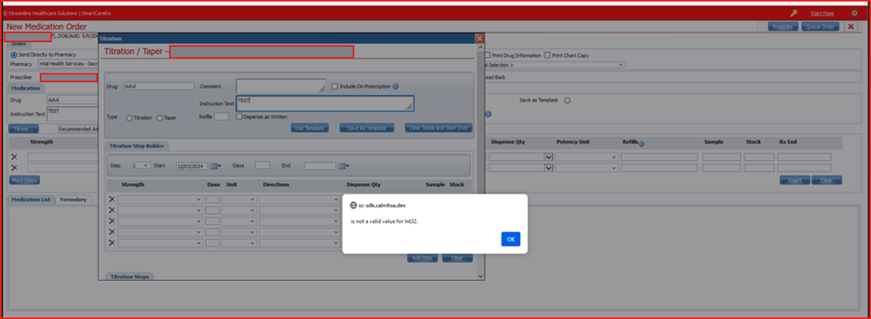

With this release, the above-mentioned issue is resolved and is working as expected. The user is able to Prescribe the titrated medications without any errors.

Author: Rajgopal Yajurvedi

126. Core Bugs # 130728: When a user clicks on the ‘Insert’ button on the Add Medication Page, the ‘End Date’ value was not acceptable and the appropriate validation message is not displayed.
Release Type: Fix | Priority: Medium

Navigation Path: Login to ‘SmartCare Application’ - ‘Client’ search – ‘Medication Management(Rx)’ link – ‘Rx Application’ – ‘Patient Summary’ screen - Click on ‘Add Medication’ button - ‘Add Medication (Not Ordered Locally)’ page - Search Medication with first three letters - Enter the value - In the ‘End Date’ box update values other than date - Click on ‘Insert’ button.
Functionality ‘Before’ and ‘After’ release:
Before this release, here was the behavior. When a user clicked on the ‘Insert’ button on the Add Medication Page, the ‘End Date’ was not acceptable value, and an appropriate validation message was not displayed. Instead, an below incorrect validation message was displayed.
Validation Message: “Please enter medication Data Initiated”
With this release, the above-mentioned issue has been resolved. Now, the correct validation message is displayed as below when a user clicks on the ‘Insert’ button on the Add Medication Page and the End Date is not an acceptable value.

Validation Message: “Please enter/verify Rx Start and End Dates. “

Author: Rajgopal Yajurvedi

127. Core Bugs # 130807: Rx: Prescription preview screen does not load the data
Release Type: Fix | Priority: High

Prerequisite: Prescribe multiple medications via the path below.

Login to SmartCare Application - ‘Client’ – ‘Medication Management Rx’ link – Rx Application – ‘Patient Summary’ screen – New Order button – New Medication Order Page - Select the Drug with starting three letters – Fill all required fields - Select the Method(Print/Fax/EPCS Pharmacy) - click on ‘Insert’ button - Click ‘Prescribe’ button - Patient Summary page.

Navigation Path: Login to SmartCare Application - ‘My Office’ – ‘Medication Management’ link – Rx Application – Start Page - Pending Review button - Prescription Review page.

Functionality ‘Before’ and ‘After’ release:

Before this release, here was behavior. The Prescription Review page of the Rx Application, was displaying a blank page due to data not loading.

With this release, the above-mentioned issue has been resolved. Now, the data on the Prescription Review page is loading and displaying correctly.

Screens

Reference No | Task No | Description
128 | EII # 127493 | Implemented Configurable option at screen level for setting up delete confirmation message

Author: Kiran Tigarimath

128. EII # 127493 (Feature - 364129): Implemented Configurable option at screen level for setting up delete confirmation message.
Release Type: Change | Priority: Urgent

Navigation Path 1: ‘Administration’ – ‘Screens’ – ‘Navigate to Screen Details’.

Navigation Path 2: ‘Client’ – ‘Select the respective Document or service Note’.

Functionality ‘Before’ and ‘After’ release:

Purpose: To enhance delete functionality across all screens where delete feature exists in the application.

With this release, the delete functionality is implemented to ensure consistency across all screens with delete feature. The validation/warning messages will dynamically display when the user tries to delete the document or service notes based on the stored procedures configured in the respective Screen Details as follows:

1. On clicking Delete, if there are no stored procedures mentioned in “Validation On Delete” and “Warning On Delete” fields of the Screen Details, then the validation message “Are you sure you want to Delete this Record?” will be displayed. This is an existing functionality.

2. On clicking on Delete, if one of the stored procedures is mentioned in any of “Validation On Delete” or “Warning On Delete” fields of the Screen Details, then following will occur;

2.1. If Validation stored procedure is mentioned, the output validation messages resulted from the stored procedure will be displayed as a validation. User will not be able to delete the respective screen until the validations are fixed and satisfied.

2.2. If Warning stored procedure is mentioned, the output warning messages resulted from the stored procedure will be displayed as a warning/confirmation message along with “Are you sure you want to Delete this Record?” If “OK” is clicked on the Confirmation Message, the record will be deleted. If “Cancel” is clicked on the Confirmation Message, no change happens, and the Pop up will be closed.

3. On clicking Delete, if both the stored procedures are mentioned in “Validation On Delete” and “Warning On Delete” fields of the Screen Details”, then first validation message will get displayed only after validations are fixed and satisfied, then the warning/confirmation message will get displayed.

Services

Reference No | Task No | Description
129 | Core Bugs #130085 | A red error was getting displayed in the Service Detail screen
130 | Core Bugs # 130618 | Mode of Delivery is not updated in the Services
131 | Core Bugs # 130674 | Bed services are created for the same day admit and discharge by considering the Client Inpatient Visit Admit Date
132 | Core Bugs # 130689 | Unable to search for service Id’s that are larger than 9 digits
133 | Core Bugs # 130790 | Getting error when 'Create Bed Services' job is executed

Author: Sunil Belagali

129. Core Bugs # 130085: A red error was getting displayed in the Service Detail screen.
Release Type: Fix | Priority: Medium

Prerequisite:
1. System configuration key “DisplayStaffAsTypeableSearchTextBox” is set to ‘Yes’.
Navigation Path: Login to SmartCare application – Client – ‘Services’ list page - Click on ‘New’ – Service Detail Page – Click on ‘Procedure’ dropdown and don’t select anything– Click on 'Program’ dropdown and select any Program – Now change the Status from Scheduled to Show – Observe that red error is displayed.
Functionality ‘Before’ and ‘After’ release:
Before this release, here was the behavior. When the user tried to create a Services for the client, selected the Program and changed the Status from ‘Scheduled’ to ‘Show’, a red error was displayed.
Red error: Error occurred during dataset merge process at server side, please contact system administrator for further assistance.
With this release, the above-mentioned issue has been resolved. Now when the user tries to create a Services for the client, selects the Program and changes the Status from ‘Scheduled’ to ‘Show’, no red error is displaying.

Author: Lavanya Shivakumar

130. Core Bugs # 130618: Mode of Delivery is not updated in the Services.

Release Type: Fix | Priority: High
Prerequisites:
1.Service exists with the ‘Show’ status, and it includes the ‘Mode of Delivery’ options.
2. Complete the service notes for the charge associated with the show status.
Navigation Path 1: Go Search-Select Services (Client)-Select a service (which is mentioned in Prerequisite) -Navigate to the Services/Note (Client)- click on the sign.
Navigation Path 2: Go search- Services (My Office)- Select the service (Signed service note from the Navigation Path 1)- Click on the DOS(date of Service) Hyperlink-Change the status to ‘Complete- Click on close -’Select Error, show and Move note from Action drop down –Click on Yes in the Service Action Pop up.
Functionality ‘Before’ and ‘After’ release:
Before this release, here was the behavior. When the user selected the completed services in the services list page and selected the “Error, Copy and Move note” from the select action dropdown, two services were created. Then, the ‘Mode of delivery’ was missing in the newly created services.
With this release, the above-mentioned issue was resolved. Now, when the user selects the completed services in the services list page and selects “Error, Copy and Move note”, the mode of delivery is displayed correctly in the newly created services.

Author: Roopa Hemanna /Sahana Gururaja

131. Core Bugs # 130674: Bed services are created for the same day admit and discharge by considering the Client Inpatient Visit Admit Date.
Release Type: Fix | Priority: High
Navigation Path: 'Administration' -- ‘Programs’ -- ‘Programs’ list page -- click on new button or existing program name hyperlink -- 'Program Details' screen -- 'Categories' section – Check 'Create Service for Same Day Admit and Discharge' checkbox.
Functionality ‘Before’ and ‘After’ release:
Before this release, here was the behavior. The following issues were observed,
1. The system incorrectly billed bed days on the discharge date for clients. This resulted in bed-day services being erroneously applied to clients in incorrectly billed revenue.
2. Bed day services were billed on the discharge date unless the client was admitted and discharged on the same day, causing inaccurate billing.
3. Manual intervention was required to identify and correct the errors, which was time-consuming and error-prone, given the volume of affected clients.
With this release, the above-mentioned issues have been resolved. Now,
1. A new function has been implemented in the logic of the ‘ssf_SCCreateServicesBedAssignmentDates’ function to handle cases where “CreateServiceForDischargeDate = 'Y'.” This ensures that the nightly billing job "Create Bed Services" (ssp_SCCreateServicesBedAssignments), creates services for same day admit and discharge by considering the Client Inpatient Visit Admit Date.
2. Added a new system configuration key “AllowBedServicesCreationToErrorBilledServices” to determine when to ‘Error’ the bed services.
Test scenarios for the Same Day Admit and Discharge Programs:
Scenario 1: When the 'Create Service for Same Day Admit and Discharge' checkbox is checked in the ‘Program Details’ screen.
1. Same Day Admit and Discharge Service Creation:
A Bed service will be created for the admission date when user creates inpatient visit for a client and assign them to a bed under program and discharge the client from both the bed and the inpatient visit on the same day.
2. Service Creation After Bed Transfer:
The job will create the Bed service only from the admit day even though the checkbox is checked, when user creates an inpatient visit for a client and assign them to a bed under the program and transfers the client to a different bed and discharge them from the second bed next day.
Scenario 2: When the 'Create Service for Same Day Admit and Discharge' checkbox is not checked in the ‘Program Details’ screen.
Prerequisites:
- An inpatient visit for the client is created, through the path: ‘My Office’ – ‘Bed board’ -- ‘Admit’ to Client in ‘Bed board’
- "ssp_SCCreateServicesBedAssignments" job is executed. The job will create a bed service entry for a client.
Test Scenarios:
1. When an inpatient Visit is created for a client for more than 2 days and on executing the ‘ssp_SCCreateServicesBedAssignments’, the bed services will be created, and services will be marked as ‘Complete’ through Manual or Nightly Billing Job, after service is completed if the bed assignment Admit and Discharge dates are changed to different days, then when a ‘ssp_SCCreateServicesBedAssignments’ job is executed the previously created bed services will be ‘Errored’.
2. Configuration Key: If “AllowBedServicesCreationToErrorBilledServices” is set to ‘No’ and when an inpatient Visit is created for a client for more than 2 days and on executing the ‘ssp_SCCreateServicesBedAssignments’, the bed services will be created, and services will be marked as ‘Complete’ and the charges are ‘Billed’. After billing, if the bed assignment Admit and Discharge dates are changed to different days, then when a ‘ssp_SCCreateServicesBedAssignments’ job is executed, the previously billed bed services will not be ‘Errored’ in this case.
If the “AllowBedServicesCreationToErrorBilledServices” configuration key value is set to ‘Yes’, then the previously billed bed services will be ‘Errored’.
3. Configuration Key: If the “ALLOWSERVICEERRORWITHPAYMENT” key value is set to ‘N’, and “AllowBedServicesCreationToErrorBilledServices” configuration key value is set to ‘Yes’.
When an inpatient Visit is created for a client for more than 2 days and on executing the ‘ssp_SCCreateServicesBedAssignments’, the bed services will be created, and the services will be marked as ‘Complete’, Bill the charges and applies payments to these bed services. After posting a payment, if the bed assignment Admit and Discharge dates are changed to different days, then when a ‘ssp_SCCreateServicesBedAssignments’ job is executed, the previously created bed services with payments will not be ‘Errored’ in this case.
If the “ALLOWSERVICEERRORWITHPAYMENT” configuration key value is set to ‘Y’ , then the previously created bed services with payments will be ‘Errored’.
Configuration Key Details:
Key: AllowBedServicesCreationToErrorBilledServices
Read Key as Allow Bed Services Creation to Error Billed Services.
Default Value: No
Allowed Values Yes, No
Modules: Bed Census / Bed Board / Client Inpatient Visits
Description: Read Key as: Allow Bed Services Creation to Error Billed Services
Overnight processing for Bed Assignments will create services for bed assignments and error services created by the process when the bed assignment record or configuration changes.
If this key is set to 'No', the system will not error services with billed charges. Invalid bed services with billed charges will need to be manually reviewed and errored.
If the key is set to 'Yes', the system will error services with billed charges.
Erroring any service with a billed charge in the system will automatically mark the charge to be voided.
If this key is set to 'Yes', the paid services will still only be errored if configuration key ALLOWSERVICEERRORWITHPAYMENT is also set to 'Y'.

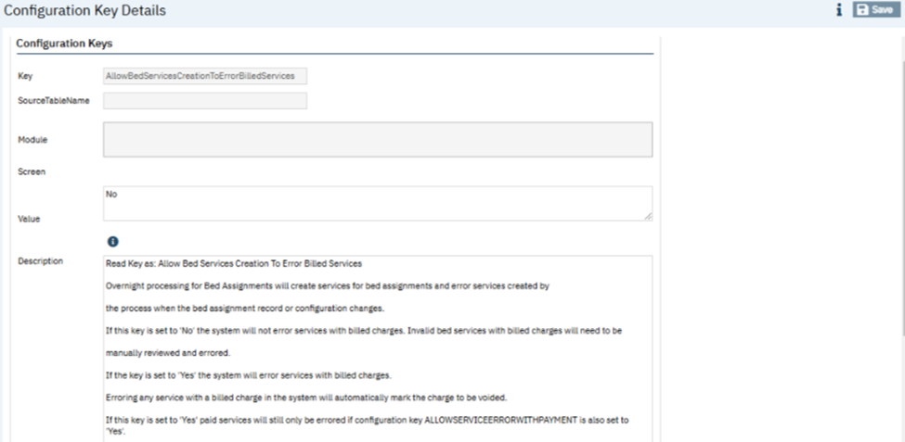

Author: Chaithra Kunjilana

132. Core Bugs # 130689: Unable to search for service Id’s that are larger than 9 digits.
Release Type: Fix | Priority: Medium
Navigation Path: Go Search- Services (My Office)- Enter Service Id.
Functionality ‘Before’ and ‘After’ release:
Before this release, here was the behavior. The Service ID field in the Service list page was restricted to only 9 digits and the users were unable to search for Service ID's that were larger than 9 digits.
With this release, the above-mentioned issue is resolved. Now, the limit of the service Id’s field is fixed to 10 digits and added the below mentioned warning message if search value is exceeding a maximum integer 2147483647.
Warning message: Please enter the valid integer value not exceed 2147483647.

Author: Debanjith Das

133. Core Bugs # 130790: Getting error when 'Create Bed Services' job is executed.
Release Type: Fix | Priority: Medium

Navigation Path: N/A

Functionality ‘Before’ and ‘After’ release:
Before this release, here was the behaviour. The 'Create Bed Services' job step in the Nightly billing job failed due to below mentioned error message.
Error Message: Null value is eliminated by an aggregate or other SET operation. [SQLSTATE 01003] (Message 8153) Warning: Null value is eliminated by an aggregate or other SET operation. [SQLSTATE 01003] (Message 8153) The INSERT statement conflicted with the FOREIGN KEY constraint "Services_ServiceDiagnosis_FK". The conflict occurred in database "SmartcareProd", table "dbo.Services", column 'ServiceId'. [SQLSTATE 23000] (Error 547) The statement has been terminated. [SQLSTATE 01000] (Error 3621). The step failed.
With this release, the error handling is improved in 'ssp_SCCreateServicesBedAssignments'. Now, the 'Create Bed Services' job step is executed successfully without any error message.

Services/Notes

Reference No | Task No | Description
134 | EII # 124048 | Ability to Create Multi tab DFA for Service Notes
135 | EII # 129552 | Implemented a new ‘Details’ and ‘List’ Screen in order to set up the ‘Telehealth Statement’
136 | EII # 130059 | Changes are added to the ‘Mental Status Exam’ tab of the Psychiatric Note
137 | Core Bugs # 130682 | Service/Notes – The Encounter form was missing from the signed PDF document.
138 | Core Bugs # 130568 | A red error was displayed on clicking the Note tab in the Psychiatric Note
139 | Core Bugs # 130608 | Current Life Events were not shown on the ‘Individual Service Note’
140 | Core Bugs # 130666 | Support Service Note Error message
141 | Core Bugs # 130769 | Client Signature details are not getting copied to the New Service when the document is moved to the newly copied Service
142 | Core Bugs # 130846 | Service Notes are not completed or signed off. The radio buttons are changed to checkboxes
143 | Core Bugs # 130756 | Tab Order Issue in "SA Initial Treatment Plan" Screen

Author: Sunil Belagali

134. EII # 124048 (Feature - 452162): Ability to Create Multi tab DFA for Service Notes
Release Type: Change | Priority: High
Navigation Path 1: DFA Multiform editor – Create a Form collection having more than one Form.
Navigation Path 2: Navigate to Documents Management screen – Select the required Document – ‘Document Codes’ detail page - add the Form collection created in Navigation Path 1 – add the respective Forms table name to the Table List – Select ‘Yes’ for Service Note field – Save.
Navigation Path 3: Select the Client – Services/Notes – New -- Click on Note tab – Observe that multiple DFA tabs are appearing and are functioning.
Functionality ‘Before’ and ‘After’ release:
Purpose: Previously, the DFA Multi-tab Document control did not support Service Notes. The control is updated to be compatible with Service Notes.
With this release, the user will be able to Create Multi-tab DFA for Service Notes.
Screenshots:
1) Form collection having more than one Form
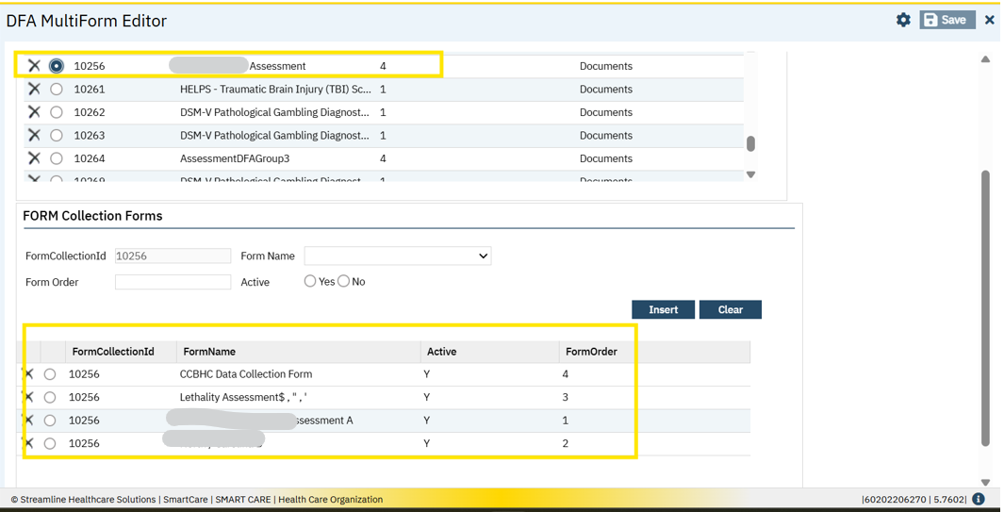
2) Documents Management screen
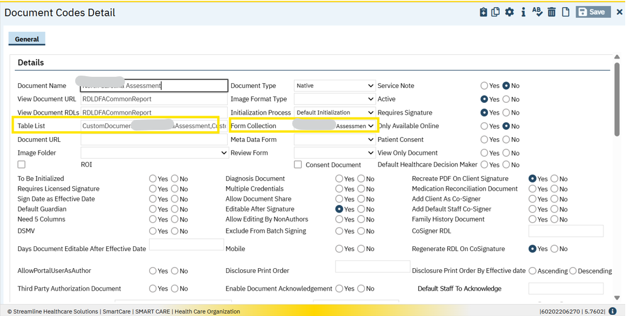
3) Multiple DFA tabs are appearing and are functioning in the Service Notes

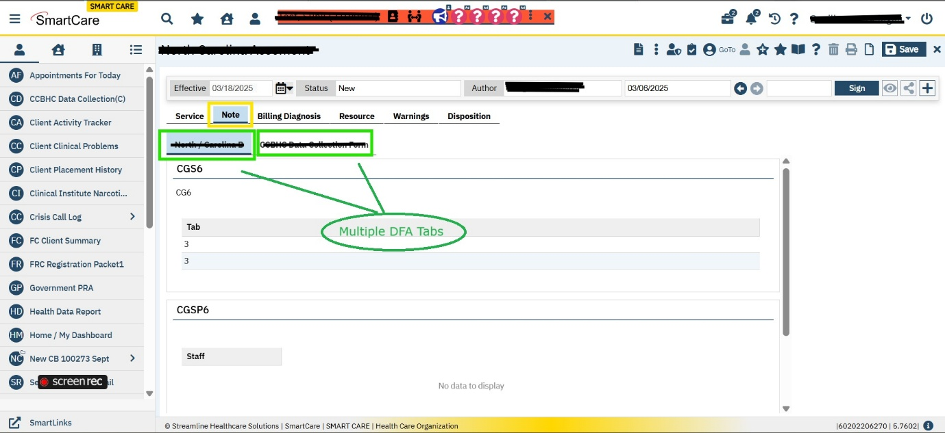

Author: Manjunath Malipatil

135. EII # 129552 (Feature - 473562): Implemented a new ‘Details’ and ‘List’ Screen in order to set up the ‘Telehealth Statement’.
Release Type: New Functionality | Priority: Urgent
Prerequisite: The screen permission for Telehealth Statement List and Telehealth Statement details screens will be turned off by default. The Permission is given for both the screen through the path:
Login to ‘SmartCare’ Application – ‘Staff/Users (Administration)’— In ‘Staff /User List’ screen – Select a user -- In ‘Staff Details’ screen, click on ‘Roles/Permissions’ tab – Navigate to ‘Permissions’ section – Select ‘Screens’ as permission – enter telehealth statement as Permission item – Click on ‘Apply Filter’ Button – Grant a permission for ‘Telehealth Statement Details’ and ‘Telehealth Statement List’ – Click on ‘Save’ Button.
Navigation Path 1: Login to ‘SmartCare’ Application – ‘Telehealth Statement List (Administration)’.
Navigation Path 2: Login to ‘SmartCare Application’ –‘Telehealth Statement Details (Administration)’.
Navigation Path 3: Login to ‘SmartCare’ Application – Select a ‘Client’ – ‘Services/Notes (Client)’ – In ‘Services/Notes’ list screen -- click on ‘New’ Button – In ‘Service Note Details’ screen -- Enter all the required fields – select any of the procedure or ‘Location’ or ‘Mode of Delivery’ associated with Telehealth Statement -- ‘Telehealth Statement’ Section.
Navigation Path 4: Login to ‘SmartCare’ Application – ‘Groups (My Office)’ – In ‘Groups’ List screen, select a ‘Group’ – In ‘Group Details’ screen -- Click on ‘Schedule’ tab—In ‘Schedule’ Tab -- Click on ‘New Group Service’ button – In ‘Group Service Client’ Popup -- select the ‘Date Of Service’ and Select the ‘Clients’ from the list –Click on ‘Ok’ Button – In ‘Group Service Details’ screen – For the selected Client check the Telehealth statement section in the ‘Service Information’ tab.
Functionality ‘Before’ and ‘After’ release:

Purpose: As per the guidelines set by Medicaid, where and how the ‘Telehealth services’ are used in the SmartCare Note.

With this release, the below screens have been implemented.

1. Telehealth Statement Details.

2. Telehealth Statement List Screen.

1. Telehealth Statement Details screen:

This is the Telehealth Statement Details screen, where users can set the ‘Telehealth Statements’ to the ‘Procedures’, ‘Locations’ and ‘Mode of Delivery’.

This screen has 2 Sections:

i. Configuration Details section

ii. Statement Details section

i. Configuration Details: This section has the following fields.

a. Telehealth Statement Name: This is a text field and is a Required field. If the user does not add any data, the below standard validation message will be triggered.

Validation Message: “Please enter Telehealth Statement Name”

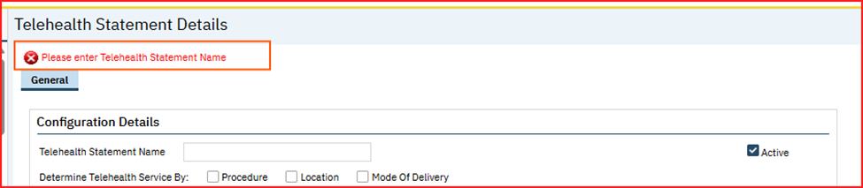

b. Active: This is a checkbox field, and by default, this checkbox is checked.
c. Determine Telehealth Service By: This field has 3 checkboxes, and it is mandatory to select at least one checkbox or else the below standard validation message is triggered.
- Procedure
- Location
- Mode of Delivery.
Validation Message:” Please select at least one Check Box for Determine Telehealth Service By”

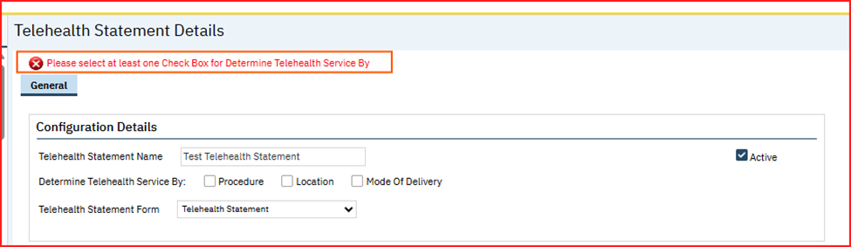

d. Procedure: This field will be hidden by default and when the user selects ‘Procedure’ Checkbox for ‘Determine Telehealth Service By:’ field, this ‘Procedure’ search field will be displayed, and it is a mandatory field.

If Procedure checkbox is checked, but procedure is not selected, then a standard validation message will be triggered.

Validation Message: “Please enter at least one Procedure”

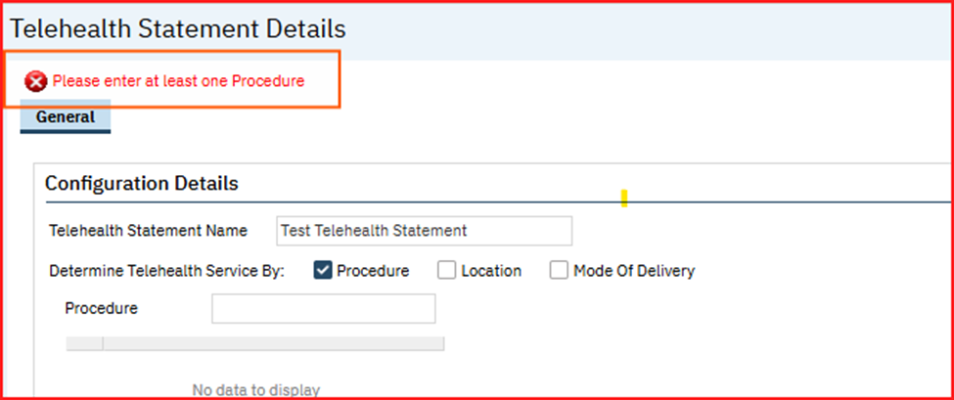

- This is the typeable search field which has a control to display the selected values. The user can search and select only ‘Active’ Procedure codes.
- User cannot select same ‘Procedure Code’ once it has been selected. If the same Procedure Code is selected, the below validation message will be triggered.

Validation Message: “Selected Procedure already exists”
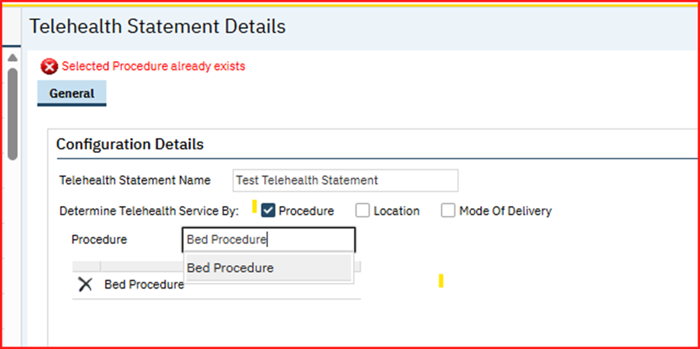

- If the Procedure is already a part of any other Telehealth statement, the below validation message will be triggered indicating the selected Procedure is already part of another Telehealth Statement.

Validation Message: “A statement with Procedure: (Procedure Name) already exists. Please remove these selected values from the Configuration Details section.”

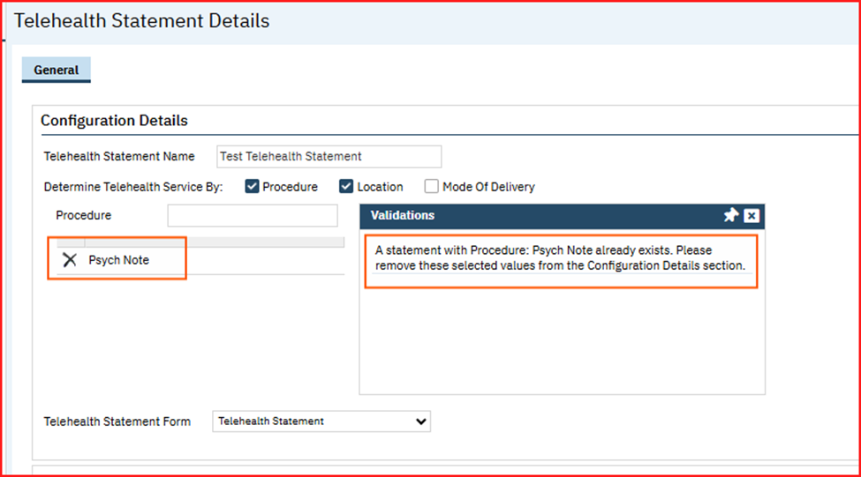
e. Location: This Field is hidden by default, when the user selects the ‘Location’ checkbox for ‘Determine Telehealth Service By:’ field, this ‘Location’ typeable search field will be displayed, and it is a mandatory field.

If the ‘Location‘ checkbox is checked but Location is not selected, then the below validation message will be triggered.

Validation Message: “Please enter at least one Location “

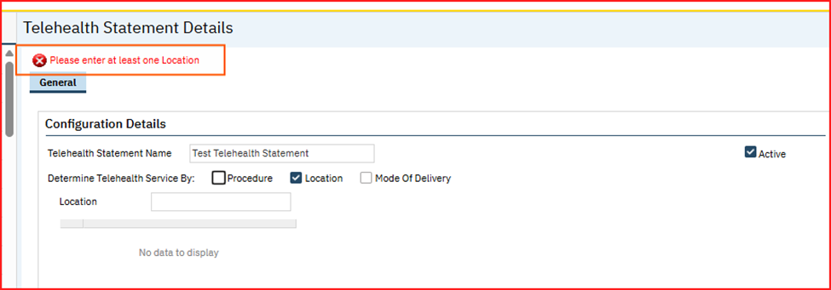

- The ‘Location’ field is a typeable search field which has a control to display the Selected values. The user will be able to search and select only ‘Active’ Locations.

- User cannot select same Location once it has been selected. If the same ‘Location’ is selected, a below validation message will be triggered.

Validation Message: “Selected Location already exists”

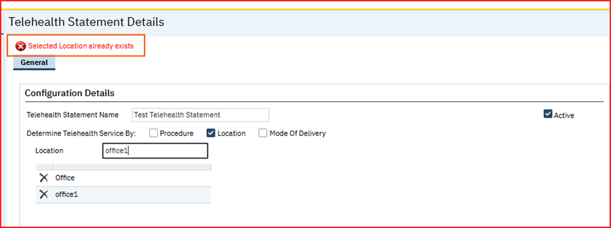

- If the selected Location is already a part of any other ‘Telehealth Statement’, a standard validation message will be triggered indicating the selected ‘Location’ is already part of another ‘Telehealth Statement’.

Validation Message: “A statement with Location: (Location Name) already exists. Please remove these selected values from the Configuration Details section.”

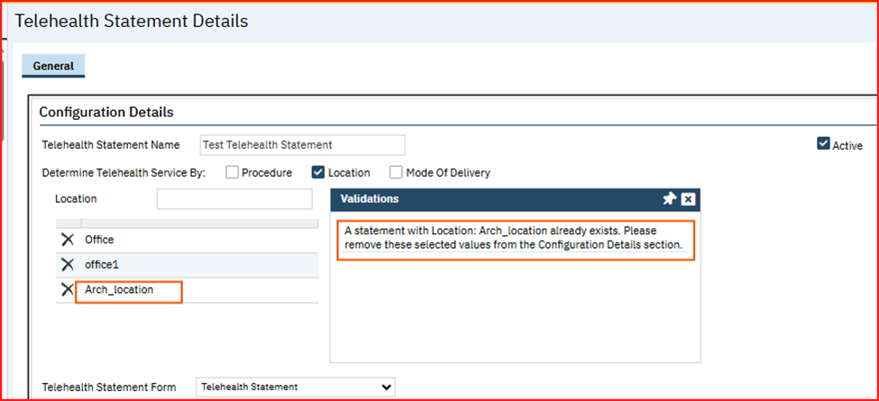

f. Mode Of Delivery: When the user selects ‘Mode of Delivery’ checkbox for ‘Determine Telehealth Service By:’ field, this ‘Mode of Delivery’ search field will be displayed. It will be hidden by default.

If the ‘Mode Of Delivery‘ checkbox is checked but ‘Mode Of Delivery’ is not selected, then a below validation message will be triggered.

Validation Message: “Please enter at least one Mode Of Delivery“

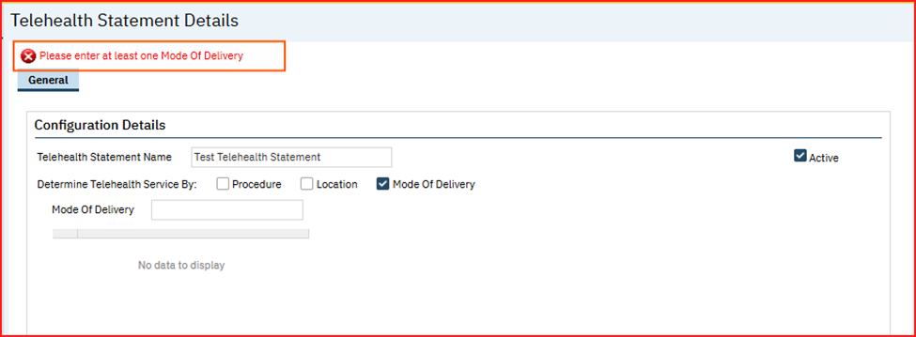
- This is the typeable search field which has a control to display the selected values. The user can search and select only the global codes under the GlobalCode category ‘MODEOFDELIVERY’.

- User cannot select same ‘Mode of Delivery’ once it has been selected. If the same ‘Mode Of Delivery’ is selected, a validation message will be triggered.

Validation Message: “Selected Mode Of Delivery already exists”

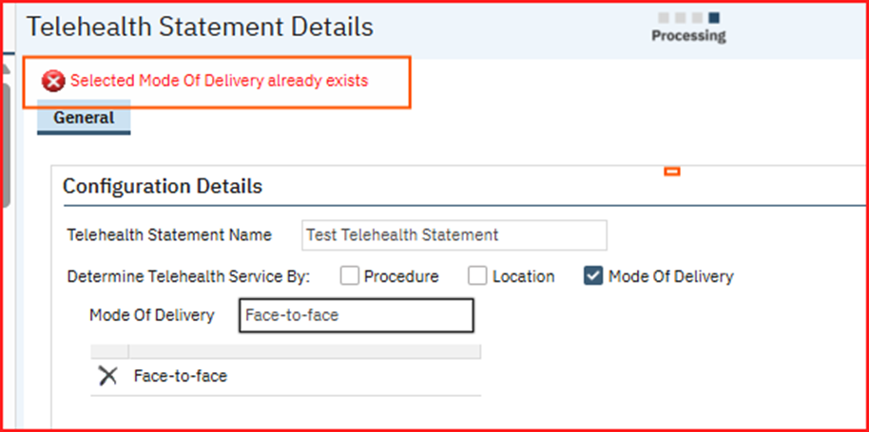

- If the selected ‘Mode of Delivery’ is already a part of any other telehealth statement, a Standard validation message will be triggered indicating the selected mode of delivery is already part of another Telehealth Statement.

Validation Message: “A statement with Mode Of Delivery (Global Code Name) already exists. Please remove these selected values from the Configuration Details section.”

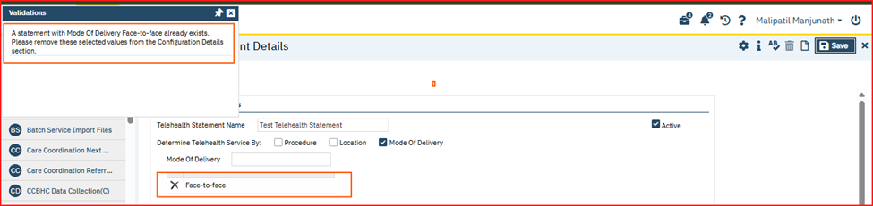
g. Telehealth Statement Form: This is the Drop-down field and is a required field.

- The Dropdown response options is the Form Names that are created using the ‘DFA Editor’ screen, in order for these forms to be considered as Telehealth Statements, the ‘Custom Identifier’ field needs to be “TelehealthStatement”. Otherwise, it will not appear in this dropdown.

- Selection of Telehealth statement form is mandatory, if this field is not selected, a below standard validation message is displayed.

Validation Message: “Please select Telehealth Statement Forms“

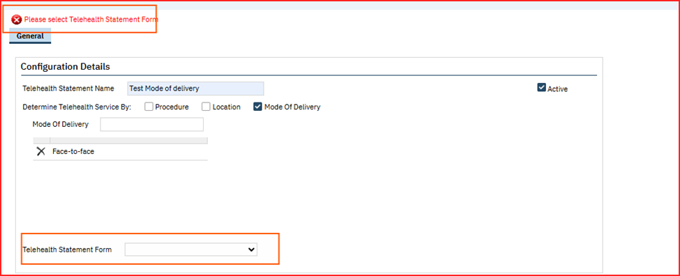

Note: Customer needs to create their own Telehealth Statements from DFA Editor using the ‘custom identifier’ field ‘TelehealthStatement’. Or can reach out to Streamline for the creation of Telehealth Statements.

ii. Statement Details: This section will be disabled by default and this section displays the Telehealth Statement associated with above selected ‘Telehealth Statement Form’ field in the ‘Configuration Details’ section.
- The Validation Messages in the Details screen will be added in the ‘ApplicationMessages’ Table.

2. Telehealth Statement List screen: This is the List screen for Telehealth Statements.
- This screen will be available under Administration.

- This Screen will be turned off by default and user needs to grant the screen permissions to access the screen.

- The List page supports the pagination.
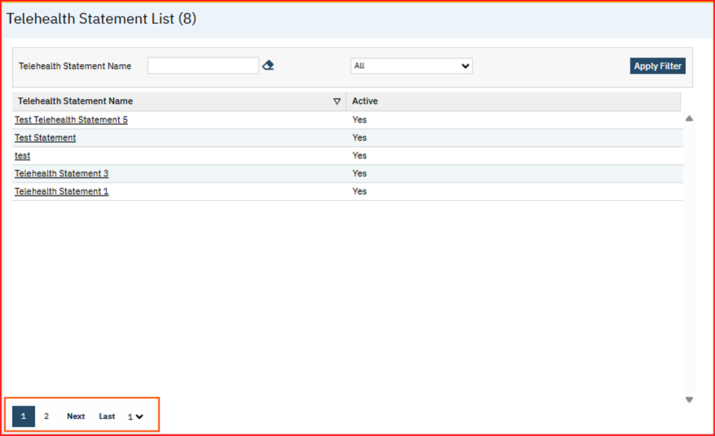

- The default sort of the list page will be based on ‘Telehealth Statement Name’.

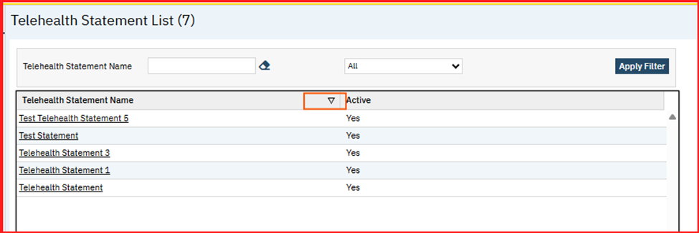

- The ‘Telehealth Statement Name’ field in the ‘Filter’ is a ‘Typeable Search Textbox’, the List will be displayed based on the filter criteria.
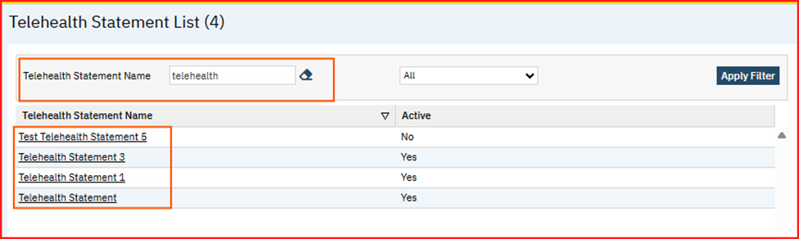

- Clicking on the ‘Telehealth Statement Name’ hyperlink, it redirects the user to the ‘Telehealth Statement Details’ screen of that Particular ‘Telehealth Statement’.
- The list will be sorted based on the columns.
- Clicking on ‘New’ button in ‘Telehealth Statement List’ screen, it will redirect the user to ‘Telehealth Statement Details’ screen.

Service Note Details:
- When the user creates the ‘Services’ in the ‘Service Note Details’ screen, if any of the selected ‘Procedure’ or ‘Location’ or ‘Mode Of Delivery’ is associated with any Telehealth Statement, then the ‘Telehealth Statement’ will appeared in the ‘Service Note Details’ screen.

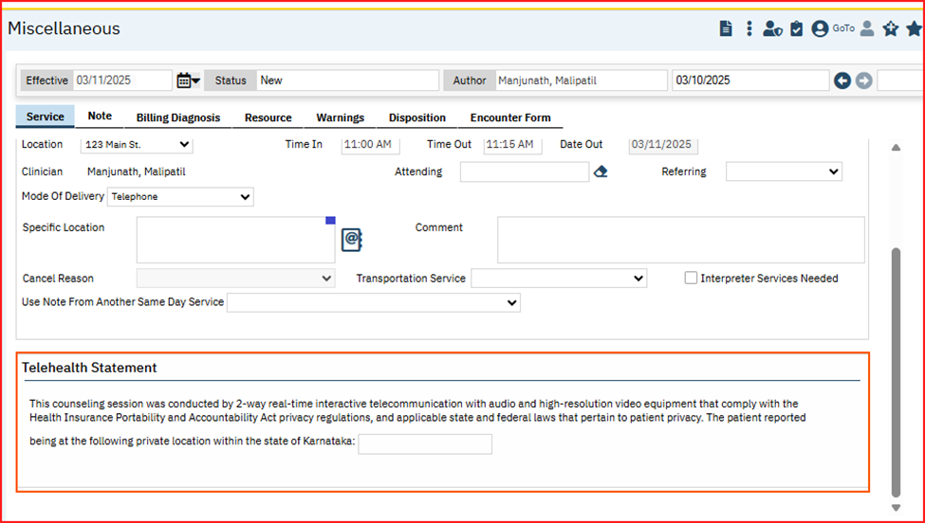

- Telehealth Statement will be a required field for saving the service, if the user does not add any data and try to save the Service, a below standard validation message will be displayed.

Validation Message: “Please complete the “Telehealth Statement” section”.

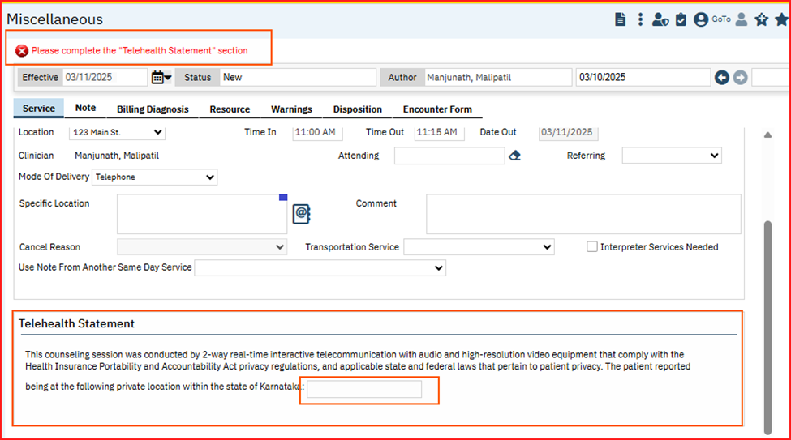

Since there can be combination of more than one ‘Procedure’, ‘Location’ and ‘Mode Of Delivery’ for a Statement, following rules can be applied:
- The priority is given to ‘Procedure’ first, then ‘Location’ and ‘Mode Of Delivery’ in the last.

- If the selected ‘Procedure’ in the ‘Service Note Details’ screen is associated with Any ‘Telehealth Statement’, the ‘Telehealth Statement’ associated with ‘Procedure’ needs to be considered irrespective of the set up available for ‘Location’ and ‘Mode Of Delivery’.

- If the selected ‘Procedure’ in the ‘Service Note Details’ screen is not associated with any Telehealth Statement’ but selected ‘Location’ has a set up for ‘Telehealth Statement’, then the ‘Telehealth Statement’ for the selected ‘Location’ is considered irrespective of the set up available for ‘Mode Of Delivery’.

- If the selected ‘Procedure’ and Location’ in the ‘Service Note Details’ screen is not associated with any Telehealth Statement’ but selected ‘Mode Of Delivery’ has a set up for ‘Telehealth Statement’, then the ‘Telehealth Statement’ associated with ‘Mode Of Delivery’ will be considered.

- If none of the Selected ‘Procedure’, ‘Location’ and ‘Mode Of Delivery’ is not associated with any ‘Telehealth Statement’, then the ‘Telehealth Statement’ section will not be displayed.

Group Service Detail Screen:
- When the user creates the ‘Group Services’ in the ‘Group Service Details’ screen, if any of the selected ‘Procedure’ or ‘Location’ or ‘Mode Of Delivery’ is associated with any ‘Telehealth Statement’, then the ‘Telehealth Statement’ will appeared in the ‘Service Information’ tab.

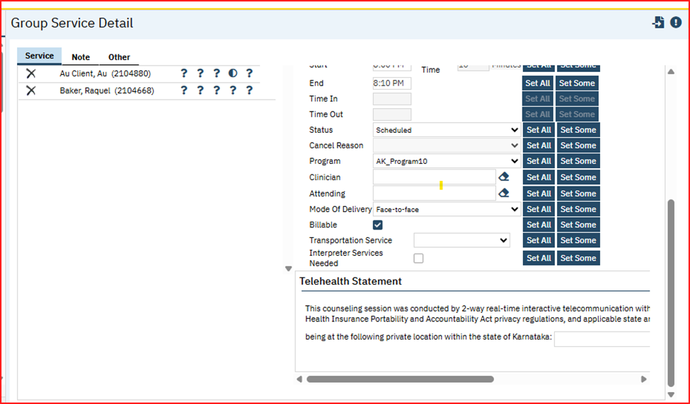

- Telehealth Statement will be a required field for saving the service, if the user does not add any data and try to save the group Service, a below standard validation message will be displayed.
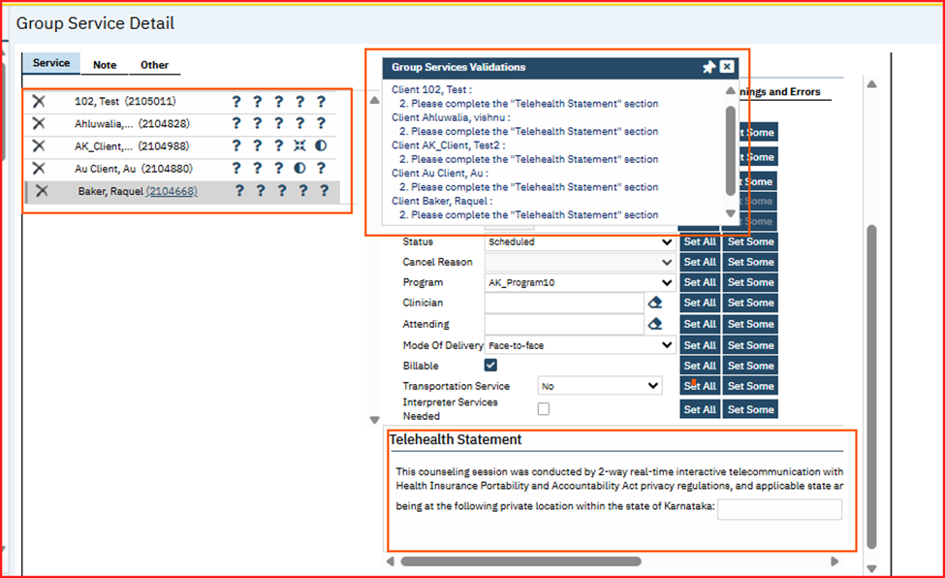

Since there can be combination of more than one ‘Procedure’, ‘Location’ and ‘Mode Of Delivery’ for a Statement, following rules can be applied:
- The priority is given to ‘Procedure’ first, then ‘Location’ and ‘Mode Of Delivery’ in the last.

- If the selected ‘Procedure’ in the ‘Service Note Details’ screen is associated with Any Telehealth Statement, the ‘Telehealth Statement’ associated with ‘Procedure’ needs to be considered irrespective of the set up available for ‘Location’ and ‘Mode of Delivery’.

- If the selected ‘Procedure’ in the ‘Service Note Details’ screen is not associated with any ‘Telehealth Statement’ but selected ‘Location’ has a set up for ‘Telehealth Statement’, then the ‘Telehealth Statement’ for the selected ‘Location’ is considered irrespective of the set up available for ‘Mode Of Delivery’.

- If the selected ‘Procedure’ and ‘Location’ in the ‘Service Note Details’ screen is not associated with any ‘Telehealth Statement’ but selected ‘Mode of Delivery’ has a set up for ‘Telehealth Statement’, then the ‘Telehealth Statement’ associated with ‘Mode of Delivery’ will be considered.

- If none of the selected ‘Procedure’, ‘Location’ and ‘Mode Of Delivery’ is not associated with any ‘Telehealth Statement’, then ‘Telehealth Statement’ section will not be displayed.

Author: Kiran Yogendra

136. EII # 130059 (Feature - 490549): Changes are added to the ‘Mental Status Exam’ tab of the Psychiatric Note.
Release Type: Change | Priority: Urgent

Navigation Path 1: Login to SmartCare application – Search and select a Client - Go to ‘Services/Notes’ - New - Select the Procedure Code associated with the ‘Psychiatric Note’ – Enter all the required values – Navigate to the ‘Note’ tab – MSE tab – ‘Mental Status Exam’ section – Enter all the required details – Click on Save button.
Navigation Path 2: Go Search – Configuration Keys (Administration) – Search – ‘DoNotShowNotAssessedMSESectionsOnEMPDF’ key – Set the Value to ‘Yes’ or ‘No’.
Functionality ‘Before’ and ‘After’ release:
Purpose: To enhance usability and flexibility to the Psychiatric Note MSE tab.

With this release, the below changes are implemented to the ‘MSE (Mental Status Exam)’ tab of Psychiatric Note.

- A ‘Clear’ button is added to all the sub-sections of ‘Mental Status Exam’ section. Clicking on that it will clear all the selections for all the fields. This includes Radio buttons, Checkboxes and the data entered within the Text boxes.
- Added a Radio button called ‘Unable to Assess’ to all the sub-sections of the ‘Mental Status Exam’ section.

- If this Radio button is selected, it disables all the associated checkboxes of the section and allows the user to select the 'Other' checkbox so that this can be used to provide section-specific comments.
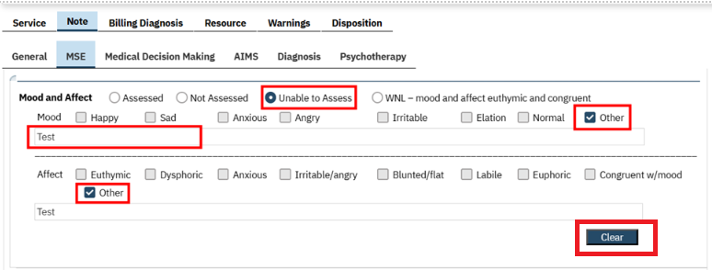
The Clear’ button & ‘Unable to Assess’ Radio button is added to the below mentioned sections:
- General Appearance
- Speech
- Language
- Mood and Affect
- Attention Span and Concentration
- Thought Content and Process; Cognition
- Associations
- Abnormal/Psychotic Thoughts/ Suicide/Homicide
- Orientation
- Fund of Knowledge
- Insight and Judgement
- Memory
- Muscle Strength/Tone
- Gait and Station

3.A new Validation message is implemented for ‘Suicide/Homicide’ section.

This validation is displayed either 'No Suicidal/homicidal concerns' OR 'Present' Radio button is selected only when 'Assessed' is selected for Abnormal/'Psychotic Thoughts'.

Validation Message: MSE - Suicide/Homicide - No Suicidal/homicidal concerns OR Present is required.

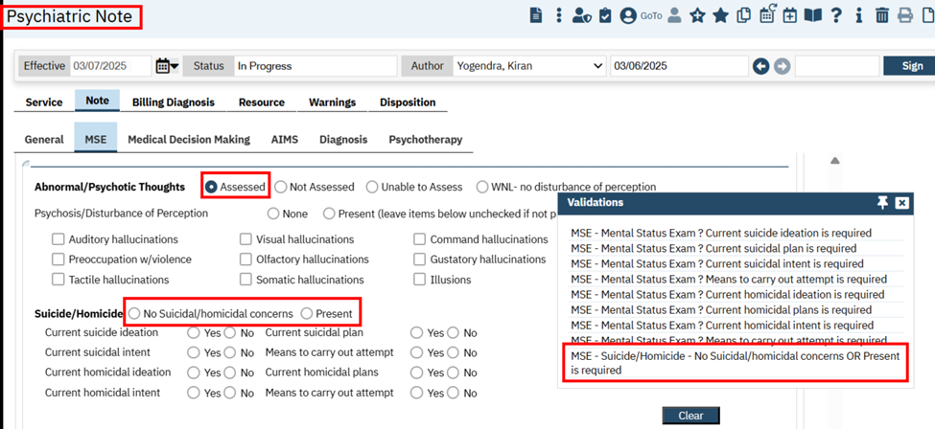
4.When 'WNL-no disturbance of perception' radio button is selected for ‘Abnormal/Psychotic Thoughts', then the system will by default select 'No Suicidal/homicidal concerns' Radio Button for ‘Suicide/Homicide’ section.
5. A Configuration Key called ‘DoNotShowNotAssessedMSESectionsOnEMPDF’ is implemented into the system which hides the ‘Not Assessed’ sections from the Psychiatric Note PDF based on the key value set. (Key value scenarios are explained below).

Newly created ‘DoNotShowNotAssessedMSESectionsOnEMPDF’ Configuration Key details.

SystemConfigKey: DoNotShowNotAssessedMSESectionsOnEMPDF

Read Key as: Do Not Show Not Assessed MSE Sections On E&M PDF.

Allowed Values: Yes, No

Default Value: Yes

Modules: SCM Clinical 2/Psych Note

Description: This is a change to the existing feature of our core product by introducing a system configuration key.

The core Psych Note document has a MSE (Mental Status Exam) Tab, which will always display on the PDF once the Psych Note is signed. With this key, the organization is able to prevent sections of the MSE not from showing on the PDF upon sign, when 'Not Assessed' is indicated per section.

A) If the key-value is set to “Yes”, "Not Assessed" sections of the MSE tab will not show on the PDF. This will be the default value of the key.

B) If the key-value is set to “No”, "Not Assessed" sections of the MSE tab will show on the PDF.

Note:

If by chance the value of the key is updated with any value apart from the allowed values, the system will consider the behavior same as the key value being "No".

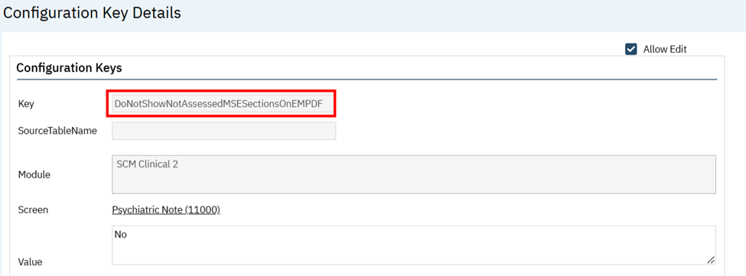

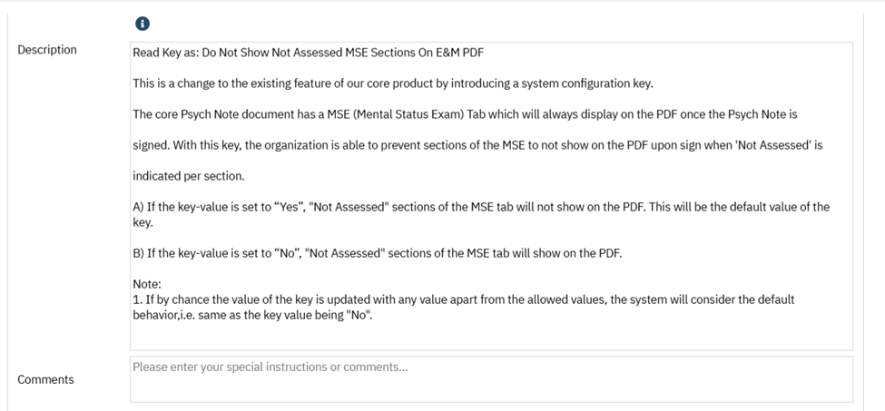

Author: Suganya Sivakumar

137. Core Bugs # 130682: Service/Notes – The Encounter form was missing from the signed PDF document.
Release Type: Fix | Priority: High
Navigation Path: Perform Client Search --- Select Client --- Navigate to Services/Notes --- Client Menu --- Service/Note List Page --- Click on New Icon --- Service Note detail page --- Select Prog/Proc/Loc values --- Select Show Status --- Enter all the required information --- Navigate to Encounter Form tab --- In Client Signature Section --- Click on Sign Button --- Signature popup displays --- Or Either signature Exempt checkbox checked -- Click on Save Icon --Click on Sign button --- Signature popup displays --- PDF generated.
Functionality ‘Before’ and ‘After’ release:
Before this release, here was the behavior. In the Service Notes detail screen, once the user signed, the Encounter Form section was missing in the generated PDF.
With this release, the above-mentioned issue has been fixed. The code is optimized to avoid the missing entry under the corresponding table. Now, the encounter form section is displayed in the generated PDF.

Author: Kiran Yogendra

138. Core Bugs # 130568: A red error was displayed on clicking the Note tab in the Psychiatric Note.
Release Type: Fix | Priority: Medium

Navigation Path: Open a client – Go Search – ‘Services/Notes’ - New - Select the Procedure Code associated with the ‘Psychiatric Note’ – Enter all the required values – Navigate to the ‘Note’ tab – Check if a red error is displayed.
Functionality ‘Before’ and ‘After’ release:
Before this release, here was the behaviour. In the new or existing ‘Psychiatric Note’, after filling the General tab sections, when the user clicked on the Note tab, the below red error was displayed:
Red Error Message: 50000*****8162*****The formal parameter "@CoreParameters" was not declared as an OUTPUT parameter, but the actual parameter passed in requested output.*****ssp_GetLabsOrder*****0*****16*****2*****csp_InitCustomtoCorePsychiatri*****1231*****16*****1
With this release, the above mentioned has been resolved. Now, in the ‘Psychiatric Note’, error message is not displaying when the user clicks on Note tab after filling the details in General tab sections.

Author: Kiran Yogendra

139. Core Bugs # 130608: Current Life Events were not shown on the ‘Individual Service Note’.
Release Type: Fix | Priority: High

Prerequisites: To initialize the ‘Current Life Events’ on the ‘Information’ section of ISN (Individual Service Note), there exists at least one Life Event added to the Client.
Path: Login to SmartCare application – Search and select a Client – Search ‘Life Events’ – Click on ‘New’ - Add all the details related to Life Event – Click on Save.

Navigation Path: Go to ‘Services/Notes’ - New - Select the Procedure Code associated with the ‘Individual Service Note (C)’ – Enter all the required values – Navigate to the ‘Note’ tab – Information section – Mouse hover on the ‘Current Life Events’ information icon (i).

Functionality ‘Before’ and ‘After’ release:

Before this release, here was the behavior. When a user tried to sign the ISN, the ‘Life Events’ added to the Client were not displayed on the Information section on hovering the mouse on info icon (i).

With this release, the above-mentioned issue has been resolved. Now, all the Life Events created or added to the Client are displayed on the ‘Information’ section of the ‘Individual Service Note’.
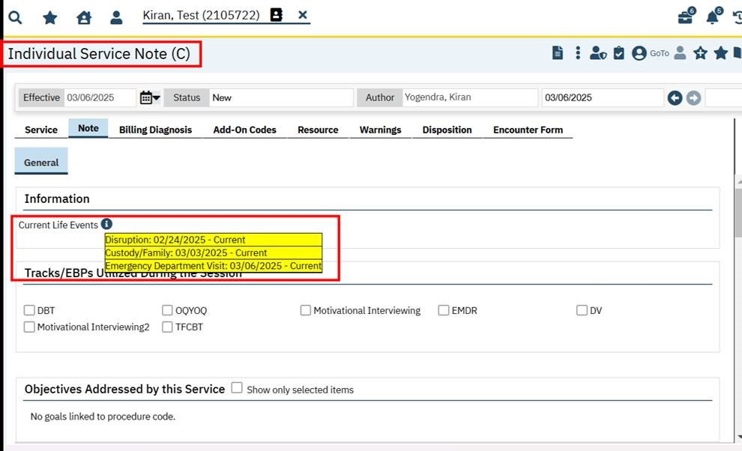

Author: Chaithra Kunjilana

140. Core Bugs # 130666: Support Service Note Error message.
Release Type: Fix | Priority: High
Navigation Path: Search and select a client – Services/Notes – New – Enter the required values in Service tab – Navigate to Add-On Codes – Select the Procedure from drop down – Enter the duration -- Save.
Functionality ‘Before’ and ‘After’ release:
Before this release, here was the behaviour. When a user tried to save Service note without selecting location in the Add-on Code tab, the below error message was displayed.
Error Message: “The INSERT statement conflicted with the FOREIGN KEY constraint "Locations_ServiceAddOnCodes_FK". The conflict occurred in database "ThresholdsSmartcareQA", table "dbo.Locations", column 'LocationId'. The statement has been terminated.”
With this release, the above-mentioned issue is fixed and now, the user can save the service successfully without selecting location in Add-on Code.

Author: Chaithra Kunjilana

141. Core Bugs # 130769: Client Signature details are not getting copied to the New Service when the document is moved to the newly copied Service.
Release Type: Fix | Priority: Medium

Navigation Path 1: Search and select a client -- Go Search -- Services (My Office) – Create a Service – Sign – Complete the Service.
Navigation Path 2: Go Search -- Client Accounts -- Make payment.
Navigation Path 3: Go Search -- Services (Client) – Open the Service for which the payment is made – Copy the Service – Save – Click on Move the Document – Select the Service – Save/Update.
Navigation Path 4: Go Search -- Services/Notes – Encounter Form tab.
Functionality ‘Before’ and ‘After’ release:
Before this release, here was the behaviour. When the user copied the service and moved the document from the service for which the Encounter form was signed in the Encounter form tab in Service Detail screen, the Client Signature details were not getting copied to the New Service.
With this release, the above-mentioned issue is fixed. Now, the Client Signature details are getting copied to the New Service when the document is moved to the newly copied Service.

Author: Navyashree Jois

142. Core Bugs # 130846: Service Notes are not completed or signed off. The radio buttons are changed to checkboxes.
Release Type: Fix | Priority: Medium
Navigation Path: ‘Client’ search -- Open a client – Search for ‘Services/Notes’ - Click on ‘New’ icon - Select the Procedure associated with ‘Individual Service Note (C)’ – Enter the required values – Go to ‘Note’ tab – Enter the required values – ‘Sign’ the Service Note.
Functionality ‘Before’ and ‘After’ release:
Before this release, here was the behavior. The Service Notes were not completed or signed off. But, the radio buttons had been changed to checkboxes. If the data had been saved with the old design, the user encountered an RDL issue as shown below:
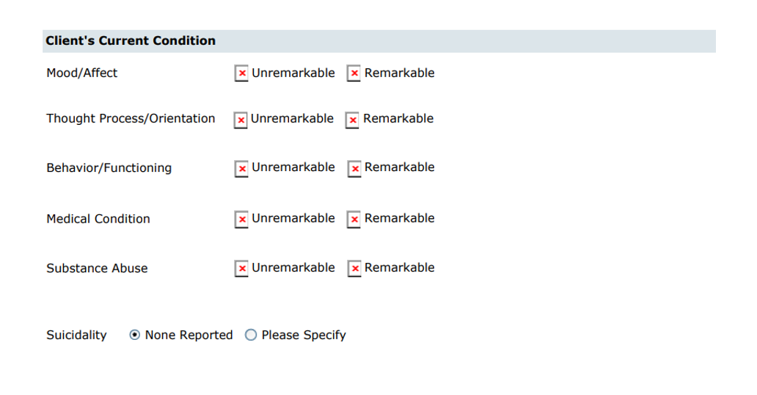
With this release, the above-mentioned issues are resolved. Now, the RDL is modified by adding the radio button images, since it throws an error if the data is saved for the radio buttons instead of checkboxes.
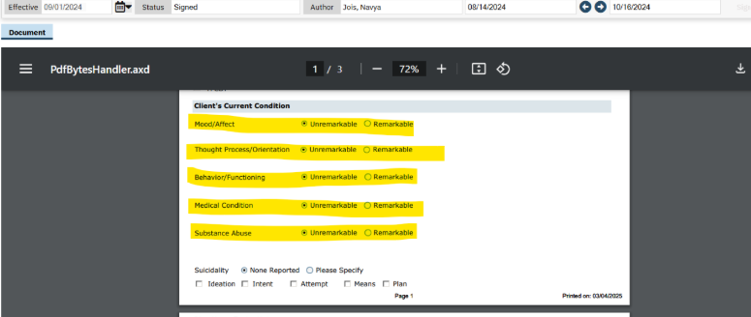

Author: Rakesh Naganagoda

143. Core Bugs # 130756: Tab Order Issue in "SA Initial Treatment Plan" Screen.
Release Type: Fix | Priority: Medium
Navigation Path: Login to SmartCare application – Client – "SA Initial Treatment Plan" Screen.
Functionality ‘Before’ and ‘After’ release:
Before this release, here was the behavior. The user was facing the tab order issue in the "SA Initial Treatment Plan" Screen.
With this release, the above-mentioned issue has been resolved. Now, the tab order issue is working as expected without any issues in the "SA Initial Treatment Plan" Screen.

SmartCare Improvements

Reference No | Task No | Description
144 | EII # 127164 | Changes on the SmartCare Cryptography key Library

Author: Rakesh Naganagoda

144. EII # 127164 (Feature - 351279): Changes on the SmartCare Cryptography key Library.

Release Type: Change | Priority: On Fire

Navigation Path: Login to ‘SmartCare’ application – Perform the functionalities affected.

Functionality ‘Before’ and ‘After’ release:

Purpose: To improve how ‘SmartCare’ stores and handles ‘Cryptographic key’ material.

With this release, instead of hardcoding Cryptographic key material and storing it within the source code, the Cryptographic key material is stored in ‘Azure Key Vault’ and the keys are retrieved upon application startup. This will improve how SmartCare stores and handles ‘Cryptographic key material’. This has been refactored for the below mentioned functionalities:

- Login and Logout
- System that uses passwords
- Password hashing
- Security questions functionality

SmartView

Reference No | Task No | Description
145 | Core Bugs # 130778 | The ‘Client Medications’ are displayed in duplicates under the ‘SmartView’ window, and the count does not match the ‘Medication’ List page.

Author: Rajagopal Yajurvedi

145. Core Bugs # 130778: The ‘Client Medications’ are displayed in duplicates under the ‘SmartView’ window, and the count does not match the ‘Medication’ List page.
Release Type: Fix | Priority: High
Prerequisite: Prescribe the multiple medications through the following path:
Login to ‘SmartCare’ Application - ‘Client’ search – ‘Medication Management Rx’ – ‘Rx Application’ – ‘Patient Summary’ screen – ‘New Order’ button – ‘New Medication Order’ Page - Select the Drug with starting three letters – Fill all required fields - Select the ‘print/Fax/EPCS Pharmacy’ - click on ‘Insert’ button - Click ‘Prescribe’ button - ‘Patient Summary page’.
Navigation Path: Login to ‘SmartCare’ Application - ‘Client’ search – ‘Medication List’ – ‘Medication List Page’–’Client On SmartView’ Icon - ‘SmartView’ window opened.
Functionality ‘Before’ and ‘After’ release:
Before this release, here was the behavior. In the ‘SmartCare’ application, under the ‘SmartView’ window, the ‘Client Medications’ were displayed in duplicates, and count was not match with the ‘Medication’ List page.
With this release, the above-mentioned issue has been resolved. Now, the ‘Client Medications’ are no longer displayed in duplicates, and the count matches to the ‘Medication’ List page.

Summary of Care Document

Reference No | Task No | Description
146 | Core Bugs # 130802 | The system is not generating ‘CCDA XML with Clinical Note information’ which is attached to the ‘USCDI document’.

Author: Munish Sood

146. Core Bugs # 130802: The system is not generating ‘CCDA XML with Clinical Note information’ which is attached to the ‘USCDI document’.
Release Type: Fix | Priority: High

Navigation Path 1: ‘Client’ search -- ‘USCDI Summary of Care’ -- Clinical Notes Included -- ‘List of Attached Documents’--‘Save’--‘Sign’.
Navigation Path 2: Client’ search -- ‘Continuity of Care Document/Record’ -- ‘Continuity of Care Document/Record Details’.

Functionality ‘Before’ and ‘After’ release:

Before this release, the system was not generating ‘CCDA XML with Clinical Note information’ which was attached to the ‘USCDI document’.

With this release, the issue has been fixed. The system is generating ‘CCDA XML with Clinical Note information’ which is attached to the ‘USCDI document’.

Telehealth

Reference No | Task No | Description
147 | Core Bugs # 130707 | A new blank browser window appears when clicking Save.
148 | Core Bugs # 130713 | The ‘Telehealth Meeting Details’ for the other clients in the group are deleted when any one of the client services within the ‘Group Service’ was marked as 'Cancel’.
149 | Core Bugs # 130865 | Meeting Details are not removed from the Outlook Calendar when deleting the Telehealth Meeting details for service with Microsoft Teams Provider.

Author: Sunil Belagali

147. Core Bugs # 130707: A new blank browser window appears when clicking Save.

Release Type: Fix | Priority: Medium

Navigation Path: Go search -- Services/Notes- New - enter details- Save.

Functionality ‘Before’ and ‘After’ release:

Before this release, here was the behaviour. When a user tried to modify and saved the Service Notes that had telehealth Microsoft Teams meeting appointments scheduled, a new blank browser window for SAML login was appearing.

With this release, the above-mentioned issue has been resolved. Now, a new configuration key ‘EnableTelehealthSAMLIntegration’ is implemented to enable or disable SAML login for Microsoft accounts during the process of Telehealth meeting operations through Microsoft Teams.

System Configuration Key Details:

SystemConfigKey : EnableTelehealthSAMLIntegration
Read Key as: Enable Telehealth SAML Integration.
Allowed Values: Yes, No
Default Value: No

Description: "This key is utilized to enable or disable SAML login for Microsoft accounts during the process of Telehealth meeting operations through Microsoft Teams.
When the System Configuration key "EnableTelehealthSAMLIntegration" is Enabled (Yes), the user is allowed to create a Microsoft Teams Telehealth meeting directly.
Whereas when the System Configuration key "EnableTelehealthSAMLIntegration" is disabled(No), the user is redirecting to Microsoft authentication page while creating Microsoft Teams Telehealth meeting.

Author: Manjunath Malipatil

148. Core Bugs # 130713: The ‘Telehealth Meeting Details’ for the other clients in the group are deleted when any one of the client services within the ‘Group Service’ was marked as 'Cancel'.

Release Type: Fix | Priority: Medium

Prerequisite: A Telehealth Group Service is scheduled with Zoom Provider through the path:

Login to ‘SmartCare Application’ – Navigate to ‘Groups List’ Screen – Select a ‘Group’ – In ‘Group Details’ screen Click on ‘Schedule’ tab – In ‘Schedule’ tab -- Click on ‘New group Service’ button ---In ‘Group Service Client Pop-up’ -- Select the ‘Date of Service’ and select the ‘clients’ -- click on ‘Select’ button – In ‘Service Detail’ screen -- Enter all the required Fields – Click on ‘Save’ button – then Click on ‘Schedule Telehealth Meeting’ icon – Schedule a telehealth Meeting with Zoom Provider.

Navigation Path: Login to ‘SmartCare Application’ -- Navigate to ‘Groups List’ Screen – Select a ‘Group’ – In ‘Group Details’ screen -- Click on ‘Schedule’ tab – In ‘Schedule’ tab -- Click on ‘New Group Service’ button – Select the above created group service – In ‘Group Service Detail’ screen – ‘Cancel the service’ for one client in the group – Click on ‘Save’ button – Navigate to ‘My Services’ screen -- Check the telehealth column for the Clients of the group service.

Functionality ‘Before’ and ‘After’ release:

Before this release, here was the behavior. When any one of the client services within the ‘Group Service’ was marked as 'Cancel', the ‘Telehealth Meeting Details’ for the other clients in the group were deleted.

With this release, the above-mentioned issue is resolved. The logic has been modified so that the ‘Telehealth Meeting Details’ for group services will only be removed when the status of the ‘Group Service’ is set to ‘Cancelled’. This means that the ‘Telehealth Meeting Details’ will now be deleted only when all client services within the group are marked as ‘Cancelled’.

Author: Manjunath Malipatil

149. Core Bugs # 130865: Meeting Details are not removed from the Outlook Calendar when deleting the Telehealth Meeting details for service with Microsoft Teams Provider.
Release Type: Fix | Priority: Medium
Prerequisite: A Telehealth Service with Microsoft teams Provider is created through the below path:
‘Client’ -- Services – ‘Services’ list page -- Click on new icon – ‘Service Details’ Screen -- Enter all the required fields -- Click on Save Button -- Click on ‘Schedule Telehealth Meeting’ Icon -- In ‘Telehealth Setup’ pop up, schedule the Telehealth meeting with Microsoft teams Provider with two factor Authentication.
Navigation Path: My Office -- ‘My Services’ --‘My Services’ list page -- Navigate to ‘Telehealth’ Column and click on Update Start button -- ‘Telehealth Set up’ Pop up -- Click on ‘Delete Meeting’ Button -- A new tab opens and copy the Auth Code and paste Auth code in the ‘Teams Auth Code’ field of ‘Telehealth Setup’ pop up -- Click on ‘Delete Meeting’ Button -- Click on ‘Close’ Button -- open the Outlook Calendar and check weather The meeting details are removed from the calendar.
Functionality ‘Before’ and ‘After’ release:
Before this release, here was the behaviour. When the user deleted the Telehealth Meeting details for service with Microsoft teams Provider, the meeting details were deleted automatically by-passing the Two factor Authentication. Due to which, the Meeting Details were not removed from the Outlook Calendar.
With this release, the above-mentioned issue has been resolved. Now, when the user deletes the Telehealth Meeting details for service with Microsoft Teams Provider, the Two factor Authentication will be triggered, once the two factor Authentication is Authenticated, then only Telehealth Meeting details will be deleted and will be removed from the Outlook Calendar.

Widgets

Reference No | Task No | Description
150 | EII # 130232 | Changes are implemented to improve the visibility of the ‘Appointments For Today’ and ‘Services for Today with Past Scheduled’ widgets by displaying the full text of the Client Name/Description when widgets are enlarged.

Author: Chaithra Kunjilana

150. EII # 130232 (Feature - 499179): Changes are implemented to improve the visibility of the ‘Appointments For Today’ and ‘Services for Today with Past Scheduled’ widgets by displaying the full text of the Client Name/Description when widgets are enlarged.

Release Type: Change | Priority: Urgent

Navigation Path 1: My Office -- Dashboard -- ‘Appointment for Today’ widget.

Navigation Path 2: My Office -- Dashboard -- ‘Services for Today with Past Scheduled’ widget (Appointment for Today with Past Schedule’)

Functionality ‘Before’ and ‘After’ release:

Purpose: To improve the visibility of the ‘Appointments For Today’ and ‘Services for Today with Past Scheduled’ widgets by displaying the full text of the Client Name/Description when widgets are enlarged.

With this Release, the below mentioned changes have been implemented in the ‘Appointments For Today’ and ‘Services for Today with Past Scheduled’ widgets.

‘Appointments For Today’ Widget:
- The ‘Appointments For Today’ widget will display full text value (Client Name and Service Type/Procedure Name) for the ‘Client Name/Description’ column for the appointments without having to hover over the hyperlink.
- If the length of the Name/Description is too long, then it will display on the next line, and adjust the row height accordingly to accommodate the text.

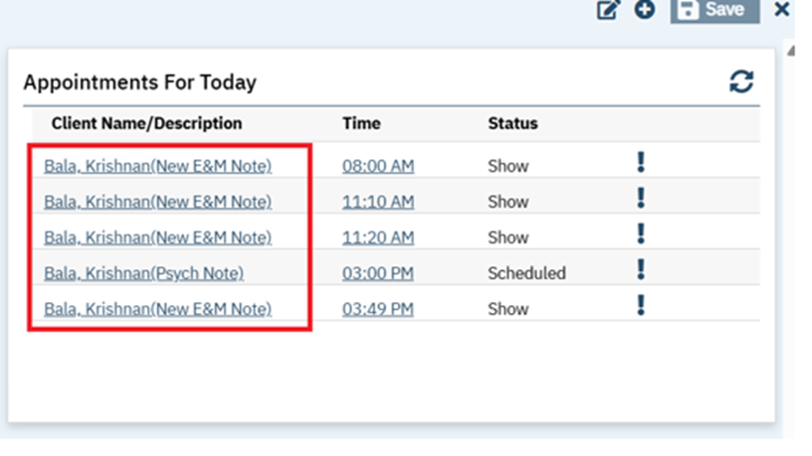
‘Services for Today with Past Scheduled’ widget: (Appointment for Today with Past Schedule’)
- Added the Description text that is ‘Service Type/Procedure Name’ of the appointments in the ‘Name/Description’ column of the ‘Services for Today with Past Scheduled’ widget.
- The ‘Services for Today with Past Scheduled’ widget will display full text value (Client Name and Service Type/Procedure Name) for the ‘Client Name/Description’ column for the appointments without having to hover over the hyperlink with the format eg: Test, Client (Therapy).
- If the length of the Name/Description is too long, then it will display on the next line, and adjust the row height accordingly to accommodate the text.

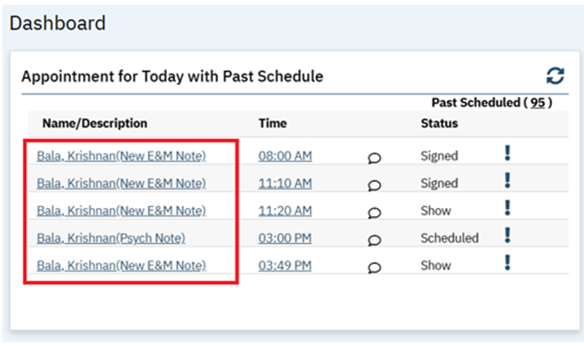

Glossary of System Configuration Keys, Global Codes, Recodes, Data Model Changes.

System Configuration Keys
125: ‘DisplayStaffAsTypeableSearchTextBox’

131: “AllowBedServicesCreationToErrorBilledServices”

136: DoNotShowNotAssessedMSESectionsOnEMPDF

147: EnableTelehealthSAMLIntegration

Global Codes
81. AXHealthIssues

82: ClientFeeType

96: MEDTRANSACTIONREASON

135: MODEOFDELIVERY

Recodes
84: SetDiscontinuedForClientOrder

88: LABWIDGETDRSTATUS

96: SetReasonsForNegativeAdjustments

Data Model Changes

89: New ‘GlobalCodeId’ and ‘MappingType’ columns included in ‘ExternalMappings’ table

89: New ‘IsExternalMappings’ column included in ‘GlobalCodeCategories’ table

92: Added New columns WarningStoredProcedureDelete, ValidationStoredProcedureDelete in Screens table.

96: A New column AccountForVariance is added to the ‘MATConfigurations’ Table.

96: A new columns ActualQuantity, QuantityBalancePriorToTransaction,VarianceMedicationTransactionId are added to the MedicationTransactions table.

99: Added table MATDispenserAPILog

108: Added a new table ‘OrderAdhocHistory’

113: A ‘DepositDate’ column is added to ‘Payments’ and ‘ERFiles’ table

115: New Column "SubsequentClaimPCNOption" added in Table "CoveragePlans"

