**How to add a modifier HF for Contingency Management services.**

Adding a modifier to a procedure code at the PLAN level:

1. Go to your search Icon (magnifying glass) at the top of your screen;

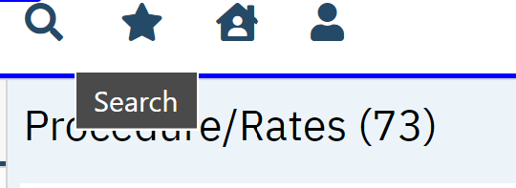

1. Type in PLANS and choose from the drop-down menu “Plans (Administration)”

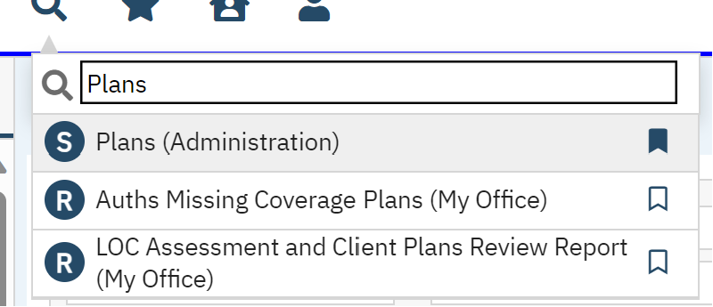

1. This takes you to the plans screen.
2. There are only 4 templates that you should have to choose from: DMH (MH-Medi-Cal); California Department of Alcohol and Drug Programs (DMC Medi-Cal); ZZ-Commercial Plan Template (commercial insurance); and ZZ-Medicare Plan Template (Medicare). Click one to get started. ***Please******note:*** *Depending on the code you are modifying, you need to choose the correct template. For instance, if you were adding the modifier HF to Contingency Management, this code is billable to a DMC service, not a MH service. So you would work all templates but DMH.*
3. Once you click on one, go to the “Billing Codes” tab.

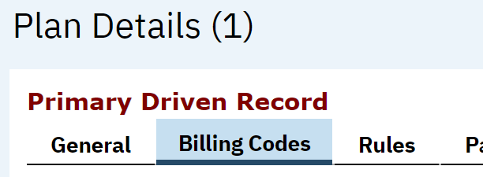

1. Next you will need to filter out the procedure code you are looking to modify.

You can do this by choosing the “all procedure codes” drop down menu in the Billing codes box.

1. Choose your procedure code and click apply filter.

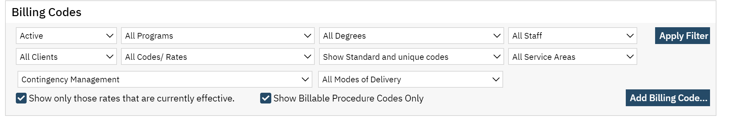

1. The procedure code that you chose will then populate in the select section.

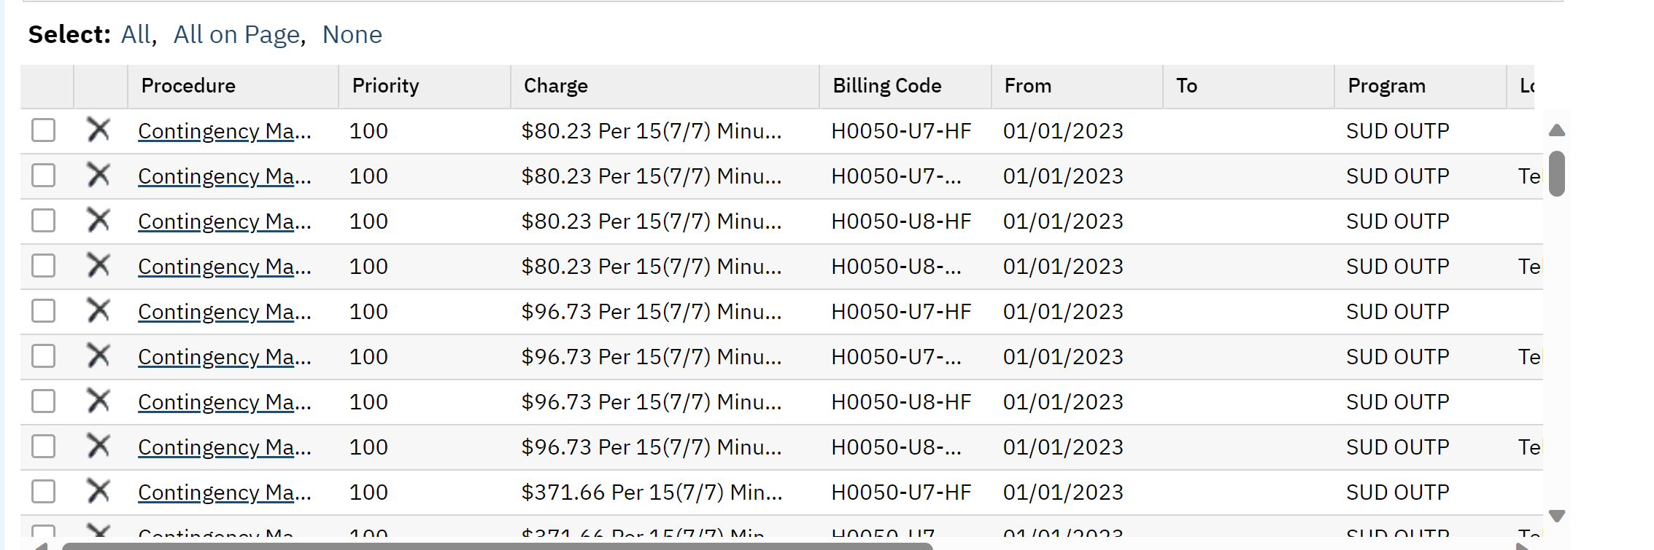

1. Next, you will need to click on the first hyperlink of the procedure code.

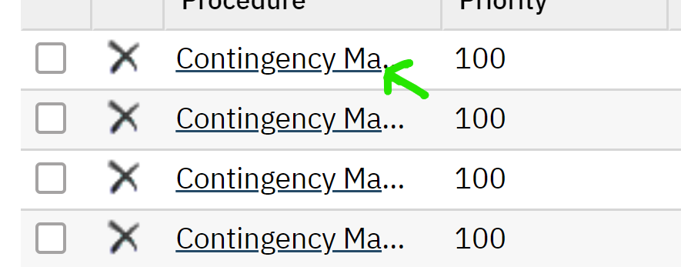

1. Once you have clicked the procedure code hyperlink, a pop up box will appear with that code’s information. Navigate to the middle section of the “Billing Code Information” box. There you will find the billing code with 4 boxes after it.

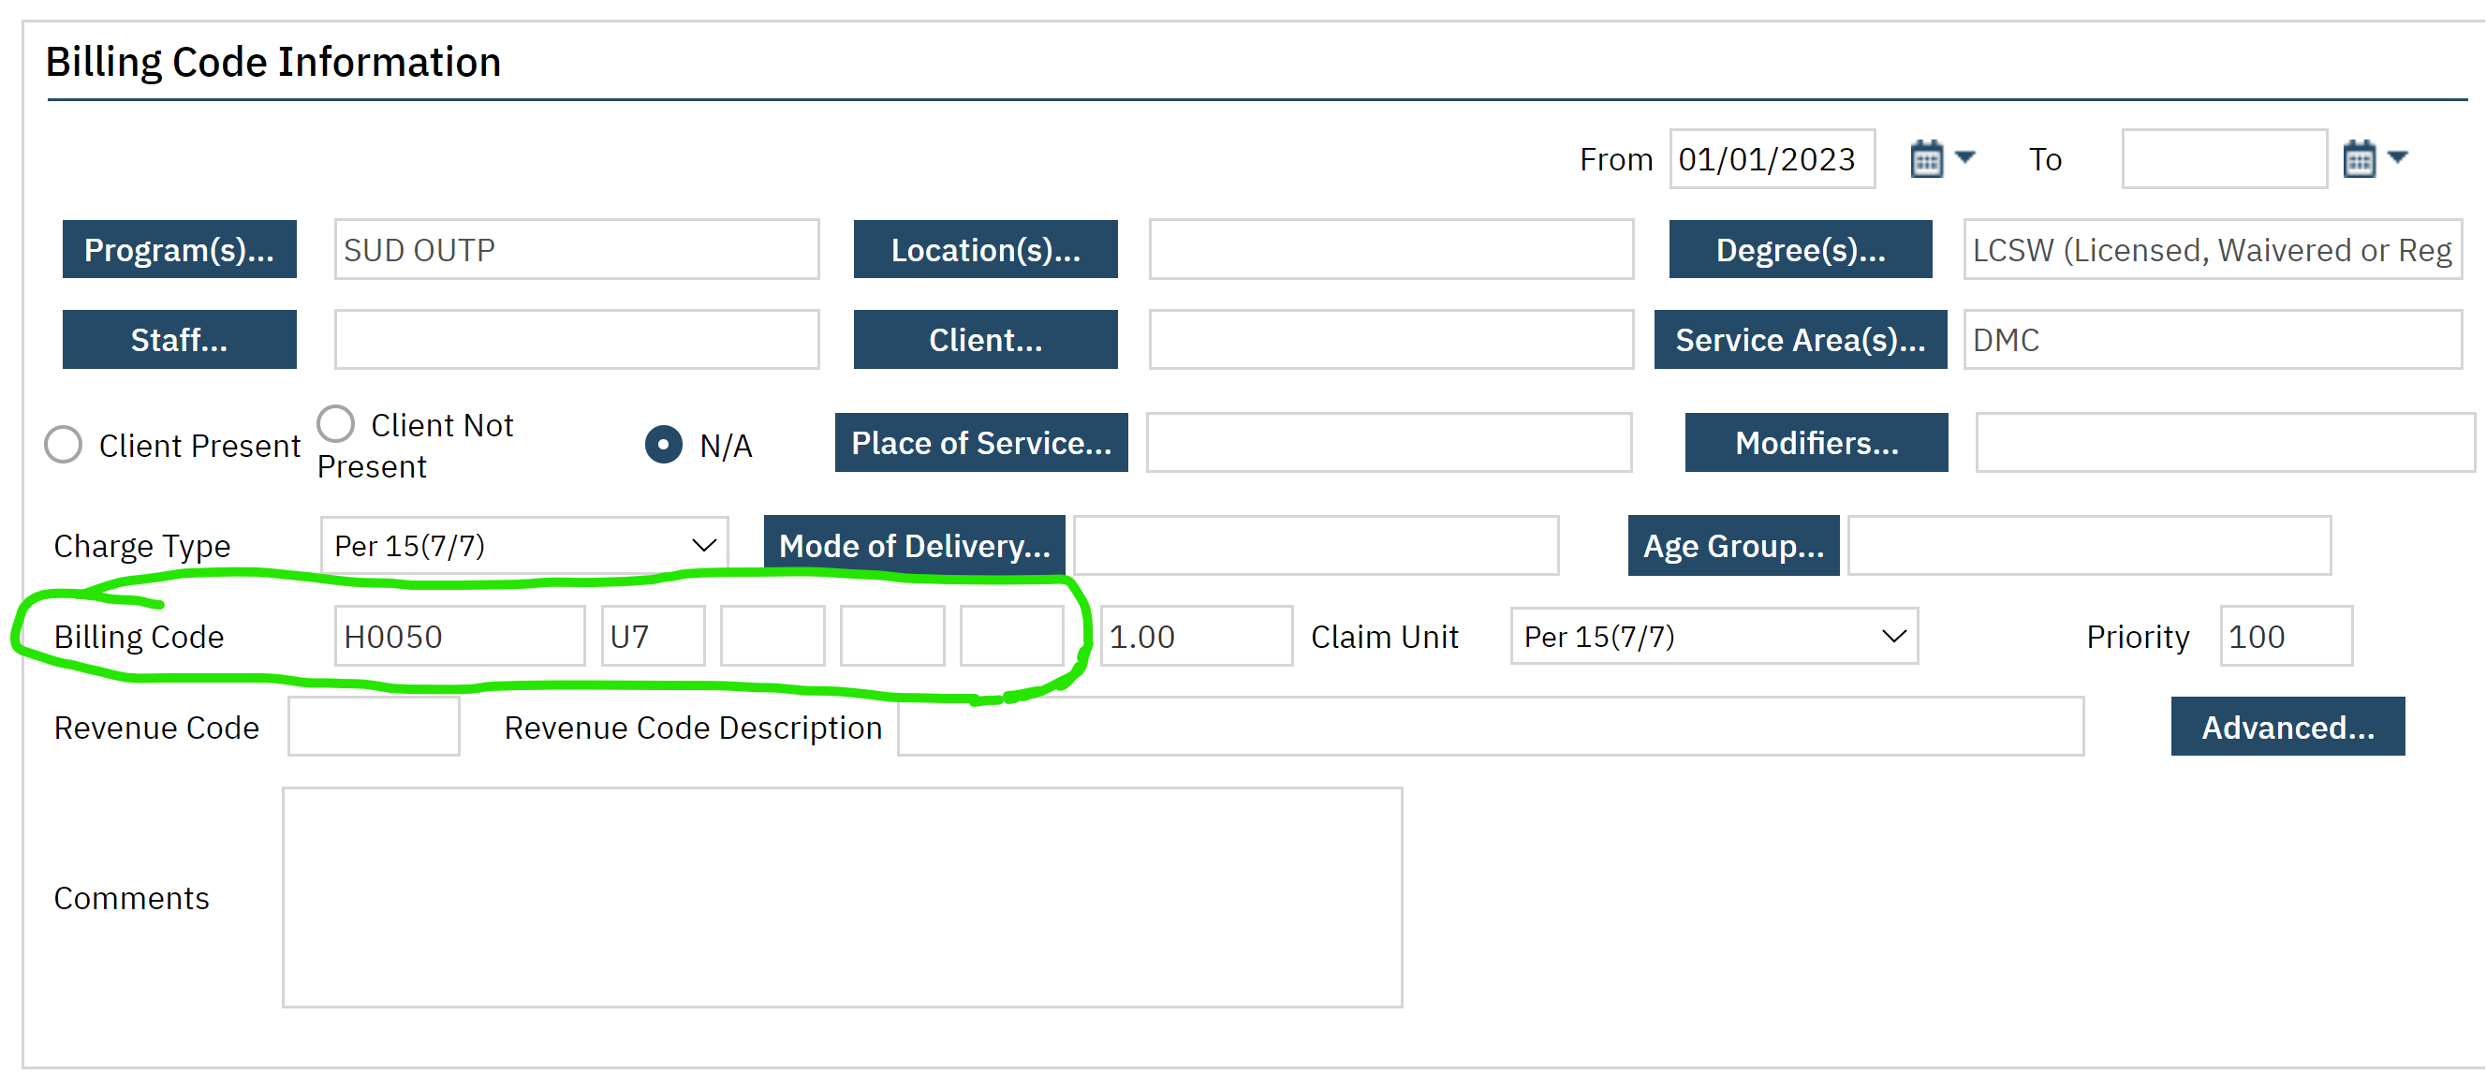

1. On the next empty box, you will enter the modifier that you need to enter. In this instance, adding modifier HF for Contingency Management.

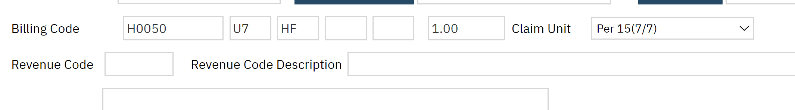

1. Once you have added the modifier, click the save button on the top left of the pop up box.

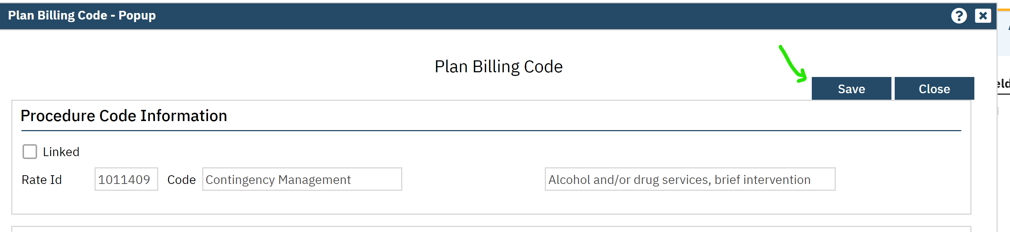

1. Click the close button next to the save button.
2. Repeat steps 9-13 for each hyperlink for the code you are modifying.