Setup in SmartCare to support DHCS claim requirements for when a beneficiary receives multiple doses of the same medication, provided on the same calendar day. In order to accommodate this requirement, the MAT procedure codes will need the Medication grouping attached. This will initiate the roll up of the same medications on the same day.

**How to add a global code to your NDC codes for the Roll up rule**

* On your search Icon type in Procedure/Rates (Administration)

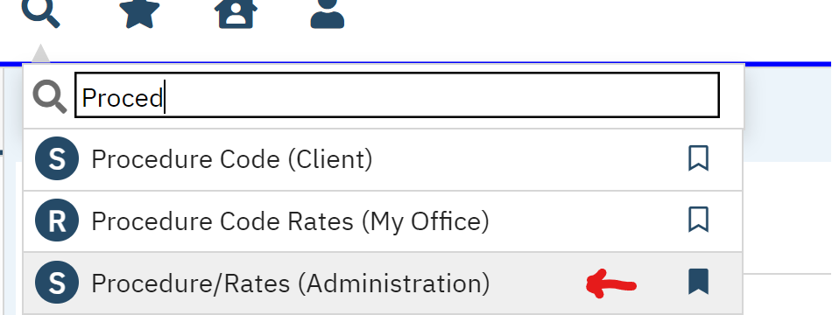

* Pull up the Procedure code by NDC # or if your County created their own version of the MAT procedure codes, search by the procedure code name.

* You will get the Drug Code associated with the NDC code.

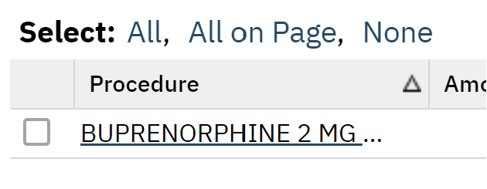

* Click on the Drug name Hyperlink
* Click on the tab labeled “Custom Fields”



Under the box labeled “Drug Information” there is a drop-down menu.

* Click on the drop-down menu and choose the Drug that coincides with the drug you are working with. (in the example above, you would choose Buprenorphine)

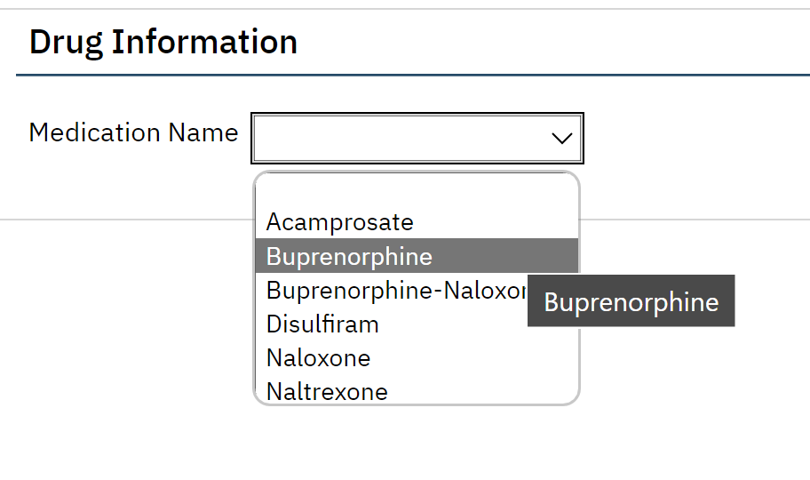

* Click SAVE

 With this in place, when you administer more than one drug in one day, it will take the drugs administered and calculate for you what was given to the client. It will go out on the 837 file like this: A close up of a document
