Special Aid Codes
Normally, for clients with Medi-Cal, SmartCare will reference the monthly MMEF file and determine on a regular basis if a client continues to be eligible for insurance coverage. This check for coverage happens whenever overnight jobs run.
There is a particular scenario when referencing the MMEF is not enough information to determine coverage. If a client has a Special Aid Code and an eligibility status code of “999,” they will not meet standard Medi-Cal eligibility criteria, but they qualify for coverage through different special situations.
The primary method for checking for Special Aid Codes is by running a 270/271 in SmartCare. After running 270/271, you will see a response screen. If there is a Special Aid Code, it will show up under the heading “Message 1.”

If you would like to look up what the Special Aid Code means, you can search on DHCS’s website and find the Medi-Cal Aid Codes list. 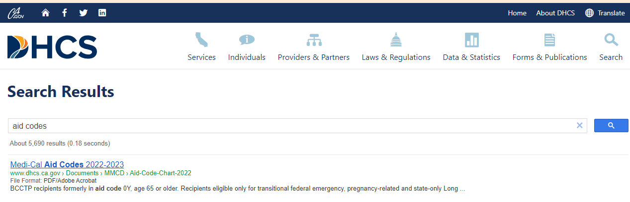
https://www.dhcs.ca.gov/services/Documents/MMCD/Aid-Code-Chart-2022.pdf

Once you have confirmed that the client has an active Special Aid Code, you can click a check box so that SmartCare does not remove coverage during overnight jobs. This must be done once per client. The system will remember this selection.
To do this, navigate to the coverage screen for the client you are working on. Click on the plan name you wish to update.
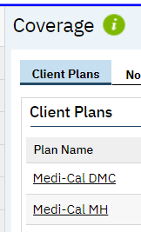

You will see a screen like the one below. Click on the Custom Fields tab. Now Click the checkbox below.
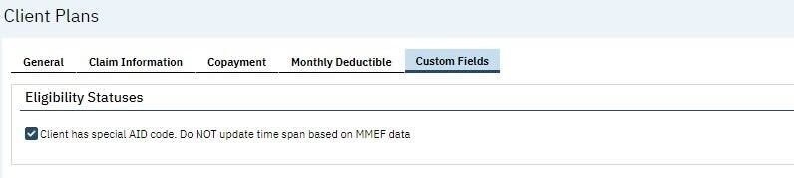
Once this is done, SmartCare will not remove this client’s coverage when overnight jobs run.

When the client no longer has a special aid code and has regular Medi-Cal Eligibility, then you can uncheck the checkbox above. Because the client in this scenario has regular Medi-Cal eligibility, they will have an Eligibility Status code that is not “999.” Therefore, the plan timespan for Medi-Cal will not be removed by SmartCare and normal eligibility updates will resume.

