CalMHSA MMEF 2 out of 3 Match Report

When looking at the MMEF file that is loaded into your county’s Production environment, you will usually find a large number of clients listed. This is because this data covers all of the Medi-Cal population that can possibly receive services in your county. Since it would be a burden to sift through this data monthly, CalMHSA has a tool that can be used to investigate potential matches in your county.

To assist counties in troubleshooting errors with client data, there is a report that can help compare and reconcile client data differences. The report is called the “CalMHSA MMEF 2 out of 3 Match Report.” Specifically, the report can show clearly what data is present in SmartCare versus what is visible on the monthly MMEF file.

It is up to counties to review this information monthly, update various fields of client data as needed, and ignore potential matches that are very different from what the MMEF file has listed. Once changes to client data have been saved, the client’s insurance coverage will be updated by the overnight billing job in SmartCare.

### How do I view the CalMHSA MMEF 2 out of 3 Match Report?

1. **Click the Search icon**.
2. **Type “****CalMHSA MMEF 2 out of 3 Match Report”** into the search bar.
3. **Click to select “CalMHSA MMEF 2 out of 3 Match Report (My Office)”** from the search results.

A new window will pop up. **Select a month of data, e.g. “202307”. Click “View Report”.** You will see the screenshot below.



To review the data on this screen, please follow these principles.

All of the columns on the **left-hand side contain data taken from a client’s SmartCare account**. All of the columns on the **right-hand side contain data taken from the MMEF report**. For example, the column “Last Name” is taken from SmartCare while “Beneficiary Last Name” comes from the MMEF report. Another example is “SSN” is taken from SmartCare while “Meds Identification Number” comes from the MMEF report.

To update client information using this screen as a tool, CalMHSA recommends the following guidelines. **It is up to counties to decide on a specific protocol for how to proceed in any given situation.**

1. Check the columns that begin with the word “Match…”. If you see any red **“No”** in these columns, these are clients where fact-checking is needed.

2. In these instances, compare the data in the left-hand column to the data in the right-hand column.

3. If there is only one column with a red **“No”**, check to see if there is a simple typo that needs to be corrected in SmartCare. You will need to open the Client Information screen in SmartCare and correct the bad data. For example, If the “DOB” column says 01-01-2010 but the “Date of Birth” column says 01-02-2010, then you would correct the information in SmartCare to read 01-02-2010 to agree with the data on the MMEF.

4. If any client has multiple red **“No”** columns, exercise caution when correcting their demographic information. For example, if the Social Security Number columns and the Date of Birth columns both have a red **“No”**, check to make sure the information is not drastically different. If the SSNs look nothing alike and the DOBs are 22 years apart, this is most likely a false match and can be ignored.

### Special Cases

Common client names can provoke a false match in this report. For example, names like John Johnson or Maria Garcia can occur commonly in the general population. Even though these names will yield a “Yes” in the Match Names columns, check other data fields for these clients to make sure you are not incorrectly making changes to clients that actually do not match.

For any clients that have a Pseudo SSN in the “Meds Identification Number” column, this information can be entered into SmartCare. A Pseudo SSN on this report will have 8 numbers followed by a letter (typically P or Q. For example, 12345678Q). People whose identity has not been linked to a valid SSN are issued Pseudo SSNs by the state.

Once you have confirmed that a client has a Pseudo SSN, follow these directions to enter it into SmartCare.

Go to Client Information for the client you are working on, then click on the Custom Fields tab. Under the California Reporting section, enter the Pseudo SSN into the field highlighted in red below. Click save.

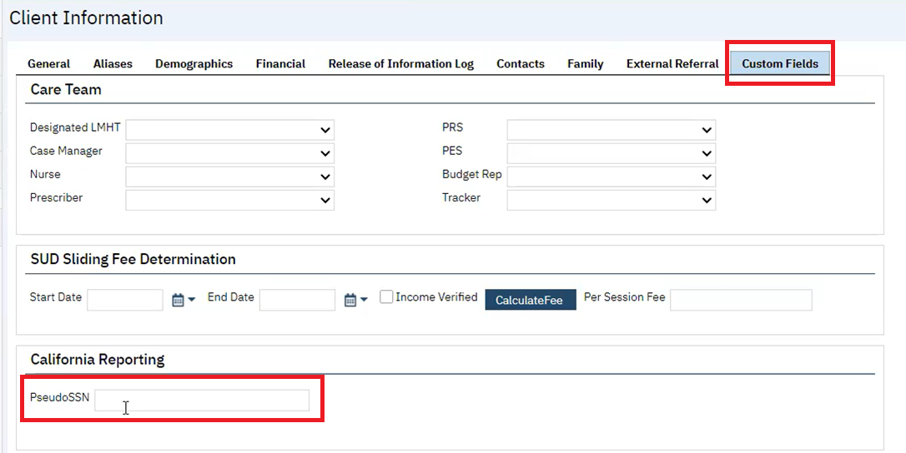

Once you have done the above steps for this client, you also need to make sure that the Social Security Number on the General tab is updated to read “999999999”.

999999999 is a valid entry for an unknown SSN in SmartCare. Therefore, in the “Match SSN” column, you will see a “Yes” if there is a 999999999. **If you see a 999999999 in the “SSN” field on the CalMHSA MMEF 2 out of 3 Match Report, you must check the other data fields for this client to see if this is a real match or a false match.**

Again, if the “Meds Identification Number” column tells you that a client has a Pseudo SSN (ending in a P or a Q), this information can be entered into SmartCare.

Go to Client Information, then click on the Custom Fields tab. Under the California Reporting section, enter the Pseudo SSN in the field labeled “PseudoSSN.”